19 Lenehan St.,
GIRALANG ACT 2617

6 February 2001

The Secretary
Senate Superannuation and Financial Services Select Committee
Parliament House
Canberra ACT 2600

Dear Sir/Madam,

Having spoken to a member of your staff yesterday I understand that you would have no objection to a short supplementary submission. I made a submission on 27 January 2001 that addressed one of your primary terms of reference.

In this supplementary submission I wish to note that when A New Tax System (ANTS) was introduced last year, Defence Force Retirement and Death Benefit (DFRDB) pensions were not increased to compensate for the introduction of the GST. Advice I received from COMSUPER states, inter alia, “Your pension under DFRDB has not increased to compensate for the GST…” As a consequence, my family is suffering economic loss.

I believe it is only fair that my DFRDB pension should be increased to compensate for the GST.
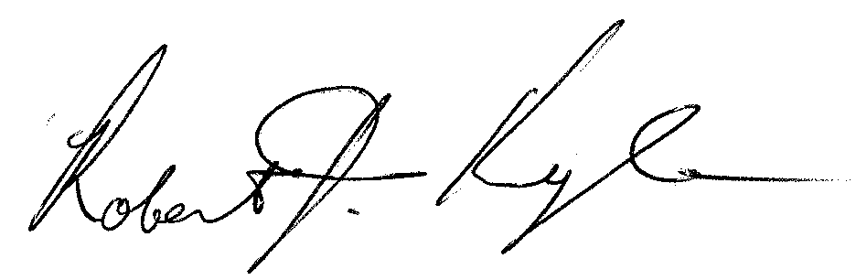
Yours faithfully,

Robert J. Kyle

