Submission to:

Senate Select Committee on Superannuation and Financial Services
Email: super.sen@aph.gov.au

Pension payments made under the CSS and PSS schemes are varied in accordance with the CPI. This is the sole indicator used to increase these payments. As I understand it, parliamentary pensions are based on the AWOTE wages based index to keep these superannuation payments in line with current wages. This index, based on its name would seem the logical choice because of the inclusive nature of male and female workforce. It is my understanding that the parliamentary pensions are adjusted twice per year, whilst the CSS pension is adjusted only once per year in arrears.

The following graph (based on ABS data) prepared by NSW SCOA member, Jim Johnson, and copied from an SCOA Newsletter, shows the cumulative percentage increases in the CPI compared with the age pension, Male Total Average Weekly Earnings (MTAWE), and Adult Weekly Ordinary Time Earnings (AWOTE) over the period 1993 to August 2000.

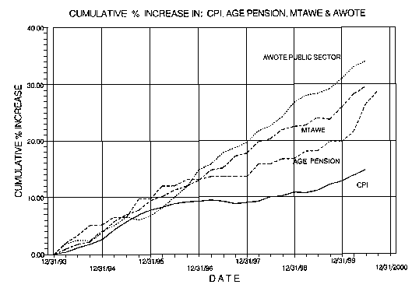
As can be seen from the above graph, all of the indices are in a reasonably close correlation from Jan 94 to Dec 95. Also, except for a short period around the end of 1995, the CPI always shows the lowest rate of increase. Since Jan 94 the AWOTE index has continued upwards more or less in a straight line whilst the CPI has flattened off considerably. The current position is that there is a very significant difference between the two types of indices.

From the graph, it is obvious that CSS retirees have steadily lost relativity with those currently employed in similar positions to those previously held. This loss of relativity has been particularly severe since Jan 94. Clearly, this is inequitable, as the compulsory Super Scheme to which we were required to belong was touted as one which would, through indexation, maintain relativity with the existing workforce.
The fact that parliamentarians use a much more favourable current wages based index for their pensions, smacks of double standards.
The leaders of all parliamentary parties espouse the notion of a "fair go". Parliamentary salaries are paid from the Public Purse and as such, they too, are Commonwealth Public Servants. As a citizen of this country, I object to elected representatives having special deals which favour themselves above others. The logic used some years ago when the previous index used by parliamentarians ceased to be relevant, was to transfer to the AWOTE index and backdate payments. The same logic is equally valid for CSS superannuants who should, without delay, likewise be transferred to the same index and have payments backdated.
Parliament should now enact whatever legislation is necessary to restore the parity of previous Commonwealth Public Servants with the current workforce by having their superannuation payments linked to the same index as is used by parliamentarians and adjusted with the same frequency.

Barry Wilson
15/24 Telopea Park
Kingston ACT 2604
30 January 2001
Email: bwilson@pcug.org.au

