19 Lenehan St.,
GIRALANG ACT 2617

27 January 2001

The Secretary
Senate Superannuation and Financial Services Select Committee
Parliament House
Canberra ACT 2600

Dear Sir/Madam,

I write to address one of your primary terms of reference, that is the method of indexation used to calculate members’ benefits in the Defence Force Retirement and Death Benefit (DFRDB) Scheme.

I am concerned that not only is the DFRDB retirement pension wholly inadequate vis-à-vis the arduous nature of Defence Service (eg during my 26 years Naval Service I endured 80+ hour work weeks, months at a time away from family, a year at war where I was shot at, blown up, shot down, and topped off by very inadequate financial remuneration) but also a DFRDB pension is indexed only once a year for changes in the Consumer Price Index (CPI).

For example, since my retirement in 1993 from the RAN the CPI has consistently risen by less than actual living costs, whereas salaries in the Defence Force have risen, on average, in step with the actual cost of living. I note that Parliamentary pensions are indexed by reference, not to the CPI, but instead to the growth in parliamentary salaries. This method of indexation ensures that retired politicians share in the growth of the nation’s real living standard in retirement. If my pension were linked to the growth in Defence Force salaries I would be about $2,000 per annum (before tax) better off after only seven years!

Not only is the Parliamentary pension scheme much more generous than the DFRDB scheme, but the method of indexation guarantees that retired parliamentarians share in the growth of the nation’s real living standard, while war veterans like myself who fought for this nation slide further and inexorably into poverty. Not only is this clearly discriminatory, but it is a shameful state of affairs!

I believe it is only fair my DFRDB pension be indexed by reference, not to the CPI, but instead to the growth in Defence Force salaries.
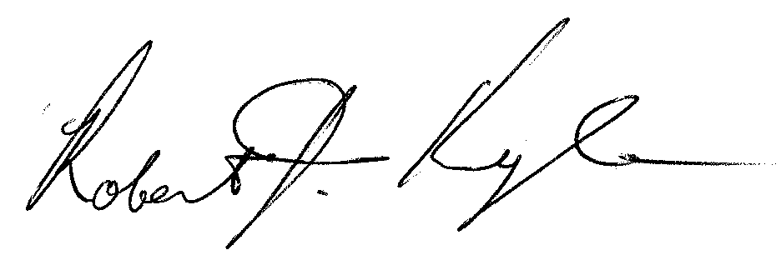
Yours faithfully,

Robert J. Kyle

