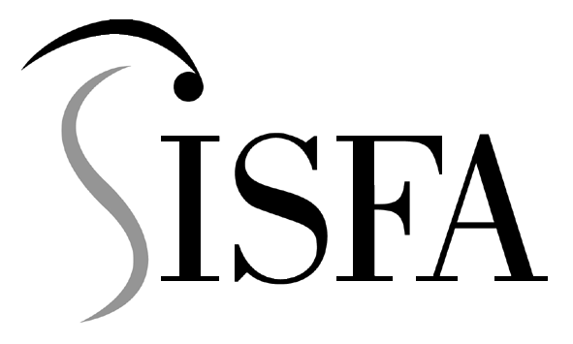
small independent superannuation funds association

12 December, 2001

The Secretary
Senate Select Committee on Superannuation and Financial Services
Parliament House
CANBERRA ACT 2600

Attention: Sue Morton

Dear Sue,

RE: EARLY ACCESS TO SUPERANNUATION

In practice, the provisions relating to the early release of superannuation benefits in the event of a member’s severe financial hardship or on compassionate grounds have limited application for self managed superannuation funds. Consequently, SISFA’s interest in the Committee’s present inquiry is also somewhat limited.

From a policy perspective, however, SISFA is an advocate of the sole purpose test and considers that the preservation standards support this fundamental principle of superannuation. In this respect, we would not support any proposal to relax the current conditions for financial hardship or on compassionate grounds. In our view, the ability to access superannuation benefits in these circumstances is beyond the scope of the sole purpose test. We also acknowledge, however, that they may have a place from a social perspective. Nevertheless, any social implications should be quantified in terms of the actual benefit that the early release provisions achieve compared with any long-term costs due to increased age pension outlays.

This proposition is consistent with our overall view of the need for superannuation to interact efficiently and consistently with social security on income tax legislations.

Turning to administrative considerations, we appreciate that these provisions may burden the trustees of some large superannuation funds with additional responsibilities, complexities and costs. The anecdotal evidence that we have gathered suggests that such concerns are not shared by the trustees of the small independent funds comprising our members – principally for the reason that the early access provisions have such limited practical application for these funds. Notwithstanding these remarks, we believe that the current requirements are to be preferred to any shift in responsibility from trustees to the APRA or ATO for administering the measures.

Yours sincerely, Yours sincerely

MICHAEL LORIMER Graeme McDougall
Director Chief Executive Officer
Chair, Policy Development Committee SISFA

