Level 4 - 111 Macquarie Street
HOBART TAS 7000
GPO Box 1547 HOBART TAS 7001
Tel (03) 6235 8996 or Fax (03) 6235 8997
Your Ref:
Our Ref:NC-526-letter-Senate Select Committee

5 December, 2001

The Secretary
Senate Select Committee on Superannuation and Financial Services
Parliament House
Canberra ACT 2600

Dear Secretary

Early Access to Super – Discussion Paper

Tasplan welcomes The Inquiry into the effectiveness and efficiency of the current rules governing early access to superannuation benefits on existing compassionate and severe financial hardship grounds.

Over the past two years Tasplan has highlighted the problems associated with the rules surrounding early access by fund members to superannuation benefits, through its written submissions and personal representations to individual Senators and The Senate Select Committee on Superannuation and Financial Services, with support from industry bodies such as the Associated Superannuation Funds of Australia Limited (ASFA).

The Trustee of Tasplan support the principle of early release of superannuation benefits on compassionate grounds and severe financial hardship.

There is no doubting the intention of the Regulations as there are genuine claims on these grounds but there are unintended consequences in the application of the regulations. Tasplan’s experience with severe financial hardship claims, in particular, has highlighted inadequacies with the Regulations as the fund has become aware of an ever increasing incidence of “questionable” claims.

To highlight this fact, Appendix A is a discussion paper put to the Tasplan Board in July 2001, which contains six cases of loopholes having been identified by members and subsequently exploited. These cases were used to demonstrate the range of such claims, but was in no way exhaustive.

Under the terms of the Trust Deed, the Trustee of Tasplan exercised its discretion to allow members to apply for such benefits but they have had the need to reconsider the provision of the benefit.

Obviously it would be a difficult decision for the Board to cease the availability of these claims as a number of members with genuine claims would be disadvantaged.

To withdraw access to benefits that have been available to members for some time would be difficult.

But given the increase in claimants, the time taken to process claims, the lack of expertise available within the fund to properly assess the claims, the Trustee needed to reconsider its position. More importantly, the benefits of other Tasplan members had to be considered as they are, in effect, meeting the Member Benefit Protection (MBP) costs caused by members re-joining the fund after a claim has been admitted.

As a result of these considerations the Trustee resolved to pay all claims that meet the basic requirements, without any assessment.

It is for these reasons that Tasplan has been vocal in its quest for the review of the Regulations in its current form.

Tasplan has identified a number of problems associated with the Regulations which are summarised as follows:

- The fundamental principle of superannuation is undermined by the fact that members gain access to their accounts prior to retirement.

- The rule imposing a single lump payment and maximum amount of $10,000 in any 12 month period is not policed, especially if a person is a member of more than one superannuation fund.

- Letters are provided by Centrelink and applications to superannuation funds are not followed up. It is the responsibility of the claimant to notify Centrelink of a successful application.

- Successful applications receive the benefit with minor interruption to their Commonwealth income support payment. Centrelink is only interested in the proportion relating to ‘interest’ as this would be deemed as income. There is a possibility that the full claim may be used by a claimant as an investment, unbeknown to Centrelink.

- Applicants may still be employed but qualify for a claim as the support payment meets the 26 weeks requirement.

- The application and subsequent payment of some claims, may in effect, be clearing debt, which in turn, does not encourage savings. A reasonable number of claims occur as a result of mis-management of finances.

- The consideration and process of claims impact heavily on superannuation funds in terms of cost and time. To fully assess the genuineness of a claim, and the needs of the claimant, is particularly complex and requires appropriate skills for the assessor to be completely satisfied with the final decision. This may only be achieved with the conduct of a personal interview. APRA guidelines to assessment are detailed and extremely complex.

- It is estimated that 15-20% of Tasplan administration activity was associated with the processing of severe financial hardship claims. This activity has decreased considerably since the Trustee agreed to pay all claims that meet the basic requirements, without assessment.

- Member Benefit Protection (MBP) is impacted when there is a small account balance remaining in the fund or if the member rejoins the fund at a later date. MBP is detrimental to other members of the fund as the fund is required to meet MBP shortfalls.

- Some funds don’t provide for severe financial hardship therefore people with genuine claims are disadvantaged.

11. It could be argued that the Government has shifted its responsibilities to assist members who are unable to meet reasonable and immediate living expenses to superannuation funds.

To alleviate the majority of the problems identified above would be to introduce the same assessment process for severe financial hardship claims as is the current system for compassionate claims. For compassionate claims APRA is the body that assesses all claims and instructs superannuation funds to meet approved claims.

The advantages of a “central body” would be as follows:

- The rule imposing a single lump payment in any 12 month period would be more easily policed. This would overcome “double-dipping” that now occurs.

- The cashing restriction of the maximum amount of $10,000 released in each 12 month period, would be more manageable and policed. As the responsibility is currently with the superannuation funds it is impossible for them to detect if a member exceeds $10,000 in any 12 period as they could be members of multiple funds.

- Costs and time associated with the administration of such claims by superannuation funds would be heavily reduced.

- Centrelink would have access to a central register of claims to be able to meet their obligations to adjust income support payments, if applicable.

- Consistency of claims assessment across all funds. Trustees of superannuation funds have the opportunity to develop flexible rules but this can lead to inconsistency of decisions within the fund and across all funds.

- Overcome the shortfall of assessment skills that exist within superannuation funds.

To overcome other shortfalls and loopholes Tasplan recommends a review of the income support payments that qualify a member for the early release of superannuation benefits on the grounds of severe financial hardship.

Tasplan is experiencing a greater number of claims where members are still employed. Whilst this should not preclude a member from submitting a claim, as a member could still be deemed to be in severe financial hardship, it does lead to claims that are made in an attempt to meet day to day expenses that would normally be met by other means. In other words, claims can be made because an opportunity exists to access superannuation to meet an expense.

In summary, Tasplan supports the principle of early release of superannuation benefits on compassionate grounds and severe financial hardship. But the rules need to be reviewed and tightened as they are open to abuse.

Trustees have a responsibility to protect the interests of their members and assist them to achieve genuine retirement income. By allowing easy access to ‘preserved’ benefits may discourage long term saving and create greater reliance on the welfare system.

Superannuation commentators and experts are constantly debating adequacy provisions under the current superannuation system, yet people are able to interrupt their retirement income capacity by accessing their superannuation to meet immediate living expenses.

The provision of severe financial hardship is a major issue that needs urgent government support to overcome the inadequacies associated with its application.

To assist with The Inquiry, Tasplan comments on the issues canvassed in the Discussion Paper are as follows:

Q.1 Tasplan does support the principle of early release of superannuation benefits on limited grounds but acknowledges that by allowing easy access to preserved benefits may discourage long term savings and create greater reliance on the welfare system.

As superannuation is a major pillar in Australia’s retirement income system, the principle of preservation of benefits until retirement can never be abandoned.

However, Tasplan’s experence is that there are genuine cases of severe financial hardship and compassionate grounds, but the rules, in particular for severe financial hardship, need to be reviewed and tightened as loopholes have been discovered.

The current system of handling claims on compassionate grounds through APRA should be adopted for severe financial hardship claims because a central body will have more control and consistency with the application of the rules and the policing thereof.

By maintaining a system that is at the discretion of superannuation funds will continue to encourage more funds to adopt the policy of admitting claims without assessment due to the cumbersome nature of applying current rules. Such policy will ultimately result in more claims and a higher incidence of “questionable” claims.

Q.2 In general, most members do associate superannuation with retirement, but, give members a reason to access their superannuation to meet certain circumstances, of course a minority of members will attempt to do so.

Sixty-five per cent of Tasplan members are under the age of thirty-five and therefore retirement is not in the thoughts of a number of these members. They could be forgiven for trying to access their superannuation to “live” for today with a mindset that there is plenty of time to top-up their superannuation at a later date.

To overcome this perception would be best achieved through education which would be supported by a more stringent process for members to access their benefits early.

Unfortunately, under the current environment superannuation funds are not helping the situation by taking the position of admitting claims without assessment. Full assessment adds time and costs to the management of the fund, which effectively impacts on the benefits of other members.

Anecdotal evidence suggests that some people view superannuation as a means of alleviating the mis-management of financial affairs and as people become more aware of the provision of early access to funds, then more and more will attempt to do so.

Q.3
Year Ending | No of Claims | Amount Paid | % of Total Claims
30 June, 1999 | 1123 | $2,462,547 | 12.10%
30 June, 2000 | 1059 | $2,110,559 | 9.87%
30 June, 2001 | 1132 | $2,014,602 | 13.20%

Over the 3 year period from 1 July, 1998 to 30 June, 2001, the proportion of total claims paid are as follows:
Rollovers - 62.71%
Transfer Out - 21.20%
Hardship - 11.56%

The remaining 4.49% of payments include Death, Disablement and Retirement Benefits.

Q.4 Tasplan has not actually costed its involvement with financial hardship claims but it recognises that 15% of administration would equate to a significant proportion of cost. This cost has reduced considerably since Tasplan has taken the position of admitting claims without assessment.

Q.5 Increased.

Q.6 Absolutely. Tasplan suggests that all claims should be assessed and approved by a third party, ie a central body such as APRA. This would provide for consistency of decisions, the development of skills to properly

assess all claims and a central register of claims that would enable greater control of rules and a more structured access to information for Centrelink.

Q.7 Tasplan believes that this decision is in the hands of Government because the ultimate responsibility of Trustees is to maximise the benefits of its members. Superannuation funds are not in the business of providing welfare payments.

Q.8 Austudy is a contentious issue and can only be resolved by Government policy. Family income and personal circumstances would need to be the major considerations in regards to Austudy.

Q.9 Unable to comment except to point out that “cumulative” is more generous than “consecutive” weeks.

Q.10 The type and standard of proof would be better suited under the control of a central body. Tasplan requests the production of a Statutory Declaration whereby the responsibility lies with the member. Tasplan has had incidences where Statutory Declarations have contained false information adding further complications to the overall process.

Q.11 Yes. Funds may never know if members have other superannuation funds, therefore a member may claim from more than one fund. Also, funds have different policy on the payment of benefits, and different assessment criteria which can lead to inconsistencies between claims.

Q.12 More defined rules would make assessment easier but again, it should not be up to superannuation funds to apply “discretion” to rules.

Q.13 Assessment of the genuineness of a claim is the most difficult factor in the process of considering such claims. Again, a central body would be far better equipped to deal with claims as a central data base would be established and claims history across all funds would be most accurate.

Q.14 It should not be more than $10,000 as this is a significant level of income in any 12 month period. In light of potential Commonwealth Income Support, family income including this $10,000 could be regarded as more than adequate to cover a normal family’s reasonable expenditure.

Q.15 Tasplan is unable to comment as the rationale of “no upper limit” is not fully understood by Tasplan.

Q.16 Current system appears adequate. This has only minimal impact for Tasplan.

Q.17 Unable to comment.

Q.18 Yes.

Q.19 Unable to comment.

Q.20 Unable to comment.

Q.21 Not to Tasplan’s knowledge.

Q.22 Tasplan takes this into account when assessing severe financial hardship as it forms part of Tasplans “Early Release of Superannuation Benefit” application.

Q.23 Unable to comment.

Q.24 Medical grounds that are not regarded as “life threatening”, but are severe nonetheless.

Q.25 Yes, as it is easier to communicate to members. It does not allow for discretion which can lead to inequity in claims assessments.

Q.26 Following discussions with Centrelink, Tasmania, Tasplan understands the role of Centrelink as follows:

- Centrelink will issue a letter to a person, at the request of the person confirming that the person meets the criteria of the objective test in respect of financial hardship. This letter is presented to a superannuation fund to support a claim application.

- Centrelink does not follow up the outcome of the persons application to the superannuation fund as it is the responsibility of the claimant to notify Centrelink of a successful application.

- If the successful applicant notifies Centrelink then Centrelink is only interested in the proportion relating to “interest” as this would be deemed as income. Centrelink would be interested if the payout was invested as the “interest/investment return” would be deemed as income.

- Centrelink state that it is out of their control and has more to do with Social Security Department.

- Centrelink were not confident, at the time of the meeting (June 2000), if the letters issued could be tracked.

Q.27 Unable to coment as Tasplan is unsure of Centrelink policy. Obviously Centrelink are made aware of early release provisions by the Department.

Q.28 Unable to comment.

Q.29 Tasplan members are fully aware of Tasplan’s internal complaint procedures as there is a requirement to publish the funds process and procedures in the Annual Trustee Report to members. The procedures refer to the role of the Superannuation Complaints Tribunal and its role is reinforced when Tasplan issues a letter to a member where claims have been rejected.

Q.30 To Tasplan’s knowledge, a complaint on the early release of benefits has not been referred to the SCT.

Q.31 Unable to comment.

Q.32 Unable to comment.

Q.33 No. Tasplan has had an experience whereby a Financial Planner has tried to exploit the system by unlocking ‘personal superannuation’ policies through the transfer of the policies to Tasplan. (See Case 6 of Appendix A)

Q.34 Superannuation funds take every opportunity to warn members of unscrupulous advisors in all circumstances but the lack of a national education program on superannuation in general, nurtures the sporning grounds of unscrupulous advisors.

Yours sincerely

Neil Cassidy
General Manager

Attachments: Appendix A
Appendix B
SEVERE FINANCIAL HARDSHIP
Appendix A

- Introduction

An important part of the Government’s Retirement Incomes Policy is to ensure that all members of the community have an adequate level of income in retirement. There are substantial taxation concessions for superannuation in order to promote self-provision for retirement and restrictions are placed on the early withdrawal of superannuation savings to ensure that they provide for genuine retirement income.

The Government recognises, however, that these restrictions may cause undue hardship for some people because of personal circumstances. The legislation therefore provides for the early release of superannuation benefits in certain limited circumstances, such as retirement due to incapacity, severe financial hardship and in a limited number of circumstances involving compassionate grounds.

In accordance with the Superannuation Industry (Supervisory) Act 1993 (the Act), Regulation 6.01(5) allows for members to access their superannuation through Severe Financial Hardship

The final decision on whether an early release is permitted on any of these grounds rests with the Trustees of the applicants superannuation fund, subject to the fund’s governing rules.

Superannuation Fund Trustees administer the release of benefits on the grounds of severe financial hardship according to an objective test as well as a subjective test.

The applicant must:
- be in receipt of a Commonwealth income support payment (Appendix 1), and have been so, continuously, for the last 26 weeks; and
- satisfy the Trustee that he/she is unable to meet reasonable and immediate family living expenses.

If both tests are satisfied, “cashing restrictions” apply. The Trustee may, in any twelve month period, release one lump sum payment. The lump sum payment is to be no more than a gross amount of $10,000 and no less than $1,000 (or the balance of the benefit if it is less than $1,000).

APRA has produced a set of detailed guidelines to assist trustees in assessing the early release of superannuation benefits on the grounds of severe financial hardship, and, in particular, the meaning of “unable to meet reasonable and immediate family living expenses”.

For members aged 55 years and 39 weeks or more, an alternative, optional, objective test of severe financial hardship may be applied.

The applicant must:
- have received a Commonwealth income support payment for a cumulative period of 39 weeks after reaching age 55; and
- not be gainfully employed on a full-time or part-time basis on the date of application to the trustee.
If the applicant satisfies the test, the trustee may release the entire benefit.

In all cases, as part of the objective test, applicants need to provide the Trustee with a letter from Centrelink or the Department of Veterans’ Affairs confirming that they meet one of these tests (Appendix 2).

- Tasplans Current Position

Under the terms of the Trust Deed, Tasplan Trustees have exercised their discretion to allow members to apply for such benefits. Tasplan has adopted its own Governing Rules (Appendix 3) for early release of benefits which are included within the Terms of Reference of Tasplans’ Administration Committee (ADCOM).

As a result of a discussion paper prepared by the General Manager on 14 June, 2000 and tabled at a Board Meeting held 21 July, 2000, Tasplan’s rules were relaxed to the extent that all applications for severe financial hardship that satisfy the objective test, that are accompanied by a signed Statutory Declaration and are made on an “Application for payment of Benefits” form, can be paid, subject to the cashing restrictions, without referral to Tasplan’s Administration Committee.

This Board decision was very much predicated on the fact that the process had become cumbersome, costly, time consuming and an increasing number of claims required detailed examination. It was estimated that 15 - 20% of Tasplan’s administration activity was associated with the processing of the claims and that Tasplan was not fully equipped with the skills necessary for proper assessment of claims. Assessments were made primarily on the written evidence provided by the claimant whereas the conduct of a personal interview would be most appropriate.

Tasplan’s decision was re-visited at the Board meeting held 15 February, 2001 and it was resolved that Tasplan continue indefinitely with the modified Governing Rules.

Tasplan’s current practice is common with most other Industry Funds although REST does not make it available to it members. ASSET makes an assessment on claims greater that $5,000 but only if there is doubt on the validity of the claim. Master Trusts vary on their treatment of claims (if they are accessible) whereas funds like SMF employ a dedicated staff member to complete a full assessment of each claim.

Tasplan Statistics

Claims processed during the last 12 months are as follows:

(a) | Quarter Ended | No. of Claims | Amount Paid
 | June 2001 | 207 | $631,315
 | March 2001 | 235 | $546,818
 | December 2000 | 343 | $635,907
 | September 2000 | 265 | $647,772

- During the last 6 months (1 Jan 2001 – 30 June 2001)

- 33 members restarted with the same employer (current average account balance $459.40)
- 34 member accounts remained active (current average account balance $2214.29)
- 63 members had made previous financial hardship claims as follows:
- 6 members had previously made 1 claim
- 47 members had previously made 2 claims
- 9 members had previously made 3 claims
- 1 member had previously made 4 claims
- 27 members had re-commenced with a new employer (current average account balance $158.98)

- Regulations Shortfalls

There are a number of problems with the Regulations that are a concern and have been identified by Tasplan:

- The fundamental principle of superannuation is undermined by the fact that members gain access to their accounts prior to retirement.

- The rule imposing a single lump payment in any 12 month period is not policed, especially if a person is a member of more than one superannuation fund.

- Letters are provided by Centrelink and applications to superannuation funds are not followed up. It is the responsibility of the claimant to notify Centrelink of a successful application.

- Successful applications receive the benefit with minor interruption to their Commonwealth income support payment. Centrelink is only interested in the proportion relating to ‘interest’ as this would be deemed as income. There is a possibility that the full claim may be used by a claimant as an investment, unbeknown to Centrelink.

- Applicants may still be employed but qualify for a claim as the support payment meets the 26 weeks requirement.

- The application and subsequent payment of some claims, may in effect, be clearing debt, which in turn, does not encourage savings. A reasonable number of claims occur as a result of mis-management of finances.

- The consideration and process of claims impact heavily on superannuation funds in terms of cost and time. To fully assess the genuineness of a claim, and the needs of the claimant, is particularly complex and requires appropriate skills for the assessor to be completely satisfied with the final decision. This may only be achieved with the conduct of a personal interview. APRA guidelines to assessment are extremely detailed and complex.

- Member Benefit Protection (MBP) is impacted when there is a small account balance remaining in the fund or if the member rejoins the fund at a later date. MBP is detrimental to other members of the fund as the fund is required to meet MBP shortfalls.

- Some funds don’t provide for Severe Financial Hardship therefore people with genuine claims would be disadvantaged.

10. It could be argued that the Government has shifted its responsibilities to assist members who are unable to meet reasonable and immediate living expenses to superannuation funds.

- Loopholes

During the time that Tasplan has made provision for servere financial hardship, there have been a number of claims where loopholes have been identified and exploited.

The following is a list of such claims experienced by Tasplan but is not exhaustive.

Each case has produced a letter from Centrelink or the Department of Veteran Affairs confirming that they met the objective test.

Case 1
- Casual employee
- Absent from work due to health problems
- Signed Statutory Declaration
- Claim paid - $5450.28

Fact – Always employed, earning $488 per shift
- Has had four accounts, three claimed against since 1994
- Current account balance $157.55
Case 2
- Aged 64
- In receipt of a Centrelink Income Support payment
- Unable to meet immediate living expenses

Fact – Has salary sacrifice arrangement in place
- Has made two previous claims - $3375.22 and $4916.79
- Current account balance $2974.92 (monthly contribution $708.34)

Case 3
- Casual employee (on call with employer)
- Signed Statutory Declaration
- Ceased employment
- Amount claimed $6402.20

Fact – Employer since confirmed that there was no cessation date
- Employee refused to return to work until paid out
- Employer confirmed cessation date
- Claim paid
- Audit trail of employer shows seven financial hardship claims by employees during last twelve months totaling $39450.64
- Employer concerned that other claims will be made by other employees – many are in receipt of Income Support payments

Case 4
- Member claimed 5 June, 2000
- Amount paid - $10,000
- Member claimed 5 June, 2001 for balance

Case 5
- Husband and wife claimed within one month of each other
- Casual employees – still working
- Statutory Declaration provided
- Both separated – reason for hardship

Fact – Separate claims paid
- Same postal address

Case 6
- Member unemployed
- Letter from financial adviser that two policies are in the process of transferring to the members’ account
- Total of member account and the transfer value from the two policies will be under $10,000

Fact – The policies that are transferring would not be able to be accessed in their current location because they are preserved and the likelihood is that severe financial hardship is not available. Hence, the rollover to Tasplan. It is quite possible that the financial adviser may be planning to consolidate the policies and the Tasplan account in another investment vehicle.

There have been a number of instances where new members have joined Tasplan since leaving the REST superannuation fund, only to transfer their REST account to Tasplan and then claim a financial hardship benefit from Tasplan. REST does not pay severe financial claims.

- Summary

There is no doubt that the intention of the Regulations are sound but there are unintended consequences in its application.

Tasplan has made written submissions to Treasurey, and the Senate Select Committee on Superannuation and Financial Services, with support from the Associated Superannuation Funds of Australia Limited (ASFA), to highlight the problems of its application and the administration thereof, but to no avail.

It is a sensitive issue for superannuation fund Trustees as there are genuine claims, but, Tasplans’ experience indicates that the Regulations are open to abuse.

Trustees have a responsibility to protect the interests of their members and assist them achieve genuine retirement income.

In reality, are superannuation funds helping members by allowing easy access to ‘preserved’ benefits which may discourage long term savings and create greater reliance on the welfare system?

Superannuation commentators and experts are constantly debating adequacy provisions under the current superannuation system, yet people are able to interrupt (or jeopardise) their retirement income capacity by accessing superannuation to meet immediate living expenses.

The provision of severe financial hardship is an issue for Tasplan (and other superannuation funds) and its provision needs to be addressed. The dilemma for Tasplan is whether this should be done now at Trustee level or await possible amendment to the Regulations.

Neil Cassidy
General Manager
12 July, 2001
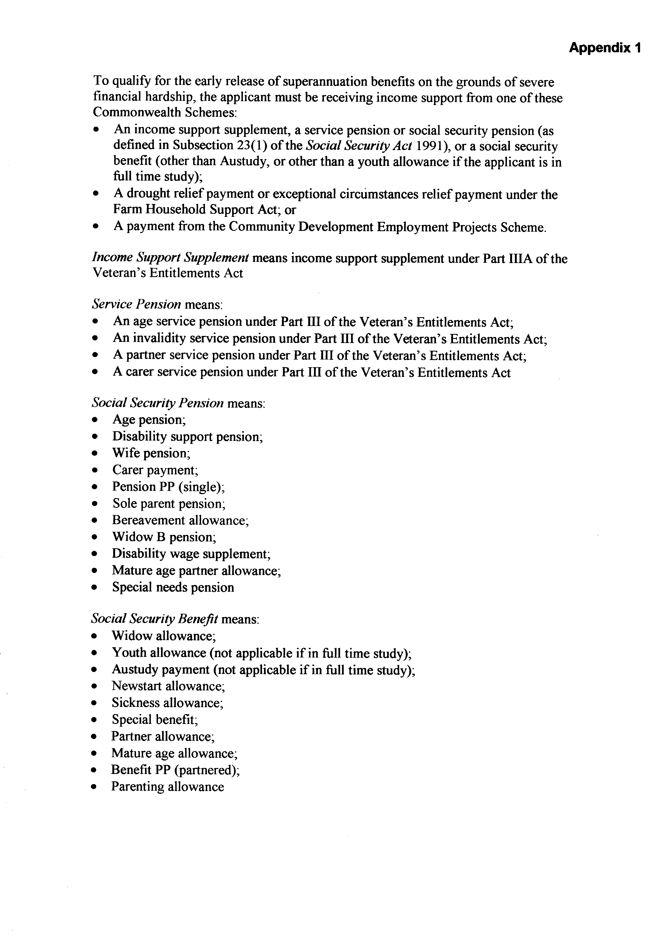
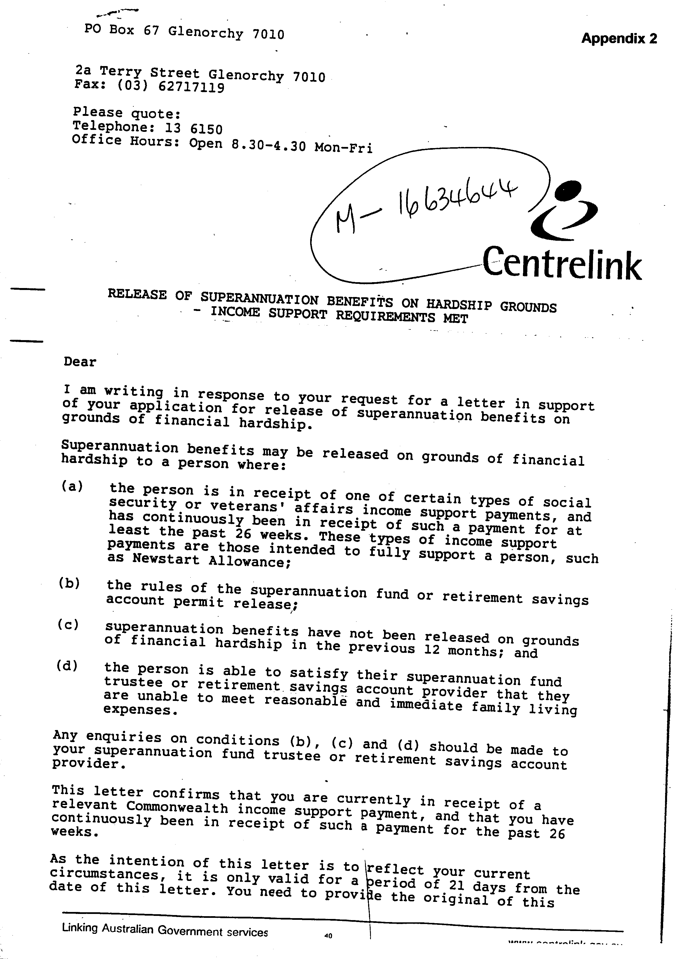


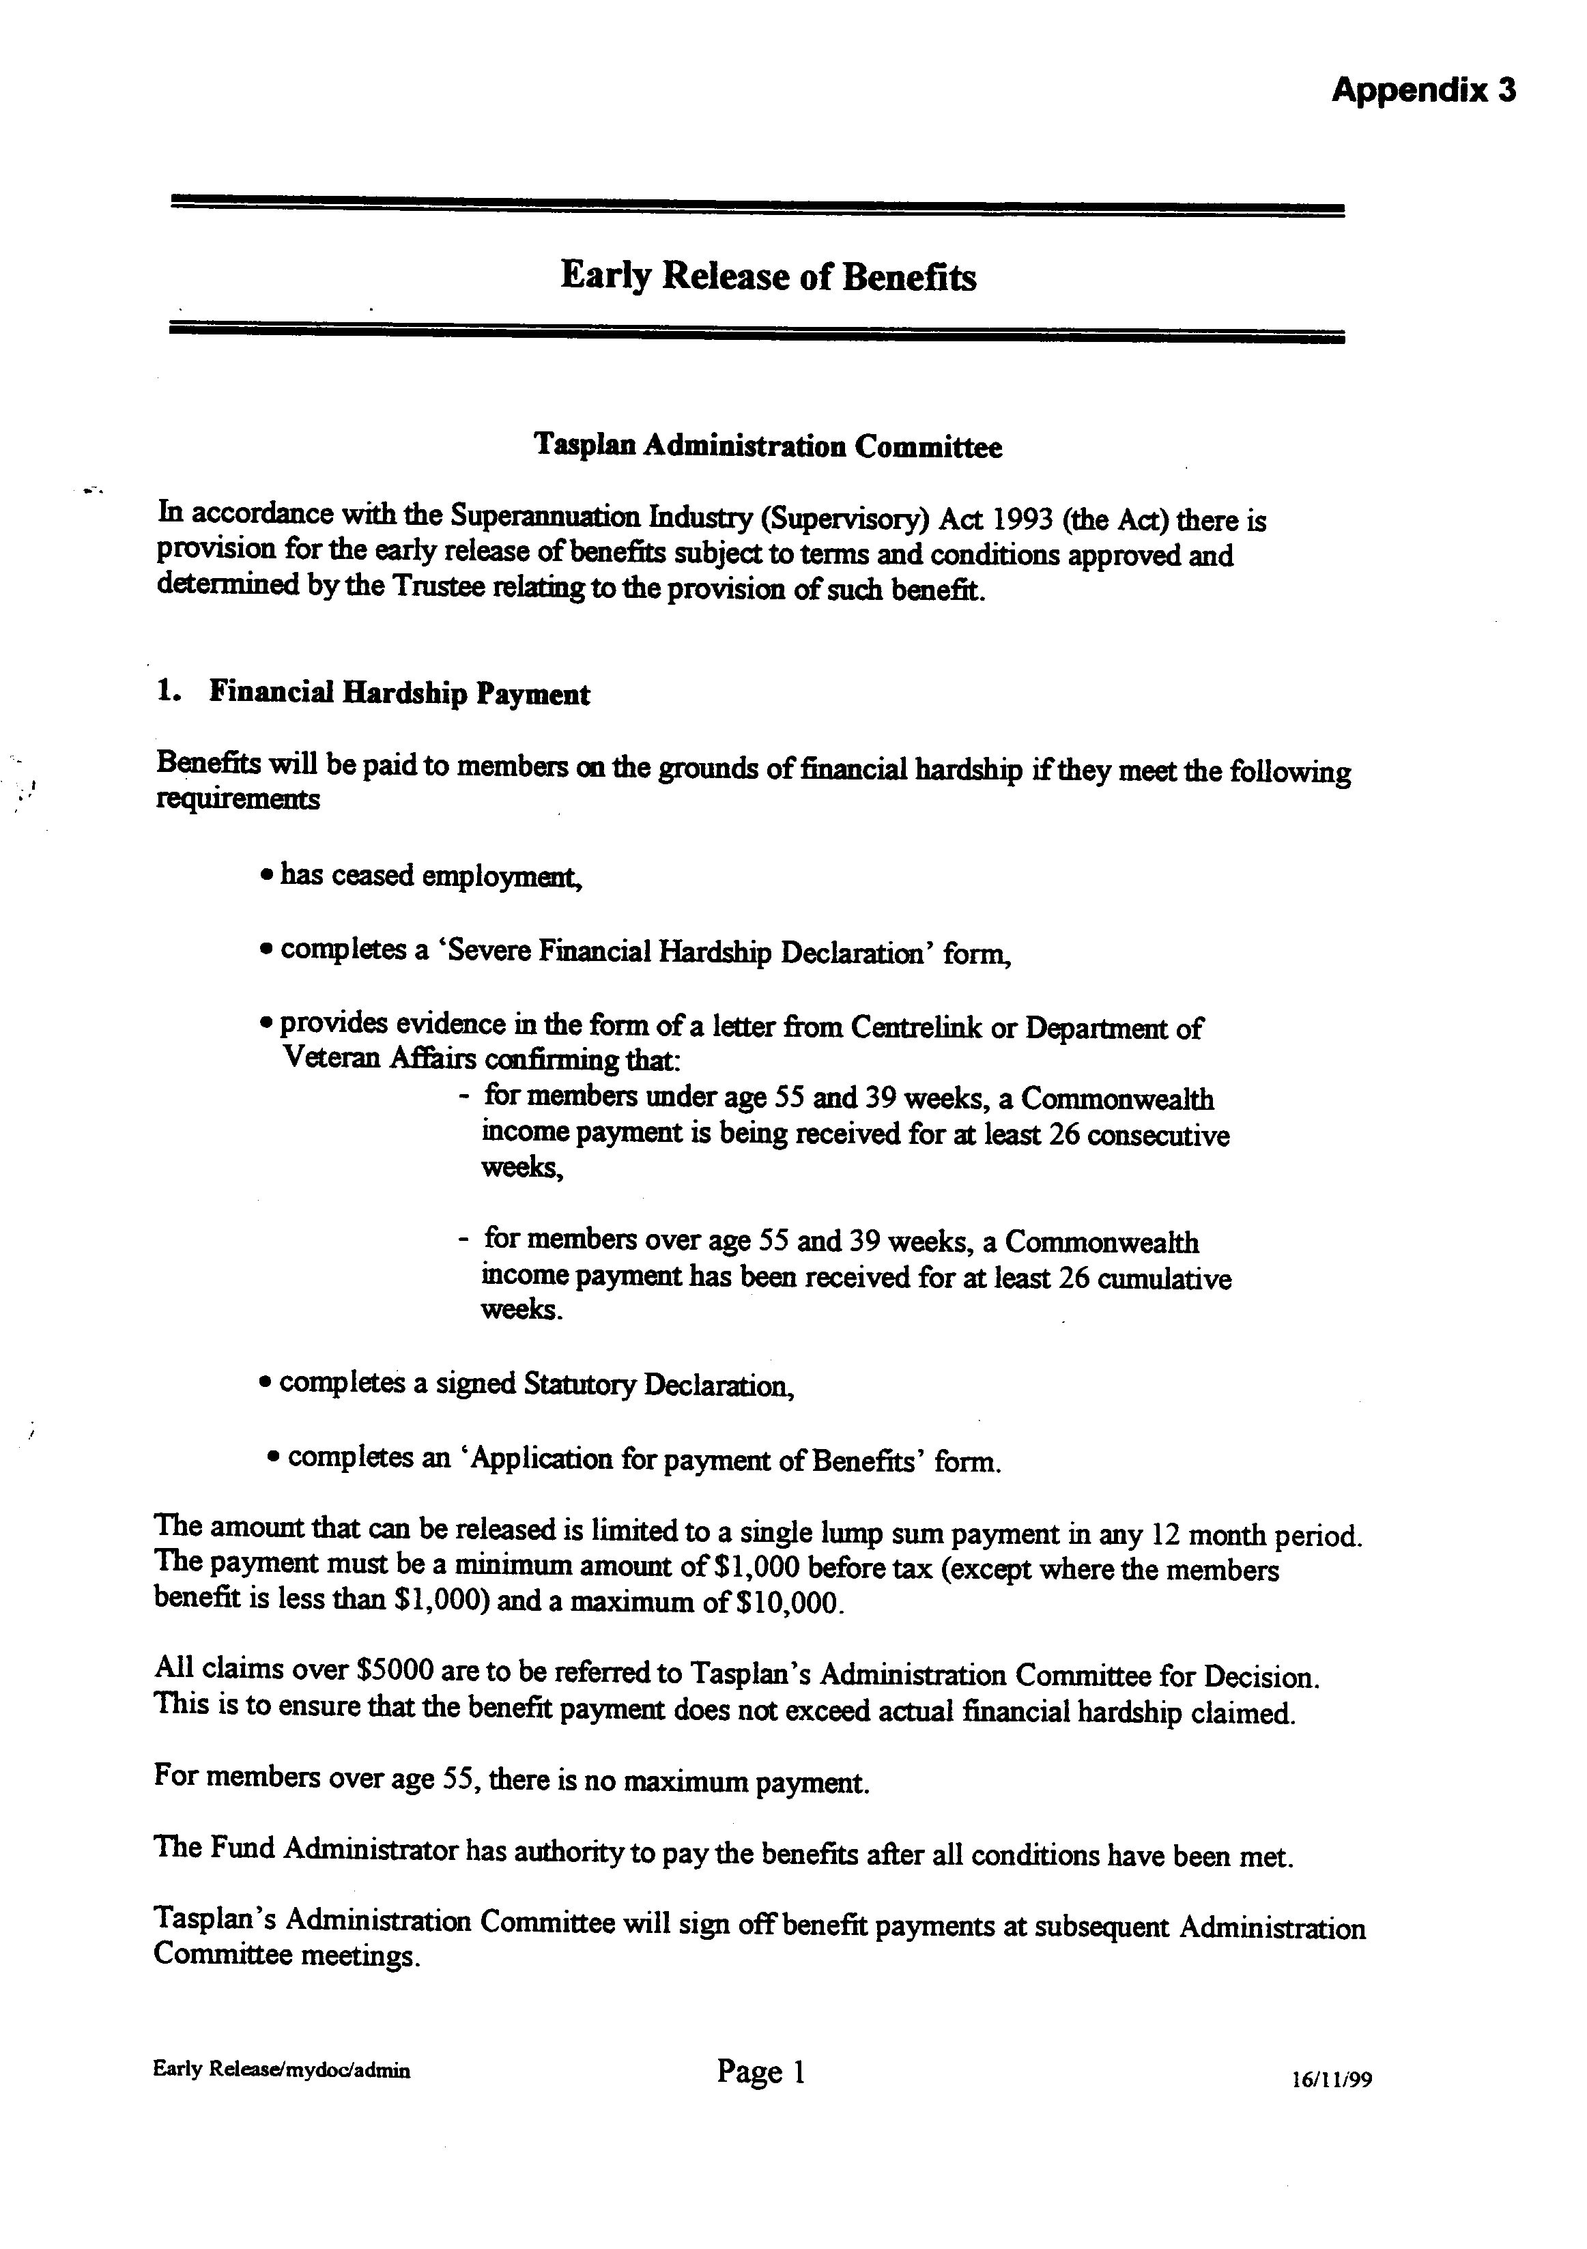

TASPLAN
Appendix B

SEVERE FINANCIAL HARDSHIP

The following paper sets out Tasplan Severe Financial Hardship issues under the following headings.

- Introduction
- Superannuation Industry (Supervision) Regulation
- Guidelines for Trustees
- Tasplan Rules
- Tasplan Administration
- Summary

- INTRODUCTION

Severe financial hardship is a benefit that may be made available to the members of a superannuation fund. The provision of the benefit is totally at the discretion of the Trustees.

Many funds, including Tasplan, have made the decision to allow members to apply for the benefit. Some funds including REST do not allow for member application of the benefit.

The rules and procedures to assess such claims are also at the discretion of Trustees although guidelines have been issued to provide Trustees with assistance in administering applications made to them for the early release of preserved benefits and restricted non-preserved benefits.

The guidelines on the test of whether a person is “unable to meet reasonable and immediate family living expenses” (the subjective test) are only guidelines – they are not “law”. Trustees have flexibility in how they administer this subjective test.

- SUPERANNUATION INDUSTRY (SUPERVISION) REGULATION

In accordance with the Superannuation Industry (Supervisory) Act 1993, (the Act) there is provision for the early release of benefits subject to terms and conditions approved and determined by the Trustee relating to the provision of certain benefits.

Generally, no cashing restrictions or additional tests apply for the release of benefits in the case of the retirement, death or permanent incapacity of a member or when the member attains age 65. However, specific rules must be met for the operation of other conditions of release.

For the release of benefits to a person because of “severe financial hardship”, the Trustee must be satisfied that:
- the person had been receiving Commonwealth income support payments (e.g. an income support supplement, a service pension, or a social security benefit or pension) for the continuous period of at least 26 weeks, and is unable to meet reasonable and family living expenses.
- for a person who has attained his or her preservation age plus 39 weeks – the person has received Commonwealth income support payments for a cumulative period of 39 weeks after attaining the relevant preservation age and was not gainfully employed on a full-time or part-time basis on the date of application for early release of benefits (Reg 6.01 {5}).

Even where these rules are met, cashing restrictions still apply to limit the amount of the benefits payable, e.g. the maximum account that can be released under reg. 6.01 (5) (a) is $10,000 in each 12 month period (Sch1, Item 105).

- GUIDELINES FOR TRUSTEES

As mentioned, guidelines have been issued for Trustees to determine possible automatic releases, appropriate forms to assess claims, the nature of an expense, and the “reasonableness” of a claim. These guidelines have been produced by the superannuation regulators and are comprehensive. They provide a clear insight into the complexities that surround the nature of such claims and the decisions confronting Trustees. The consideration of claims, which are guidelines only, are summarised as follows:

Meaning of ‘unable to meet reasonable and immediate family living expenses’

In assessing whether a person has assets that could be used to meet reasonable and immediate family living expenses, the family home is excluded from consideration.

Essentially, for a single applicant the phrase means there is a gap between his/her personal income and his/her expenses which are associated with everyday living; and the person has no assets which could, (reasonably and realistically), be used or sold to cover the gap, apart form the asset of the preserved superannuation benefits.

For an applicant with a family, the phrase means there is a gap between the combined income of the applicant and his/her family and the combined family expenses which are associated with the everyday living of the family; and the combined assets of the family could not, (reasonably and realistically speaking), be used or sold to cover the gap, apart from the asset of the preserved superannuation benefits.

Some Trustees may consider that a member should not be forcing his or her dependants to contribute any income they derive to satisfy debts incurred by the member. However, for the purposes of determining whether the subjective test is satisfied, the most sensible guide for Trustees is that if an applicant has a family, then that family’s combined resources and outgoings should be considered. To make assessments without regard to the whole family’s position, could lead to unjust decisions being made involving either unjustified release or unjustified non-release.

Regulation 6.01(5)(a) is silent on what period needs to be taken into consideration for the purposes of determining the amount to be released. However, Schedule 1 of the SIS Regulations refers to the maximum amount that can be released in each 12 month period. For administrative efficiency and convenience trustees may decide to release an amount which would alleviate the shortfall in income for a 12 month period. However, they may consider that an applicant’s financial circumstances could improve within 6 months, and therefore decide to release an amount, based on a shortfall for a 6 month period. Ultimately, it is a decision for the Trustees, taking into account all relevant circumstances.

Possible ‘automatic’ releases

As an alternative to detailed assessments being made by Trustees of an applicant’s income and expenses, Trustees may decide, as a matter of administrative efficiency and convenience, that if an applicant satisfies the objective test in Regulation 6.01(5)(a), then they satisfy the subjective test, if certain factors exist. These factors could include matters relating, for example, to the small size of the superannuation benefits held, (e.g. if they are $10,000 or below); and/or if the total value of net assets held (excluding the family home) is below $50,000; and if the amount sought to be released is under, say $5,000. These suggested ‘ threshold figures’ are only a guide for Trustees. Ultimately, Trustees have a discretion to determine when the subjective test is satisfied.

If Trustees choose to adopt this ‘automatic’ release system, they will need to enquire into the value of an applicant’s assets (apart from the family home). A statutory declaration could be used to obtain relevant information from the applicant i.e. information as to the size of the account and the net value of assets apart from the home.

If however, a case falls outside any ‘threshold figures’ determined by a Trustee as relevant to his/her particular fund, the following comments on more detailed assessments can be used by Trustees as assistance in developing their own internal guides to determine whether the subjective test has been satisfied.

Form for assessing inability to meet reasonable immediate family living expenses.

The guidelines provide a suggested form for completion by applicants for early release of their superannuation benefits. This form requests information which will assist Trustees to assess whether there is an inability of the applicant to meet reasonable and immediate living expenses. Tasplan has developed its own form based on the pro-forma included with the guidelines.

The sample form does not suggest that information about assets owned by an applicant is sought, as it is assumed that, if such persons are on means tested Commonwealth income support, their assets (apart from the family home) are not significant, and certainly they could not reasonably, and realistically speaking, be used or sold, to cover a gap between income and expenses.

Sometimes applicants will include expenses which are clearly not reasonable or ‘immediate’ or which are clearly not in the category of a ‘family’ living expense.

In some instances, it may not be clear whether an expense is ‘reasonable’ and/or ‘immediate’. In these cases, Trustees are advised not to automatically reject the expense but to carefully consider the particular facts of each case, before deciding whether or not to accept the expense.

What is a ‘reasonable’ family living expense

The ‘reasonableness’ test refers to both the nature of the expense and the amount claimed for it.

The nature of the expense

The types of items that can, at the discretion of the Trustee, be considered to be ‘reasonable’, will depend on the circumstances of the case (e.g. the age, state of health, location of an applicant and/or his/her dependants).

Additionally, some applicants may have above average expenses, for example, special school tuition fees for their children. Such expenses should not automatically be rejected by Trustees as relevant to the subjective test. This is because, generally speaking, these types of expense may have been paid out for some time, and it would not be reasonable to expect parents to immediately remove their children from special schooling arrangements even if they are experiencing severe financial hardship. Applicants will need time to adjust to their reduced financial circumstances. In any event, their financial circumstances may improve (e.g. if employment is obtained). In other words, Trustees should ‘take applicants as they find them’.

The amount claimed

Trustees may decide, as a matter of administrative efficiency and convenience that certain ‘maximum’ amounts should apply to the usual living expenses, e.g. so much for the weekly food, clothing, rent, etc.

If Trustees choose to administer the subjective test by this means, then it needs to be stressed that if an applicant claims that he/she is paying more than this ‘maximum’ amount, for a particular item, a Trustee should not automatically disallow the amount exceeding the ‘maximum’ because of an applicant’s particular circumstances may be unusual and the additional amount of expense may be fully justifiable.

What is an ‘immediate’ living expense

An ‘immediate’ living expense is one that is, at the time of the early release of benefits application, due and payable.

Arrears are clearly covered.

With credit cards, it is only the amount that is in arrears and the amount that is billed as ‘minimum amount due’ which can be considered an ‘immediate’ living expense.

Trustees may decide not to release money to enable an applicant to pay outstanding credit card balances above the ‘minium amount due’ as the portion of the debt not in arrears or ‘minimum amount due’ is not an ‘immediate’ living expense. However, if a strict application of this principle is adopted, then in some cases, this could lead to a ‘debt spiral’. This could occur where an applicant cannot even pay minimum amounts due on several credit cards and debt levels continue to rise.

In such cases, Trustees could use their discretion to agree to release sufficient money to reduce overall debt to a level that the applicant could service from his/her reduced income.

Generally speaking, an anticipated expense, for example, for a service not yet provided to the applicant, but anticipated, is not an ‘immediate’ expense.

However, Trustees may, in certain circumstances, accept an expense as ‘immediate’ if the expense will (i.e. in the sense of undoubtedly) become payable very soon. Examples could include:
- money to be paid for household repairs required to be done urgently but not yet commenced, such as a leaking gas stove; and
- money to be paid for urgent dental work that must be done very soon.

What is a ‘family’ for the purpose of family living expenses

‘Family’ should be given a broad interpretation to reflect changing social values. Clearly covered would be spouse, defacto partners, and parents living with an applicant, children, and stepchildren. Also covered would be same-sex couples living in bona fide domestic relationship and foster children.

Can ‘business expenses’ be ‘family living’ expenses

It is possible for a person operating a business to be eligible for Commonwealth income support. The issue of ‘business expenses’ can therefore become relevant in assessing eligibility for early release of benefits on severe financial hardship grounds.

Generally speaking, ‘business expenses’ should not be accepted as ‘family living expenses’. Usually, there is a distinction between domestic/private/family expenses and expenses associated with conducting a business. For example, contrast the mortgage repayments or rental payments owing on a home with the rent payable in respect of business premises or insurance premiums payable on the family home as distinct from insurance premiums payable in respect of business premises.

The issues as to when business expenses can be counted for the purpose of assessing whether a person is unable to meet their reasonable and immediate family living expenses can arise when a business is continuing; when a business is failing; and also where a business has already failed. In any of these circumstances if an applicant is personally liable for business debts or personally liable for the debts of the former business, such expense may be relevant to an inability to meet reasonable and immediate family living expenses.

Sometimes family and business affairs or family and business expenses are intermingled to such an extent that the distinction becomes blurred. For example, a shopkeeper may live on the business premises, and use his motor vehicle for business and private purposes.

In these cases, the business expense that may be accepted by Trustees as falling into the ‘family living expenses’ category would, again, include those for which an applicant is personally liable.

Claims that inability to pay business expenses will lead to the loss of the business and consequent inability to pay for family expenses.

Trustees should not accept such claims, as the Regulations do not permit release in these circumstances. The test is actually to pay family expenses, not a possible, future inability to pay family expenses, should the business not survive.

- TASPLAN RULES

Under the terms of the Trust Deed, Tasplan Trustees have exercised their discretion to allow members to apply for such benefits. The Tasplan rules as adopted by the Trustees are as follows:

Early Release of Benefits

Tasplan Administration Committee

In accordance with the Superannuation Industry (Supervisory) Act 1993 (the Act) there is provision for the early release of benefits subject to terms and conditions approved and determined by the Trustee relating to the provision of such benefit.

Financial Hardship Payment

Benefits will be paid to members on the grounds of financial hardship if they meet the following requirements

- has ceased employment.

- completes a ‘Severe Financial Hardship Declaration’ form.

- provides evidence in the form of a letter from Centrelink or Department of Veteran Affairs confirming that:

- for members under 55 and 39 weeks, a Commonwealth income payment has been received for at least 26 consecutive weeks.

- for members over age 55 and 39 weeks, a Commonwealth income payment has been received for at least 26 cumulative weeks.

- completes a signed Statutory Declaration.

- completes an ‘Application for payment of Benefits’ form.

The amount that can be released is limited to a single lump sum payment in any 12 month period. The payment must be a minimum amount of $1,000 before tax (except where the members benefit is less than $1,000) and a maximum of $10,000.

All claims over $5,000 are to be referred to Tasplan’s Administration Committee for decision. This is to ensure that the benefit payment does not exceed actual financial hardship claimed.

For members over age 55, there is no maximum payment.

The Fund Administrator has authority to pay the benefits after all conditions have been met.

Tasplan’s Administration Committee will sign off benefit payments at subsequent Administration Committee meetings.

- TASPLAN ADMINISTRATION

The assessment of Tasplan member applications is conducted by the Administration Committee on behalf of the Trustees. AAS collect and collate the information for presentation to the Administration Committee. The information is obtained via the “Application for the Release of Tasplan Benefit” which is completed by the claimant (Attached).

The process has become cumbersome, costly, time consuming and the validity of an increasing number of claims are being questioned. The principle and magnitude of claims has become such a concern, that Trustees need to give consideration to the continued provision of the benefit.

It has become evident that the number of claims has increased over the past two years, which is impacting on the administration of Tasplan and the time imposed on Trustees in assessing such claims. (See attached statistics)

At the recent CMSF 2000 Conference, Senator Rod Kemp made it quite clear that the Superannuation Guarantee Contributions were for retirement income only.

Based on the actual claims received by Tasplan, indications are that some members are attempting to access their superannuation for immediate consumption. To fully assess the genuineness of a claim and the needs of the claimant is particularly complex and requires appropriate skills to be completely satisfied and comfortable with the final decision.

As Tasplan is not fully equipped with the skills necessary for assessment, and that assessments are made primarily on the written evidence provided by the claimant, it is difficult to fully understand the claimants actual situation without gathering additional information and the possible conduct of a personal interview. This would be very time consuming and costly.

Australian Administrative Services (AAS) estimate that the process of these claims currently represents approximately 15-20% of administration activity which is an intolerable situation.

- SUMMARY

This discussion paper is to provide the Trustees with relevant information necessary to reconsider the provision of this benefit.

Obviously, it would be a difficult decision for the Board to cease the availability of these claims as a number of members with genuine claims would be disadvantaged. To withdraw access to a benefit that has been available to members for some time, would be difficult.

But given the increase in claimants, the time taken to process the claims, the lack of expertise available to properly assess the claims, the Board does need to reconsider its position. Most importantly, the benefits of other Tasplan members must be protected as they are, in effect, meeting Member Benefit Protection (MBP) costs.

The Board needs to take into consideration the problems and concerns that are associated with the provision of this benefit. Those identified are as follows:

- the fundamental principle of superannuation is undermined by the fact that members gain access to their accounts prior to retirement.
- the practice is open to abuse by members.
- it is having a major impact on administration in terms of cost and time. It is estimated that 15-20% of Tasplan administration activity is associated with the processing of Severe Financial Hardship Claims.
- the rule imposing a single lump sum payment in any 12 month period is not policed, especially if a person is a member of more than one superannuation fund.
- successful applicants receive the benefit with minor interruption to their Commonwealth income support payment. The applicant may lose the support payment for one fortnight only.
- the application and subsequent payment of some claims, is in effect clearing debt, which in turn, does not encourage savings. A reasonable number of claims appear as a result of mis-management of finances.
- Member Benefit Protection (MBP) is impacted when there is a small account balance remaining in the fund or if the member re-joins the fund at a later date. MBP is detrimental to other members of the fund.
- it is too convenient for Centrelink to ‘handpass’ such cases to Superannuation Funds.

Should the Board decide to withdraw the benefit, members would need to be notified. Members could be notified via the Annual report and be given three months notice of the Boards decision. Given that the Annual Report will be mailed in mid-October and possibly not received by members by the end of October, the effective date would be 1 February, 2001.

Ideally, an amendment of the Regulations rather than having to make the decision for Tasplan to withdraw the benefit, would be more preferable, but such an amendment could take some time to be effected.

The Board has three options available:

- To retain the benefit for members indefinitely

- To withdraw the benefit with the earliest effective date of 1 February, 2001.

- To delay a decision with a view to monitoring the progress of a possible amendment to the Regulations. This would overcome the situation of being seen as withdrawing the benefit. The decision would be taken out of the hands of the Trustees.

Neil Cassidy
General Manager
14 June, 2000

