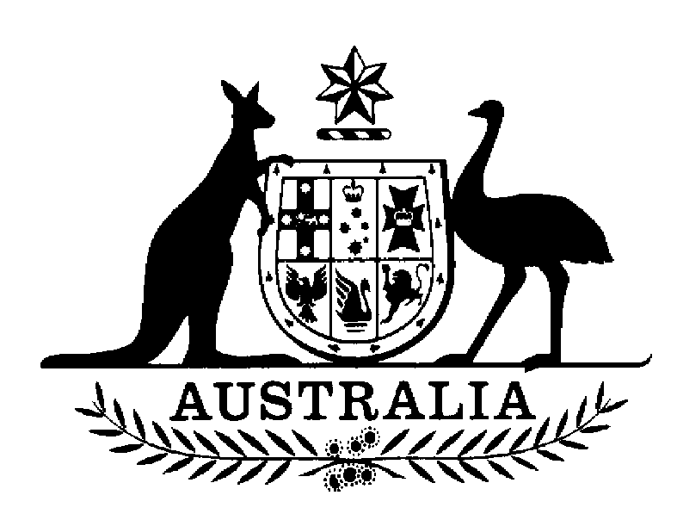
AUSTRALIAN SENATE

SELECT COMMITTEE ON SUPERANNUATION

Media Release

Inquiry into planning for retirement -

Upcoming program of hearings

The Chair of the Senate Select Committee on Superannuation, Senator John Watson, today confirmed that the Committee will hold a series of public hearings next week in connection with the Committee’s inquiry into planning for retirement. A list of the dates and details of the public hearings is as follows:

Monday 5 May, 9.00am – 6.00pm, NSW Parliament House, Sydney
Thursday 8 May, 9.30am – 4.30pm, Melbourne Town Hall, Melbourne
Friday 9 May, 9.00am – 3.15pm, Adelaide Town Hall, Adelaide

The Committee has received over 40 submissions in response to its inquiry from a variety of individuals and organisations, including peak bodies in the superannuation industry, academics and educational institutions, unions, as well as both Commonwealth and State government departments.

Commenting on the hearings program, Senator Watson indicated: ‘The issues raised in the submissions suggest that the hearings will be very interesting. A number of good options have been put to the Committee that would assist people to plan for, and make the transition from work to retirement. The Committee looks forward to exploring these options more in the coming days.’

The program for the three hearing days is attached.

The Committee is due to report on its inquiry to the Senate by the last sitting day in June 2003.

For further details, contact:
For comment: Senator John Watson, Chair
02 6277 3686 (Parliament House, Canberra)
03 6331 4544 (Launceston,Tasmania)

For information: Stephen Frappell, Acting Secretary
02 6277 3533
super.sen@aph.gov.au

30 July 2026
SENATE SELECT COMMITTEE ON SUPERANNUATION
INQUIRY INTO PLANNING FOR RETIREMENT

PUBLIC HEARING

Monday 5 May 2003
Jubilee Room, Parliament House
Macquarie Street
SYDNEY

PROGRAM
9.00am | Australian Consumers’ Association (ACA)  Ms Catherine Wolthuizen, Senior Policy Officer, Financial Services
9.45am | Centrestone Wealth Management Pty Ltd  Ms Carly O’Keefe, Technical Research Analyst  Mrs Glenese Keavney, Authorised Representative
10.30am | Morning tea
10.45am | Australian Bankers’ Association  Mr David Bell, CEO  Ms Ardele Blignault, Director
11.30am | Association of Superannuation Funds of Australia (ASFA)  Dr Michaela Anderson, Director Policy and Research  Mr Ross Clare, Principal Researcher
12:15pm | UNSW Research Centre on Ageing and Retirement  Dr Diana Olsberg, Director
1.00pm | Lunch
2:00pm | Investment and Financial Services Association (IFSA)  Mr Richard Gilbert, CEO  Mr Bill Stanhope, Senior Policy Manager
2.45pm | Association of Independent Retirees  Mr Stan Goodacre, Chairman, Standing Committee on Taxation and Investment
3.30pm | Afternoon Tea
3.45pm | NSW Committee on Ageing  Dr Dawn Linklater, Chair  Mr John Cormack  The Hon. Ross Free  Ms Sarah Fogg, Senior Policy Officer
4:30pm | Small Independent Superannuation Funds Association  Mr Graham McDougall, CEO  Mr Michael Lorimer, Chairman Policy Development Committee
5:15pm | Institute of Chartered Accountants in Australia  Mr Tony Negline, Financial planning consultant
6.00pm | Close
SENATE SELECT COMMITTEE ON SUPERANNUATION
INQUIRY INTO PLANNING FOR RETIREMENT

PUBLIC HEARING

Thursday 8 May 2003
Condell Room, Melbourne Town Hall
Swanston Street
MELBOURNE

PROGRAM

9.30am | Australian Securities and Investments Commission (ASIC)  Mr Ian Johnston, Executive Director, Financial Services Regulation  Ms Pam McAlister, Director, Legal and Technical Operations
10.30am | Morning tea
10.45am | ACTU  Ms Linda Rubinstein, Senior Industrial Officer
11.30am | Working Connections, Over 50s Association  Ms Grace Johnston, Manager
12.15pm | Corporate Super Association  Mr Nicholas Brookes, Chief Executive Officer  Ms Elizabeth Goddard, Head of Research
1.00pm | Lunch
2.00pm | Country Women’s Association (CWA)  Ms Margaret Davis  Ms Gwen Mason
2.45pm | Financial Planning Association (FPA)  Mr Ken Breakspear, CEO  Mr Con Hristodoulidis, National Manager, Policy and Government Relations  Mr Ken Robinson, FRA Superannuation Committee
3.30pm | Afternoon Tea
3.45pm | Council on the Aging (COTA)  Ms Patricia Reeve, Director, National Policy Secretariat
4.30pm | Close

SENATE SELECT COMMITTEE ON SUPERANNUATION
INQUIRY INTO PLANNING FOR RETIREMENT

PUBLIC HEARING

Friday 9 May 2003
Prince Alfred Room, Adelaide Town Hall
128 King William Street
ADELAIDE

PROGRAM

9.00am | Australian Retired Persons Association (ARPA) (SA)  Mr Geoff Parkinson, President
9.45am | Associate Professor Owen Covick, Flinders University (private capacity)
10.30am | Morning tea
10.45am | Association of Independent Retirees (AIR) (Whyalla and Districts Branch)  Mr Bob Shaw, Branch President  Mr Ian McArthur, Branch Secretary
11.30am | University of the Third Age (Adelaide)  Mr Colin Lawton, Deputy President
12.00noon | Mr Les Kemp (private capacity)
12.45pm | Lunch
1.45pm | SA Government Superannuation Fund  Mr Ken Smith  Mr Kevin Crawshaw  Mr Adrian Butterfield
2.30pm | Retired Union Members’ Association of SA  Mr Victor Potticary, Honorary Secretary
3.15pm | Close

