

51 Walker Street
North Sydney NSW 2060
PO Box 289
North Sydney NSW 2059

ABN: 76 369 958 788
17 June 2002
TEL: (02) 9466 5566
FAX: (02) 9466 5599

The Secretary
Senate Select Committee on Superannuation
Parliament House
CANBERRA ACT 2600

ATTN: Ms S Morton

Dear Ms Morton,

QUARTERLY PAYMENT OF SUPERANNUATION GUARANTEE CONTRIBUTIONS
We understand that the Senate Select Committee on Superannuation is conducting a public hearing on Thursday next on a number of issues. These apparently include consideration of the proposal of the Federal Government to introduce a requirement that employer contributions paid pursuant to the Superannuation Guarantee (Administration) Act be made at least quarterly.

Unfortunately, the Australian Industry Group is unable to attend the hearing in Canberra at this time. However, we would indicate that Ai Group believes that such a reform is appropriate and should contribute to further improving the fairness, efficiency and security of the superannuation system.

Should you require any additional information on this or related matters, we would invite you to contact our Executive Director – Finance, Administration and Superannuation, Mr Grahame Willis.

Yours sincerely,

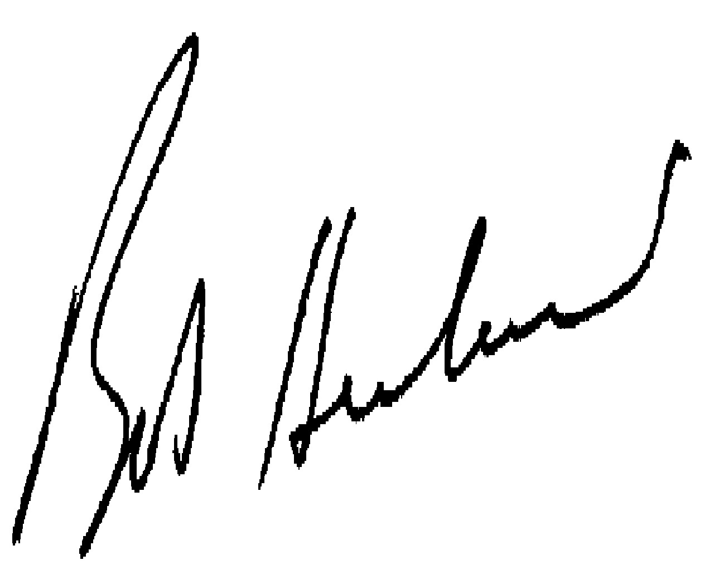
(R N HERBERT)
CHIEF EXECUTIVE

