


FaCS Submission to the
Senate Select Committee on Superannuation Inquiry into Planning for Retirement

April 2003
Table of Contents

Executive Summary Page 1

1 Retirement Incomes Page 4

1.1 Demographic Factors Page 4
1.2 Factors Determining Retirement Page 4
1.3 Trends in Retirement Incomes Page 6
1.4 Most Early Retirement is not Voluntary Page 6

2 Planning for Retirement Page 12
2.1 Retirement Planning Information Page 12
2.2 FaCS Portfolio Retirement Planning Information Page 13
2.3 Effectiveness of Retirement Planning Information Page 16

3 Conclusion Page 16

Attachments Page 18

Attachment A Assessed Income and Assets of Age Pensioners
Attachment B Labour Force Status and Transitions
Attachment C Retirement Planning Undertaken by Mature Age People
Attachment D How to Access FaCS Portfolio Retirement Planning Information

Executive Summary

The Committee has advised that “the inquiry will focus on mechanisms to assist people to plan for, and make the transition from work to retirement, with particular reference to exploring the opportunities available for older people to plan for their retirement. In conducting the inquiry the Committee will examine in particular:
- the effects of ageing on workers’ productivity;
- the continuing relevance of the concept of a fixed retirement age;
- the potential to encourage progressive transitions from work to retirement,
including through possible new benefit access and contribution arrangements, and
part-time work;
- any scope for older workers to access their superannuation to finance retraining to
continue work that is more suitable for older people;
- ways to assist older workers plan for their retirement;
- the short and long term effect on the Budget of any proposals for change; and
- any issues for the Federal or State workplace relations systems.”

EXECUTIVE SUMMARY

The terms of reference address some critical issues facing Australia – the need to assist mature age Australians make the transition from work to retirement and to help them plan for retirement. This submission addresses issues of most direct relevance to the portfolio namely, transitions from work to retirement and ways to assist older workers plan for their retirement.

The Department of Family and Community Services’ July 2002 submission to the Committee’s inquiry into Superannuation and Living Standards in Retirement argued that the adequacy of retirement incomes is determined by the capacity of people to earn income and to save, and by the length of time they spend in the workforce and in retirement. The Submission argued that boosting mature age workforce participation and providing flexible approaches through which mature age people can contribute to the workforce will be important drivers towards lifting standards of living for people currently and through retirement.

FaCS argued in its December 2002 submission to the House of Representatives Standing Committee on Ageing that promoting higher labour market participation and reducing premature retirement will help counteract the reduction in the growth of the population of working age and so help address the effects of demographic change. The demographic change in prospect is the structural ageing of our population - a population where there are relatively more older people (as people live longer) and fewer younger people (due to fertility falling) in the workforce.

There is no official retirement age. Retirement decisions are affected by such factors as personal preferences and labour market outcomes, which may be influenced by the preservation age (the age at which people may access their superannuation) and/or the age at which Age Pension can be claimed. The preservation age is currently age 55 (gradually rising to age 60) and men may claim Age Pension at 65. Currently women may claim Age Pension at 62, but that age is gradually rising to 65.

Among people of mature age, workforce participation rates are low – for example, only half of men aged 60-64 are in the workforce. For many individuals, withdrawal from the labour force was not voluntary and came prematurely, mostly due to ill health, disability, caring responsibilities or involuntary job loss and many of those who sought another job were unsuccessful. “Early retirement” followed. Men and women experience different labour market outcomes and causes of early labour force withdrawal. Labour force participation rates among mature age women are much lower than rates among mature age men. Premature withdrawal from the labour market reduces the capacity to build retirement savings. Any uncertainty around future employment may further complicate a person’s task in planning for their retirement.

These factors underscore the need to promote higher labour market participation. However, there have been some encouraging trends that suggest employment outcomes may be improving. Part time employment among older Australians has been rising and full time employment rates remain stable. Part time employment may offer opportunities for people to supplement retirement income where they are willing and able to do so.

Existing policies aim to encourage older Australians to continue working. The Australians Working Together package provides incentives, assistance and support for people, including mature aged, to participate in the economic and social life of their communities. The Pension Bonus Scheme encourages people of Age Pension age to continue working.

The provision of information on planning, saving and preparing for retirement can promote participation, independence and self-reliance and to help people plan as they enter a new phase of their lives. Retirement planning information has a particular role in encouraging voluntary saving for retirement. It is also important to provide people with information that assists them to make the most effective use of their savings through retirement, and to make the investment choices that are best for them.

A FaCS survey of mature age people found that 70 per cent of those who had “retired” at a time of their choosing had undertaken pre-retirement planning.

The FaCS portfolio provides free information through a number of means to promote participation, independence and self-reliance for those planning, saving and preparing for retirement that complements information available from the private sector. FaCS portfolio information is provided through:

- the Financial Information Service (FIS) provided by specialist Centrelink officers;
- a series of information publications for retirees and pre-retirees; and

- the National Information Centre on Retirement Investments Inc (NICRI).

This information is to assist people irrespective of whether or not they are a Centrelink customer, that is, receiving an income support payment. Apart from delivering information through a range of community groups and other organisations, Centrelink’s FIS conducts a community education program directed at changing community attitudes and approaches to retirement planning in the broader community.

In summary, substantial steps towards helping people plan for retirement can be taken through promoting higher labour force participation and assisting people plan for retirement. Strategies to promote transitional retirement (to enable people to combine some workforce participation with other activities) and attitudinal change towards mature age work participation would also assist in achieving those objectives. The Government has announced that it is examining approaches to boost participation among all workforce groups, including mature age people, through its Demographic Taskforce.

1. Retirement incomes

Demographic factors

In its July 2002 submission to the Committee’s inquiry into Superannuation and Living Standards in Retirement, the Department of Family and Community Services (FaCS) noted that workforce participation and saving during working life determine retirement incomes. However, the submission noted that:

- over 50 per cent of people coming to Age Pension were previously receiving another income support payment;
- participation rates for older men and women are low; and
- 82 per cent of people of Age Pension age receive an income support payment;
- two thirds of age pensioners are paid the maximum rate because their assessable assets and income are below the relevant free areas.

FaCS’ December 2002 submission to the House of Representatives Standing Committee on Ageing “Inquiry into long term strategies to address the ageing of the Australian population over the next 40 years”, argued that while Australia is well placed to manage an ageing population, there are significant challenges ahead:

- in line with many other developed countries, Australia’s population is ageing. The combined effect of falling fertility rates and an ageing population will increase the number of retired people relative to the number of working-age people;
- the proportion of the population aged 65 and over is forecast to increase from its current 12 per cent to 22 per cent in 2031 and 26 per cent in 2051. The population aged 65 and over will grow from around 2.4 million people to around 6.5 million people over the same period; and

this ‘structural ageing’ is expected to reduce the rate of economic growth, due to lower workforce and population growth, unless participation rates increase. Workforce participation among mature age Australians is relatively low.

While economic forces may be expected to increase the demand for older workers in the face of workforce growth decline, this outcome cannot be taken for granted. Policy settings need to promote higher labour market participation and reduce premature retirement to counteract the reduction in the growth of the population of working age, which can include smoothing the transition from workforce participation to retirement.

People who enter income support before Age Pension age and remain there until Age Pension age are likely to be least financially prepared for retirement. The number of people aged 55-64 will increase by almost half in the current decade. If the trend to greater reliance on income support is not halted, a significant number of these people will have reduced capacity to earn, and to accumulate retirement and other savings. For many people their capacity to save for retirement is reduced by a working life that is cut short.

Factors Determining Retirement

Australia does not have an official retirement age and proposed age discrimination legislation would prohibit dismissal on the basis of age unless specified exemptions apply. To support older Australians who wish to continue in employment, the Government has taken action to remove barriers to workforce participation. For example, the compulsory retirement age of 65 was removed for federal public servants in 2000. That said, there are various age criteria that are relevant for people in planning their work and retirement decisions. These are:

- the preservation age, that restricts the ability of people to access their superannuation benefits until they have reached age 55 and retired from the workforce. The preservation age will gradually rise to age 60 by 2024;
- the age at which people may claim the Age Pension, which is age 65 for men and currently age 62 for women, rising to 65 by 2014; and
- the age until which people can contribute to superannuation, which is 75 years.

The Government has announced that it is examining approaches to boost workforce participation for all workforce age groups, including mature age workers, through the Demographic Taskforce. Further, existing policies aim to encourage older Australians to continue working to the extent they are willing and able to do so.
As part of the Australians Working Together package, the non- activity tested payments of Partner Allowance and Mature Age Allowance will close from 20 September 2003. The majority of customers who receive these payments are of working age, and the closure of these payments to new claimants sends an important message to the community about the importance of maintaining an attachment to the labour market.
Under AWT, allowees aged between 50 and Age Pension Age have been given access to Centrelink Personal Advisers. Centrelink Personal Advisers help mature age people plan to maintain their connection to the workforce for as long as possible or move into the workforce for the first time. They do this by helping people develop individually tailored participation plans that focus on moving towards paid work, to the extent possible, addressing barriers to workforce participation, and by guiding and motivating people to improve their workforce participation. Part of this process may be referral to services, such as formal retirement planning or Centrelink’s Financial Information Service, discussed later in this submission.
The Pension Bonus Scheme encourages people of Age Pension age to defer claiming the Age Pension while continuing to work. If they choose to continue working they can accrue a tax-free lump sum at the time they claim and receive the Age Pension. Take-up of the Pension Bonus will depend on the number of people reaching Age Pension age who are still working. Currently, few people of Age Pension age are working. For example, of those older persons aged 65-69:
- 5.7 per cent of women are employed part-time and 2.6 per cent employed full-time; and
- 7 per cent of men are employed part-time and 11.9 per cent employed full-time.

The number of people registered on the pension bonus scheme, 48 740 at 31 December 2002, is around one quarter of those of Age Pension age who are working, which is a relatively high take up. Low rates of labour force participation among people of Age Pension age reflect the fact that most people reaching Age Pension age have withdrawn from the labour market.

Trends in Retirement Incomes

As noted in the earlier FaCS submission to the Committee, Australia has a retirement income system that consists of three components or pillars:

- compulsory employer superannuation contributions through the Superannuation Guarantee (SG);
- voluntary superannuation and other private savings; and
- social security payments (Age Pension for those of Age Pension age) funded from general revenue and targeted to those in need through the income and assets tests (the means test), supported by a range of additional concessions and benefits.

The retirement income system will evolve substantially in coming decades. By 2050, with a fully mature Superannuation Guarantee, it is expected that no more than 75 per cent of people aged 65 or over will receive Age/Veterans’ Service Pension or Income Support Supplement compared with 82 per cent today.

In future decades, people will be reaching Age Pension age with greater means than the current generation of age pensioners. By 2050, it is expected that around two-thirds of pensioners will receive a reduced pension because their income or assets exceed the free areas, compared with around one third of all age pensioners today.

For most people currently receiving an Age Pension, assessable asset holdings are modest. The main asset held by most age pensioners is their home, which is exempt from the social security assets test. National Centre for Social and Economic Modelling (NATSEM) data suggests that overall 53 per cent of the total wealth of those aged 50 to 64 is held in the home.

- Among the two thirds of age pensioners receiving a full rate of pension, assessable assets (excluding exempt assets) average around $30 500, with people recently claiming Age Pension holding slightly more assets, averaging at $32 500.
- Among the one third of age pensioners receiving a part rate – either because their income or assessable assets are over the “free” areas – assessable assets average around $86 600, with people recently claiming Age Pension holding an average of $110 800.

More detailed data is at Attachment A.

1.4 Most Early Retirement is not Voluntary

For most people, retirement, or withdrawal from the labour force, comes earlier than expected and this reduces their capacity to prepare for retirement.

Australian Bureau of Statistics (ABS) labour force data shows that labour market participation drops markedly among people older than the age group 45-54 (Figure 1 below). The overall participation rate falls from 80.5 per cent for those aged 45-54 to 62.5 per cent for those aged 55-59, with the 60-64 age group having the lowest participation rate within the working age population (36.7 per cent). The pattern for males and females is similar, although the decline in the participation rate for mature age people is sharper for men than women. While female participation has risen over time across most age groups, female participation rates remain below male participation. Male participation rates, particularly among the mature age groups, have fallen markedly from rates observed in the 1960s. Participation rates measure the percentage of the population employed or looking for work.

Figure 1: Labour Force Participation Rates, 2002

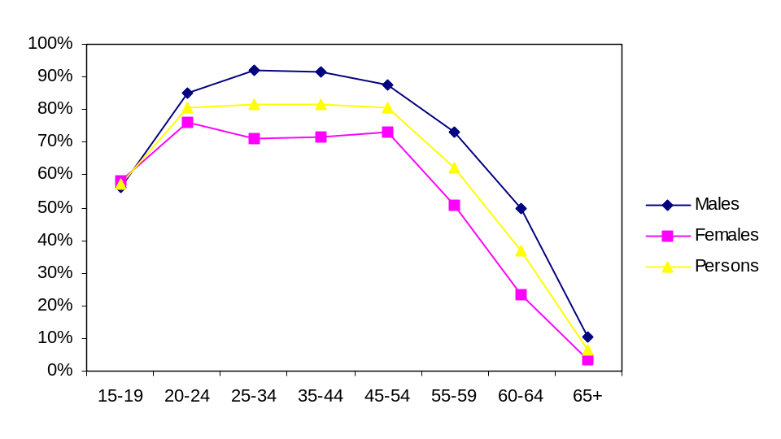

In 2000, the Wallis Consulting Group undertook a survey “Workforce Circumstances and Retirement Attitudes of Older Australians” on behalf of FaCS. The survey examined the labour market experiences of Australians aged between 45 and 69, and covered people in receipt of an income support payment and those not receiving any payment. For those who last left a main job within the past nine years, reasons for job departure and subsequent labour market experience were explored. To examine the labour market experiences of mature age people approaching Age Pension age, the survey results for people aged 55 to 64 years are considered in this submission. The survey indicated that, within this age group, as shown in Table 1:

- 20 per cent of had been working in the same main job for at least the past nine years. More men had been working in the same job (27 per cent) than women (13 per cent);
- 50 per cent had last left a main job in the past nine years; and
- 28 per cent had last left a main job ten years or more ago. More women (42 per cent) fell into this group than men (16 per cent). This group was not asked why they had last left a main job because the passage of time may have affected the reliability of the answers.

Table 1: Persons aged 55-64, job history status, 2000

 |  | Men | Women | Persons
 |  | ------------------------Proportion------------------------
 | Worked in same main job for at least nine years | 26.8 | 13.1 | 20.1
 | Last left main job in last nine years | 57.6 | 42.7 | 50.3
 | Last left main job ten or more years ago | 15.5 | 41.5 | 28.2
 | Have not had job | 0.2 | 2.8 | 1.5

Those who had last left a main job in the last nine years were asked why they had left. The results are summarised in Table 2, which shows:

- 28 per cent left because of ill-health/disability, to reduce stress or to care for an elderly or sick relative;
- 23 per cent left involuntarily, due to redundancy or dismissal or were otherwise required to leave their job. For men, this was the major single cause of job departure (30 per cent), markedly less so for women (13 per cent);
- 21 per cent of men and women left because of other job related reasons, such as the impact of company restructure, sale of business, desire to move to another job;
- 16 per cent of men and women left to retire or live off their investments and/or income support; and
- 13 per cent left for personal reasons, such as a decision to take a break, family reasons, or a move to a new location. This factor was more significant for women (21 per cent) than for men (8 per cent).

Table 2: Persons aged 55-64 who left jobs in nine years prior to 2000, reason for leaving job

 | Reason for last leaving a main job | Men | Women | Persons
 |  | ------------------------Proportion------------------------
 | Disability/ill health/caring/stress | 26.1 | 29.8 | 27.6
 | Retire/live off investments/income | 15.5 | 16.0 | 15.7
 | Involuntary job-related reason | 30.0 | 12.5 | 22.7
 | Other job-related reason | 20.9 | 21.0 | 20.9
 | Other personal reason | 7.6 | 20.7 | 13.0

In summary, while 20 per cent of people surveyed continued in a job, most who last left a main job in the last 9 years lost their job or left because of such reasons as disability or ill health. Leaving a job need not impede planning for retirement if the person can find a new position. However, many do not find new work. Those who had last left a main job within the last nine years and were currently not in the labour force, were asked if they had wanted to continue working or had tried to find new work. The results are summarised in Table 3, which shows:

- 51 per cent of those who lost a job involuntarily claimed to have sought a new job. A higher percentage of men (52 per cent) did so than women (48 per cent);
- One third of people who left a job because of other job related reasons, such as the impact of company restructure, sale of business, desire to move to another job sought a new job. A higher percentage of men (48 per cent) did so than women (24 per cent);
- 22 per cent of women who left a job for personal reasons sought a new job; and
- relatively few people who left a job due to disability, illness, to reduce stress or to care for an elderly or sick relative sought a new job (around 17 per cent of both men and women).

Table 3: Persons aged 55-64 not in the labour force who left a job in the nine years prior to survey by selected reason for leaving last main job and sex - proportion who looked for work since leaving labour force, 2000

 | Reason for last leaving a main job | Men | Women | Persons
 |  | -----------Per cent who looked for work-----------
 | All reasons | 29.3 | 21.3 | 25.6
 | Involuntary job-related reason | 52.1 | 47.9 | 50.9
 | Other job-related reason* | 47.9 | 23.8* | 33.5*
 | Other personal reason | 44.5** | 21.8 | 27.9
 | Disability/ill health/caring/stress | 17.2 | 16.9 | 17.1
 | Retirement/live off investments/income support | 10.4* | 10.9* | 10.6*
* A small number of cases were excluded from analysis due to missing data on relevant variables.
** Sampling variability too high for most practical purposes.

People were asked about the difficulties they faced in finding work. As shown in Figure 2:
- Around 20 per cent of people aged 45 to 55 said they found it fairly difficult and over 30 per cent found it very difficult to re-gain employment. That is, over half the population within the 45 to 55 age group found it difficult to regain employment.
- Over 40 per cent of people aged 55 to 65 found it very difficult to regain employment and around 15 per cent found it fairly difficult. That is, almost 60 per cent of the age group found it difficult to regain employment.

Figure 2: Difficulty of re-entering workforce rises with age

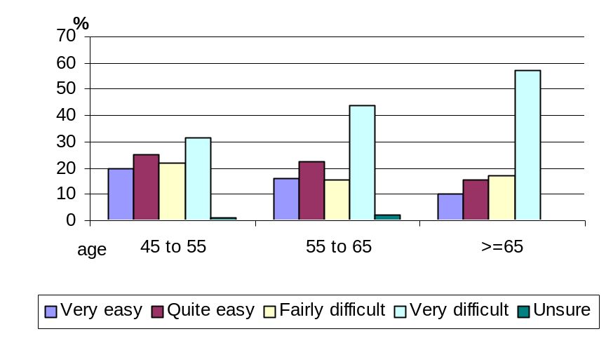Reflecting these factors, half the 55 to 64 age group is currently not in the labour force, as shown in Figure 3. Figure 3 (and Figures 3a and 3b in Attachment B) show labour market outcomes for the age group and for males and females respectively. Employment includes full-time, part-time and casual work. Key findings are:

- 53 per cent of men in the age group were employed, 6 per cent are looking for work and 40 per cent were not in the labour force. Fewer women were working (39 per cent), 3 per cent are looking for work and 59 per cent were not in the labour force;
- 58 per cent of employed men and 60 per cent of employed women were in the same main job over the prior nine years;
- 36 per cent of men and about 28 per cent of women who had last left or lost a main job within the past nine years were currently employed;
- 46 per cent of women and 21 per cent of men currently not in the labour force had last left a main job 10 or more years prior to the survey;
- for men and women last leaving a main job for disability, illness, to reduce stress or to care for an elderly or sick relative – the largest single cause of job departure – only about 9 per cent of men and 14 per cent of women were currently employed; and
- for those who had lost a job involuntarily – most of whom wanted to secure new work- only 25 per cent of women and 37 per cent of men regained employment; and
- among men who left a job to retire or to live off their investments, 26 per cent were currently employed in some capacity, with 7 per cent for females in this category.
The above reinforces the need to boost workforce participation for mature age people as a critical pathway to improving retirement incomes. The results suggest many mature age people may face uncertainty in planning for retirement. Women face particular labour market challenges and lower participation outcomes. The results also suggest some “early retirees” re-enter the labour force.

Figure 3: Labour Force Status and Transitions of People Aged 55-64

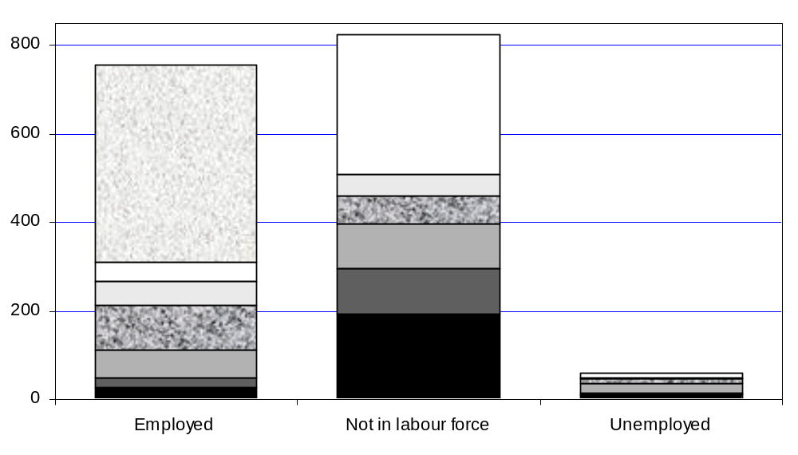No. (‘000)

 |  | Disability/ill health/caring/stress |  | Other personal reason
 |  | Retire/live off investments/income support |  | Reason unknown/have not had job
 |  | Involuntary job-related reason |  | In same main job for at least 9 years
 |  | Other job-related reason

Notwithstanding the relatively low workforce participation rates for mature age people, ABS labour force data indicates that there are some encouraging trends emerging. The proportion of people aged 55-64 in employment has picked up over the last five years, reflecting growth in part time employment. Since 1978:

- there have been increases in part time employment for both men and women aged 60-69, but particularly younger women in this age group (see Figure 4); and
- there has been a slight increase in full-time employment for the younger women in that age group (see Figure 5).

While part time employment may not give a mature age person as much capacity to prepare for retirement as a full time job, it may offer more scope for people to supplement post retirement by engaging in transitional employment where they are willing and able to do so.

Figure 4: Proportion of older persons employed part-time by sex and selected age group, Australia 1978-2002*
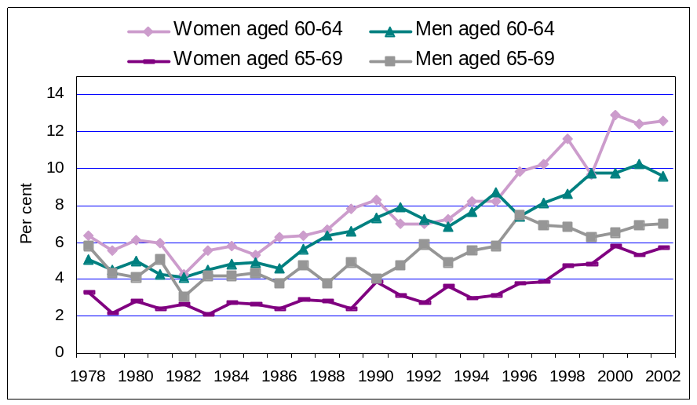

Figure 5: Proportion of older persons employed full-time by sex and selected age group, Australia 1978-2002*
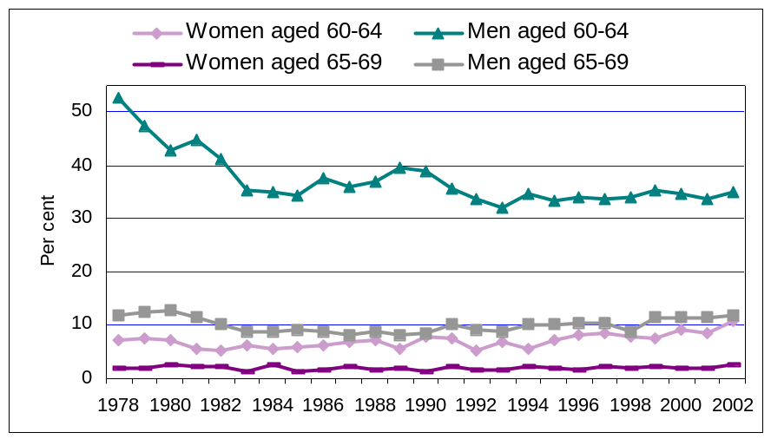

*Uses August data points only

2. Planning for retirEment

2.1 Retirement Planning Information

Retirement planning information can help people to make informed choices about the quantum of savings necessary to support a desired standard of living in retirement over and above the superannuation guarantee, and the appropriate vehicles in which to invest their savings. This information can also help people plan how they can make a smooth transition from full time employment to retirement.

It is also important to provide people with information that assists them to make the most effective use of their savings through retirement, and to make the investment choices that are appropriate to their needs and expectations.

Further, the approach to retirement also poses people with choices to make regarding housing and activities outside work including the scope to undertake volunteering, caring and social and community participatory activities.

As regards assistance on financial matters, there is a range of retirement information and specialist financial information available from the private sector and government to assist people.

Private sector information is available from a range of sources, including:

- financial planners;
- accountants and solicitors;
- banks, credit unions and building societies;
- stockbrokers; and
- superannuation funds.

The Government works in partnership with the private sector to assist in providing retirement planning information.

The FaCS survey on the Workforce Circumstances and Retirement Attitudes of Older Australians, mentioned earlier in this submission, asked people aged 45 to 69 who had ceased work/retired at a time they had chosen had taken any steps to plan their retirement income prior to ceasing work/retiring. It found that:

- 70 per cent had taken some steps prior to their retirement. The range of planning activities reported included consulting financial advisers, establishing a superannuation fund, drawing up a budget and/or starting to make financial investments; but

- 30 per cent had not done so.

However, these results apply to only a relatively small group – the survey did not address this question to people who had not retired at a time of their choosing, which, as noted earlier, comprises the bulk of mature age people. Further information is at Attachment C.

The demand for retirement planning information can be expected to increase because of such factors as:

- the growth in the pre retirement population;
- the growth in average retirement saving, particularly because of the maturing of the superannuation system; and
- increases in the variety of retail products available to customers.

2.2 FaCS Portfolio Retirement Planning Information

The FaCS portfolio provides free information through a number of means to promote participation, independence and self-reliance for those planning, saving and preparing for retirement by assisting them to make the best use of savings and investments to maximise their income and maintain their standard of living.

FaCS works with industry bodies, other Government agencies including Treasury and the Australian Securities and Investments Commission (ASIC), financial associations and community groups in producing and delivering this information.

FaCS portfolio information is provided through:

- the Financial Information Service (FIS) provided by specialist Centrelink officers;
- a series of information publications for retirees and pre-retirees; and

- the National Information Centre on Retirement Investments Inc (NICRI).

Where possible, information is also delivered through the internet.

Information on how people can access this information is at Attachment D.

Financial Information Service

The FIS program, delivered by specialised Financial Information Service Officers in Centrelink, aims to ensure that clients, potential clients and others planning their retirement have sufficient information to make effective use of their private resources for self support, informed decisions about retirement issues and adequate financial preparation for a retirement that allows participation in their community. FIS officers provide investment information, not investment advice. FIS officers provide face to face and phone interviews to individuals (who may or may not be current Centrelink customers) and seminars that are open to the public.

FIS officers can provide information on a wide range of issues including:
- the advantages and disadvantages of different investment options and strategies;
- superannuation and annuities;
- banking and financial services;
- the income and assets tests;
- accommodation issues, such as buying and selling a home;
- taxation and how it affects investments; and
- social security payments.

FIS Seminars are run across Australia and target financial information at pre-retirees, retirees, people becoming redundant or retrenched and rural communities. They also provide information for intermediaries, such as financial, welfare, community and industry groups. Seminars are held on particular topics. In 2002, seminar topics included ‘Managed Investments’, ‘Income Streams for Effective Retirement Income’ and ‘Superannuation Investments – The Basics’. Seminars are free and advertised in local media. FIS seminars are directed at changing community attitudes and approaches to retirement planning, and assisting and encouraging pre-retirees to commence planning for retirement.

Seminars aim to complement those run by the financial industry and help people to assess the options available to them.

There are approximately 120 FIS Officers throughout Australia. Between 1 July 2002 and 20 March 2003, FIS Officers had conducted 142 027 calls and 53 082 interviews. Over the same period, 1 442 FIS seminars were held, attended by 52 820 people.

Portfolio Retirement Planning Publications

FaCS portfolio publications for retirees and pre-retirees are directed at helping people plan for their retirement. These are publications from the Department of Family and Community Services and from Centrelink. The products in the Department’s Retirement Planning Information Program are:
- Investing Money – Your Choices, which provides information on the basics of financial planning and on different types of financial products, including on the taxation and social security treatment of these products. This is a joint FaCS/NICRI publication;
- Home and Residence – Choices for Older People, which aims to assist older people and their families with important lifestyle and housing decisions and the effect on access to payments. Information is also provided on how older people can get the care they need, whether in their own home or in residential care;
- Australian Retiree – Your Choices, which is a resource to help self-funded retirees become aware of the products, services, concessions and organisations available to assist them to maximise their choices and lifestyle through retirement;
- Moving House – Your Choices, which aims to assist people to improve their lifestyle in retirement by making informed choices about their housing. This is a practical guide to selling, buying, financing, renovating and moving. It also provides information on helpful organisations and how different decisions may affect entitlement to payment; and
- Understanding Retirement Income Streams, which explains retirement income streams and how they might be used in retirement planning. It is a joint publication that was developed with the then Australian Retirement Income Streams Association Limited (ARISA).
Centrelink publications include:
- Age Pension News for Seniors, a quarterly magazine distributed to all people paid an Age Pension, a Veterans’ Affairs Service Pension or holding a Commonwealth Seniors Health Card. It keeps readers informed about issues of interest and changes that may affect retirees; and
- Are you planning for or needing help in retirement, a booklet that provides information about payments and services people may be able to access if they are planning for or needing help in retirement.
The Departmental publications are distributed through Centrelink, NICRI, financial planners, solicitors, accountants and through community groups. They are also available on the FaCS and Centrelink internet sites. From July 2002 to the end of February 2003, over 230 000 copies of the Departmental publications were distributed.
FaCS publications are revised on an ongoing basis. New editions of Investing Money – Your Choices, Home and Residence – Choices for Older People and Australian Retiree – Your Choices were published in October 2002.

National Information Centre for Retirement Investments (NICRI)
NICRI is an independent body funded by the Commonwealth Government to provide the public with free information on planning and saving for retirement, investment options and effective use of financial resources in retirement. NICRI does not represent government or the financial industry. NICRI provides financial information, not financial advice.

NICRI information is targeted towards helping retirees and pre-retirees:
- understand the generic nature of investment products (eg term deposits) and how they work;
- consider their financial requirements for retirement;
- maximise their overall retirement income;
- understand investment basics, such as the need to balance the risks of investments with the returns; and
- approach their own retirement planning with more confidence.

NICRI delivers its services to the public through a toll-free telephone inquiry service and an extensive range of information leaflets. NICRI publishes media articles and makes presentations in external seminars.

NICRI complements the work of FIS. FIS uses NICRI information (eg NICRI pamphlets) to help customers understand investments and approaches to investments. NICRI also provides a training and information service to FIS officers, and a telephone information service on technical issues concerning investment and savings products.

Between July 2002 and February 2003, NICRI:
- addressed 35 seminars (32 FIS seminars, 3 other);
- distributed 99 656 information leaflets on types of investment, financial planning and preparation for retirement;
- responded to 3 050 telephone enquiries from the general public; and
- provided a web site at www.nicri.org.au, which was accessed 10 970 times.

Information was provided over this period on a range of retirement planning issues, including:

- investment products such as superannuation and rollover investments and income stream investments;
- other investment options such as managed investments; and
- general financial planning issues.

2.3 Effectiveness of Retirement Planning Information

The FaCS portfolio information strategies recognise that retirement information can play a critical “early intervention” role in influencing retirement planning and in helping to prevent adverse outcomes down the track. The portfolio’s strategies engage various stakeholders in the market place to maximise their impact on people planning for retirement. That drives much of the joint work noted above, including provision of material to financial advisers and planners to assist them to better advise their clients.

3. Conclusion

As a result of the introduction of compulsory superannuation through the Superannuation Guarantee, most people will have a better retirement income than from Age Pension alone. However, to achieve optimal retirement income outcomes, individuals have a role in planning and saving for their own retirement. Workforce participation for longer periods across working life gives people more options to add to retirement incomes. However, many people face premature departure from the work force, which reduces their capacity to save for retirement.

The Government is examining strategies to promote higher labour market participation, including for mature age workers. Possible future directions could include:
- Promoting transitional retirement: could enable people to combine some workforce participation with other responsibilities and interests. Phased or transitional retirement allows for a gradual transition from full-time work to no paid work, providing flexibility to accommodate other responsibilities or interests, for example, caring responsibilities and volunteering; and
- Attitudinal change: promoting greater awareness among employers and the broader community of the knowledge and skills of older workers, as well as assessing and reviewing policies that either support early withdrawal from the labour market or prevent phased retirement.
The provision of information on planning, saving and preparing for retirement can assist people to maximise their retirement income, and make the lifestyle choices that are best for them so that they have a satisfying retirement. Overall, approaches to planning for retirement need to recognise the impact of a range of factors on individuals’ circumstances.

attachment A assessed income and assets of age pensioners

Selected statistics for age pensioners, December 2002

 | All Age Pensioners | Recent Claimants (a)
Population number | 1 829 274 | 129 384
Full Rate Pensioners
Percentage on full rate | 67.6 | 56.0
Average assessed income | $740 | $661
Average assessed assets | $30 492 | $32 463
Part Rate Pensioners
Percentage on part-rate | 32.4 | 44.0
Average assessed income | $7 839 | $9 529
Average assessed assets | $86 643 | $110 856
(a) People in receipt of age pension for less than one year.

attachment B: Labour Force Status and Transitions of People Aged 55-64 by Sex, Australia, 2000
Figure 3a
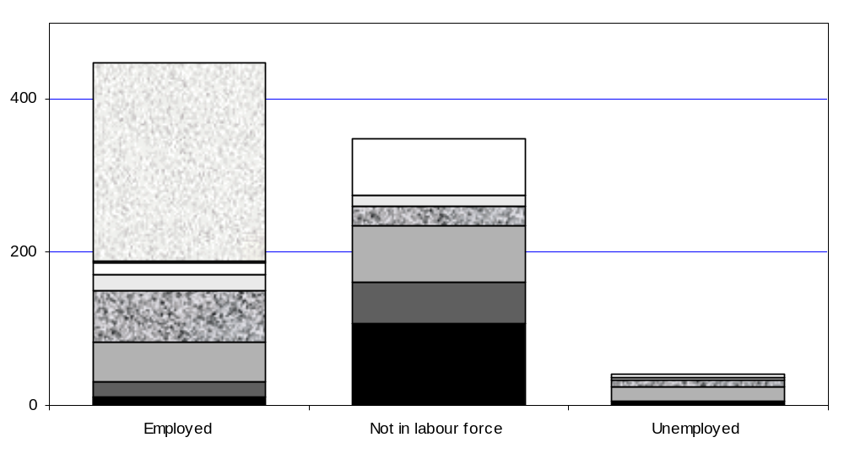MEN (No. ‘000)

Figure 3b
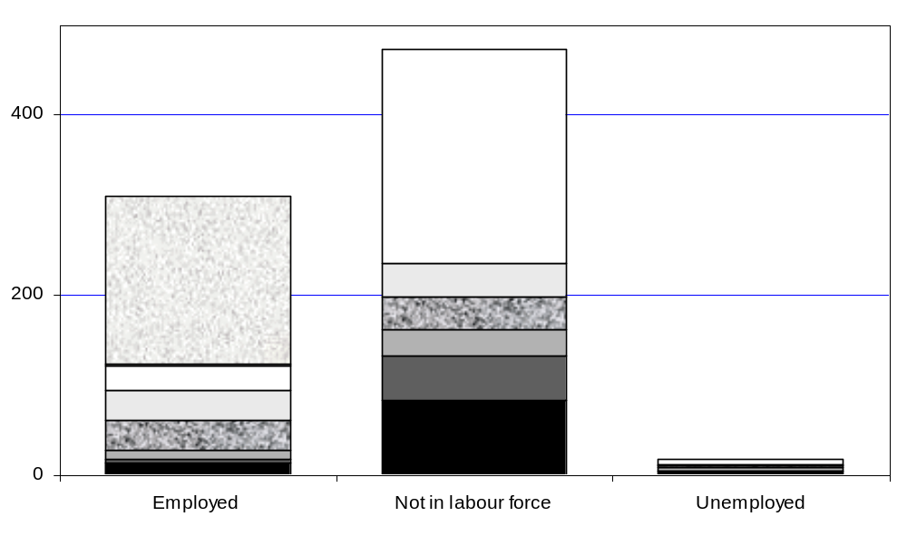WOMEN (No. ‘000)

 |  | Disability/ill health/caring/stress |  | Other personal reason
 |  | Retire/live off investments/income support |  | Reason unknown/have not had job
 |  | Involuntary job-related reason |  | In same main job for at least 9 years
 |  | Other job-related reason

attachment C: retirement planning undertaken by mature aged people* who had planned to retire when they did

Proportion of mature age workers who had taken/had not taken active steps prior to retirement to ensure they had adequate retirement income:
 | Per cent
Proportion of those who had not taken any steps at all (but had still planned to retire when they did) | 29.3
Proportion of those who had actively taken steps | 70.7

Steps taken to plan for retirement:

 | Consulted financial adviser / accountant/bank manager | 23.7
 | Read books / newspapers / magazines/drew up a plan or budget | 14.4
 | Started saving | 7.5
 | Set up superannuation fund | 34.9
 | Contacted superannuation fund | 29.6
 | Started investing in shares / trusts / bonds/property | 31.1
 | Other | 7.9
 | Don't know | 2.6

*Age ranged from 45 to 69. Note that those who were working at the time of the survey and could have been planning for their retirement were not asked the question.

Source: Workforce Circumstances and Retirement Attitudes of Older Australians' Survey 2000

attachment D: how to access facs portfolio retirement planning information

FINANCIAL INFORMATION SERVICE

Information about FIS can be obtained by calling Centrelink on 13 2300.

Information about FIS seminars or workshops being held in the near future can be obtained by calling Centrelink on 13 6357.

THE NATIONAL INFORMATION CENTRE ON RETIREMENT INVESTMENTS

NICRI can be contacted by:
- FREECALLTM 1800 020 110 between 9am and 5pm (AEST) Monday to Friday;
- the NICRI website at www.nicri.org.au (all of NICRI’s leaflets can be obtained from the website);
- e-mail nicri@nicri.org.au;
- fax on 02 6285 3787;
- mail to PO Box 893, Woden ACT 2606;
- Telephone Interpreter Service on 13 1450.

SENIORS INFORMATION BOOKLETS

These FaCS publications are available free from Centrelink offices or by calling Centrelink on 13 2300.

The publications are also available on the Internet at www.facs.gov.au/seniorsinfo.

To qualify, people must work for at least 960 hours each year - an average of 20 hours a week over 48 weeks each year.
ABS Labour Force data. Selected Summary Tables, Australia, Monthly (Catalogue No. 6291.0.40.001). See Figures 4 and 5 below.
Other assets exempt from the assets test include complying income streams. (56,900 age pensioners hold a complying income stream).
NATSEM Income and Wealth Report 2002
Labour Force, June 2002, ABS Cat. No. 6203.0
6 The bars show numbers in each labour market category. Slices show labour history: reasons for last leaving main job within 9 years; if last left main job over 9 years ago (reason unknown); or never had/ left main job.
ABS Labour Force data cubes, Selected Summary Tables, Australia, Monthly (Catalogue No. 6291.0.40.001).

