Too Young to Go

A review of good practice in the employment of mature workers

Implications for policy
and practice
The NSW Committee on Ageing advises the Premier, through the Minister for Ageing, on matters affecting the needs, interests and well-being of older people in NSW. The 14 members of the Committee come from diverse backgrounds and have skills and interests in many different areas of public policy.
This report was guided by the Mature Age Employment Task Force established by the Committee. The Project Coordinator was Margaret Tucker.
The members of the Task Force were:
Ross Free Committee on Ageing
Les MacDonald Committee on Ageing
Dawn Linklater Committee on Ageing
Eric Bedford Committee on Ageing
Ray Harris Committee on Ageing
Neil Tucker Council on the Ageing NSW
Col Parker Commonwealth Department of Employment, Workplace Relations & Small Business
Virginia Dryden Department of Local Government
Michael Brown Mission Australia
Mark McCormick Department of Ageing, Disability and Home Care
Shefali Rovik Commonwealth Department of Family and Community Services
Alison Peters Labor Council of NSW
Sally Heycox Department of Education and Training
Peter Hack Department of Education and Training
Caroline Davidson Premier’s Department

Report written by: Julia Perry and John Freeland
Case study interviews by: Shane Warren
Edited by: Sarah Fogg
Design: Anthouse Communications, anthouse@acay.com.au
© NSW Committee on Ageing, December 2001
ISBN 0 7313 9841 6
For information about the Committee’s complementary report, Counting on Experience: A review of good practice in the employment of mature workers, and other Committee publications, or to comment on the report, contact the Committee at:
NSW Committee on Ageing
Level 13, 83 Clarence St, Sydney NSW 2000
Ph: (02) 9367 6860 Fax : (02) 9367 6890
Email: ccoa_info@add.nsw.gov.au
Website: http://www.coa.nsw.gov.au

Disclaimer
While every care has been taken in the preparation of this publication and the information it contains is believed to be accurate, this document contains guidelines only in relation to its subject matter. The NSW Committee on Ageing cannot be liable for any error or omission in this document or for damages arising from the supply, performance or use of the publication and makes not warranty of any kind, either express or implied in relation to this material.

Foreword
Mature age unemployment is a significant problem in New South Wales, not only because of the impact on the quality of life of people directly affected, but also because of the impact on government revenue and expenditure, both State and Commonwealth. Moreover, mature age unemployment represents a major loss of skills and experience to industry and the economy of the State.
Many people are also concerned about the effect of early retirement and predict a shortage of labour as the first of the baby boomers reach their mid fifties and start to take early retirement, whether by choice or involuntarily. The impact of early retirement and mature age unemployment will be felt way into the future as they affect not just people’s current living standards, but also their future quality of life in retirement.
The Committee on Ageing has a long standing interest in mature age employment and unemployment. Earlier this year, with the approval of the Minister for Ageing, the Hon. Faye Lo Po’, it established a Mature Age Employment Task Force to oversee its Mature Age Employment Project.
The Task Force membership was drawn from key government departments and non-government organisations, and the Committee on Ageing itself. The Task Force’s expert advice and assistance has been invaluable, although the Committee takes full responsibility for the contents of this report.
This report is a major outcome of the Committee’s Mature Age Employment Project. The report aims to paint a picture of the nature and dimensions of mature age unemployment and early retirement in NSW and to identify policy and practice implications for the NSW Government.
The Project will also be producing complementary reports highlighting ‘good practice’ in recruiting and retaining mature age workers, and the impact of mature age unemployment and early retirement on NSW Government funded expenditure and services.

John Mountford
Chairperson

Table of contents
Executive Summary 8
1 Introduction 13
Commonwealth income support and employment assistance
Implications for NSW
Healthy Ageing to active citizenship
Age as a disadvantaging factor
This report
2 Demographic and participation trends 19
Demographic trends
Labour market trends - overview
Labour force trends - men
Labour force trends - women
Under-employment and disappointed job seekers
Summary
3 Labour force dynamics 31
Job leaving
Reasons for leaving
Job search experience
Summary
4 Characteristics of early exit 40
Education and training
Disability
Housing
Occupation and industry
Occupation
Industry
Geographical distribution
Summary
5 Attitudes of employers and mature workers 55
Impact of joblessness
Financial effects
Impact on families
Attitudes towards mature age unemployed people
Summary
6 Constitutional responsibilities for ageing 63
Social security
Industrial relations
Human rights
Public sector employment
Full employment
Labour market programs and vocational education and training
Disability
Health, housing, community services and transport
Commonwealth policy on ageing
NSW policy on ageing
Summary
7 Social security 71
Description of entitlements
Recipient numbers
Policy directions
Issues for the NSW Government
8 Superannuation 79
Introduction
History of occupational superannuation
Tax concessions
Superannuation fund standards
Accumulation and defined benefit schemes
Summary and future directions
9 Commonwealth employment assistance programs 83
Introduction
Program types
Assistance for mature age people
History of assistance for mature age people
Current labour market program arrangements
Policy directions
Summary
10 Disability and caring responsibilities 96
Introduction
Characteristics and extent of caring
Mature age and disability
Commonwwealth programs and services
Linking labour market programs and disability employment programs
Future directions for mature workers with a disability
NSW programs and services
Workers' compensation
Summary
11 Labour market assistance in NSW and other States 106
Introduction
NSW Mature Workers program
NSW labour market assistance — history
Programs in other states
Summary
12 Mature age workers and anti-discrimination measures 116
Introduction
Abolition of compulsory retirement
Discrimination on the basis of age
Discrimination on the basis of caring responsibilities
Industrial relations legislation and discrimination
Tax provisions for early retirement schemes
Effectiveness
Conclusion
13 Conclusions and recommendations 123
Appendix A: Selected recommendations from key reports 133
References 151

List of figures
Figure 1: Age profiles — NSW — 1985, 2000, 2015
Figure 2: Employment to population ratios by age, men — NSW —
1981 to 2000
Figure 3: Employment to population ratios by age — women —
NSW — 1981 to 2000
Figure 4: Estimated labour market position by age group — men —
NSW — August 2000
Figure 5: Estimated labour market position by age group —
women — NSW — August 2000
Figure 6: Employment to population ratios by age and
educational attainment — men — Australia — May 1998
Figure 7: Employment to population ratios by age and
educational attainment — women — Australia — May 1998
Figure 8: Vocational education and training by age - employed
people - Australia 1997
Figure 9: Employment by age by housing — men aged 45-69 —
Australia 2000
Figure 10: Employment by age by housing — women aged 45-69 —
Australia 2000
Figure 11: Mature age people as a percentage of the population
aged 15 and over, and employment to population ratios
for men age 55-64 and total — by region - NSW 1996
Figure 12: Mature age people as a percentage of the population
aged 15 and over, and employment to population ratios
for men age 55-64 and total — by population density -
NSW 1996
Figure 13: Income support and activity tested payments — receipt
by age — persons — NSW — March 2001
Figure 14: Income support categories by age — men aged 15-64 —
NSW — March 2001
Figure 15: Income support categories by age — women aged 15-61 —
NSW — March 2001
Figure 16: Disability Support Pensioners — % of population by age
by sex — 1992, 2000
Figure 17: Injuries by duration per 1000 wage and salary earners —
1998-99

List of tables
Table 9: Men and women retrenched or made redundant in previous
three years — status at July 1997 — age group — Australia
Table 10: Men and women who left a job less than 10 years ago —
probability of re-employment by reason and age — Australia 2000
Table 11: Source of current jobs — men and women who had become
employed or self-employed in last 10 years — Australia 2000
Table 12: Leaving the labour force — exit rate over 12 months by age
and whether unemployed before exit — Australia 1994
Table 13: Occupational age profiles — men — Australia 2000
Table 14: Men who left work in the last 5 years — former occupational
distribution by age — Australia 2000
Table 15: Occupational age profiles — women — Australia 2000
Table 16: Women who left work in the last 5 years — occupational
distribution by age — Australia 2000
Table 17: Employed men by age and industry — NSW 1996
Table 18: Employed women by age and industry — NSW 1996
Table 19: Rates of pension and benefit — adults — August 2001
Table 20: Age profiles, Income Support, Job Network, Job Search
Matching and Intensive Assistance, May to Sept 2000
Table 21: Post assistance outcome rates by age, May 1998 to
September 2000
Table 22: Post assistance outcomes for NEIS by age, May 1998
to September 2000
Table 23: Age profile of CSDA service clients — 1998
Table 24: Mature Workers Program — Participation and outcomes
by age, 1999/2000

Executive Summary
This report examines the impact of the early exit from the workforce of a substantial section of the NSW mature age population. The report was commissioned by the NSW Committee on Ageing, an advisory committee to the NSW Government, and aims to identify issues for consideration by the NSW Government.
The report provides a description of mature age unemployment and early retirement in NSW, an analysis of current and proposed Commonwealth and NSW Government initiatives for mature age workers and a discussion of the potential role for NSW in complementing and monitoring Commonwealth initiatives.

Demographic and labour market trends
Over the last twenty five years, NSW has experienced a major decline in the employment of mature age men. The employment of mature age women has been rising, but remains lower than that of men. A minority of men and few women work to the age of 65 and very few beyond that.
At the same time, demographic changes are increasing the proportion of the population aged 55 and over. On average, a person who entered employment at 20 and retires at 55 can expect only a decade less in retirement than he or she spent in employment.
In NSW in August 2000, an estimated 131,000 men and 131,000 women aged 45 and over wanted more work than was available for them. Most were not in the labour force but wanted to work, some were unemployed and others worked part-time but wanted full-time work.

The impact on individuals
The fall in employment among mature age people has significant financial consequences for the individuals concerned. Income support reliance has increased dramatically over the last quarter century as the proportion of mature age men in employment has fallen. Despite rising employment among mature age women, their reliance on income support has increased because of the decline in their partners’ employment. Over a third of NSW residents aged 55-64 receive social security pensions or allowances. Many men and women are neither employed nor receiving income support and are presumably depending on retirement savings. If they are depleting their assets, their likelihood of needing income support at some time in the future is increased.
Many who lose their jobs and are unable to find re-employment suffer shock, grief, humiliation, loss of confidence and long term adverse effects on their health and wellbeing. Mature age people began their careers at a time when jobs (at least for men) were expected to be permanent and full-time. Many have no recent experience in job seeking and are ill-equipped to do so. The demoralisation and age discrimination they suffer means that their employability depreciates at a rapid rate once unemployed.

The causes
The causes of early exit from the labour force are complex and appear to include a reluctance (amounting often to discrimination) among employers and employment agencies to recruit mature age people, the low average levels of formal educational qualifications among mature age people, lack of skills in new technology, work experience in declining industries, locational disadvantages, and disabilities and caring responsibilities that limit their employment options.
A proportion of mature age men and women take early retirement voluntarily. However, a large number leave jobs through retrenchment and redundancy and then leave the labour force unwillingly (involuntary early retirement) because of severe barriers to re-employment.
Companies downsizing may find it easier to shed older workers, not necessarily because they have lower productivity, but because redundancy packages and social attitudes make it more acceptable to retrench them than prime age workers.
While some employers discriminate against older staff in providing training, there appears also to be a reluctance among mature age people to train, for a range of reasons. Both employers and mature age workers may think there is little point, that it is the other’s responsibility or that they are too old. The training available is likely to be geared to younger people’s needs and unsuitable in either form or content to the needs of mature age people.

Impact on retirement incomes
The role of superannuation is endangered by the trend to use it to finance late career unemployment and early retirement. However, many in the current generation of mature age people have low levels of superannuation having had limited or no access to employer supported schemes during most of their working lives. Levels of superannuation adequate to support a person throughout an extended period of retirement have tended to be available only to people at the higher end of the income scale and in a few industries.
Early retirement and exclusion from the labour market prevent mature age people from being able to build up more substantial superannuation and other assets for retirement.

Impact on industry and government
Low rates of labour market participation are also a problem for industry and government as mature age people’s skills and experience are lost to the economy. Moreover, instead of contributing to economic production and to tax revenue, many become dependent on social security, with flow-on effects on public spending by the NSW Government.

Role of public policies
Mature age people’s employment is strongly influenced not only by the labour market but also by public policies. These include industry and regional policies, public sector employment, industrial relations, anti-discrimination legislation, training, education, labour market assistance, social security, tax and superannuation policies. Each of these policy areas is examined in the report.
Public policies in relation to retirement age are somewhat conflicting with some encouraging early retirement and others discouraging it.
The main avenue of labour market assistance is the Commonwealth-funded Job Network. Despite criteria that would appear to favour mature age job seekers, they are in fact under-represented among people using Job Network services and among people achieving positive results from doing so. There is evidence that their employment outcomes from the Job Network are improving. Other labour market programs and disability employment services strongly favour younger or prime age people.
However, the Commonwealth has announced the gradual introduction of a range of measures to assist mature age unemployed people.
At the same time the Commonwealth is gradually reducing the range of social security payment types for people aged between 50 and 65. As a result mature age social security recipients will generally be expected to remain active job seekers. However, on its own this is unlikely to reverse the low employment and labour force participation rates among mature age people.
Since 1989, the NSW Government has run the Mature Workers Program, an effective and popular program. However, it is a small program, assisting only around 7,500 people a year in a State where over 33,000 people age 45 and over are unemployed and many more are hidden unemployed.
The far reaching social and economic consequences of the large scale displacement of mature age people from the labour force are important issues for Commonwealth and State Governments. While the Commonwealth has primary responsibility for employment policy, a number of areas of State responsibility either affect or are affected by mature age unemployment patterns. This report argues that assistance to mature age job seekers is not as well targeted as it might be with a better articulated Commonwealth-State policy.

Recommendations to the NSW Government
The recommendations not only address the inequity and loss of quality of life experienced by many mature age unemployed people. They also seek to reduce the current and future costs to governments of supporting mature age workers – through social security, through demand on the health system from ill health caused by depression and poverty and, lastly, the costs associated with the wastage of the expertise and resources of mature age people.
The recommendations also take into account the recommendations of a number of other key recent reports on aspects of mature age employment and unemployment.
1. NSW should review its policies across portfolios in order to identify and remove any incentives for early retirement and any incentives to exclude mature age people from employment. It should also encourage the Commonwealth to do likewise.
2. NSW should strongly recommend to the Commonwealth that it adopt the Human Rights and Equal Opportunity Commission’s recommendation on age discrimination legislation without delay, to ensure consistency across all States.
3. Employment of mature age unemployed people may be improved if NSW were to introduce an Employment Office to:
• monitor labour force trends and emerging supply and demand mismatches across NSW;
• monitor and co-ordinate State policies affecting the supply of and demand for labour;
• analyse Commonwealth policies and programs as they affect NSW; and
• take primary responsibility for liaison and partnerships on employment issues with the Commonwealth, other State Governments, local government and employers.
The Office would work in cooperation with portfolio areas with responsibility for community development, industrial development, industrial relations, vocational training, employment services and other relevant agencies. Such an Office could have other benefits outside the parameters of this report.
4. NSW should approach the Commonwealth to establish a joint research unit to monitor and analyse NSW labour market trends and advise both Governments. This would allow resources to be used more effectively by avoiding duplication between the Commonwealth and State, while providing the State with a regular source of advice and expertise rather than relying on one-off commissioned research.
5. NSW should seek innovative ways for the Mature Workers Program to be expanded to deliver employment initiatives on behalf of the Commonwealth to mature age workers, including those with disabilities, carers, former carers and other mature age groups with specific needs.
6. NSW should examine, in its review of workers’ compensation, ways to ensure that injured mature age workers have equal access to return to work assistance.
7. NSW should seek a partnership with the Commonwealth and other States in a public education and awareness campaign to promote the benefits of mature age employment and life long learning.
8. NSW could consider establishing an employers’ forum on mature age workers and a system of recognition for innovation and best practice by employers.
9. NSW should encourage the Commonwealth and other states to develop an employers’ code of practice for mature age workers.
10. NSW should encourage the Commonwealth to ensure that specialist services for mature age workers are funded, on an economically sustainable basis, in the third round of Job Network contracts.
11. NSW should encourage the Commonwealth to provide extra funds so as to ensure that specialist Centrelink and Job Network staff have proper training in meeting the needs of the disadvantaged groups they serve.
12. The Department of Education and Training should further examine the training needs of mature age workers and undertake research on innovative training options to ensure that appropriate courses and training methods are available through TAFE and are encouraged in employer provided training and private training services.
13. NSW should encourage the Commonwealth, through the Australian National Training Authority, to take action to increase the level of employer provided or funded training, either through mandating a certain amount of expenditure per employee for training or through a compulsory levy on employers.
14. NSW should request that the Commonwealth amend the relevant provisions of the social security system to amalgamate Austudy and Newstart and create a single payment with sufficiently flexible activity testing arrangements to allow mature age unemployed people to undertake long term training without suffering a drop in payment level.
15. NSW should encourage the Commonwealth and other States to pass legislation requiring industrial awards and workplace agreements to make provision for unpaid study leave for employees seeking to upgrade their skills.
16. The Department of Industrial Relations should identify provisions in state awards and industrial agreements which discriminate against older workers, including those who are ineligible for the Superannuation Guarantee. The NSW Government should encourage the Commonwealth to do the same with federal awards.
17. Copies of this report should be sent to the Premier and relevant Ministers for their advice on implementation of the above recommendations.

1 Introduction
In the closing decades of the twentieth century, New South Wales, like the rest of Australia and most other OECD countries, has experienced dramatic changes in the transition from work to retirement. The majority of men now leave work before the age of 65, some as early as their mid 50s. Mature age women’s labour force participation has been increasing, although their employment rates are still lower than those of men and many of those without work can no longer rely on a working husband for financial support.
Certainly part of the fall in employment among mature age men is due to voluntary early retirement. However, a large number of mature age men and women leave jobs through retrenchment and redundancy and then leave the labour force unwillingly because of severe barriers to re-employment. Others who leave work because of illness, disability or injury who might once have returned to some form of employment are now unlikely to.
Although the decline in mature age employment has slowed in the boom period since the early 1990s, the ageing of the baby boom generation is beginning to swell the number of people in this age group and will soon lead to growth in the total number of mature age people who are not employed.
This has not only adverse financial consequences for mature age people, both while unemployed and throughout their retirement, but also adverse consequences for their psychological and social well-being. It is also a problem for industry and government in NSW. Instead of contributing to economic production and to tax revenue, a great many mature age people are required to resort to dependence on the social security system, with flow on effects on public spending by the State.
Employment patterns are not determined only by the market. They are also strongly influenced by public policies. These include the interactions among industry and regional policies, public sector employment, industrial relations, equal opportunity and anti-discrimination legislation, training, education and labour market assistance and income policies, such as wages, social security, tax and superannuation.

Commonwealth income support and employment assistance
Both income support and labour market assistance are primarily the responsibility of the Commonwealth.
The social security system now provides pensions and allowances for over a third of NSW residents aged 55-64, largely because of the collapse in the labour market for mature age workers, men in particular. Although more women are employed than ever before, the total rate of income support reliance for women has grown because many who are not employed now have non-employed partners.
The range of social security payment types for people aged between 50 and 65 is being reduced under a number of gradual measures. These particularly affect women but both men and women aged 60-64 will be affected by the phasing out of Mature Age Allowance from 2003. The generosity of payments has been reduced by a general trend to replace pensions with allowances — this has occurred for partners, widows and recipients of Mature Age Allowance. Nevertheless, the majority of recipients aged 40 or over are pensioners. Apart from the difference in the rates of payment, allowances have much stricter income and assets tests than pensions. Pensioners and long term allowance recipients aged 60 and over qualify for Pensioner Concession Cards.
Around sixteen per cent of people aged 55-64 or 10 per cent of people aged 45-64 are neither employed nor receiving social security payments. Some of these are living on low incomes or running down savings or superannuation assets and this will increase the number in poverty in later life. The role of superannuation, paid for by employers and employees in NSW, in improving the living standards and self reliance of retirees and in increasing the level of savings, is endangered by the trend to make early use of it to finance early retirement and unemployment.
The age of access to preserved superannuation is currently 55, while the age pension age is 65 for men and 62 for women, being increased to 65 for those born after 1948. The superannuation preservation age will be increased gradually for those born after 1960. This age discrepancy in the two retirement income systems provides a strong incentive for mature age people without work to use superannuation as bridging income rather than using it as an alternative to an age pension after the age of 65.
The main avenue of Commonwealth active labour market assistance is the Job Network, established in 1998. Under the Job Network, non-government agencies are contracted to assist job seekers. Job Network assistance is mainly targeted to those receiving Newstart Allowance, although recipients of most other social security payments, are able to participate on a voluntary basis. People on the excluded payments or not receiving income support are eligible only for basic job matching assistance, rather than Job Search Training or Intensive Assistance. Other programs, such as Work for the Dole, are mainly targeted towards younger people. In addition, the Commonwealth funds a number of disability employment services, but these too are overwhelmingly directed to people under the age of 50.
As part of its 2001 Budget package of measures known as ‘Australians Working Together’, the Commonwealth has announced a program of measures to assist mature age unemployed people, commencing in 2002. These include measures to assist mature age people with a disability.
Other recent Commonwealth interest in the issue of early retirement and mature age unemployment includes the development of a National Strategy for an Ageing Australia by the Office for Older Australians.
In 2000, the House of Representatives Standing Committee on Employment, Education and Workplace Relations published Age Counts: An inquiry into issues specific to mature age workers (House of Representatives, 2000). This made a large number of recommendations on ways to assist mature age unemployed people to find work.
The Human Rights and Equal Opportunity Tribunal published a report in 2000, Age Matters: a discussion paper on age discrimination (HREOC, 2000), which recommended a number of measures to combat discrimination including Commonwealth legislation.

Implications for NSW
New South Wales and other States have developed auxiliary programs for assisting mature age unemployed people because of perceived gaps in Commonwealth provision. The NSW Mature Workers Program is arguably the most effective program among the States. But the dual Commonwealth/State responsibility as it currently stands is sub-optimal. The total package of assistance to this group is not as well targeted as it might be with a better articulated Commonwealth-State policy.
Effective measures to assist and encourage mature age workers to find re-employment are also needed in the workers compensation system. The percentage of injuries in NSW assessed as causing permanent incapacity to return to work increases strongly with age — less than a fifth of injured workers aged under 35 are assessed as permanently incapacitated but this reaches a third of those aged 50-54 and half of those aged 60-64.
It is a concern for the State Government that high numbers of mature age citizens are leaving the workforce before they are ready to and are suffering the financial and psychological consequences. For many, employment ends unexpectedly and they may face the prospect of inadequate income and marginalisation from mainstream society for the rest of their lives.
It is also a concern that their skills and experience are lost to the NSW economy. Companies downsizing may find it easier to shed older workers, not because they have lower productivity, but because redundancy packages and social attitudes make it more acceptable to retrench them than prime age workers. However, the demoralisation and age discrimination suffered by mature age job losers mean that their employability depreciates at a rapid rate once unemployed. They have longer average duration of unemployment than younger job losers and are far more likely to leave the labour force permanently as a result.
The high proportion of mature age people receiving income support because of low income has flow-on effects to the State in the form of increased expenditure on concessions, increased demand for housing assistance and the health and family effects of unemployment and poverty. New South Wales, like other States, provides pensioner concessions for public transport, water, sewerage, electricity, council rates, some health services and recreational facilities and some councils provide rate concessions. The long term effects of mature age joblessness on future age pension eligibility will increase this financial pressure.
The importance of work and living standards and the significance of active ageing as part of the lifecycle mean that State Governments cannot afford to ignore this issue. While States may be concerned to avoid further cost shifting from the Commonwealth, it is strongly in the interest of each State to ensure that Commonwealth programs operate effectively for the citizens of the State and that State policies effectively complement those of the Commonwealth.

Healthy Ageing to active citizenship
In 1998, a year prior to the United Nations International Year of Older Persons, the NSW Government announced its Healthy Ageing Framework 1998-2003 (NSW Minister for Ageing, Minister for Health, 1998).
The Healthy Ageing Framework, with a primary focus on those aged 65 years and over, had the objective of ensuring “a society in which all older people lead satisfying and productive lives with maximum independence and well-being”. It also promoted a number of principles:
• The independence of older people as full and contributing members of society will be recognised.
• Older people will be treated fairly and equitably, free from unlawful discrimination.
• The diverse needs of older people including differences in gender, culture, language, geographical location and socio-economic circumstances will be taken into account in programs, policies and services.
• The unique needs of older Aboriginal and Torres Strait Islanders will be recognised in programs, policies and services.
• Policies, programs and services will be culturally and linguistically appropriate for older people from diverse backgrounds.
The Mature Age Employment Project, of which this report forms a part, represents a natural progression from the Healthy Ageing Framework. It moves the main focus from those aged 65 years and over, to those of mature age (45 years and over) and, especially, to those aged 55 to 64. If those aged 65 years and over are to enjoy ‘maximum independence and well-being’, and if they are to be ‘full and contributing members of society’, it is imperative that they do not lose the basis of their independence and participation before they are able to retire as independent, contributing members of society.
The theme of Healthy Ageing tends to focus attention on physical and psychological well-being. The concept of Active Citizenship complements that theme and society’s objectives for mature age labour market participation. Resourcing people of mature age for continued active citizenship provides the basis for determining a system of policies, programs, campaigns and services designed to enable and encourage them to continue in paid employment. This would allow more people to make a successful transition to an independent, participatory post-retirement lifestyle.

Age as a disadvantaging factor
It is broadly accepted that mature and older age workers experience variable forms of discrimination. Some discrimination appears almost natural and is hard to see because it takes the form of an encrusted cultural legacy. Some discrimination is unintended — the consequence of apparently well meaning attempts to ensure, for example, an ‘appropriate’ age balance in a particular work force, or to ensure employment opportunities for others experiencing their own forms of discrimination.
Age discrimination occurs where an opportunity is denied to a person solely because of his or her chronological age and age is irrelevant to the person’s ability to take advantage of that opportunity. Age is commonly used as an efficient proxy for desired characteristics such as fitness, financial viability, responsibility, honesty or skill. This will be discriminatory when age does not provide a true indication of the characteristic. …. Age discrimination in employment takes place in a context of negative attitudes and stereotypes of older people in general. Whether in recruitment, promotion, training, retirement or redundancy, older people are left feeling judged on their age rather than their abilities (HREOC, 2000).
Age is not the only determining factor of the advantages and disadvantages experienced by mature and older age workers. It co-exists with other factors, such as socio-economic status, gender, ethnicity, Aboriginality, disability, region, low education, a narrow skill base and so on. How all of these factors come together in the lives of individual people determines their life opportunities and barriers. And even then, what any particular individual makes of those opportunities and barriers is strongly influenced by their abilities, their outlook and their effort.
Policies for mature age workers have to encourage and facilitate the active involvement of the participants. Policies that seek to enhance the outlook and competencies of the mature age workers themselves, and which encourage and support their efforts to help themselves retain or secure employment, will be more effective than those which treat participants as passive recipients.
It is important to distinguish between broad structural factors and specific social and cultural factors to explain variations in mature age employment prospects.
It is possible to identify a number of provisional characteristics for an effective suite of policies, programs, campaigns and services for mature age people.
First, there is a need for policies with a primary focus on assisting mature age individuals who are either threatened with undesired joblessness or are already jobless. These should:
• have as a starting point respect for disadvantaged mature age workers and recognition of their need to play an active role in improving their own situation;
• seek to enhance the outlook of participants, deepen and broaden their competencies and more adequately resource their efforts;
• involve participants in identifying, understanding and addressing the mix of factors contributing to their situation and circumstances; and
• address locational disadvantage in particular communities.
Second, there is a need for discrete policies to redress age discrimination. They should:
• address institutional and systemic forms of age discrimination; and
• complement initiatives designed to redress other forms of discrimination based on gender, ethnicity, socio-economic circumstance, disability and so on.
Third, initiatives should:
• aim to bring the average levels and duration of undesired joblessness among mature age workers into line with the average for the whole labour force; and
• be developed as integral parts of broader strategies that aim to raise the overall level of employment and to reduce socio-economic and socio-cultural inequity.

This report
This report was commissioned by the NSW Committee on Ageing as part of its Mature Age Employment Project. The objective is to look at the consequences of a simultaneous ageing population and early work force exit for NSW.
The report provides:
• a description of mature age unemployment in NSW;
• case studies of the effect of unemployment on mature age people, including their experiences in looking for work;
• an analysis of current and proposed Commonwealth and NSW Government policies affecting mature age employment and a discussion of the potential role for NSW in complementing and monitoring Commonwealth initiatives; and
• identification and discussion of challenges relating to mature age employment and training issues in the NSW context.
The aim of the report is to identify issues for development and resolution by the NSW Government. These include:
• the need to monitor employment in NSW, monitor trends and influence Commonwealth policies affecting NSW citizens, understand the effect of State policies in industry and regional/ community development on the level and distribution of employment, and to be aware of problems caused by mature age unemployment;
• the interactions between the Mature Workers Program, the Vocational Education and Training (VET) system and the Job Network;
• the interaction between Commonwealth income support and State support for low-income people;
• ways in which State and Commonwealth responsibilities could be better articulated;
• the scope to modify employment practices to encourage employers to retain or recruit mature age workers, and to influence public awareness about the need for mature age people to remain in the workforce.
In all cases, the critical question is how to better resource older people for active citizenship through their retirement.

2 Demographic and participation trends
The total employment to population ratio for Australia for those aged 15 and over has fluctuated between 55 per cent and 60 per cent for most of the last half century, rising above 60 per cent only twice, in 1970 and 1973, and falling below 55 per cent only twice, in 1954 and 1983. In August 2000, it was again nearly 60 per cent.
However the composition has changed dramatically in that time, with far more women and fewer men employed. In addition young people start full-time employment later and more older men leave it early than at any time in the post war period.
The problems associated with early exit, for both individuals and the broader society, are exacerbated by demographic trends.
This chapter looks at how the ageing of the population in NSW will affect the age profile. Both the life expectancy of individuals and the total proportion of mature age and older people are projected to increase.
It then discusses the labour force patterns of the population, in general, and of mature age people in particular.

Demographic trends
In 2000, of the 6.5 million people living in NSW, 13 per cent were aged over 65, and 9 per cent were aged 55-64. Men outnumbered women slightly among all age groups to 64, but women made up 56 per cent of the population aged 65 and over.
As in the rest of Australia, the age profile of the NSW population is changing, because of both increased longevity and lower birth rates over the last 35 years.
In 1968, the life expectancy of a 65 year old in Australia was 12.6 years for a man and 15.7 years for a woman. By 1998, life expectancy at 65 was 16.3 for a man and 20.0 for a woman. These are expected to grow to 19 and 23 years respectively by 2051 (ABS, Cat.3302.0, 1999). In 1968, a man who retired at 65 needed enough resources, along with an age pension, to support himself for around 13 years. In 2001, a man who leaves work at 55 needs resources for an expected 26 years. If current patterns remain, a person who entered employment at 20 could expect only a decade less in retirement than he or she spends in employment.
The ‘baby boom’ cohort, born between 1946 and 1962, is now moving into the age of early retirement. Since the 1960s birth rates have been much lower than in the post war period. This has meant a change in the population profile with a higher number of middle aged people than of young people. The first of the baby boom cohort turns 55 in 2001 and the population aged 55-64 will increase rapidly as the population bulge moves into that age range.
As a result of these two phenomena, over the next 15 years the number of people in NSW aged 55-64 will grow by 51 per cent, while those aged 15-54 will grow by only 6 per cent. The proportion aged 65 and over will increase by 45 per cent (Figure 1).

Figure 1: Age profiles – NSW – 1985, 2000, 2015
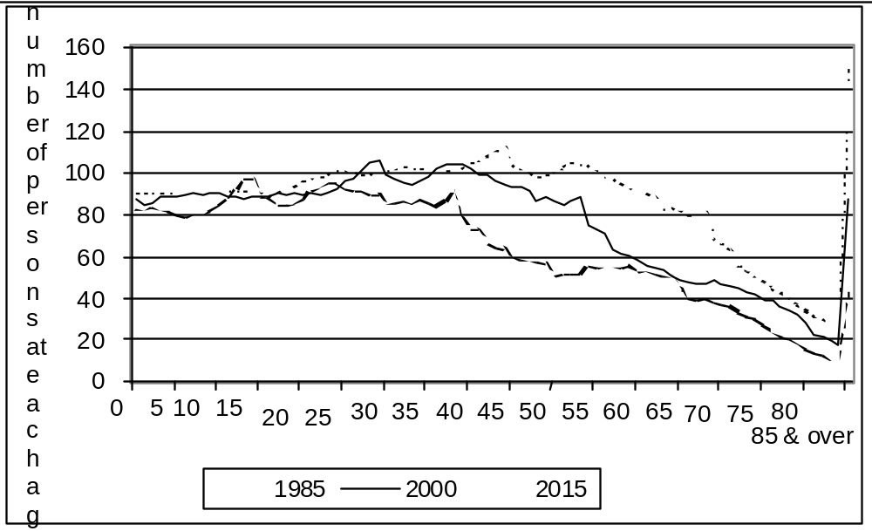
Source: ABS Estimated Resident Population, Population Projections, series 1a

The implications of these trends are that, to maintain the current standard of living over a longer period of retirement, individuals will need to save far more over their lifetimes than they have in the past, and/ or the working population will have to provide income support and health costs for a much higher proportion of older people. Increasing the level of employment among the working age population and encouraging or enabling mature age people to stay in work longer would provide a greater base for both individual saving and for public spending.
The other significant demographic trend is the fall in the proportion of married couples, and a rise in the number of sole parents. This has not yet reduced the proportion of women aged 55 and over who are married because the higher number who are divorced or separated has been offset by falling numbers who are widowed.
However, women of the baby boom cohort and later groups are much more likely to be divorced, separated or never married than earlier cohorts. Data from the 1986 and 1996 censuses found that, in NSW, the baby boomers are almost 50 per cent more likely to be divorced than the group ten years older than them.
Women’s traditional expectation of substantial reliance on a husband for financial security during working age and retirement will not be tenable for a large number in these cohorts. Even for those who are partnered, their position is made more insecure as men’s employment becomes less secure. Divorced or separated women are usually less well provided for by their former partners than are widows.
Women’s lifetime earnings and savings are rising, but not sufficiently for many to avoid relative poverty during a long period of retirement.

Labour market trends — overview
In August 2000, among mature age people in NSW, three-quarters of those aged 45-54 were employed but only 45 per cent of those aged 55-64 were. Over two-thirds of women aged 45-54 are employed, but only one-third of women aged 55-64 are. Eighty-three per cent of men aged 45-54 are employed, dropping to 70 per cent of 55-59 year olds and 41 per cent of 60-64 year olds. The difference between the age groups is even greater in terms of full-time employment.
Total mature age employment to population ratios have been rising, although the distribution of employment has changed. The falls in male employment have been more than offset by the increase in the proportion of women who are employed. The fastest employment growth has been among female partners of employed men, causing a growing gulf between two income households and households where no one is employed, and a shrinking in the proportion of one-income, two adult families.
Despite the growth in mature age female employment to population ratios and the decline in mature age male employment to population ratios, the employment ratios of women remain well below those of men. However, the big difference in employment ratios between women aged 45-54 and those aged 55-64 is partly due to the fact that the cohort now aged 45-54 has, throughout their working lives, had higher employment levels than the group 10 years older than them. Although women have traditionally retired at a younger age than men, this cohort of women may continue to have higher employment rates than their predecessors. Continued labour force participation will be encouraged by social security policy changes that make income support less accessible for them than it was for the older group. On the other hand, higher levels of employment for women aged between 55 and 64 will only be possible if labour market conditions and other policies are favourable.
Over the last quarter century, labour force participation and full-time employment have fallen for men of all ages, but far more so for mature age men, aged 55-64, and older men, aged 65 and over. Although the rates for these groups seem to have stabilised in recent years, they remain low.
The questions that arise concern labour force dynamics. Are mature age people more likely than younger people to leave jobs, either voluntarily or not? Do mature age people who are out of work behave differently from younger jobless people? Do they have more trouble finding new jobs? The answers to these questions are critical in designing strategies for encouraging and enabling mature age people to remain in employment longer. These questions are addressed in Chapter 3.
We need to recognise the diversity of the mature age group. They are very heterogeneous and the differences in their circumstances are not all to do with age. The differences relate to socio-economic circumstances, ethnicity and region, and also with their life courses — in particular their levels of education and training and the types of work they have done. Some of these issues are addressed in Chapter 4.
The fall in mature age male employment appears to have started with the recession of the mid 1970s and also to have been related to the economic re-structuring and rapid changes in technology of the 1980s. However, in the period since then, the levels of employment up to the age of 65 have not recovered to former levels, despite comparatively strong employment growth for younger age groups.
Do the changes in the economy and the demand for certain types of labour mean that we have to think beyond the particular cohorts who have suffered a loss of employment, to the way we structure our life courses and our careers? It appears that our overall expectations of the career path reflect a time when the process of change was slower than it is now, or is likely to be for the foreseeable future.
It is difficult to distinguish voluntary from involuntary retirement. Those who lose their jobs, or respond to pressure to resign from them, and who subsequently cannot find re-employment are likely to suffer severe financial and psychological distress. Many have not been able to build up sufficient superannuation or other resources to last through a long period of retirement. Many are not psychologically prepared for the loss of social identity and connectedness that can result from premature and unplanned joblessness. On the other hand, for those few who have sufficient financial resources to meet their needs and who welcome the opportunity to follow other interests or contribute through voluntary work, early retirement can be a liberating experience.
From a broader community perspective, the loss of the mature age workforce is economically costly: valuable skills, knowledge and experience are wasted; the economy’s productive potential is not realised as a result of under-utilising a significant proportion of the potential labour force; taxation revenue falls and income support expenditure increases.
While a sizeable proportion of men and women now choose to retire early, on average mature age men and women who do look for work experience a longer period of unemployment than their younger peers. This is despite the fact that mature age people display a higher tendency to give up the search for re-employment and leave the labour force. Many factors contribute to involuntary early retirement:
• a greater reluctance to employ mature age workers during periods of reduced labour market demand;
• structural and technological change combined with a reluctance to re-train among mature age workers;
• a sense among some that mature age people should make way for younger job seekers;
• a belief among some mature age people that they are too old to learn new tricks; and
• reports from some mature age people that they unable to work because of disability or poor health.
In aggregate, these factors lead to reluctant work force departure and early retirement, thus artificially reducing the real level and duration of mature age unemployment.

Labour force trends — men
In Australia in 1970 some 77 per cent of 60-64 year old men were in employment, but by the year 2000, this had fallen to only 43 per cent. Over the same period, the proportion in full-time employment halved from 73 to only 34 per cent; and the proportion in part-time employment doubled from four to eight per cent. For 55-59 year old males, the employment to population ratio fell from 90 to 68 per cent between 1970 and 2000. Their full-time employment to population ratio fell more dramatically from 88 to 60 per cent, while their part-time ratio increased from 3 to 7 per cent.
New South Wales has mirrored the national trends. By August 2000 only 41 per cent of 60-64 year old men were employed — two percentage points below the national figure. Their full-time ratio was only 33 per cent, and their part-time ratio stood at eight per cent. For 55-59 year old males the employment to population ratio had fallen to 70 per cent — two percentage points above the national figure. Only 61 per cent were employed full-time, while their part-time employment to population ratio had increased to 9 per cent.
Since the 1970s, in Australia and NSW, the largest falls in male employment were among teenagers and mature age men. Mature age and older men have experienced falls in their employment ratios each recession and partial recoveries during the upturns. These trends (from 1981) are shown in Figure 2 and Table 1.

Figure 2: Employment to population ratios by age, men – NSW – 1981 to 2000
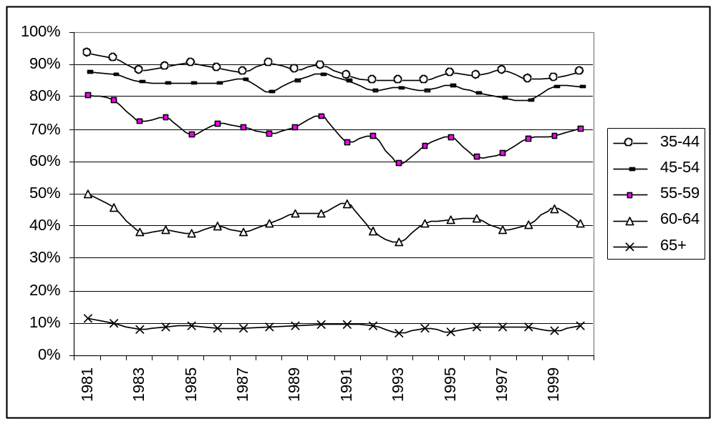
Source: ABS AUSSTATS — Labour force survey data at August — April 2001

For each age group, greater falls in full-time employment have been partly offset by increased part-time employment. It is significant that full-time employment ratios in 1990, at the peak of the 1980s growth cycle, were higher than the ratios in 2000 at the peak of the 1990s growth cycle.
Although there has been a shift from full-time employment to part-time employment among mature age men, it has not been sufficient to provide a replacement source of employment for those who have lost their full-time jobs.

Table 1: Full-time and part-time employment to population ratios – mature age men – NSW – 1981 to 2000
Aged | Status | 1981 | 1985 | 1990 | 1995 | 2000
 |  | % of population
45-54 | Full-time | 85.2 | 81.0 | 83.8 | 80.2 | 77.7
 | Part-time | 2.7 | 3.4 | 3.2 | 3.4 | 5.3
55-59 | Full-time | 76.4 | 65.3 | 68.6 | 61.9 | 61.2
 | Part-time | 4.0 | 3.0 | 5.3 | 5.8 | 8.8
60-64 | Full-time | 46.8 | 32.3 | 37.5 | 32.4 | 32.7
 | Part-time | 3.0 | 5.4 | 6.6 | 9.5 | 8.3
65+ | Full-time | 7.3 | 5.8 | 5.9 | 4.0 | 5.3
Source: ABS AUSSTATS – Labour force survey data at August each year

Among those not employed, mature age men are more likely to be classified as ‘not in the labour force’ than as ‘unemployed’ (see Table 2). The unemployed are defined by the Australian Bureau of Statistics as people who were not employed during the reference week, had actively looked for work and were available for work. It does not include those who would like to work but had not actively looked during that week, and it does not include those who would like to work and looked for a job, but who were unavailable to take up a job offer in that week. These groups, along with those who are fully retired or unable to work, are classified as not in the labour force.
From 1981 to 2000 the proportion of 55-59 year old men who were unemployed remained stable at two per cent (although it increased during recessions), while those not in the labour force increased from 18 to 28 per cent. Over the same period the proportions of 60-64 year old men who were unemployed increased marginally from one to one and a half per cent, while the proportion not in the labour force increased from 49 to 58 per cent.
Table 2: Unemployment and non-participation as a percentage of population – mature age men – NSW – 1981 to 2000
Aged | Status | 1981 | 1985 | 1990 | 1995 | 2000
 |  | % of population
45-54 | Unemployed | 2.4 | 4.9 | 2.6 | 3.7 | 3.3
 | Not in labour force | 4.4 | 5.3 | 6.7 | 6.6 | 8.3
55-59 | Unemployed | 2.0 | 7.1 | 2.9 | 5.0 | 1.8
 | Not in labour force | 17.5 | 24.6 | 23.2 | 27.2 | 28.2
60-64 | Unemployed | 0.9 | 3.6 | 3.4 | 3.5 | 1.5
 | Not in labour force | 49.3 | 58.7 | 52.6 | 54.6 | 57.6
65+ | Unemployed | 0.3 | 0.3 | 0.2 | 0.0 | 0.3
 | Not in labour force | 88.1 | 90.7 | 90.3 | 92.8 | 90.4
Source: ABS AUSSTATS, 2001 – Labour force survey data at August each year

Labour force trends - women
Women’s employment trends and patterns have been quite different from those of their male peers. Women are much more likely to work part-time, but both part-time and full-time employment have increased among mature age women. The majority of the growth has been in part-time work with a slower growth in full-time work. While their employment ratios are still lower than those of men, and women still retire earlier than men, women do not seem to share the trend to earlier retirement. It seems likely that their employment ratios will continue to increase as the baby boom cohort, with its higher levels of employment, moves into the older age ranges.
The employment growth has been far greater among married women than among single women. In fact the full-time employment rate for single women fell over the period from 1970 to 2000, largely due to the growth in the number of sole parents. The available data for NSW does not provide employment status by age by marital status. However, it would be expected that similar trends would have occurred in NSW.
Looking first at the national data, the employment to population ratio for 45-54 year old women rose from 41 per cent in 1970 to 67 per cent in 2000, with full-time employment increasing from 24 per cent to 40 per cent and part-time employment from 14 per cent to 28 per cent.
Among 55-59 year old women, the employment ratio almost doubled from 25 per cent in 1970 to 46 per cent in 2000. Most of this has been due to the increase in their part-time employment ratio from 9 to 23 per cent, while the proportion in full-time employment increased from 18 to 23 per cent.
The increase has been less significant for 60-64 year old women, reflecting the age pension eligibility age. Their employment to population ratio increased from 16 per cent in 1970 to 21 per cent in 2000. The proportion employed full-time fell from 10 per cent to 6 per cent in the early 1980s before recovering to 9 per cent in 2000; while the proportion in part-time employment doubled from 6 to 12 per cent.
New South Wales mature age women’s employment to population ratios have mirrored the national trends (see Figure 3 and Table 3).
Between 1981 and 2000, the employment ratio for 45-54 year old women in NSW rose from 47 to 67 per cent. Their full-time employment increased from 27 to 43 per cent, while their part-time ratio increased more slowly from 20 to 25 per cent.
For 55-59 year old women in NSW, total employment increased from 29 to 45 per cent. Increases were from 16 to 23 per cent for full-time and from 14 to 22 per cent for part-time employment. Employment ratios for 60-64 year old women increased more slowly, from 13 per cent to 19 per cent, comprising increases from 6 to 8 per cent for full-time employment and from 7 to 11 per cent for part-time employment.

Figure 3: Employment to population ratios by age – women – NSW – 1981 to 2000
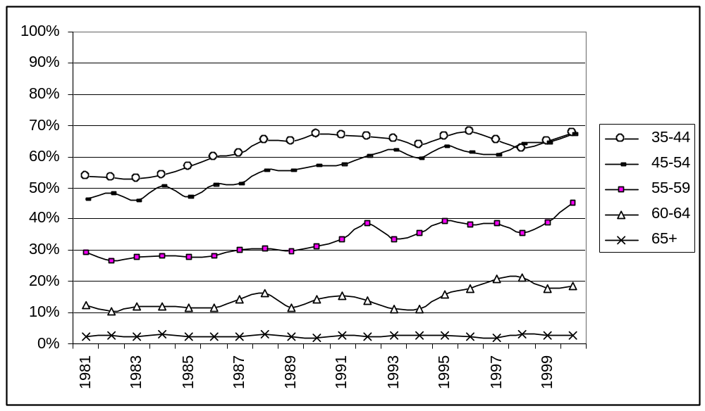
Source: ABS AUSSTATS – Labour force survey data at August each year

The baby boom cohort is likely to continue to have higher rates of full-time employment than the cohort before them. The probability of this occurring is increased by the decision to raise the pension eligibility age for women and to phase out various payments for partners and widows.
Table 3: Full and part-time employment – mature age women - NSW - 1981 to 2000
Aged | Status |  | 1981 | 1985 | 1990 | 1995 | 2000
 |  |  | % of population
45-54 | Full-time |  | 26.6 | 28.5 | 35 | 39.1 | 42.8
 | Part-time |  | 19.9 | 18.7 | 22.2 | 24.2 | 24.5
55-59 | Full-time |  | 15.9 | 17.8 | 15.9 | 21.4 | 23.3
 | Part-time |  | 13.5 | 10.2 | 15.1 | 18.1 | 22
60-64 | Full-time |  | 5.9 | 5.9 | 7.3 | 7 | 8
 | Part-time |  | 6.5 | 5.9 | 6.9 | 9 | 10.5
65+ | Full-time |  | 1.1 | 0.8 | 0.6 | 0.9 | 0.6
 | Part-time |  | 1.3 | 1.4 | 1.4 | 1.8 | 2.1
Source: ABS AUSSTATS – Labour force survey data at August each year

Mature age jobless women are even less likely to be classified as unemployed than their male counterparts (see Table 4). The proportions of 45-54 and 55-59 year old women who were unemployed have grown over the last two decades from 1 to 2 per cent and from 0.5 per cent to 2 per cent respectively.
Table 4: Unemployment and non-participation as a percentage of population – mature age women - NSW - 1981 to 2000
Age | Status | 1981 | 1985 | 1990 | 1995 | 2000
 |  | % of population
45-54 | Unemployed | 0.8 | 2.8 | 2.1 | 2.9 | 2.3
 | Not in labour force | 52.7 | 50.0 | 40.7 | 33.7 | 30.4
55-59 | Unemployed | 0.4 | 0.9 | 1.1 | 1.0 | 1.6
 | Not in labour force | 70.1 | 71.1 | 67.8 | 59.5 | 53.1
60-64 | Unemployed | 0.3 | 0.0 | 0.4 | 0.7 | 0.0
 | Not in labour force | 87.3 | 88.3 | 85.5 | 83.3 | 81.5
65+ | Unemployed | 0.0 | 0.1 | 0.0 | 0.0 | 0.0
 | Not in labour force | 97.6 | 97.7 | 97.9 | 97.3 | 97.3
Source: ABS AUSSTATS – Labour force survey data at August each year

Under-employment and disappointed job seekers
As well as the more traditional categories of labour force status described above (full-time and part-time employed, unemployed and not in the labour force), the ABS Labour Force Survey collects data on under-employment and on people ‘not in the labour force’ as conventionally measured but who would like to work. While this data is not available for NSW, the national data can be taken as indicative.
Table 5 shows under-employed workers — those who would prefer to work longer hours than they do — as a percentage of part-time workers. Mature age part-timers are much less likely to prefer more hours of work than their younger peers, but men of all age groups are more likely than women to want more hours. These figures reflect women’s pattern of combining paid work and unpaid domestic and caring work. The comparison of 25-34 and 55-59 year old males’ incidence of under-employment — 47 and 27 per cent respectively — suggests that mature age men are more inclined to accept part-time employment, as a stepping stone towards retirement. But it should be noted that over a quarter of men and an eighth of women aged 55-59 who work part-time do so reluctantly and would prefer more work.
Table 5: Part-time workers who would prefer more hours – by age and sex – Australia – September 1998
 | 15-19 | 20-24 | 25-34 | 35-44 | 45-54 | 55-59 | 60-64 | 65+ | Total
 | % of part-time workers
Males | 26.5 | 40.8 | 47.2 | 45.7 | 39.5 | 26.6 | 14.8 | 2.1 | 33.2
Females | 19.8 | 34.8 | 17 | 16.2 | 17.2 | 12.5 | 7 | 4.3 | 18.1
Source: ABS, Under-employed workers, Cat. 6265.0 – Sept 1998 – Table 4

Table 6 shows people who wanted to work although they were recorded as not in the labour force. This includes those who were ‘marginally attached’, that is, wanted to work and were available to start work but were either not currently looking or were looking but not in the week they were interviewed. It also includes those who said they wanted to work but were not available to start within four weeks. 1998 data shows that 46 per cent of 45-54 year old men and 37 per cent of men aged 55-59 year old men who were not in the labour force actually wanted to work and were available to start work. For women the proportions were lower — 34 per cent for 45-54 year olds and 17 per cent for 55-59 year olds.
Table 6: Not in the labour force, wanted to work – by sex and age – Australia – September 1998
 | 15-19 | 20-24 | 25-34 | 35-44 | 45-54 | 55-59 | 60-64 | 65+ | Total
 | % of those not in the labour force
Males | 48.4 | 48.7 | 57.0 | 56.7 | 45.4 | 36.8 | 20.2 | 10.8 | 35.8
Females | 44.7 | 54.3 | 58.2 | 53.5 | 34.4 | 17.3 | 9.7 | 5.4 | 35.7
Source: ABS, Persons not in the Labour Force, Cat 6220.0, September 1998

Summary
Figures 4 and 5 summarise the labour market position of mature age men and women in 2000 in NSW, applying the proportions from the 1998 Australian data in Tables 5 and 6 to the NSW population and labour force data of 2000. Despite a clear trend towards reluctant or willing early retirement, the proportion of men who are under-employed or not working, but would like to work more, remains high through to the age of 65. The proportion of women in this situation remains high to the age of 60.
Taking the broadest definitions, it is estimated that in NSW in August 2000, 131,000 men and 131,000 women aged 45 and over wanted more work than they had available. Nearly three quarters of these were people who were not in the labour force but said they wanted to work. While the recorded unemployment rate is not high in comparison to other age groups, mature age people who are unemployed have the highest rate of long term unemployment (more than 12 months) — 46 per cent of unemployed 45-54 year olds and 48 per cent of unemployed 55-64 year olds had been unemployed for over twelve months in May 2000 (DEWRSB 2000c).
It may be assumed that employment ratios among mature age women will continue to rise, in both full-time and part-time work, both because of the high labour force attachment of younger cohorts and because of tightening of access to income support.
Male employment is currently stable, but on recent trends their part-time employment is more likely to increase than their full-time employment. As early retirement becomes normalised, new generations of men with higher superannuation assets might be more inclined to leave the labour force voluntarily from the age of 55, and employers may be even less inclined to recruit mature age employees.
Even if employment rates remain stable, the absolute numbers of mature age people not employed will rise because of population ageing. Labour shortages can be predicted in some areas of employment, although these are most likely to occur among the higher skilled.

Figure 4: Estimated labour market position by age group – men – NSW – August 2000
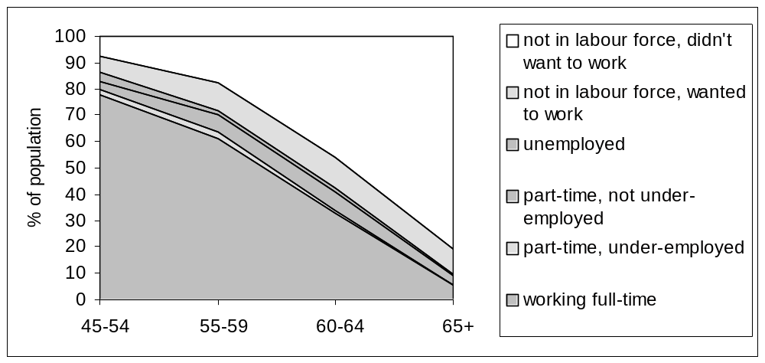
Source: ABS Labour Market Survey data, August 2000 (AUSSTATS), ABS, Under-employed workers, Cat. 6265.0 – September 1998, ABS, Persons not in the Labour Force, Cat 6220.0, September 199

Figure 5: Estimated labour market position by age group – women – NSW – August 2000
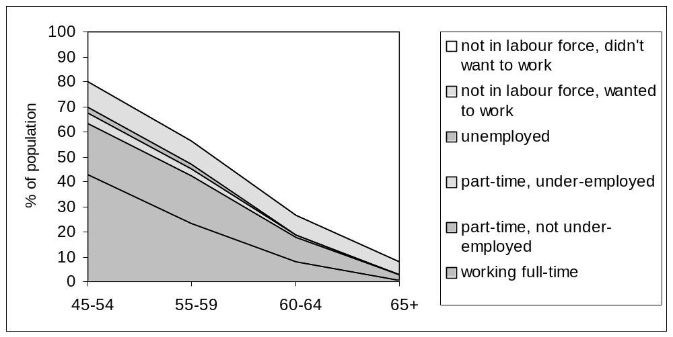
Source: ABS Labour Market Survey data, August 2000 (AUSSTATS), ABS, Under-employed workers, Cat. 6265.0 – September 1998, ABS, Persons not in the Labour Force, Cat 6220.0, September 1998

3 Labour force dynamics
In trying to understand the dynamics of early exit there are a number of key issues and questions:
• Are mature age people more likely to involuntarily lose their jobs than prime age people?
• Are they more likely to have to leave for reasons of poor health or injury?
• Are they more likely to have to leave to assume caring responsibilities?
• Are they more likely to leave their jobs voluntarily to change jobs?
• When they are out of work, are they less likely to search for work than younger people?
• If they do seek work, are they less likely to be successful in finding it?
The answers to these questions are of vital importance in finding the most effective strategies to increase employment rates among mature age people.

Job leaving
From the age of fifty, employees are more likely than younger workers to lose or leave a job (ABS, Survey of Employment and Unemployment Patterns, 1997) and the older the person, the less likely he or she is to return to employment after leaving a job. The reasons for job departure include leaving to change jobs, retrenchment or redundancy, ill health or disability, to assume family/caring responsibilities, to retire or a number of other factors.
First, mature workers are less likely to change jobs than younger workers. In the year to February 2000, 27 per cent of employed 20-24 year old men left their job to secure another. This rate declined for successive age groups, with only seven per cent of 55-69 year old men leaving to change jobs. The pattern was similar for women, with 26 per cent of 20-24 year olds and only five per cent of 55-69 year olds leaving their jobs for another (ABS Cat. 6209.0, Feb 2000).
Second, ABS data (Cat. 6266.0, 1997) during the three years to July 1997 indicate that male retrenchment and redundancy rates are at their minimum among workers aged 35-44, and are significantly higher for both 15-24 and 55-64 year olds. The retrenchment rate was 9 per cent for 35-44 year olds, and 13 per cent for 18-24 and 55-64 year olds. Young workers were more likely to experience multiple retrenchments, while mature age workers who were retrenched were far less likely to find a new job at all. Women had a far lower retrenchment rate than men at all ages and their retrenchment rates were not as strongly age related, fluctuating between six and seven per cent for the age groups between 18 and 54, and rising to nine per cent for 55-64 year olds.
These ABS data relate to three years during the recovery phase of the trade cycle, and may present a different picture for retrenchment rates and patterns during a recession.
Table 7 is drawn from a national survey of 5,548 people aged 45-69, commissioned by the Department of Family and Community Services in 2000. A third of the men and 29 per cent of the women had left a job or entered employment within the previous five years, some now being re-employed or self employed and some not. The remainder had either been in the same job or self employed for 5 years or more or had not worked in the last 5 years.
Table 7: Labour force movement over 5 years – men and women aged 45-69 – Australia
Men | 45-49 | 50-54 | 55-59 | 60-64 | 65-69 | Total
 | % of sample in each age group
Same employer more than 5 years | 40.2 | 34.8 | 23.9 | 14.1 | 4.9 | 27.0
Self employed more than 5 years | 20.4 | 26.5 | 21.1 | 16.0 | 10.8 | 20.1
Changed status or job in last 5 years
now employed | 21.2 | 13.7 | 16.0 | 7.2 | 3.4 | 13.7
now self employed | 5.5 | 5.0 | 3.3 | 2.7 | 1.2 | 3.9
now not employed | 6.1 | 9.5 | 19.5 | 26.9 | 25.9 | 15.4
Total changed in last 5 years | 32.8 | 28.2 | 38.8 | 36.7 | 30.6 | 33.1
Has not worked in last 5 years | 6.6 | 10.5 | 16.2 | 33.2 | 53.7 | 19.9
Total | 100.0 | 100.0 | 100.0 | 100.0 | 100.0 | 100.0
Women | 45-49 | 50-54 | 55-59 | 60-64 | 65-69 | Total
 | % of sample in each age group
Same employer more than 5 years | 40.1 | 38.1 | 31.1 | 9.0 | 6.1 | 28.6
Self employed more than 5 years | 8.3 | 10.3 | 8.6 | 6.8 | 4.4 | 7.8
Changed status or job in last 5 years
now employed | 28.5 | 17.5 | 8.8 | 5.9 | 2.6 | 15.1
now self employed | 3.0 | 3.1 | 2.0 | 1.4 | 0.3 | 2.0
now not employed | 7.4 | 9.5 | 16.4 | 19.8 | 12.9 | 12.3
Total changed in last 5 years | 39.0 | 30.0 | 27.3 | 27.1 | 15.8 | 29.4
Has not worked in 5 years | 12.6 | 21.5 | 33.1 | 57.1 | 73.7 | 34.1
Total | 100.0 | 100.0 | 100.0 | 100.0 | 100.0 | 100.0
Sample size | 1174 | 1261 | 1194 | 1202 | 717 | 5548
Source: FaCS Survey, 2000, unpublished data

Table 7 shows that, apart from particular stability in the 50-54 year old group, the likelihood of men leaving their jobs does not change very much with age. The big difference with age is the decreasing probability of becoming re-employed after leaving a job, so that the jobless numbers accumulate with age.
Mobility among women decreases with age but the effect of age on the falling probability of re-employment is greater among women than among men. This is partly due to their reasons for leaving jobs (see below).
A higher proportion of men than women are self employed. Self employment tends to be more stable than being a wage or salary earner. There is not a great deal of evidence of people moving from being employed to self employment. In fact many seem to move the other way.

Reasons for leaving
Those who had left a job or self employment in the previous 5 years were asked their reasons for leaving and these have been grouped (Table 8). The figures in Table 8 are based on the reasons given by men and women in each age group for leaving or losing a job in the last 5 years. These are shown as a percentage of all reasons given. Some people gave more than one reason.
Table 8: Men and women who left a job less than 5 years ago - reason by age – Australia 2000
Men | 45-49 | 50-54 | 55-59 | 60-64 | 65-69 | Total
 | % of responses
Retrenched/redundant | 23.7 | 28.3 | 25.9 | 26.9 | 6.5 | 23.4
Job loser - other | 24.7 | 28.9 | 16.5 | 17.9 | 17.4 | 21.3
Left to change jobs | 26.3 | 21.7 | 12.7 | 3.0 | 1.1 | 14.9
Ill-health/disability | 10.5 | 10.5 | 19.6 | 27.6 | 17.4 | 16.4
Family/caring reasons | 2.1 | 2.6 | 1.3 | 6.0 | 3.3 | 2.9
To retire | 0.0 | 0.0 | 15.8 | 23.1 | 53.3 | 14.5
Other job leavers | 20.5 | 27.6 | 17.7 | 11.2 | 16.3 | 19.4
Number | 190 | 152 | 158 | 134 | 92 | 726
Women | 45-49 | 50-54 | 55-59 | 60-64 | 65-69 | Total
 | % of responses
Retrenched/redundant | 8.5 | 11.0 | 12.8 | 9.2 | 9.8 | 10.1
Job loser - other | 21.8 | 21.2 | 21.1 | 20.7 | 19.6 | 20.8
Left to change jobs | 33.0 | 27.4 | 10.1 | 4.6 | 2.0 | 20.3
Ill-health/disability | 9.0 | 16.4 | 24.8 | 18.4 | 15.7 | 16.0
Family/caring reasons | 10.1 | 13.0 | 11.0 | 18.4 | 11.8 | 12.4
To retire | 2.7 | 2.1 | 9.2 | 33.3 | 49.0 | 12.5
Other job leavers | 33.5 | 25.3 | 20.2 | 14.9 | 19.6 | 24.9
Number | 188 | 146 | 109 | 87 | 51 | 582
Source: FaCS Survey, 2000, unpublished data
Notes: Reasons are shown as percentages of those who had left a job in the previous five years in each age and sex category. The reasons for leaving sum to more than 100% because some respondents gave multiple reasons.
The number of respondents has been weighted to reflect population by age and sex.
Of the reasons given by 45-69 year old men for leaving a job, 45 per cent were because of job loss. This covered retrenchment and redundancy, dismissal, business failure, downsizing, restructuring, short term contract, or business moving. Sixteen per cent left because of ill-health or disability. This was more common among the men aged 55-64 than among those aged 45-54.
Fifteen per cent retired and 15 per cent left to change jobs. The proportion identifying job change fell with age (from 19 per cent for 45-49 year olds to 3 per cent for 60-64 and 65-69 year olds). No men aged under 55 and only 16 per cent of those aged 55-59 said they had left a job to retire.
Family and caring responsibilities were identified as factors by only three per cent of men.
As a group, 45-69 year old women were less likely than men to have lost their jobs, rather than leaving voluntarily, over the five year period (30 per cent of women).
Women more commonly gave family and caring responsibilities as a reason for leaving work than did men (12 per cent compared with 3 per cent). Ill health or disability peaked as an identified factor among 55-59 year old women (25 per cent), and it was identified by the same proportion of men and women overall (16 per cent). Fewer women overall gave retirement as a reason for leaving employment, but traditional retirement age was not as significant for women as for men.

Job search experience
Less prolonged, less effective and less successful job searching are often identified as factors contributing to the above average unemployment duration and higher rates of labour market exit among mature age workers. It is therefore important to identify the extent to which these contentions are supported by the available evidence.
ABS (Cat. 6266.0) data on the labour force position of men and women retrenched during the three years to July 1997 throw light on these issues (see Table 9). For the age groups from 25-54, most of those retrenched were employed at the end of the period, under a third were unemployed and relatively few (8 to 10 per cent) were not in the labour force. However, for 55-64 year old men, only a third were employed in July 1997, 30 per cent were unemployed and over a third had left the labour force.
Table 9: Men and women retrenched or made redundant in previous three years – status at July 1997 – age group – Australia
 | 18-24 | 25-34 | 35-44 | 45-54 | 55-64 | Total
Males | % of those who had been retrenched
employed | 46.9 | 60.4 | 64.6 | 58.4 | 33.4 | 55.2
unemployed | 47.6 | 31.9 | 27.4 | 31.6 | 29.5 | 33.6
not in the labour force | 5.6 | 7.7 | 8.1 | 10.0 | 37.1 | 11.2
total retrenched | 100.1 | 100.0 | 100.1 | 100.0 | 100.0 | 100.0
Number ('000) | 90.7 | 130.9 | 101.7 | 92.3 | 53.6 | 469.2
Females | % of those who had been retrenched
employed | 52.5 | 57.1 | 56.4 | 55.7 | 30.2 | 53.6
unemployed | 32.2 | 19.1 | 18.9 | 15.4 | 6.4 | 19.8
not in the labour force | 15.4 | 23.8 | 24.6 | 28.9 | 63.4 | 26.6
total retrenched | 100.0 | 100.0 | 100.0 | 100.0 | 100.0 | 100.0
Number ('000) | 42.3 | 60.1 | 49.1 | 47.4 | 17.2 | 216.1
Source: ABS, Retrenchment and Redundancy, Catalogue 6266.0, July 1997

Of the women who were retrenched, over half of those aged 25-54 years were employed at the end of the three year period, and this proportion fell to less than a third for 55-64 year olds. Nineteen per cent of 25-44 year old women were unemployed, and around a quarter were no longer in the labour force. For 45-54 year olds, the proportion who were unemployed fell to 15 per cent and those not in the labour force increased to 29 per cent. Only 6 per cent of retrenched 55-64 year olds were unemployed and almost two-thirds were not in the labour force.
In summary, mature age men who had been retrenched were increasingly less likely to be employed and increasingly more likely to not be in the labour force, with a larger proportion to 55-64 year olds out of the labour force than in employment. Prime age retrenched women were almost as likely as their male peers to be employed at the end of the three year period, but much less likely to be unemployed and three times more likely to have departed from the labour force. Similarly, retrenched mature age women were almost as likely to be employed as their male peers, were much less likely to be unemployed and much more likely to have left the labour force.
The 1998 ABS publication, Successful and Unsuccessful Jobseekers (Cat. 6345.0), provides age group breakdowns of unsuccessful (not employed) outcomes and successful (employed) outcomes and divides the latter group into those job seekers who were employed and those who were not employed while they sought an alternative/new job.
The data demonstrate that, as job seekers’ age increased, the likelihood of successful job search fell. Among 55-64 year old job seekers, only around 45 per cent secured employment, compared with over 60 per cent success for job seekers aged from 25-44 and just under 60 per cent for 45-54 year olds.
Table 10 uses data from the FaCS survey previously referred to, and shows the probability of re-employment for men and women by the various reasons for leaving jobs. This is the percentage of those who had left or lost a job or self employment in the last 5 years who were employed or self employed at the time of the survey, rather than being out of work. It presents a picture similar to that provided by ABS data, but provides a more detailed breakdown, both by age group and by reason for leaving the last job.
Table 10: Men and women who left a job less than 5 years ago - probability of re-employment by reason and age – Australia 2000
Men | 45-49 | 50-54 | 55-59 | 60-64 | 65-69 | Total
 | % of those who had left a job
Retrenched/redundant | 71.1 | 69.8 | 34.1 | 22.2 | 16.7 | 50.0
Job loser - other | 76.6 | 52.3 | 46.2 | 25.0 | 31.3 | 54.2
Left to change jobs | 98.0 | 87.9 | 100.0 | 100.0 | 0.0 | 94.4
Ill-health/disability | 30.0 | 18.8 | 9.7 | 8.1 | 0.0 | 12.6
Family/caring reasons | 75.0 | 0.0 | 0.0 | 0.0 | 0.0 | 14.3
To retire | .. | .. | 32.0 | 25.8 | 4.1 | 17.1
Other job leavers | 84.6 | 69.0 | 64.3 | 40.0 | 13.3 | 63.8
Total | 78.9 | 62.5 | 43.7 | 23.9 | 8.7 | 48.8
Number re-employed | 150 | 95 | 69 | 32 | 8 | 354
Women | 45-49 | 50-54 | 55-59 | 60-64 | 65-69 | Total
 | % of those who had left a job
Retrenched/redundant | 75.0 | 75.0 | 28.6 | 12.5 | 0.0 | 49.2
Job loser - other | 73.2 | 58.1 | 26.1 | 27.8 | 10.0 | 49.6
Left to change jobs | 95.2 | 100.0 | 100.0 | 100.0 | 100.0 | 97.5
Ill-health/disability | 23.5 | 4.2 | 7.4 | 12.5 | 25.0 | 11.8
Family/caring reasons | 36.8 | 36.8 | 33.3 | 12.5 | 33.3 | 29.2
To retire | 0.0 | 33.3 | 10.0 | 6.9 | 16.0 | 11.0
Other job leavers | 76.2 | 78.4 | 40.9 | 23.1 | 50.0 | 63.4
Total | 73.4 | 61.0 | 33.9 | 18.4 | 15.7 | 49.5
Total re-employed | 138 | 89 | 37 | 16 | 8 | 288
Source: FaCS Survey, 2000, unpublished data
Note: Sample sizes, particularly in the age groups aged 55 and over were small so percentages should be treated as indicative only

Regardless of the reason for leaving a job, the older a person was, the less likely he or she was to become re-employed.
As might be expected, those men who had left to change jobs or seek another job were the most likely to be employed at the time of the survey, followed by those who had left for other voluntary reasons. Those who had lost jobs or were retrenched or made redundant were less likely to get a job than those who had left voluntarily. Those who had left because of ill-health or disability were the least likely to be employed.
Women who left to change jobs had almost the same chance as a man did of being employed. However, women who left for other reasons were less likely to return. Those who left for illness or disability were the least likely to return, and the rate of return was also low for those who left for family or caring reasons.
Men who had retired were often employed at the time of the survey, while this was rare among women. It may be that ‘retirement’ means different things to men and women. For men it might mean retirement from a career job and a move into more casual or part-time employment. Others may leave their job with the intention of retiring, but then reverse that decision at a later stage. For women it seems to mean retirement from any employment.
The FaCS survey asked respondents aged 45-69 who had looked for a job what action they had taken. The top five methods were (1) looking at advertisements, (2) personal networks, friends, word of mouth, (3) Job Network, Centrelink, CES; (4) calls, letters, cold canvass, contact and (5) another employment agency. Only 5 per cent used the Internet, and not surprisingly they tended to be the younger age groups.
Of those who had looked for employment, those who were employed at the time of the survey period were more likely to have sought opportunities through word of mouth than those who were still unemployed or who had left the labour force. Reinforcing this point, successful job seekers placed much less reliance on Job Network/CES or direct canvassing than unsuccessful job seekers.
When those who had been successful were asked how they had obtained a job (see Table 11), the top two methods were word of mouth and the Internet (25 per cent of responses each) with word of mouth being particularly important for older men. Answering advertisements and direct canvassing were next in importance. Only six per cent found their jobs through Job Network and another six per cent found theirs through other agencies. Job Network was a more important source of work for the oldest groups than for the younger ones, while other agencies were less so.
Table 11: Source of current jobs – men and women who had become employed or self-employed in last 10 years – Australia, 2000
Males | 45-49 | 50-54 | 55-59 | 60-64 | 65-69 | Total
 | % of those who had found work in last 10 years
Advertisements | 11.6 | 9.9 | 9.4 | 10.3 | 13.3 | 10.3
Approached employers | 8.4 | 8.5 | 3.1 | 3.4 | 6.7 | 6.2
CES | 0.0 | 0.0 | 0.0 | 0.0 | 0.0 | 0.4
Employment National | 2.1 | 0.0 | 12.5 | 0.0 | 0.0 | 2.5
Job Network/C’link facilities | 0.0 | 0.0 | 0.0 | 0.0 | 0.0 | 0.8
Recruitment/Employment Agency | 5.3 | 4.2 | 3.1 | 3.4 | 6.7 | 4.5
Internet | 33.7 | 32.4 | 12.5 | 10.3 | 6.7 | 25.5
Networks/friends/Word of mouth | 6.3 | 11.3 | 21.9 | 10.3 | 26.7 | 11.5
Self employed/Own business | 0.0 | 12.7 | 12.5 | 10.3 | 6.7 | 7.0
Training/retraining/other field | 0.0 | 0.0 | 6.3 | 0.0 | 6.7 | 1.2
Employers approached me | 0.0 | 0.0 | 0.0 | 3.4 | 6.7 | 1.2
Old employer asked me back | 5.3 | 2.8 | 0.0 | 10.3 | 0.0 | 4.1
Approached by friend/colleague | 10.5 | 8.5 | 12.5 | 17.2 | 6.7 | 10.7
Started my own business | 5.3 | 2.8 | 0.0 | 0.0 | 0.0 | 2.9
Other | 10.5 | 8.5 | 6.3 | 24.1 | 20.0 | 11.1
Total respondents | 95 | 71 | 32 | 29 | 15 | 243
Females | 45-49 | 50-54 | 55-59 | 60-64 | 65-69 | Total
 | % of those who had found work in last 10 years
Advertisements | 14.4 | 5.6 | 12.9 | 14.3 | 8.3 | 11.2
Approached employers | 3.1 | 8.5 | 3.2 | 21.4 | 0.0 | 5.4
CES | 0.0 | 0.0 | 0.0 | 0.0 | 0.0 | 0.4
Employment National | 7.2 | 5.6 | 3.2 | 0.0 | 0.0 | 5.4
Job Network/C’link facilities | 0.0 | 0.0 | 0.0 | 0.0 | 0.0 | 0.0
Recruitment/Employment Agency | 5.2 | 7.0 | 0.0 | 7.1 | 0.0 | 5.4
Internet | 32.0 | 28.2 | 12.9 | 7.1 | 0.0 | 25.4
Networks/friends/Word of mouth | 7.2 | 4.2 | 9.7 | 7.1 | 0.0 | 6.7
Outplacement service | 0.0 | 0.0 | 0.0 | 0.0 | 0.0 | 0.0
Self employed/Own business | 0.0 | 0.0 | 0.0 | 0.0 | 0.0 | 0.0
Training/retraining/other field | 0.0 | 0.0 | 0.0 | 0.0 | 0.0 | 0.0
Employers approached me | 3.1 | 2.8 | 12.9 | 0.0 | 0.0 | 4.0
Old employer asked me back | 4.1 | 2.8 | 3.2 | 7.1 | 33.3 | 5.4
Approached by friend/colleague | 5.2 | 23.9 | 16.1 | 0.0 | 58.3 | 15.2
Started my own business | 4.1 | 0.0 | 0.0 | 0.0 | 0.0 | 1.8
Other | 14.4 | 9.9 | 16.1 | 35.7 | 0.0 | 14.3
Total respondents | 97 | 71 | 31 | 14 | 12 | 224
Source: FaCS Survey, 2000, unpublished

Finally, how many workers of each age group leave the labour force? And do they leave the labour force straight from work, or do they look for work before leaving?
Table 12 shows the probability of prime and mature age men and women leaving the labour force in the twelve months to September 1994 (the most recent data available). The proportion of men leaving is very low, at 2 to 3 per cent, for 35-54 year olds, but it doubles to 6 per cent for 55-59 year olds and then more than doubles to 15 per cent for 60-64 year olds. The proportion of women leaving the labour force is 8 to 9 per cent for 35-54 year olds, jumping to 14 and 18 per cent for 55-59 and 60-64 year olds respectively. Between a third and half of those leaving the labour force are unemployed before they leave, except for those over age pension age.
Table 12: Leaving the labour force – exit rate over 12 months by age and whether unemployed before exit – Australia – 1994
Males | 35-44 | 45-54 | 55-59 | 60-64 | 65-69 | Total
Exits as % of labour force at Sep 1993 | 2.3 | 2.8 | 6.2 | 15.4 | 17.7 | 8.4
% unemployed before exit | 51.7 | 45.7 | 34.5 | 46.3 | 33.6 | 70.5
Females | 35-44 | 45-54 | 55-59 | 60-64 | 65-69 | Total
Exits as % of labour force at Sep 1993 | 9.3 | 8.4 | 14.1 | 18.4 | 11.6 | 12.0
% unemployed before exit | 49.6 | 50.4 | 44.1 | 24.5 | 0.3 | 49.1
Source: ABS Catalogue 6267.0.40.001, September 1994, Persons who have left the labour force in the previous 12 months (to September 1994)

Summary
In summary, in answer to the questions posed at the beginning of this chapter about why so many mature age people are out of work, compared with prime age people, available statistical evidence indicates that:
• Mature age men are only slightly more likely to leave or lose a job than are younger men and mature aged women are less likely to lose or leave a job than younger women. However, those who do leave or lose a job are far less likely to become re-employed. Women aged 45-54 who lose jobs are more likely to become re-employed than are men, while women aged 55-59 are far less likely to become re-employed than are men.
• Mature age men and women are unlikely to voluntarily leave their employment to change jobs, and less likely to do so than are prime age men and women.
• Mature age men and women are more likely to leave their jobs for reasons of ill-health or disability than those under the age of 55.
• Mature age men are not more likely to leave their job to assume family caring responsibilities, but mature age women are more likely to do so and much more likely to do so than their male peers.
• Mature age men begin to retire from the age of 55, but often this is phased retirement. Women are less likely to describe their departure from the labour force as retirement, but when they do it is more likely to mean complete retirement from paid work.
• Mature age men and women are more likely than younger people to leave the labour force directly from a job and less likely to be unemployed before leaving.
• Mature age men and women who are retrenched or made redundant are less likely to secure reemployment than their prime age peers.
• Mature age unemployed men and women are likely to experience longer periods of unemployment.
• The most common methods of job search among mature age job seekers are checking and responding to advertisements, personal networks and word of mouth, the Job Network and direct canvassing.
• The most effective methods of job search for mature age job seekers are personal networks and word of mouth, the Internet, answering advertisements and direct canvassing.
• Very small minorities of mature age job seekers use the Internet, and very few report that they secured employment through the Job Network.

4 Characteristics of early exit

Education and training
While many anecdotes in the media draw attention to older white collar workers and managers who have lost their jobs and found themselves unable to find another, Australia-wide data suggest that mature age joblessness is correlated with low skill and education levels. At all ages, those with higher levels of educational attainment are more likely to be in work.
Furthermore, the growth in education participation since the late 1960s has meant that each succeeding cohort has higher education levels than the previous one. Among those currently aged 55-64, 43 per cent of men and 60 per cent of women did not complete high school or gain formal post school qualifications. By contrast, only 28 per cent of men and 32 per cent of women in the 25-34 years cohort were in this position. The younger cohort is more than twice as likely as the mature age cohort to have a degree.
Figures 6 and 7 show the probability of being in work for men and women of different ages and education. Of those aged 55-64 who did not finish school or obtain post school qualifications, only 50 per cent of men and 24 per cent of women are employed, compared with 67 per cent of men and 69 per cent of women of that age with a degree.
Men aged 55-64 are less likely to be employed than prime age men with the same qualifications, but their total employment levels are made worse by the fact that their education levels have not been as high as younger cohorts. The education gap is even more significant for women. Mature age women with skilled vocational qualifications are an anomaly to the general pattern. They have the lowest employment rates in the group aged 55-64. The difference in education accounts for slightly over half the difference in total employment between men aged 45-54 and those aged 55-64, and eighty per cent of the difference between women aged 45-54 and those aged 55-64.
Education can hamper or improve employment chances in two ways. First, it provides people with the formally recognised skills and knowledge to perform the tasks of the modern workplace. Thus, the higher education level of each succeeding cohort would be expected to lead to higher levels of employment in the future.
The second factor is ‘credentialism’, that is, the use of formal qualifications as a criterion for sorting job applicants, regardless of whether those qualifications are essential to the job. Where employers use credentialism, mature age people will continue to be at a disadvantage in competition with ever more qualified younger groups.

Figure 6: Employment to population ratios by age and educational attainment – men – Australia – May 1998
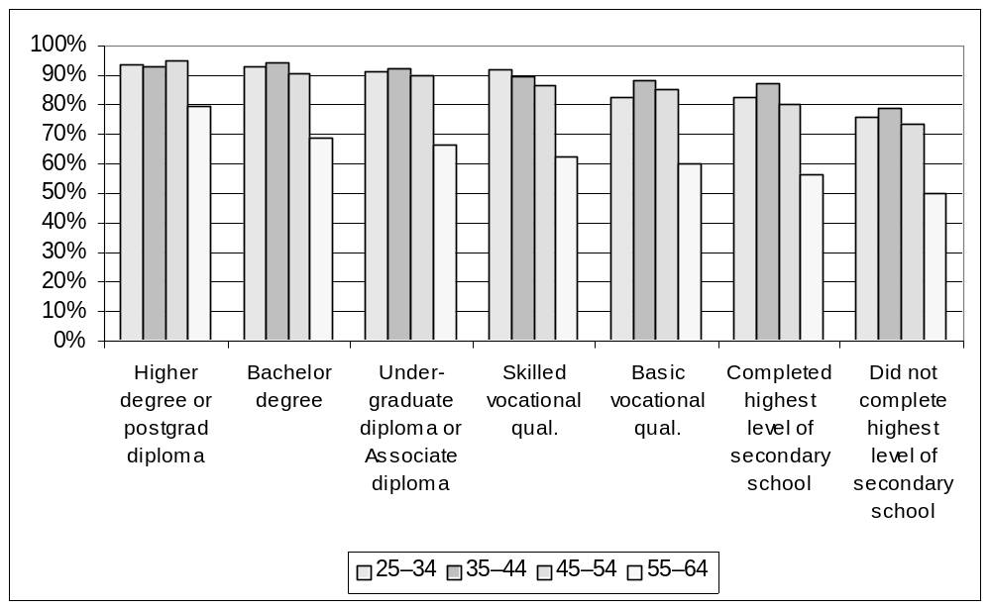
Figure 7: Employment to population ratios by age and educational attainment – women – Australia – May 1998
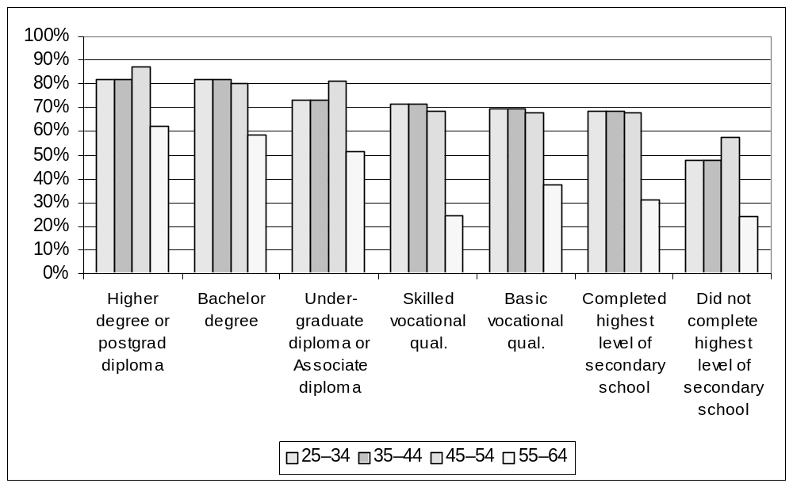
Source: NILS, 1999, from ABS, Transition from Education to Work survey, unpublished data.
Those with higher levels of education are also more likely to participate in further education and training during their working lives, thus widening the gap in education and training during the lifecycle.
Participation in training is a way to build work skills, keep skills up to date and remain competitive in the workforce. While it is most important to those without existing skills, it is also important as the skills required in the workplace change or to assist workers to improve productivity, change jobs or seek promotion.
In 1999, the National Institute of Labour Studies (NILS, 1999) undertook a detailed analysis of ABS data on education and training for the Commonwealth Department of Education and Youth Affairs. While the analysis was based on Australia wide statistics, it can be assumed to apply to NSW. This report found that not only are people with higher educational qualifications more likely to engage in further education, but also in all forms of formal work related training. This tendency increases with age.
The NILS report found that mature age workers were less likely to participate in all forms of work related education and training than people of younger ages, but that the participation patterns are not consistent. Participation in some forms, such as education and unstructured training, is highest for those aged under 25 and declines steadily with age. Among other forms, in house and external formal training, participation peaks at 35-44 and is lower at later ages (see Figure 8).
Between 1989 and 1997, there was a strong growth in participation in training among employees aged 45-54 and 55-64, particularly employer supported or on the job training. This appears to reflect a recognition among employers and possibly employees of the need to address the training needs of mature age workers. Although their participation rates are still low, the gap has narrowed considerably over this period.
The analysis found that employees were more likely to have participated in work related training than the self employed, who were in turn more likely to have participated than the unemployed or those marginally attached to the labour force. This is largely due to employees being able to benefit from on the job training.

Figure 8: Vocational Education and Training by age – employed people –Australia, 1997

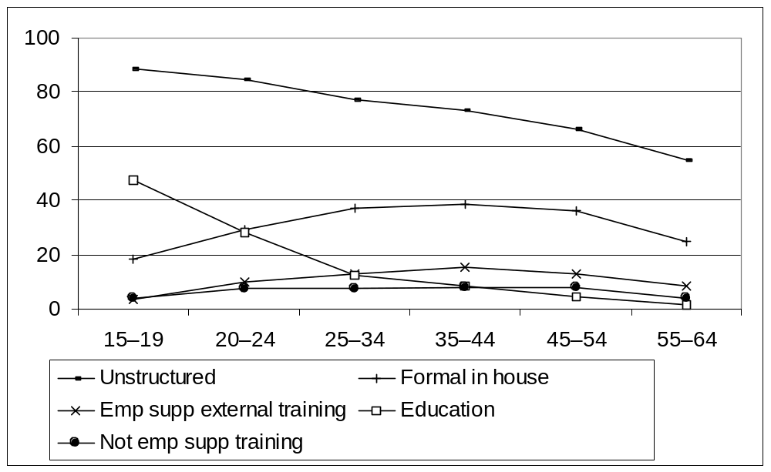
Sources: NILS, 1999, from ABS, Survey of Education and Training Experience 1997, unpublished data.
Base: Percentage of persons with a wage or salary job in last 12 months, excluding secondary school students.
Note: External training includes attendance at external training courses by persons who were not a wage or salary earner at the time.

Some 28 per cent of 20-24 year olds and 13 per cent of 25-34 year olds participated in work related education, but only 5 per cent of 45-54 year olds and 2 per cent of 55-64 year olds participated. Unstructured or on-the-job training is highest among 15-19 year olds (89 per cent) and falls with age to 55 per cent of 55-64 year olds.
Employer supported external training was more evenly spread across the age range, with 15 per cent participation among 35-44 year olds. Running against common expectations, some 13 per cent of 45-54 year olds and 8 per cent of 55-64 year olds participated in employer supported external training. Similarly, formal in-house training peaks at 39 per cent for 35-44 year olds and with 36 per cent of employees in the 45-54 years age group participating. Again surprisingly, a quarter of 55-64 year old employees participated in some formal in-house training.
Mature age female employees are as likely to participate in training as their male counterparts, although male employees of prime ages (35-54) were more likely to participate than prime age female employees.
There is little evidence available on the relationship between work related training and continued employment. There are a number of possible explanations for the lower rates of employer supported training among 55-64 year olds.
First, as previously noted, those who enter the workforce with higher vocational education and training qualifications are more likely to participate in employment related training throughout their working lives; and workers in the older age groups had significantly lower entry level education and training qualifications. It is therefore understandable that people in the 55-64 year old age group would have lower participation levels in employer supported training. Second, it might be that the low training participation rates among 55-64 year old workers reflect an implicit recognition of their greater levels of vocational competence acquired through longer employment.
On the other hand, human capital theory suggests that both employers and employees may not consider it as worthwhile to train mature age people, as their future careers are shorter, thus reducing the potential return on investment.
There are two problems with this thinking. The first is that younger workers are mobile, so the employers who invest resources in training them might not gain any more benefit from this investment than they would from a mature age person who might remain as long, if not longer, with that employer.
The second is that the assumption that mature age workers will soon retire could be self fulfilling. Training would lengthen a person’s ability to continue in productive employment and therefore retire later. The FaCS survey, discussed in the previous chapter, asked respondents who had left a job during the previous 9 years about the training they had received in the 3 years before leaving. Those who had undertaken some training were more likely to be employed at the time of the survey than those who had not. That survey found no significant differences in the proportions of male and female employees aged 50 and over in receipt of training, either in their present job or in their previous job.
A third factor might be that the training available might not meet the needs of mature age people, either in form or content.
However, despite evidence to the contrary, it is probable that both employers and employees do share aspects of commonly held notions of mature workers being too old and inflexible to learn, particularly where it entails new technology. This is supported by an ABS survey (Cat. 6278.0, 1997) which found that the majority of 55-64 year olds who had not undertaken training reported that they did not think it would have been useful to them. Younger workers were more likely to report time or cost related barriers to training.
Disability
The survey commissioned by the Commonwealth Department of Family and Community Services in 2000 described in the previous chapter, found that 38 per cent of men aged 50-64 and 24 per cent of women aged 50-59 who were not employed described themselves as permanently or temporarily disabled, and 33 per cent and 36 per cent respectively who were not employed but had left a job in the preceding ten years had left because of illness, injury or disability. Fourteen per cent of men and nine per cent of women in these age ranges receive disability support pensions. For further discussion about mature age people with a disability, see Chapter 10.

Housing
The option of leaving work also becomes more feasible for people who have finished paying off their homes. On the other hand, those still paying a mortgage have greater reason to continue earning, unless a retirement package provides scope for completing the purchase. For those in rental accommodation, housing costs will continue at much the same level unless they move to cheaper accommodation.
On the other hand, those who have the greatest earning power are inclined to invest in home ownership. For the population in general, the unemployed are more often renters or boarders than home owners.
Figures 9 and 10 show the relationship between labour force status and housing tenure by age group for men and women aged 45-69. Those who are purchasing their own homes have a higher rate of employment at all ages than do owners, while renters and others have a much lower rate of employment. Although the employment rate of people in each housing category falls with age, more buyers stay in employment and the gap between them and the others thus increases with age. This is true of both men and women.
Figure 9: Employment by age by housing – men aged 45-69 – Australia 2000
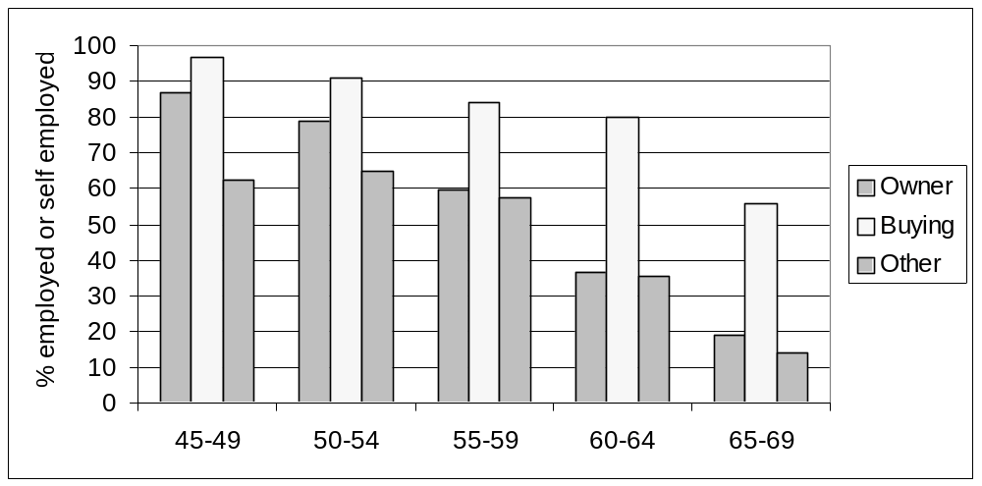
Source: FaCS Survey, 2000, unpublished

Figure 10: Employment by age by housing – women aged 45-69 – Australia 2000
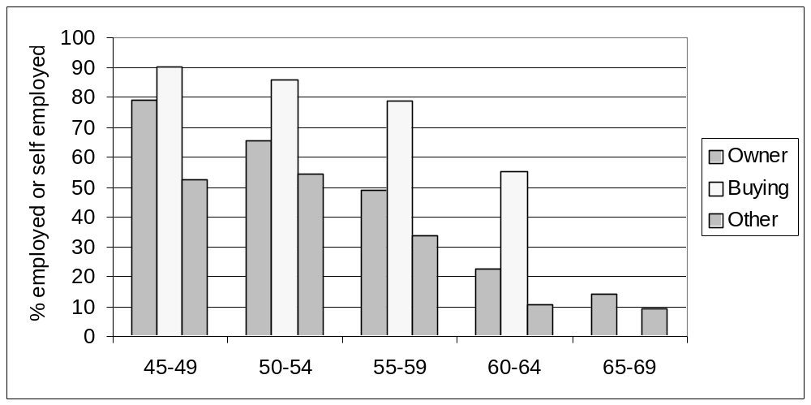
Source: FaCS Survey, 2000, unpublished

However, from 55 onwards home owners and renters are more likely than mortgagees to be unemployed or out of the labour force, while mortgagees are more often still employed. This suggests a mix of voluntary retirement by home owners and the use of superannuation or retirement packages to pay off houses.

Occupation and industry
One hypothesis for the phenomenon of earlier exit is that industrial changes have displaced older workers from the industries and occupations in which they are skilled and experienced, while growing industries have recruited younger workers. This hypothesis would explain the particular effect on older men, as employment has tended to decline in industries in which men predominated, while the growth industries have been those with a high proportion of women.
Without good time series data it is hard to assess the degree to which industrial and occupational changes have contributed to the displacement of mature age men. Some industries and occupations have always had a younger age profile, because of the heavy nature of the work or because of career progression.
The distribution of early exit across occupations and industries is important in planning responses to mature age unemployment, as it determines the work background of the people involved. A better knowledge of the occupational and industrial experience of both voluntary and involuntary jobless would enhance planning of programs to provide training or assist them to find new jobs.
A difficulty in using ABS series is that the coding bases have changed recently for both occupation and industry. The employment rates of mature age men have not fallen in the period since the later series were introduced.
When the ABS time series data becomes available, it will be worthwhile analysing the phenomenon of early exit by these factors, both to examine age profile and cohort effects for explanatory purposes and to get a better picture of the backgrounds of mature age unemployed people.

Occupation
Table 13 shows the occupational distribution of mature age men in paid employment in Australia in 2000, drawn from the FaCS survey. It is difficult to find clear patterns in this data, probably because differences are due to either cohort effects or differences in exit rates. An example of a cohort effect is that tradespersons or labourers made up higher proportions of the group now aged 60-64 than the cohort 10 years younger than them. An example of exit rate differences is the high proportion of managers and professionals in the employed 65-69 year age group, suggesting that these people are more likely than those in other occupations to remain in employment longer.
Table 13: Occupational age profiles – men – Australia – 2000
 | 45-49 | 50-54 | 55-59 | 60-64 | 65-69 | Total
 | % in each occupation
Manager /Administrator | 11.9 | 19.0 | 16.2 | 16.4 | 24.0 | 16.3
Professional | 26.1 | 19.6 | 23.3 | 22.3 | 30.2 | 23.4
Associate Professional | 14.5 | 15.9 | 11.8 | 6.3 | 7.3 | 12.7
Tradesperson & Related Worker | 16.2 | 14.5 | 16.1 | 19.0 | 9.1 | 15.6
Advanced Clerical & Service Worker | 0.0 | 1.0 | 1.7 | 0.8 | 4.0 | 1.0
Intermediate Clerical, Sales & Services | 5.8 | 9.9 | 6.6 | 4.4 | 11.6 | 7.3
Intermediate Production & Transport | 9.7 | 9.6 | 10.2 | 9.6 | 3.6 | 9.4
Elementary Clerical, Sales & Services | 3.3 | 2.5 | 5.9 | 4.1 | 2.5 | 3.7
Labourer & Related Worker | 12.5 | 8.2 | 8.1 | 17.1 | 7.6 | 10.7
Total | 100.0 | 100.0 | 100.0 | 100.0 | 100.0 | 100.0
Source: FaCS Survey, 2000, unpublished data.

To shed some further light on the data above, Table 14, also drawn from the FaCS survey, gives an occupational breakdown of men not currently in paid work who left a job less than five years before the survey. This indicates that managers, administrators and professionals have later exit rates, associate professionals and clerical, sales and service workers tend to leave in their mid 50s, while tradespersons, production and transport workers and labourers leave earlier.
Table 14: Men who left work in the last 5 years – former occupational distribution by age – Australia 2000
 | 45-49 | 50-54 | 55-59 | 60-64 | 65-69 | Total
 | % in each occupation
Manager /Administrator | 6.6 | 5.9 | 9.4 | 10.4 | 14.5 | 9.5
Professional | 9.1 | 7.5 | 12.9 | 13.3 | 19.2 | 12.5
Associate Professional | 14.5 | 16.3 | 20.4 | 16.6 | 15.0 | 16.9
Tradesperson & Related Worker | 23.2 | 26.1 | 18.2 | 20.6 | 15.5 | 20.7
Advanced Clerical & Service Worker | 0.7 | 4.1 | 2.9 | 0.4 | 0.5 | 1.6
Intermediate Clerical, Sales & Services | 7.3 | 8.4 | 9.8 | 5.9 | 6.2 | 7.4
Intermediate Production & Transport | 15.5 | 13.0 | 10.7 | 16.3 | 14.5 | 14.2
Elementary Clerical, Sales & Services | 2.7 | 6.5 | 5.8 | 4.4 | 4.7 | 4.8
Labourer & Related Worker | 20.5 | 12.2 | 9.8 | 12.0 | 9.8 | 12.5
Total | 100.0 | 100.0 | 100.0 | 100.0 | 100.0 | 100.0
Source: FaCS Survey, 2000, unpublished data

Tables 15 and 16 give the same profiles for women. Female managers or administrators, professionals and associate professionals appear to be more likely to work past pension age than other occupations, while there is an age cohort effect with professionals — younger women are more likely to be professionals. The lower status occupations appear to have an earlier average exit age.
Table 15: Occupational age profiles – women – Australia - 2000
 |  | 45-49 | 50-54 |  | 55-59 | 60-64 | 65-69 | Total
 | % in each occupation
Manager /Administrator |  | 8.3 |  | 6.9 | 6.6 | 13.9 | 34.9 | 9.3
Professional |  | 27.1 |  | 25.9 | 27.0 | 19.4 | 13.8 | 25.3
Associate Professional |  | 9.6 |  | 9.8 | 10.6 | 12.2 | 6.3 | 10.0
Tradesperson & Related Worker |  | 4.1 |  | 5.0 | 3.7 | 4.2 | 8.5 | 4.5
Advanced Clerical & Service Worker |  | 5.3 |  | 5.9 | 11.1 | 12.3 | 5.8 | 7.5
Intermediate Clerical, Sales & Services |  | 23.5 |  | 21.9 | 21.9 | 16.4 | 9.0 | 21.3
Intermediate Production & Transport |  | 1.6 |  | 1.3 | 2.0 | 0.9 | 2.6 | 1.6
Elementary Clerical, Sales & Services |  | 11.4 |  | 12.0 | 8.2 | 9.2 | 10.1 | 10.6
Labourer & Related Worker |  | 9.1 |  | 11.2 | 9.0 | 11.5 | 9.0 | 10.0
Total |  | 100.0 |  | 100.0 | 100.0 | 100.0 | 100.0 | 100.0
Source: ABS, Occupation by age and sex - NSW - Census 1996 – community profiles

Table 16: Women who left work in the last 5 years – occupational distribution by age – Australia 2000
 | 45-49 | 50-54 | 55-59 | 60-64 | 65-69 | Total
 | % in each occupation
Manager /Administrator | 2.7 | 4.4 | 3.6 | 5.6 | 34.0 | 6.4
Professional | 15.1 | 9.8 | 13.9 | 20.1 | 49.1 | 17.1
Associate Professional | 16.2 | 18.9 | 14.3 | 25.8 | 21.7 | 18.8
Tradesperson & Related Worker | 12.6 | 10.2 | 5.1 | 1.9 | 0.0 | 6.5
Advanced Clerical & Service Worker | 6.7 | 4.4 | 3.9 | 3.9 | 11.3 | 5.0
Intermediate Clerical, Sales & Services | 21.7 | 22.7 | 24.4 | 22.5 | 14.2 | 22.4
Intermediate Production & Transport | 4.2 | 3.7 | 1.3 | 2.6 | 0.9 | 2.6
Elementary Clerical, Sales & Services | 12.9 | 13.8 | 20.2 | 16.7 | 0.0 | 15.2
Labourer & Related Worker | 10.6 | 16.5 | 16.8 | 6.4 | 2.8 | 12.5
Total | 100.0 | 100.0 | 100.0 | 100.0 | 100.0 | 100.0
Source: FaCS Survey, 2000, unpublished data.

The NSW Board of Vocational Education and Training commissioned the National Institute of Economic and Industry Research (NIEIR, 1999) to provide forecasts for employment in NSW from 2000 to 2005. This study analysed occupations using more detailed ASCO classification information. It forecast employment growth for certain high skill occupations with an above average representation of workers aged 45 and over, and some growth in low skill occupations in which many mature age women work, but falls in employment in other low skill occupations, particularly those now favouring mature age men. The forecast growth in occupations in which the majority of mature age workers are to be found at present does not match the forecast growth in the labour force of that age which will be brought about by demographic ageing.

Industry
The industry data in Tables 17 and 18 are drawn from the 1996 Census. Again, further analysis using time series data could be useful to separate cohort effects from exit rate effects.
Just over half the employed men aged 55 and over are from five industry sectors: manufacturing; property and business services; agriculture, forestry and fishing; retail trade; and construction. Agriculture, forestry and fishing has the oldest age profile of any sector. Men aged 55 and over have a higher than average proportion of the jobs in heath and community services, education, property and business services, and transport and storage. Compared with the group aged 45-54 they have a very low proportion of the jobs in mining and electricity, gas and water. They also have a very low share of the jobs in communication services and finance and insurance.
Table 17: Employed men by age and industry – NSW – 1996
 | 15-19 | 20-24 | 25-34 | 45-54 | 55+ | Total
 | % of employed men in each industry sector
Agriculture, Forestry and Fishing | 3.7 | 7.3 | 19.0 | 43.5 | 26.5 | 100.0
Mining | 1.4 | 5.2 | 22.0 | 63.7 | 7.8 | 100.0
Manufacturing | 4.6 | 10.9 | 27.0 | 46.7 | 10.8 | 100.0
Electricity, Gas and Water Supply | 1.5 | 6.4 | 19.9 | 62.4 | 9.9 | 100.0
Construction | 5.5 | 12.7 | 27.6 | 44.8 | 9.4 | 100.0
Wholesale Trade | 3.4 | 10.4 | 27.9 | 47.2 | 11.2 | 100.0
Retail Trade | 17.8 | 16.0 | 22.5 | 34.5 | 9.1 | 100.0
Accommodation, Cafes and Restaurants | 9.8 | 18.9 | 25.3 | 35.9 | 10.1 | 100.0
Transport and Storage | 1.6 | 6.8 | 24.7 | 54.4 | 12.4 | 100.0
Communication Services | 1.2 | 8.1 | 28.6 | 53.8 | 8.3 | 100.0
Finance and Insurance | 1.9 | 11.8 | 32.8 | 45.2 | 8.3 | 100.0
Property and Business Services | 2.6 | 9.5 | 26.2 | 49.0 | 12.6 | 100.0
Government Administration and Defence | 2.3 | 9.0 | 26.3 | 52.2 | 10.2 | 100.0
Education | 1.7 | 5.6 | 17.7 | 61.8 | 13.2 | 100.0
Health and Community Services | 1.6 | 6.6 | 23.6 | 52.8 | 15.4 | 100.0
Cultural and Recreational Services | 6.4 | 13.1 | 28.1 | 42.6 | 9.8 | 100.0
Personal and Other Services | 3.0 | 8.0 | 28.2 | 49.5 | 11.2 | 100.0
Total | 5.4 | 10.7 | 25.4 | 46.8 | 11.7 | 100.0
Source: ABS Census 1996, Community Profile, NSW, Table B19 Industry by Age by Sex

Table 18 provides the corresponding data for women. Mature age women are concentrated in different industries from male employment, 52 per cent in four industry sectors: health and community services; retail trade; education; and property and business services. They have a relatively high representation in agriculture, forestry and fishing and a very low share of jobs in electricity, gas and water supply, and finance and insurance.
Table 18: Employed women by age and industry – NSW – 1996
 | 15-19 | 20-24 | 25-34 | 45-54 | 55+ | Total
 | % of employed women in each industry sector
Agriculture, Forestry and Fishing | 2.2 | 4.6 | 14.5 | 49.6 | 29.2 | 100.0
Mining | 2.7 | 12.7 | 33.5 | 44.8 | 6.3 | 100.0
Manufacturing | 3.5 | 10.6 | 26.4 | 52.2 | 7.4 | 100.0
Electricity, Gas and Water Supply | 1.9 | 13.6 | 36.6 | 43.9 | 3.9 | 100.0
Construction | 2.4 | 7.3 | 27.2 | 54.6 | 8.5 | 100.0
Wholesale Trade | 3.4 | 12.5 | 28.6 | 48.2 | 7.3 | 100.0
Retail Trade | 23.2 | 15.2 | 19.0 | 36.4 | 6.2 | 100.0
Accommodation, Cafes and Restaurants | 11.1 | 18.6 | 23.2 | 40.9 | 6.2 | 100.0
Transport and Storage | 3.2 | 14.5 | 33.4 | 42.2 | 6.6 | 100.0
Communication Services | 2.0 | 12.9 | 31.1 | 47.6 | 6.5 | 100.0
Finance and Insurance | 3.1 | 17.5 | 38.1 | 37.4 | 3.9 | 100.0
Property and Business Services | 4.1 | 14.2 | 29.4 | 44.7 | 7.6 | 100.0
Government Administration and Defence | 1.8 | 10.3 | 31.7 | 49.7 | 6.4 | 100.0
Education | 1.1 | 6.7 | 20.3 | 63.3 | 8.6 | 100.0
Health and Community Services | 2.2 | 9.9 | 23.8 | 55.3 | 8.8 | 100.0
Cultural and Recreational Services | 7.8 | 15.6 | 29.6 | 40.3 | 6.6 | 100.0
Personal and Other Services | 9.3 | 17.3 | 28.5 | 38.7 | 6.1 | 100.0
Total | 6.9 | 12.5 | 25.4 | 47.2 | 7.9 | 100.0
Source: ABS Census 1996, Community Profile, NSW, Table B19 Industry by Age by Sex

Geographical distribution
The geographical analysis below uses 1996 census data from local statistical areas (SLAs) in NSW. The population distribution and labour force participation rates by age and sex in each SLA was analysed using two codes of categorisation. The first groups them by regions as defined by the ABS. The second groups them by population density using a classification developed by Bray (2001).
The questions are:
• whether mature age people tend to be concentrated in regions where the general employment rate is low; and
• how strongly the employment rates of mature age people are affected by the overall employment rates in particular localities.
The population of Sydney is younger than the non-metropolitan regions. The Far West has the lowest proportion aged 65 and over, while the retirement regions of the mid-North Coast and Richmond-Tweed have the highest.
Figure 11 shows the percentages of people aged 55-64 in the workforce age population by region, based on data from the 1996 Census. It also shows the employment rates for men aged 55-64 and the employment rates for the population.
The proportion of 55-64 year olds in the Sydney population is low and Sydney has a relatively high employment rate. The differences among other regions in the proportion of the population aged 55-64 were not great.
The population density analysis supports this finding, showing that Sydney and other cities or large towns have the lowest proportions of mature age people, while rural or small town areas have the highest (Figure 12). However, their employment rates were high in the rural (non-urban) and small town (pop<2000) categories as well as in Sydney and large towns. The rural and small town employment rates for men aged 55-64 were relatively high in relation to the employment rates of younger men.

Figure 11: Mature age people as a percentage of the population aged 15 and over, and employment to population ratios for men age 55-64 and total – by region – NSW – 1996
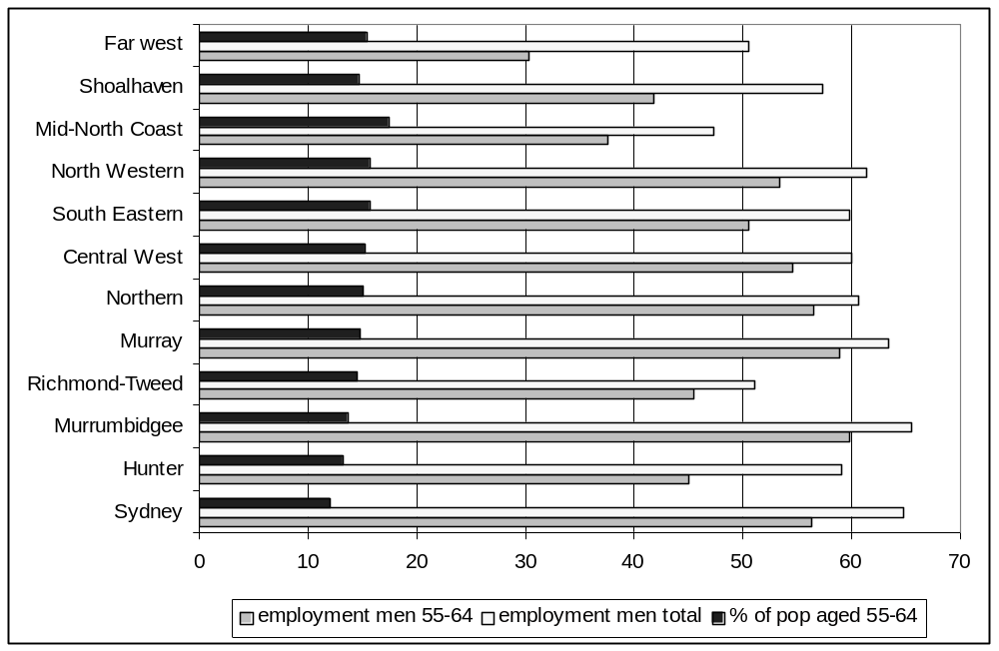
Source: ABS 1996 census data

Figure 12: Mature age people as a percentage of the population aged 15 and over, and employment to population ratios for men age 55-64 and total – by population density – NSW – 1996
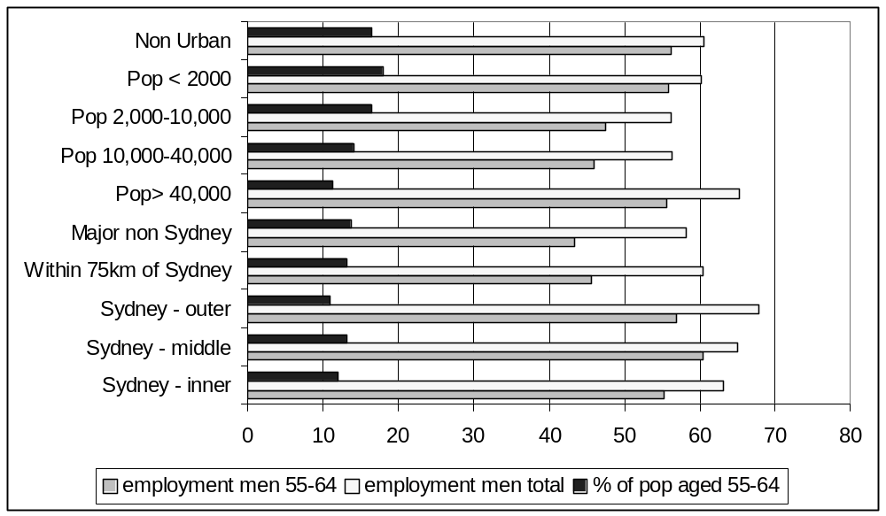
Source: ABS 1996 census data

Analysis by SLAs shows that the variations in both population distribution and employment rates for both region and population density are significant. There was also a significant inverse relationship between the proportion of the population aged 55-64 and the employment rate across all SLAs in the State (Pearson correlation -.45, significant at the .001 level). This gives some support to the hypothesis that mature age people are more likely to live in low employment areas than are younger people, who might find it easier to move to find work.
The employment ratio of both men and women aged 55-64 was highly correlated with the total employment rate across all SLAs (Pearson correlation .75 and .72, significant at the .001 level). The unemployment rates for men and women were also highly correlated with the general unemployment rates (.76, .58, significant at the .001 level) as were the labour force withdrawal rates for both men and women aged 55-64 (.72 and .62). This suggests that not only unemployment but also early exit from the labour force are very strongly related to the general availability of jobs in an area, rather than being mainly due to voluntary early retirement for more positive reasons.

Summary
This chapter has looked at a number of characteristics associated with employment and non-employment among mature age people in NSW. There are some important characteristics that were not discussed because of a lack of suitable data.
• Education and training levels are a source of disadvantage for mature age people in the labour market as each succeeding cohort has higher formal qualifications than the last. In each age group, those with higher education levels have a higher employment rate and also a higher rate of participation in education and training.
• Mature age people may have less access to employer provided training and also show reluctance to engage in training, possibly because it does not meet their needs, they lack confidence or they do not believe it will help their employment prospects.
• Where it is likely that training will be of value in finding or retaining jobs, a three part strategy is needed:
• first, to ensure that the training is of a type and in a form that is accessible to mature age people who may not have participated in formal training for a long time;
• second, to encourage mature age people, both in work and out of work, to participate in it;
• third, to address barriers to training for this group, including employer attitudes and government policies.
• Mature age people have a high incidence of disability, particularly physical disability and, for men, sensory disability. The interaction of age and disability creates severe workforce barriers. However, with an increase in the number of jobs that do not require full physical fitness, these forms of disability should be less of a barrier to work performance.
• While a particular disability might not prevent a person being able to perform various jobs, it may mean that employers are not willing to employ him or her, particularly when there is competition from younger people without disabilities.
• Housing tenure is related to labour force status. The proportion of people who have completed paying for their houses increases with age, and the proportion of purchasers thus drops, while the proportion in other forms of tenure remains more or less constant at around 15 per cent. Those paying off a house have very much higher employment rates than owners or others, particularly at later ages, suggesting that they are highly motivated to keep a sufficient income to complete the purchase. Those who neither own nor are buying their own homes have the lowest rate of employment and labour force participation and the highest unemployment rates.
• The level of home ownership is expected to be lower for the cohorts of people born after the baby boom period than for those older than them.
• It is hard to gain insights into the role of occupational and industrial change in mature age unemployment on the data available. The NEIR (1999) findings are insufficient to show overall trends. Further research with time series data would be useful, to look at typical exit rates from different industries and occupations to separate out changing age profiles.
• Mature age people are less likely than younger people to live in Sydney, which has a higher employment rate than the rest of NSW. Although mature age people in most areas have lower employment rates than prime age people, the geographical distribution of mature age people tends to be biased towards lower employment areas. The exception to this is in rural communities where the employment rates of mature age men are relatively high compared to those of other age groups. It is more difficult for people to move house to areas of higher employment as they grow older because of housing and family constraints, established social relationships and recreational activities.
• Important factors not examined in this chapter, because of insufficient data, particularly NSW data, are marital status, ethnicity, income and wealth. These should be the subject of further research.

5 Attitudes of employers and mature workers

The impact of joblessness
In a thorough Australian study of the impact of unemployment on mature workers, their families and their lifestyles, Lobo and Parker (1996) found that the effect of job loss and subsequent unemployment on mature age workers tends to be staged. The initial reaction of anger, shock and betrayal tends to be followed by a deeper sense of loss, profound rejection and failure. However, for some the reaction is not so negative. Among those who have founded less of their identity and life meaning on their job, and those with other socially recognised roles to fall back on, the reaction to retrenchment is less negative and damaging.
Lobo and Parker found that, whether displaced mature age workers immediately seek re-employment or postpone their job search, it involves a high probability of failure. The more intense the job search and the more frequent the rejection of applications, the more intense the feelings of personal inadequacy and failure. Over time the pattern of application and failure compounds to an extent that many people reduce the intensity of their job search and eventually withdraw entirely as discouraged job seekers. Their withdrawal can be influenced by:
• the desire to avoid further rejection,
• the onset of anxiety, depression and psychosomatic illness,
• an increasing unwillingness to waste yet more time on an apparently fruitless exercise, or
• combinations of these factors.
The longer a person looks for work, the less effective the search tends to become, as a result of both the person’s loss of contact with the world of work and of his or her diminishing effectiveness in managing time. In some cases mature age unemployed people rationalise the initial retrenchment and rejection into an apparently more proactive decision to ‘retire’.
Over time, the self concept and sense of identity of unemployed people can be quite seriously damaged, and the burdens of being unemployed are made worse by the public belief that the unemployed are responsible, if not to blame, for their own situation. Unemployed people usually sense a loss of what is valued — of the status associated with work, the sense of making a contribution, of colleagues, outside friends and networks — and rarely a gain of something that is desired. They feel the strain of not being able to be the sort of person they were, and do the things they were able to, when employed.
Unemployed people experience depression, anxiety and general distress, together with low self esteem and confidence, and continuing unemployment causes further reductions in the well being of middle-aged people. Perhaps perversely, people with a stronger personal commitment to having a job and who undertake more intensive job search activity are likely to experience worse mental health during unemployment. When confidence and self esteem depend heavily on work involvement, the depression following job loss is associated with anxiety and agitation. On the other hand, after many months of useless search for jobs, depression is different in character and is associated with feelings of lethargy, resignation and withdrawal. Anecdotal reports suggest a high level of alcohol abuse among jobless men.
The ill effects of unemployment can linger even for those who find a new job, particularly for those who have experienced long term unemployment. Those who secure re-employment quickly experience a sense of relief and re-affirmation. Those who remain unemployed for half a year or longer before securing a new job do not experience the same sense of relief. There is a high probability that the psychological and psychosomatic damage will be carried into the new job and perhaps affect their initial performance in that job. For those who accept a lower status job than their previous one, their self confidence may be permanently eroded by the whole experience.

Financial effects
These patterns are compounded by the financial effects of joblessness.
For those people in their fifties and early sixties who are financially secure and who plan an early and active retirement, the act of leaving the work force is relatively unproblematic although some subsequently change their minds and take up work again. They can enjoy early retirement as a reward for hard work and prudent forward planning. But for most, job loss or unplanned early retirement have serious financial effects, which can be permanent.
For those with an employed partner, the family will have to cope with a significant reduction in income. For single income households the immediate economic future is determined by the size of any redundancy package, accumulated superannuation and the balance of their savings and debts, particularly for those with mortgages. If job search is unsuccessful, the future economic viability of the family will be dependent upon the combination of accumulated savings and entitlements to income support. Whatever their circumstances while employed, long term unemployment for mature age workers and their families carries the high probability of rapidly diminishing economic circumstances and prospects. For many it will end in long term dependence on social security.
This outlook contrasts bleakly with what was an expected period of family transition and consolidation. The longer term hopes and expectations of parents in their fifties typically concern the successful transition of their children to independence, consolidating their own economic security — including paying off housing debts and accumulating superannuation — and perhaps providing some assistance to their children and grandchildren. Retrenchment and an extended period of unemployment can be experienced as a negation of all their planning, preparation and hard work.
Household expenditure is reduced to necessities and major household service bills or housing repayments become a major problem. Expenditure on entertainment and leisure become luxuries. In these circumstances, people’s ability to effectively manage their budgets becomes increasingly important. Similarly, the ability to transform previous hobby activities into income generating activities can ease family financial pressures.

Impact on families
With regard to internal family relations, the experience of unemployment may change the distribution of domestic work and power. Family reactions to an unemployed male breadwinner range from sympathetic support through to disdain and being seen as less of a real man. The psychological effect of unemployment on mature age men can be transferred to their domestic situation, with the man feeling less adequate, hence strengthening the negative spiral. Again, anecdotal evidence suggests a high level of separation in these families.
For women, the effects are more diverse. On the one hand, women may be somewhat less likely than men to perceive their roles and status in the family and society as based on their employment. However, many do. Single women, particularly those who have been sole parents, are less likely to have superannuation and other savings, and less likely to receive redundancy packages. For those women who are employed but whose husbands are out of work, the role reversal can be very stressful.
It is self evident that the longer the period of joblessness the more profound the economic, social, psychological and physical impact, and the greater the direct and indirect burden on immediate family members and the wider society.
When society fails to provide sufficient employment opportunities for all who seek them, it bears a double cost. First, there is a reduction in general market economy contribution and a commensurate reduction in the public revenue base. Second, society bears the additional costs associated with income support, retraining and job search assistance, increased health costs, accommodation and transport subsidies and increased use of community services. In this sense unemployment both reduces the revenue base of, and increases the expenditure demands on, all levels of government.
The longer the unemployment experience the greater these social costs become, and the longer it takes to secure a new job, the longer it takes for the personal and social costs to ease. If no new job is found, eventual withdrawal from the labour force — reluctant retirement — extends and perhaps deepens these costs.

Attitudes to mature age unemployed people
It is not difficult to find an association between discouragement, early retirement and age discrimination (Sheen, 2000). A recent study by Drake Personnel Limited (1999) highlights a widespread belief among employers that mature age workers are less productive than their younger peers. The Drake study found that when employers were retrenching employees, some 64.5 per cent preferred to retrench those aged 51 years and over, and a further 22 per cent preferred to target those aged 41-50 years. Only 11 per cent targeted those aged 31-40 years.
On the recruitment side, the Drake study found that some 62 per cent of employers preferred to recruit among those aged 31-40 years, and a further 22.5 per cent targeted those aged 41-50 years. Not one employer identified those aged 51 years and over as the preferred age group for recruitment.
Australian and overseas research has found both positive and negative employer attitudes to the qualities of mature age workers. On the positive side, mature age workers are “valued for their skills, experience, corporate knowledge, commitment, strong work ethic, reliability and low absenteeism” (Bittman, Flick, Rice, 2001). On the negative side, employers believe mature workers to be:
• inflexible;
• lacking in initiative;
• resistant to change;
• unwilling to learn new technologies;
• prone to ill health and high absenteeism;
• deteriorating in mental and physical capabilities;
• prone to work place injury; and
• generally more difficult to manage.
A recent review of the literature on barriers to mature age employment by Keys Young (2000) grouped negative employer attitudes to mature workers into perceptions about their:
• abilities: intellectually slower, less creative, less physically fit, less skilled in new technology, hold out-of-date qualifications, and less likely to receive training;
• attitudes: lacking in drive and enthusiasm, more conservative in outlook and more cautious, dislike for taking orders from younger managers and expect special treatment;
• adaptability: more inflexible and unable to cope with change, inability and unwillingness to adapt to new technologies, workplace structures and demands, and an unwillingness to retrain;
• associated costs: more prone to ill health, absenteeism, sick leave, workers compensation, higher age related wage costs, a poor long term investment in relation to training.
It is not very surprising that many mature age workers themselves are susceptible to the same cultural stereotypes. Their labour market experience over the past 25 years, their generally lower levels of initial education and training compared with those under 40 years, the over-representation of male mature age workers in those industries and occupations in relative structural decline, the general focus on youth and youthfulness in the broad culture, and prevailing attitudes to older workers all contribute to many mature workers sharing the same perceptions.
The Reark study of the attitudes of 55-64 year olds found that they question their physical ability to continue work and their ability to cope with technology and other changes at work, including stress associated with work. Further, their fundamental attitudes to work are a barrier (Reark,1990).
Much literature (NILS, ABS) finds that mature age workers do not see any value in participating in training, while younger people say they have time or cost constraints. While they might not have as many opportunities, the reluctance to train among mature age workers themselves seems to account for more of the disparity in participation than lack of offers. It could be because the types of training offered are not suitable or because of fear that they will not be able to learn. It could also be related to their lower educational attainment in the past, which is strongly correlated with participating in training during the working life period.
Reark found that the experience of retrenchment and unemployment entrenched these attitudes and compounded them with a sense of the futility of job search, and concluded that “the major objective should be to keep workers in the workforce, rather than encouraging older people to return to the workforce” and that attitudinal barriers need to be addressed.
Consideration of such attitudes led Sheen (2000) to note that,
At the present time, Australia is at an impasse. Our population and workforce is ageing, there is a large cohort of older people who want and need to work but employers are hooked on the culture of youth and insist that younger workers are who they wish to employ. However, the time is approaching that the impasse must be broken. There is a growing community and government perception that the situation is no longer sustainable. The facts are that we cannot afford to maintain the present status quo of early retirement and unemployment however it is defined and measured amongst mature age people.
In this context, the findings of a study undertaken by the Australian Centre for Industrial Relations Research and Teaching (ACIRRT, 1995) for the NSW Mature Workers’ Advisory Committee are particularly significant.
ACIRRT extended the research undertaken and reported by Reark, which did not investigate the social and organisational context in which policies and practices about the employment, assignment of work tasks and the employment experience of mature or older workers operate. The underlying assumption of the ACIRRT research was that neither the 45-64 year old age group nor their labour market experience is homogeneous, and that their labour market experience reflects industry and occupational factors as well as age group, gender, ethnicity and so on. Any strategies and policies “which assumed that the group was homogeneous would be unlikely to achieve optimum effectiveness”.
Accordingly ACIRRT undertook case studies of five workplaces covering four different industry sectors and five occupational areas in order to identify issues of policy and practice in a range of contexts:
• The Advance Bank. A service sector enterprise where the employment of older workers was part of the organisation’s overall employment strategy.
• Australian Industrial Relations Commission. A group of older managerial/professional employees who performed a range of specialised skills which were positively related to age and experience.
• The Lend Lease Corporation. A construction employer undergoing a process of workplace reform.
• The Prestige Group. A small to medium manufacturing enterprise with a relatively older workforce which had been rescued from collapse through the introduction of new technology and a transformed, flexible production system.
• A suburban supermarket. A service sector organisation which was part of a large chain employing casual and permanent part-time mature age workers.
Observing that the consensus in the literature was that “although mature workers are regarded by employers as possessing ‘more desirable psychosocial qualities’, they are also viewed as possessing ‘fewer productivity-related skills’”, the case studies investigated five commonly held perceptions about mature age workers. The case study findings are significant and are reported here for each perception tested.
• Mature age workers have deteriorating physical and mental abilities. There was some evidence in the manufacturing and construction industry case studies that declining physical strength had reduced some workers’ capacities, but this generally was compensated for by undertaking tasks in different ways. The service sector and professional and semi-professional case studies suggested that mature workers’ experience and mental abilities made them attractive in certain occupations.
• Mature age workers are not receptive to new technology. Although there was evidence in manufacturing and among re-entrants in the finance and retail sectors of mature age workers being intimidated by new technology, appropriate training opportunities and techniques overcame these fears. In the construction industry mature age workers were able to adapt quickly to new technology and were able to play valuable training and mentoring roles.
• Mature age workers are more resistant to organisational change. In the two case studies which involved organisational change, construction and manufacturing, mature age workers were able to adapt to the changes provided they were introduced with appropriate human resource strategies. In the service sector where part-time employment was increased, the mature age workers found the more flexible employment conditions appealing.
• Mature age workers lack the appropriate skills and are difficult to retrain. With non-professional mature age workers in finance, retail, manufacturing and construction, appropriate training strategies building on their previous skills and knowledge were the key.
• Mature age workers lack the drive, ambition, energy and creativity of their younger counterparts. This perception did not apply to the professional and semi-professional workers. In the manufacturing and construction case studies, the mature age workers responded positively to appropriate support, training and the opportunity to assume new responsibilities which utilised their accumulated skills and knowledge. In the retail and service case studies the changed patterns of labour use restricted career paths for employees, but this appeared to suit those mature age workers who sought such positions.
The overall conclusions drawn from the ACIRRT case studies were that it is not valid to draw generalised conclusions about mature age workers, and that, “ultimately, it is management decisions on work organisation and skill development which reflect the productivity outputs of mature and older age workers, not any innate abilities of the workers themselves”. Moreover, the nature of the productivity and adjustment problems encountered with mature age workers vary with the specific industry and occupation in question, and with the composition and past experience of the particular work force.
The expectation that employers develop and provide appropriate training opportunities and adjustment support to their mature age workers may appear to impinge upon their management prerogatives and bottom lines. However, the long term solution does not lie in adopting strategies which deny appropriate training and adjustment support. A well trained and supported workforce will provide long term rewards in the form of commitment, loyalty, flexibility, competence and productivity.

Summary
While it is misleading to apply stereotypes to individual cases, the attitudes and perceptions of employers, and mature age workers themselves, may account for quite a large component of the difficulties mature age unemployed people experience in finding work.
The issues raised in this chapter should be seen in the context of other more objective labour market disadvantages which many mature age job seekers face. As discussed in the last chapter, these include lower levels of formal education and qualifications; lack of skills in new technology, particularly IT; work experience in declining industries that may not be transferable to the new industries; locational disadvantages; and disabilities, poor health or caring responsibilities that limit their employment options.
Beyond these workforce disadvantages, the picture that emerges is of a range of attitudes, perceptions and behaviours stemming from a loss of self confidence. While this is a problem afflicting unemployed people of all ages, there are some differences between the young unemployed and those of mature age. The stereotypes of mature workers explored in the ACCIRT study above are all consistent with low confidence and unfamiliarity with change.
Many men and some women have built their careers with a single employer or industry, operating in an internal labour market, and have invested many years within a relatively narrow work environment. Such people are inexperienced in looking for work in the external labour market, where they cannot rely on people who have worked with them for a long period assessing their abilities.
Many mature age jobseekers hope to return to permanent wage or salary employment and regard short-term or contract employment as risky and stressful. They often lack skills in preparing job applications, performing well at interviews or seeking jobs through informal means, the conventions for which have changed since they may have last looked for work. Younger people are more likely to have experienced a career of relatively short-term jobs and to regard job seeking and job change as part of a normal career.
Similarly, many mature age people have not participated in training or education for a long time and have doubts about their capacity to learn. While the evidence is that the ability to acquire new skills and knowledge does not decline significantly by the ages in question, there is a ‘practice effect’ and confidence and familiarity with the training environment are also important incentives to participate. The concept of life long learning is relatively new — the old lifecycle pattern was of youth as being the time for education and formal skills acquisition, with adulthood being the time to employ and build on those skills through experience over a career.
There is undoubtedly a culture of age-role expectations affecting most aspects of life. Employers and unemployed people have an expectation that job seeking is appropriate for young people. The figures show a higher level of job and career change, as well as intermittent unemployment at younger ages. This churning in the labour market is traditional for young people exploring their career options, while older people were expected to have settled into a more stable career. Thus it may seem inappropriate in terms of age roles for a man in his fifties to be starting anew. Here women are somewhat less disadvantaged as women have traditionally broken their careers to raise children and often returned to the workforce later — albeit into part-time or low status jobs.
Finally, many people who have been in stable careers and lose their jobs or take voluntary redundancy suffer from a sense of loss, betrayal, shock and so on. For those who have not been unemployed before, there is a sense of failure and humiliation. There is also a loss of the social identity that comes from the type of work a person does, where he or she works, relationships with workmates and the time structure of regular working hours.
It is hard to say whether the loss of work after many years of employment is worse than unemployment is for those who have never had stable employment. However, there is a need for policy makers, service providers and employers to recognise the particular issues faced by the older group.

6 Constitutional responsibilities for ageing
The ageing population, high rates of joblessness among mature age workers and early retirement will continue to affect all levels and areas of government responsibility. Public sector revenues are decreased through reduced levels of income and consumption tax payments. On the other side of the ledger, demands on most forms of public sector services are increased by reduced levels of self sufficiency among mature age unemployed people and reluctant early retirees.
All levels of government share the costs of, and the responsibilities for, meeting the needs of mature age people for additional direct and indirect support, but no level of government has sole responsibility for these issues.
The Australian Constitution specifies the powers of the Commonwealth Government, with residual matters being the responsibility of the States. The Commonwealth’s powers can be altered by referendum or by the States referring powers to the Commonwealth.
Both the Commonwealth and NSW Government have recognised their responsibilities as they relate to an ageing population, including the employment problems of mature age people, and have developed cross portfolio policies on ageing. This Chapter briefly examines the constitutional responsibilities borne by the Commonwealth and the States, and provides an overview of the policy frameworks, with a primary focus on responsibilities and policies relating to employment patterns and practices.

Social security
Social security is a Commonwealth responsibility. The Constitution originally gave the Commonwealth power to make laws with respect to old age and invalid pensions and a 1946 referendum added unemployment benefits and other social security payments.
The State Governments, however, provide a number of in-kind benefits such as concessions for transport, electricity, some health services and entry to museums and national parks for low income people, particularly social security pensioners. These vary among States. Local Governments also provide concessions on rates to pensioners who own and live in their own homes.

Industrial relations
The Australian Constitution gave the Commonwealth powers over arbitration and conciliation for the prevention and settlement of industrial disputes extending beyond the limits of any one State. The States have authority for disputes contained within the boundaries of specific States. This broad division of responsibilities exists today, with the industrial relations powers being used by governments of both levels to establish industrial relations machinery and to legislate in relation to workplace relations, award structures and procedures, equal employment opportunity and other employment conditions such as maternity leave and occupational health and safety.

Human rights
The Commonwealth has the power to enact anti-discrimination legislation in various areas where there are international conventions, through the external affairs power. It has done so in the areas of sex, marital status, pregnancy, disability, race and ethnicity but not in the area of age discrimination.
The States have enacted anti-discrimination legislation covering discrimination in employment. The NSW Anti-Discrimination Act 1977 was amended in 1993 to include age discrimination (Encel and Studencki, 1998). Among other things, this legislation outlaws compulsory retirement and age discrimination against applicants for work or employees.

Public sector employment
The public sector plays a major role in establishing standards for employment patterns and practices. Commonwealth and State governments have legislated provisions relating to equal employment opportunities within their workforces. Both levels of government have legislated to remove compulsory retirement age for government employees.
Both Commonwealth and State governments are in a position to take a lead in developing and implementing employment policies and practices consistent with their concerns for prolonging the labour market participation of mature age employers. In 1998, the NSW Premier’s Department issued Mature Workforce Policy and Guidelines as part of a commitment to maintaining fair employment practices within the NSW public sector.

Full employment
Although there was no allocation of Constitutional responsibility for maximising employment or, indeed, securing and maintaining full employment, Commonwealth governments from the early 1900s utilised a combination of powers and policies to maximise employment and to ensure a “living wage”.
In 1945, post-war reconstruction planners adopted Keynesian macro-economic theories and policies as the basis for committing the Commonwealth to attaining full employment in the White Paper, Full Employment in Australia. Within this framework, the Commonwealth assumed responsibility for monitoring employment patterns and trends and passed the Re-establishment and Employment Act. It also established the Commonwealth Employment Service to provide a more efficient labour market vacancy notification and filling mechanism, and introduced unemployment benefits. The Reserve Bank Act 1959 charged the Board with implementing monetary and banking policy to the greatest advantage of the people of Australia and to the maintenance of full employment.
While State governments do not have primary responsibility for employment policy, they are responsible for a range of policy areas which affect employment levels and practices. The concern to ensure prosperity and economic security for their electorate is reflected in State government actions to attract and encourage investment in each State with a variety of subsidies and concessions. Regional development strategies and community building strategies are also directly relevant to employment levels and patterns in particular geographic areas. The implementation of Commonwealth/State supervised National Competition Policy has an impact on industrial and regional employment patterns. As well as direct public employment, State government tendering arrangements also have significant impacts on employment patterns.
States therefore have an interest in ensuring that the demand for labour is high and that the supply of labour is suitable for the needs of industry.
All States other than NSW and Tasmania now have a Department of Employment, usually in conjunction with Training and sometimes Education, which co-ordinates State employment related policies, vocational training and labour market assistance.

Labour market programs and vocational education and training
The Commonwealth assumed primary responsibility for labour market programs from the early 1970s through to the present Job Network. While the State governments have accepted the primacy of the Commonwealth in this area, they have at times played significant roles in program delivery and they have maintained a number of their own specifically targeted programs designed to complement those of the Commonwealth. The NSW Government has run a labour market program targeting mature workers since 1989 — the Mature Workers Program (discussed further below and in Chapter 11).
The development of labour market programs has, however, seen them become more closely linked with vocational education and training — which has historically been a primary State responsibility.
At first, labour market programs designed to provide vocational training were kept separate from the mainstream vocational education and training (VET) system but, with the 1980s training reform agenda, pressure built to develop an integrated training system with labour market program training articulating with the competency based training framework. Moreover, more labour market program training was provided, through tender and contract, by the public technical and further education (TAFE) systems run by the States.
States had traditional responsibility for apprenticeships, but the Commonwealth moved into this role from the mid 1980s to the current New Apprenticeship System.
The development of the Job Network and the competitive training market has seen the referral of Job Network participants to TAFE courses, and TAFE competing with private and community sector training providers to secure training contracts, thus further blurring the boundaries between labour market programs and vocational education and training.
TAFE itself remains a primary State responsibility but the Commonwealth has provided increased funding and, through the impact of labour market programs, the development of traineeships and the Australian National Training Authority, has significantly influenced the development of public sector vocational education and training provision.

Disability
Responsibility for assistance to people with a disability is particularly salient as the incidence of disability increases with age and disability is one of the main barriers to employment faced by mature age people.
Disability programs include:
• income support for people unable to support themselves financially because of their disabilities;
• workers compensation and motor accident compensation schemes for people whose ability to work is impaired by work related injuries or medical conditions;
• specific programs to assist people with a disability to participate in education, training and employment;
• medical and rehabilitation services directly addressing causes of disability;
• care services ranging from home care to residential and respite care;
• measures to improve access to transport, housing, services, facilities and so on; and
• anti-discrimination legislation and monitoring.
The Commonwealth has responsibility for social security for people with a disability and funds services providing labour market assistance. States are responsible for workers compensation and associated rehabilitation and return to work programs. These can involve training and supported job placement.
Under the Commonwealth/State Disability Agreement of 1998, the Commonwealth has responsibility for the planning, policy setting and management of employment services, and the States and Territories for specialist disability services other than employment (advocacy, print disability and information services are joint responsibility) (AIHW, 1999).
State government responsibilities include accommodation, community support, community access and respite care.
There are definitional problems in distinguishing between measures to improve employment opportunities or reduce social security outlays and more general assistance. Rehabilitation provides an example: the Commonwealth Rehabilitation Service (CRS) was established in 1948 to help ex-servicemen and invalid pensioners return to employment. From 1985 the CRS became responsible for ‘tertiary’ or vocational rehabilitation, while the States were responsible for acute and secondary stage rehabilitation, helping people recover their general level of functioning. But there is a close association between restoring function generally and restoring it to the point where a person can return to employment.
Both NSW and the Commonwealth have legislation providing rights against discrimination on the basis of disability.
For more discussion about services available to mature age people with a disability, see Chapter 10.

Health, housing, community services and transport
As with education and training, the States retain primary Constitutional responsibility for health, housing, community services and transport, but the Commonwealth has had increasing involvement with these through a number of Commonwealth/State Agreements and Joint Ministerial Councils and is responsible for medical and pharmaceutical benefits.

Commonwealth policy on ageing
Commonwealth policy on ageing is the responsibility of the Minister for Aged Care and, since 1998, policy has centered around developing a National Strategy for an Ageing Australia. The project started as the Commonwealth’s response to the 1999 International Year of Older Persons and the establishment of a Commonwealth-State Healthy Ageing Taskforce. The Commonwealth also takes prime responsibility for residential aged care and related schemes.
The primary objectives of the National Strategy are to promote and inform the Australian community of the impact of population ageing and to advise the Commonwealth Government on short, medium and long-term policy responses to population ageing, as part of a coordinated national framework.
A background paper, The National Strategy for an Ageing Australia, was released in 1999 and a number of reports into different issues have been published. Those relevant to this project are Ageing Gracefully: an overview of the Economic Implications of Australia’s Ageing Population Profile (DHAC, 1999); Employment for Mature Age Workers (Bishop, 1999); and Population Ageing and the Economy (Access Economics, 2001).
The Healthy Ageing Task Force, established by Commonwealth, State and Territory Health and Community Service Ministers in October 1996, has developed a Strategy on Healthy Ageing (DHAC, 2000). It provides a broad framework and basis for planning and coordinating ongoing cross-jurisdiction policy research and development in response to the consequences of an ageing population. The Strategy endorsed six universal principles of healthy ageing to guide implementation:
• support independence;
• encourage a good quality of life for Australians as they age;
• promote fairness and equity;
• recognise interdependence;
• recognise and respond to Australia’s growing diversity; and
• encourage personal responsibility while providing support for those most in need.
In addition, the Strategy identified a number of desired outcomes:
• improved community attitudes to ageing and older people;
• improved health and wellbeing for all older Australians;
• more older people in employment and community activities;
• realistic and fair provision of financial support for older Australians by governments, communities and individuals;
• appropriate living environments and local communities for older people;
• appropriate and affordable support so that older people can meet their needs and aspirations and remain in their own homes as long as possible; and
• maximum use of good quality data, including older people’s experiences.
More recently, the Healthy Ageing Task Force has been developing a National Reference Guide on Mature Age Employment that will provide a resource for all jurisdictions in their promotion of the value of mature age employment for individuals and the community.

NSW policy on ageing
The NSW policy for an ageing population is encapsulated in the five year policy statement, NSW Healthy Ageing Framework: 1998-2003, released in 1998 by the Minister for Ageing and the Minister for Health. The Ageing Issues Directorate in the then Department of Ageing and Disability and the NSW Committee on Ageing were to coordinate implementation of the Framework and advise the Government on progress and possible improvements.
In addition, the Premier released the Mature Workforce Policy and Guidelines (1998) covering public sector employment. All public sector agencies were responsible for developing, implementing and monitoring their own strategies to eliminate unlawful age discrimination and “to optimise employment and career development opportunities for mature aged people”.
While the Healthy Ageing Framework reflects its primary focus on retired persons, it does identify increased mature age employment opportunities among its objectives and key areas for government action:
• Improved attitudes to ageing and older people and decreased unlawful age discrimination.
• Increased participation of older people in the workforce, education, leisure and volunteering.
• Provision of information about services and rights so that older people can make informed decisions in these areas.
• Provision of accessible and supportive living environments which make it possible for older people to live as independently as possible.
• Promotion of independence, well-being and health for older people through provision of health, accommodation, care and support services.
• A planned approach to policy and service provision in NSW for older people, based on high quality data and research, and supported by equitable and sustainable resourcing.
With regard to the second objective the Framework committed the NSW Government over a five year period to:
• Develop and/or review computer and other technology training programs to improve their access and relevance to older people.
• Work with Industry Training Advisory boards and companies about opportunities to expand access to traineeships for older people retrenched from the workforce.
• Investigate the opportunities for upgrading the skills and employability of mature age workers at risk of unemployment.
• Develop and increase the number of education and training initiatives targeting the needs of older learners and provide language and literacy training relevant to the workplace.
• Increase funding for volunteer support and recruitment projects through the Home and Community Care and Ageing Programs.
• Continue to support initiatives such as the Mature Workers Program which encourage government and private sector employers to develop flexible work practices and attitudes that are supportive of the continued participation of mature workers in paid employment.
Consistent with these objectives and areas of action, the Mature Workforce Policy and Guidelines required that all public sector agencies:
... examine their existing employment practices and procedures to ensure that they are non-discriminatory in terms of age, and to introduce workplace policies aimed at the ongoing development and recognition of the skills and experience of mature aged workers.
Agencies were to follow guidelines which recognised that, to be effective, a mature workforce program should be an integral part of an overall human resource management approach and that it should be broadly publicised through the agency. The document identified the major components of an effective mature workforce program and strategy as:
• merit based recruitment and selection;
• a willingness to consider applicants contacted through Commonwealth or State programs such as the Mature Workers Program;
• a positive approach to life long learning and providing retraining to mature age workers;
• the recognition of prior skills and competencies;
• work related criteria based performance assessment and management; and
• flexible work practices.
Finally the guidelines warned against unthinkingly retrenching (voluntarily or compulsorily) mature age workers, and cautioned that “restructuring or retrenchment programs should be carefully examined to ensure that they do not result in direct or indirect discrimination against any employment group”.

Summary
Debates over the division of powers between the Commonwealth and the States have always been a major issue for Australian governments.
Responsibilities for social policies, apart from social security, have become blurred as these have become more complex and as the interactions between them become more apparent. Employment policy, in particular, is closely connected with economic policies as it determines the supply and demand for labour and the quality and attributes of jobs and workers. It is also closely connected with the demand for social services, particularly as these have become targeted to lower income people, and as unemployment and poverty are linked to social indicators such as mental and physical health, family stability, community welfare and possibly crime.
Disputes over responsibilities and the need for Commonwealth and State Governments to be jointly involved in determining policy directions on most major issues, have led to the evolution of mechanisms such as inter-governmental agreements and joint ministerial councils. At the very least, States need to maintain a watching brief on the effect of Commonwealth action on the welfare of the State and be in a position to negotiate bilaterally, where joint mechanisms do not exist.
While Commonwealth/State distinctions are very important to policy makers on both sides, the issue is not one that is always foremost in the minds of the electorate. To those outside government, such deliberations and subtleties can appear as bureaucratic red tape frustrating the ability of either level of government to respond quickly to emerging needs. The electorate might expect solutions from either or both Governments without regard to the Constitution.
The importance of the issue of population ageing and the many policy areas affected have led to both Commonwealth and NSW Governments formulating broad strategies. The principles espoused in these strategies are generally similar, although the emphasis differs because of the different responsibilities.

7 Social security
Social security is provided by the Commonwealth through Centrelink, which delivers programs under contract to the Department of Family and Community Services. Thirty-six per cent (214,000) of NSW residents aged 55-64 received social security payments at June 2000.
Description of entitlements
Social security payments are classified into pensions and allowances (benefits), the former being more generous than the latter. Table 19 shows the rates for pensions and benefits at August 2001. In addition to these rates, pensioners (and long term allowees aged 60 and over) receive some supplementary payments and a Pensioner Concession Card. Allowees receive a Health Care Card. The Commonwealth Seniors Health Card is available to people over age pension age with income less than $50,000 (single) or $80,000 (couple combined) and provides concessions on pharmaceuticals and telephone rental.
Pensioners and allowees with dependent children, like other low income families, are eligible for family payments. Those in private rental accommodation are entitled to rent assistance.

Table 19: Rates of pension and benefit – adults – August 2001
Customer status | Pension | Benefit
 | $ per fortnight | $ per fortnight
Single, no children | 410.50 | 364.60
Single, 60 or over after 9 months | 410.50 | 394.30
Single, with children | 410.50 | 394.30
Partnered | 342.60 | 328.90
Source: Guide to the Social Security Legislation

Pensions and allowances are income and assets tested. The pension income test is more generous than that for allowances. Allowances have a free area of $62 a fortnight and benefit is reduced by 50 or 70 cents for each dollar above that amount (the taper rate). Pensions have a free area of $112 ($200 for a couple) and a taper rate of 40 per cent.
The assets test for pensions allows a graduated withdrawal of entitlement for assets above the limit, while allowances are not payable if assets exceed the limit. For example, a couple who own their own home are not eligible for benefit if their other assets exceed $200,500, but are eligible for part-rate pension with assets up to $426,500.
This is of some significance for mature age people, who are more likely than younger people to have accumulated retirement savings.
Pensions comprise:
• Age Pension: for men aged 65 and over and women aged 62 and over, being increased gradually to 65 for women born after 1948.
• Bereavement Allowance: for the recently widowed and some former carers.
• Disability Support Pension: for those who, because of a severe disability, are unable to work full-time at full wages, or be re-trained to be able to do so, for at least two years.
• Parenting Payment (Single): for sole parents with a dependent child aged under 16.
• Widow B Pension: for certain widowed, divorced or deserted women born before July 1942.
• Wife Pension: for women whose partners receive Age or Disability Support Pension — no new grants since June 1995.
• Carer Payment: for people caring for a severely disabled adult or child where the care is likely to prevent them participating in the labour force, education or training more than 20 hours a week.
There is no requirement for people on these payments to seek work. Apart from Disability Support Pension and Carer Payment, there is no restriction on how many hours of work they can engage in, although income from paid work is taken into account under the income test and may affect the rate of payment received.
Allowances comprise:
• Newstart Allowance: for people who are unemployed, aged 20 and over, who meet the activity test and associated requirements. Recipients can be employed part-time or intermittently but are generally required to be looking for full-time work.
• Youth Allowance: for unemployed youth and young students.
• Austudy: for students who commence a full-time education course over the age of 24, provided they meet certain requirements; Austudy is paid at lower rates than other allowances.
• Sickness Allowance: for people who are temporarily incapacitated but who will return to a job, self employment or education when they recover.
• Special Benefit: for people with special needs not met by other payments.
• Partner Allowance: for partners of people receiving another pension or benefit apart from Carer or Parenting Payment, provided the claimant is not qualified for Parenting Payment, was born on or before 1 July 1955, and has not been employed for 20 hours or more a week for 13 weeks in the 12 months before claiming.
• Widow Allowance: for non-partnered women aged 50 or over who were divorced, separated or widowed after the age of 40 and meet the age and recent employment rules as for Partner Allowance.
• Mature Age Allowance: for people aged between 60 and age pension age, who have been receiving Newstart for nine months or another payment within 13 weeks of claiming and who meet the recent employment rule as for Partner Allowance.
• Parenting Payment (partnered): for partnered parents with primary care of a dependent child aged under 16, provided their partners are not receiving this payment.
Only Newstart, Youth Allowance and Austudy recipients are required to look for work or participate in other approved activities to qualify (the activity test) and there are certain, somewhat discretionary restrictions on the amount of work recipients can engage in.
Newstart recipients are not allowed to engage in long term full time education or training, and if they do must transfer to the lower paid Austudy.
The ‘recent employment’ rule for Widow, Partner and Mature Age Allowance only applies to claimants at the time they claim, but once receiving the payment there is no restriction on paid employment, subject of course to the income test. Parenting Payment has no restrictions on the hours of paid employment a recipient can be engaged in, either at the time of claim or to remain eligible.
There is thus a wider range of payments available for mature age people than for younger people and they are less likely to be subject to the activity test.
While the availability of non-activity-tested payments provides more choice for mature age people to determine the level of their labour force participation, it also has tended to leave them with less access to labour market programs and employment assistance. As Chapter 9 will discuss, these have tended to be directed to those receiving Newstart and, even among those, to be directed to younger Newstart recipients.
The Newstart activity test is broader for people aged 50 and over. Unlike younger recipients:
• They are not required to take up jobs away from the area in which they live.
• If they have received a payment for 12 months, they do not have to seek full-time work, if they are employed part-time and earning at least 35% of male total average weekly earnings.
• They are allowed to engage in full-time unpaid voluntary work for at least 32 hours a fortnight or at least 40 hours combined unpaid voluntary work and paid work.
• They are not required to participate in ’mutual obligation’ requirements. These are required of recipients aged under 35 after specified periods in receipt of Newstart or Youth Allowance and will be extended to those aged up to 49 from next year.
Disability Support Pension has a concession for claimants aged 55 and over in that when considering their capacity to return to employment after undertaking training, Centrelink can take into account the availability of suitable work in their local labour market. This does not affect many people.
To encourage those over pension age to remain in employment, the Deferred Pension Bonus Plan was introduced in 1998 to provide an incentive to postpone retirement. It provides a 9.4 per cent bonus to the age pension for each year a person remains in paid work up to 5 years beyond pension age. At current rates, this would be $1014 a year for a single pensioner.
Recipient numbers
The percentage of people receiving social security pensions and allowances rises with age from 50 to 65 as the rate of employment falls. The proportion receiving activity tested payments also falls with age (Figure 13).

Figure 13: Income support and activity tested payments – receipt by age – persons – NSW – March 2001
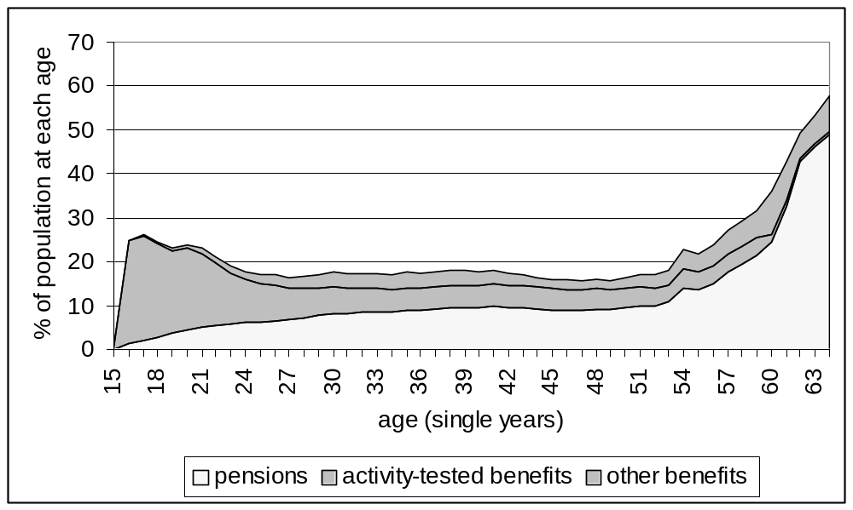
Source: FaCS data, March 2001

The payments received by mature age men and women differ. Most men aged 50 to 64 receive Disability Support Pension, Newstart or Mature Age Allowance, while mature age women are more likely to receive payments for partners or widows.
Figures 14 and 15 show the distribution of payment categories for men and women respectively in NSW in March 2001. Men’s income support receipt rises from the age of 54 to 64. The increase in receipt at this age suggests that this is a point at which men tend to be excluded from the labour market.

Figure 14: Income support categories by age – men aged 15-64 – NSW, March 2001
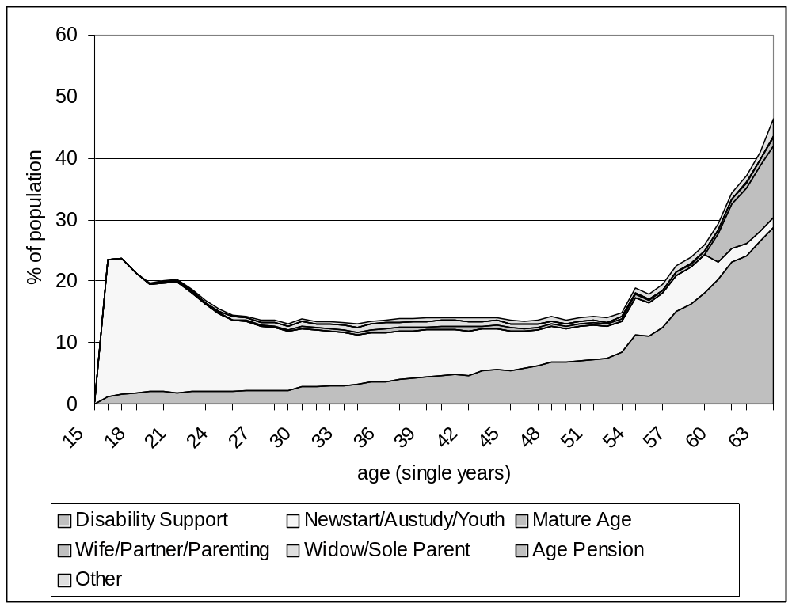
Source: FaCS data

A higher proportion of mature age women receive payments than do mature age men, reflecting the lower employment rate of women, their lower levels of income and assets, and perhaps that the types of income support available to them are more easily accessible and less stigmatising.
The rise in mature age women’s use of social security starts from age 50 but also has a jump at the age of 54, mainly in Disability Support Pension and payments for partners. Prime age women have a relatively high rate of receipt, compared with men, because of the number who are caring for dependent children and are not employed.
The proportion of women receiving Newstart and Disability Support Pension is low compared with men. However, as payments for widows and partners are phased out and the female age pension age is raised, more mature age women are claiming Newstart and Disability Support Pension.

Figure 15: Income support categories by age – women aged 15-61 – NSW, March 2001
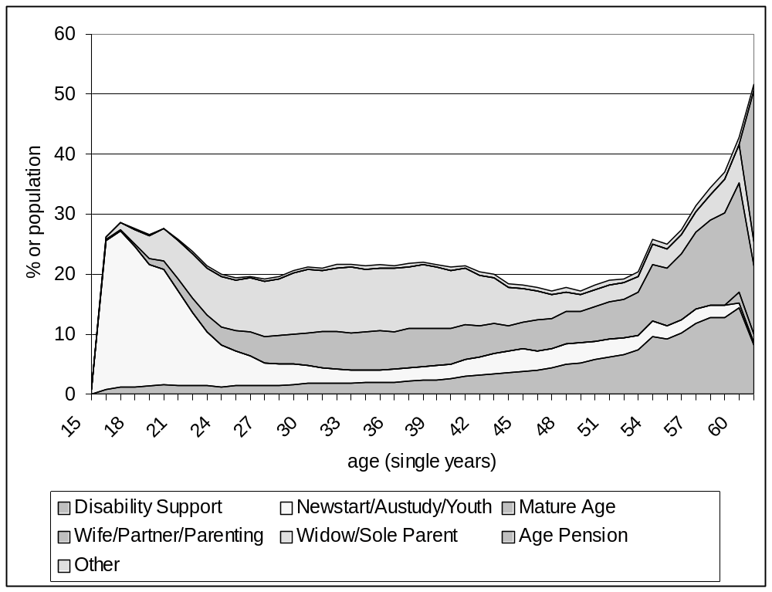
Source: FaCS data

The age specific rates of income support in NSW are very similar to those in the rest of Australia, except for the discontinuity for both sexes at the age of 54, which does not occur elsewhere.

Policy directions
Under current policies, the proportion of mature age women receiving Wife, Widow and Age Pensions will decrease over time. On present trends, this will lead to higher rates of employment for women aged in their late 50s and early 60s, particularly as the coming cohort has higher levels of employment experience than their predecessors. It has already and will continue to lead to higher rates of take-up of Disability Support Pension among those with severe disabilities who have formerly preferred to claim one of the other pensions.
The higher rates of divorce and separation among the baby boom cohort will result in an increase in the proportion of mature age women who are single. This will lead to higher rates of income support receipt among this group.
Women born since July 1955 will not be eligible for Partner or Widow Allowance and are expected to have a higher future rate of take-up of Newstart as a result.
In the 2001 Budget, the Commonwealth Government announced that Mature Age Allowance will be abolished in 2003. Its abolition will be accompanied by various measures to assist mature age people and people with a disability, among others, to undertake training and return to the labour force. These are discussed further in Chapter 9.
Amounts preserved in superannuation funds will no longer be counted under the assets test arrangements for those over the age of 55.
Another measure that affects recipients of Newstart and other payments more generally is the Working Credit, providing an income test concession to those starting work.

Issues for the NSW Government
The tightening of access to income support payments for mature age people and measures to encourage them to find employment need a favourable labour market environment to be effective. It is important that all levels of government respond by encouraging employers to overcome their reluctance to recruit mature age job seekers.
The NSW Government provides a number of concessions to people holding Pensioner Concession Cards and a lesser range to allowees who hold Health Care Cards. These concessions affect public transport, water and sewerage rates and electricity as well as state recreational facilities. NSW provides much the same concessions for pensioners as do other States but provides the least to allowees of any but the Northern Territory and Queensland.
Figure 13 shows that mature age people are not only more likely than people of younger ages to receive income support, but are also far more likely to receive pensions. In addition, long term allowees aged 60 and over qualify for a Pensioner Concession Card. As the population ages, the number of pensioners will rise, although this will be offset to some extent by the reduction in women’s access to pensions.
Low employment levels thus have a direct effect on State revenue through the concessions. The living standards of pensioners and allowees, and their ability to participate economically and in voluntary and community activity, are crucially dependent on these concessions.
Any action that the State can take to facilitate higher levels of employment among this group will not only allow individuals to achieve higher incomes, better living standards and more retirement savings, but would also reduce the drain on State revenue.
NSW, like other States and Territories, provides Seniors Cards to people over the age of 60 regardless of income or assets, if they are not employed more than 20 hours a week. Eligibility for the Commonwealth Seniors Health Card is based on income but not hours of work.
The NSW Seniors Card provides access to concessions for public transport and various recreational facilities. As well, discounts are offered by over 6,500 businesses throughout the State. The NSW Seniors Card website estimates that users can save ‘in excess of $500 per year’. The financial value of these cards may be small relative to earnings. However, eligibility based on hours of work rather than income may give an impression that it is a reward for leaving full-time work before pension age.

8 Superannuation

Introduction
The Australian Constitution limits the Commonwealth Government’s direct power to regulate superannuation. The now rather extensive regulation is largely managed through compulsory standards applying to the schemes that can qualify for favourable tax treatment. Occupational superannuation is concessionally taxed, and the tax subsidies can be seen as an alternative form of public expenditure on retirement income. The taxation power is used to mandate the superannuation guarantee.
The main features of the superannuation standards of direct relevance to this report are the superannuation guarantee, vesting and preservation.
The superannuation guarantee requires that employers contribute to superannuation for all employees below the age of 65, except those with very low wages. This contribution is a percentage of wages and represents a minimum. Many employees have a higher level of coverage.
Vesting means that an employee is entitled to the superannuation contributed by or on behalf of him or her. Before vesting standards were introduced, employees who resigned, were retrenched or left before the fund’s retirement age, or those with a short duration of service, may have had little or no entitlement.
Preservation means that a person cannot draw on his or her superannuation before a certain age (without incurring large tax penalties). The minimum age of access to preserved superannuation is 55, conditional on a stated intention by the member that he or she has retired, or 65 for those not retired. Individual superannuation funds can impose a higher age.
A particular feature of the superannuation system is the custom of taking benefits in the form of a lump sum, rather than an income stream.
The lump sum form and the low preservation age are likely to create a strong incentive to employees to leave work early, despite the fact that they miss out on further accumulation of entitlements. They also provide an incentive for employers to favour the retrenchment of people aged 55 or over because they perceive that those people will be able to use superannuation to support themselves.

History of occupational superannuation
Before the mid 1980s, superannuation was widespread in the public sector but was otherwise mainly confined to high status or managerial employees and white collar workers, particularly in the finance industry. Traditionally most schemes were defined benefit schemes and they varied in terms of vesting and preservation. Schemes often had a minimum period of employment before access and little or no benefit on resignation. Many employees were unable to benefit if they left employment before retirement age and many lower status employees, particularly women, were not covered. Retirement ages also varied among schemes.
In 1986, the Australian Council of Trade Unions, supported by the Commonwealth Government, won a decision through the Conciliation and Arbitration Commission, for a 3 per cent employer contribution to superannuation (with a 1 per cent tax benefit) in lieu of a 4 per cent wage increase. This was to be negotiated under individual awards. The Government’s interest was not only in improving retirement income, but also in encouraging greater household savings and reducing consumption while ensuring that employees maintained a share in economic growth.
In 1992, the Commonwealth Government introduced the Superannuation Guarantee (SG). This requires employers to provide contributions for compulsory minimum coverage of employee, starting at 3 per cent of earnings in July 1992 and rising to 9 per cent by 2002. Those employers who do not do this are charged a special tax, the Superannuation Guarantee Charge, which is passed on to their employees. There are exemptions for a small number of employees, including very low income employees and those aged 65 and over.
The superannuation guarantee represents the minimum cover. Under many schemes, entitlements are higher, and people employed under individual contracts may be able to negotiate how much of their remuneration is paid in the form of superannuation contributions through salary sacrifice. The maximum is regulated on the basis of limits on the benefits that are eligible for concessional tax — $500,000 if taken predominantly in lump sum form, and $1 million in net present value if at least half the benefit is taken in annuity form.

Tax concessions
Before 1983, all employer contributions to superannuation funds were exempt from tax while contributions made by employees were paid from after tax income. Earnings of superannuation funds were non taxable. Benefits taken as a pension were fully taxable as income, while only 5 per cent of benefits taken as a lump sum were taxable.
These arrangements gave a strong incentive for employees to negotiate with employers to maximise the proportion of employer contributions against employee contributions. It also encouraged employees to maximise the proportion of benefits that could be taken as lump sums.
In 1983, the tax treatment of lump sums was changed, to reduce the tax expenditure and to reduce the incentive to take lump sums. This imposed a 15 per cent tax on the first $50,000 and a 30 per cent tax on the remainder if benefits were taken over the age of 55. For benefits taken under that age, the tax was 30 per cent on the total benefit. At that time the top marginal tax rate was 60 per cent. If the member’s marginal tax rate was less than 30 per cent, the tax rate was applied to the benefit. Nevertheless the remaining concessions were substantial because of the compound earnings on the deferred tax component.
In 1988, the tax concessions were reduced by the introduction of a 15 per cent tax on the earnings of superannuation funds and the introduction of capital gains tax. This was offset by reducing the tax on lump sums to nil for the first $60,000 and 15 per cent on the remainder if the lump sum was taken on or after the age of 55, and 20 per cent for benefits taken before that age. Benefits taken in pension form attracted a 15 per cent tax rebate.
In 1992, a tax rebate was introduced for employee contributions and in 1996 a 15 per cent surcharge was introduced on employer contributions for employees earning over $70,000.

Superannuation fund standards
Before 1987, there was relatively little regulation of the design of superannuation schemes. As well as a basic division into defined benefit and accumulation schemes, rules varied widely with regard to access, waiting periods for benefits, benefits on resignation or dismissal, retirement age and other features. As part of the 1986 case before the Conciliation and Arbitration Commission, the Commonwealth, trade unions and employers negotiated on the establishment of new standards.
These came into effect in December 1987 and provided for full vesting of all contributions and earnings apart from administration costs, preservation to the age of 55, establishment of “rollover” vehicles to allow entitlements to be paid on resignation or dismissal while remaining preserved, member involvement in the control of superannuation funds and greater security and accountability.
In 1992, the Commonwealth announced that the preservation age will be raised progressively, affecting those born after June 1960. The preservation age for those born after June 1964 will be 60.

Accumulation and defined benefit schemes
As mentioned, there are two principal types of scheme, defined benefit and accumulation schemes.
Defined benefit schemes provide entitlements based on wage or salary levels at retirement, as well as years of membership up to a limit of, say, 20 years. While member contributions are typically a proportion of earnings, the employer contribution is not allocated individually until benefits are drawn. Most pre 1986 schemes were of this type, particularly in career occupations such as the public sector and financial sector. These had minimum age levels for access to benefits usually at 60 or 65. In general, these have been altered to allow members to withdraw benefits at retirement from the age of 55.
In the main Commonwealth Government fund, people with long term careers can have a higher entitlement if they resign before the age of 55 and preserve their entitlement, than if they retire after the age of 55. This creates a strong incentive to career public sector employees to retire before that age.
The typical post 1986 scheme is an accumulation scheme. In this type employer contributions are made to individual members’ accounts as they earn. The superannuation guarantee must be paid into this type of scheme. These schemes are simpler to understand and allow far greater flexibility for employees to change jobs. Benefits increase the longer the funds are preserved as the assets continue to earn interest, because they are not capped at a certain percentage of final salary.
The accumulation type should therefore provide stronger incentives for individual members to prolong employment.

Summary and future directions
The relatively recent extension of superannuation to cover almost all employees means that the entitlements of current mature age people vary widely. Those who had been covered before 1986, particularly men in more privileged employment sectors, can have sufficient entitlements to provide adequately for their retirement, even when it begins early.
At the other end of the spectrum, those who only became covered in 1992 by the minimum three per cent superannuation guarantee contribution (rising to 9% in 2002), have very little entitlement and most will depend on a full or part age pension in their retirement (after age pension age). This is particularly the case for those who have had low earnings and/or intermittent employment.
Those who continue in paid employment over the age of 65 are able to gain access to their superannuation entitlements without the need to state that they have retired from full-time work. However they are not covered by the superannuation guarantee and their wages are not compensated for the lack of payment of superannuation contributions. This is directly discriminatory in that their total remuneration is lower than that of a younger employee in the same job. They do not have the same capacity to increase their retirement savings as younger employees, although many might not have had access to superannuation coverage during the earlier part of their careers.
The ability of more privileged employees to retire with superannuation at 55 creates issues of equity. Those not fortunate enough to have had long term access and high employer contributions to superannuation are less likely to have sufficient resources to support themselves without recourse to social security when they retire or find themselves out of work. Nevertheless, the image of voluntary early retirement for those at the top of the income and social scale creates aspirations for others to have the same option.
The largest NSW public sector scheme has taken a lead on the preservation age in that members are not able to claim their preserved benefits until the age of 58.
Superannuation is a relatively unconditional and legitimate means of support for early retirement, while Newstart and Disability Support Pension are conditional on demonstrating either continued ‘participation’ or severe long term disability.
In the future, people reaching 55 will on average have higher levels of superannuation entitlements. The preservation age will not begin to increase until 2015, by which time the pattern of early retirement could well have become too entrenched in social expectations to change.

9 Commonwealth employment assistance programs

Introduction
Labour market programs emerged in the early 1970s with the collapse of full employment. Their primary objective is to supplement passive support (social security) for the unemployed with more active assistance.
Whereas people receiving unemployment related benefits had previously been required to seek work as a condition of payment, it was increasingly recognised that in order to find work, many needed assistance through training, work experience, counselling and so on. The requirement to seek work was broadened to include other activities, such as short-term training, participation in labour market programs or part-time employment. The emphasis subsequently shifted to a focus on participation as an end in itself, first with the inclusion of voluntary work and later with the concept of mutual obligation.
Assistance has also been provided to other categories of income support recipients to assist their transition to paid employment on a voluntary basis. Individuals not receiving social security payments were formerly able to register for labour market assistance.
Until 1998, labour market assistance was characterised by a number of separate programs, either offering different types of assistance or aimed at specific groups of unemployed people.
With the establishment of the Job Network in 1998, the Commonwealth substantially withdrew from the role of providing or regulating traditional labour market programs, leaving it to the discretion of employment service providers to purchase or organise training or other programs for their customers. The Commonwealth has, however, returned to the field with literacy and numeracy training and other assistance, particularly for youth, and the mutual obligation programs such as ‘Work for the Dole‘.
The connection with unemployment provided the basis for the Commonwealth’s primary responsibility for labour market programs, although the States have also provided labour market programs of various sorts.
This also provided the basis for distinguishing them from mainstream technical and further education (TAFE): labour market programs were for the unemployed while TAFE was traditionally for the employed.
Training and labour market programs need to be seen as elements of a broader more inclusive category of employment policies and programs, supporting those in work as well as those not in work to maintain or up-grade their skills.
There has always been a tension between the aim of providing services to all who need them and the aim of reducing public expenditure by targeting programs towards social security recipients. There has also been a tension between directing assistance to those required to look for work and allowing non-work-tested recipients to receive assistance as well. Some components of assistance through the Job Network are now restricted to those eligible for income support.

Program types
Employment and training programs in operation recently in Australia can be divided into five broad categories of service provision:
• formal off-the-job training;
• structured training;
• employment experience;
• personal and job search assistance; and
• enterprise, industry and regional development assistance.
Formal off-the-job training refers to preparatory and remedial general education and training. It ranges from accredited higher education and TAFE courses and private sector vocational courses to short courses.
Structured training refers to combinations of employment experience and training, such as apprenticeships and traineeships. The advantages of structured training are the ability to involve industry in the determination of its labour force needs and in providing the trainee with formal skills and workforce experience as well as building a link with an employer.
Employment experience refers to limited duration on-the-job experience with no obligation on the host employer to provide related vocational training. Public programs have included either full or partial subsidisation of wages or unpaid placements. These have varying trade-offs in the incentives for employers and the threat of displacing market based jobs.
Personal and job search support services, also known as case management, include personal counselling, assessment and job search assistance, mobility and relocation assistance, client advocacy and post placement support. It is the intention that, from July 2002, Intensive Assistance under the Job Network will provide greater emphasis on more individualised assistance in response to recommendations in the McClure Report (Reference Group on Welfare Reform, 2000, see Appendix A of this report).
Enterprise development assistance services include small enterprise advice, training and initial income support for unemployed people. These services are provided through the New Enterprise Incentive Scheme.
Regional, industry and enterprise adjustment assistance is designed to assist these entities make labour adjustments in response to, or as part of, structural change. For example, industry assistance can be provided for retrenched employees, with participants being entitled to immediate access to the full range of off-the-job training, employment experience, and personal and job search support services. Enterprise adjustment packages seek to prevent retrenchments by providing restructuring assistance and skill enhancement assistance to companies, and regional packages include assistance with labour market analysis, regional employment, education and training committees, and economic, small business and training strategy development.
To maximise employment prospects the ideal mix or sequence of program assistance will depend on the state of the labour market and individual circumstances.

Assistance for mature age people
While the income support system has tended to place less pressure on mature age jobless men and women than on younger people to actively seek work, mature age people who wish to work have not received a proportionate level of labour market program assistance. There are a number of reasons for this:
• Mature age people are less likely to be eligible for or aware of assistance. Many who are seeking work do not receive income support. Some of this is due to the effect of their retirement savings on the assets test and some because their partners are employed. It may be that some do not feel comfortable with claiming payment to which they are entitled.
• A smaller proportion of mature age than younger unemployed people claim Newstart because of the availability of other income support payments, and those who are receiving Newstart do not have the same level of activity requirements.
• Finally, many programs are either formally restricted to younger people or administered with a bias towards younger people. Very few measures have targeted mature age unemployed people.

History of assistance for mature age people
In 1985, the Committee of Inquiry into Labour Market Programs found that:
… the program emphasis on young people is also clear from the approval figures for 1984-85. Of the programs covered by [the program information system], some 57 per cent of approvals were accounted for by teenagers, with a further 25 per cent going to young people aged 20 to 24 years. … Those aged 45 to 54 years and those aged 55 years and over accounted for only 2.5 per cent and 0.8 per cent respectively of these program approvals (Kirby, 1985).
All programs except the New Enterprise Incentive Scheme (NEIS) had an under-representation of mature age unemployed people, including the employment experience program, JobStart. It was the only program to record better outcomes for mature age people than for other age groups.
The program with the highest mature age representation was NEIS, with 19 per cent representation and a 73 per cent positive outcome rate for mature age participants.
In 1989 and 1991 the first and second Newstart Strategies moved the emphasis to long term unemployed people. The Newstart Strategies were the first moves towards individual case management and activity agreements. The interim Newstart evaluation report noted:
Older job seekers were much less likely to receive job referrals than younger unemployed people in 1992. … (The) older unemployed were also disadvantaged in terms of program places (110 per 1000) but appear to be particularly under represented on JobStart (DEET, 1994).
To address the problems of older clients, the evaluation recommended:
• structured support groups to improve self confidence and motivation;
• self help groups to promote self employment;
• expansion of voluntary work as a stepping stone to paid employment;
• a marketing campaign to change attitudes in the community, among older people themselves and service delivery staff; and
• pre-retirement advice.

The Older Unemployed Strategy
In 1990, the Departments of Employment, Education and Training and Social Security implemented an Older Unemployed Strategy, in recognition of the disproportionate loss of jobs by 55 to 64 year olds. This had five components:
• improved interview, assessment, counselling and referral processes for 55-64 year olds — 3 models: early intervention, joint interview and community brokerage;
• access to labour market programs after one month of unemployment;
• a national strategy to change employer attitudes;
• improved incentives and obligations for labour force participation; and
• increase in benefit payment rates for men 60-64.
The evaluation of the strategy (DEET, 1992) found disappointing results. It found that unemployed people aged 50 and over are vulnerable to particularly rapid demoralisation; that employer discrimination affects those over the age of 45; but that unemployed people aged 50-54 are more willing to participate in training than those over 55.
The early intervention and joint interview models did not improve employment or education outcomes, and the results were inconclusive for the community brokerage model. Early access to labour market programs did not increase participation by the target group, partly because of clients’ reluctance to engage in training and partly due to a lack of appropriate positions.
Wage subsidy assistance was more beneficial in improving employment outcomes for the group than the other labour market programs. The attitude change campaign was local and did not involve a national campaign, and there was some success in improving community and employer attitudes, particularly through direct contact on behalf of individual job seekers. The results for women were better than those for men.
Staff in both Departments supported early intervention strategies for older people. Clients believed that it was important to have contact staff of a similar age who understood their needs. There was support for community brokers, although the lack of a clear definition of their role and inadequate communication between the Departments and the community brokers may have reduced the effectiveness of this intervention strategy.
It also has to be recognised that the barriers to the employment of this group stem from a wide range of interacting factors such as the attitudes of employers, the community and older workers themselves, and the individuals’ personal characteristics and low self-esteem. While the Government may have a leadership role in increasing the opportunities for this group, there are limitations on what can be achieved (DEET,1992).

Working Nation
The Working Nation Package and Job Compact were introduced in 1995. The range of activities allowable under the activity test were broadened to include part-time work and voluntary work, particularly for older clients, as well as labour market and training programs.
The Job Compact guaranteed a job offer for all people who had been receiving unemployment payment for 18 months or more and recipients were required to accept the offer. Case management for long term unemployed people was expanded and provided by either the CES or by contracted non-government agencies.
Another major component of the Working Nation strategy was early intervention for those assessed as at risk of long term unemployment.
Assessment of eligibility for early intervention (immediate case management) was by means of a job seeker classification instrument (JSI) and CES staff judgement. Apart from those aged under 18, the probability of being assessed as at risk was weighted towards those aged 45 years and over. The evaluation of the Working Nation Package reported:
There were no specific measures in Working Nation for older job-seekers and there has been some concern that this group may not be receiving enough assistance. In 1994-95 job seekers aged 50-64 years represented 12 per cent of the CES register. As they were 15 per cent of all recipients of Newstart, Job Search and Youth Training Allowance clients, this indicates that they have a higher rate of exemption from the activity test than younger clients. They represented a higher proportion of clients in case management (16%) but received a significantly lower proportion of other types of assistance. They represented 8% of all labour market program participation, including only 4% of employment program participants and 6% of JobStart participants. They also received only 6% of job referrals. … [Since Working Nation] their share of all labour market program assistance has increased by two percentage points, including a three percentage point increase in their share of employment program places and a two percentage point increase in their share of job search and JobStart programs places (DEETYA, 1996).
In 1994 ten Mature Workers’ Centres were established within the SkillShare program, and a further five were added in 1995. These centres provided job referral, needs assessment, advocacy to employers and personal support, focussing on the needs of participants aged 35 years and over.
This brief overview shows that over the last two decades mature age unemployed people have not received a proportionate share of mainstream labour market assistance, even as the focus moved from young people to the long term unemployed. The availability of non activity tested social security has been accompanied by a long standing lack of assistance for those who wish to find re-employment.

Current labour market program arrangements
Labour market programs from 1970 to 1998 evolved in a number of ways:
• from programs towards an individual case management approach;
• from national standards towards decentralised local delivery and administration;
• towards greater articulation between labour market programs and the vocational education and training system;
• putting greater emphasis on reciprocal rights and obligations for individual registrants, employers and society;
• towards a more participatory approach to local, regional and national policy development and delivery, involving the community, unions and employers.

Centrelink and the Job Network
In 1997, delivery of income support and labour market assessment were brought together through the establishment of Centrelink.
In 1998, labour market assistance was contracted out to the Job Network, comprising public, commercial and not for profit agencies, competing for Commonwealth labour market assistance through tendering.
Job Network agencies provide three levels of service: Job Matching, Job Search Training and Intensive Assistance. Funding is provided on the basis of the number of cases and successful outcomes. Instead of the suite of labour market programs available under Working Nation, service providers are left to decide what services and assistance to purchase or offer, within loose guidelines.
• Job Matching entails basic employment agency services: obtaining vacancies from employers and recording these on the National Vacancy Data Base; meeting with job seekers, identifying their skills, helping them prepare resumes and matching them with employers.
• Job Search Training is offered over 15 consecutive days “to help job-seekers adapt to the routine of work” (DEWRSB, 2000a). Providers are required to interview all individuals referred to them, assess their needs and employment barriers, negotiate a job search skills plan, provide support and practical experience and provide office facilities.
• Intensive Assistance provides case management for 12 or 18 months depending on the disadvantage of the job seeker.
Service providers were able to tender to deliver specialist services to nominated disadvantaged groups. In the first round of contracts 12 providers provided specialist services for mature age job seekers, but there were none in the second round. None of the first round mature age specialist services were in NSW.
Only people who are eligible for income support are eligible for job search assistance and intensive assistance. Age Pensioners, Mature Age Allowees and Sickness Allowees are not eligible. As with people not receiving income support, they are only able to seek job matching assistance. Full-time students and people working more than 16 hours a week are not eligible for any form of assistance.
Other current programs include the:
• New Enterprise Incentive Scheme (NEIS), delivered through the Job Network;
• Jobs, Education and Training Program (JET);
• Return to Work Program;
• New Apprenticeships;
• Indigenous Employment Program; and
• Community Support Program.

Participation in Job Network
Centrelink assesses a job seeker’s level of need using the Job Seeker Classification Instrument (JSCI), a re-designed version of the JSI, which may be accompanied by other forms of assessment. Points are allocated on the basis of a client’s socio-economic and socio-cultural characteristics (age, educational qualifications, duration of unemployment, family status, location, English language and literacy, indigenous status, disability, and so on), with the more disadvantaged receiving the higher scores.
Those with severe and multiple disadvantages may be eligible for the Community Support Program, while those with disabilities may be eligible for disability services available through the Department of Family and Community Services.
Table 20 gives the age profile of all income support recipients, the Job Network eligible population and participants in Job Search Training, Intensive Assistance and NEIS.
Table 20: Age profiles, Income Support, Job Network, Job Search Matching and Intensive Assistance, May to Sept 2000
 | Age Group |  | Income support |  | Job Network eligible* |  | Job Matching Placements** | Job Search Training | Intensive Assistance | NEIS
 |  | Each age group as % of total column
15-24 |  | 22.8 |  | 32.4 |  | 42.8 |  | 35.4 | 22.8 | 9.3
25-34 |  | 19.0 |  | 24.7 |  | 25.3 |  | 31.0 | 25.1 | 34.3
35-44 |  | 18.7 |  | 19.7 |  | 16.6 |  | 21.1 | 22.1 | 33.0
45-54 |  | 15.9 |  | 15.6 |  | 11.9 |  | 9.8 | 21.2 | 18.8
55-64 |  | 23.5 |  | 7.5 |  | 3.3 |  | 2.7 | 8.9 | 4.6
Total |  | 100.0 |  | 100.0 |  | 100.0 |  | 100.0 | 100.0 | 100.0
Source: DEWRSB, 2001, p25, FaCS data at June 2000
Note: Data from the Job Network Evaluation: Stage Two have been used as more recent monitoring data do not break down the age group over 45.
*”Job Network eligible” includes those who are receiving income support (other than ineligible payments) and who are registered with Centrelink as unemployed.
** Job Matching Placements include only Job Network eligible people

Although 24 per cent of income support recipients of workforce age were aged 55-64, one-third of those received Age Pension, Mature Age Allowance and Sickness Allowance and were not eligible for Job Search Matching or Intensive Assistance. Of the other two thirds, it appears that only half as many of those aged 55-64 have registered with Centrelink as unemployed, compared with income support recipients aged 45-54. However, as Mature Age Allowance and the lower female Age Pension age are phased out, many more of this age group will be expected to become Job Network eligible.
The proportion of the Job Network eligible population participating in Job Matching and Job Search Training falls with age as the proportion in Intensive Assistance increases. This reflects the higher JSCI scores of the older groups. Thus those aged 45-54 and 55 and over are under-represented in Job Matching placements and Job Search Training, as more of them qualify for Intensive Assistance. The age groups 35-44 and 45-54 are over-represented in NEIS, while those aged 55 and over are under-represented.

Outcomes for mature age jobseekers
Table 21 provides details on post assistance outcomes for Job Matching, Job Search Training and Intensive Assistance to September 2000. For Job Matching a positive outcome is defined by being in employment or in education three months after placement. For Job Search Training and Intensive Assistance, positive outcomes are participants who ceased assistance between May 1998 and June 2000 who were employed by September 2000. Employment rates include not only those placed through the program but also those who found employment themselves.
Table 21: Post assistance outcome rates by age, May 1998 to September 2000
Age Group | Job Matching | Job Search Training | Intensive Assistance | Job Matching | Job Search Training | Intensive Assistance
 | % employed |  |  | % in education
Under 18 | 65.0 | 38.2 | 31.3 | 17.9 | 19.5 | 21.6
18-20 | 76.9 | 42.3 | 36.2 | 18.7 | 18.2 | 14.7
21-24 | 71.6 | 43.3 | 37.0 | 13.2 | 17.9 | 12.6
25-34 | 67.9 | 40.3 | 38.3 | 8.5 | 12.6 | 9.7
35-44 | 67.4 | 36.1 | 37.4 | 6.0 | 11.2 | 8.5
45-54 | 71.3 | 35.6 | 36.2 | 6.9 | 9.3 | 6.0
55 and over | 65.3 | 25.6 | 25.0 | 5.9 | 5.7 | 3.2
TOTAL | 69.7 | 38.4 | 35.4 | 10.0 | 13.6 | 8.1
Source: DEWRSB, 2001, pp 46-49

Not surprisingly, the employment outcome rate was highest for Job Matching, 70 per cent, as these refer to actual placements and this group is also the least disadvantaged. The rate of positive outcomes among mature age people from Job Matching increased between 1999 and 2000.
The overall rate of employment after Job Search Training was slightly higher than that for Intensive Assistance, 38.4 per cent compared with 35.4 per cent.
However the relative distribution across ages differed between these three categories of assistance. The positive employment outcomes from Job Matching placement were above average for 45-54 year olds and below average for those aged 55 years and over. For Job Search Training the highest employment outcomes were for those aged between 18 and 34, while those after Intensive Assistance were more evenly spread. For those aged 35 and over, the Intensive Assistance outcomes were almost the same, if not slightly higher, than those from Job Search Training.
The rates of positive education and training outcomes declined with age for all three categories.
In the Stage Two evaluation (DEWRSB, 2001), outcomes for people participating in Intensive Assistance were analysed to measure the net impact compared with outcomes for non-participants. Patterns of leaving Intensive Assistance and positive outcome rates over time indicate that those who leave assistance early are more likely to achieve a positive employment or education outcome than those who participate longer. Of those who leave in the first month some 70 per cent were in employment or education three months after leaving.
At the other end of the spectrum, over 70 per cent of those participating for 12 or more months leave without securing a positive outcome. These people go to another provider, leave due to incompatibility with the provider, change income support type or reach the end of their assistance. The group with the longest participation time in Intensive Assistance was those aged 55 years and over. This age group of job seekers is more likely to leave due to their qualifying for another income support payment or to their leaving the labour market.
The Intensive Assistance cost per employment outcome is higher than that of JobStart, the former marginal wage subsidy based employment experience program. Given the effectiveness of JobStart for mature age job seekers — a 62 per cent positive outcome rate — and given that subsidised work experience is not used extensively by Job Network providers, it may well be time to consider making specific provision for subsidised work experience for mature age long term Intensive Assistance participants. Such provision could well contribute to a significant improvement in outcome rates for mature age participants.

New Enterprise Incentive Scheme
The New Enterprise Incentive Scheme (NEIS) has been incorporated into the Job Network. Services include marketing, assessing business ideas, training in business skills, approving business plans and self-employment development assessment. To be eligible, a person must be Job Network eligible, that is receiving income support other than excluded payments and registered with Centrelink as unemployed. As well he or she must be aged 18 or over, looking for full-time work and have a potentially viable business idea. Those with approved plans are not required to seek other work for 12 months, or 6 months for self-employment development.
Table 22 shows the outcome rates after participating in the NEIS program. They are higher than those following the other categories of assistance and that reflects the nature of the selection process. Older groups were as successful as those of prime age in establishing self-employment. However, younger participants who did not succeed with their plan were more likely to have become employed than the older groups, particularly those aged 55 and over, and far more likely to have gone into education or training.
Table 22: Post assistance outcomes for NEIS by age, May 1998 to September 2000
Age Group | Self-employed | Employed | Total Employed | Education/Training
 | % with positive outcome
Under 21 | 28.2 | 31.7 | 59.9 | 16.7
21-24 | 59.2 | 25.8 | 85.0 | 14.2
25-34 | 65.5 | 18.1 | 83.6 | 9.1
35-44 | 67.4 | 13.0 | 80.4 | 8.4
45-54 | 64.3 | 15.8 | 80.1 | 7.9
55 and over | 67.8 | 10.0 | 77.8 | 6.4
TOTAL | 65.2 | 16.0 | 81.2 | 8.9
Source: DEWRSB, 2001, p.52

Other programs
The Community Support Program (CSP) was introduced for those with severe or multiple disadvantages considered not ready for the assistance provided by the Job Network. The evaluation of Working Nation had found that case managers estimated that:
… about 15 per cent of their case loads would not be able to find sustainable employment even with intensive assistance [due to] age, lack of motivation, low self-esteem, substance abuse, having a disability, limited or outdated skills, English language difficulties and geographical isolation (DEETYA, 1996).
CSP was designed to provide more appropriate assistance through needs assessment, personal support and referrals to specialist services. Participants might receive assistance with finding stable accommodation, dealing with alcohol or other substance abuse problems, financial difficulties, gambling and so on, and are not required to look for work during the duration of the program.
Only Newstart recipients are eligible to participate in the Community Support Program. Those who transfer to other payments such as Partner, Parenting or Widow Allowance, while participating, are able to remain in the program. Those who transfer to Disability Support Pension, Mature Age Allowance or Age Pension do not continue in the program. The majority of participants are prime aged. Twelve per cent are aged 50-59, while 0.4 per cent are aged 60 or over. Sixteen per cent of people receiving Newstart are aged 50-59 and 2 per cent are aged 60-64, so mature age people are under-represented on CSP.
The New Apprenticeships Program is largely targeted to youth, although participation among people over 25 grew from 16 per cent in 1995-96 to 41 per cent in 1998-99. Separate figures are not available for those aged 45 and over.
The Jobs, Education and Training (JET) Program is available to income support recipients receiving certain payments, such as Parenting Allowance, Carer Payment and Widow Allowance. The Return to Work Program is designed for people returning to the workforce after a long period caring for children or people with disabilities. This is discussed further in Chapter 10.

Policy directions
As part of Australians Working Together, announced in the 2001 Budget, the Commonwealth Government has announced changes in policy for people aged between 50 and age pension age. The focus will be on moving people towards working or upgrading their skills and experience to find work.
All Newstart recipients in this age group will be required to develop an activity plan. However, the range of acceptable activities will recognise that the circumstances, skills, recent workforce experience and aspirations of mature age people vary considerably. Activities such as caring and voluntary work will be recognised within the new requirements. These requirements are not as great as those for Newstart recipients aged under 50.
People will also be given help to identify any obstacles they face in finding work and, where appropriate, will be referred to relevant programs and services to assist them. There will be additional places for mature age people in programs and services such as literacy and numeracy training, rehabilitation, disability services, education, training, financial information and counselling. There will also be allowances (Training Credit and Literacy and Numeracy Training Supplement), for people undertaking training. As mentioned in Chapter 7, an income test concession for earnings (Working Credit), will be introduced to encourage people to take up short term or casual work opportunities.
The Community Support Program will be replaced by the Personal Support Program. The number of people that can be assisted will be tripled to 45,000 and the level of funding per participant will be increased. The new program is intended to have a broader focus, not just on improving the capacity of participants to work, but also on assisting them to stabilise their lives and become more socially functional.

Summary
To sum up, mature age unemployed people have:
• a relatively low placement rate for job matching;
• a relatively low rate of both eligibility for and positive outcomes from Job Search Training;
• a relatively high rate of eligibility for and participation in Intensive Assistance, but relatively low positive outcome rates;
• a relatively high rate of participation in and almost average rates of positive outcomes from the New Enterprise Incentive Scheme; and
• relatively low use of the Community Support Program.
The total Commonwealth labour market assistance system continues to devote more resources to young people than to mature age people. There are no specialist services for mature age people in the Job Network.
Many respondents to the Inquiry into Mature Age Workers (House of Representatives, 2000) suggested that mature age people had particular needs that were not the same as those of younger people. Older men have often been in the same job for many years before being retrenched, have low levels of formal skills but high levels of work experience and are naive in the job market. Older women have often had intermittent employment.
The Job Seeker Classification Instrument appears to direct more Job Network assistance to mature age job seekers, and those with socio-economic and socio-cultural characteristics which compound any age based disadvantage are identified for priority assistance. Despite this, mature age job seekers are under-represented among people using overall Job Network services and among people with successful outcomes.
In 2000-2001, the Commonwealth trialled some new interventions for mature age people receiving Newstart, Partner, Widow or Mature Age Allowance and those not receiving income support. The interventions consisted of in depth interviews with Centrelink officers, development of a participation plan and agreed activity strategy, with follow-up interviews 2 and 6 months later. Cash assistance was available to assist participants overcome identified barriers. Results of this intervention are not yet available.
The measures announced under Australians Working Together to provide special assistance for mature age people are welcome initiatives.

10 Disability and caring responsibilities

Introduction
Mature age people are more likely than younger people to have caring responsibilities (apart from caring for their children), short term or chronic ill health or disabling conditions. This chapter describes the programs and initiatives aimed specifically at people with a disability and carers, including mature age workers, and highlights the barriers to access often faced by eligible people of mature age. It focuses on initiatives developed by the NSW and Commonwealth Governments to assist carers and people with a disability maintain employment and/or return to the workforce.

Characteristics and extent of caring
Many mature age workers or reluctant retirees, especially women, have significant caring responsibilities, particularly for elderly parents, and/or a chronically ill or disabled spouse. Some are caught in the middle of two generations — caring for younger family members as well as elderly relatives. In Chapter 3, Table 8 showed that, among 45-69 year old women who had left a job in the five years to 2000, 12 per cent of women (compared with 3 per cent of men) gave family and caring responsibilities as a reason for leaving work. Altogether there are 798,000 carers in NSW (Cat. 4430.0, 1998).
The likelihood of being a primary carer of a person with disability is highest in middle age. An ABS survey in 1998 showed there were 161,600 primary carers aged 45-54 years in NSW (Cat. 4443.1, 2001). This was the largest number of carers in any age group. However, the largest proportion of carers were aged 55-64 (24%). Increasingly, this age group cared for partners or parents rather than for children. Half the primary carers provided assistance for 20 hours or more a week, of whom 53,600 reported an average of over 40 hours per week.
The 1998 Survey of Disability, Ageing and Carers also showed that there were 67,100 primary carers in NSW who were either unemployed or not in the labour force. Of these, one third (22,200) indicated they would like to work if suitable employment was available, with three-quarters of these stating a preference for part-time work. The Victorian Carers Program, a large scale survey using a representative sample of carers, found that two thirds (67%) of all carers who were not in paid work would like to be, either while giving care or after it ceases (Schofield et. al.,1998).
Fifty per cent of carer pensioners in NSW are aged 50-64. There are many other mature age people whose caring responsibilities constrain their employment options, who are either receiving other payments or who are ineligible for social security payments.

Mature age and disability
There is a significant correlation between disability and age. Disability or ill health peaked as a reason in Table 8 for leaving or losing work among 55-64 year old men and women (23 per cent). Sixteen per cent of men and women overall identified it as a reason for leaving work. Disability and chronic or acute ill-health not only act as a trigger for many to leave the workforce, but are also significant factors in reducing the capacity of mature workers to find another job when they are ready to do so.
As noted in Chapter 6, both the Commonwealth and States have responsibilities in the area of assisting people with a disability and people with caring responsibilities to remain in or return to paid work. These relate to income support, program initiatives and legislative responses such as anti-discrimination legislation (see Chapter 12).

Commonwealth programs and services

Income support
Commonwealth social security payments including non-activity tested pensions such as Disability Support Pension and Carer Payment are described in Chapter 7. While there has been an increasing link between income support recipients and certain labour market programs over the past 4-5 years, the reality is that many mature age workers with a disability and/or caring responsibilities are not actively encouraged to join labour market programs.
To qualify for Carer Payment, caring responsibilities have to be extensive and thus the vast majority of recipients would not be seeking work. Recent changes to the eligibility criteria now allow a carer to work 20 hours a week, rather than the former 10. Caring responsibilities can also be time-limited, so many would be seeking a return to the workforce. Similarly, to obtain Disability Support Pension, claimants are subject to an impairment assessment and assessment of their incapacity to work full-time.
Carer Payment recipients are able to access the Jobs, Education and Training Program (JET) and those who have been substantially out of the workforce because of caring responsibilities may be eligible for the Return to Work Program.
In September 2001, of the 260 Carer Payment recipients participating in the JET Program, Australia wide, only 14 per cent were aged 50-64. Seventy-three per cent of Return to Work participants were aged 35-54, and 2% aged 55 and over.
These programs are designed to help people such as sole parents and carers to enter or re-enter the workforce through assessment, counselling, education and training, as well as help to develop plans for returning to work. Participation is voluntary. From 2002, under Australians Working Together, these will be restructured into a Transition to Work program, with some elements of JET remaining separate.
Fourteen per cent of men aged 50-64 and 9 per cent of women aged 50-60 in NSW receive Disability Support Pension. Over half of all Disability Support Pension recipients are aged 50 or over. Many of these may be able and wish to undertake some level of paid work and they should have access to labour market assistance to enable them to do so.
The Australians Working Together initiatives, to be implemented progressively from 2002, are likely to change the landscape for mature age recipients, with a greater proportion being streamed into Newstart and others, such as disability support pensioners, being offered more labour market assistance. Training Credits of up to $800 will be available from July 2002 for mature age job seekers. Nevertheless, many mature age people below 65 will remain disability support pensioners and will not be encouraged to re-enter the workforce unless specific targets are set.

Employment services and vocational rehabilitation
Commonwealth employment programs for people with a disability have always been administered quite separately from mainstream labour market programs, and under separate enabling legislation. Since 1986, this has been the Disability Services Act. The Programs administered under the Act, which include the Disability Services Program and the Commonwealth Rehabilitation Service (CRS), are not entitlement programs like social security payments. Each targets its resources under agreed guidelines and services are expected to work closely with generic labour market programs, currently the Job Network.
Both the Disability Services Program and the CRS are overwhelmingly targeted towards younger people, not mature age persons.
In 1998, only 9 per cent of participants in Commonwealth disability employment services were aged 50 or over, while 55 per cent of disability support pensioners were that age.
The CRS also tends to focus on younger people — in 1998-99, 29 per cent of new entrants were aged 45 and over, as compared to 67% of disability support pensioners. The figures are, predictably, starker for those aged 60-64, who make up 19 per cent of disability support pensioners but only 0.9 per cent of CRS clients.
The Disability Services Program bias towards younger people with a disability (especially those 15-24) is long standing. It is associated with the type of disability targeted, particularly people with lifelong moderate to severe intellectual disabilities and/or long term physical disabilities identified in childhood or early adulthood. Many employment support services, particularly for people with an intellectual or other developmental disability, are provided immediately post-school.
The majority of services also focus on job-seekers who need support on the job in the workplace, rather than simply assistance with getting or preparing for work, for example, preparation for interview and job placement, re-training, workplace adjustment or redesign of duties. It is highly probable that many mature age workers with a disability — whether or not they are disability support pensioners or recipients of another income security payment — require little or no support on the job because of their disability. Mature age job seekers with a psychiatric disability may be the exception.
However, under the Australians Working Together changes, from September 2002 the Disability Services Program intends, not only to increase the total number of places, but also to expand its focus to specifically target mature age workers.

Job Network
The replacement of Commonwealth labour market assistance with the Job Network changed the way services were delivered to people with a disability who were not eligible for Disability Support Pension, or who were eligible and sought assistance through Job Network on a voluntary basis.
As we saw in Chapter 9, in the first round of tenders for the Job Network a number of providers won contracts to provide specialist services for mature age people, although none were in NSW. In the first round (DEWRSB, 2000a), there were more sites specialising in services for people with a disability: 48 to provide Job Matching, 12 for Job Search Training and 34 for Intensive Assistance (out of 745 Intensive Assistance sites in total). It is not clear how many provided more than one level of service.
In the second round, specialist services were engaged only for Intensive Assistance. No sites were funded to provide specialist services for mature age people and 24 were funded for people with a disability, out of a total of 1,119 Intensive Assistance sites (DEWRSB, 2001). This represents a substantial shift towards mainstreaming of these disadvantaged groups.
The two evaluation reports (DEWRSB 2000a and 2001) do not show participation in services and outcomes for people with a disability by age.

Linking labour market programs and disability employment programs
Since 1991, when the Commonwealth introduced the Disability Reform Package, there has been a greater interaction between mainstream labour market programs and disability employment and vocational rehabilitation programs.
Mainstream employment services included certain provisions for people with a disability, including work experience with wage subsidies, post placement support and training, and subsidies to employers to reimburse them for the cost of workplace modification needed to accommodate people with a disability. These services were intended for jobseekers with a disability of all ages, including disability support pension recipients.
The Disability Services Program provides funding for competitive employment training and placement (CETP) services and supported employment services. These focus largely on the employment needs of people with an intellectual disability, who are encouraged to access these services post school or in early adulthood. Rehabilitation services are provided by the CRS.
The evaluation of the Disability Reform Package (Disability Task Force, 1995) found that although disability increases steadily with age, 78 per cent of Disability Service Program clients were aged under 35 (compared with 18 per cent of disability support pensioners), 72 per cent of CRS clients were aged under 45 (34 per cent of disability support pensioners) and 97 per cent of DEET clients with a disability were aged less than 55 (60 per cent of disability support pensioners). Unfortunately the data used from different sources used different age ranges.
The evaluation also found that, although around 55 per cent of disability support pensioners were aged 50 and over, they made up only 16 per cent of those referred for panel assessment and assistance and received less than 5 per cent of disability employment services (Disability Task Force, 1995).
Figure 16 compares the age profile of disability support pensioners in June 1992, 7 months after the Disability Reform Package was implemented, and in June 2000.

Figure 16: Disability support pensioners: percentage of population by age by sex, 1992, 2000
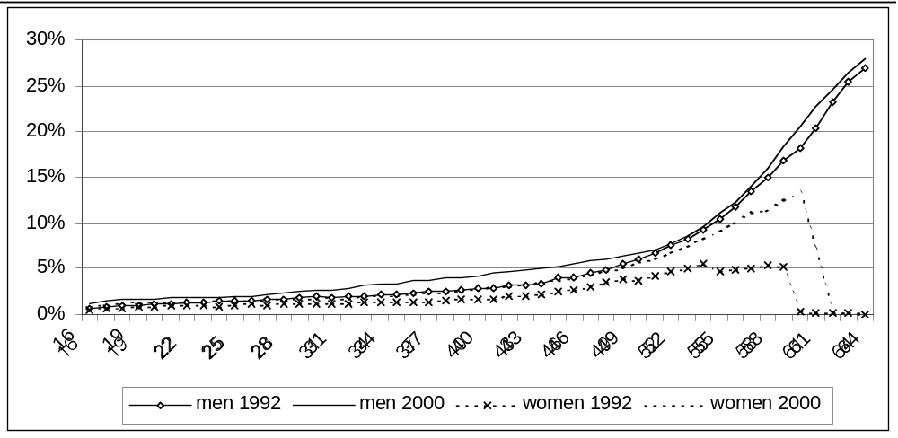
Source: FACS Data, ABS Estimated Resident Population

This shows that, as a percentage of men and women at each age, there has been a rise of 1 or 2 per cent in male take-up of Disability Support Pension among prime age and mature age men, a similar increase among prime age women and a more than doubling of take-up among women between the ages of 56 and 60.
Table 23 shows the age profile of recipients of Commonwealth/State Disability Agreement services in 1998.
Table 23: Age profile of CSDA service clients – 1998
Age group | NSW | Commonwealth
 | % | %
0-4 | 6.7 | 0.0
5-14 | 11.6 | 0.0
15-24 | 17.2 | 22.7
25-44 | 40.6 | 58.4
45-59 | 17.3 | 17.2
60+ | 5.6 | 1.6
not stated | 0.9 | 0.0
Total | 100.0 | 100.0
Number | 12793 | 18137
Source: AIHW, 1999, Table A3.1

Future directions for mature workers with a disability
Given plans under Australians Working Together to specifically target mature age workers, consideration could be given to combining the expertise of the NSW Mature Workers Program and the Disability Services Program. The joint delivery of programs and/ or encouragement of Mature Workers Program providers to tender for the new places should be given serious consideration.

NSW programs and services
The NSW Government administers and/or funds a range of programs and services which are critical to the employment prospects of many mature job seekers or employees with a disability or caring responsibilities. These include anti-discrimination measures and complementary employer awareness initiatives — outlined in Chapter 12 — as well as injured worker rehabilitation, respite care and other carer support initiatives. In addition, the NSW Government has committed itself to removing barriers to employment and government services for people with a disability.

NSW Government Disability Policy Framework
The goal of the NSW Government Disability Policy Framework 1998 is “a society in which individuals with a disability and their carers live as full citizens with optimum quality of life, independence and participation” (NSW ADD and NSW Health, 1998).
The Framework has three objectives:
• The achievement of a planned, coordinated and flexible approach to policy and service provision in NSW for and with people with a disability and their carers.
• The creation and promotion of opportunities, services and facilities which enable people with a disability and their carers to participate in the wider community and to attain a better quality of life.
• Provision of ways for State Government service providers to measure and report on their progress in increasing access for people with a disability.
The Framework encourages all State Government agencies to identify barriers to access to services, facilities and employment opportunities for people with a disability and their carers. Additionally, the policy encourages life long learning for older people with a disability.
Given that the NSW Disability Services Program provides funding for respite for the carers of people with a disability, consideration should be given by the NSW Government to working with the NSW Mature Workers Program and/or Job Network providers to develop and resource models that would maintain and support the carers of people with a disability in employment.

Support for carers
Other initiatives include the NSW Government’s Care for Carers Program which is the joint responsibility of the NSW Health Department and the Department of Ageing, Disability and Home Care. The budget for this program is $12.9m over four years and the objectives are to:
• provide additional services for carers;
• strengthen existing measures to support carers; and
• promote the broader community’s support for carers.
This initiative recognises and complements the various respite and other carer support services available through the Home and Community Care Program, the Disability Services Program, Commonwealth aged care strategies, Veterans’ programs and other initiatives. These programs, providing services to carers of older people and children and adults with a disability, are growing in size and significance. However, the allocation of hours per person for respite still severely limits the capacity of a carer to sustain full-time or even part-time employment. Most who are working are only able to sustain employment through a combination of formal respite and private arrangements.

Workers’ compensation
There is also evidence that the NSW workers’ compensation system tends to classify mature age claimants as being less able to return to work than younger claimants.
Figure 17 shows the incidence of injuries regarded as short-term, long-term or permanent per 1000 wage and salary earners in 1998-99 (Workcover Authority of NSW, 1999).

Figure 17: Injuries by duration per 1000 wage and salary earners, 1998-99
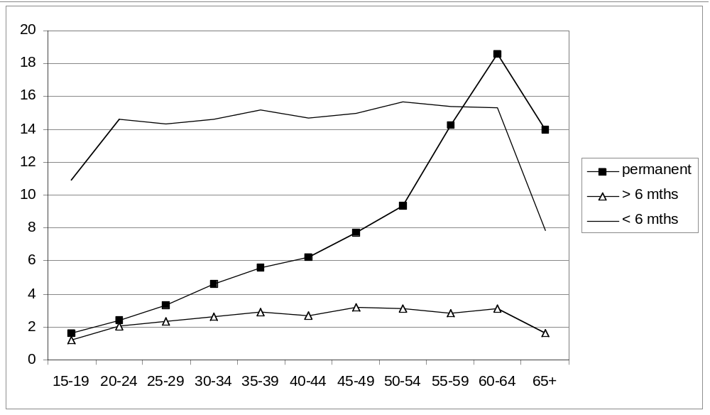
Source: NSW Workers Compensation Statistics 1998-99, Table 1.3

This shows that the incidence of successful workers compensation claims rises with age to a maximum of 37 per 1000 wage and salary earners aged 60-64. However the increase is almost all due to cases regarded as causing permanent incapacity. It is beyond the scope of this report to examine whether or why the incidence of injury or work related medical conditions is higher among mature age wage and salary earners in NSW.
Under the NSW Workplace Injury Management Act 1998, an insurer must establish an injury management plan for injured workers with significant injuries. Depending on the situation, employers, insurers, WorkCover NSW and the injured worker have responsibility for establishing a return to work program. This might consist of work being found within the worker’s capabilities, vocational re-education, subsidies to employers and so on. The capacity of the worker to return to employment is assessed by an authorised rehabilitation service provider, on the basis not only of medical reports but on their assessment of the needs and capacities of the injured worker.
There are a number of features of this system that appear likely to result in greater assistance being given to younger workers. First, the assessment of the person’s likelihood of being able to return to employment would probably take into account the work opportunities and the worker’s capacity to benefit from re-training. As we have seen in earlier chapters there are many factors – including skill levels and career background, employer and employee attitudes and the low levels of access to and participation in training – that make a mature age person, particularly one with a disability, less likely to find re-employment. Anecdotal evidence suggests that employers may be reluctant to take on a worker with a history of workers’ compensation claims. Financial factors also come into play as the loss of potential earnings (and therefore also compensation Iiability) is much higher the further away a worker is from retirement. Therefore it may be that insurers regard expenditure on rehabilitation and re-training for mature age workers as less cost effective than expenditure on younger workers.
It is not clear whether there has been any substantial research on whether these considerations do result in direct or indirect discrimination against mature age workers. There is scope for further research on whether the same condition is more likely to be assessed as causing permanent rather than temporary incapacity, if the injured worker is of mature age.

Summary
People with a disability and primary carers are likely to face difficulties in finding employment. The difficulties vary with the type and severity of disability, the adequacy of formal and informal respite support services and the other work related advantages and disadvantages, in particular, age.
Employment services provided vary with the type of disability. The Disability Services Program tends to focus on people with intellectual and psychiatric disabilities, who make up 80 per cent of participants, while another 6 per cent have learning disorders or acquired brain injury. Less intensive employment services may be provided by Job Network specialist or mainstream providers.
Resources for employment services for people with a disability are limited. The bulk of assistance seems to be directed to those who are expected to benefit the most, that is, those furthest from retirement. However, mature age people have the highest rates of disability. They also have the highest rate of caring responsibilities.
People with the double disadvantage of age and disability seem to have very limited access. However, the literature on employment for people with a disability has very little information on age profiles. Further research would be helpful on the interaction of age and disability, taking into account the type and severity of disability. This would assist policy makers analyse the level to which the barriers faced by mature age people with a disability are due to the impact of disability or due to combinations of age and disability discrimination.
Similar effects are likely in the workers’ compensation system, where there is anecdotal evidence of age discrimination and of assumptions being made that injured workers would have retired early anyway in the absence of the injury.
In both the Commonwealth Job Network and the State workers’ compensation systems, return to work services are provided by private organisations. The design of the funding they receive can make a significant difference to their capacity to meet the needs of people with the most severe barriers or combinations of barriers. While specialist programs are designed around a particular barrier, such as disability, they are less likely to take into account the particular needs created by other barriers. This ‘silo approach’ is problematic from the point of view of equity.
The cost to taxpayers of providing the resulting Disability Support Pensions on the one hand and the cost of compensation for the high incidence of ‘permanent’ injury on the other, warrants far greater attention to overcome the specific employment barriers facing mature age job seekers.
Additional programs could be developed to address the impact on employment of the functional disabilities characteristic of mature age people, such as mobility disabilities, along with meeting the particular labour market needs of this group. An injured worker of 50 should be seen as having the potential to work until 65 or beyond. Instead there seems to be a tendency to ‘write off’ such a person and turn a blind eye to their financial needs, and to their desires to continue to participate economically and socially. Paradoxically, at the same time there is concern at the growing cost of disability support pensions and workers’ compensation.
To conclude, there is scope to develop and pilot mature age worker projects which would use the combined expertise of rehabilitation providers, the Mature Workers Program, the Disability Services Program (both employment services and respite services) and other carer initiatives, in co-operation with the Commonwealth Australians Working Together initiative.

11 Labour market assistance in NSW and other States

Introduction
The NSW Government has several programs to provide labour market assistance and vocational training for people who are unemployed, of which the one most relevant to this report is the Mature Workers Program. The other States and Territories have also established programs of various kinds aimed at mature workers. Other target groups for NSW Government assistance are indigenous people, youth and people from non-English speaking backgrounds. Programs for these groups are also typically found in other States, with varying levels of priority.
To avoid overlap with Commonwealth responsibility, such programs are usually directed towards those who are not eligible for Commonwealth assistance. Thus the Mature Workers Program services are not available to people who are eligible for Job Search Training or Intensive Assistance under the Job Network.
The lack of clear delineation between State and Commonwealth responsibilities creates two key dilemmas.
The first is whether the demand for State services reflects inadequate or inequitable provision for mature workers by the Commonwealth, which should be addressed by changes to the Commonwealth system. Has the Commonwealth reduced the level of assistance to mature age unemployed people because of the States’ activities in this area? On the other hand, it could be argued that States should bear some of the responsibility for employment services. There are no a priori principles to decide such matters.
The other dilemma is whether the efforts to avoid overlap coincide with the most effective way to meet the needs of mature age unemployed people. The differences between the two systems may address different needs within the client group — it may be that certain mature age workers would be more likely to gain employment through the types of services provided by the Mature Workers Program while others may be best served by the Job Network. However the selection of individuals depends on the social security payment type for which they qualify and their assessment, based on the scores on the Job Seeker Classification Instrument (JSCI). These do not take into account the suitability for an individual of the particular features of the two systems.
The NSW Government provides vocational training through TAFE and directs funds through other training programs including the Contracted Training Provision (CTP) Program, based on identified skill needs in the State. The CTP funds originate from the Commonwealth under the Australian National Training Authority.

NSW Mature Workers Program
The Mature Workers Program is the longest standing program in Australia targeted specifically at mature age unemployed people, having been in operation since 1989 through the NSW Department of Education and Training (DET). It is aimed at people aged 40 and over who become unemployed, are entering or re-entering the workforce or changing careers.
In 1998-99, there were 4,412 placements, exceeding the State target of 4,200. It is estimated that 70 per cent of participants are successfully placed, two-thirds in employment and one-third in education or training. The cost of the program in 2001/02 is $3.131 million to provide assistance for an estimated 7,500 people.

Objectives
The aim of the program is to maximise the retention of mid-life and older workers in the workforce and to facilitate the entry of unemployed mature age people into the workforce.
The objectives of the program are:
• to fund community based projects to provide training and job placement opportunities;
• to encourage employers to create workplace opportunities; and
• to place mature age persons in jobs or training in growth industries (NSW DET, 2000).

Activities
Until 1999, the Mature Workers Program had two strands. Strand I included assistance with job search skills, training, finding suitable vacancies and facilitating placement with employers.
Strand II was originally intended to deliver accredited vocational training courses to upgrade the skills of mature age workers who are unemployed/facing unemployment and/or to retrain unemployed mature age people in new skills in growth industries/occupations. Since 2000, Strand II has largely been replaced by the provision of coupons or vouchers that enable clients to purchase training from other providers. This was largely aimed at ensuring that training provided through the program was more tailored to the specific skill needs of individual clients, rather than the previous one-size fits all approach of Strand II. It also recognised that there was a large amount of unused training capacity among various commercial or non-profit providers and that use of these existing training providers was more efficient than direct funding or provision of training through the program.
The strengths of the program include its flexibility to provide assistance appropriate to local labour markets and to trial different strategies, the emphasis on service quality in selection and monitoring, case management and the ability to form partnerships with the local community and local employers. As well as the standards of case management, short term work experience and peer support through self help group activities have been found effective in building confidence and motivation among participants.

Eligible providers
Funding is provided to community based organisations to arrange job search skills or training, group support sessions, find vacancies and facilitate work experience placements, or placements into paid work. Training is funded through a voucher system providing up to $200 per client that can be spent on training. This can be used for training provided by a range of providers. In addition, training for participants is available through the TAFE system, usually without charge.
Funding for approved providers can be provided for project staff, administrative and travel costs. Organisations are contracted to place a target number of participants in employment or training outcomes and funded at a notional average of $610 per outcome in the city or $710 in rural or regional areas. There are a number of operating guidelines (DET, 2000).

Outcomes
Fifty per cent of participants in the Mature Workers Program are aged 45-54, with 29 per cent aged 40-44 and 19 per cent aged 55-64. One per cent are aged 65 or over.

Successful outcomes are defined as:
• full-time work or part-time work exceeding 12 hours a week, for at least 6 weeks, or
• ongoing casual work in some circumstances, or
• completion of a training course of at least 150 hours in school, higher education or approved vocational education or training.

Table 24: Mature Workers Program – Participation and outcomes by age, 1999-2000
Age Group | Participants | Employment | Training
 | number | % of participants
40-44 | 2217 | 42.8 | 16.9
45-54 | 3806 | 48.4 | 16.3
55-64 | 1459 | 37.3 | 11.8
65+ | 78 | 17.9 | 2.6
Total | 22680 | 44.3 | 15.5
Source: Data provided by NSW Department of Education and Training

Table 24 shows outcomes by age for 1999/2000. This shows that the number of positive outcomes is negatively related to age, particularly in employment, consistent with the general findings on the age-related difficulty in finding employment. The employment outcomes of 48 per cent for 45-54 year olds and 37 per cent for 55-64 year olds compare favourably with the 36 per cent and 25 per cent for the corresponding age groups from the Job Network Job Search Training and Intensive Assistance

Client groups
People aged 40 and over deemed eligible include those who:
• are currently unemployed
• have recently been or are about to be retrenched
• have never worked
• are changing careers
• have retired are returning to the workforce.
Priority is given to disadvantaged groups (except those receiving Job Search Training or Intensive Assistance through the Job Network who are excluded altogether). This includes people who are not eligible for income support — for example, those whose income or assets, or those of their partner, preclude them, and those who choose not to claim payments. It also could include people receiving Age Pension, Mature Age Allowance or Sickness Allowance who are excluded from those Job Network services. Another group are those receiving payments other than Newstart — particularly Disability Support Pension, and those receiving payments as partners, widows or parents, the latter groups being predominantly female — who have not sought Job Network assistance. The final large group are those whose JSCI scores and assessment do not qualify them for Job Search Training or Intensive Assistance.
Priority is also given to people from specified disadvantaged groups: indigenous, those with disabilities, ex-offenders, long term unemployed, non-English speaking background and sole parents.
The Mature Workers Program does not have a compulsory element, unlike the Job Network, which is part of the system for ensuring that Newstart recipients meet their activity test and Newstart Agreement requirements. Mature Worker Program clients are more likely to be motivated to find employment, both because those who do not wish or need to work will not seek assistance through the Program and also the voluntary nature of seeking assistance is likely in itself to build motivation.
Because of the restriction on accepting Job Network clients in Job Search Training or Intensive Assistance, Mature Workers Program clients are less likely to be receiving income support or to be assessed by the JSCI as disadvantaged. On the other hand some may be those not eligible for Job Network services because they have been assessed as unlikely to benefit or because they are receiving other payments.

Evaluation
A review of the Mature Workers Program (MWP) in 1999 (Wheelahan et al, 1999b) found that it was highly regarded and had good cost/outcomes ratios. In particular, it found that the case management model was very effective.
The review identified the following areas for improvement:
• wide variation in unit costs for successful outcomes between projects;
• high cost of outcomes from many Strand 2 courses;
• loose definition of outcomes;
• relatively low outcomes by equity groups;
• uneven demographic coverage of the program across NSW;
• the need for the professional development of project officers.
Among the changes proposed were:
• the dropping of Strand 2 enabling more funding for Strand 1 and a capacity to fund short training places for clients;
• the reinforcement of some elements of earlier practice such as structured work experience and group sessions;
• greater regard to the inclusion of equity groups;
• a needs-based allocation model that relates funding more closely to levels of mature age unemployment in the various DET Regions of NSW, and enables better provision for smaller centres;
• direct links between the targets set for an MWP provider and the level of funding it receives;
• a more thorough-going Expression of Interest process to select providers; and
• improved administrative features including a more focused application form, revised reporting arrangements, and increased provision for the professional development of MWP project officers.
DET made a number of modifications to the program in response to these recommendations.

NSW labour market assistance — history
The current proportion of labour market assistance provided by the States is lower than it has been in the past. From 1978 to 1983, NSW introduced a number of programs for young unemployed people. In 1984 a Department of Employment was established, which provided a number of State schemes for youth and women, including mature age women, and administered the joint State/Commonwealth Community Employment Program. In 1985 it added a Local and Regional Initiatives Program, and in 1987 a Migrant Employment Program. Total State expenditure on employment programs in 1987-88 was over $30 million and remained at that level for the next three years.
The Department’s role was expanded to monitor and analyse labour market trends and the impact of economic restructuring on employment in the State and advise the Government on the impact of Commonwealth policies in the labour market area and on the impact of broader State Government policies.
During the 1998-1992 period of government, the NSW Government moved from direct provider to funder of services provided by the community sector. These developed a case management approach to assisting people find work, and also drew on Commonwealth funding to provide subsidised wages for employment placements.
The Mature Workers Program, programs for indigenous people and self employment assistance were established during the late 1980s and early 1990s.
The State also was involved in a number of Commonwealth/State programs. One key feature was the State’s success in bidding for contracts to provide Commonwealth funded services.
During the 1998-1992 Government, the Department of Employment became part of the Department of Industrial Relations, Employment, Training and Further Education. It retained a strong role in labour market analysis and providing advice on Commonwealth State issues in the employment arena.
In 1995, in the light of the Commonwealth’s Working Nation initiative and increased funding, the State’s activity in the area of employment assistance was substantially reduced to the current programs. The term ‘Employment‘ was dropped from the title of the new Department of Training and Education Co-ordination (now simply Department of Education and Training) and the level of monitoring and analysis of employment and labour market issues in NSW were also reduced.

Programs in other states
Other State Governments have introduced more recent programs to assist mature age workers. Wheelahan et al (1999b) recommended that the NSW Mature Workers Program assess whether any interstate innovations might be a valuable addition to its activities, in particular employer incentive programs and marketing campaigns to promote mature age unemployed to employers.

Victoria
The Victorian Government has a Community Business Employment program, funding agencies to provide employment assistance. Target groups for the program are young people, people aged over 45 and people from non-English speaking backgrounds.
In 1999 Victoria piloted a program called 40 Plus. Training was provided to complement or up-date existing skills. Participants were required to have a job offer from an employer subject to successful completion of the training. The program was not successful as there were insufficient applicants who could meet this criterion and the program was wound up on the change of Government.
Accompanying this was an campaign to increase the awareness of the community, employers and mature age people themselves of the benefits of mature age employment. This campaign was assessed as successful.
The current Victorian Government has a program called the Community Jobs Program that supports community organisations, local government and other government agencies to employ local job seekers on community projects. Projects provide a combination of work experience and skills development which is linked to the skill needs of the local labour market.

Queensland
Queensland introduced two programs specifically for mature age workers in July 2001 — the Mature Age Wage Subsidy and the Mature Age Job Ready Program. It also has a program called Breaking the Unemployment Cycle, operating since 1988, which includes four Community Employment Programs, the Community Jobs Plan, the Community Employment Assistance Plan and the Worker Assistance Program and Community Training Partnerships.
The Mature Age Wage Subsidy, with the slogan ‘Experience Pays’, provides an incentive for organisations to hire mature workers aged 45 years or more. A wage subsidy of up to $4,400 (including GST) is available to employers who employ eligible job seekers aged over 45 for 12 months.
The Mature Age Job Ready Program with the slogan ‘Back to Work’ provides 50 hours training and support in job seeking and basic computer skills. The program is offered at Learning Network Queensland’s 50 Learning Centres. The program is free for people aged 45 years or over who are currently unemployed and have been for a period of three months or more.
The Community Jobs Plan funds community based organisations to provide full-time employment for three to six months, for long-term unemployed people and those at risk of long-term unemployment. Mature age workers made up 19 per cent of participants in 1999/2000 (Qld Dept of Employment, Training and Industrial Relations). Projects include public works projects, land care and environmental restoration project, innovative and one off projects tailored to the needs of identified target groups.
The Community Employment Assistance Program funds community sector organisations to provide employment assistance and training to long-term unemployed people (unemployed for 12 months or more), and those at risk of experiencing long-term unemployment. Mature age people, aged 40 or over, make up 30.7 per cent of participants. People not receiving Job Search Training or Intensive Assistance are eligible.
Depending on the needs of the target group, project proposals may include:
• individual skills audit and training needs analysis;
• literacy and numeracy assistance;
• living skills training;
• vocational skills training;
• work experience;
• job search training;
• job placement;
• post placement support; and other relevant assistance.
The principal objective of the Worker Assistance Program is to act as a circuit breaker to prevent retrenchment developing into long-term unemployment. It is intended as an intervention when large employers close down or lay off staff. The Program provides support for eligible retrenched workers to make the transition to alternative employment and contribute to a more skilled and mobile workforce. Of the 800 retrenched workers assisted, about 50 per cent are aged 45 or over.

South Australia
South Australia set up a number of initiatives directed at mature age unemployment in 1999-2000. These programs have not yet been evaluated. In addition, the South Australian Government has provided funding to a community organisation called Don’t Overlook Mature Age Experience (DOME) for some years to provide specialist employment assistance for mature age people.
The Mature Age Employer Incentive Scheme (MAEIS) is designed to encourage non government employers to hire mature age job seekers, by the offer of a financial incentive of up to $2000. The employer must take on an unemployed or recently retrenched worker for an average of 20 hours or more per week for a minimum of 6 months. Participants must be aged 40 years and over, have been unemployed for at least 3 months or have been retrenched within the last 3 months.
The Mature Age Skills Training Grant provides grants of up to $500 for mature age unemployed people for re-training. It aims to enable them to gain new skills, particularly in areas of job growth, in order to increase their competitiveness in the labour market.
Participants must be 40 years of age or over, unemployed, not receiving Job Search Training or Intensive Assistance and not be enrolled in any other full-time study.
Mature Age Labour Market Forums are for people aged over 40 who are unemployed or facing imminent redundancy. They provide information about job search methods and finding local job opportunities. They also aim to encourage mature age people to consider alternative modes of employment, training and education and to provide “personal encouragement and renewed inspiration in looking for work” (SA Department of Education, Training and Employment).
South Australia ran an Employer Awareness Campaign in 2000 to promote the potential contribution of older workers (Tunks, 1999).

Western Australia
The Western Australian Mature Employment Program is primarily aimed at people who have been unemployed for 3 to 12 months. These can be people who have lost jobs, are entering or re-entering the labour force or changing careers. Those eligible for Intensive Assistance under the Job Network are not eligible.
The program has five elements: access officers, career restart, skills re-direction, skills recognition; and cyber job link (WA Training and Employment, 2000).
Access officers in community organisations (Job Links) provide case management for up to 12 months, career assessment and counselling, support and mentoring, advice and referrals to assistance, arrange information sessions, contact employers to canvass opportunities and assist in placing clients. Career restart is a program of regional intervention strategies when large employers close or lay off workers.
The skills re-direction element helps people identify their needs and options and a return to work plan. As well as full-time employment, this could involve training, self-employment or contract work, or a graduated return to work through casual or part-time work. The program provides up to $100 per participant for workshops or information sessions providing job search techniques, learning techniques, career counselling, life skills training and motivation and information.
Access officers follow up participants after the courses to identify further needs and can draw on ear-marked funds to purchase training from an accredited training provider, generally to a maximum of $1000 and equivalent to six weeks full-time, although clients can pay the difference for more expensive courses.
Skills recognition is an assessment of an individual’s employment related skills and competencies. As well as formal qualifications, these involve identifying skills acquired through experience, including experience outside the paid workforce. The cyber job link is a trial of service delivery via telecommunication to improve access for people living in remote areas.

Summary
The NSW Government has needed to adapt to the changes in the Commonwealth labour market assistance arrangements. The Department of Education and Training commissioned Wheelahan, Lewis and Abrahart (1999a) to examine the implications for State provision. This research raised a number of issues, some of which have also been identified by the authors of this report.
First, there is a need to re-consider the question of the State’s role in employment policy. As with other States, NSW altered its previous involvement in this field when the Commonwealth introduced Working Nation. The NSW Department was abolished, although it actively engaged as a service provider for some Commonwealth initiated programs.
With the Commonwealth’s reduced activity in direct provision of specific programs in favour of the contracted out assistance through the Job Network, there is a need for greater monitoring and assessment of the operation of the Job Network in each State.
NSW is now one of the few States not to have re-introduced a designated Employment Department since the establishment of the Commonwealth’s Job Network and the abolition of the Working Nation labour market programs. The only others without such a Department are Tasmania and the ACT.
Like other States, NSW provides an employment service for mature age job seekers. This service has strong employment outcomes and provides evidence that specialist services might be more effective in meeting the needs of mature age job seekers than are generalist services.
In the past NSW Mature Workers Program participants were able to make use of Commonwealth labour market assistance programs, which were available to job seekers regardless of their income support status. The Commonwealth’s replacement of these programs with the Job Network, providing only basic Job Matching for people not receiving income support and for those receiving certain payments, has in effect shifted the cost to the State to assist such people.
Furthermore, Job Network providers can refer people to the NSW TAFE system for free training, while retaining Commonwealth payments as profit. It needs to be determined whether the $800 training credits to be introduced in 2002 for mature age job seekers in Job Search Training or Intensive Assistance would be received for courses provided by NSW TAFE.
Under the Australians Working Together initiatives, the Commonwealth has signalled the need for greater cooperation and partnerships between all levels of government as well as with employers and the community. This provides a good opportunity for NSW to review its employment related policies and activities and work with the Commonwealth for the most effective delivery of services and the most efficient use of resources.

12 Mature age workers and anti-discrimination measures

Introduction
The widespread attitudinal and systemic barriers to employment and career development faced by mature age workers has been recognised throughout Australia. In an attempt to minimise discrimination in employment, education and in the provision of goods and services, a range of anti-discrimination measures have been adopted. Apart from the obvious example of age-related discrimination (affecting both youth and mature age people), legislation against discrimination on the basis of caring responsibilities and disability may also be very relevant to mature age workers and job seekers.
The Commonwealth and a number of States have legislated against age discrimination in matters relating to employment. However, the coverage of the legislation varies across jurisdictions.
The Commonwealth has abolished compulsory retirement for its own employees under the Commonwealth Public Service Act, and has provisions in the Workplace Relations Act against age based discrimination. The Commonwealth Public Service has a minimum retiring age of 55, but no maximum retiring age. Given that for many long term Commonwealth public servants, under the Commonwealth Superannuation Scheme, preserved benefits are higher for those resigning before 55 than those retiring from the age of 55, this has provided a strong incentive to leave before 55.
However, it has not enacted general age discrimination legislation, along the lines of its legislation on sex, race and disability discrimination. There is nothing to stop superannuation, social security, taxation and insurance having provisions based on age which act as disincentives to continued labour force participation by mature age workers.
In its 1996 Election Policy, the Federal Coalition promised to allow people over 65 to continue contributing to a regulated superannuation fund if they maintain a bona fide link with the workforce (HREOC, 2000).
The Human Rights and Equal Opportunities Commission recommended the introduction of national age discrimination legislation (Appendix A).

Abolition of compulsory retirement
The NSW Anti-Discrimination Act 1977 prohibits compulsory retirement for employees, although it does not prohibit voluntary retirement schemes based on age. It also outlaws discrimination in a number of areas, including employment and on other relevant grounds such as caring responsibilities and disability.
Section 49ZV of the NSW Anti-Discrimination Act 1977 states that:
It is unlawful for a person: (a) to retire an employee from employment, or (b) to require an employee to retire from employment, or (c) to threaten to retire an employee from employment, or (d) to engage in conduct with a view to causing an employee to retire from employment, on the ground of the employee’s age.
This does not prohibit the establishment of retirement schemes providing encouragement for employees to retire voluntarily, on the ground of the length of service. This practice can be used as a proxy for age. However it is important to note that such schemes cannot be made compulsory.
The Act has no specific provisions regarding harassment or vilification on the basis of age, as it does on the grounds of race and sexual preference.
The effect of the abolition of compulsory retirement is often held to encourage employees to work beyond retirement age and some do. However it is likely that it has also encouraged some employees to retire early, particularly when employment contracts, legislation, industrial awards or superannuation schemes have provisions relating to retirement with minimum ages below the pension age.

Discrimination on the basis of age
The Act defines discrimination as occurring when the perpetrator:
(a) treats the aggrieved person less favourably than in the same circumstances, or in circumstances which are not materially different, the perpetrator treats or would treat a person who is not of that age or age group or who does not have such a relative or associate who is that age or age group, or
(b) requires the aggrieved person to comply with a requirement or condition with which a substantially higher proportion of persons who are not of that age or age group, or who do not have such a relative or associate who is that age or age group, comply or are able to comply, being a requirement which is not reasonable having regard to the circumstances of the case and with which the aggrieved person does not or is not able to comply.
The Anti-Discrimination Board has issued fact sheets for employers about these provisions, and while the majority of employers appear to be aware of the provisions, the Board does not appear to have the resources to pro-actively encourage employers to adopt affirmative action strategies to recruit or retain older workers. .

Discrimination on the basis of caring responsibilities
In March 2001, the NSW Government implemented the Anti-Discrimination (Carers’ Responsibilities) Act 2000, prohibiting discrimination on the basis of caring responsibilities. Around 800,000 people in NSW, or 13% of the population, are carers. The characteristics of mature age carers and the extent of caring are described in more detail in Chapter 10.
The legislation can be seen as intended to do two things: assist those carers who are currently employed to achieve a better balance between their work and family responsibilities; and address some of the barriers that exclude many carers from the workforce. The legislation is, however, limited to people providing care or support to immediate family members.
The Anti-Discrimination Board has implemented a range of information strategies regarding this legislation. Those targeting employers have focused on informing them of their legal obligations, and assisting them to develop best practice human resource policies regarding caring responsibilities. Correspondingly, strategies targeting carers and the community have been aimed at informing them of the law, employees’ rights, and again, best practice for employers.
It is too early to tell if these measures are having an effect in sustaining mature age workers in employment during times of critical caring responsibilities. However, the signs are positive, at least in government agencies and larger corporations.
It has been noted that disability increases significantly after the age of 45. Legislation implemented in 1993 under the Commonwealth Disability Discrimination Act 1992 complements the long-standing provisions on the grounds of disability under the NSW Anti-Discrimination Act 1977.
However, all anti-discrimination measures are complaints based. While various pieces of legislation, particularly the Disability Discrimination Act, encourage the adoption of Action Plans and the development of policies, guidelines and initiatives by employers, the fact remains that complaints must be initiated by or on behalf of a person who suffers discrimination. It is notoriously difficult to have a complaint of discrimination in employment upheld, since most discrimination is either indirect or is denied on the basis of competitive recruitment procedures.

Industrial relations legislation and discrimination
The primary Commonwealth industrial relations legislation is the Workplace Relations Act 1996.
Among its objects is:
..respecting and valuing the diversity of the work force by helping to prevent and eliminate discrimination on the basis of race, colour, sex, sexual preference, age, physical or mental disability, marital status, family responsibilities, pregnancy, religion, political opinion, national extraction or social origin.
The Australian Industrial Commission must have regard to these in making decisions or determinations, maintaining a safety net of fair minimum wages and conditions of employment, or certifying a workplace agreement. An employer must not terminate an employee’s employment on the basis any of these factors unless the action is based on the inherent requirements of the particular position concerned, or one of these factors conflicts with a particular creed or religion.

Tax provisions for early retirement schemes
There are also provisions in the Commonwealth taxation system that allow tax concessions for employees taking bona fide redundancy payments and early retirement schemes. The Australian Taxation Office (ATO) advises employers that:
If you are rationalising or re-organising your business operations you may want to offer employees incentives to retire early or resign. An ‘early retirement scheme’ is a scheme that you put in place for this reason.…If your scheme is approved, tax benefits apply to the payments you make (ATO, 2000).
To gain approval, employers must nominate one of a number of short term objectives which include “replacement of a group of employees (age not less than 55) with younger employees”.
Bona fide redundancy occurs when an employee is dismissed because the job he or she was doing is made redundant. This can include a ’constructive’ dismissal.
This is when you place an employee in a position where the employee has little choice but to resign. An example is when you offer an employee to choose between a package and the alternative to the package is a job different to the employee’s qualifications and experience, or a reduction in pay, or dismissal without the benefits of a package… (It is not available if) another employee of similar age or skills replaced your employee soon after (ATO, 2000).
Both of these arrangements permit dismissal on the basis of age.

Effectiveness
There are a number of schools of thought about the effectiveness of anti-discrimination legislation, including that it reduces flexibility in the labour market or, conversely, that it enhances productivity by encouraging employers to select the best person for the job rather than exclude people because of characteristics that are irrelevant to their potential performance.
In their study of employer and employee attitudes, Bennington and Wein (2000) found that 61 per cent of employers considered the overall impact of anti-discrimination legislation to be ‘neutral’, while just over half agreed that it was ‘fair’ (51 per cent).
While some employers expressed negative comments such as ‘you can’t advertise the way you intend to operate’ and ‘(it) makes it more difficult to word questions’, others commented that ‘there’s lots of holes in the equal Employment Opportunity Act and you can normally find a way around it’.
When asked about the effect of various attributes that are addressed in the anti-discrimination legislation, employers were generally neutral about all except age and pregnancy. The three attributes attracting the most negative responses were people who were over 60 years old (75 per cent), those who were currently pregnant (66 per cent) and those who were aged 51-60 (57 per cent).
Among job applicants, Bennington and Wein (2000) found a fairly low level of awareness of anti-discrimination legislation. Forty-six per cent said it protected them against discrimination in work and 20 per cent said they did not think it did. In relation to selection interviews, 44 per cent of those who remembered discriminatory questions reported that they were asked about their age, far higher than any other ground. Nearly 30 per cent thought that their age worked against them in the selection process and 17 per cent thought it was an advantage for them.
In another study Rennington (1998) found:
…evidence of both employer preference for younger workers, recruitment consultants directly asking the age of applicants, and a strong emphasis on what seemed to be flexibility of the worker at the end of the day. … It is possible that employers might wish to cast this variable in terms of flexibility, rather than think of themselves as discriminating against carers. However, there was certainly a clear suggestion that if the reason for having to depart at a fixed time related to further study, the type of emphasis to be placed on this type of restriction might well be different.
She also found that despite the prohibition on discriminating on the basis of age, there was evidence of subtle discrimination in the wording of job advertisements; for example, use of words such as ‘youthful’, ‘buzzy’ or ‘mature’. Bennington contended that age discrimination is both persuasive and dynamic and that the application of age was more extensive in recruitment and selection than in any other area of human resource management. The chances of a formal complaint are slight, but the consequences of discrimination may be far-reaching.

Conclusion
In conclusion, it is unlikely that anti-discrimination legislation on the grounds of age, caring responsibilities and disability will be successful, on its own, in removing discrimination against mature age workers. It will be effective only when accompanied by both community awareness of its existence and a belief that it is unfair or unacceptable to discriminate.
However, it does provide a strong foundation on which to build more pro-active policies and programs. It encourages program managers to design and implement tailored initiatives and flexible services to meet the specific needs of mature workers. As well as providing a legislative safety net, it expresses a community value against discrimination, which contributes to albeit perhaps, slow improvement in employer behaviour towards the recruitment, management and retention of mature workers, carers and people with disabilities.
Anti-discrimination legislation has been demonstrated to be effective in redressing the worst excesses of discrimination.

13 Conclusions and recommendations
This Report has found that NSW, like the rest of Australia and indeed like almost all OECD countries, has experienced a major decline in the employment of mature age men in the closing decades of the twentieth century, while mature age women’s employment rates have increased. The rates of employment among mature age men appear to have stabilised during the late 1990s at a level well below that pertaining up to the 1970s. A minority of men and few women now work to the age of 65.
Increasing longevity and the demographic changes associated with the baby boom generation are increasing the proportion of the population aged 55 and over. These trends will increase more rapidly from 2001 onwards.
These labour market and demographic trends make it important that governments act to encourage later retirement so that:
• both private and public retirement income arrangements can adjust to the ageing of the population,
• people can continue to participate in the economic and social life of the community with a reasonable balance between work and leisure across the lifecycle; and
• valuable human resources are not lost to industry.
The causes of early exit from the labour force among men are complex and appear to include voluntary early retirement, a reluctance (amounting sometimes to discrimination) among employers to recruit mature age people and low demand for mature age people with low levels of formal educational qualifications, disabilities or other perceived disadvantages. In addition, it is often reported that mature age men who lose their jobs appear particularly prone to severe emotional distress, low confidence in participating in training and seeking jobs, and a naivete in their job search methods.
Increased employment among mature age women appears to result primarily from a cohort effect as the women now moving into this age group have had higher levels of workforce attachment throughout their lives. The majority of employed women over the age of 55 work part-time. There is some anecdotal evidence that mature age women who have lost jobs are not as prone to emotional distress resulting from loss of identity and social isolation as men. Nevertheless, the overall labour market position of mature age women is worse than that of men.
Linking all of these is an apparent cultural shift towards discounting the potential contribution of mature age workers in favour of more recently educated younger people and an ambivalence in policies surrounding appropriate retirement ages.
Although mature age people are more likely than prime age people to leave jobs through retrenchment or redundancy, their total probability of leaving jobs is not higher than that of prime age people. However, the probability of becoming re-employed is much lower for mature age people who lose or leave jobs than it is for younger people. Many leave the workforce, either willingly or reluctantly, while those who continue to look for work are unemployed for longer than are younger people.
Labour force problems appear to be more acute for those mature age job seekers with low educational attainment, with an employment background in manufacturing or as labourers and related workers, and particularly among those with disabilities. For such people, age interacts with other disadvantages to severely inhibit their capacity to find employment.
These are often people with low financial resources for retirement, as they are less likely to have had access to superannuation schemes during their working life and may not own a house or have other savings. Women are particularly vulnerable to long term poverty in this sense.
The far reaching social and economic consequences of the large scale displacement of mature age people from the labour force should be important issues for both Commonwealth and State Governments.
A number of other recent reports have recommended policy directions for the Commonwealth and NSW Governments. Recommendations from selected reports are listed in Appendix A. The following discussion is cognisant of these recommended policy directions and refers to those that are relevant to this discussion.

Commonwealth and State initiatives
The Commonwealth has primary responsibility for employment policy, but a number of areas of State responsibility either affect or are affected by unemployment patterns. While the NSW Government reduced its involvement in the field of employment during the mid 1990s as the Commonwealth increased its activities, there is a need to re-consider this in the light of more recent changes to Commonwealth policies (Wheelahan, Lewis and Abrahart,1999a).
This includes a need to understand the employment implications of state-wide, regional and community development policies; industrial relations policy; workers compensation; health and social services policy. There is a need for better co-ordination of the State’s policies on employment assistance and training, and a more effective capacity to negotiate with the Commonwealth and other State Governments on issues relating to employment in NSW.
The NSW Government has a successful Mature Workers Program which provides specialised assistance for mature age job seekers, although this program has come under greater pressure with the loss of Commonwealth provided labour market programs to which it was formerly linked.
There could be better co-ordination between the Commonwealth Job Network and the Mature Workers Program to make optimal use of the potential of both programs, particularly in relation to the criteria for allocating case loads between them.
The NSW TAFE system also plays a major role in training mature age workers. However, it needs to be backed up with programs to encourage mature age people to participate in training, and initiatives to develop methods of training to meet the particular needs of this group. There is evidence that mature age people who have had little formal education or training in the past can feel embarrassed and lack confidence in a formal training setting.
To the extent that TAFE courses are provided free to Job Network participants, for whom the Job Network provider receives a payment from the Commonwealth, the provider might be seen as free riding. On the other hand, charging the provider could provide a disincentive for mature age Newstart recipients to enrol in TAFE courses or for Job Network providers to encourage their mature age clients to do so.
The NSW Government has passed legislation establishing rights against discrimination on the basis of age in employment, education and other areas. The Commonwealth has anti-discrimination legislation on the basis of sex, marital status, pregnancy, race and disability but not on the basis of age. The Commonwealth Workplace Relations Act 1996 has some provisions prohibiting age based discrimination. The HREOC Report (2000) recommended that the Commonwealth introduce age discrimination legislation.
Under the new approach announced in Australians Working Together, the Commonwealth has signalled that it is open to working in partnership with other levels of government. It is exploring the scope for building more effective links between Governments as well as between Commonwealth agencies and community and private sector organisations. This was a major theme of the report by the Reference Group on Welfare Reform (2000). It is timely for NSW to take this opportunity to review its objectives and role in relation to labour market assistance and employment generally, and mature age unemployment in particular.
Threshold Issues

Clarification of policy
In considering what actions Governments might take in relation to the findings of this report, there are a number of threshold questions.
The first of these is whether the NSW and Commonwealth Governments are prepared to adopt a policy stance designed to increase the labour force participation and employment of mature age workers. Both Governments have endorsed this in principle (Healthy Ageing Task Force, 2000).
It is, however, apparent that in both jurisdictions there are conflicting policies on this, with some policies encouraging early retirement and others seeking to discourage it. Such contradictions prevent the transmission of clear messages to either employees or employers.
If the intention is to increase mature age employment, then both Governments need to take action. It will not be possible to achieve behavioural change among employers, workers and the community without consistency in the policies of both levels of Government. Both Governments need to:
• encourage employers to recruit mature age job seekers;
• discourage employers from retrenching employees in their fifties and early sixties, and withdraw support of early retirement schemes based on age through tax and anti-discrimination exemptions;
• encourage employers, where retrenchments of mature workers are necessary, to assist them to move to other employment;
• require large employers to offer outplacement services for people made redundant, particularly mature age people with a long duration of employment;
• encourage employees and unemployed people to maintain and upgrade their work related skills and work practices throughout their careers and encourage the development of more diverse types of training;
• provide labour market assistance aimed particularly at job seekers aged 50 and over, to assist them to adjust quickly to job loss and overcome barriers to re-employment;
• assist people who are no longer able to work in their former occupations due to injury or disability to find alternative employment;
• discourage mature age people from retiring early, particularly those in higher status occupations, by restricting their ability to access lump sum superannuation, while maintaining a fair, accessible safety net for those who are disadvantaged and whose chances of re-employment are very low.
If, on the other hand, Governments prefer to accept the fact of early retirement as a desirable way to manage surplus labour, then the individuals displaced by the labour market should not bear the burden imposed by circumstances over which they have little control. Governments need to ensure that the costs of early retirement are shared fairly among taxpayers, individuals and employers. This would mean:
• taxpayers restructuring income support to match retirement age by reducing the age of eligibility for age pension to 60;
• individuals and employers increasing superannuation contributions to ensure that superannuation is sufficient to cover a lengthening period of retirement;
• employers increasing redundancy payments for mature age workers, recognising that they are unlikely to find re-employment.
This report would strongly recommend the former course of action: encouraging later retirement.

The role of the NSW Government
The second threshold question raised by this report is the appropriate level of involvement for the NSW Government. Mature age employment lies at the intersection of two areas of policy that are of crucial importance in the economic and social life of the State. These are employment and the management of the life course.
The first, employment, or labour supply and demand, is at the heart of the ability of industry to thrive. It is also the primary source of income for individuals and of the social stability that rests on a fair distribution of living standards among the population.
The second, the management of the life course, determines people’s understanding of their roles in society and their expectations for the future. The example of mature age people having their livelihoods terminated unexpectedly without time to prepare financially or psychologically, creates a sense of insecurity among other mature age people and also among younger people who realise that their expected life course is no longer predictable nor controllable.
The issue is therefore too important to be left to one level of government. Both the Commonwealth and NSW Governments need to understand the issues, have a reasonably clear delineation of responsibilities and be confident that the other level of Government will deliver acceptable outcomes.
This report endorses the comment by Wheelahan, Lewis and Abrahart (1999a):
The State does not currently have suitable structures or processes that would enable it to receive proper advice on employment and labour market issues, or to develop and assess employment policies. It especially lacks adequate means for monitoring and analysing the impact of Commonwealth initiatives in employment and training.
The Board of Vocational Education and Training and the Department of Education and Training have made worthwhile efforts to improve the knowledge of employment, education and training in NSW, commissioning valuable research from Keys Young (2000a, 2000b) and the National Institute of Economic and Social Research (1999) and Wheelahan, Lewis and Abrahart (1999).
Nevertheless, it would be desirable to establish a continuing monitoring, analytical and research function. The Commonwealth Department of Employment, Workplace Relations and Small Business has a Labour Market Policy unit in each state that monitors labour market trends. To avoid duplication of effort, the NSW Government could raise with the Commonwealth the possibility of a jointly funded unit to undertake labour market monitoring and research for both Governments.
There is fragmentation of responsibility for different areas of policy affecting labour supply and demand in NSW, including:
• education and training,
• employment services such as the Mature Workers Program, those for indigenous people, young people and migrants,
• the work of the Department of Education and Training Industry Programs and Services Directorate,
• the work of the Department of State and Regional Development,
• the public sector management function, and community and regional development functions of the Premier’s Department.
While each of these have specific roles, there is no State coordinating body to improve the match between supply and demand. This is particularly important in regional areas of NSW, where the loss of a single large employer can greatly alter the level of unemployment, or where opportunities for new enterprises require a suitably skilled local labour force. It is important to understand the age, sex, ethnicity and skill structure of the local labour force.
Finally, there is no State agency with clear responsibility for liaison and negotiation with the Commonwealth and other States on employment matters. This weakens the capacity of the State to:
• influence Commonwealth policy affecting the State labour market, to ensure that it meets the needs of NSW citizens;
• learn effectively from the examples of other State policies;
• make the best use of Commonwealth opportunities such as the Area Consultative Councils, Regional Assistance Program, and the Job Network; and
• ensure that Commonwealth employment programs and State programs such as the Mature Workers Program operate in a complementary manner.
Specific issues

Mature Workers Program
The Mature Workers Program (MWP) is clearly an effective and popular program, which has a high rate of success in placing mature age unemployed people into jobs and also in assisting them to remain active. It has an effect beyond its immediate clients in providing a useful service to employers and in demonstrating to the community the State’s concern for this disadvantaged group. Because of its specialist orientation it appears to be more effective than the Job Network in meeting the needs of mature age job seekers. However, it is a relatively small program, assisting around 7,500 people a year in a State population where over 33,000 people age 45 and over are unemployed and many more are hidden unemployed.
To avoid direct overlap with the Commonwealth service, eligibility is defined in reactive terms of non-eligibility for Job Network Job Search Training and Intensive Assistance. Yet those with high scores on the Job Seeker Classification Instrument might be those in greatest need of the specialist services of the Mature Workers Program.
It would be preferable to increase the reach of the Mature Workers Program by enabling it to take over some of those who are now Job Network clients, with appropriate reimbursement from the Commonwealth. Any such arrangement would need to ensure that the essentially voluntary nature of the Mature Workers Program was not compromised. At present, a number of providers deliver both Job Network services and Mature Workers Program services but because of the rules applying in each program, the two need to be kept separate.
It would be worth exploring options such as making participation in the Mature Worker Program an activity which satisfies the Newstart activity test, as an alternative to seeking employment through the Job Network system. Commonwealth funding for Mature Workers Program schemes assisting Newstart recipients could be based on an average Mature Workers Program outcome rate. This would need to be trialled selectively.

Disability and carer services
There is also scope for better co-ordination with the Commonwealth’s disability employment services. Until now these have been overwhelmingly directed toward younger people with a disability, particularly those with an intellectual or psychiatric disability, while the majority of people with a disability are aged 50 and over. Mature age people are more likely to have a physical and/or sensory disability or long term chronic illness.
The Commonwealth has announced an intention to provide more places for mature age people with disabilities. There is scope for the Mature Workers Program providers, with their specialist expertise, to assist in the delivery of such services.
There are also specialist services in NSW engaged in the workers’ compensation system to assist injured workers return to work. A co-operative venture between these and Mature Workers Program providers could be a very effective strategy for delivery of Commonwealth funded assistance.
In its current review of workers’ compensation, the NSW Government should consider the structure of financial incentives that might indirectly lead to discrimination against mature age employment and rehabilitation.
The inclusion of carers in the NSW Anti-Discrimination Act 1977 has the potential to protect the rights of mature age people who are trying to combine employment and caring responsibilities. As shown in Tables 8 and 10 in Chapter 3, this is a reason many mature age women leave jobs and both men and women who leave for this reason have relatively low rates of re-employment. The anti-discrimination legislation needs to be supported by active measures to ensure that respite care services and workplace support are available for carers.
As well as assisting people who are currently carers, there is a need to help people return to employment when their caring responsibilities cease. The Commonwealth has a Return to Work Program aimed at people in this situation, but it is not known how adequate it is in meeting the needs of mature age people. The Commonwealth has announced a change of name for this program from mid 2002 and an expansion of its activities to incorporate services currently provided under the Jobs, Education and Training Program (JET).

Employer attitudes
To complement the Mature Workers Program and Commonwealth labour market initiatives, the State should seek Commonwealth support for a public awareness campaign aimed at employers, mature age workers and the community. For employers this would emphasise the benefits of a balanced workforce and the value of experience and other characteristics of mature workers. For mature age workers, it would emphasise the positive financial and personal implications of later retirement as well as options for career renewal and re-orientation. For the community it would stress these and the need to respond to population ageing. Such a campaign was recommended in the House of Representatives (2000), HREOC (2000), McClure (2000) and Keys Young (2000) reports (see Appendix A).
Some of the reports also recommended various forms of incentives for employers to take on mature age workers or those at risk of long term unemployment. Suggestions ranged from tax incentives to an Australian version of the British Employers Forum on Age through to recognition of employers through Awards. While this report considers that tax incentives are not a priority for spending in this area, there is much merit in encouraging employers to take an active part in developing policies in this area, although efforts by the Commonwealth Minister for Aged Care and Jobs East in Victoria showed a somewhat disappointing response by employers. This report would recommend a public recognition of employers for initiatives in employing mature age people.

A Code of Practice
The House of Representatives (2000) and Keys Young (2000) recommended a National Code of Practice for Mature Age Employment. This report endorses this.
Such a Code would include:
• awareness of anti-discrimination legislation and industrial legislation;
• the recognition of experience and skills acquired through a career as alternatives to formal qualifications in recruitment and retention practices;
• the benefits of life long learning and training and various options for employers to maximise the productivity of staff at all levels through either providing, supporting and encouraging appropriate, relevant training and education; including innovative forms of training for staff without recent classroom experience and those with language or literacy barriers;
• cultural sensitivity in management, particularly change management, valuing and benefiting from the organisational loyalty and corporate memory of long-term staff, skills analysis of existing staff, particularly unused skills and those without formal credentials, managing young boss-old subordinate tensions, and so on;
• best practice in retrenchment, including an awareness of the barriers to re-employment of mature age staff, and retrenchment strategies including personal counselling, training, financial advice and outplacement services rather than only financial packages.
Such a Code would need to be developed in partnership between Government, employers, unions and other staff organisations, utilising experts in various fields of management, cost benefit analysis, psychology etc. It should take account of overseas examples but be designed for the Australian legislative and cultural context.

Specific needs of mature age people
A number of reports have drawn attention to the differences between the needs of mature age unemployed people and those of younger unemployed people. Such differences argue strongly for specialist as well as mainstream services. Workers in specialist services should receive training and information on meeting the needs of mature age people.
Most mature age unemployed people have well developed work habits and the Commonwealth’s emphasis on development of these in young people is not a priority for the mature age group.
Many mature age unemployed people have no recent experience in seeking work in the open labour market while younger people, apart from immediate school leavers, usually do. Mature age people may have an understanding based on labour market characteristics that no longer apply. Therefore they need assistance in navigating the market, particularly with networking, preparing appropriate resumes, use of the Internet and interview skills.
Many mature age people have low levels of formal education but valuable skills acquired during their lives, both in work and outside. They need assistance to identify these and build on them in changing careers.
Mature age people began their careers at a time when jobs were expected to be permanent and full-time. Many need assistance and advice to adjust to the increasing prevalence of shorter term, irregular, contract or portfolio employment and to adjust their plans and expectations accordingly.
People who have been employed for many years, particularly if in a single firm, suffer shock, grief, humiliation and a severe identity crisis when they lose jobs. Often their main friendships are with former workmates. These issues need to be addressed quickly and appropriately before they become chronic and present major barriers to re-employment. As well as counselling, self help groups appear to be particularly effective in rebuilding confidence and independence.
Mature age people frequently encounter insensitivity and age discrimination from young or inexperienced staff in labour market program service providers. This aggravates problems of humiliation and loss of confidence. Specialist service providers, familiar with their situation, are likely to be more effective.

Training and labour market assistance
It appears that while some employers may discriminate against older staff in providing training, there is also a distinct reluctance among mature age people to participate. There seem to be various reasons for this:
• People with low levels of formal education are less likely to participate in further education or training than are those with higher levels. Mature age people have on average lower education levels than young people and their formal education was long in the past.
• Because training and education are traditionally associated with youth, mature age people are likely to encounter age discrimination from training providers and younger fellow students.
• Mature age people may believe that they are too old to learn, although research indicates that this is not the case, other things being equal.
• Mature age people may believe that there is no point in undergoing training as they are close to retirement, or that the workforce barriers they already suffer due to age mean that training will not save them — this is a self fulfilling expectation.
• Mature age people may be more passive in assuming that their employer will provide training as needed and their role is to serve their employer, while younger people are more inclined to invest in their own human capital and more actively plan their careers.
• The training available and the form of that training may be inappropriate to the needs of mature age people. For example, training may assume levels of literacy and English proficiency or computer skills that some do not have; conversely, if it is designed for young people, it may not take into account the levels of pre-existing knowledge, life experience and skills of mature age people.
These factors suggest that special courses and training methods designed for the needs of mature age people may be needed in some fields, in addition to mainstream courses and that pre-training orientation might be useful. This seems to be particularly the case in computer training.
As well, there is a need to encourage prime age and mature age people to see the value in training and to take the initiative to ensure that they keep their skills and qualifications relevant.
Finally, there is a need for changes to employment conditions and income support provision to encourage post youth training and education. This should include removing the restriction on Newstart recipients undertaking education and long term training. There should be provision in industrial awards and workplace agreements for at least unpaid study leave.
The Commonwealth and State systems of apprenticeships and traineeships should aim to provide equal participation by people of all ages, and traineeships should require employers to provide proper training.
The Commonwealth should examine the structure of incentives for employer supported mid career training, possibly including re-introduction of a compulsory general training levy.

Recommendations
The recommendations in this report not only address the inequity and loss of quality of life experienced by many mature age unemployed people. The recommendations also seek to reduce the current and future costs to governments of the support of many mature age workers through the social security system; costs to the health system from ill health caused by depression and loss of feelings of self worth; and lastly the costs to our nation from the loss of the expertise and resources that lie in this large body of people who, usually through no fault of their own, are discarded by employers so that they can no longer participate in productive and useful remunerative work.

Recommendations to the NSW Government
1. NSW should review its policies across portfolios in order to identify and remove any incentives for early retirement and any incentives to exclude mature age people from employment. It should also encourage the Commonwealth to do likewise.
2. NSW should strongly recommend to the Commonwealth that it adopt the Human Rights and Equal Opportunity Commission’s recommendation on age discrimination legislation without delay, to ensure consistency across all States.
3. Employment of mature age unemployed people may be improved if NSW were to introduce an Employment Office to:
• monitor labour force trends and emerging supply and demand mismatches across NSW;
• monitor and co-ordinate State policies affecting the supply of and demand for labour;
• analyse Commonwealth policies and programs as they affect NSW; and
• take primary responsibility for liaison and partnerships on employment issues with the Commonwealth, other State Governments, local government and employers.
The Office would work in cooperation with portfolio areas with responsibility for community development, industrial development, industrial relations, vocational training, employment services and other relevant agencies. Such an Office could have other benefits outside the parameters of this report.
4. NSW should approach the Commonwealth to establish a joint research unit to monitor and analyse NSW labour market trends and advise both Governments. This would allow resources to be used more effectively by avoiding duplication between the Commonwealth and State, while providing the State with a regular source of advice and expertise rather than relying on one-off commissioned research.
5. NSW should seek innovative ways for the Mature Workers Program to be expanded to deliver employment initiatives on behalf of the Commonwealth to mature age workers, including those with disabilities, carers, former carers and other mature age groups with specific needs.
6. NSW should examine, in its review of workers’ compensation, ways to ensure that injured mature age workers have equal access to return to work assistance.
7. NSW should seek a partnership with the Commonwealth and other States in a public education and awareness campaign to promote the benefits of mature age employment and life long learning.
8. NSW could consider establishing an employers’ forum on mature age workers and a system of recognition for innovation and best practice by employers.
9. NSW should encourage the Commonwealth and other states to develop an employers’ code of practice for mature age workers.
10. NSW should encourage the Commonwealth to ensure that specialist services for mature age workers are funded, on an economically sustainable basis, in the third round of Job Network contracts.
11. NSW should encourage the Commonwealth to provide extra funds so as to ensure that specialist Centrelink and Job Network staff have proper training in meeting the needs of the disadvantaged groups they serve.
12. The Department of Education and Training should further examine the training needs of mature age workers and undertake research on innovative training options to ensure that appropriate courses and training methods are available through TAFE and are encouraged in employer provided training and private training services.
13. NSW should encourage the Commonwealth, through the Australian National Training Authority, to take action to increase the level of employer provided or funded training, either through mandating a certain amount of expenditure per employee for training or through a compulsory levy on employers.
14. NSW should request that the Commonwealth amend the relevant provisions of the social security system to amalgamate Austudy and Newstart and create a single payment with sufficiently flexible activity testing arrangements to allow mature age unemployed people to undertake long term training without suffering a drop in payment level.
15. NSW should encourage the Commonwealth and other States to pass legislation requiring industrial awards and workplace agreements to make provision for unpaid study leave for employees seeking to upgrade their skills.
16. The Department of Industrial Relations should identify provisions in state awards and industrial agreements which discriminate against older workers, including those who are ineligible for the Superannuation Guarantee. The NSW Government should encourage the Commonwealth to do the same with federal awards.
17. Copies of this report should be sent to the Premier and relevant Ministers for their advice on implementation of the above recommendations.

Appendix A

Selected recommendations from key reports
1. House of Representatives Standing Committee on Employment, Education and Workplace Relations, 2000, Age Counts: An inquiry into issues specific to mature-age workers, The Parliament of the Commonwealth of Australia, Canberra, June
2. Human Rights and Equal Opportunity Commission (2000) Age Matters: A report on Age Discrimination, HREOC, Sydney
3. Reference group on Welfare Reform (2000) Participation Support for a More Equitable Society: Final Report, AGPS, Canberra
4. Wheelahan, M., G. Lewis and A. Abrahart (1999a), The Impact of the Job Network on NSW Employment/Training Programs, unpublished, provided by the New South Wales Department of Education and Training
5. Wheelahan, M., G. Lewis and A. Abrahart (1999b), Mature Workers Program: A Review
6. Keys Young (2000) Older Workers and Education and Training: final report, NSW Board of Vocational Education and Training, Sydney
7. Healthy Ageing Taskforce (2000) Commonwealth, State and Territory Strategy on Ageing, Commonwealth Department of Health and Aged Care, Canberra
8. Victorian, South Australian and Western Australian Equal Opportunity Commissions and Australian Employers Convention, Age Limits: Age related discrimination in employment affecting workers over 45, March 2001

1 House of Representatives Standing Committee on Employment, Education and Workplace Relations, 2000, Age Counts: An inquiry into issues specific to mature-age workers, The Parliament of the Commonwealth of Australia, Canberra

Recommendation 1: Raising public awareness
The Committee recommends that the Government develop, in consultation with the States/Territories, a sustained national strategy and campaign targeting employers, to promote the benefits of maturity and age-balance in the workforce. Such a campaign should be subject to formal assessment and evaluation.
Recommendation 2: Employer awareness
The Committee recommends that the Minister for Employment, Workplace Relations and Small Business promote among business organisations, an Australian version of the British Employers Forum on Age. The Forum would be an important means of developing an age-diverse workforce and to counter age discrimination.
Recommendation 3: Code of Practice
The Committee recommends that the Department of Employment, Workplace Relations and Small Business work with representatives of large and small businesses, employees and other relevant organisations to:
• Develop a code of conduct or a set of best practice principles …;
• Promote the finalised code among large and small businesses; and
• Consider a process of certification, to be managed by business organisations, for businesses which commit themselves to implement the code.
Government members consider such a code should be voluntary. Non-government members consider the code should be prescribed in legislation or through appropriate industrial instruments.
The Committee further recommends that the effectiveness of the code should be assessed after two years.
Recommendation 5: Labour Market Assistance
The Committee recommends that the Government fund a universal, professional careers guidance service, available without fees ... to all job seekers on benefits.
Recommendation 6: Labour Market Assistance
The Committee recommends that Job Network providers in reasonable proximity should co-operate in the delivery of training courses for mature-age job seekers. These courses should .. be designed specifically for mature-age clients; ... and include work experience sessions where relevant.
Recommendation 7: Labour Market Assistance
The Committee recommends that the Minister for Employment Services trial a training credit scheme, linked to a definite job offer, for long-term unemployed, mature-age people so they may develop appropriate skills when employed in that job.
Recommendation 8: Labour Market Assistance
The Committee recommends that the Government fund a national computer literacy and training program for mature-age people.
Recommendation 9: Labour Market Assistance
The Committee recommends that the Minister for Employment Services ensure that where appropriate, training components funded under Job Network be given vocational training recognition according to endorsed national competency standards.
Recommendation 10: Labour Market Assistance
The Committee recommends that the Government introduce a specific subsidy for mature-age people undertaking traineeships or apprenticeships.
Recommendation 11: Labour Market Assistance
The Committee recommends that the Government fund a series of longitudinal studies on unemployed people to provide comprehensive data for shaping future labour market programs.
Recommendation 13: Health
The Committee recommends that the Commonwealth, in discussion with the States/Territories, develop national conformity in the information provided about the occupation of the deceased on death certificates so that data may be collected for research.
Recommendation 14: Labour Market Assistance
The Committee recommends that the Government allow mature-age people on Intensive Assistance, who find work but lose it within 12 months, to resume access to Intensive Assistance without a new application or a waiting period, provided their job loss was involuntary and they were not dismissed for unsatisfactory performance.
Recommendation 15: NSA & Part-time Work
The Committee recommends that the Government index the amount that can be earned before a reduction in benefits; and reduce by 10 cents, the 50 and 70 cents in the dollar withdrawal rates for long-term unemployed mature-age people, to encourage them to accept and report part-time and casual work.
Recommendation 17: Transport
The Committee recommends that the Commonwealth Government, in co-operation with the States/Territories, examine the extent to which transport difficulties are disadvantaging job seekers in outer metropolitan, rural and regional areas.
Recommendation 18: Transport
The Committee recommends that the Commonwealth Government trial a transport reimbursement scheme for job seekers experiencing transport difficulties in outer metropolitan, rural and regional areas. The trial should be managed by Centrelink in those locations.
Recommendation 19: Employee Education Campaign
The Committee recommends that the Government fund an education campaign targeting mature-age people, especially men, concerning the changing nature of the labour market and the issues associated with portfolio employment, including its possible benefits.
Recommendation 20: Labour Market Assistance
The Committee recommends that the Work for the Dole program, under a name not stigmatising to mature-age workers, be extended on a voluntary basis to long-term unemployed job seekers over 45. Where possible, those over 45 should be given the option to work on individual assignments rather than as part of a group on unemployed people.
Recommendation 21: Labour Market Assistance
The Committee recommends that unemployed people over 45 appropriately screened for skills and aptitude, be trained as mentors and supervisors in Work for the Dole programs.
Recommendation 22: Superannuation & Partial Retirement
The Committee recommends that the Minister for Finance amend the Superannuation Industry (Supervision) Regulations to allow workers over 60 to have partial access to their superannuation as a supplement to reduce wages, if they wish to partially retire. Such a change should be accompanied by effective measures against coercion.
Recommendation 23: Retrenchment
The Committee recommends that Centrelink display on its internet site and in its literature, a prominent notice informing retrenched people they may register with Centrelink immediately they are unemployed, even if they may not be eligible for benefits.
Recommendation 26: Labour Market Assistance
The Committee recommends that the Job Search Classification Instrument (JSCI) be applied to all retrenched employees, before assessing their eligibility for income support, preferably while they are still in employment. Where mature-age job seekers are assessed by the JSCI as being at high risk of long-term unemployment, and meet the assets and income tests, these clients should be immediately assigned to intensive Assistance.
Recommendation 29: Superannuation
The Committee recommends that:
• The government remove the 26 weeks waiting period before people on Newstart Allowance benefits are able to access superannuation funds to meet mortgage payments. The existence of mortgage commitments should be deemed to satisfy the financial hardship grounds for such access;
• The government explore the feasibility of allowing anyone over 45 to access their superannuation contributions for mortgage payments purposes in the immediate unemployment period up to a maximum of 26 weeks; and
Centrelink publicise on the internet and in other relevant publications that superannuation fund members who are receiving Newstart Allowance benefits may access up to 3 months’ repayments and 12 months’ interest on the outstanding balance of a loan in order to make payments to save the family home from foreclosure.
Recommendation 30: Newstart Allowance
The Committee recommends that the Government review the liquid assets test waiting period for mature-age job seekers so that those without superannuation may have the threshold savings amount and the waiting period varied.
Recommendation 36: NEIS
The Committee recommends that the Department of Employment, Workplace Relations and Small Business examine why mature-age NEIS participants have lower positive outcomes than younger participants so that the NEIS program may be better tailored to suit their specific needs.

21 Human Rights and Equal Opportunity Commission (2000) Age Matters: A report on Age Discrimination, HREOC, Sydney

Recommendation 1: Raising public awareness
The Commonwealth should conduct a national public and business education program to counteract prevalent negative stereotypes about young people and older people, particularly with respect to their abilities in the workplace, and to inform young people and older people of their entitlements, including the right to be considered and treated without discrimination on the ground of age.
Recommendation 2: Labour Market Assistance
The Department of Employment, Workplace Relations and Small Business should continue the following special measures of assistance for...older workers:
(a) Allocating age-related points to reflect the level of disadvantage faced by job seekers and researching strategies to assist mature-aged job seekers.
Recommendation 3: Labour Market Assistance
The following measures of assistance for older workers should be implemented.
(a) The Department of Employment, Workplace Relations and Small Business should identify and resource employment agencies specialising in assisting older unemployed workers.
(b) Measures such as assistance with re-skilling and job search should be made available to older workers made redundant who face disadvantage in finding further employment.
(c) Measures for extra notice of redundancy for older workers over 45 years provided in the Workplace Relations Act 1996 should be examined for the appropriateness of the age limit and, if disadvantage is perceived as occurring earlier, special measures for those under 45 should be introduced on a graduated basis.
Recommendation 5: Workers Compensation
(a) The Safety, Rehabilitation and Compensation Act 1988 and the Seafarers Rehabilitation Act 1992 should be amended to extend eligibility for weekly workers’ compensation payments to all employees irrespective of age.
(b) Alternative methods of capping payments for workers’ compensation other than by reference to age should be developed.
Recommendation 7: Social Security
The Federal Government should review social security income and assets tests and benefits to ensure that older unemployed people are not discouraged from pursuing employment opportunities and saving for retirement.
Recommendation 12: Superannuation
(a) The Superannuation Industry (Supervision) Act 1993 should be amended to remove the restriction on superannuation funds accepting contributions in respect of members after they attain a certain age.
(b) The Superannuation Industry (Supervision) Regulations should be amended to remove the requirement that benefits must be compulsorily cashed out when members reach 65 unless employment tests are met.
(c) The requirement that members over 70 must be gainfully employed or compulsorily cash out their benefits should be reviewed and alternative means of limiting indefinite deferral of tax treatment explored.
(d) The Superannuation Guarantee (Administration) Act 1992 should be amended to remove age distinctions (whether young or old) in the requirement for employers to make superannuation contributions for employees.
(e) All age distinctions in superannuation and related legislation should be evaluated for their necessity in achieving the objective of superannuation.
Recommendation 14: Anti-discrimination legislation
Federal Parliament should enact a more rigorous and effective legal regime to prevent and to remedy acts of discrimination based on age. Options include:
1. Comprehensive national anti-discrimination legislation including the ground of age
2. An Age Discrimination Act
3. Provision of enforceable remedies for age discrimination in employment covered under the Human Rights and Equal Opportunity Commission Act 1986 (Cth).

3 Reference group on Welfare Reform (2000), Participation Support for a More Equitable Society: Final Report, AGPS, Canberra

A. Individualised service delivery
Recommendation A5
Expand the range of assistance for mature age people who have become or are at risk of long term joblessness. Assistance measures might include financial counselling, personal counselling, access to Job Network services and other relevant programs and assistance for return to work needs.
Recommendation A6
Solicit through the Job Network and other employment assistance programs, employers and organisations that are prepared to offer work experience for mature age jobless people (including voluntary work), perhaps with a focus on small business.
Recommendation A8
Develop a better means of assessing the capacity of people with disabilities to participate in employment and other activities. Consideration should be given to the results of the Government’s Assessment and Contestability/Trial for People with Disabilities and the limitations on both the effectiveness of the Work Ability Tables and the appropriateness of utilising treating doctors opinions in the measurement of work capacity.
Recommendation A9
Move towards a significant change in the framework of employment services to people with a disability, including a greater focus on outcomes, earlier intervention, better case monitoring and support for job seekers with a disability. The evaluation of the Governments Assessment and Contestability Trial for People with Disabilities should inform this process.

B. Simple & responsive income support structure
Recommendation B6
Simplify and rationalise Newstart Allowance, Sickness Allowance and Austudy into a single payment for adults who are in the labour market and/or education. This would replicate the introduction of Youth Allowance for younger unemployed people and students, simplify arrangements and provide greater consistency of treatment across these payments.
Recommendation B7
Further investigate cash and/or in-kind assistance for the costs of disability, as part of the development of a participation support payment.

C. Incentives and financial assistance
Recommendation C4
Develop the research base necessary for further policy development on work. incentives, encompassing:
• The optimum withdrawal rates and means tests structures for the participation support payment and needs-based supplements.
• The best approach to improving in-work benefits.
• The balance between incentives for full-time work as well as part-time work.
• Interactions between the participation support system and the wage setting system.
Recommendation C5
Undertake pilots to test the merits of alternative approaches that address the costs of participation and the transition from income support reliance to paid employment, encompassing:
• Alternative approaches to participation supplements / accounts, testing alternative design features as discussed earlier in Section C.
• Return to work benefits, eg return to work earnings supplements.
• Income contingent loans for higher cost education, training and small business start up costs.
It is important to ensure as far as possible, that such pilots are carefully designed and are randomised.
Recommendation C6
Introduce a transition bank and associated administrative measures to improve the incentives for and returns from casual work and provide a smoother transition to paid employment for people on income support.
Recommendation C8
Governments work together to identify ways to mitigate the negative financial effects of paid work on public housing tenants, with the aim of improving incentives for people in public housing to take-up paid work.

D. Mutual obligations
Recommendation D9
Implement a mutual obligations framework for mature age jobless people, which requires some form of participation with a priority on economic participation where appropriate.
Recommendation D10
Business, government and community jointly establish a comprehensive set of early intervention arrangements to enable retrenched mature age workers to receive their employee entitlements and to receive early referral for appropriate levels of assistance.
Recommendation D13
Develop participation expectations and requirements for people with a disability in the light of the outcomes of the Disability Assessment and Contestability Trial.
Recommendation D14
Review the capacity for work criterion (the 30-hour threshold) for people with disabilities ensuring that any such criterion is in line with contemporary patterns of labour market participation.
Recommendation D15
Review the level and nature of support for long term unemployed people to provide recognition and incentives for business to employ jobless people.
Recommendation D16
Government and business to work in partnership to achieve attitudinal change and improve incentives and recognition for business to employ people at risk of long term joblessness. New initiatives could build on:
• The Employer Incentives Strategy for people with disabilities, to increase awareness and take up of provisions that support the employment of people with disabilities.
• The Indigenous Employment Strategy to increase awareness and take up of provisions that support the employment of Indigenous Australians.
• Good practice codes in industry for family friendly work environments, the development of awareness, training and resource materials about family friendly practices and the Corporate Work and Family Awards.
In addition, specific initiatives are required to publicise the contribution that mature age people make to businesses and the community and to counter age discrimination in employment, which places mature age people at high risk of long term joblessness and social disadvantage.

E. Social partnerships: building community capacity
Recommendation E4
Further develop and expand the role of Rural Transaction Centres as a. focus for community capacity building in rural and remote communities.
Recommendation E5
Resource the Prime Ministers Community Business Partnership to promote and support business involvement in social partnerships, including the establishment of local community business networks to support partnerships between business and communities.
Recommendation E6
Encourage and support companies with extensive involvement in regional and depressed communities to take a leading role in demonstrating the effectiveness of community-business partnerships.
Recommendation E7
Develop pilots to encourage business to invest in community economic development and to provide business leadership skills to disadvantaged communities to help generate community economic development.
Recommendation E8
Ensure that the Stronger Families and Communities Strategy is implemented with the close participation of business and community innovators.
Recommendation E9
Develop strategies to foster the growth of micro-businesses, particularly in regional and other disadvantaged communities.
Recommendation E10
Develop an on-line clearinghouse for ideas, case studies and general information to support the growth of social entrepreneurship.
Recommendation E11
Continue and increase support for small and micro business development programs such as the New Enterprise Incentive Scheme and funding for the establishment of business incubators.
Recommendation E12
Review programs across government which support community capacity building and encourage social partnerships in order to ensure the most effective targeting of resources and the identification and application of good practice.
Medium to long term

A. Individualised service delivery
Recommendation A1
Implement a new individualised service delivery system based around the following:
• Effective coordination between Government departments and across all levels of government and the social support network.
• Integration of income support and other services through a. central gateway to brokerage and service
• Streaming of people into different levels of service interventions based on an assessment of individual (not categorical) needs, capacities and circumstances, using high quality assessment staff and sophisticated assessment or profiling tools that take account of the risk factors associated with likely long-term joblessness.
• Linking services, brokers and the assessment role as part of the ongoing monitoring of outcomes, enabling the system to be responsive to diverse circumstances and needs.
• Provision of a continuum of assistance through further development, of the network of economic and social participation services and breaking down the barriers between service delivery markets to ensure that people can move easily between services as their circumstances change.
• An integrated IT system encompassing the whole participation system, providing the link between improved targeting of assistance and outcomes.

C. Incentives and financial assistance
Recommendation C1
Introduce an integrated participation support payment system which:
• Ensures strong incentives for both part-time and full-time work
• Targets assistance to need and provides incentives for participation.
• Extends in-work benefits.
Recommendation C2
Adopt participation supplements / accounts to help meet participation costs and assist with the transition to employment.
Recommendation C3
Consider the introduction of income-contingent loans to meet the costs of more expensive forms of education, training and self-employment start-up.

4 Wheelahan, M., G. Lewis and A. Abrahart (1999a), The Impact of the Job Network on NSW Employment/Training Programs, unpublished, provided by the New South Wales Department of Education and Training

The State needs the capacity and ability to:
• develop initiatives to maximise the growth of employment in the State;
• carry out detailed labour market analysis, particularly to monitor the impact of structural change on employment in New South Wales;
• assess the employment impact of industrial and commercial development in the State;
• assess the impact of Commonwealth and State employment policies and programs; and
• cooperate with the Commonwealth, as appropriate, in administering relevant employment programs and, where necessary, undertake joint activities.
More particularly it needs:
• improved coordination within the State;
• better access to various information sources than it has now;
• better networking arrangements with relevant groups such as the Area Consultative Committees now operating throughout the State; and
• the capacity to report to Government on its findings.
Finally, it needs adequate arrangements for coordinating and cooperating with the Commonwealth’s Department of Employment, Workplace Relations and Small Business (DEWRSB).

A. Institutional Capacity
The State does not currently have suitable structures or processes that would enable it to receive proper advice on employment and labour market issues, or to develop and assess employment policies. It especially lacks adequate means for monitoring and analysing the impact of Commonwealth initiatives in employment and training..... It is recommended that:
The State should upgrade its capacity for labour market analysis and policy advice similar to its capacity in related fields such as school education and vocational education and training.
The functions needing to be developed include:
• Undertaking research and analysis into issues related to the interface between employment, education and training in NSW.
• Linking into suitable information sources (ABS data, DEWRSB Job Network data, information on State employment and training programs, etc) so as to facilitate monitoring, evaluation, analysis and policy advice.
• Capacity to liaise effectively with the Commonwealth in relation to the impact on the State of Commonwealth initiatives in employment and training.
• Providing strategic overviews of State employment and training programs to ensure that they continue to be appropriately targeted.
• Providing regular reports on the state of the NSW labour market and identifying emerging skill shortages on an industry, occupation and regional basis.

B. Coordination
Improved coordination is required at three separate levels: (a) within DET itself, (b) among State agencies, and (c) between the State and the Commonwealth.
It is recommended that
Within DET: Programs which bear most closely on employment and related training should be brought together organisationally although they would remain independent programs. These programs include:
• Mature Workers Program
• Indigenous Programs
• Youth Assistance Programs
• Specialist Migrant Placement Officer Program.
(a) There should be regular interchange of information between relevant groups within the DET portfolio. This would include the Adult and Community Education and Education Access Directorate, TAFE, the Industry Services Directorate and the Board of Vocational Education and Training.
(b) Among State Agencies: DET’s existing vocational education links with central departments such as the Premier’s Department and the State Treasury should be extended to include employment issues. It should also establish closer formal links with key agencies which have a close involvement in employment issues such as the Departments of State and Regional Development (DSRD) and Aboriginal Affairs.
(c) Between the State and the Commonwealth: The State should establish a means of maintaining regular consultations on employment-related issues with the two main relevant Commonwealth agencies, the Department of Employment, Workplace Relations and Small Business (DEWRSB) and the Department of Education and Youth Affairs (DETYA). A designated unit should take responsibility for handling employment issues that arise in existing Commonwealth/State Ministerial forums such as the Ministerial Council on Education, Employment, Training and Youth Affairs (MCEETYA).
With respect to Area Consultative Committees, the State should:
• Seek membership of all NSW Area Consultative Committees.

5 Wheelahan, M., G. Lewis and A. Abrahart (1999b), Mature Workers Program: A Review, New South Wales Department of Education and Training

Program Components: Strand 2
It is recommended that Strand 2 projects be abolished and the funds reallocated to increase the number of Strand 1 projects, particularly in terms of filling gaps in service provision in regional and rural areas.
Mature Workers Program (MWP) project officers should also make greater efforts to access formal training for their clients through suitable TAFE courses, ACE courses and places on DET Contracted Training Provision (CTP) courses.
It is recommended that a renewed commitment be made by MWP providers to the provision of structured work experience and group sessions or mini-Job Clubs as highly effective means of assistance.
The need for active use of these strategies should be incorporated into the Program guidelines and application form and be closely monitored.

New Initiatives
Subject to satisfactory trial and evaluation, the Training Coupon Pilot Project should become an ongoing feature of the program and should be absorbed into Strand 1 funding in due course.
Funds from the MWP budget should be earmarked each year for support initiatives such as:
• marketing the Program,
• Employer Awards, Mature Workers employer seminars,
• production of a quarterly MWP Newsletter for distribution to projects.

Funding Allocations
It is recommended that:
• Mature Worker Program funds should be allocated using a more explicit process based broadly on Regions’ share of mature aged unemployed, adjusted as necessary to take account of special circumstances which may apply in different Regions.
• More flexible service delivery arrangements should be negotiated with providers to enable wider access to the program and enable services to reach remote or smaller centres.

Selection of Providers
It is recommended that a Statewide Expression of Interest process should be conducted annually.
The EOI should call for services to be provided on a Industry Training Services Centre (ITSC) basis with projects to be located in urban centres of high mature age unemployment and providing good access for clients from neighbouring centres. In country locations major townships should be identified with scope for outreach services to meet the needs of centres not able to support a full-time service.
Potential providers should be required to demonstrate in their application:
• the capacity to provide a full range of employment assistance services;
• ability to arrange and conduct structured work experience and group sessions;
• proven track record in providing similar services;
• a commitment and capacity to achieve employment and training targets; and
• details of sponsor contribution to the cost of the project.

Payments System
It is recommended that:
• clearer links be established between the targets set for an organisation and the level of funding it receives;
• definitions of employment placement and training outcomes be reviewed and made more explicit;
• the existing two-stage payments system be maintained.
Administration
It is recommended that:
• a review of existing administrative and reporting forms be conducted to streamline reporting;
• the collection of interim outcome information be discontinued;
• the current Application Form, Guidelines and Funding Agreement be revised with much greater emphasis on the actual services that the project will provide;
• additional management reports be made available through the MWP EAS Database to DET Regional staff and project providers and, if necessary, training be provided to ensure that reports are accessed and used more effectively to assist in monitoring performance.

Professional Development
It is recommended that a suitable program be put in place for Mature Workers Program Project officers as soon as possible. The program should cover topics such as:
• project and performance management;
• counselling skills;
• identifying groups with special needs within the community;
• best practice in client service delivery and networking skills;
• approaches to group dynamics and motivation;
• other needs identified by MWP project officers and Senior Program Field Officers.

MWP/Industry Services Centre Partnerships
It is recommended that more effective liaison, support and monitoring arrangements be put in place to ensure MWP providers are operating effectively.

6 Keys Young (2000), Older Workers and Education and Training: final report, NSW Board of Vocational Education and Training, Sydney

Findings arising from the review of literature and international best practice indicate that there is a need to:
• Encourage greater responsibility amongst employers for transition to new employment (particularly at times of restructuring involving redundancy or downsizing) by including skills-based retraining, job search training and counseling in workers’ redundancy packages.
• Diversify places and methods at training institutions so that these institutions are more attractive to mature age workers.
• Design and structure education and training in ways that overcome older adults’ fears and apprehensions about training.
• Promote the concept of lifelong learning amongst mature age adults and employers.
• Encourage employers to see their contributions to training as an investment (rather than a cost0 that can increase productivity.
• Introduce computer technology into training in a non-threatening way, making use of the most user-friendly platforms available.
• Accommodate alternative learning styles in training.
• Recognise existing skills and workplace experience when older adults enter training.
• Develop and make readily available inexpensive and efficient processes for recognition of prior learning.
• Address literacy and numeracy in mature age workers and do so in a sensitive way recognising the potential for stigmatisation and embarrassment.
• Explore the benefits of subsidies and tax relief as ways to encourage employers to provide education and training to mature age workers.
• Explore, in partnership with business, employers, and labour organisations, a State-wide or national Code of Good Practice for education and training for workers of all ages.

7 Healthy Ageing Taskforce (2000), Commonwealth, State and Territory Strategy on Ageing, Commonwealth Department of Health and Ageing, Canberra

Community Attitudes: Areas for Action
• Aim to achieve national consistency and effectiveness of age discrimination legislation.
Increased Labour Force Participation: Areas for Action:
• Build on research on employment for mature workers. This could involve work options, flexible work programs, attitudes of mature workers and employers, barriers to employment, and international trends/responses.
• Extend research into volunteer/community contribution of older people.
• Extend awareness among employers and workers of options for flexible work including tapered retirement and the better integration of work and family responsibilities.
• Model approaches to flexible work options, tapered retirement and the better integration of work and family responsibilities within the public sector workforce.
• Promote targeted training and employment programs for older workers.
• Encourage national consistency and effectiveness of age discrimination legislation.
• Promote the concept of transitions throughout life, as well as retirement planning.
• Develop and promote policies and practices which enable life-long learning, including the use of schools as whole-of-life centres.
• Encourage the involvement of older people in the tertiary and community education sectors.
• Extend the models of education provision available to improve access for frail older people, older people with disabilities and isolated older people.
• Encourage the increased use of information technology applications among older people through the provision of training opportunities.

8 Victorian, South Australian and Western Australian Equal Opportunity Commissions and Australian Employers Convention (2001), Age Limits: Age related discrimination in employment affecting workers over 45, March

It is recommended that:
1. State Governments, in partnership with the Commonwealth, respond to the findings of this report through strategies to raise awareness amongst all stakeholders of the issues affecting the ongoing employment opportunities of Australians as they age by;
(a) developing and promoting education tools for employers and their agents, older workers and the community stakeholders which dispel ageist stereotypes and encourage recognition of the true capacity of people over the age of 45 years to continue to contribute through work.
b) facilitating and resourcing the development of strategies to enhance older Australians’ opportunities to participate in work.
c) reviewing structural and policy barriers that act as agents for ageist practices or stereotypes.

2. Employers, their agents and related networks and associations actively pursue opportunities to understand the issues affecting Australian workers as they age by,
a) reviewing their current practices in relation to age balance, training participation, older workers’ access to training and promotion as well as age related patterns in outplacement and retirement within their workplaces;
b) becoming active partners in strategies to enhance the ongoing employment opportunities and attachment to work of people as they age;
c) managing change in relation to the ageing demographic of the workforce.
This could include the development and promotion of case studies and tools to encourage best practice in age balance.

3. Unions and professional associations take an active role in understanding the issues affecting older workers and providing them with further information to assist them to identify when their rights are being impinged on and to protect their employment opportunities, by:
a) providing older workers with support and assistance at all stages of employment, for example, combating age barriers in recruitment, interviewing, presentation of CVs and in training;
b) ensuring that older workers, particularly those seeking transition to employment, understand how to lodge complaints with Equal Opportunity Commissions to protect their employment opportunities and have the necessary support to enable them to take such action.

4. The recruitment and employment service industries actively promote age balance in the workforce to Australian employers and develop protocols to ensure,
a) compliance with the age discrimination legislation;
b) recognition of the value which older workers bring to organisations;
c) encouraging employment service providers to be responsive to age related recruitment disadvantages;
d) advocate the provision of appropriate feedback to applicants to positions.

5. The education and training sector,
a) actively pursue opportunities to understand the issues affecting Australian workers as they age;
b) review the current age profile of their student base;
c) investigate the vocational education and training needs of workers as they age;
d) develop and actively promote training options to enhance the ongoing employment opportunities of workers as they age.

6. Organisations responsible for retirement policies and practices,
a) actively pursue opportunities to understand the constraints and incentives that will restrict or enable the retention of older workers;
b) investigate and instigate opportunities to expand retirement options.

References
Access Economics 2001, Population Ageing and the Economy, Report for the Commonwealth Department of Health and Aged Care, Canberra.
AIHW 1999, Disability Support Services provided under the Commonwealth/State Disability Agreement: national data 1998, Australian Institute of Health and Welfare, Canberra, AIHW Cat. No. DIS 16.
Artcraft Research 1989, Employer Attitudes to Older People, Commonwealth Department of Employment, Education and Training and Commonwealth Department of Social Security, Sydney.
ACIRRT 1995, Productivity of Older Workers: employers’ attitudes and experiences, by Pickersgill, R., Briggs, C., Kitay, J., O’Keeffe, S. & Gillezeau, A. of the Australian Centre for Industrial Relations Research and Teaching and Freeland, J. for the NSW Mature Workers’ Advisory Committee, Sydney.
Australian Taxation Office (ATO) 2000, Eligible Termination Payments: A guide for employers on redundancy of an employee, www.ato.gov.au.
Bennington, L (1998) ‘Has the legislation failed? Age and carer discrimination in the recruitment process’, Management Research News, Vol 21 No. 12 pp 7-9
Bennington, L. and Wein, R. 2000, Anti-discrimination legislation in Australia: Fair, effective, efficient or irrelevant?, International Journal of Manpower Planning, Vol 21 No 1 pp 21-33.
Bishop, the Hon B. 1999, The National Strategy for an Ageing Australia: background paper, Office of Older Australians, Commonwealth Department of Health and Aged Care.
Bishop, the Hon B. 1999, Employment for Mature Aged Workers, Office of Older Australians, Commonwealth Department of Health and Aged Care.
Bittman, M., Flick, M. and Rice, J. 2001, The Recruitment of Older Australian Workers: A Survey of Employers in a High Growth Industry, report prepared for the Department of Family and Community Services, Canberra.
Bray, J. R. 2001, Social indicators for regional Australia, FaCS Policy Research Paper No. 8, Department of Family and Community Services, Canberra.
Crowley, P. and Cutbush, G. 2000, Ageing Gracefully: An Overview of the Economic Implications of Australia’s Ageing Population Profile, ACIL Consulting Pty Ltd commissioned by the Commonwealth Department of Health and Aged Care.
DEET 1992, Annual Report 1993-94, Department of Employment, Education and Training, AGPS.
DEET 1994, Newstart Evaluation, Interim report on effectiveness, Department of Employment, Education and Training, Evaluation and Monitoring Branch.
DEET /DSS 1992, Evaluation of the Older Unemployed Labour Market and Income Support Strategy, Evaluation and Monitoring Branch Report 2/92, Commonwealth Department of Employment, Education and Training and Commonwealth Department of Social Security.
DEETYA 1996, Working Nation: Evaluation of the employment, education and training elements, Department of Employment, Education, Training and Youth Affairs, Evaluation and Monitoring Branch, EMB Report 2/96.
DEWRSB 1999, Mature Age Workers, Supplement to the June 1999 Labour Market Report, New South Wales Labour Economics Office, Economic Analysis Unit, Commonwealth Department of Employment, Workplace Relations and Small Business.
DEWRSB 1999, Labour Force Experience Of Persons With Disabilities, Labour Force Experience Of Older Workers, New South Wales Labour Economics Office, Economic Analysis Unit, Supplement to the May 1999 Labour Market Report.
DEWRSB 2000a, Job Network Evaluation Stage 1: implementation and market development, Department of Employment, Workplace Relations and Small Business, Evaluation and Performance Branch, EPPB Report 1/2000,
DEWRSB 2000b, Labour Market Assistance Outcomes: June Quarter 2000, Department of Employment, Workplace relations and Small Business, Evaluation and Performance Branch.
DEWRSB (2000c), The Long Term Unemployed in NSW: September 2000, NSW Labour Economics Office, Department of Employment, Workplace Relations and Small Business.
DEWRSB 2001, Job Network Evaluation Stage 2: progress report, Department of Employment, Workplace Relations and Small Business, Evaluation and Performance Branch, EPPB Report 2/2001.
Disability Task Force 1995, Evaluation of the Disability Reform Package, AGPS, Canberra.
Drake Personnel Limited 1999, Age discrimination is alive and well, Media Release, 25 October 1999.
Eardley, T. 1997 New Relations of Welfare in the Contracting State: The Marketisation of Services for the Unemployed in Australia, Social Policy Research Centre Discussion Paper No. 79.
Economic Planning Advisory Council (EPAC) 1988, Economic Effects of an Ageing Population, Council Paper No. 29.
Economic Planning Advisory Council (EPAC) 1994, Australia’s Ageing Society, Background Paper No. 37, by R. Clare and A. Tulpule.
Encel, S. and Studencki, H. 1998, Over the Hill or Flying High?: An analysis of age discrimination complaints in New South Wales, NSW Committee on Ageing, Sydney.
Grimes, the Hon D. 1985, New Directions, Report of the Handicapped Persons Review, AGPS, Canberra.
Healthy Ageing Task Force 2001, First Draft National Reference Guide on Mature-Age Employment, Office for Older Australians, Commonwealth Department of Health and Aged Care, Canberra.
House of Representatives 1990, Is Retirement Working?, Report by the Standing Committee on Community Affairs, AGPS, Canberra.
House of Representatives 1992, Expectations of Life, Report by the Standing Committee on Long Term Strategies, AGPS, Canberra.
House of Representatives 2000, Age Counts: An inquiry into issues specific to mature age workers, House of Representatives Standing Committee on Employment, Education and Workplace Relations, Canberra.
Human Rights and Equal Opportunity Commission (HREOC) 2000, Age Matters?: A Report on Age Discrimination, Human Rights and Equal Opportunity Commission, Sydney.
Keys Young 2000a, Older Workers and Education and Training: Final Report, prepared for the NSW Board of Vocational Education and Training.
Keys Young 2000b, Older Workers and Education and Training: Quantitative Report, prepared for the NSW Board of Vocational Education and Training.
Keys Young 2000c, A survey of employers’ attitudes to employing older people, commissioned by the Commonwealth Department of Employment, Workplace Relations and Small Business.
Kirby, P. E. F. 1985, Report of the Committee of Inquiry into Labour Market Programs, AGPS.
Lobo, F. and Parker, S. 1995, Late Career Unemployment: Implications for Social Policy, Reports and Proceedings No. 122, Social Policy Research Centre, Sydney.
Lobo, F and Parker, S 1999, Late Career Unemployment: impacts on self, family and lifestyles, HM Leisure Planning Pty Ltd, Williamstown.
Mature Workers Taskforce 1993, Final Report, NSW Consultative Committee on Ageing, Sydney.
National Centre for Vocational Education Research 1999, Creating a Future: training, learning and the older person, edited by Smith, A, NCVER, Leabrook.
National Centre for Vocational Education Research 2000, New Directions in Australia’s Skill Formation: lifelong learning is the key, by Robinson, C, NCVER, Leabrook.
National Institute of Economic and Industry Research 2001, New South Wales Employment and Economic Forecasts: 2000-2005, Advice prepared for the NSW Board of Vocational Education and Training.
National Institute of Labour Studies 2001, Barriers to Training for Older Workers and Possible Policy Solutions, Report prepared for the Department of Education, Training and Youth Affairs, by Wooden, M., Vanden-Heuvel, A., Cully, M. and Curtain, R., Canberra.
NIEIR 1999, New South Wales Employment and Economic Forecasts: 2000-2005, Advice to the Board of Vocational Education and Training, National institute of Economic and Industry Research, Clifton Hill, Victoria.
NSW Ageing and Disability Department and NSW Health 1998, NSW Government Disability Policy Framework, NSW Government, Sydney.
NSW Ageing and Disability Department, Anti-Discrimination Board and NSW Department of Industrial Relations 2001, Carers and Work fact sheet, Sydney.
NSW Committee on Ageing 1998, Who Pays?: the impact of user pays and economic policy on older people, Papers by Savage, E., Fine, M. and Chalmers, J., Sydney.
NSW Consultative Committee on Ageing 1994, Public Policy and Older People, Sydney.
NSW Department of Education and Training 2000, Mature Workers Program Guidelines 2000-2001, Adult and Community Education Access.
NSW Government 1999, Submission to the Commonwealth House of Representatives Standing Committee on Employment, Education and Workplace relations inquiry into issues specific to older workers seeking employment, or establishing a business following unemployment.
NSW Minister for Ageing, Minister for Health 1998, NSW Healthy Ageing Framework: 1998-2003, NSW Ageing and Disability Department, NSW Health, Sydney.
Reference Group on Welfare Reform 2000, Participation for a More Equitable Society, Final Report to the Minister for Family and Community Services, (McClure Report), Canberra.
Reark Research 1990, Attitudes of People Aged 55-64 to Employment, Unemployment and Early Retirement, Report for the Commonwealth Department of Employment, Education and Training, Canberra.
Reark Research 1994, Attitudes of Employers Towards Older Workers, Report for the NSW Office of Ageing, Sydney.
Schofield, H., Bloch, S., Herrman, H., Murphy, B., Nankervis, J and Singh, B. 1998, Family Caregivers: Disability, Illness and Ageing, Allen and Unwin, Sydney.
Sheen, V. 2000, Older Australians: a Working Future?, report for the Council on the Ageing Australia and the Committee for Economic Development of Australia, Melbourne.
Sidoti, C. 2000, Launch of Age Matters: A report on Age Discrimination, Human Rights Commissioner, Council on the Ageing Australia, Melbourne.
Stretton, A. 1983, A Review of Policies affecting the labour market experiences of older workers, Bureau of Labour Market Research, Working Paper No 21, Canberra.
Tunks, C. 1999, Maximising Opportunites for Mature Age Employment: The South Australian Government’s Approach, paper presented at the Council on the Ageing National Congress, Adelaide, November 1999.
Western Australian Training and Employment 2000, Mature Employment Program Guidelines, Western Australian Government.
Wheelahan, M., Lewis, G. and Abrahart, A. 1999a, The Impact of the Job Network on NSW Employment/Training Programs, unpublished, provided by the New South Wales Department of Education and Training.
Wheelahan, M, Lewis, G and Abrahart, A 1999b, Mature workers program: Review, unpublished, provided by the New South Wales Department of Education and Training.

These recommendations and those of other key reports are listed at Appendix A.
In this paper, unless otherwise noted, employment is described in terms of the employment to population ratio, that is, those who are employed as a percentage of the relevant population.
The data shown in Table 7 and others from this survey (referred to as the FaCS Survey) is based on a weighted sample. The sample has been adjusted by sex and single year of age from ABS estimated resident population and a further adjustment has been made to reflect the proportions receiving social security payments.
This term is used here to include pensions and benefits only, and does not include service pensions, family payments or supplements such as mobility allowance or carer allowance.
Means testing does not apply to pensioners who are blind. For other payments, either the income test or the assets test is applied in each individual case.
These were labour market assistance strategies, not to be confused with Newstart Allowance, which is an income support program.
Although all of the major programs (JobStart, Jobtrain, Skillshare, NEIS, Job Clubs, Mobility Assistance) were targeted at the long term unemployed (unemployed for six months or longer), supplementary equity group targets (15 to 24 years, female, NESB, Aboriginal or Torres Strait Islander, 45 years and over) gave priority access before the six months, thus negating the long term criteria.
These figures and those for the CRS were provided by the Commonwealth Department of Family and Community Services
The implications of the lack of specialist services for the mature age in the second round of Job Network contracts are not yet clear — it is not possible to compare the figures on mature age participation and outcomes from the two evaluations (DEWRSB, 2000a and 2001) as they use different age groups to present the findings.

