
18 July 2003

Submission by The Society of Superannuants

To The Senate Select Committee on Superannuation Inquiry

Into Portability of Superannuation

Introduction.

In general this Society views Superannuation Portability as complimentary to Fund Choice and not a substitute for Choice. Clearly if superannuants are to be able to choose where their mandated employer contributions are to be paid, reason would suggest that this be their sole superannuation provider.

Many of the Choice issues that superannuants are concerned about are also applicable to Portability. This Society understands that the Senate Superannuation Committee is cognisant of these issues and has already reported on them. Notwithstanding, SOS believes that the Senate Superannuation Committee should review the “Portability Hazards” of partial Choice and offers the following for its consideration.

SOS on Portability Hazards.

- Membership Default Fund. SOS advocates that industrial associations and/or unions are afforded the right to negotiate with corporate trustees in order to determine one or more recommended default funds to cover all corporate employees. Such funds should be endorsed via an enterprise/award agreement or a specific membership vote to determine each associations/unions Fund of Choice. Should employees agree collectively to such funds, then SOS suggests that Portability Legislation should not require employers to transfer existing benefits whilst the sponsoring employer continues to make employer contributions to the employee endorsed funds unless at least 50% of the employees in the designated fund vote otherwise.

- Fees. SOS acknowledges that Entry and Exit fees effectively stymie Fund Choice. It is difficult to imagine that Portability would not be hampered by similar concerns. Should the Committee not be convinced that entry and exit fees are inappropriate, then we suggest that such fees be limited to the actual administrative cost of entry and exit. We further suggest that any such fees should be no more than a flat dollar amount equivalent to the fund’s average annualisied MER. That is, calculated using the average member balance in the year of joining and applied to members who exit the fund within twelve months of joining.

- Disclosure. Meaningful disclosure is a fundamental necessity if members are to be able to adequately compare funds. Empirical testing needs to be undertaken before Portability Legislation is finalised. Further, it needs to be clearly established what, if any, expenses the member will incur when joining or exiting a fund and how these expenses will either be recouped from the member’s account or on what basis costs would be paid for by the sponsoring employer.

- Education. The provision of education is essential if members are to understand how Portability is to operate. How this education is to be paid for is a matter of considerable concern to both members and their fund. SOS would suggest that legislation adequately proscribe how education will be delivered and who will pay for it. SOS suggests that all funds be provided with Government assistance to educate their members, based upon a flat dollar per head amount.

Conclusion.

Whilst Portability is essential if Fund Choice is to proceed, this Society believes that if it is implemented in such a way that it allows “unintended” implementation of partial Fund Choice, then the resultant confusion would further reduce already fragile consumer confidence in superannuation products.

The Society would like to thank all Senators for the opportunity to make known its views on Portability and trusts that whatever recommendations the Committee determines will encourage discretionary expenditure in superannuation investment by self-funding retirees.

Submitted by,
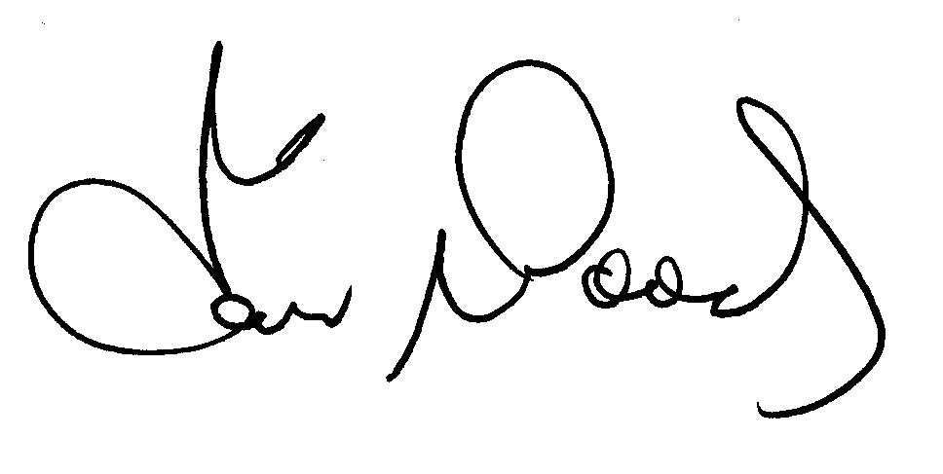Captain Ian Woods
SOS President

