
Level 29, Casselden Place
2 Lonsdale Street
MELBOURNE VIC 3000
Telephone: (03) 9923 7122
Fax: (03) 9657 4301
Email: info@aist.asn.au
Website: www.aist.asn.au

24 April 2002

The Secretary
Senate Select Committee on Superannuation
Parliament House
Canberra ACT 2600

Dear Senator Watson

SENATE INQUIRY: SUPERANNUATION AND STANDARDS OF LIVING IN RETIREMENT

The Australian Institute of Superannuation Trustees (AIST) is a national independent member organisation for representative Trustees of not for profit superannuation funds, including public sector, corporate and industry funds. AIST is pleased to enclose the following submission into the Senate Select Committee Inquiry into Superannuation and standards of living in retirement.

Representatives of AIST would also be pleased to have the opportunity to attend a public hearing on this matter.

If you have any questions please don’t hesitate to contact me on 02 9664 1920 or by e-mailing me on sryan2@bigpond.net.au.

Yours sincerely
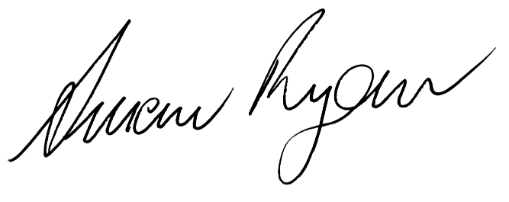

Susan Ryan AO
President
AIST

