Email: super.sen@aph.gov.au

21 May 2002

Senator the Hon John Watson
Chair
Senate Select Committee on Superannuation
Parliament House
CANBERRA ACT 2600

Dear Senator

Inquiry into superannuation and standards of living in retirement

Introduction

We refer to a letter from the Committee Secretary dated 28 March 2002 inviting the Taxation Institute of Australia (TIA) to make a submission to the Committee in its inquiry into superannuation and standards of living in retirement. Thank you for this opportunity to provide comments.

By way of background, the Taxation Institute is a tax education body, and was established in 1943. Our 11,000 members range from small rural and suburban accountants to senior members of the bar specialising in all areas of tax. The Institute’s Superannuation Subcommittee, which is constituted by practitioner members of the Institute who specialise in this area, have examined the proposals put forward and, accordingly, provide the following comments for your consideration.

The TIA’s interest is in tax law and policy. While other bodies will make submissions, the TIA wishes to be involved in any tax-related item and the development of any tax reforms.

The encompassing issue of this particular inquiry is whether the current taxation arrangements for superannuation and related policy are adequate to address the retirement income and aged care needs of Australians.

We submit that the present scheme of taxation of superannuation is inadequate and in need of reform in order to ensure Australians are afforded reasonable standards of living in retirement. Basically, superannuation is over taxed and greater incentives are required to encourage long-term retirement savings given the tight regulatory framework.

Inadequacy of current taxation treatment of superannuation

The main factor in determining how adequate the accumulated superannuation savings of an individual will prove to be is the taxation treatment those superannuation moneys receive. We submit that the existing taxation of superannuation arrangements are wearing away the adequacy of superannuation savings for retirement.

We understand that the broad policy issue on point is the excessive taxation of superannuation in Australia. Australia is the only country to impose tax on superannuation at three stages: when contributions are made; when the fund earns income; and when entitlements are paid out. Australia is not following world best practice in this area, as most other leading economies only tax superannuation moneys upon retirement or exit from the fund.

According to policy guidelines of the Australian Taxation Office, there should be no greater taxation of superannuation proceeds than 48.5% (including the Medicare levy). However, this is still occurring on multiple fronts, as contributions tax plus surcharge on contributions plus tax on excess benefits on payments of eligible termination payments (ETPs) and pensions from funds effectively result in 64.5% tax being paid.

Reform of the existing superannuation tax scheme

To stop the erosion of the expectation of a reasonable standard of living in retirement, and to make superannuation a simpler, more appealing and more realistic savings alternative for Australians, there should be reform to the current taxation treatment of superannuation moneys.

We submit that the specific reform required is the elimination of the superannuation contributions tax and surcharge.

Abolishing the contributions tax and surcharge would provide a very effective increase to Australia’s level of superannuation savings. In fact, over a period of time, having no contributions tax or surcharge would result in a bigger tax base on which to levy the exit tax amount, without increasing the rate.

The elimination of the surcharge would also increase the retirement standard of living while saving on administration expenses. This is because the surcharge is notoriously costly to administer – the superannuation surcharge collection system is recognised as one of the most inefficient tax collection methods in Australia. Collection costs are estimated at $200 million plus, and this would not change even if the tax rate was lowered as proposed with 3 incremental 1.5% p.a. reductions from July 2002. When compared with the Government’s projected surcharge tax collections of approximately $400million once the full rate reduction is in place, the appalling waste of resources in collecting and administering this tax is very clear. Why persist with a cumbersome and costly system that reduces living standards in retirement?

The concessional tax treatment of superannuation should continue, notwithstanding abolition of surcharge and contributions tax, as superannuation saves the Government considerable expense by transferring the responsibility for old age pensions and aged care from the Government into the hands of individuals. The Government could include in Treasury’s cost estimates of providing tax concessions to the superannuation industry the amount of money saved by not paying old age pensions due to people having self-funded their own retirement. Treasury often substantially overstates the real quantum of those savings.

Conclusion

The abolition of the contributions tax and surcharge on superannuation would not only stop the current erosion of the standard of living in retirement, but would also bring Australia into line with world best practice in the area of private retirement funding.

Given that superannuation is a compulsory system, it is imperative that Governmental policies provide long-term certainty and security for superannuation investors. Further, given that superannuation is a long-term savings vehicle, consistent long-term vision is required and not continual tinkering. Legislative change must be kept to a minimum, as there is a big disincentive in continual change.

The TIA would like to be kept informed of any ongoing developments as they relate to taxation law and policy. We would like to keep informed of any proposed changes before they occur, to ensure taxation issues are not overlooked.

If you would like to discuss any of the matters in this submission in more detail, please do not hesitate to contact the Tax Director, Michael Dirkis, on 02 9232 3422 to arrange for one of our Superannuation Subcommittee members to talk with you.

Yours sincerely

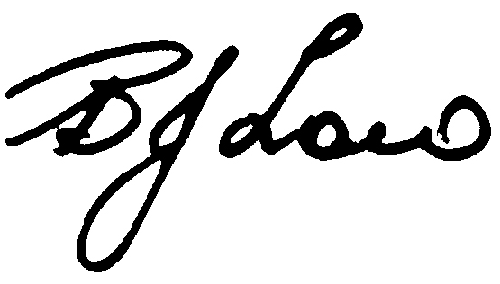

Barry Low
President

