The Surcharge and Defined Benefit funds

Introduction

The fundamental problem is that members of defined benefit superannuation funds can have their employer-financed superannuation benefit reduced by more than 15% due to the introduction of the surcharge in August 1996.

The reason for the possibility of this problem to occur is relatively straightforward.

The member’s defined retirement benefit is generally determined by the product of the relevant multiple, the length of service and the member’s final (average) salary. Most DB funds have also set up a negative account to offset the surcharge which must be paid during the member’s actual membership period. The simplest and most common approach has been to set up a negative accumulation account increased by the fund’s investment earning rate and reduce the gross defined benefit by this accumulation amount at retirement.

However, as the defined benefit and surcharge account increase at different rates, due to the different factors that are used to calculate the amount in each case, it is feasible that the ‘net’ employer-financed retirement benefit will be less than 85% of the ‘gross’ employer-financed retirement benefit. In effect, a hybrid super scheme has been established where part of the benefit is determined by years of service and the defined benefit scale and part is determined by contributions and the fund earning rate. It is this hybrid nature of the arrangement that causes the problem.

Some basic facts about the surcharge for DB funds

Before proceeding, it is helpful to set out some basic facts about the surcharge for members of defined benefit funds.

- The surcharge is based on a individual member’s entitlement from superannuation in respect of the employer’s contribution in a particular year.
- The level of the employer’s contribution is easily defined for an accumulation fund but is problematical for defined benefit funds. This problem was always acknowledged and the Government set up an Actuarial Advisory Committee at the time the surcharge was introduced to consider the issue. It is not a new problem.
- As with all actuarial calculations for contribution rates to defined benefit funds, certain assumptions are required. To resolve this issue, Regulations have been issued by the ATO prescribing a discount rate of 8% pa and a salary growth rate of 4.5% pa. That is, a gap of 3.5% between these two rates is used. No promotional salary scale is assumed.
  - In broad terms, the major long term issue in these assumptions is the “gap” between the long term investment earning and the long term salary increase rate. It is noted that the NSCF assumptions use a gap of 3.5% whereas it is not uncommon for actuaries to use a gap for funding purposes, after allowing for salary promotion, of 2 per cent or less over the long term. Hence the 3.5% gap could initially be considered reasonable from the member’s perspective.
  - It is recognised that in most circumstances, if the actual ‘gap’ experienced by the fund is greater than the assumed gap, the level of contributions has been too high and the fund moves into surplus. Similarly, in respect of the NSCF, if the gap experienced is greater than 3.5%, the negative accumulation account is likely to be greater than 15% of the employer-financed defined benefit that it relates to.

Hence, it is feasible that if a superannuation fund’s investments earn a rate that is say 5% above the long term salary experience, then the negative accumulation account at retirement could be 20-30% or higher of the employer-financed defined retirement benefit. The actual result will also depend on the individual member’s salary movements.

An example

This problem can arise in all defined benefit funds. However to highlight the issue, let us take a real example, namely the QANTAS Pilots, who are members of Division 3 of the Qantas Super Plan.

In this case, some basic details are as follows:

- Retirement benefit: 18% of final average salary per year of service
- Retirement age: 60
- Member’s contribution: 5% of salary

Based on a report prepared by the Fund’s Actuary, Mark Thompson of Towers Perrin, the accumulated net surcharge amounts at retirement, expressed as a percentage of the employer financed benefits, assuming a 3.5% investment return over salary increase and no promotional salary increase (which are the ATO assumptions), is as follows:

Entry age | Surcharge amount as % of employer financed benefit at age 60
30 | 15.9%
40 | 15.4%
50 | 14.9%

However the actual result is likely to be very different from these figures due to two factors:
- The actual salary experience received by the member
- The actual gaps experienced between the investment earning rates and general salary increases
The following tables show these percentages under three “salary scenarios”:

- no salary scale
- a conservative salary scale averaging 1.8% pa from age 30 to 60 and 0.5% pa from age 40 to 60
- a more generous salary scale averaging 2.8% pa from age 30 to 60 and 1.3% pa from age 40 to 60

In addition, a 2% pa salary increase is used in all cases.

Surcharge amount as % of employer funded benefit at age 60 - Entry age 30

Fund  earning rate | 5% | 6% | 7% | 8% | 9% | 10%

Salary scale
Nil | 13.5% | 18.0% | 26.0% | 44.7% | 134.3% | Neg
Conservative | 11.4% | 14.4% | 19.0% | 27.3% | 46.1%¹ | 128.5%
Generous | 10.1% | 12.3% | 15.6% | 20.7% | 30.1% | 52.3%

1 This example is used in the graphs below.

Surcharge amount as % of employer funded benefit at age 60 - Entry age 40

Fund  earning rate | 5% | 6% | 7% | 8% | 9% | 10%

Salary scale
Nil | 13.8% | 16.2% | 19.4% | 23.7% | 30.0% | 40.0%
Conservative | 13.4% | 15.6% | 18.5% | 22.4% | 28.1% | 36.6%
Generous | 12.9% | 14.9% | 17.5% | 21.0% | 25.9% | 33.1%

These tables highlight the following general results:

- The higher fund earning rate, the larger the problem;
- The longer the period (i.e. the earlier entry age), the larger the problem at retirement;
- A higher salary promotion reduces the problem as the “gap” reduces;
- In extreme cases, it is even possible for the accumulated surcharge account to exceed the employer financed benefit.

This last result can arise when there are member contributions. The reason is simple. The member contributions together with high fund earnings contribute a higher proportion of the defined benefit. Hence whilst the surcharge account is growing with high fund earning rates, the actual employer-financed portion is declining. As a result, the surcharge account can actually exceed the employer-financed defined benefit.

Figures 1 and 2 show the outcome assuming a long term fund earning rate of 9% pa using an entry age of 30 and the conservative salary scale. In this example, the surcharge account represents 46% of the employer financed benefit at age 60.

Figure 1: The accumulation of benefits over 30 years
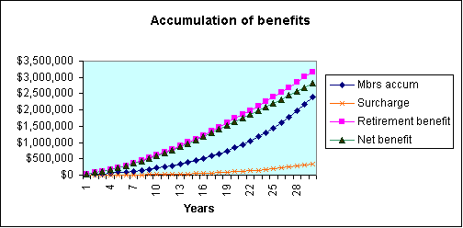

Figure 2: The division of the defined benefit at retirement
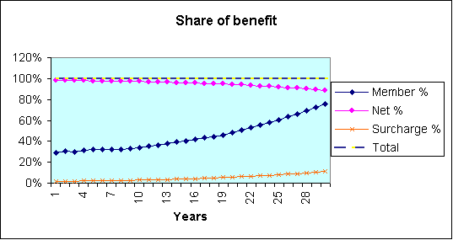

Whilst the actual impact will vary between individuals, there is no doubt that under certain economic circumstances, the reduction of the employer financed benefit at retirement due to the surcharge can exceed 15% by a considerable margin.

The underlying cause is that there has been over taxation due to the assumptions used in calculating the Notional Surchargeable Contribution Factors. That is, the assumptions have assumed a 3.5% “gap” between investment earnings and salary increases. The actual gap experienced has been higher than assumed so that the NSCFs used have been too high resulting in an excessive surcharge collection.

The suggested solution

Given that the above problem arises over a period of years, it is not suggested that major reform is needed to the surcharge to solve this particular problem. Rather, it is suggested that a check be made at the point of benefit payment similar to that used in the public sector and constitutionally protected schemes, such that the surcharge reduction is capped at 15% of the employer financed benefit.

Of course, such a check would also need to prescribe the method to accumulate the surcharge accounts in respect of each member. It is recommended that the accumulation rate be defined as the crediting rate used for other surcharge accounts in the fund. Most DB funds would also have defined contribution members who may also have surcharge accounts. If the same accumulating rate is not used, a new anomaly would develop.

Should a member’s surcharge account exceed 15% of the employer financed benefit at the point of payment, then there has been an over taxation of the surcharge, caused by the positive economic conditions. In this case, it is suggested that the ATO should refund the superannuation fund, the difference between the surcharge account and the 15% cap of the employer financed benefit.

David Knox
9 October 2001

