

Australian Medical Association Limited
ABN 37 008 426 793
42 Macquarie Street, BARTON ACT 2600; PO Box E115, KINGSTON ACT 2605
Telephone: (02) 6270 5400 Facsimile: (02) 6270 5499

3 May 2002

The Secretary
Senate Select Committee on Superannuation
Parliament House
CANBERRA ACT 2600

Inquiry into Superannuation and Standards of Living in Retirement

The AMA believes that the Government’s broad policy of encouraging private superannuation savings is correct, but that current tax arrangements for superannuation are inequitable and provide a disincentive for people to invest in superannuation as the primary means of ensuring an adequate income in retirement.

Introduction

Other submissions will no doubt produce data on Australia’s ageing population and the future inability of governments to fund retirement incomes and health care demands. There is a range of issues to be explored around this, including workforce participation and health care strategies, but suffice to say for this submission that individual Australians need increasingly to provide for their own retirement by building financial assets over a lengthy period. The time frame is a critical factor because the compounding effect of returns on investments is the essence of funds accumulation. Long term financial and retirement planning does not come naturally to most people because there are always immediate needs and shorter term goals which can soak up available income. This scenario is the basis of the action taken by successive governments, under their taxation powers, to require employer contributions to superannuation and to encourage individuals to maximise their investments in approved superannuation funds.

AMA Position

While medical practitioners as a group are not likely to impose on government a call for income support in retirement through the age pension, one of the key measures of the government’s policy success is the extent to which Australians’ standard of living can be maintained in retirement. This very much depends on their long term commitment to voluntary savings and the outcome of that commitment in dollar terms. In turn, this requires tax arrangements which provide an incentive to save in superannuation funds and do not undermine the cumulative build-up of funds.

Criticism of the current tax arrangements focuses on equity and complexity. The real test is whether lack of equity and too much complexity undermine the objective of encouraging superannuation savings by all Australians. The AMA argues that they do.

Operation of the Tax System

Australia is the only country which imposes tax on superannuation at three levels:
- on entry into the fund;
- on accumulation while in the fund;
- on exit from the fund.

The standard 15% contributions tax on entry to the fund is only the first phase of the tax take. It is imposed on money which is not income and is not accessible by the individual until many years down the track at retirement age. This is questionable in principle and undermines the concept of long term retirement provision through accumulation of relatively small amounts. The cumulative effect of losing 15% of contributions up front over 20 or 30 years serves to significantly reduce fund accumulation.

Then there is the surcharge, which applies to many doctors. Since this applies to grossed up assessable income, it increases the up-front tax bite to 30% for many. It is also difficult to administer, thereby increasing administrative costs, especially for small funds, and reducing the return. In the case of defined benefit funds, or at least those outside the public sector, there is a negative surcharge account set up within the fund which increases at the long term bond rate. That rate can be higher than the fund earning rate, leading to a rapid accumulation of surcharge debt which can reduce, with potentially dramatic effect, the value of the fund benefit on reaching retirement. The surcharge is inequitable and a disincentive in itself to superannuation saving.

Earnings in the fund are taxed at an additional 15%. There is no tax relief if fund earnings are negative, as was the case for many funds in 2001. Fund administrative fees, ranging generally from 0.5% to 2.5% of funds held, are a significant factor as we enter an era where investment returns are projected to remain below 5% per annum for most funds. The tax on earnings needs to be considered in this context.

Finally, there is a tax on benefits. Certainly there are tax concessions, but these depend on what form the benefits are taken in and are complex and difficult to understand. Above a certain minimum level of lump sum or pension benefit, which most doctors are likely to exceed, benefits are taxed at a minimum rate of 15%. In the eyes of contributors at least, whatever construction an actuary might place on it, the total tax take on their superannuation contributions reaches 60%+. Add in the fund administrative fees and a sequence of low or negative investment returns and superannuation begins to look like a very poor retirement savings vehicle.

Recommendations

The AMA recommends that:

- the tax on contributions be reviewed;
- the surcharge be removed;
- individuals incur taxes only at the time they are able to access their superannuation funds.

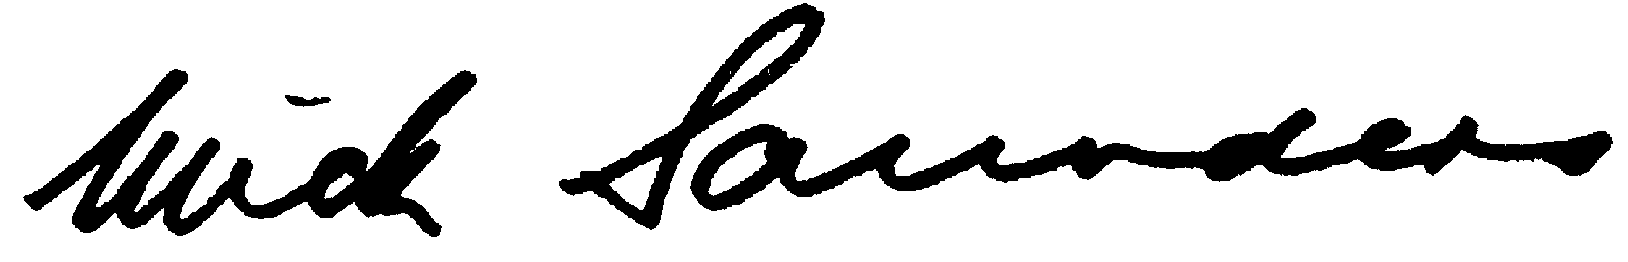
Mick Saunders
Senior Policy Adviser
Workplace Policy Department

g:\Workplace\Policy&Legislation\Superannuation\Senate Inquiry submission May 02

