3 May 2002

Senator John Watson
Chair
Senate Select Committee on Superannuation

SUPERANNUATION AND STANDARDS OF LIVING IN RETIREMENT

I attach a submission to your inquiry.

Your inquiry covers many areas of concern, but I will concentrate on the retirement incomes of superannuants. Retirees with superannuation lump sums are increasingly investing them in allocated pension or complying pensions to take maximum advantage of tax and social security concessions for these products.

A complex issue is the correct setting of the tax rates and age pension deductions based on income and assets tests. It is important to encourage the maximum use of a person’s assets by setting these rates and deductions at the correct level so that the combined pension and superannuation income less taxes plus other age related benefits, is always more than a person with a lower or no personal income.

It is also important to review the conditions of allocated and complying pensions to ensure that the maximum income can be earned from these investments without social security conditions causing major differences in the two products.

My submission concentrates on the potential benefits of an allocated pension, which has complying status for Social Security and Reasonable Benefit Limits purposes. Naturally, the conditions would be much more restrictive than the current allocated pension rules, but with these restrictions, would provide the potential for the pension to be larger or last longer. A complying allocated pension should also encourage the maximum income streams available from a retiree’s invested capital.

Thank you for the opportunity to lodge this submission, as I believe it has been an oversight in the development of a flexible retirement incomes system.

I am the Executive Officer of an Industry Superannuation Fund, but this submission is a personal submission.

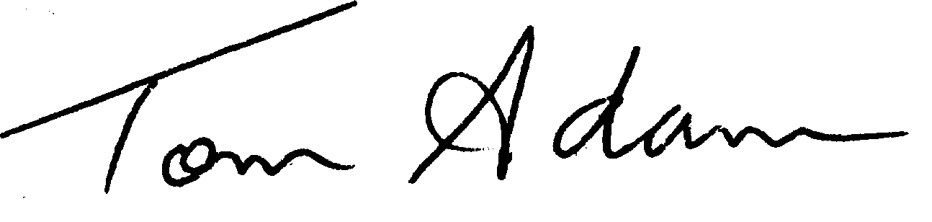Yours sincerely

Tom Adams
Executive Officer

Independent Schools Superannuation Trust
Level 1, 104 Frome Street
ADELAIDE SA 5000
Work Phone: 08 8205 4905
Email: tomadams@isst.net.au

Superannuation and standards of living in retirement

Complying pensions

A complying pension or annuity provides significant advantages to Retirees. The income stream is assessed for Centrelink purposes but the purchase price is not included in the assets test. Retirees with a lump sum in excess of the lump sum RBL are able to double the RBL by investing at least 50% of their retirement benefit in a complying pension or annuity.

To comply, the pension or annuity must have the following characteristics:-

At least a guaranteed annual payment fixed at the commencement of the arrangement

Payments to be for life or for a term of 15 years or at least the life expectancy of the retiree.

Increases to the payments limited to the increase in CPI.

No commutation allowed and no residual capital value at the end of the term of the income stream.

Sufficient reserves are required to enable an organization to offer such a product and this is appropriate to ensure that the guaranteed income stream is paid to the retiree. However, the guarantee does come at a cost and that cost is that a conservative interest rate is used in the calculation of the original amount of the payment. This rate has to be set to cover the uncertainty of the variability of the earning rate, the CPI increases and the longevity of the retiree. In some cases the issuer may loose, in others they will win. On balance the rate has to be set to cover the risks and to also make a profit for the issuer.

The expectation is that the issuer will make a profit and increase reserves. This also means that the retiree receives less and the Government pays higher age pensions.

Choice of Product

Retirees with considerable lump sums (say over $100,000) have generally accepted that the majority of their superannuation should be invested to generate income payments for their retirement. The most popular product is the allocated pension, which provides an income stream but no certainty that those payments will last for the whole of their life. However, all of the money invested in the Allocated Pension plus earnings will be paid to the retiree, their spouse or their estate.

The reason retirees invest in a complying pension is generally for social security purposes to ensure that at least some of the age pension will be paid to them. While the guaranteed income is a good selling point, the expected lower level of income and uncertainty that all of the money will be paid to them detracts from the product. From the experience of a number of financial planners I talked to, the term complying annuities (15 years) appear to be more popular than lifetime annuities. This supports the argument that retirees are more concerned to ensure that their full retirement benefit is paid to them or their family. Reducing the term of the annuity increases the potential for the retiree to receive an appropriate benefit.

The legislation should be amended to allow a complying allocated pension type retirement product. There would need to be some strict conditions on this product but some of the major selling points of the Allocated pension could be retained.

Important conditions of a complying retirement product

From reviewing the complying pension and also considering the importance of the use of superannuation to provide an income stream during retirement, the necessary conditions of a complying pension appear to be:-

The total benefit invested is used to generate an income stream (no commutation)

An appropriate amount is paid from the amount invested. The first payment should have a relationship to the amount invested and the age of the retiree.

The other conditions do not appear to be as important:-

The annual increase in the pension to be limited to CPI. It is important to restrict excessive withdrawals to ensure that the pension will be paid until at least the life expectancy of the retiree but if there is a balance in excess of these requirements the pension should be increased by more than CPI. Increased income payments mean less Government support is required.

No Residual. If there was a residual value after the death of the member it would be used for a continuation of the income payments to the spouse or paid to the estate where it would be taxed accordingly. There would be no increase in cost to the Government and is more likely to earn the Government more tax revenue.

A complying allocated pension could be developed to meet the necessary conditions. The major difference would be that the allocated pension would not guarantee income payments for the rest of the retiree’s life but this does not seem to be an issue because the current conditions allow for term pensions which may not pay for the whole lifetime of the retiree.

Conditions of a complying Allocated Pension

To cover the necessary conditions of a complying pension an allocated pension product could be developed with the following conditions:-

- The balance of the complying allocated pension account is the amount invested plus earnings less charges and pensions paid.
- No lump sum withdrawals allowed
- The amount of the starting pension to be calculated by using a complying allocated pension factor being the average of the current minimum and maximum pension factors for allocated pensions.
- Pension increases will generally be limited to CPI increases but where the balance is excessive, the pension to be increased. The pension would then be calculated by dividing the balance divided by the complying allocated pension factor for the age of the retiree.
- Investment Choice and reversionary pensions be allowed
- Pension ceases when balance of allocated pension is nil
- On death of Retiree and spouse if a balance remains, it is to be paid to dependants or the estate.

Advantages

The advantages of a complying allocated pension are:-

More suppliers could be expected to offer this product thus increasing the choice for retirees. Retirees could choose between a current complying pension with guaranteed return and no capital residual and a complying allocated pension with less certainty of the income stream but a guarantee that all capital plus earnings would be paid to them or their estate.

Increased competition will reduce charges. In an allocated pension the charges are more transparent.

Members are able to participate in higher returns from growth assets and receive the benefits of higher market returns. As against that, members also suffer if returns are low. Over the long term, returns would be expected to be higher than a current complying pension with conservative rates.

Government outlays are reduced if the amount of pension payment is higher or the term of income payment is longer. With lower costs and market earning rates, on average, an allocated pension is expected to achieve these conditions.

