`
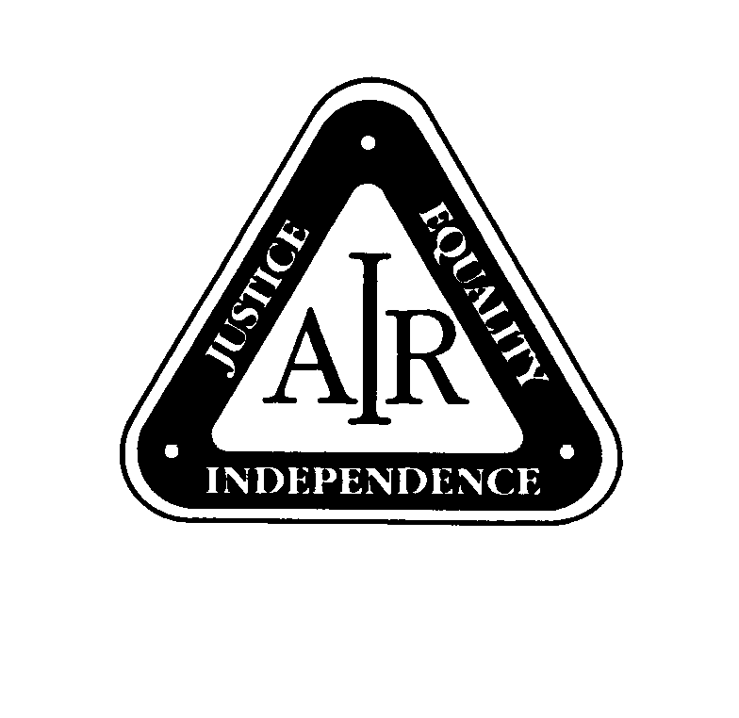
ASSOCIATION OF INDEPENDENT RETIREES Inc.

ABN 38 059 010 418 Incorporated in Queensland with Limited Liability

SUBMISSION
to the
Senate Select Committee on Superannuation

Inquiry into
Superannuation and Standards of Living in Retirement

Executive Summary

The Association of Independent Retirees Inc. [A.I.R.Inc.] is the peak organisation working with the Commonwealth Government on behalf of all fully and partly self-funded retirees. A.I.R.Inc. is the only national organisation whose prime purpose is to represent this rapidly growing sector of the Australian community.

Being fully or partly self-funded in retirement indicates that these people have saved during their working lives, invested for their retirement and contributed to superannuation or accumulated capital in other ways to meet their need for income during the many years of life expected after leaving employment.

Issues relating to Superannuation are of critical importance to Australians funding their retirement fully or partly. The multiplicity of changes made to rules applying to accessing one’s superannuation and to the taxing of same have led to much confusion among our members and other self funded retirees.

Australia’s superannuation system has many faults and is among the most complex and heavily taxed in the world. The Government needs to provide sufficient incentives for people to contribute more money to superannuation and so create a more adequate retirement for our aged population.

Consequently, A.I.R.Inc. recommends that a complete review of legislation relating to superannuation be conducted by a representative group, including superannuants who understand the needs of people in retirement. The Association would welcome such an initiative and offers its services to such an inquiry.

Introduction
The Association of Independent Retirees Inc.[A.I.R.Inc.] is now the peak organisation advocating on behalf of all self-funded retirees.
The Association was founded in 1990 to represent fully and partly self-funded retirees (SFRs) to all levels of government, Federal, State and Local. Before the formation of A.I.R.Inc., no body existed whose single purpose was to represent this rapidly growing section of the Australian population.
A.I.R.Inc. is a non-party political, non-profit organisation, representing people who are not in full time employment and do not receive a full age pension. It will continue to advocate on behalf of SFRs to achieve justice and equity from the three tiers of government.
A.I.R.Inc. has currently 83 branches in all States and the ACT and plans to expand its membership base of over 17,000 financial members in 2002 and beyond. This growth has demonstrated that self-funded retirees recognise the importance of representation by an organisation able to communicate and negotiate with Governments at all levels. A.I.R.Inc. regularly and consistently presents its opinions and proposals to Government Ministers and maintains close contact with members of both Houses of Parliament. through the Association’s extensive branch and state division network.
Membership of A.I.R.Inc. comes from a broad cross-section of the retired community and a typical branch has members with past occupations as diverse as teacher, public servant, storekeeper, dentist, farmer, tradesperson, manager, engineer, company director, member of the defence forces, etc.
Over the next 40 years, the ageing of the Australian population will see a marked increase in the proportion of Federal Government revenue going to fund aged and veterans’ pensions. Treasury’s Retirement and Income Modelling Unit projects this to rise from the present 3 percent to 4.5 percent of GDP in the year 2040. It makes sound economic to encourage retirees to be self-funding, in full or in part, for as long as possible to reduce what will be payable in pensions.
In Australia, the number of partly and fully self-funded retirees over the pension eligibility age already exceeds one million. In addition there are some 1.25 million retirees between the age of 50 and pensionable age. Of these, the number that are self-funded is unknown. SFRs represent a major economic asset to the nation.

- Superannuation Rules.

The superannuation rules are far too complex and do not meet the needs of people moving to or already in retirement. The Government needs to start again to balance the objectives of superannuation – equity and cost to the community. There are some worrying gaps in the super coverage and the Government needs to police controls adequately in order to ensure protection of all workers especially casual, part-time, self-employed, and contract workers.

Last year funds reported losses and this situation has eroded confidence in superannuation. Additionally, the failures and breach of trustee duties in some funds have served to highlight the need of a pro-active regulator. There is also a need to monitor funds better and acknowledge the importance of regulations relating to ‘arms length investments.’ Any failures are unacceptable: enhanced vigilance is essential. Security of investments is imperative.

Recommendation 1.

- That the government conduct a complete review of superannuation legislation; and

2. That this review be undertaken by a representative group, including experienced superannuants who understand the needs of people in retirement.

- Superannuation Surcharge.

The Government has recognised that the Superannuation Surcharge is not attractive and does not encourage Australians to save for their retirement. Commencing 1 July 2002, the surcharge rate will be reduced by one tenth of the current level over each of the next three years (i.e. a maximum of 1.5 percentage points each year).

The Government has also promised to review the surcharge arrangement after the three years to determine if any further changes should be made.

It is the view of the Association that this surcharge should be abolished as soon as possible and so encourage additional contributions to superannuation funds.

Recommendation 2

That the superannuation surcharge tax apply only to the amount above the threshold and that it be reduced by 2.5% pa until it disappears.

3.Contribution Tax.

The focus of attention should to be on reducing the taxes on superannuation.

There are several critical issues that warrant close consideration, including::
- Adequacy of provision;
- Reduction in complexity of the application of taxes on superannuation;
- Simplification and transparency of the rules.
- Equitable and efficient application of the law.;
- Encouragement of retirees to make full use of their retirement savings.

The first two points have one simple solution: superannuation should be taxed once only when benefits are taken.

Because of its very complexity, nothing short of an expert review as indicated in Recommendation S1 will solve this problem.

The tax on contributions gives the government $2.5billion which is equal to the cost of a $6.00 per week per person tax cut. However, unlike a normal tax cut, such would boost private savings and immediately move to reduce the growing debt Australia will face with the ageing population.

Recommendation 3.

That the superannuation contribution tax be phased out over a five year period.

- Indexation of Commonwealth & Defence Forces Pensions.

There is substantial evidence that the value of Commonwealth and Defence Force superannuants’ retirement incomes have not kept pace with the cost of living over the last ten years as a result of the indexation method used.

In the 10-year period 1990 to 2000, pensions for Commonwealth and Defence Force superannuants increased by 24 per cent based on the movement of the CPI. Meanwhile, over the same period, Average Weekly Earnings increased between 37 and 47 percent, Australian Public service salaries on average increased by 40 per and parliamentary pensions by 50 percent. In the case of such retirees who have long retired, their benefits have significantly lost relativity with those at equivalent levels retiring now.

A similar situation is evident for women and early retirees.

Recommendation 4.

That the Federal Government adopt an indexation for the Commonwealth public sector and defence force superannuation schemes, which more adequately reflects the actual increases in the cost of living for Self-Funded Retirees. The use of Average Weekly Ordinary Time Earnings as the index is recommended and adjustments should be made quarterly.

- Age Limitations.

The present legislation covering Superannuation Funds allows for the setting up of ‘Do It Yourself’[DIY] funds with less than five members. These funds have great utility in arranging and maintaining control of funds for small groups.

A.I.R.Inc. believes that age should not preclude a person from becoming a member, participant, office bearer or trustee of a fund, provided the person is of sound mind and attends at least 75% of trustee meetings. In a DIY Superannuation Fund provided in the current legislation the recommendation below would make it possible for people to administer and control their own Complying Pension Fund or Allocated Pension Fund, irrespective of age.

Recommendation 5.

That legislation be changed to enable retirees over the age of 70 years to be participants, office bearers and Trustees of ‘small superannuation funds’ provided they are of sound mind and able to attend at least 75% of the General meetings of the fund/s of which they are a member.

6. Income Splitting of Superannuation Pensions.

For those approaching retirement and for those in the early years of retirement, it is common practice to so arrange their assets as to roughly balance the incomes applicable to each member of the retiree couple. This is a procedure aimed specifically at minimising the total tax payable each year by the couple.
This is recommended as a matter of routine by financial advisers and is a perfectly legitimate arrangement. The practice may be applied to the majority of classes of assets; shares, investment property, fixed interest securities, managed funds, mortgages, and so on.
This practice of income splitting is available to all retirees. However, for those who derive the bulk of their retirement income from the proceeds of Commonwealth, State or company superannuation pensions, it is an option of little benefit. They must report all the pension income in their own tax return and pay tax at the correspondingly higher rate. The result is the payment of higher taxation for a given level of income by superannuation recipients than is the case with other retirees on the same total income.
This is clearly an inequitable situation and should be addressed without further delay. It could be corrected simply by legislation allowing for tax purposes the notional splitting of the income from the superannuation fund or funds between each of the partners.

Recommendation 6
That recipients of income from superannuation funds in which the recipient has no control over the disposition of the pay-out be permitted to split the income with their partners for income tax purposes.
7. Superannuation Rebate.

For those retirees living on superannuation or allocated pensions and annuities, a situation can arise where the 15 percent superannuation rebate allowable exceeds any taxation liability. The position is somewhat analogous to the previous loss of excess imputation credits.
The rebate was intended to refund the 15 percent contributions tax involved when premiums were paid into the superannuation fund from which the funds are now being used to make the regular payments to the recipient.
Any excess rebate available should be offset against the Medicare Levy liability and any residual, along with any excess imputation credits, refunded to the taxpayer.

Recommendation 7
That, where the 15 percent Superannuation Rebate exceeds the taxpayer’s tax liability, any excess be offset against the Medicare Levy and any residual amount be refunded to the taxpayer.

SUMMARY OF RECOMMENDATIONS

Recommendation 1.

[a] That the government conduct a complete review of superannuation legislation; and

[b] That this review be undertaken by a representative group, including experienced superannuants who understand the needs of people in retirement.

Recommendation 2

That the superannuation surcharge tax apply only to the amount above the threshold and that it be reduced by 2.5% pa until it disappears.

Recommendation 3.

That the superannuation contribution tax be phased out over a five year period.

Recommendation 4.

That the Federal Government adopt an indexation for the Commonwealth public sector and defence force superannuation schemes, which more adequately reflects the actual increases in the cost of living for Self-Funded Retirees. The use of Average Weekly Ordinary Time Earnings as the index is recommended and adjustments should be made quarterly.

Recommendation 5.

That legislation be changed to enable retirees over the age of 70 years to be participants, office bearers and Trustees of ‘small superannuation funds’ provided they are of sound mind and able to attend at least 75% of the General meetings of the fund/s of which they are a member.

Recommendation 6
That recipients of income from superannuation funds in which the recipient has no control over the disposition of the pay-out be permitted to split the income with their partners for income tax purposes.
Recommendation 7
That, where the 15 percent Superannuation Rebate exceeds the taxpayer’s tax liability, any excess be offset against the Medicare Levy and any residual amount be refunded to the taxpayer.

ABS Data

