4 September 2002

Chair
Senate Select Committee on Superannuation
Parliament House
Canberra ACT 2600

Dear Senator Watson,

The following is a brief submission to your inquiry into the Superannuation (Government co-contributions) Bill (2002) and the Superannuation legislation amendment Bill (2002) We do not seek to appear before the Committee for this inquiry.

This submission deals specifically with the proposals to:
- reduce the Superannuation Surcharge for high income-earners; and
- replace the existing tax offset for contributions by low-income employees with a Government co-contribution.

This submission is best read in conjunction with our previous submission to your Inquiry into Superannuation and Standards of Living in Retirement.

Superannuation surcharge

The Government proposes to reduce the Superannuation Surcharge for contributions made on behalf of high income-earners (those on more than $85,000 per year) from a maximum of 15% down to 10.5% over the next 3 years, at a cost to revenue of $200 million annually by 2005-06.

ACOSS considers this proposal to be an unnecessary and wasteful tax cut for high income-earners. Only the 5% of wage-earning tax-payers earning more than $85,000 would benefit. Its impact on private saving levels and future Age Pension outlays would be negligible, since high income-earners have a high propensity to save regardless of tax incentives, and are unlikely to qualify for the Age Pension in any event.

The proposal would deepen the inequity of the present tax treatment of superannuation, without reducing the complexity and compliance costs associated with the surcharge.

We do not support alternative proposals to reduce the tax rate on employer contributions generally, as this would increase the wasteage of public revenue on superannuation tax concessions for high income-earners without improving the overall equity of the system.

Fundamental reform of the tax treatment of superannuation contributions along the lines proposed in our submission to your Inquiry into Superannuation and Standards of Living in Retirement is necessary to improve the equity and efficiency of superannuation. In the absence of such reform, the 15% surcharge should remain in place.
Government co-contribution

The Government proposes to replace the present 10% rebate for personal contributions of up to $1,000 per year by individuals earning less than $31,000 with a matching co-contribution of $1,000 for those earning less than $20,000 (falling to zero at an income of $32,500).

Although a co-contribution of up to $1,000 is much more generous than the present 10% rebate, the maximum amount will apply to far fewer employees so that the Government anticipates saving $10 million per year as a result of this change.

ACOSS supports the principle of a co-contribution for low income-earners. In our previous submission, we advocated a dollar-for-dollar co-contribution in respect of contributions from all sources of up to 0.5% of average earnings (approximately $200 - $250 per annum). Although this is less than the $1,000 contributions "ceiling" in the Government's proposal, it would apply to Superannuation Guarantee contributions as well as voluntary contributions. This feature of our proposal is important because it ensures that the vast majority of low wage-earners would actually benefit.

A co-contribution that is restricted to voluntary contributions would not benefit large numbers of low income-earners, especially if it is confined to those earning less than $20,000. The vast majority of such wage-earners do not make voluntary contributions, and would not be induced to do so by the co-contribution.

It is likely that the majority of the beneficiaries of this measure would be the partners of middle and high income-earners. This raises equity concerns about the targeting of the measure.

If a co-contribution is to be introduced, it should extend higher up the income scale to somewhat less than average full-time earnings, and should preferably extend to Superannuation Guarantee contributions. It should be funded by reducing the existing tax concessions for high income-earners, as proposed in our previous submission.

Should you have any inquiries about this submission, please contact Peter Davidson at this office.

Yours sincerely
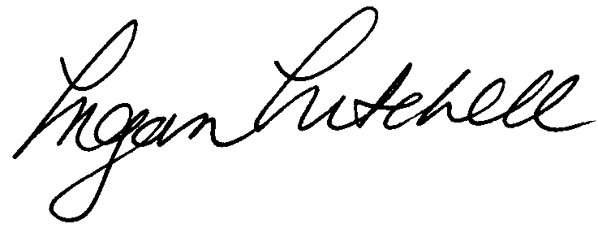
Megan Mitchell
Director

Peter Davidson - Senior Policy Officer

Australian Council of Social Service
Level 3 619 Elizabeth St Redfern NSW 2016
Locked Bag 4777 Strawberry Hills NSW 2012 AUSTRALIA
Ph 02 9310 4844 Fax 02 9310 4822
Website: www.acoss.org.au

1 in 9 Australians lives in poverty - ACOSS works for them

