30 August 2002

Ms Sue Morton
Secretary
Senate Select Committee on Superannuation
SG60 Parliament House
CANBERRA ACT 2600

Dear Sue

I am writing in response to your request for comments on the recently released Superannuation Bills. On behalf of the Institute of Actuaries of Australia we submit the following observations.

Choice of Fund legislation

The Institute had not intended to make a formal submission to the Committee on the detail of the Fund Choice legislation currently being considered. However, in response to the specific invitation we do take this opportunity to restate the broad principles that have underpinned the Institute’s position since Fund Choice was first proposed.

- The Institute understands the rationale behind the Government’s desire to introduce Choice of Fund legislation.

- The key to the successful implementation of Choice legislation is full, and understandable, disclosure of the information necessary to allow individual Australians to make the appropriate choice for them. The Institute’s views on this have been widely canvassed in past IAAust submissions.

- The nature of defined benefit superannuation funds needs to be taken into account in developing and implementing any Choice legislation. The pooling of assets within such funds; the fact that many member benefits are unrelated to investment performance; and the fact that the sponsoring employer accepts much of the risk/reward attached to investment performance necessitate careful application of the resulting legislation. Again, the Institute’s position on these issues is on the record.

We are aware that a number of industry bodies and individual firms have presented lengthy submissions to Government concerning the detail of the current legislation. We understand that the points raised above are likely to have been thoroughly canvassed by these other submissions. However we would be happy to provide further comments on specific issues with the current legislation that may be raised with the Committee if that would be of assistance.

……/over

Co-contributions

The Institute views the introduction of the co-contribution proposals as a positive step as the IAAust supports the development of enhanced incentives for voluntary contributions to superannuation. We would recommend there be further investigation into extending opportunities for voluntary co-contributions beyond the current co-contribution initiative, which is only offered at lower income levels and on a very limited basis. The Institute has been participating in the modelling work as part of the research project being undertaken by the Investment and Financial Services Association on extending co-contributions. Preliminary results of that research would indicate that there is merit in giving further consideration to extension of the current proposals.

Surcharge

The proposal to reduce the Superannuation surcharge from 15% to 10% over three years has some merit. However the Institute’s view is that the surcharge legislation is complex, and results in many inequitable and anomalous outcomes for individuals. Hence, we feel that the surcharge legislation needs more extensive review, and that this should be considered as part of a broader taxation review of Superannuation.

As discussed with you, the Institute is not able to attend any of the hearings of the Senate Committee, and we wish you well in your deliberations. Please contact Catherine Beall, Chief Executive should you require anything further in relation to this matter (tel: 02-9239 6106).

Yours sincerely

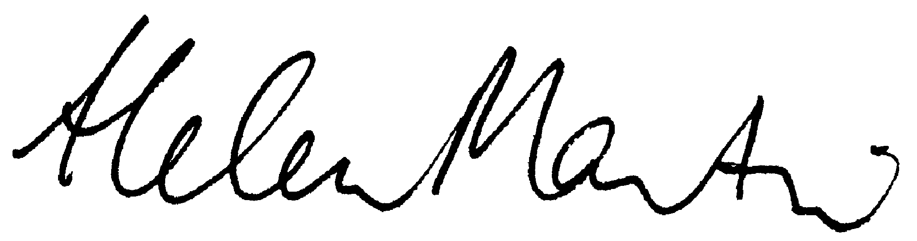

Helen Martin

President

