SUBMISSION

to the

SENATE RURAL AND REGIONAL AFFAIRS AND TRANSPORT COMMITTEE

on

IMPORTATION OF APPLES FROM NEW ZEALAND

by

APPLE AND PEAR GROWERS ASSOCIATION OF SOUTH AUSTRALIA INC.

6 Frederick Street,
CAVAN. SA. 5094

14th June 2004
INTRODUCTION:

While the Apple and Pear Growers Association of South Australia has many issues it would like to raise with the Senate Rural and Regional Affairs and Transport Committee, the time frames applied to both the Revised Draft Import Risk Analysis and the Senate inquiry make it difficult to achieve detailed responses.
The Association has placed its limited resources with Apple and Pear Australia Limited with the aim of preparing the best possible national response to the Revised Draft Import Risk Analysis. We hope that through the national submission the Association will be given the opportunity to present appropriate evidence to the Senate Committee through an industry wide presentation at the Senate hearing.

Notwithstanding this the Association would offer the following new material to the Senate Committee for their consideration. In addition, the Association would table a range of personal communications collected that highlight the folly of the proposals recommended within the Revised Draft Import Risk Analysis released by Biosecurity Australia in February 2004.

HOST PLANTS WITHIN SOUTH AUSTRALIA

Within the RDIRA, probability of distribution is considered as a major part of the pathway. P61 makes reference to the term ‘Exposure Group’ and identifies the following

“Susceptible commercial fruit crops
Susceptible Nursery Plants
Susceptible Household and Garden Plants, including Weed Species, and
Susceptible wild (Native and Introduced) and Amenity Plants including Susceptible Plants Growing on Farmland”

P67 references the IPPC criteria for establishment or spread and the RDIRA says:

“Availability of suitable hosts, alternate hosts and vectors in the PRA areas.

Whether hosts and alternate hosts are present and how abundant or widely distributed they may be, whether hosts and alternative hosts occur within sufficient geographic proximity to allow the pest to complete its life cycle, whether there are other plant species, which could prove to be suitable hosts in the absence of the usual host species,………..”

Pages 99 to 109 including tables 26, 27 and 28 offers a range of judgements regarding the proportion of utility points near host plants susceptible to Erwinia Amylovora; probability of exposure of susceptible host plants; and partial probabilities of distribution.

Similar documentation is presented for each of the major pests within the RDIRA

The RDIRA is inadequate in it fails to understand and highlight the actual situation within the apple/pear growing regions of Australia

Recent work by Creeper & Nicholson (2003) within South Australia indicated that:

“Derelict orchards and feral trees present a significant biosecurity threat to the industry from a number of perspectives.”

“Primarily this paper seeks to identify the best methods of locating derelict pome orchards and feral trees and to identify current data availability and requirements.”

The initial focus outlined in this paper is the Lenswood Region, as it is the main commercial production area of the State. However, other areas such as the Riverland and the South East may be investigated in later stages. The principles and recommendations from this paper will generally also be applicable to these areas.

The paper defines the hazard in the following manner:

“For the purposes of this paper, derelict or abandoned orchards may be defined as those not currently actively managed, particularly in relation to pest and disease control. Feral apple trees refer to those not deliberately planted, and have germinated either on roadsides, other properties and /or among other vegetation”.

“Derelict orchards not only enable residual untreated codling moth populations to exist, but also act as a significant biosecurity threat to the Pome fruit industry in South Australia. These orchards pose a significant threat to any Fire Blight eradication effort should an outbreak occur in the future, which has the potential to devastate the industry”

“Key issues from the report are:

1. In addition to increasing Codling Moth control costs, derelict orchards and feral host
trees also undermine efforts to control other pests and diseases. These orchards also represent significant biosecury threat, particularly in relation to any potential Fire Blight outbreaks.

2. Derelict orchards and feral apple trees represent a major barrier for the reduction in
insecticide use by the Pome industry.

3. The management or removal of derelict orchards and feral trees will contribute ot the
future access of the SA Pome fruit Industry into export markets currently unavailable”.

From the initial report two case studies were conducted with the Lenswood growing region:

Case Study 1

Apple grower, packer domestic and interstate supplier and exporter within the Adelaide Hills. Approximately 20 km from the Central Business District of Adelaide.

The site includes a:
Commercial orchard are of 5.0ha
Mature packing facility
Major distribution facility for apples going to the domestic, interstate and international markets

The business is an approved supplier of apples to at least one of the major retail supermarket chains as well as many independent retailers within Adelaide and South Australia.

Case Study 2

Pear Grower, Packer, Domestic and Interstate Supplier and Exporter within the Adelaide Hills

Approximately 30km from the Central Business District of Adelaide

The site includes:

Commercial Pear orchards of 31 ha
Major packing facility
Major distribution facility for pears going to the domestic, interstate and international markets.

This business is an approved supplier of pears to at least one of the major retail supermarket chains as well as may independent retailers within Adelaide and South Australia

Conclusions

The attached maps and tables detail the level of derelict orchards feral plants and host plants in home gardens and on roadsides in the zones of 300m, 600m and 1km from the commercial orchard.

These case studies would be typical of all other major commercial orchards and/or packing houses within the Adelaide Hills Region and within other regions throughout Australia

A snapshot of the Adelaide Hills Region is as follows:

a) A number of large retail supermarkets

b) Feral plants that are along roadsides, creeks and within National Parks that form
‘ribbons’ from Metropolitan Adelaide into and through the Commercial Growing Regions within the Adelaide Hills

c) Many urban dwellers and hobby farms scattered throughout the Commercial Growing
Region and in close proximity to both commercial orchards.

d) An Apple / Pear Industry which is highly vertically integrated industry with many
commercial growers having major infrastructure including cool storage and packing facilities. They supply fruit through the marketing chain

(1) Through their own wholesale agency within the Adelaide Produce Market

(2) Directly to the major retail supermarket chains

(3) Directly to Independent fruit shops

e) There are 10 growers / packers within the Adelaide Hills region who supply apples /
pears to the three retail supermarket chains – Woolworths, Coles/BiLo and Foodland.

As suppliers to the major retail supermarket chain it is a very likely scenario that they would import, store, re-pack and distribute Imported fruit as part of their role as category manager for apples/pears.

Again this ‘snapshot’ would be typical of growing regions in Perth, Melbourne, Sydney and Hobart.

This ‘snapshot’ offers a far different position than is outlined within the RDIRA.

References:

Creeper, D and Nicholson, H (2003). Examining Removal and Management Strategies : Derelict Pome Orchards in South Australia.

(A Full copy of this report is available for the Senate Committee if required)

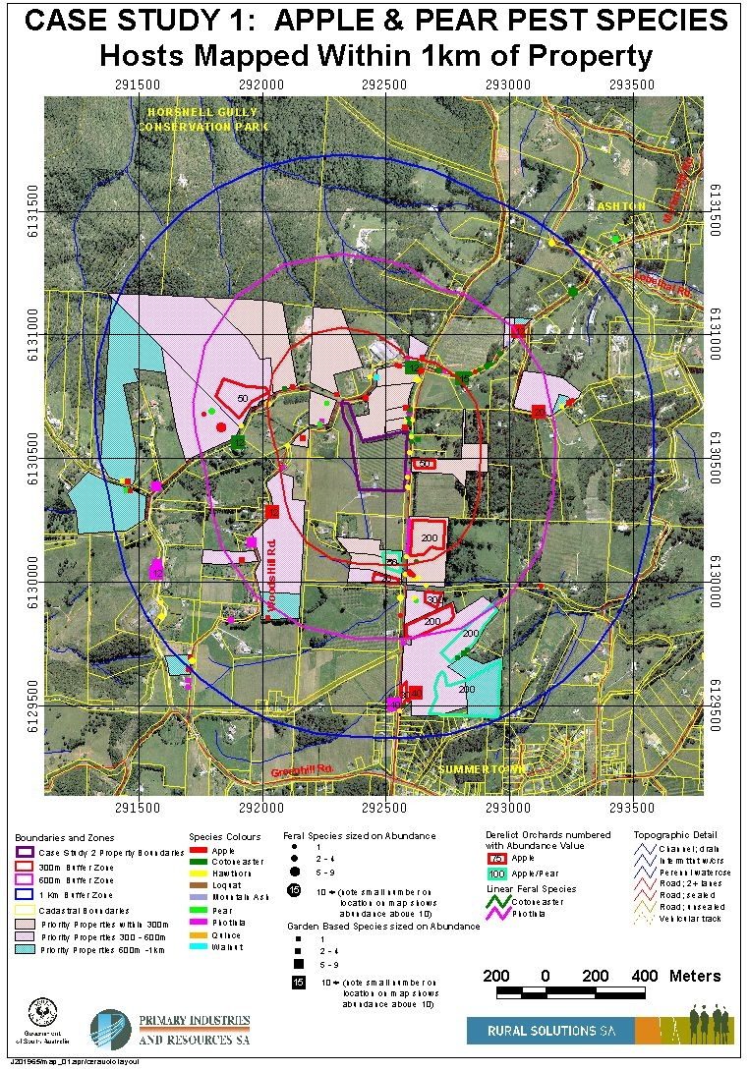

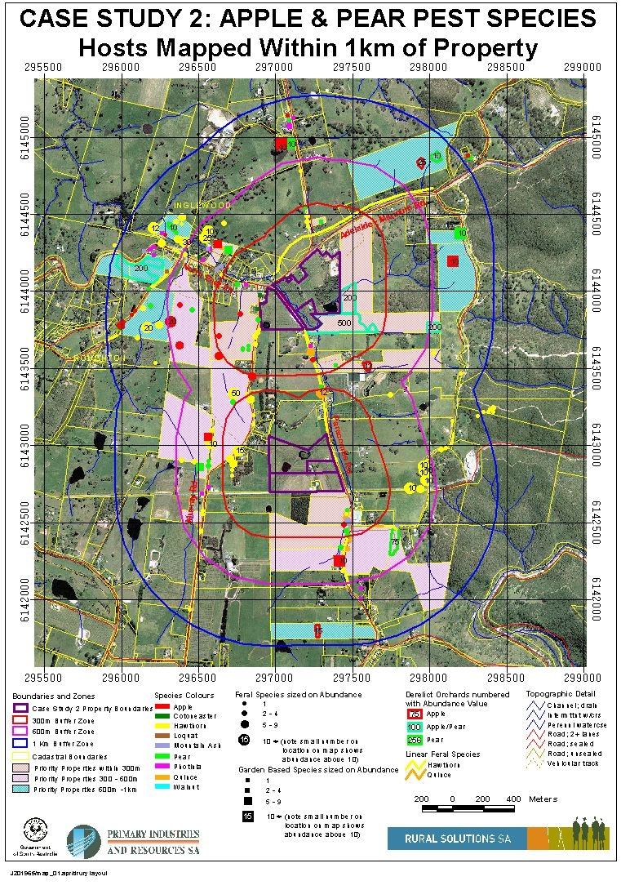

PERSONAL COMMUNICATIONS

1. John Morton, Chief Fieldman, Oregan Cherry Growers, USA.

“Oregon and Washington states in the Northwest Region of the US are areas with fire blight (Erwinia a.) problems in both apple and pear. The fruit growing valleys of our districts such as the Hood River Valley in Oregon or Yakima Valley in Washington state fight a constant battle to control this organism.

Pears are the big crop in the Hood River Valley and nearly every variety is susceptible to fire blight in both apple and pear. The most susceptible pear varieties are Bartlett (Duchess), d’Anjour, and Bosc. We rate control measure in apple by the varieties also.

1. Very susceptible:
a. Pink Lady
b. Gala

2. Highly susceptible:
a. Braeburn
b. Fuji
c. Granny Smith
d. Ginger Gold

Control Programs
Outlined below are control programs our growers use to keep Erwinia a. at bay. Growers who do not follow this program will lose an entire orchard in 2-3 years time if they do not religiously follow these regimes. The orchards have to be removed because there is less than 50% of fruiting wood left after two years in our districts.

1. Warm, humid weather with spring showers initiate the infection period. In our area that would be early May (November in Australia). Warm, succulent shoots of new growth are the source of initial infection. Use of too much fertilizer, irrigation and practices that cause “good shoot growth” compound the problem of Erwinia a. infections. Temperatures of 19-27C combined with high humidity is the most susceptible time period.
2. Walk through each row every 14 days and remove fire blight strikes
3. Tools must be disinfected between cuts with alcohol or chlorine solution
4. Cuts on the strike limbs must be 30-45cm below the strike.
5. Dead, infected material must be removed immediately form the orchard floor and burned after it is cut.

Chemical Controls
1. Fall application of Copper is necessary
2. Spraying Aliette in spring is needed on Pink Lady variety
3. Frequent use of antibiotics have not been successful. Spray applications of
Streptomycin or Terramycin have not been successful. Frequent applications quickly initiated resistance to these products for controlling the fire blight bacteria.

In summary, it is a big job to keep this “bugger” under control!! Walking through a block once or twice a year does not make control!! All of the above have to be used to maintain any hope on control. Some years are worse for infection than others due to weather conditions.”

2. “Apple Crop” Bulletin board 22nd May 2004.

“We haven’t had the type of dieback you are talking about here in the Southeast to my knowledge but man, we’ve got fir blight. The strep sprays didn’t make much of a dint on my trees. Hardest hit, Scarlett O’Hara. Others hit: Pink Lady, Gala, Mutsu/M27, of course, Goldens ….Those safest … Liberty, Priscilla, W. Pride, Goldrush, Enterprise….as expected….

A year like this really let’s you see the importance of breeding for Fire Blight resistance.
BTW, everything looked fine well into bloom but we have had 2 very late frosts that I think contributed to the injury.”

Comments attributed to John Cummins.

3. Colin Bower, Consulting Entomologist , 17th May 2004.

“…..that sixty percent (60%) of inspections of New Zealand apples entering the USA contain the apple leafcurling midge in the calyx.” (a comment recently made by the Trade Councillor, US Embassy in Canberra)

This means that the majority of New Zealand fruit going into the USA has unacceptable levels of this insect and it cannot be unloaded in California without fumigation. It would seem to me that this situation fully justifies the same protocol for entry into Australia. I think it would justify the mandatory fumigation of all fruit before it leaves NZ.

4. Trevor Ranford, Horticultural Consultant

Recent discussions that Trevor Ranford, Project (Manager) had with an individual within the Plant Health area indicate that Wheat Bug has been detected on produce coming across the Australian borders.
This indicates that the pest will easily move on produce.

5. Satish Wimalajeewa, Consulting Pathologist, 6th May 2004.

“The other issue that needs to be hit very hard is kairomore attraction of insects to discarded fruit. (I have been doing clinical studies of attraction of pear pests (Codling moth and consperse stick bug) to wounded pear fruit the last few years, and know this to be a relatively new developing research area which is ahowing that insects have great attraction to compounds in fruits. They will immediately find discarded fruits because of these kairomones present, although the longevity of the kairomones in stored fruit needs to be studied. Insect monitoring kairomone lures are now commercially available to monitor certain insects like codling moth. This area of research was little touched in the previous effort against the New Zealand apples and I’m not sure if Japan addressed the issue in the current case.”

(Information came through a personal communication with Broc Zoller BSc (Plant Pathology) with Honors., PhD (Plant Pathology). USA.)
6. Factiva (Dow Jones/Reuters), NZPA, Wellington, 17th May 2004-06-11

“While business leaders called for a common border and a seamless trans-Tasman business environment at the weekend’s ANZ Australia – NZ Leadership Forum, not all NZers were in agreement. Environmental lobby organisation Forest and Bird Awareness Officer, Geoff Keey, referred to the concept as ‘nuttt’. “Austtalia’s pests could not only devastate NZ’s forests, but they could do servere damage to our economy and health as well”. He referred to the Tasaman Sea as a moat and an advantage that NZ should never give away. The development of the Biodiversity Strategy for NZ is aimed at being better at keeping pests out. “We should be careful not to lay out the welcome mat for Australian pests.”

(Information extracted from ‘Apple and Pear World News’. Vol 7, Issue 18. 4th June 2004. Victoria, Australia.)

7. Harleigh Mason, AG & HC Mason, Forest Range, SA. 3rd June 2004.

“In the case of Fire Blight entering our country the chances of the disease becoming established is increased in ratio to the available suitable host plants. We consider the available host plants to be very numerous and widespread. Beside the commercial orchards of apples and pears, the back yard fruit trees, the ornamental hosts, the bountiful supply of hawthorns on the face hills, and the lavish plantings of ornamental pears by the urban Councils, all give wide opportunity for infection to occur.”

This is a comment from a commercial orchard and supports the information detailed under the Section on New Science.

SUBMISSION PREPARED BY: Trevor Ranford. BSc., Dip MP(AIMSA), CPMgr
General Manager.
Apple & Pear Growers Association of South Australia Inc
6 Frederick Street.
CAVAN. SA. 5094.

Phone: 08 8349 4556
Fax: 08 8349 5316
E-mail: aplnpear@ozemail.com.au

