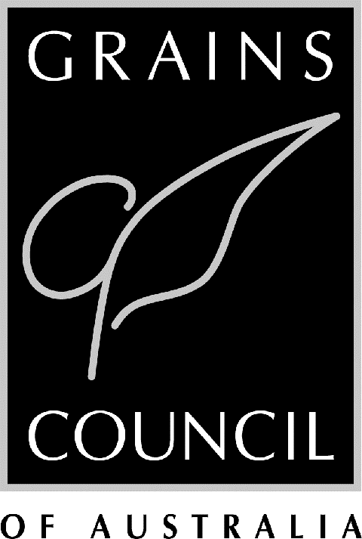

Grains Council of Australia

Supplementary Submission

To

The Senate and Rural and Regional Affairs and Transport Legislation Committee

On

Wheat Marketing Amendment Bill 2002

26 May 2003

Introduction

In the Grains Council of Australia’s initial submission it was recommended that the Committee’s considerations should be confined to the intent of the Wheat Marketing Amendment Bill 2002 – which is to provide a longer term funding mechanism to meet the operating costs of the WEA plus other minor changes to improve the operational efficiency of the WEA – and not on other aspects which have been the subject of a public debate.

The GCA reiterates its position and asks that the Committee focus on the intent of the Bill when making its recommendations.

The GCA addressed the funding aspects in its earlier submission and made a number of recommendations in this regard based on the distribution of the benefits of the single desk arrangements.

Nevertheless a large number of other issues have been raised by both some of the submissions to the Committee, and the Committee’s questioning during the public hearings. Furthermore recent media commentary suggests that the Committee may make recommendations regarding the exports of bags and containers, WEA’s role and performance, and aspects of the AWB(I) and AWB Ltd relationship which are outside the scope and purpose of the Bill.

Even though GCA does not believe that recommendations regarding those issues are within the scope of the present Inquiry it will provide comment on some of those. In particular this submission will canvass the following:

- GCA’s representativeness and the weight of its views
- Impact of deregulation of exports of bags and containers
- An independent tribunal to undertake 2004 review
- Industry confidence in WEA
- AWB Ltd issues

GCA’s Representativeness and the Weight of its Views

Representing the interests of some 50,000 growers Australia wide the Grains Council of Australia is the peak policy body of the Australian grains industry. The Government recognises the GCA as the peak grains industry body in legislation including the Wheat Marketing Act.

The GCA’s members are the five mainland farmer organisations – AgForce Queensland, New South Wales Farmers Association, Victorian Farmers Federation, South Australian Farmers Federation and the West Australian Farmers Federation.

As such the GCA’s initial submission to the Committee has the support of all its five state affiliates- that is the five main grower groups in Australia. This is also the case with this supplementary submission which incorporates the views expressed by GCA's Affiliates since the commencement of the Senate Inquiry and thus includes Grains Week 2003 decisions.

It is thus perturbing that the Committee appears to have taken the stance that ‘weight of opinion’ is simply formed by the number of submissions, supporting a particular view no matter where particular submissions are from, how representative they are in the industry nor what the Constitutional objectives of these organisations are.

The facts that the GCA submission has the support of its five affiliates Australia wide and that its Constitutional objective is to maximise the economic and social welfare of Australia’s grain growers does not appear to be acknowledged by the Committee.

Instead the Committee appears to be influenced by the ‘weight of opinion’ of vested commercial interests with company profits rather than growers returns as their objectives and who would be the beneficiaries should the present single desk arrangements be altered or completely dismantled.

Impact of Deregulation of Exports of Bags and Containers

The suggestion that has been made throughout the Inquiry that as bags and containers represent a small proportion (less than 5 per cent) of total wheat export deregulation would have no impact on the returns to Australian wheat growers of pool or bulk exports fails to understand the impact that this would have.

The majority of containers are sold in those markets which are premium paying markets for the national pool, that is those markets that receive above the pool return which is an average of all the markets within respective grades. Exporters of containers are able to acquire wheat domestically at the average pool return. Thus there is the prospect for these sellers to make a return in the premium markets by ‘cherry picking’ these markets. In the process, however, the price in these markets is competed down.

These lower prices are also transferred to other Australian markets. Furthermore displaced bulk pool wheat from the premium market is sold in lower paying markets.

The result is that Australian growers returns suffer losses through lower prices and lower volumes in premium markets.

Nevertheless exports of bags and containers by non-AWB sellers are an important adjunct to bulk sales provided it is complementary to pool sales. Provided that they do not negatively impact on pool sales the GCA is supportive of exports in bags and containers.

Indeed this is the basis upon which the revised consents guidelines are based and thus the basis upon which they are considered by the WEA. The Minister in requesting the WEA to review the consents guidelines in 2001 indicated that container exports should complement the single desk arrangements in maximising pool returns through AWB(I) while at the same time facilitating the development of niche and complementary markets where this can benefit growers.

The WEA has reported to the GCA in the context of the GCA/WEA Consultative arrangements that the revised consents arrangements are working well and that users of the consent system are supportive of the arrangements.

There would thus be no reason to change these arrangements unless the intent is to either erode growers returns or to dismantle the single desk arrangements by stealth.

To deregulate the export of bags and containers would lead to the inevitable erosion of the single desk arrangements. Deregulation would provide the opportunity for exporters to leverage this opportunity and erode pool returns and undermine the single desk. Large well resourced companies could also use the opportunity to accelerate the erosion by pricing in overseas markets on a loss leader basis.

Independent Tribunal

It has been suggested that an independent tribunal rather than the WEA should undertake the 2004 review of AWB(I)’s performance.

Such a suggestion fails to recognise the work already undertaken by WEA towards the 2004 review already through the reporting to the Minister in 2001 and 2002 on AWB(I)’s performance and on the work undertaken towards the 2003 report to the Minister.

The 2003 review will draw heavily on the data and evaluation of the three reports 2001 to 2003 and be supplemented with additional analysis and information.

In effect the analysis underlying the 2004 review is two-thirds completed.

The rationale behind the suggestion to start this task again would need to be questioned. Furthermore the suggestion fails to recognise that the WEA is itself an independent tribunal by a different name.

Industry Confidence in WEA

Throughout the inquiry many have suggested their lack of confidence in the work of the WEA. Such a position fails to take into consideration the following:
- That WEA’s performance Monitoring Review and Reporting Framework for assessing AWB(I)’s performance was not completed until the later part of 2001. Since that time data relating to two pool periods has been analysed and reported on to the Minister
- The WEA’s role is to assess the performance of AWB(I) in maximising growers returns. WEA’s role is not to scrutinise the activities of AWB Ltd or its other subsidiaries. It does this only where the activities of AWB Ltd could have an impact on pool returns.
- WEA’s role is not that of ASIC, ASX and the ACCC. These bodies can scrutinise AWB Ltd and AWB(I) as its subsidiary.
- The WEA’s task is a difficult one and invariably is going to be brought into question given the nature of the task.

The GCA supports the WEA and is working closely with it to ensure growers interests are identified and addressed in its monitoring of AWB(I). The GCA and the WEA through their consultative process have recently developed a mechanism whereby issues pertinent to the AWB(I)’s task of maximising growers returns are brought to the WEA’s consideration and response.

The GCA believes that the reporting to growers should be more comprehensive and extensive. Discussions have already been held with WEA with this objective. Similarly GCA believes that reporting to growers should be on a more frequent basis than presently is the case.

AWB Ltd Issues

Throughout the Inquiry a range of issues on the relationship between AWB(I) and AWB Ltd have been raised as either being detrimental to growers pool returns or alternatively providing a benefit to AWB Ltd which is not available to its competitors.

It was indicated in the previous section that a mechanism has been established for the GCA and its five Affiliates to raise questions pertaining to AWB(I)’s performance with the WEA.

In a similar way there is an established forum under the GCA/AWB Ltd consultative arrangements for GCA and its Affiliates to raise issues and seek explanations from AWB Ltd. In this process the GCA also meets with AWB(I) and members of its Compliance Committee. Under this process GCA continues to monitor and where necessary question and review, the structures and operations to ensure that benefits are delivered to growers. In doing so GCA’s Affiliates have the opportunity to constantly review a range of matters. The matters discussed under this process include the following, which have been raised in the Senate Inquiry: cash trading and pools, Geneva Office, and AWB Ltd’s roles in seed breeding and varietal classification.

Conclusion

A common thread of all the submissions received by the Inquiry is the pivotal and important role the WEA undertakes in ensuring that AWB(I) maximises grower returns in its management of the single desk export rights. It is thus a matter of priority to put in place a funding mechanism for the WEA to enable it to continue its task.

The GCA reiterates its support for the Wheat Marketing Amendment Bill 2002 and asks that the Committee recommends its acceptance and that the funding of the WEA is as outlined in the recommendations (Attachment 1) in the GCA’s first submission to the Committee.

Attachment 1

Recommendations

- The consideration of the Senate Rural and Regional Affairs and Transport Legislation Committee should be confined to the intent of the Wheat Marketing Amendment Bill 2002.
- The Federal Government should part fund the operations of the WEA.
- Grower contributions to the funding of the WEA should cover grain supplied to both the domestic and export markets.
- The introduction of a levy/charge is to apply to all the wheat of a whole season to avoid inequity.
- Fees for export consents should be introduced at the earliest possible date and should be at a level to cover the costs of their administration.
- There will be a formalised requirement that the already established GCA/WEA consultative process will cover the budget and levy/charge setting process.

