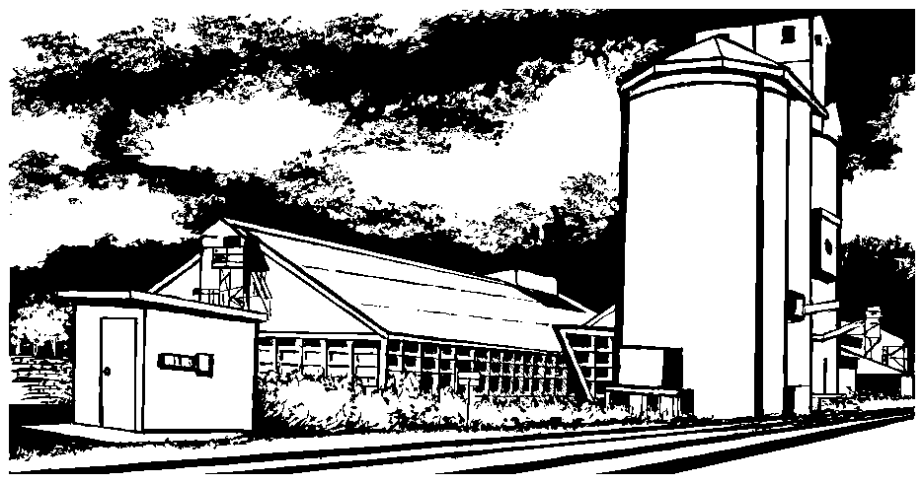
Shepherds Producers
Co-Operative Limited

The Secretariat,
Senate Rural and Regional Affairs and Transport Committee
Room SG.62, Parliament House,
CANBERRA ACT 3560

TO WHOM IT MAY CONCERN

Wheat Marketing Amendment Bill 2002

Shepherds Producers Co-operative is pleased to take the opportunity to provide comment on the Wheat Marketing Amendment Bill 2002.

It is of the Co-operatives belief that the current situation within the grain industry has resulted in:
- Commercial conflicts of interest among monopoly’s;
- Unbalanced commercial growth favoring monopoly’s;
- Lack of cost savings for industry groups and growers and
- An anti-competitive industry promoting inefficiencies within the industry.

This review presents our Co-operative with a unique opportunity to encourage better management of the wheat export single desk for growers to achieve more transparency in the Australian Wheat Board group operations, resulting in a more effective watchdog to police the operations of the wheat export single desk operator.

In order for the Wheat Export Authority (WEA) to effectively promote transparency, and to provide independent industry oversight and control, it must be sufficiently resourced.

A reassessment of the WEA’s current charter is needed to enable it to effectively operate as an industry regulator. I refer in particular to the inability of the WEA to seek information about the contract between the Australian Wheat Board (AWB) International and AWB Limited. Our Co-operative believes this is a significant limitation the power of the industry regulator. It is vital that to be effective, the WEA is independent, robust and properly funded.

100 Gurwood St Telephone: 02 6921 7314
Wagga Wagga NSW 2650 Facsimile: 02 6921 7717
www.shepherdsproducers.com.au Mobile: 0414 917 314

‘Farmers marketing quality grain’

It is recommended to ensure this independence, the removal of consultation with the AWB on bag/ container exports and bulk exports is necessary. Access to container and bagged export permits should be more widely available and not restricted to so called “niche markets” given the clear and obvious advantage a bulk supplier (AWB) has in terms of freight and logistical capacity. We note AWB Ltd is not excluded from the container trade however they do not require a permit to export in this manner.

As WEA contracts the custodianship of Australia’s Single Desk Marketing System to AWB (International) Ltd, a wholly owned subsidiary of the ASX public listed company AWB Ltd, there is a belief that the presence of vested interest in the organisation is impeding the performance of the industry as a whole in its current form.

This is highlighted in the following example. After significant market research and development, non-AWB exporters developed premium markets for Australian wheat in Vietnam. AWB moved to curtail the trade and subsequently opened an office in Vietnam. Vietnam was a market the AWB previously ignored or only sold to via specially appointed “agents” who effectively kept AWB shielded from the premiums available in that market. This example is important as Australian wheat was working to displace Indian wheat, which is a growing competitor to Australian wheat exports in South East Asia.

This aggressive behaviour is shown through use of another example. It was recently reveled that AWB Ltd moved to stop one of the industry’s leading research organisation’s sending its staff to Japan, to talk to end-users about Australian wheat varieties milling and processing performance. AWB Ltd made it clear that they wanted to control contact with current and future export wheat customers and threatened to involve the Federal Government if the research organisation did not pull its staff out of Japan.

This type anti- competitive activity is severely impeding the industry’s ability to respond to market shifts, global prices changes, customers needs and sales opportunities.

An increase in WEA resources needs to occur to ensure the organisation is adequately equipped to ensure timely consideration and return of applications. The current application process severely limits our organisation’s ability to respond to opportunities in a timely and effective manner.

- The time taken to receive a response to an application often means the opportunity passes by the time a response is given;
- The process of having an application passed by AWBI for approval means that valuable market information is passed on to an aggressive competitor in the industry and;
- The current expectation by industry is that applications will not be successful. This, combined with the short term nature of the permits, ensures the industry will not invest time or capital in ventures that have limited scope firstly for success and secondly for ongoing growth.

We believe AWB International cannot serve two masters: it cannot fulfill its duty to maximise returns to growers delivering to the national pool by minimising costs while simultaneously achieving a margin that satisfies the shareholders of its parent AWB Ltd. In this way, we believe the Board of AWB International (or any other single desk manager) should have a separate board completely to AWB Ltd, its parent company.

Our Co-operative believes it is necessary to consider the findings of various industry reports, including Kronos Report and the Accenture Review which address the need to improve competition in the supply chain in order to ultimately deliver cost savings to growers.

Findings of ‘A Review of Structural Issues in the Australian Grain Market 2002’ Kronos;

- “A greater degree of accountability and transparency is appropriate as an inherent responsibility associated with an export monopoly. In particular a fully disaggregated breakdown of all logistics and finance costs deducted from pool returns should be made publicly available. Appropriate corporate governance would also include a declaration of where these services are provided by associated entities, and what margins are being extracted.”
- “In a market structure that contains an export monopoly there is a need for public information to be provided by the monopoly holder to ensure that the market is functioning properly. Too much of this information is currently not available under the guise of commercial in confidence.”
- “In its current form WEA is not effective. Both the WEA and Grains Council of Australia (GCA) need to be adequately funded and resourced to provide an important oversight role. At the present time neither has sufficient funding or current expertise to be able to adequately assess the performance of AWBL and the impact that its activity has on grower returns.”
- “For the WEA to play an effective role it needs to be more independent of AWB in its activities. It is our recommendation that the structure of the export arrangements, and the WEA itself, be reviewed and enhanced.”
- “Full details of rail arrangements negotiated by the holders of export monopolies be disclosed to appropriate bodies such as WEA, UGH or GCA so that growers can confirm whether the cash activities of these organisations are using pool volume for advantage in their non pool activities.”

Our opinions are also in line with those of the Grain Growers Association through the Accenture Review, which are for:

- Separation of AWBI from AWBL, to put the single desk above commercial interests.
- Introduction of competition into the single desk's domestic supply chain, to reduce costs to the pool.
- Revision of the single desk arrangement to allow growers and grower co-operatives to readily establish a useful information flow back from overseas customers and end-users
- Transparency of information, so growers, research groups and others have access to the same level of information available from the old Australian Wheat Board
- Strengthening of the powers of the Wheat Export Authority, to give it oversight rights similar to those of other competition regulators, such as the ACCC

This reform is required to ensure the Australian grain growing industry is globally competitive and responsive to change and presented opportunities.

Should the present situation remain, the strongest balance sheet will ultimately prevail and leave us with reduced competition, exposure to businesses that will be dividend focused and leave the grain growers interests at farm gate behind. As our Co-operative’s mantra is to ‘maximise farm gate returns’, we find the current structure unsatisfactory.

Yours sincerely

Scott Bradley

CHIEF EXECUTIVE OFFICER
sbradley@shepherdsproducers.com.au

