The Secretariat
Senate Rural and Regional Affairs and Transport committee
Room SG.62, Parliament House
Canberra ACT 3560
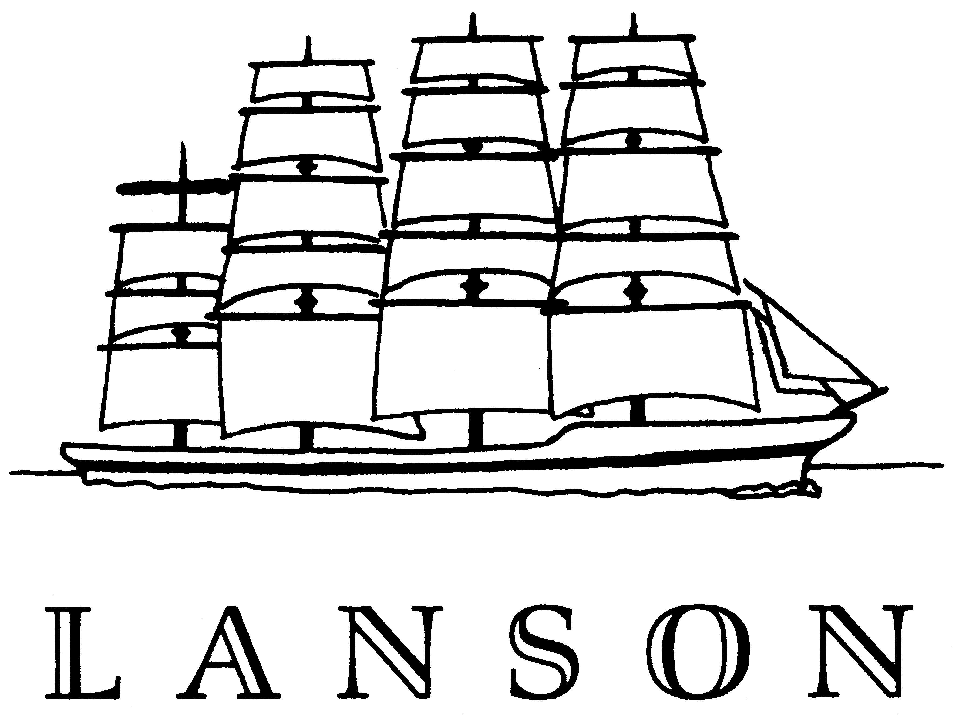
Australia

2003-02-26

Private & Confidential

Dear Sirs,

We note with interest matters relating to the Wheat Marketing Amendment Bill 2002. As a small commodity business based in Melbourne our focus is on the International Markets and in this respect we have some understanding of the operations of AWB Ltd and the WEA. Accordingly we offer some comment, which we hope, is constructive. The mechanics of the WEA are we would suggest extremely bureaucratic and although established for some time, the organisation displays a lack of understanding of the International Market and in fact does not appear to be improving. Therefore it seems unrealistic for growers to be funding an organisation, which is not performing satisfactorily.

Their annual report for example provides little evidence of real achievements, yet there is strong evidence to show dissatisfaction throughout the Australian Wheat Industry with their performance. Our company does not export Australian wheat as we cannot get a permit and we have given up. But there are many small trading operators who supply in containers who have developed strong business links in Asia particularly and have suffered as a result of WEA lack of initiative. It is reasonable to suggest the frustration by small grain industry participants with the WEA will mean many will not bother to make any comment in response to this inquiry.
In fact many had a better arrangement on permits with the AWB prior to the formation of WEA.

Our strong recommendation is that if a levy is applied, a complete restructure of the WEA operation is necessary. This Authority needs to show some leadership; particularly in it’s relationship with AWB LTD. It needs a clear understanding of the International Market Place. The WEA must have the ability to understand AWB International’s strategy for each market, and the value adding policy on wheat. Further it must be in a position to report on the flow of value added funds, and determine if the revenue from grower’s wheat is going into pool returns, or the dividends of AWB LTD.

As an important Industry body it’s position on separating AWB International from AWB LTD would be of interest to the Industry. With some significant issues facing the wheat growers of Australia it is about time the Authority got involved, rather than just having a focus on permit issues.

As stated we like many have given up on applying for consideration in providing Australian Wheat to our customers. In the Middle East for example we are forced to focus on Ukraine, Hungarian, Argentine wheat as a result, whilst this may have displaced AWB sales in the past, the AWB LTD company has now established a trading operation in Geneva, which is also displacing Australian wheat sales as they seek the same supply base as ourselves. Yet we are unable to source Australian wheat.
It is important that the WEA understands this position and has a view on the impact of AWB LTD decisions on the management of the Single Desk responsibilities.
We have applied for permits into markets where AWB is losing market share or markets not of great interest to the AWB .For example Bahrain where Australia sold 67,271 tonnes in 1996/97 has reduced to 22,405 tonnes in 1999/00 .The grain is purchased through public tender from sources such as USA, Argentina, or Australia. However the AWB has offered Argentine and US wheat to this market at a time we sought to supply 1500 tonnes of Australian wheat at premium prices.

At the time we felt the provision of the parcel would assist in re capturing lost market share, however we obtained the normal WEA response stating “ WEA considers granting you a request for permit is likely to jeopardise sales achieved, or premiums obtained by AWB International for wheat into that market “.
Yet optional origin wheat seems to be acceptable.

We have made a number of applications to the WEA on the basis that the AWB has been selling wheat below the market, in fact our permit applications have included constructive information for the WEA to assess not only the merit of our request, but also understand pricing comparisons with Australia’s competition.

When we sought a 30,000 tonne bulk wheat permit to supply a shipment to Egypt, it was on the basis that the AWB had sold 180,000 tonnes at a price below the lowest USA soft white wheat price. As Australia enjoys a significant freight advantage we also factored this advising that we felt there had been a sale which was $8.22 us below the nearest price of grain from the Pacific North West of the USA.

Whilst we did not anticipate a permit, it was a good opportunity to raise some awareness with the WEA .We felt it might assist in the process of forming benchmarks for AWB’S management of the Single Desk. On a number of occasions we have provided significant detail on various pricing and market information, however there is only the usual, “ unsuccessful “ response. At no time has there been a request for more information, which would indicate that this organisation is not attempting to understand Australia’s performance in the grain market through consultation. If it is not getting information from the AWB or failing to get the correct material, it is breaking down on all fronts. Accordingly our earlier recommendations may improve this perception.

The task of the Committee is difficult and the tight timetable seems to be an issue, accordingly our comments are brief, but should you require information we are happy to assist.

Yours sincerely,

E.J.Laskie

