Bass Forest Focus Forum, 3-4 May, 2003

“The comparative value of forest water to various land uses to the regional community”.

David Armstrong
Agricultural Consultant
Armstrong Agricultural Services, Launceston.

Important note. The water balance calculations used in this paper are simplistic. Although based on well recognised methodology, the analysis uses crop factors relating evapo-transpiration to pan evaporation that are based on experience without field verification. As a result, the calculations of evapo-transpiration and thus runoff and drainage must be regarded as tentative. Despite this, the results are consistent with rational expectations.

Summary

This paper aims to describe the fate of rainfall, by partitioning the rainfall into the main components of evapo-transpiration, and runoff plus drainage. The estimate of evapo-transpiration for a range of land uses has been used to calculate the farm gate value of production per 100 mm of water used by a range of crops (includes pastures and forestry as crops).

The analysis is somewhat simplistic; sophisticated computer models are available, but they have not been verified in Tasmania. As a result, the estimation of evapo-transpiration (and thus runoff and drainage obtained by difference) must be treated with caution. It is considered, however, that the relatively between the various crops is reasonable, and the calculated values of farm-gate production per 100mm of evapo-transpiration are realistic.

The highest farm-gate returns per hectare per 100 mm of evapo-transpiration are produced by hops and potatoes ($1,542 and $1,337). The lowest returns are from timber from native forest and plantations for pulp production ($42-$43). Returns from pine plantation for sawlogs, and grazing of dryland pasture for meat production are similar (in the range $150-$200).

Water cycle

The fate of rainfall is generally described by the Water Balance Equation:

P + IRR = I + E + T +RO + D + SS

P = precipitation (i.e., rainfall) ] Water inflows
IRR = Irrigation ]

I = Interception plant canopies, subsequently evaporated ] Combined to give
E = Evaporation from the soil surface ] evapo-transpiration
T = Transpiration by plants ]

RO = Runoff ] Water outflows
D = Leakage below the root zone into groundwater ]

SS = Change in soil moisture storage.

Rainfall is easily measured, but the other components are much more difficult.

For this paper I have tried to estimate evapo-transpiration, and therefore runoff plus drainage by subtraction.

There are established relationships between evapo-transpiration and measurements of weather factors (such as temperature, sunshine, wind, relative humidity and evaporation). An evaporimeter is used to measure evaporation. The device used in Australia is a “Class A pan”. This is simply a tank or pan about a metre in diameter, and 250 mm deep, usually with a mesh screen to keep out birds, dogs and other animals. The water level is restored to a fixed point each day and the amount of water added is a measure of the evaporation.

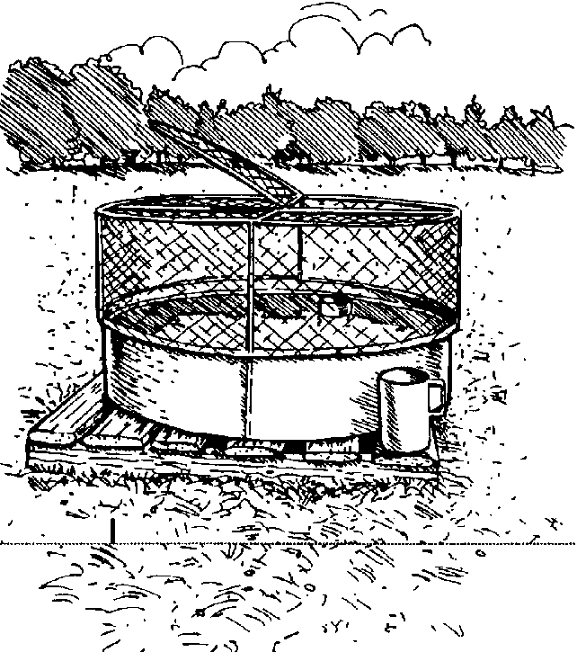

Class A pan evaporimeter

Crop evapo-transpiration varies from about 60% of pan evaporation in cooler weather, to about 100% of pan evaporation in summer months when crops are growing vigorously.

Runoff can drain to the sea, can evaporate, or can be diverted for our use, for example for domestic supplies or irrigation.

Groundwater, can also drain through rocks and sediments to the sea, or be extracted for various uses, including irrigation, stock and domestic and industrial use.

The quantities of water moving in these various directions will vary depending on the particular conditions, including the type of vegetation, soil type, geology etc. Although I can not look at the water balance components in precise detail, I would like to illustrate with two examples.

Native forest, in 800mm rainfall zone.

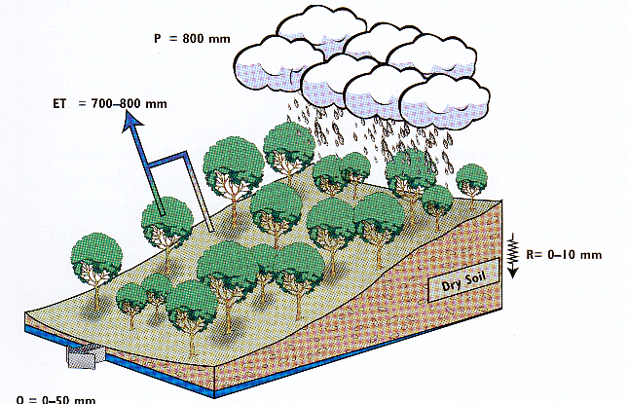

P = 800 mm, per year.
Evapo-transpiration = 700-800 mm.
R = Recharge or drainage to groundwater of 0-10 mm.
Q = Runoff (streamflow) and groundwater flow from the system = 0-50 mm.

Replacing the native eucalypt vegetation with pasture changes the water balance considerably. Eucalypt forests transpire more water, particularly because of their evergreen foliage and deeper root system. Evapo-transpiration by the pasture is much less, allowing more water to run off or move through the soil to the groundwater.

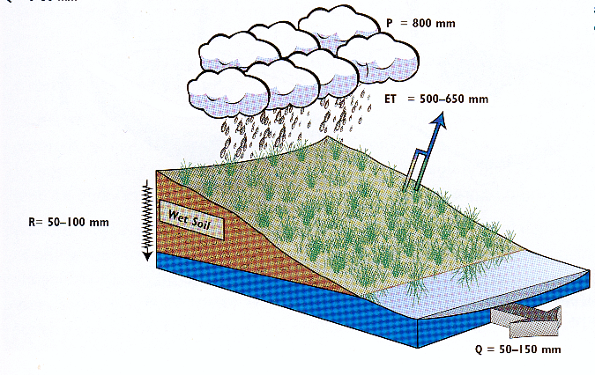

In this example, Q (streamflow and groundwater flow) has increased from 0-50mm per year under native forest, to 50-150 mm/year under pasture.

Uses of water

One of the uses for water is for commerce, but there are obviously others including domestic and urban consumption, environmental and recreational uses. In the remainder of this paper I will look in more detail at the commercial uses, particularly use for agricultural and forestry production. I have used the estimates of water use (evapo-transpiration) to calculate the value of produce at the farm-gate for a number of land uses, including dryland and irrigated agricultural enterprises, and forestry.

Weather data and calculation of evapo-transpiration

Average monthly rainfall and evaporation are shown in the following chart (note that the evaporation data is from Scottsdale, rainfall from Ringarooma).

This graph shows several important characteristics of the rainfall and evaporation.

1. Total average annual rainfall is about 1225 mm per year, and is highest in winter.

2. Total average annual pan evaporation is about 1067 mm/year, and is highest in summer.

3. In January, evaporation exceeds rainfall by about 100mm; this results in a water shortage for plant growth. Without irrigation, plant growth slows or ceases.

4. In July, rainfall exceeds evaporation by about 110mm; this results in a large excess of water that will either run-off, or infiltrate into the ground water.

5. Rainfall exceeds evaporation for 7 months, from April to October.

This information can be used to develop a monthly water balance. This is illustrated for irrigated pasture in the following table.

 | J | F | M | A | M | J | J | A | S | O | N | D | Total
Rainfall, mm | 64 | 58 | 65 | 94 | 120 | 135 | 153 | 146 | 121 | 111 | 81 | 77 | 1225
Evap, mm | 164 | 140 | 105 | 63 | 43 | 39 | 43 | 53 | 63 | 90 | 117 | 146 | 1066
Crop factor* | 1 | 1 | 0.9 | .8 | .8 | .8 | .8 | .8 | .9 | 1 | 1 | 1
E-T, mm | 164 | 140 | 95 | 50 | 34 | 31 | 34 | 42 | 57 | 90 | 117 | 146 | 1001
Water deficit | 100 | 82 | 30 |  |  |  |  |  |  |  | 36 | 69 | 317
Water excess |  |  |  | 44 | 86 | 104 | 119 | 104 | 64 | 21 |  |  | 541
* Crop factor is a measure of the relationship between pan evaporation and crop evapo-transpiration.

This table shows a water deficit over the year of 317 mm. There is capacity for the soil to store about 40 mm of the excess winter rainfall, for use in early spring. As a result, the irrigation requirement is reduced by about 40 mm to 277mm, and the amount of runoff and drainage reduced by 40 mm to 501 mm.

It should be noted that the estimates of water use do not take account of inefficiencies associated with irrigation (including distribution losses). A consequence of this is that more water must be stored and pumped for irrigation to meet this evapo-transpiration requirement.

Agricultural and forestry enterprises

So how is the rainfall used, and what does it produce?

The main agricultural enterprises in the northeast are:

Grazing, with dairy cows, irrigated and dryland.
Grazing, beef cattle.
Potatoes, under irrigation.
Poppies, under irrigation.
Hops, under irrigation.
Native forest timber.
Plantation timber, for woodchips and sawlogs.

These enterprises use water that falls directly as rain, and in several instances, additional water is applied by irrigation.

Using the water balance procedure described above, I have estimated the components of the water balance equation, particularly evapo-transpiration, for a range of enterprises.

I need to repeat that the analysis is simplistic, so please do not place undue emphasis on the actual figures, However, I believe the general picture that the figures portray is about right.

For example, actual evapo-transpiration is highest for irrigated pasture, and lowest for annual pasture. Drainage is highest under potatoes and lowest under plantation forest.

Based on the estimates of evapo-transpiration I have calculated the farm-gate value of produce per 100 mm of water used.

Remember, these economic figures are the returns for 100 mm of water used by evapo-transpiration; they are not direct indicators of profit.

Conclusions

We need to be careful about the interpretation of these figures; the models are simplistic.

The greatest returns per 100 mm of evapo-transpiration are from hops and potatoes. The markets for these crops, however, are limited, and no expansion is anticipated in the short term. And crops such as potatoes and poppies can only be grown in rotation with other crops or pasture. Potatoes are normally limited to 1 year in 5 or 6 in a particular paddock, and poppies to one year in 3-5 (to reduce risks of diseases and so that the soil is not degraded).

Irrigated pasture used for milk production provides the highest return in the grazing industries, and pines for sawlogs provide the greatest return in the forest enterprises.

Note that this analysis is based on gross farm-gate returns, not profitability. Production costs are lower for plantations than most farming enterprises, and an analysis of profitability will reduce (but not eliminate) the differences between irrigated high value crops and timber.

In all analyses of this type, the economic conclusions need to be balanced with practical issues. For example, plantations may be planted for timber, but they may also be planted to provide an economic return on marginal farming land, to lower groundwater tables and aid management of dryland salinity or to stabilize land-slip areas. But it is clear that the land uses with the greatest farm gate returns consistently provide the greatest returns per unit of water use.

Refer. “Trees, water and salt, an Australian guide to using trees for healthy catchments and productive farms”. Ed. Richard Stirzaker, Rob Vertessy and Alastair Sarre. 2002.

