11 May 2004
Ms. Maureen Weeks
The Secretary
Senate Rural and Regional Affairs and Transport Legislation Committee
Suite SG.62
Parliament House

CANBERRA ACT 2600

By Email: rrat.sen@aph.gov.au Our Ref: G400-034
Dear Ms Weeks,
Civil Aviation Legislation Amendment (Mutual Recognition with New Zealand and Other Matters) Bill 2003 (“the Bill”)
We refer to our letter dated 3 May 2004 and to your letter dated 24 March 2004.
This is a submission from the Australian and International Pilots Association (“AIPA”) to the Senate Rural and Regional Affairs and Transport Legislation Committee (“the Committee”) in relation to the Bill.
- Introduction
AIPA is an organisation of employees registered pursuant to the Workplace Relations Act 1996. AIPA represents pilots and flight engineers employed by Qantas Airways Limited.
Australia has an aviation safety record that is second to none. Qantas has the best safety record of any airline in the world. This outstanding record is due, in no small part, to the professionalism and skill of Australian, and particularly Qantas, pilots.
AIPA is very concerned that this Bill has the potential to make Australian aviation less safe. Any reduction in Australia’s aviation safety standards is unacceptable.

- The Premise of the Bill
The Bill is apparently premised on an acceptance that:
“…while some systems and processes may vary, Australia and New Zealand have safety standards that produce equivalent safety outcomes in high capacity airline operations”
In other words the Bill assumes that the Australian aviation safety standards are the same as New Zealand aviation safety standards and that New Zealand airline operations are as safe as Australian operations.
- AIPA’s Concerns
The problem that AIPA sees with the assumption that apparently underpins the entire Bill is that it has not been established. It is asserted in the Explanatory Memorandum to the Bill and the Second Reading Speech that the two regulatory systems produce equally safe skies however no evidence is supplied to support this assertion.
Civil Aviation Safety Authority CASA Analysis
It is stated that:
“CASA has advised that a detailed analysis of the safety systems has been conducted and both sides are confident that aviation can interoperate safely in the form being considered”
To the best of AIPA’s knowledge this detailed analysis has not been made public. It has not been scrutinised and, as far as we are aware, has not been the subject of independent review. AIPA and the Australian public have no way of assuring themselves that CASA’s analysis is accurate. AIPA is not stating that the analysis done by the CASA is faulty. However AIPA does believe that, given that the whole Bill is apparently premised on the accuracy of CASA’s analysis, it is critical that it be properly scrutinised and this has not been done.
Compliance with International Civil Aviation Organisation (“ICAO”) Audits
It is also asserted that:
“As signatories to the Chicago Convention, Australia and New Zealand are both subject to ICAO audits; the publicly available audit findings indicate both have equivalent safety regimes”
AIPA has not had the opportunity to review any publicly available audit findings. However, it is AIPA’s position that audit results do not establish that Australia and New Zealand have equivalent aviation safety regimes. ICAO audits determine the status of implementation of relevant ICAO Standards and Recommended Practices, associated procedures and safety-related practices. They do not analyse and compare the aviation safety regimes of different nation States. New Zealand’s aviation safety system may well comply with the standards required by ICAO and still offer a lesser standard of aviation safety than Australia’s system. Finally it is AIPA’s position that compliance with ICAO standards represents the minimum level of aviation safety, not the desirable level.
Lack of detailed analysis of accident and incident statistics
According to the Explanatory Memorandum no detailed analysis of how New Zealand’s accident and incident statistics compare with Australia’s has been carried out, although it is apparently considered that the two countries have comparable safety records. AIPA believes that a detailed analysis of each jurisdiction’s aviation safety record is essential if any proper comparison of those systems is to take place. AIPA does not understand how it can be asserted that the two systems offer equivalent safety standards without a detailed examination. AIPA believes that an examination of this material is absolutely essential.
- Conclusion
AIPA is concerned that the fundamental premise of this Bill, that mutual recognition will have no adverse impact from a safety perspective, has not been established. The detailed analysis by CASA that apparently supports this position has not been made available to any interested parties, or the public. Accordingly its accuracy and reliability has not been tested. Reliance is placed on ICAO audit data where this data is patently unsuitable for the type of comparative analysis that is required in this case. The fact that the aviation safety systems in Australia and New Zealand meet ICAO requirements does not mean that they are equivalent. Finally no detailed analysis of the effectiveness of the New Zealand’s aviation safety system, in terms of accident and incident statistics, has been conducted.
Before mutual recognition can be accepted it must be properly established that there will be no reduction in Australia’s aviation safety standards. This has not been done.
The Committee must now satisfy itself that the passage of the Bill will not make Australia’s skies less safe. Any reduction in Australia’s aviation safety standards is unacceptable to AIPA, its members and to Australia’s travelling public.
We are happy to provide any further assistance that the Committee may require. Should you require any further information or assistance please contact me or Michael O’Neil.

Yours faithfully,
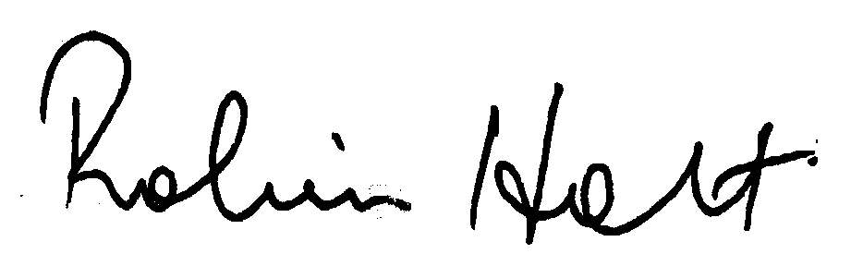
Captain Robin Holt
President
Australian and International Pilots Association

Explanatory Memorandum to the Bill at page 3.
Tuckey, Wilson, MP Minister for Regional Services, Territories and Local Government, House Hansard, 25 June, 2003, page 17422.
Ibid, pages 3, 9 and 12.
Ibid, page 12.
http://www.icao.org/cgi/goto.pl?icao/en/anb/mais/index.html
Op cit at note 1, at page 12.

