Chapter Three

gear statutory fishing right management

Introduction
- This chapter examines whether gear statutory fishing right (SFR) management is the best means of addressing the overfishing problem. As indicated, AFMA supports gear SFR management on the basis that headrope length bears a closer relation to swept area performance than Class A SFRs, and is more practical and cost effective to reduce. However, the Committee was presented with modelling, which showed no meaningful relationship between headrope length and swept area performance.
- The Committee also considered alternatives to gear SFRs for the management of the NPF. These alternatives included another buy-back, policing of engine power, implementing time and effort units and further net restrictions. Again, various problems with each of these alternatives were raised in submissions and during hearings.

Gear SFR Management and Swept Area Performance

Trawl Performance Prediction Modelling
- The Committee received three technical submissions questioning whether regulation of headrope length as proposed under the amendment management plan would work. These submissions were made by Mr Sterling from D J Sterling Trawl Gear Services, Mr Eayrs and Mr Wakeford from the Australian Maritime College, and Mr Kim Klaka, Director of Maritime Science and Technology at Curtin University.
- In his written submission, Mr Sterling argued that the swept area performance of a vessel depends upon the vessel thrust. Greater thrust allows:
    - Nets to be towed faster;
    - Bigger nets to be towed;
    - The mouth of the nets to be stretched wider by the use of larger otter boards.

- These three means of increasing swept area performance are shown in Figure 3.1 below.
Figure 3.1: Relationship between vessel speed, gear size and width
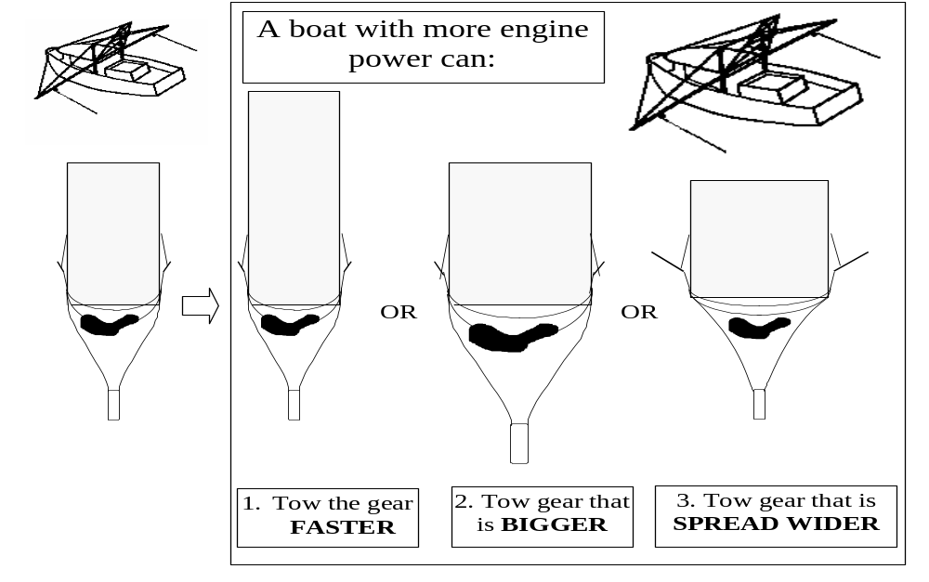

- Based on this three way relationship between vessel speed, gear size and width, Mr Sterling argued in his written submission that a 10 per cent reduction in headrope length would only result in a 0.3 per cent reduction in swept area performance in the NPF. The reason for this is that the 10 per cent reduction in headrope length would reduce the size of the net towed. However, this reduction in size and therefore drag of the net would lead to a corresponding increase in the speed at which the net was towed, and the width of the net mouth.
- Mr Sterling reiterated this point in hearings, noting that the increase in trawl speed would not even require a conscious decision on behalf of the operator – it would simply follow from the reduced size and drag of the net. However, Mr Sterling also noted that were further larger reductions in headrope length to be enforced, then a more substantial reduction in swept area performance would be achieved, if only due to significant declines in the size of the net. Mr Stirling argued that the problem with such an approach is that the fleet would become tremendously less technologically and economically efficient than it is at the moment.
- The research by Mr Sterling was supported by the written submission of Mr Eayrs and Mr Wakeford from the Australian Maritime College in Launceston, Tasmania. They presented a table in their written submission showing that with a reduction in headrope length, there is a corresponding reduction in drag, in turn leading to a gain in towing speed. As a result there is only a small reduction in swept area. This table is reproduced below.
Table 3.1: Percentage changes in trawl drag, towing speed and swept area resulting from headrope length reductions.

Headrope reduction (%) | Drag reduction (%) | Gain in towing speed (%) | Reduction in swept area (%)
5 | 7.3 | 3.8 | 1.2
10 | 14.3 | 8.1 | 1.9
15 | 21.3 | 12.7 | 2.3
20 | 28.8 | 17.8 | 2.2
25 | 34.5 | 23.5 | 1.5

- Table 3.1 indicates that the proposed 15 per cent reduction in headrope length would lead to only a 2.3 per cent reduction in swept area. To recover this loss, Mr Eayrs and Mr Wakeford argued that the engine power of boats would need to be increased by only 3 per cent. Alternatively, the same result would be achieved by a reduction in the netting twine by 2 filaments.
- Furthermore, Mr Eayrs and Mr Wakeford also pointed out that with periodical adjustment of headrope length, operators would often need to replace their trawls, which would be used as an opportunity to trial gear innovations, such as low drag twines, in the hope of increasing catches. As a result, overfishing would continue, with the effort control ‘merry-go-round’ in turn requiring a new round of headrope length reductions.
- The Committee notes, however, that nets used in the NPF are normally replaced each season. Accordingly, provided that adjustments to headrope length are made annually, the Committee does not anticipate there being significant additional costs from headrope length reductions.
- In hearings, Mr Eayrs reiterated the argument that swept area performance would remain virtually unchanged in response to an initial reduction in headrope length:
Our results show that due to other inputs currently available to fishers that are not being regulated, such as towing speeds and spread ratio, the 15 per cent reduction in headrope length will be offset by gains in these other inputs and amount to little in terms of reducing swept area performance.
- However, like Mr Sterling, Mr Eayrs did acknowledge that if larger reductions in headrope length were enforced than the proposed 15 per cent cut, then they would eventually lead to more sizeable reductions in swept area:
So, basically, your swept area performance does not change for a 15 per cent reduction in headrope length. If you go further than that, start going beyond and getting to more sizeable reductions – 30 per cent, 40 per cent and so on – then you start having an impact, but then we start getting around with big boats towing little try nets.
- Finally, in his written submission, Mr Klaka also reiterated the three-way relationship between vessel thrust, speed and lateral force exerted on the otter boards. As Klaka stated:
If the proposed gear unit system is implemented without vessel speed measurements (and control), the vessels will all trawl faster, so the total effort will increase.
- The Committee notes that the CSIRO is intending to undertake a two-year project to look at the statistical modelling of Mr Sterling, and the consequences to management of his findings. This project will be undertaken in conjunction with DJ Sterling Trawl Gear Services and the Australian Maritime College.

Limits on Vessel Speed
- In response to the modelling by Messrs Sterling, Eayrs, Wakeford and Klaka, advocates of the amendment management plan disputed that the proposed reduction in headline length effected by the management plan would have virtually no impact on fishing effort. As Mr Jeffriess, chairman of NORMAC, stated:
… every fisher I have ever met believes that net size is a reasonable proxy for effort. … No-one is saying that it is a one-for-one translation from reduction in net units to reduction in effort, but certainly it is a reasonable proxy.
- In particular, it was suggested that operators would be unlikely significantly to increase the speed of their trawl in response to restrictions on headrope length. The following three points were made in support of this argument.
- First, Dr Hill from the CSIRO argued that doubling a vessel’s speed would be uneconomic because it would lead to an exponential quadrupling of fuel costs for the operator. To place such an increase in fuel costs in context, Dr Hill cited estimates from the latest Australian Bureau of Agriculture and Resource Economics survey of the Northern Prawn Fishery. Dr Hill cited the latest ABARE figures, stating that "the average boat made a profit of $250,000 in 1998 and the average boat in the fishery spent $135,000 on fuel"..
- Mr Sterling agreed in hearings that trawling faster would lead to a reduced catch proportional to fuel consumption. However, he argued that most boats in the NPF are trawling at somewhere near their maximum rpm and engine load, and that as a result fuel consumption is relatively fixed. Rather, the decline in catch proportional to fuel consumption would reflect additional thrust being consumed in driving the boat through the water, leading to a corresponding decline in the thrust available to the gear.
- Secondly, Dr Hill also expressed the opinion that were nets to be towed at increased speeds across the uneven surface of the seabed, the behaviour of the prawns themselves might vary and, as a result, up to 50 per cent of the prawns could escape either by going under or over the net:
What we do not know at this stage is, if you begin towing much faster, how that affects the biology of the prawns: whether they will jump into the net fast enough or more will go under the net or more will go over the top of the net. So it is quite possible that if you tow a net faster, the catch will go down, and in fact there is one report I see by the Australian Maritime College in which they did try running a net faster, and the catch dropped very significantly.
- Thirdly, various submissions also argued that if vessels in the NPF attempted to tow at speeds significantly above approximately 3.5 knots, they would encounter difficulty in ensuring that their net stayed on the sea bottom. For example, Mr Gamba from WANTOA stated that in the Exmouth and Shark Bay prawn fisheries, no restrictions are placed on engine capacity, however vessels still trawl at the most economical speed of about 3.8 knots, dropping back to 3.4 knots in rough weather. Similarly, he argued that if it were possible for vessels in the NPF to catch more prawns by trawling faster than around 3.5 knots, then they would certainly be doing so today.

Further Gear Restrictions
- While arguing that there are restraints on the speed at which vessels trawl, proponents of the amendment management plan agreed in hearings that the initial 15 per cent reduction in headrope would not achieve a corresponding 15 per cent reduction in effort. For example, Mr France stated during that the proposed 15 per cent reduction in headrope length would do well to achieve a 5 – 10 per cent reduction in effort.
- Accordingly, proponents of the amendment management plan argued that the implementation of gear SFR management would merely be the first step in a series of gear reductions moving towards reduced effort in the NPF. As stated by Mr Edwards:
I believe that, if the gear unit system is in place, as was mentioned by Mr Gamba yesterday in his presentation, we will see further reductions in capacity in the industry. The gear units will be the first step and then further reductions which are readily manageable will occur.
- In this regard, Mr France argued that further refinements to the management system could occur not only through further restrictions on headrope length, but also through restrictions on the ground chain, door shape, door size and so forth. He likened this to ongoing refinement of gear restrictions in the western lobster fishery, although he noted that the fishing techniques used in the two fisheries are very different. Initially, management of the western lobster fishery was through limiting entry alone. Subsequently, however, operators have been restricted to three pots per foot of boat, and regulations have been implemented limiting the size and the neck of those pots.
- In his supplementary written submission, Mr Sterling also noted the differences between the western lobster fishery and the NPF. In particular, prawn trawling is an active fishing method, whereas lobster fishing utilises passive techniques. Accordingly Mr Sterling argued that any comparison between the two fisheries is invalid, and simply an attempt to connect the gear SFR proposal with ‘a success story in fisheries management’.

Alternatives to Gear SFR Management

Additional Seasonal Closures
- In recent years, additional seasonal closures have been AFMA’s main response to overfishing of the NPF. In 1996 and 1998, the season was 198 days long, however in 1997 and 1999, the season was reduced to 174 and 164 days respectively. For the 2000 season, AFMA is proposing to limit the fishing season to 154 days. As indicated earlier, the 1999 draft Fisheries Assessment Group Working Paper indicates that the 1999 season closures may have led to a 32 percentage point reduction in fishing effort in the tiger fishery.
- The argument against further season closures is that they are very uneconomical. In 1999, the fishery was closed for 6½ months, during which time vessels in the NPF worth in excess of $3 million each were idle. In future years, without any other effort reduction measures, the season will need to continue to be shortened to compensate for the estimated 5 per cent annual effort creep. Accordingly, vessels could potentially be tied up for ever increasing periods.
- In addition, Dr Hill noted in hearings that reducing the season to 5 or 6 months is a poor management technique for the tiger prawn fishery. This is because tiger prawns spawn in Spring (August – October), and have a maximum life span of 12 – 15 months. Accordingly, they are best caught in September/October the following year, after the reopening of the fishery but before large numbers die naturally.

Another Buy-back
- The written submission from A Raptis and Sons Pty Ltd argued for a further reduction of vessels operating in the NPF, coupled with a corresponding extension of the present season. In hearings, Mr Raptis defended an extension of the season on the basis that fishermen must now work for up to 10 years before they have sufficient continuous fishing time to be eligible for a skipper’s certificate. Similarly, vessel crews are only employed for a short season before returning home.
- In response, Mr Smith from the NTTOA noted in hearings that Class A SFRs are valued at around $6,500 each. Accordingly, the removal of 35 per cent of Class A SFRs from the fishery would cost something like $122.5 million (over $1 million in levies for each boat remaining in the fleet), which the government would be unlikely to guarantee. In addition, as Mr McColl from AFMA indicated in hearings, buy-backs tend to work best when a fishery is not very profitable and many fishermen are willing to leave the industry.
- As an alternative to a government guarantee of the buy-back, Mr Hopkins advocated in his written submission that the levy to pay for the 1993 restructure be continued in order to build up a fund for voluntary buy-outs. One option is to conduct a poll of the industry, possibly by AFMA, to ascertain whether the majority of operators would support such a proposal.

Policing Engine Power
- Mr and Mrs Menzel argued in their written submission that AFMA have not policed engine power since the introduction of the current Class A SFR system in 1984, but that doing so would lead to an immediate reduction in effort of between 10 and 20 per cent.
- In response, Dr Hill argued that controlling engine power is simply not possible. Dr Hill presented to the Committee the preliminary results of a NORMAC funded survey which indicate that at least 38 per cent of the present fleet have engines that are capable of producing more horsepower than the capability shown on the A unit certificate. As Dr Hill stated:
… right now the evidence we are sitting with is that, although we had high expectations of controlling horsepower, we have actually not been able to.
- Companies like Caterpillar are today producing basic engines that may be set to a whole range of different horsepower ratings. For example, Mr Hodge tabled during hearings the specifications of two engines produced by Cummins and Caterpillar. Both are sold de-rated to fewer than 400 horsepower, yet are capable of producing 800 and 850 horsepower respectively.
- Similarly, in his written submission, Mr Binging presented the specifications of two different engines supplied by Energy Power System. Both are rated at 600 horsepower, however the greater engine capacity of one of them provides it with far greater torque, allowing it to increase its pitch on the propeller and pull faster and more powerfully. These specifications are shown in Table 3.2 below.
Table 3.2: Engines sold by energy power systems, Perth, WA
 | Caterpillar 3412c  (Capacity 27 litres) | Caterpillar 3508  (Capacity 43.5 litres)
Engine Speed (RPM) | 1800 | 1200
Kilowatt | 447.7 | 447.7
Horsepower | 600 | 600
Torque NM | 2374 | 3563

- However, other submissions argued that it would be relatively easy to police engine power in the NPF. For example, Mr Sterling noted that companies such as Caterpillar meet obligations in other industries such as the road transport industry to comply with regulations on the maximum engine speed. Indeed, even with a de-rated engine, Mr Sterling argued that engine manufacturers could ensure that it was continuously set to any specified capacity on the compliance plate.
- Similarly, in a supplementary written submission, the NPF (Qld) TA argued that Caterpillar and Cummins already install anti-tampering, governor seals on their new and rebuilt engines to allow monitoring of engine horsepower, and that this could easily be applied in the NPF. Figure 3.2 below shows a governor seal wire installed on a caterpillar engine.
Figure 3.2: Governor seal installed on a Caterpillar engine
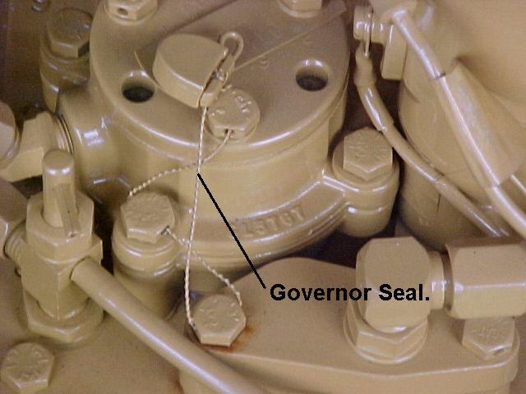
- The submission from Mr Klaka also advocates enforcement of controls on engine power. However, in measuring an engine’s output, Mr Klaka argued:
- Fuel injection pumps can be sealed, however ‘it might still be possible for an innovative mechanic to achieve increased engine power without disturbing the seal’.
- A computerised monitor of fuel supply may be installed. ‘This would diminish, but not eliminate, the opportunities to illegally increase engine power’. In particular, vessel thrust depends upon engine power, but also propeller shaft speed and the propulsive efficiency of the hull and propeller.
- Vessel thrust could be measured directly using lead cells placed in the trawl lines. This however brings with it ‘operational impracticalities’.
- Accordingly, Mr Klaka advocates that engine power should be measured directly at the propeller shaft using a torquemeter and tachometer. Using these devices, engine output could be monitored continuously in combination with a computerised vessel monitoring system. ‘This instrumentation is sufficiently sophisticated to deter the typical mechanic from modifying it (unlike a diesel engine).’

Implementing Time and Effort Units
- Messrs Eayrs and Wakeford argued in their written submission for the retention of Class A SFRs and the enforcement of engine power restrictions, coupled with the introduction of time units. Time units would entitle operators to a certain number of nights of operation in the fishery, giving AFMA increased flexibility in its management of the NPF, while concurrently allowing operators the flexibility to fish at times best suited to their operation. As stated by Mr Eayrs in hearings:
Potentially, it will make the operation more efficient as well. If you have your allocation of nights – let’s say you have an allocation of 200 nights within 300 – you can then adjust your nights to best suit your operation.
- The NPF (Qld) TA adopted a similar position in its written submission, arguing for the adoption of effort units. Effort units would comprise engine units and hull units (effectively the current Class A SFRs) in combination with time units. Again, this would allow operators the flexibility to buy and sell effort units, and effectively mix their input of time, engine and hull units according to their needs. The proposal could be enforced through calibration and sealing of fuel pumps by accredited calibration stations, and by utilising the Vessel Monitoring System to determine when a vessel is out fishing.
- In response to this proposal, Mr Edwards noted in hearings that its administration would be complex. As Mr Eayrs and Wakeford acknowledged in their written submission, administration of the proposal would require a formula to be developed allowing transfer of time units from one vessel to another, while accounting for the variation in catching power between those vessels.
- Furthermore, Mr France noted that some fishing days are more productive than others. Accordingly, it would be likely that every boat would go fishing only on the most productive days in the most productive areas, thereby decimating particular sites..
- Finally, Mr Jeffriess argued the enforcement of time units would encourage operators to band together by sending out one boat to search for large prawn stocks while the other vessels remained in port. Only when a good supply of prawns was found would the remainder of the boats begin fishing, potentially leading to an increase in effort.
- While acknowledging these difficulties, the Committee considers that further research should be conducted into the time unit proposal, to examine whether time units provide a more flexible alternative to the current seasonal closures enforced in the NPF.

New Net Restrictions
- In its written submission, the NTTOA advocated that the current Class A SFR system be retained and a cap placed on the amount of net a vessel can tow based on average net towed, as entered in the vessel’s logbook, over the past two or three years. Effectively, this proposal reinstitutes the net controls that were lifted by AFMA in 1993.
- Mr Featherstone also advocated a variation of this approach in his written submission. Mr Featherstone suggests that the Class A system should be retained, but with 350 Class A SFR trawlers restricted to 9 fathom nets, 450 SFR trawlers to 12 fathom nets, and over 450 SFR trawlers to 14 fathom nets.
- In response to these submissions, Dr Hill noted that this proposal is ‘really a variation upon the present [gear SFR] proposal’. While not limiting the net towed by individual vessels (vessels may trade headrope length), the amendment management plan places an overall limit on the amount of net that may be towed by the fleet.
- In addition, Mr Hodge noted that implementing net restrictions based on previous years removes the flexibility to move to a bigger boat and tow bigger nets (as would be possible by buying more gear SFRs), or alternatively move to a smaller boat and tow less net. This is because owners are restricted to towing the same size of net as they did in previous years.

Submission 69, p 1
Submission 67, p 3
Submission 67, pp 3-5
Evidence, RRAT, 3 February 2000, p 29
Submission 65, p 6
Submission 65, p 14-15
Submission 65, p 9
Evidence, RRAT, 3 February 2000, p 34
Evidence, RRAT, 3 February 2000, p 37
Submission 63, p 3
Evidence, RRAT, 3 February 2000, p 30
Evidence, RRAT, 4 February 2000, p 119
Evidence, RRAT, 3 February 2000, p 16
Evidence, RRAT, 3 February 2000, p 27
Evidence, RRAT, 3 February 2000, p 17
See for example submission 70, pp 6-7
Evidence, RRAT, 3 February 2000, p 63
Evidence, RRAT, 4 February 2000, p 102
Evidence, RRAT, 4 February 2000, p 82
Evidence, RRAT, 4 February 2000, pp.98-99, 102
Evidence, RRAT, 4 February 2000, p. 98
Submission 67A, p 7
B.Taylor & D.Die (Eds) (1999), op cit, pp 13-14.
AFMA Correspondence, 6 March 2000, p 4
Evidence, RRAT, 3 February 2000, p 15
Submission 26, p 3
Evidence, RRAT, 4 February 2000, p 87
Evidence, RRAT, 3 February 2000, p 7
Submission 55, p 2
Submission, pp 5-6
Evidence, RRAT, 3 February 2000, p 16
Evidence, RRAT, 3 February 2000, p 16
Evidence, RRAT, 3 February 2000, p 16
Evidence, RRAT, 4 February 2000, p 104
Submission 66, pp 5-6
Evidence, RRAT, 3 February 2000, p 32
Submission 63, pp 4-5
Submission 65, pp 12-13
Evidence, RRAT, 3 February 2000, p 38
Submission 74, pp 41-44
Evidence, RRAT, 4 February 2000, p 84
Submission 65, p 13
Submission 79, p 8
Evidence, RRAT, 4 February 2000, p 119
Evidence, RRAT, 4 Feb 2000, pp 89-90
Submission 14, p 1
Evidence, RRAT, 4 February 2000, pp 104-105

