Parliamentary Joint Committee on Native Title and the Aboriginal and Torres Strait Islander Land Fund

Indigenous Land Corporation Annual Report 1999-2000

Submission No: 3
10 May, 2001
Mr R G Haebich
Acting Chief Executive Officer
Indigenous Land Corporation
PO Box 586
Curtin ACT 2605
02 6269 2500 02 6260 3899
E-mail:

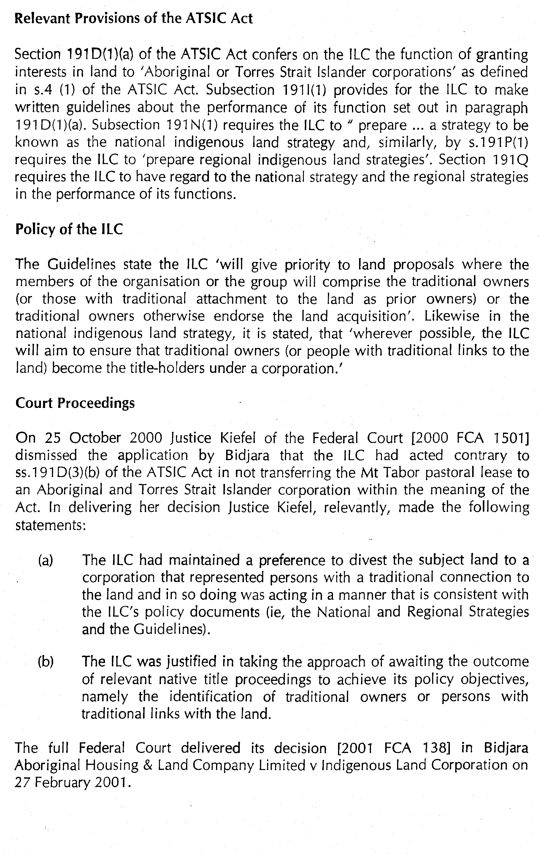
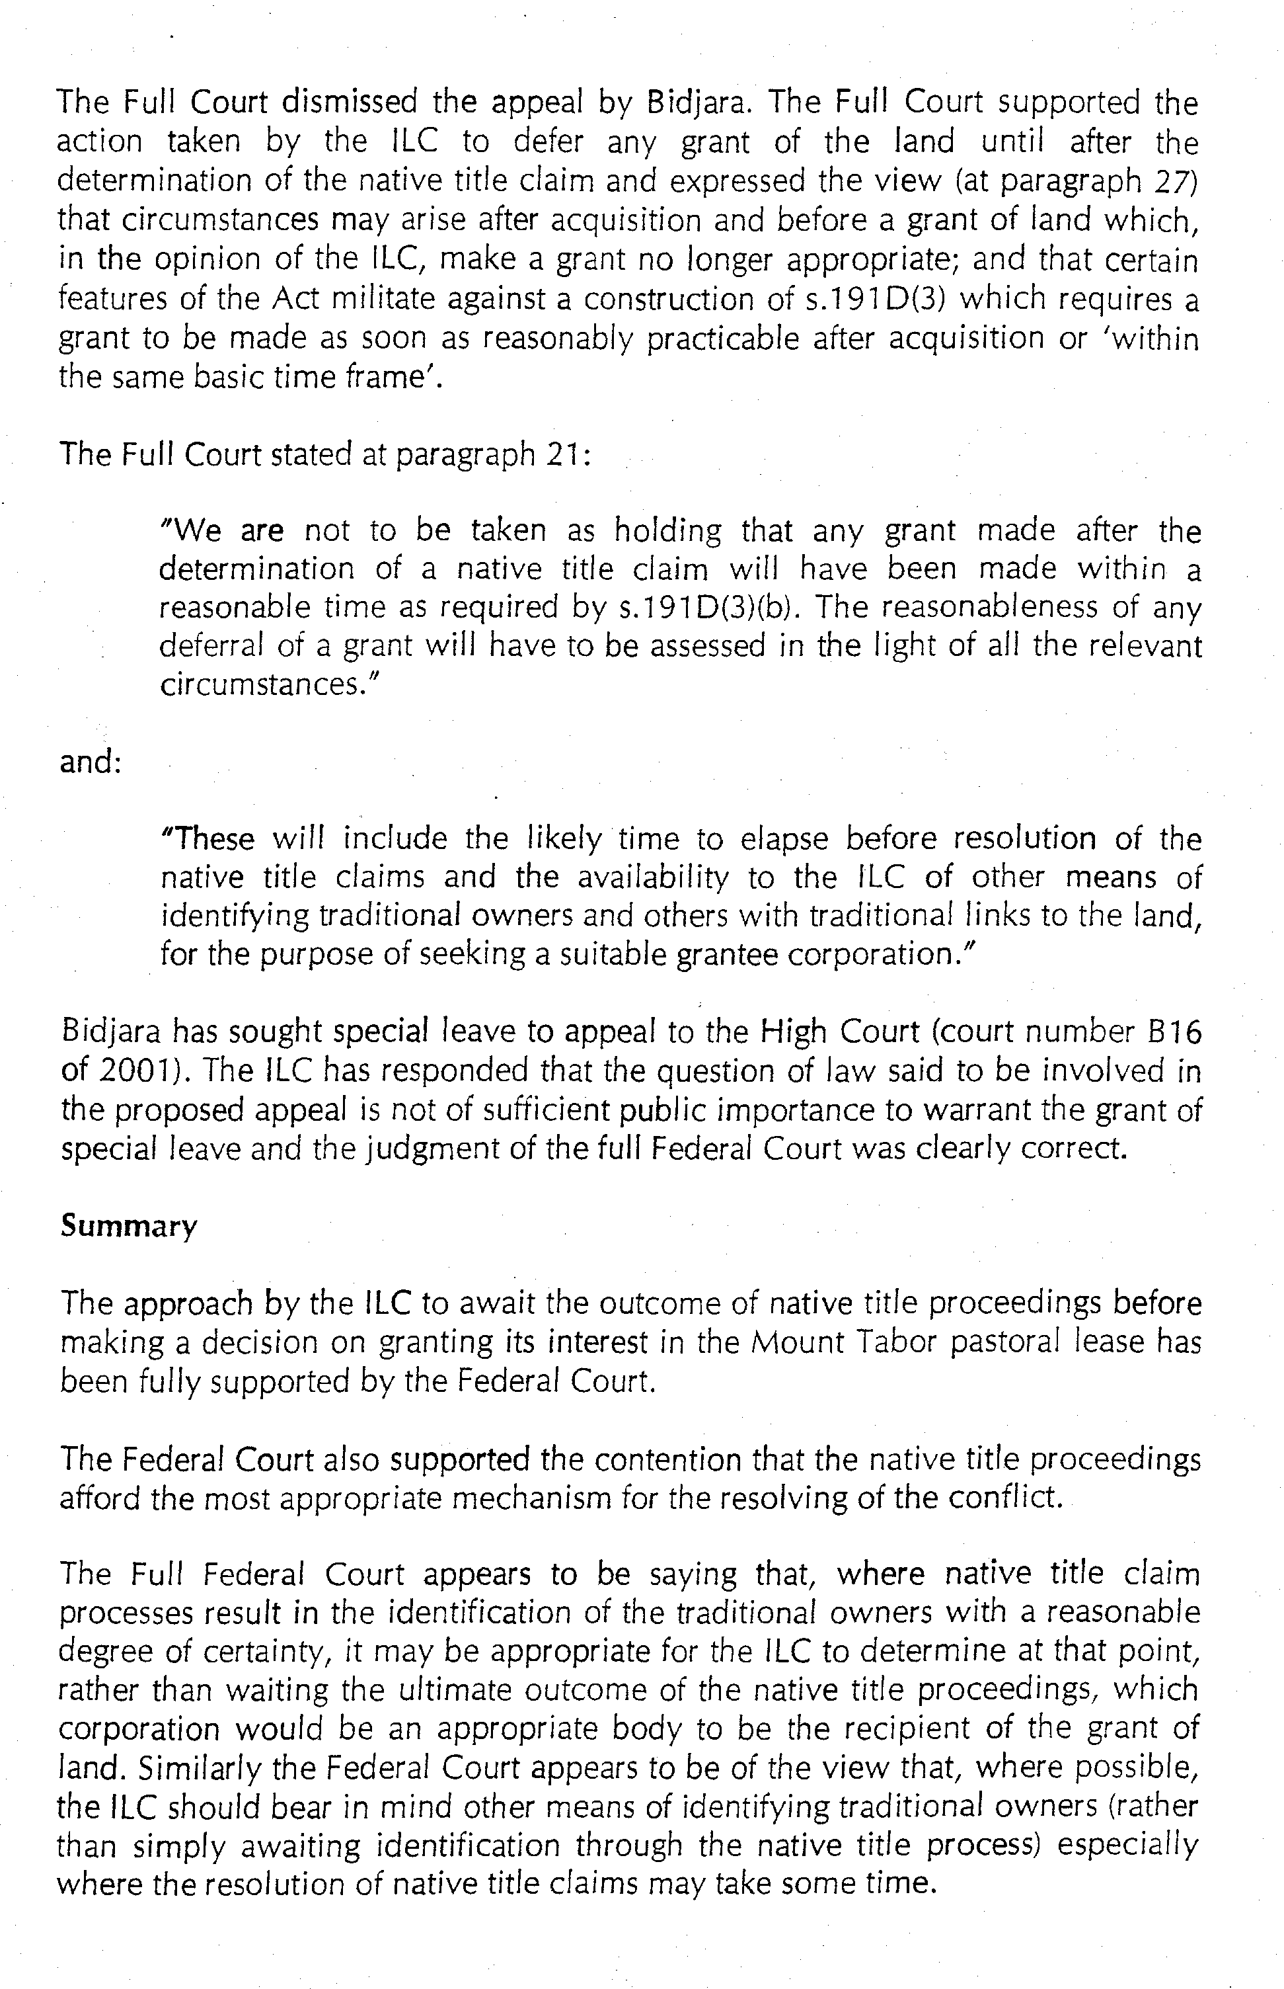
1 p 1,2 On page 2 of your annual report you state:
To 30 June 2000, the ILC has purchased a total of 127 properties, of which 73 have been divested to indigenous Corporations. How many of these properties have been purchased in urban areas for urban indigenous people?

The ILC has purchased a total of 32 properties in urban locations across Australia (of a total of 139 purchases) for the benefit of urban Indigenous people. Six are in NSW, two in the Northern Territory, five in Queensland, sixteen in Victoria and three in Western Australia. Urban locations are taken to be those that fall within town boundaries. The House of Representatives Standing Committee
on Aboriginal and Torres Strait Islander Affairs Inquiry into the Needs of Country and Metropolitan Urban Dwelling Aboriginal and Torres Strait Islander Peoples has defined “urban” as being centres with populations of greater than 1,000.

2 p 3 I am interested to know what type of properties you are buying. Are they dairy properties? Are they grain properties? Are they grazing properties? Is there some background to the reasoning behind their purchase in this area, or do they add on to other existing properties?

Land acquired by the ILC has been used for a wide variety of purposes, including grain production and grazing.

The following table lists 169 uses to which 139 properties were being put at the time of acquisition by the ILC. Grazing was a major land use on 73 (52.5%) of the total.

Table 1: Previous land use of ILC acquired properties

Previous land use of acquired property | Count
Aquaculture | 1
Commercial offices | 1
Cultural heritage | 9
Cropping -dryland | 22
Cropping - irrigated | 2
Dairy | 4
Factory – fish processing | 1
Farm forestry | 1
Feedlot | 1
Grazing (cattle, sheep, goats) | 73
Horticulture (including citrus and grapes) | 3
Industrial Estate | 4
Mixed farm | 1
Quarry | 1
Residential (rural and other) | 13
Store | 3
Social programs | 2
Timber harvesting | 1
Tourism | 5
Training and education | 5
Various enterprises (eg. Transport depot, former fuel depot, former school) | 3
No historical use | 3
Not stated | 10
Total land uses | 169
Total number of properties acquired by the ILC | 139

The background reasoning for a purchase is its cultural significance to Indigenous people. The fact that a significant proportion of its acquisitions have been grazing properties is probably a function of the fact that such properties lie in rural and remote areas where attachment to land has remained stronger than in more developed areas. It might be noted that while many proposals relate to rural and remote areas it is frequently the case that many who have attachment to those areas live in urban areas. The ILC has no policy or other priority on the acquisition of grazing properties. Generally, acquisitions are not designed to add on to other properties but to respond to a submission by a proponent that will contribute to the development of a representative Indigenous land base.

3 p 3 I note that the number of new acquisition proposals has declined substantially from the previous year—from 208 to 132. What is the explanation for the lack of approval for proposals?

Page 17 of the Annual Report states that the “… decline in the number of land acquisition proposals is a result of the ILC’s emphasis on the LNPP through the ILC Board’s directive of April 1999”. This directive was that the Board would not acquire properties unless they had been identified as a priority in Sub-regional Overviews of Land Needs prepared as part of its national Land Needs Planning Process. This decision was made as a result of the Board’s concern to take a more strategic approach to land acquisition.

4 p 4 I would be interested to know what proposals you have for northern Australia, how long you have had them, and when you will expedite them.

It is understood that the question relates only to the Northern Territory. A total of 63 proposals have been registered by the ILC for acquisitions.

Proposals received by financial year: 96/97 (17)
97/98 (7)
98/99 (20)
99/00 (13)
00/01 (6)

Submitted to Board: 23 (approved – 21, declined – 2)

Acquisition successful: 11

Currently under assessment: 15

Proposals submitted by Land Councils: 18 (NLC – 9, CLC – 9)

When a proposal is registered by the ILC, it does not automatically follow that it will be acquired by the ILC. In cases where the owner does not wish to sell, the ILC will normally retain the registration for possible acquisition in the future which may give the impression that it is failing to progress proposals. In fact, the ILC must compete on the open market as any other buyer and its power to acquire land is subject to the same market forces as that of other buyers. In some cases we are simply not successful in our bids.

If a land need is registered by the ILC but is found not to be consistent with either the National or the Regional Indigenous Land Strategy, it will not be pursued.

The ILC makes considerable efforts to work through the reasons why a proposed acquisition might not be acquired with proponents. In some cases, alternative properties are acquired where those properties might be available on the market, within the ILC’s resources to acquire and consistent with its policies and legislative brief.

5 p 5 Does the board have a policy? If it does, what is it in relation to the issue of purchasing land over which there are native title claims?

The Board’s policy in relation to native title is stated in the 1996 National Indigenous Land Strategy.

The ILC aims to complement other land rights and land acquisition laws, including the Native Title Act and State-based legislation related, for example, to land rights and sacred sites. As a general principle, the ILC will give priority to meeting identified land needs where other mechanisms for indigenous groups to gain access to rights over land cannot or have not met the land needs of indigenous peoples.
The ILC will prioritise the acquisition of land for groups who are unlikely to have land needs met because their native title has been extinguished, or a native title claim has not been successful. The ILC is also required to inform itself of any native title claims to land which is being considered for acquisition. In considering the acquisition of land the ILC will have regard to whether other legislative mechanisms for claim, acquisition, or protection have proven unsuccessful, or are unavailable. (p13-14)

To date, the recognition given to surviving native title interests on pastoral leases falls far short of an interest commensurate with full beneficial ownership. As a consequence, as reported in the 1998-1999 annual report, the Board has decided that it would continue to consider, and where appropriate, approve, proposals for the purchase of land held under pastoral leasehold. The new National Indigenous Land Strategy continues this policy.

6 p 12 How many Aboriginal people are in the situation that I referred to as opposed to the clapped out properties?

In the ILC’s Central Division, the total number of Indigenous people benefiting from acquisitions of good properties acquired bare is estimated to be 3,325 which includes the entire Indigenous population of Tasmania as land acquired in that State is to be vested in a State Land Council for the benefit of all Indigenous inhabitants.

In the Western and Eastern Divisions it is estimated that approximately 1,500 and 11,515 people respectively may be in this situation.

7 p 12 How many good properties are there where you have purchased land only and no capital or stock?

Central Division – 9
Western Division – 12
Eastern Division - 23

It should be noted that while the historical use of a property may not be supported, the ILC’s land management function can come into play to provide packages of assistance to enable landholders to derive benefits through sustainable land uses. These may result in the acquisition of both capital and stock as the case study outlined below (question 9) indicates.

8 p 12 How many of those have actually applied for a loan to you and they have been either accepted or rejected?

The ILC has accepted two loan applications and rejected one (on the basis that the applicant had inadequate management skills and the high risk nature of the project). There are two further applications currently being considered.

It should be noted that the ATSIC Act (subsection 191F(1)) requires the ILC to act in accordance with sound business principles whenever it performs its functions of a commercial basis.

9 p 12 I would be interested in a case study. I do not want you to identify the community or the property, but you could say, for example, ‘Property was identified, and these are the steps and this is the process that we went through.

The following is an example of a property purchased bare of stock but in which the ILC and the proponents worked together to design an appropriate package of land management assistance to meet their needs within the capability of the land and the proponent’s skill base.

A dairy property in Victoria was acquired bare by the ILC in late 1996/early 1997, and divested in November 1997. Independent expert advice at the time recommended that the existing dairy herd not be purchased as it was aged, of poor quality and there were some indications of possible disease. The proponent group wanted the cattle included in the acquisition but reluctantly accepted the ILC’s position. The group undertook considerable business planning over a period of time convened a series of meetings with a range of relevant agencies, including ILC and ATSIC. After rigorous assessment a grant/loan funding package was approved by both agencies and approximately $1m was provided for the purchase of a quality herd, the construction of a new dairy and a range of initial operating costs.

10 p13 I ask you also to provide examples of where you provide training—directors’ training and management training? Perhaps you could provide some of the material? I am aware, for example, that you have had successive management training exercises in the Kimberley?

Directors’ training has was conducted for Mogila Merino Stud in November 1999. In this financial year Directors’ training has been conducted at Bilaluna Station in and Managers’ training was conducted at Port Hedland both in Western Australia and at Tingah and Glen Innes in New South Wales.

Descriptions of these training exercises can be found on pages 23-27 of the “ILC/LEA Extension, Education and Training Strategy” and throughout “Towards an Extension, Education and Training Program” both of which papers are provided as attachments (1 and 2).

The ILC also conducted a National Indigenous Land Managers Conference in August 1999 as an opportunity to get managers together to start identifying issues for Indigenous managers of land based enterprises.

11p13 I note you are due for a review of your strategy. What sorts of policies are you looking at? What sorts of changes are you considering?

Some of the issues that the Board is considering are those relating to accommodating the range of varying Indigenous interests in land, the focus and content of its land management function, the question of equity and its relationship with other Indigenous bodies. The Board approved a revision of the National Indigenous Land Strategy at its meeting on 4 May 2001. A copy of the revised National Indigenous Land Strategy is required to be tabled in both Houses of Parliament pursuant to subsection 191N(6) of the ATSIC Act.

12 pp16,17 can you tell us where you are currently at with Roebuck Plains? How is it being managed? Can you tell us a little about the stocking of the property? Mr Snowdon mentioned its valuation as being closer to $10 million than $8 million. We would be interested to know the way in which the property has been managed and, in particular, what has happened to the cattle at that station. Is it up for sale?

Mr Ned McCord who is employed by Roebuck Plains Pastoral Company, an ILC subsidiary, is currently managing the property. Mr McCord reports to the Operations Manager, LEA, Dr Stuart Phillpot who reports to the ILC CEO.

The station mustered a total of 19,652 and following sales it currently has 15,621 head or 12,148 livestock equivalents that is 3,000 under its maximum stocking rate of 14,950.

The ILC recently received an offer of $9 million for Roebuck Plains. Westfarmers made the offer on behalf of an unnamed buyer. The ILC Board declined the sale.

13 p18 Which board member moved for the purchase of Roebuck Plains?

D. G. (Gatjil) Djerrkura

14 p18 I assume, therefore, that it is roughly a couple of years. There has been a cattle muster since then and some capacity, therefore, to assess how many cattle are there, whether the number that were alleged to be there really are there, and what sort of condition they are in.

In July 2001, the ILC settled on the purchase of 17,828 head. In October 2001, the ILC management mustered 18,332 adult cattle and all these cattle were branded, cross branded and tagged with a year colour coded tag.

At present the cattle are in forward store to fat condition.

15p22 in the last two years what has actually happened on Roebuck Plains? Is it profitable? Have you got managers in there who are part of any indigenous group? Have you leased it out to third party managers? Is the property making a profit? If it is, where does that profit go? How is it being dispersed while you are trying to work out who are the traditional
owners?

In the last two years, the ILC has terminated the original management agreement with Great Northern Pastoral and has worked at improving the property’s infrastructure.

The current profit and loss indicates that the property is profitable. It has not been leased out to a third party. Whilst the present manager is non-Indigenous, the Board has directed that a program to facilitate Indigenous employment be implemented.

The profit is retained by ILC and has been reinvested in the property.

16p23 The other thing that would be interesting in that context is not only whether the principal property is profitable but whether the annual report refers to it. No doubt it has an opportunity to add value to other holdings. So even if it is not profitable, and there is any capacity to make an assessment, to some extent it is what Mr Haase was referring to. The theory is—and your annual report suggests—that it is adding value to the other holdings. So it might be indirectly profitable even if it is not directly profitable. That is much harder. You will not be able to give a ledger entry that gives you the answer to that question because it is not so straightforward. But I would be interested in the best assessment you can make about that.

Roebuck Plains has the potential to add value to the other Indigenous properties in the Kimberley. At present, the Kimberley Aboriginal Pastoralists Association (KAPA) has conducted a feasibility study to assess if Roebuck Plains can be used as a depot facility in order to ship Indigenous owned cattle all year round. This study is to be considered by KAPA early in May and submitted to the ILC Board in June. A draft of the feasibility study provided to the ILC indicates that it is expected that Roebuck Plains can add value to the other properties.

17p27 Re money that the ILC has spent on education and training strategies –Could you tell me a little about how that is working? How do you go about preparing those skilled training courses? Are you using any existing government departments or TAFEs, or do you have a contract arrangement to bring in people to carry out this training? How is it actually done?

The ILC Board allocated $196,000 to trial an integrated rural extension education and training system. Several parts of the initial stage have been completed successfully.

Generally, the process for preparation is to scope the market for training packages appropriate for Indigenous people. When these are not found, mainstream packages are adapted.

Training providers were selected on the basis of a competitive tender and engaged by contract. The contractors used are Outdoor Experience (Victoria), Murrumbidgee College of Agriculture (New South Wales), Kadina TAFE (South Australia) and Management Services Unit Aboriginal Corporation (Western Australia).

All training is competency based.

18p27 Do you contract out training programs? Do you work with TAFEs? Do you work with the Department of Industrial Relations, for example? How do you go about structuring your training programs? How much are you spending on that sort of activity?

Training is contracted out.

During the pilots LEA worked with the Department of Employment, Workplace Relations and Small Business and with Agriculture, Forestries and Fisheries Australia. Other agencies involved are listed on page 48 of the Annual Report.

The structure is outlined on pages 11 to 29 of the attached Strategy (attachment 1).

Total amount spent was $214,786.

19p27 Are the people who do the day-to-day training in-house people, or is it contracted out? If it is contracted out, how are those contracts let, by how many people, and where are they held?

Training is contracted out by open tender/expression of interest.

There have been four contractors (see question 17).

Training has been held at Goodooga, Tingah and Glen Innes (New South Wales), Mabel Creek (South Australia), Port Hedland and Bilaluna Station in Western Australia.

20p27 Why are you still running pilot projects?

The pilot phase remains necessary because this is the first time such a program has been coordinated on a national basis. The pilot phase enables consideration of local and regional variation within the Indigenous populations (including the variations in educational standards) and allows the curriculum to be trialled and adapted as required.

21p28 How many people have taken part in it?

Sixty people have taken part to date.

22p28 I would like to know how much is spent, how many people have gone in, for how long they go, how many have graduated, and how it is operating on the ground.

The total cost has been $214, 786. Of the sixty people who have undertaken training all but twelve have successfully completed the courses. These twelve will be graduating shortly. The courses vary in length from twelve month traineeships to day and half workshops.

Operation on the ground involves the selection of appropriate packages and service providers together with a location convenient to those to be trained. Outcomes from the initial evaluation are indicated in the following table.

Please see Attachment 2 for further details.

23p28 Breakdown of costs of legal difficulties of the Board

The Roebuck Plains enquiry has to date cost the ILC $235,000 but further bills are expected. The ILC has also been asked to pay $200,000 in costs for the Minister’s inquiry into the behaviour of the ILC Board. A further $44,000 in legal costs was incurred in respect of the unsuccessful action against the ILC brought by Mrs Firebrace in the Federal Court. Costs were awarded to the ILC and are currently being pursued.

24 p30 I am interested to know your explanation for the amount of funds that have been spent on the Kimberley beef strategy so far. I see that the Kimberley Aboriginal Pastoralists Association has received an amount of $273,739.99. I am wondering whether either of you are aware of the make up of or justification for that figure? Can you at the time of answering give me some indication if at this stage any cattle have been moved off the Kimberley stations up through Roebuck Plains to market?

Kimberley Beef Strategy expenditure.

Planning Costs: Research into cooperative models, establishment of the steering group/ working group, pre-feasibility study, general planning meeting costs. $96,800

Immediate Needs Funding: Essential infrastructure development (fences, water, yards), purchase of improved bulls, training and education. $589,054

TOTAL KABS COSTS to 31 March 2001 $685,854

Justification of Kimberley Aboriginal Pastoralists Association (KAPA) Expenditure.

Total ILC funding for financial year ending 30 June 2000 = $273,739

Services provided to ILC by KAPA under the agreement:
- Secretariat services to the Kimberley Aboriginal Beef Strategy project including coordinating communication and liaison with lessees/managers, assisting in the development, planning and endorsement of the co-operative.
- Advice on development of support packages
- Assisting properties implement support packages
- Assisting the ILC administer its support
- Monitoring and reporting on support packages
- Provision of the services of the KAPA’s staff and the KAPA office facilities, equipment and vehicles to assist the ILC as required by the demands of the Kimberley Aboriginal Beef Strategy project.

The ILC’s commitment to KAPA is significant and consequently the Board considers it prudent to review its involvement from time to time.

Cattle moved through Roebuck Plains
1000 head of cattle were sold through Roebuck Plains station last year as a trial.

25 p32 How much of this legal advice, if any, is not to do with land purchases? Could you find out for us and let us know what the issues are for which you receive legal advice, apart from land purchases?

The following table shows the purposes for which legal advice was sought by the ILC in matters not related to land purchases.

DATE OF ADVICE | SOURCE OF ADVICE | CONTENT OF ADVICE
22/07/99 | AGS Sydney | Whether the C’th Places (Application of Laws) Act makes an ILC property subject to the Land Acquisition (Just Terms Compensation) Act NSW. Relating to construction of a power line by a State authority across an ILC property
23/07/99 | AGS Canberra, Office of General Counsel | Whether it is within the land management function of the ILC to purchase an oyster Aquaculture licence.
9/08/99 | AGS, Office of General Counsel | Application of GST to the purchase of rural property
19/08/99 | AGS, Barton, ACT | Amending the ILC standard form agistment agreement to allow the ILC to place a lien on unpaid fees.
31/08/99 | AGS Canberra, Office of General Counsel | Aquaculture licence
12/11/99 | AGS Perth | Whether a lessee of ILC leased land in WA is liable to pay rates (‘Gibbagunya Farm’).
24/11/99 | AGS Canberra, Office of General Counsel | Whether ILC land leased to an Aboriginal corporation is ‘indigenous-held land’ as defined in the ATSIC Act.
Nov 99 | AGS Canberra, Office of General Counsel | Whether a grant of monies for purchase of a fishing boat under s.191E ATSIC Act is within the land management function. Relates to Far West Scallop Factory, Carnarvon, WA
10/01/00 | AGS Barton, ACT | Advice relating to Standard form ILC Management Agreement.
22/02/00 | AGS Canberra, Office of General Counsel | Relationship between the Parliamentary Joint Committee on Native Title and the Land Fund and the ILC
25/02/00 | AGS Canberra, Office of General Counsel | Application of ILC funds for land management purposes to ILC land.
13/03/00 | AGS, Office of General Counsel | Appointment of Acting GM of the ILC
16/03/00 | AGS Office of General Counsel | Authority of suspension order (power of the Chair of the ILC to suspend a GM)
4/04/00 | AGS, Office of Litigation | Claim by W Johnstone for compensation, liability of the ILC
17/04/00 | AGS Office of General Counsel | Ex gratia payment, power of the ILC to make such payments
18/04/00 | AGS Office of General Counsel | ILC - Ex gratia payment re claim by person invalidly appointed by the Chair as GM
9/05/00 | AGS, Office of General Counsel | Whether a trust under the Aboriginal Land Act 1991 (Qld) is an 'Aboriginal Corporation' for the purposes of the ATSIC Act 1989.
12/05/00 | AGS Adelaide | Liability of ILC to pay SA Emergency services Levy
18/05/00 | AGS Brisbane | Issues relating to Bidjara Aboriginal Housing and Land Company Limited v ILC - Federal Court No. 209 of 1999.

26 p32 Are you using KFPW agency on a regular basis? Is that the subject of a tender to supply that service? Was KPFW involved in negotiations on behalf of the ILC for the purchase of Roebuck Plains?

KFPW is used by the ILC on a regular, though not exclusive basis. KFPW is the former Australian Property Group and was the Commonwealth’s purchasing agent at the time the ILC was established. The firm continued to provide this service after the ILC called for expressions of interest. It was not involved in negotiating the purchase of Roebuck Plains.

27 p33 Do the lists of salaries, directors fees and consultants fees on pp 62,107, 127 cover both ILC and LEA

The salaries indicated in Table 5 on page 62 of the Annual Report for 1999/2000 are those for the staff of the ILC only.

The Directors fees indicated on page 107 show remuneration received by Directors of both the ILC and LEA.

The consultants listed on page 127 are those engaged by the ILC only.

28 p34 Can the chair direct someone within the ILC to do something, apart from the chief executive officer

The functions of the ILC Chairperson are described in subsections 192J(1) and (4) of the Act as being to convene such meetings as he or she deems necessary for the efficient performance of the Board’s responsibilities and to preside over these meetings. There is nothing in the ATSIC Act that would empower the Chair to direct someone within the ILC. No ILC employee, including the Chief Executive Officer, currently has terms and conditions of employment determined under subsection 192S(1) that include the taking of direction from the Chair. Subsection 192K(3) requires the ILC General Manager to act in accordance with any policies determined by, and any directions given by the ILC Board. The General Manager must also manage the day-today administration of the ILC under subsection 192K(2).

29 p34 Does the chair have the capacity to determine policy independent of the board?

No legal capacity. The Chair has the functions outline above (question 28). Policy determination is a responsibility of the full Board under Section 191W.

33 p41 How much was costing each day to have Mr Phillpot at Roebuck for nine months?

The average daily cost (salary and allowances) of having Mr Phillpot in Broome was $540.13.

34 p44 The $14,800 to Dodson Lane on the Kimberley beef strategy, is that part of the corporate plan and the business plan for Roebuck Plains, or is that for a general beef strategy for the Kimberley?

The $14,800 was paid to Dodson Lane for assistance in the community consultation with Kimberly Aboriginal Beef Strategy. The Company also attended the muster on Roebuck Plains to make an independent count.

35 p44 I would be interested in getting a brief from you
on properties which have been sought for purchase by land councils, individual families or groups of people in the Northern Territory over the last 12 months and why they have not proceeded.

Six properties have been proposed for acquisition by Northern Territory groups in the last twelve months. One property was sold to another party, two have been scheduled for consideration at the 15 May meeting of the Board and contract on the sale of another is currently being prepared. Two others, while having been registered, were not identified in the Land Acquisition and Access Strategies prepared by groups in the respective areas.

The groups having registered these needs are a language group, two associations, a community government council and traditional owner groups.

ATTACHMENT 1: ILC/LEA Extension, Education & Training Strategy

ATTACHMENT 2: Towards An Extension, Education And Training Program

Land Needs Planning Process

