APPENDIX 5

ATTORNEY-GENERAL’S LETTER

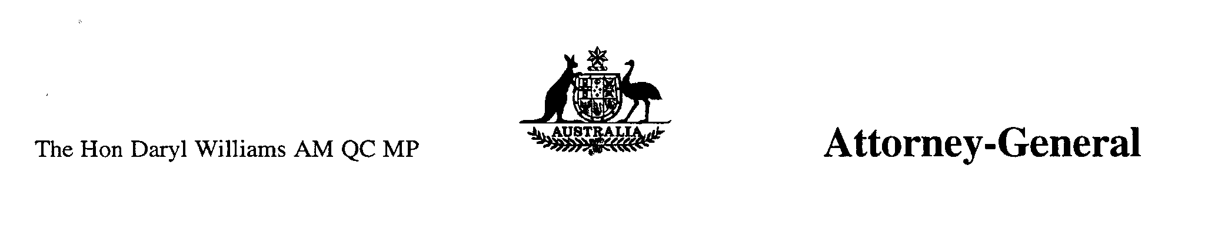
Senator Jeannie Ferris
Chair
Parliamentary Joint Committee
on Native Title and the Aboriginal
and Torres Strait Islander Land Fund
Parliament House CANBERRA ACT 2600

Dear Senator Ferris

I am writing in response to your letter of 30 June 1999. You refer to a request from the National Aboriginal and Torres Strait Islander Legal Services Secretariat Limited (NAILSS) for the Parliamentary Joint Committee on Native Title and the Aboriginal and Torres Strait Islander Land Fund to hold an inquiry into the March 1999 CERD report on the native title legislation.

As you are aware, in August 1998 the CERD Committee requested information from the Australian government on the reforms to the native title legislation, amongst other things. In response Australia provided a detailed report, and was represented at the meeting of the CERD Committee by Mr Robert Orr, Deputy General Counsel, Australian Government Solicitor and the Acting Head of Mission in Geneva.

The detailed legal submissions provided by the government, both orally and in writing, have not so much been rejected by the Committee as largely ignored. At the time of the decision I expressed disappointment that the CERD Committee in its examination of the Native Title Act 1993 had failed to consider the issue in a more balanced fashion. It was clear from the decision that some Committee members did not understand Australia's legal system let alone the detail of the complex native title issue.

In its decision of 18 March 1999 the CERD Committee took into account the `willingness of the State party to continue the dialogue with the Committee over these provisions' and decided to keep the matter on its agenda for its next meeting in August 1999.

It is important to note that since mid 1997 the native title legislation has been significantly amended, closely scrutinised by Parliamentary Committees, and has been subject to over 100 hours of debate in Parliament as well as vigorous public debate. The Bill was the subject of reports by both the Parliamentary Joint Committee on Native Title and the Aboriginal and Torres Strait Islander Land Fund and the Senate Legal and Constitutional Affairs Legislation Committee. All the issues raised in the CERD Committee report have been canvassed extensively during that period.

Due to the fact that the Australian government is still making representations to the CERD Committee, and that there was significant Parliamentary and community scrutiny of native title proposals at the time of the passage of the Native Title Amendment Act 1998, I do not believe that it is appropriate or necessary for the Parliamentary Joint Committee on Native Title and the Aboriginal and Torres Strait Islander Land Fund to hold an inquiry into the CERD report on the native title legislation.

Yours sincerely

[Document scanned – text unchanged but formatting altered for inclusion in this report]

