APPENDIX 4

NAILSS SUBMISSION DATED 22 MARCH 1999

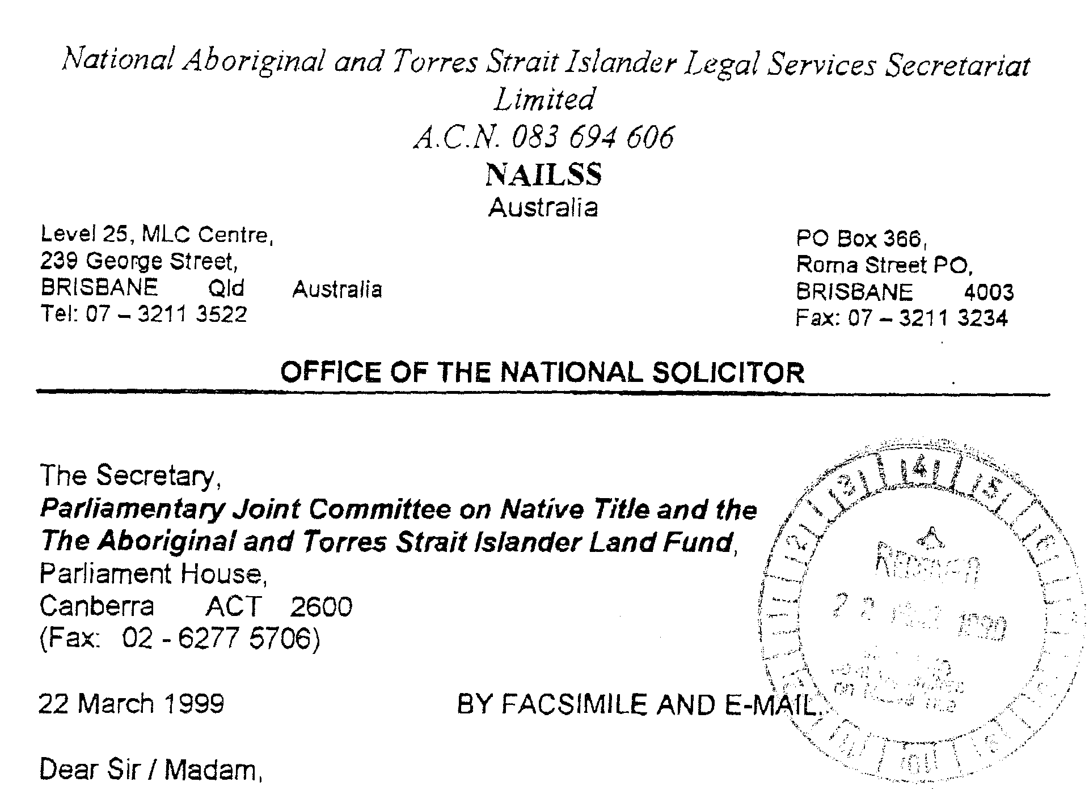
Before the CERD Ruling of the United Nations recently, this National Secretariat provided the Joint Parliamentary Committee with a submission regarding the discriminatory aspects of the Native Title legislation as amended,

In light of the United Nations ruling and the requirement that Australia as a member State of the UN should now freeze the implementation of the amendments, could the Joint Parliamentary Committee please advise this National Secretariat together with the people of Australia what actions will be taken to comply by the parliament of Australia to comply with the United Nations ruling.

Will it be necessary for Aboriginal and Torres Strait islander peoples in Australia to launch urgent litigation in the Australian courts to secure a declaration as to the invalidity of the legislative amendments in light of Teoh's case and recalling the impact of intemational condemnation of Australia when the Tasmanian Gays legislation case arose?

In the circumstances, we now respectfully request that the Joint parliamentary Committee convene an urgent Inquiry to allow consultation with all sectors of Australian society on ways and means in which the discrimination in the Native Title legislation can be properly removed.

This National Secretariat respectfully submits that this would provide clear evidence to the United Nations that the Parliament of Australia (if not the Federal Executive Council) is serious about responding to the concerns of the International community on the matter of the discrimination under the current Native Title legislation.

We stand ready as a National Secretariat for most Aboriginal and Torres Strait islander Legal Services (ATSILS) and Aboriginal Legal Services (ALS) in Australia to assist the Parliament and the people of Australia in remedying this serious international condemnation of Australia.

We look forward to hearing from you and the members of the Joint Parliamentary Committee at the Committee's convenience

If this National Secretariat can be of any further assistance to the Parliament of Australia regarding the above or any other matter, please do not hesitate to contact the writer at our National Headquarters above on Tel: 07 - 3211 3522 or by fax on 07 - 3211 3234 or -mail to either nailss@powerup.com.au or to the writer directly at the Office of National Solicitor on giatkson@powerup.com.au

Trusting the above will be of assistance.

[Document scanned – text unchanged but formatting altered for inclusion in this report]

