RURAL DOCTORS ASSOCIATION OF AUSTRALIA

FEDERAL BUDGET SUBMISSION
2004-05



CONTENTS
EXECUTIVE SUMMARY 1
introduction 3
Figure 1: Services and MBS benefits per capita, by RRMA grouping, 2001-02 3
Table 1: Medicare transfers from rural and remote areas to urban areas, 1999-2000 3
Figure 2: Simple doctor patient ratios (DPRs) by RRMA grouping, 2000 4
The future of rural medicine 4
Figure 3: Median age in years, capital cities and rest of state, 2001 4
Figure 4: Medical services per person by age (left) and hospital use per person by age (right) 5
What is needed and why this Budget? 5
Table 2: Death rates attributed to four major causes by rurality, non-indigenous Australians under 65 6
THE FIRST PILLAR – PRICING ISSUES: REBATES and Indexation 7
Rebate levels – higher gaps, higher costs and greater complexity in the bush 7
Figure 5: Supply and demand for medical services, rural and urban 7
Figure 6: Average ‘gap’ prices paid by GP patients in urban and rural/remote areas, 2000-01 & 2001-02 7
Figure 7: Practice costs higher for smaller GP practices 8
Table 3: Modeled outcomes: rural loadings on GP MBS items 10
Table 4: Modeled outcomes: higher MBS rebates for poorer Australians 11
Indexation 11
Figure 8: Average annual Commonwealth spending per FTE GP, relative to AWOTE 11
Figure 9: Hourly gross GP earnings, annual average, urban and rural, by gender 12
Figure 10: Real MBS Item 23 rebate, under WCI5 indexation. 12
Figure 11: RDANSW indexation compared to MBS rebate increases 13
Table 5: Modeled outcomes: WCI5 compared to other potential indices 13
Claims 13
Blended payments 14
Table 6: PIP loadings by RRMA 14
THE SECOND PILLAR – QUANTITY ISSUES: WORKFORCE 15
Table 7: Medical labour force indicators by RRMA grouping 15
Figure 12: GP shortages (percentage of total GPs required to meet need) by LGA 16
Students 16
Table 8: Medical rural bonded scholarships – Option 2 (MRB#2) costings 17
Junior Doctors 18
Table 9: Phased expansion of RRAPP sites 18
Rural workforce 19
Table 10: On call hours per GP by RRMA, listed and worked 19
Table 11: After hours, on-call and leave package for doctors in RRMA 5 to 7 20
Table 12: Infrastructure capital safety nets for practices in RRMA 5 to 7 21
THE THIRD PILLAR–QUALITY ISSUES 22
Accreditation and certification 22
Rural hospitals 22
Specialist support 22
Practice nurses 22
Informatics 23
THE FOURTH PILLAR–EQUITY ISSUES 25
Indigenous health 25
Table 13: ATSI health check, costed proposal 26
SUMMARY OF COSTED PROPOSALS 27
Table 14: Summary of costed proposals, $million, 2004-05 to 2006-07 28
REFERENCES 29
APPENDIX: RRMA (Rural, Remote and Metropolitan Area) categories 30

EXECUTIVE SUMMARY

The Rural Doctors Association (RDAA) was formed in 1991 to give rural doctors a national voice. It is a federal body with seven constituent members – the Rural Doctors Associations (RDAs) in all States and the Northern Territory, all of whom are represented on the national Board of Management. Most members of the state bodies are general practitioners (GPs) who work and live in rural and remote Australia. The Board of Management is supported by a small secretariat in Canberra.

The RDAA has a particular focus on promoting the maintenance and expansion of a highly skilled and motivated medical workforce to provide quality health care to the people of rural and remote Australia. Much of its work therefore concentrates on recruitment and retention issues, and the viability of rural medicine. However, RDAA is also an active participant in policy and program development on a range of health issues including indigenous health, health financing and advanced nursing practice.

Today, the 30% of Australians who live in the bush get 20% of Medicare rebates and are served by 15% of the medical workforce. Rural and remote Australia remains medically under-supplied and under-financed relative to urban areas, with severe workforce constraints in many areas of need. The problems are set to worsen as demographic ageing progresses, and they are a key factor contributing to rural decline in Australia.

Less access to medical care continues to result in worse health outcomes, with higher mortality and morbidity. Death rates are up to 20% higher than in capital cities. The inequities in health are a national disgrace.

In FY2004-05, with a $7.5bn cash surplus in hand and a favourable political climate, there is both scope and opportunity to deliver in the Budget what has long been necessary – adequately funded, comprehensive strategies to address the adverse health outcomes for rural and remote Australians.

Current rural programs have stemmed the decline in the rural medical workforce. However, doctor shortages in many areas persist due to the inability to attain key minimum work force requirements. The strategies in the Government’s A Fairer Medicare package are not comprehensive; many are not well targeted, not equitable, not simple, and economically, not first-best interventions, driven instead by politically and media determined considerations. RDAA estimates only 15% of its members will take up the initiative. The package components should be disaggregated, with those aimed at addressing rural medical workforce considered separately from the proposed incentives to increase bulk billing rates. Statistical analysis shows that the strongest determinant of bulk billing is not income, but region. The RDAA maintains that the most effective and simple means for addressing pricing issues is through the MBS rebate, not via administratively complex and poorly targeted incentive schemes.

Reform is bound to fail unless it is based on a restructure of the MBS rebate. This restructure must include an increase to bring the rebate into line with the current costs of medical service provision and a shift from the political and professional paradigm that regards an ‘equal’ Medicare rebate for all as an immutable component of the health care system. Equal is not equitable. The standard rebate does not reflect the greater costs and complexity of rural medicine and does not reflect the principles of equity or universality of access on which Medicare was based.

The Federally funded Viable Models project has derived empirically based benchmarks that support the proposals in this submission.

- The best intervention to redress the current inequities and improve access to Medicare-funded services for Australians in rural and remote areas, who are disadvantaged by location and socio-economic status, is through differentiated higher rebates. This is achievable for an estimated spend of $187m in 2004-05, based on modeling current PIP proportions for each RRMA to MBS rebates.

- Together with appropriate indexation (worth $109m in 2004-05 in both rural and urban areas), RDAA believes this would contribute to an increased rural medical workforce by balancing remuneration with the higher costs and greater complexity of rural medical practice. Access to direct electronic rebate claiming for rural and remote GPs is also a priority.

- To directly address workforce constraints, this submission proposes (with 2004-05 costings in brackets):

  - a viable workforce locum package to achieve minimum benchmarks for after hours and on call duties, annual leave and professional education, for outer rural and remote areas ($11m);
  - an underwriting scheme for capital infrastructure to provide safety nets and encourage recruitment ($19m);
  - expansion of medical rural bonded scholarships through the offer of a middle-road option ($8m);
  - a further 12 sites for doctors in training through the Rural and Remote Area Placement Program ($0.6m); and
  - provision of quality infrastructure support largely through expansion of existing mechanisms for specialist support (MSOAP), practice nurses (through PIP), family support and informatics ($31m).
- An MBS item for a biennial indigenous health check for ATSI people of all ages ($24m) is also proposed.

Such measures are imperative in order to provide a rural health workforce that can translate the equal entitlement of all Australians to Medicare into equitable service provision for those who live in rural and remote areas.

RDAA trusts that the Government will note the priorities and recommendations in this document when finalising its Health Budget for 2004–05.

Dr Ken Mackey
RDAA National President
9 October 2003

introduction

The inequities persist
People in rural and remote Australia represent 28% of the population yet access only 21% of MBS GP services. Figure 1 illustrates differences in services in each RRMA (Rural, Remote and Metropolitan Area) classification, which declined from 5.5 in capital cities to 3.4 in remote areas in 2001-02. Figure 1 also shows that MBS billing per person falls steadily by RRMA category, from nearly $160 per person in capital cities in 2001-02 to less than half of that – under $80 per person – in other remote areas (DHA, 2003, p21). Moreover, bulk-billing rates also decline, from over 80% in capital cities to well under 60% in rural and remote areas and even to 30% in some electorates (DHA, 2003). The recent 2003 Rural Viability Models data show bulk-billing had fallen to 36% in the RRMA 3-7 practices surveyed.

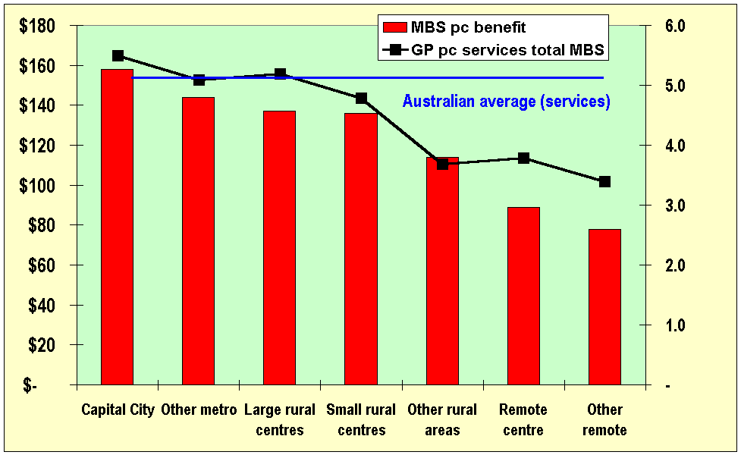
Figure 1: Services and MBS benefits per capita, by RRMA grouping, 2001-02
Source: DHA (2003) and AMWAC (2000) extrapolated to 2001-02.

Table 1 shows that the transfer from rural and remote taxpayers to urban beneficiaries is around $40.68 for each person in the bush. To restore the balance, rural funding through rebates would need to increase by $221.0m pa.

Table 1: Medicare transfers from rural and remote areas to urban areas, 1999-2000
RRMA group | Population (m) | HIC Benefits
1 Capital cities | 12.25 | 1,547.2m
2 Other metropolitan | 1.47 | 176.0m
Total urban | 13.72 | 1,723.1m
% of total | 72% | 79%
Per capita |  | $125.59
3-5 Rural/regional | 4.87 | 436.5m
6-7 Remote | 0.56 | 24.9m
Total rural and remote | 5.43 | 461.3m
% of total | 28% | 21%
Per capita |  | $84.91
Total | 19.15 | 2,184.4m
Per capita |  | $114.05
Rural-urban transfer |  | $221.0m
Per capita |  | $40.68
Source: ABS population data as at end-June 2000. HIC special data request for benefits data.
A fairer Medicare would urgently require that the under-spend in rural and remote areas is addressed.
Figure 2 illustrates the associated workforce issues as discussed in AIHW (2003), in terms of numbers of people per doctor – the simple ‘doctor patient ratio’ or ‘DPR’ – which rises from 326 in capital cities (877 people per doctor) to 1,064 in other rural areas (1,282 per doctor).

Figure 2: Simple doctor patient ratios (DPRs) by RRMA grouping, 2000
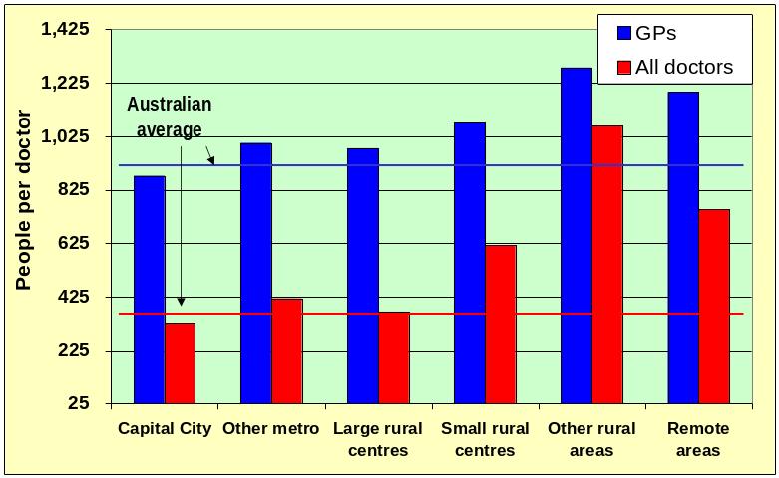
Source: AIHW (2003).

Specialist shortages are particularly acute in rural and remote areas. Exacerbated by medical indemnity issues, procedural rural medicine is under pressure in many rural areas, with substantial impacts on the Accident and Emergency departments of local hospitals. For example, between 1995 and 2002 in NSW, the number of rural obstetricians declined from 261 to 141, anaesthetists from 131 to 98, obstetric units from 67 to 45 and deliveries from 6,817 to 5,360. Other skills shortages are set to exacerbate with demographic ageing – notably surgical specialties such as ophthalmology, cardiothoracic surgery and urology (Etzioni et al, 2003).

The future of rural medicine
Demographic ageing is driving rapid increases in demand for health services. Rural and remote areas of Australia are already more advanced in their demographic transition, with older populations as measured by higher median age as well as a greater proportion of people aged over 65 years. shows a lower median age in capital cities for all states except Western Australia (partly due to lower average age in mining towns) and the Northern Territory (partly due to the lower life expectancy of indigenous people). In contrast, Adelaide and Hobart are the only capital cities with a median age above the national average.

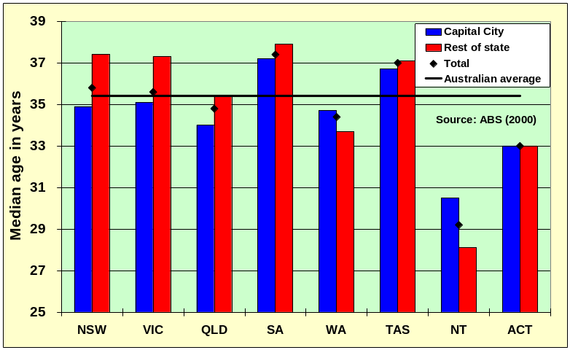
Figure 3: Median age in years, capital cities and rest of state, 2001
Figure 4 demonstrates the higher usage levels of medical and hospital services by older people. Demographic drivers of demand are already higher in rural and remote areas, and set to continue that way as young people are net emigrants from the bush to urban areas.

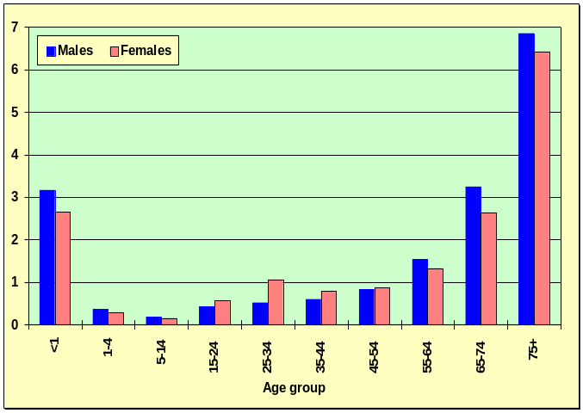
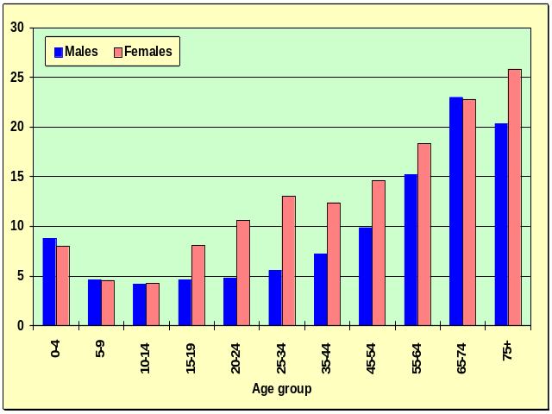
Figure 4: Medical services per person by age (left) and hospital use per person by age (right)

Moreover, in contrast to Europe and the United States, where there is overarching support for rural communities, there is no similar strategy for fostering rural growth more generally in Australia. Lack of medical services is a key input into general rural and remote economic wellbeing, yet increasingly the lack of a doctor in town is exacerbating rural decline, with teachers and other key community figures moving away. The RDAA, Australian Local Government Association, Country Women’s Association and the National Farmers Federation (NFF) are currently negotiating a Memorandum of Understanding regarding these issues, including the ‘critical mass’ provided by the availability of medical services.
“It’s a bit of a bummer for the community when you can’t have your baby here” (Eakins, 2002)¹
In summary, rural and remote Australia remains medically under-supplied and under-financed relative to urban areas, with severe workforce constraints in many areas of need. The problems are set to worsen as demographic ageing progresses, and they are a key factor contributing to rural decline in Australia.

What is needed and why this Budget?
Already there are many strategies aimed at these issues. Initiatives such as the 2000-01 Regional Health Strategy helped to commence a number of medical education, service and training initiatives. However, the evidence presented above suggests that the inequities continue, because some key issues remain unaddressed. People in rural and remote areas of Australia continue to have poorer health than their metropolitan counterparts, including higher death rates and consequent lower life expectancy. Travelling to a large centre for diagnosis and treatment is a serious barrier. People in rural and remote areas also experience the highest levels of socio-economic disadvantage, a major determinant of morbidity (Stratigos, 2003). Compared to people in capital cities, people in rural and remote areas:
- have up to four years lower life expectancy;
- have up to 20% higher mortality rates from all causes – with lower survival rates for cardiovascular disease and cancer as well as other illnesses – see Table 2;
- have even higher specific death rates – eg, 50% higher for death from injury for males and more than double the deaths from road vehicle accidents and from suicide; and
- suffer higher morbidity and hospitalisations (Strong et al, 1998), as well as higher domestic violence, abuse and other social risk factors.

Table 2: Death rates attributed to four major causes by rurality, non-indigenous Australians under 65
Cause | City | Inner regional | Outer regional | Remote | Very remote

Males
Cardiovascular disease | 46 | 51 | 54 | 56 | 57
Cancers | 62 | 71 | 71 | 63 | 64
Respiratory disease | 6 | 7 | 9 | 9 | 12
Injury | 48 | 62 | 67 | 75 | 85

Females
Cardiovascular disease | 16 | 19 | 21 | 20 | 24
Cancers | 55 | 57 | 56 | 50 | 56
Respiratory disease | 5 | 6 | 6 | 9 | 9
Injury | 15 | 20 | 18 | 18 | 19
Source: AIHW: age-standardised death rates 1997-1999.

The corollary is that rural and remote Australians have the most to gain from health investments. Rewards to health investments – particularly in primary care – are manifoldly demonstrated in longevity gains, improved quality of life and cost savings, particularly at the more expensive end of the health care spectrum (institutionalisations).

The rural doctor shortage is not an impossible problem – but its solutions require a commitment from government to stop ‘playing at the edges’ and bite the bullet – to commit the resources required to provide equitable access to healthcare for all Australians, including the 30% in the bush.

The strategies in A Fairer Medicare include a number of valuable proposals, such as the establishment of new medical school and GP places, that are too important to be linked to other initiatives in a way that could preclude the rigorous examination they deserve. However, the focus has been on bulk-billing trends. While bulk-billing rates are determined by other factors (ideology, competition, expectations, income of patients), the critical determinant has been found through statistical analysis to be region (McAuley, 2003). Thus halting and reversing the bulk-billing decline in rural Australia can only be achieved through strategies that respond to the higher cost structures, service complexity and workforce shortages there.

Rather than a piecemeal approach, a coordinated package is required, based on four key economic pillars – prices, quantities, quality and equity. Packaged and costed proposals are detailed in the following chapters.
With the Federal cash balance for 2002-03 at $7.6billion compared with a projected $3.9 billion, and with strong company profit tax takes and Reserve Bank dividends, as well as a favourable political climate, there is ample scope and opportunity to deliver in the 2004-05 Budget what has long been necessary for rural Australia – adequately funded, comprehensive strategies to address the higher mortality and morbidity in rural and remote areas.

THE FIRST PILLAR – PRICING ISSUES: REBATES and Indexation

Rebate levels – higher gaps, higher costs and greater complexity in the bush
The first major issue in the provision of medical services to rural and remote areas is that Medicare rebates do not take account of cost differences relative to urban areas. Figure 5 shows that, if costs are higher in rural and remote areas, the supply curve (SR) is higher than in urban areas (SU); hence, with the same MBS rebate and demand (D), fewer services will be provided per capita at a higher price to the patient.

Figure 5: Supply and demand for medical services, rural and urban
Price
$
SR

SU

PR PU
MBS

D
O
Services per capita (Q)
QR QU

The result is that patients in rural and remote areas are hit twice – once with payment gaps (price barriers since PR>PU) and once with queues (quantity constraints indicating non-price rationing or, ultimately, no access – QR<QU). Figure 6 below shows that prices faced by GP patients in rural and remote areas, who are less able to afford the gaps, are around twice the gaps in urban areas. Quantity constraints, in terms of fewer services per capita, were illustrated earlier in Figure 1 and are documented more fully in the next chapter.

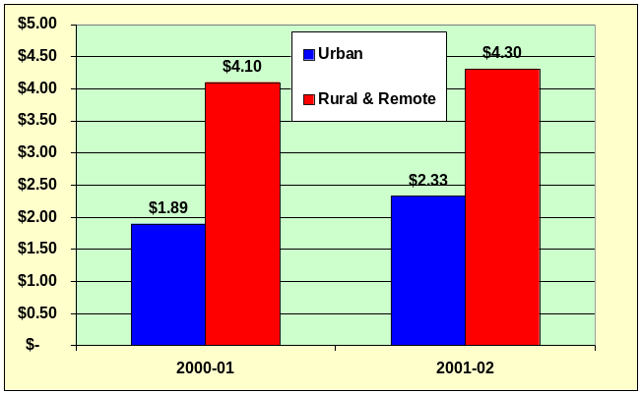
Figure 6: Average ‘gap’ prices paid by GP patients in urban and rural/remote areas, 2000-01 & 2001-02
Source: MOU data. Urban is RRMA 1 and 2; rural & remote RRMA 3-7. Data is year to October.

Gap prices for GP patients in rural and remote areas are more than double those in urban Australia.

Underlying cost differentials are of three main types:
- practice costs (including costs of continuing education and training)
- time and travel costs (patients and providers)
- complexity of services (with associated responsibility, and related insurance issues).

ACRRM (the Australian College of Rural and Remote Medicine), BEACH (Bettering the Evaluation and Care of Health) study and other data present a plethora of evidence supporting the premise that rural doctors are a different group of doctors generally dealing with more complex issues at higher cost. Strasser (1995) concludes:
“Rural doctors carry a higher level of clinical responsibility and provide a wider range of services in relative isolation… Certainly rural doctors live and work in a different world from their urban counterparts. The psychology and sociology of rural communities are markedly different from the cities. Also the spectrum of illness and injuries with which rural doctors have to cope is specific to rural areas, and the structure and process of health services in the country are quite different.”

Most recently, the Commonwealth funded Viable Models project has come to the same conclusion.
“The results provide clear evidence that the nature and complexity of general practice activities differ significantly by geographical location and rurality. The more rural or remote the GP, the more likely they are to be regularly engaged in critical emergency treatment employing an expanded skill base. Variation in the nature and complexity of general practice activities impacts on the workload, pressure and responsibility, vocational satisfaction, the need for professional education and support, and importantly on the costs and remuneration of practice (both economic and social). Clearly a ‘one-coat-fits-all’ approach to programs designed to support and remunerate GPs practising in non-metropolitan locations is inappropriate.” Humphreys et al (2003)

Differences in complexity were significant in the Viable Models project for all indicators – treatment for myocardial infarction, administration of systemic cytotoxic drugs, police-requested forensic examination of a sexual assault victim, and routine involvement in the stabilisation of injured patients pending retrieval or evacuation. The depth of involvement is substantially greater in the practice as well as in hospital work.

Rural doctors are more likely to be involved in procedural work – obstetrics, surgery, anaesthetics and accident and emergency services, with higher medical indemnity associations. Without easy access to specialists and other healthcare providers, rural doctors have to manage more, and more complex, matters than their urban counterparts. Prevention and community health services, expected of GPs in rural communities, are time consuming and entail higher spending on staff, infrastructure and facilities, which attract little or no remuneration.

Most rural and remote practices are small (1-3 FTE GPs) with solo practices more common with increasing rurality/remoteness. There are not the economies of scale obtainable in urban areas in areas such as medical and IT equipment. For practices in areas without a hospital, there may be a need to purchase expensive items such as ultrasound and X-ray imaging equipment. Figure 7 illustrates that smaller practices incur higher costs, based on data from the AMA 2001 Survey of General Practice, up to twice those of larger practices.

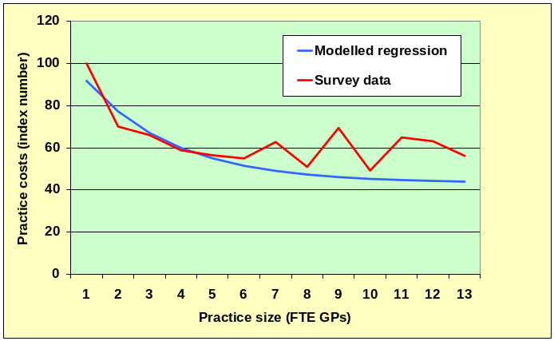
Figure 7: Practice costs higher for smaller GP practices
Source: Access Economics (2002).

Transport, communications and many consumer items generally cost more in the country. Costs of servicing equipment (eg, phone, IT, X-ray, ultrasound) 1,000kms from a service base are substantial. Locum relief, eg for professional development, can cost up to $5,000 per week with $3,000 per week (plus expenses) a minimum. Although purchase or rental costs are lower, there is often a poor or negative return to investment, in contrast to urban areas, which is a significant deterrent to younger doctors buying in and which can prevent older GPs from retiring. There is the substantial opportunity cost of losing a spouse’s second income, which is now the norm in Australian households, and of higher education costs for children’s education, as well as the family separation that frequently entails at higher levels.

The Viable models project found that practice costs averaged 52% of gross practice income, over $138,000 per FTE GP. RDAA has estimated that members’ practice costs are on average double those of urban counterparts, with significant variations depending on the area and on specific events (eg, hospital or airline collapse). Economic uncertainty is a key reason why many young doctors avoid rural practice.

Because of cost and price differentials, models that try to address urban-rural medical services maldistribution without including pricing solutions will always miss their target. As early as 1998, AMWAC noted that “the universality of the rebate across Australia provides no financial weighting for the additional financial and social costs of practice in many geographic or socioeconomically disadvantaged locations, or for higher skill levels and longer consultations with may be necessary” (AMWAC, 1998). Unfortunately, the extra incentive payments offered in A Fairer Medicare do not even keep pace with indemnity cost increases in rural areas. The IBNR levy also represents a huge threat to the viability of many rural practices. As concluded by the RDAA in its submission to the Senate Enquiry:
“The proposed interventions will sap workforce morale, aggravate uncertainty and threaten financial viability, and so diminish interest in investing in rural practice and even in remaining in it. Thus access will be decreased as the workforce shrinks and fewer doctors are able to maintain bulkbilling or low fees.” (RDAA, 2003, p9)

The first-best intervention (in economic terms) in this segmented market situation is through the basic price mechanism, the MBS rebate. Support is growing in Australia – in GP groups as well as amongst MPs – for rebates distinguished either by area or by income group of patients. In Quebec, Canada, a similar differential rebate system is already in place.

Proposal 1 – As a matter of urgency, increase MBS rebate levels for GP items, with potential for extension to other MBS items, to address the lack of access to medical services for rural and remote Australians.

Option 1 – Rural loadings for existing MBS items $186.5 m (2004-05)
increasing to up to $279.7m (2005-06)

The simplest and most economically pure solution would be to introduce a rural loading to MBS GP items for certain rural and remote areas. For the proposal modelled here, the loading would apply to services delivered in towns and communities of less than RRMA categories 3-7, and would increase with increasing remoteness. Item numbers would not change. It would also be possible to extend the loading to specialist items. This option would be simple to initiate and administer, and would assist in attracting and retaining GPs working in these rural and remote areas, at the same time avoiding any new political divide within general practice.

The scenario here models the current PIP loadings applied to GP items RRMA 3-7, with a dynamic quantity effect assumed to be 50% of the price effect. The total cost is $187m initially (price impact), potentially increasing to around $280m per annum as more services are provided in those areas (Table 3). The lag for the full quantity effect to be realised is estimated to be up to two years.

Table 3: Modeled outcomes: rural loadings on GP MBS items
 | RRMA category
 | 3 | 4 | 5 | 6 | 7 | Total
Price loading (% rebate) | 1.15 | 1.20 | 1.40 | 1.25 | 1.5
Static impact on MBS bill, $m | 23.1 | 33.2 | 111.7 | 4.9 | 13.5 | 186.5
Quantity response (%) | 1.08 | 1.10 | 1.20 | 1.13 | 1.25
Dynamic impact on MBS bill $m | 34.6 | 49.8 | 167.6 | 7.4 | 20.3 | 279.7

Option 2 – Rural Consultation Item Numbers $187.5 m (2004-05)
increasing to up to $280.7m (2005-06)

A second option is that of separate MBS rural consultation item numbers (RCINs). This would achieve the same effects as the rural loading, in terms of providing recognition of increased complexity and costs of rural medicine through the MBS rebate. However, there has been less support for separate RCINs from other organisations, and the proposal would involve a greater degree of administrative complexity. The proposal here would be to fund the RCINs to the same level as the dynamic (long run) impact of the rural loading above, with an allowance ($1m) for the costs of introduction and administration. The lags associated with behavioural response are estimated to be similar. Extending the proposal to specialist items would require additional funding.

Option 3 – Income (SEIFA) based differentiation $205.7 m (2004-05)
increasing to up to $308.5m (2005-06)

Those who live in rural and remote areas, indigenous Australians and people in disadvantaged urban areas all suffer relatively poorer health. The common factor is that these are the poorest groups in the population. The domestic and international evidence linking health outcomes and socio-economic status – measured by income, employment and educational levels – is unequivocal: people in lower socio-economic groups do not live as long, on average, as those materially more fortunate and they are sick more often. They are less likely to take steps to prevent disease or to have their illnesses detected early.

Rural regions have average incomes some 30% lower than inner metropolitan areas (McAuley, 2003). Twelve of the 20 least advantaged federal electoral divisions and 36 of the 40 poorest areas of Australia are classified as rural or remote. Analysis of Socio-Economic Indices For Areas (SEIFA) reveals that, whether measured by indices of advantage or disadvantage, economic resources or education and occupation, people who live in the cities are better off than those who do not, with those in remote areas the least fortunate.

This proposal would see an increase in the Medicare patient rebate for medical services delivered in areas of socio-economic disadvantage. The decline in bulk-billing rates is having its most severe impact on these people. While A Fairer Medicare proposes incentive measures that may act to increase bulk-billing rates, such measures are economically inferior and administratively more complex than directly addressing the source of the issue, the level of the rebate. A higher rebate (allocated on the basis of an existing income assessment device, perhaps a reviewed Health Care Card) would enable the higher medical costs in rural and remote areas to be borne by Medicare (our universal entitlements system), rather than by disadvantaged patients or providers of medical services. However, the integrity of the Health Care Card system is in doubt, with around 7 million cardholders at present, over one third of the Australian population – while others legitimately in need, such as the working poor, do not hold cards. Hence there would be a need for review of the Card. Overall, RDAA believes this option would be more difficult and costly to apply and enforce nationally than Options 1 or 2.

Option 3 is costed on the basis of providing a 25% higher rebate for the poorest 30% of patients initially in 2004-05, with the option to extend as appropriate to other services, based on evaluation of outcomes. Table 4 shows the Medicare bill across a range of services. A 25% increase for GP services would initially cost $206m, with a maximum dynamic cost estimated as $308m. To extend this to specialist services would cost $425m, while to extend to all services would cost $881m for the whole package.

Table 4: Modeled outcomes: higher MBS rebates for poorer Australians
 |  | 25% increase to poorest 30%
 | Benefits 2001-02 | Price effect | Max dynamic effects | Cumulative dynamic impact
GP attendances | 2,742.2 | 205.7 | 308.5 | 308.5
Specialist attendances | 1,038.4 | 77.9 | 116.8 | 425.3
Obstetric services | 70.5 | 5.3 | 7.9 | 433.2
Anaesthesia | 187.2 | 14.0 | 21.1 | 454.3
Pathology | 1,254.1 | 94.1 | 141.1 | 595.4
Diagnostic imaging | 1,216.9 | 91.3 | 136.9 | 732.3
Operations | 746.6 | 56.0 | 84.0 | 816.3
Optometry | 171.9 | 12.9 | 19.3 | 835.6
Other | 401.8 | 30.1 | 45.2 | 880.8
Total | 7,829.6 | 587.2 | 880.8
Source: Column of benefits (2001-02) from DHA (2003), p4, Table 1, from Medicare data.

Indexation
The second key pricing issue is indexation. Indexation to the WCI5 (or half WCI5, as it was for some years) has resulted in an erosion of MBS rebates in real terms as well as an erosion of real incomes of GPs. Figure 8 shows the erosion of Commonwealth spending per full time equivalent (FTE) GP – relative to average weekly ordinary time earnings (AWOTE) – over the period 1992-93 to 2002-03. The erosion includes spending through the Practice Incentives Program (PIP) and other blended payments. shows how this erosion of spending has resulted in a fall in real GP hourly earnings, while Figure 10 shows the decline in real terms in the MBS rebate for Item 23 (the modal level B GP item), as a three year moving average (1989-90 base year, compared to a composite cost index).

Figure 8: Average annual Commonwealth spending per FTE GP, relative to AWOTE
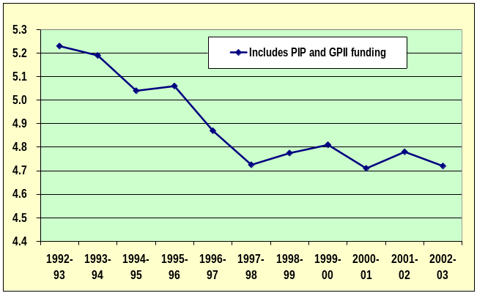
Source: DHA (2003), p20, derived from Figure 8. AWOTE = average weekly ordinary time earnings.

Figure 9: Real MBS Item 23 rebate, under WCI5 indexation.
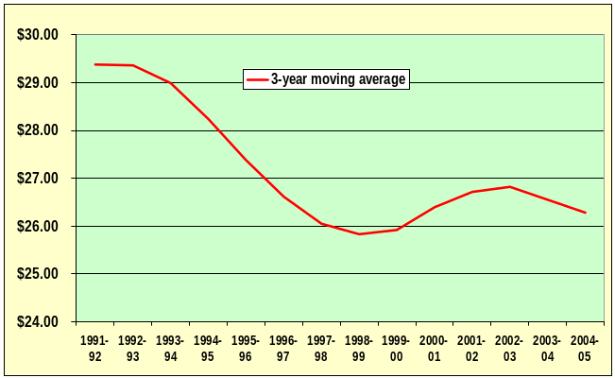
Source: Access Economics (2002).

Figure 10: Hourly gross GP earnings, annual average, urban and rural, by gender
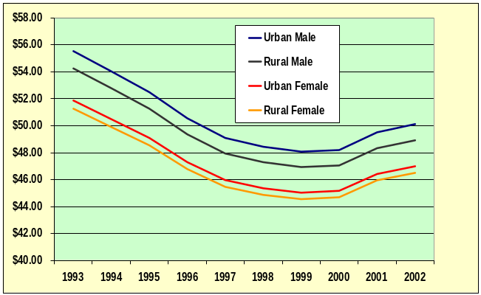
Source: Access Economics (2002).

Clearly the WCI5, while a useful Department of Finance tool in other areas of economic policy, produces fee increases that do not keep pace with growth in health practice costs. There are some clear anomalies in the construction of WCI5, for example the assumption that medical indemnity costs increase in line with CPI. The use of a more appropriate indexation tool is a matter currently under review in the Attendance Item Restructure Working Group (AIRWG), which is considering other alternate indices for use in General Practice.

One alternative worth noting is the indexed financial support scheme in the RDANSW Rural Doctors Settlement Package. Since its inception in 1987, its scheduled fees have gradually risen from 85% to 130% of the MBS fee. The success of this package in attracting and retaining doctors who work in rural hospitals underscores the importance of adequate remuneration and indexation for addressing workforce deficits (see Figure 11).

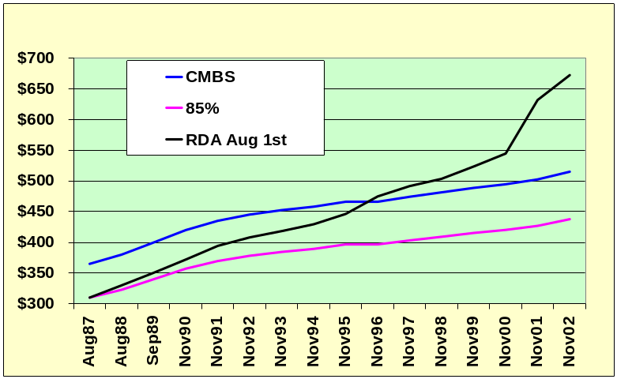
Figure 11: RDANSW indexation compared to MBS rebate increases
Note: Item 9039/30020 comparison (Item description constant).

Table 5 provides as a comparison the increase in professional attendance costs in the coming financial year were they indexed to AWOTE rather than to the WCI5. The average growth rates of these indices over 1997-98 to 2002-03 is used to calculate the difference for 2004-05, as $108.6m.

Table 5: Modeled outcomes: WCI5 compared to other potential indices
 | WCI5 | AWOTE | Prof. Attendances ($m)
1997-98 | 1.7% | 4.1% | 3,390.4
1998-99 | 1.5% | 3.7% | 3,454.3
1999-00 | 1.5% | 3.4% | 3,546.9
2000-01 | 1.2% | 5.3% | 3,696.0
2001-02 | 2.0% | 5.5% | 3,915.6
2002-03 | 2.5% | 4.8% | 3,985.9
2003-04* | 2.5% | 4.5% | 4,085.5
Average | 1.8% | 4.5%
2004-05 | 4,160.8 | 4,269.4 | 108.6

Proposal 2 – As a matter of urgency, reassess the indexation of MBS items, in particular GP items, to accord with real growth in medical costs, rather than use of the generic WCI5 index, which has proved inappropriate. The government should commit in this Budget to implement the recommendations of the AIRWG for a more appropriate index.
$108.6 m (2004-05, if applied to all professional attendances at average AWOTE growth rate), ongoing

Claims
In A Fairer Medicare, the government offers the ‘carrot’ of subsidising an electronic reimbursement system for those who buy in, allowing patient co-payment at point of service coincidental with direct rebate reimbursement. However, the subsidy amount proposed to assist with the costs of the necessary technology will not cover those costs in many rural areas. The assistance is important and should not be limited just to those who buy in; rather this capacity should be used to ensure that all rural practices have access to technology to support the provision of quality care and ease cash flow problems. To implement these changes, a budget of approximately $5m is proposed, noting the need for appropriate technology (eg, bi-directional satellite in rural areas without ADSL). Introduction of this measure would also see immediate and ongoing savings to government in its administration of Medicare.

Proposal 3 – Access to direct electronic rebate claiming should be made available to all rural GPs, allowing patient co-payment at point of service coincident with direct rebate reimbursement.
$5.0m (2004-05), one-off

Blended payments
The value of Practice Incentive Payments (PIP) is recognised and appreciated. They are a significant acknowledgement of the value of rural medicine as well as a practical and effective response to recruitment and retention difficulties. Unlike the Service Incentive Payments (SIP), where qualifying and claiming can be complex, RDAA members generally find the PIP system user friendly. Rural loadings for PIP are summarised in Table 6 below.

Table 6: PIP loadings by RRMA
RRMA | Loading
1 and 2 Capital cities and other metropolitan areas | 0%
3 Large rural centre | 15%
4 Small rural centre | 20%
5 Other rural area | 40%
6 Remote centre | 25%
7 Other remote area | 50%

THE SECOND PILLAR – QUANTITY ISSUES: WORKFORCE

In addition to addressing price constraints (gap payment inequities and cost differentials) through the rebate, addressing supply side quantity constraints are fundamental to correcting maldistribution of health services. This means overcoming current obstacles to attracting and retaining doctors by adopting a wholistic lifecycle approach emphasising a continuum of support from medical school training, through registration to rural practice.

Workforce maldistribution issues are well documented. Figure 1 and Figure 2 in the Introduction and Figure 12 and Table 7 below highlight the evidence of workforce constraints – relatively low doctor numbers, fewer per capita services and acute measured shortages. Wait times tend to be longer – 6-8 weeks in some areas to see a GP – and the workforce is ageing. Workforce feminisation (including greater part time, less flexibility and longer consultations), as well as social change indicating that younger GPs intend to work fewer hours, present major issues for the future of rural medicine. Table 7 demonstrates the fall in medical practitioners from 307 per 100,000 in capital cities to 94 in RRMA 5 and 133 in RRMA 6 and 7.

Table 7: Medical labour force indicators by RRMA grouping
Rate per 100,000 population | Capital  City | Other  metro | Large rural centres | Small rural centres | Other rural areas | Remote areas | Total
Primary care | 114 | 100 | 102 | 93 | 78 | 84
Hospital non-specialist | 29 | 29 | 39 | 15 | 4 | 20
Specialist | 99 | 73 | 101 | 41 | 9 | 13
Specialist-in-training | 35 | 23 | 16 | 5 | 1 | 6
Total clinicians | 277 | 224 | 256 | 154 | 92 | 123
Non-clinicians | 31 | 14 | 15 | 9 | 2 | 10
Total medical practitioners | 307 | 239 | 271 | 162 | 94 | 133 | 267
FTE rate (45 hrs/week) | 307 | 248 | 286 | 168 | 97 | 145 | 270
FTE rate (35 hrs/week) | 395 | 318 | 368 | 217 | 124 | 186 | 347
Total DPR | 326 | 418 | 369 | 617 | 1,064 | 752 | 375
GP DPR | 877 | 1,000 | 980 | 1,075 | 1,282 | 1,190
Specialist DPR | 1,010 | 1,370 | 990 | 2,439 | 11,111 | 7,692
Other practitioner DPR | 1,053 | 1,515 | 1,429 | 3,448 | 14,286 | 2,778
Source: AIHW (2003).

These average figures conceal particularly acute shortages in many areas of need. Figure 12 (over the page) illustrates severe GP shortages (over 20%) in the Northern Territory and northern South Australia, southwest Western Australia and southern New South Wales. Nearly half (44%) of the rural population live in areas of severe shortfall (Access Economics, 2002).

Excessive workload is further evidence of shortage, as well as a workforce ‘push factor’. GPs in RRMAs 3-7 work an average 52 hour week, compared with an average 45 hour week in city practices (Humphreys et al, 2003). Rural GPs average 130 consultations per week, compared with 123 consultations in urban areas, and also have more indirect (eg telephone) encounters. Many work in the local hospital also, not recorded in Medicare data. Nearly half rural practices provide after hours care themselves, compared to 20% in urban areas (BEACH). A sustainable after-hours roster has been identified as the single most important issue in retaining a rural medical workforce. While urban GPs are on call for 24.5 hours per week on average, the extent of on-call increases with rurality to 55.7 hours per week on average in remote areas. There is a lack of casual relief through deputising services. Other key constraints include access constraints to specialist and hospital support, access constraints for ongoing training to maintain the necessary higher skill levels, and lack of opportunities for spouse and family work and education.

Figure 12: GP shortages (percentage of total GPs required to meet need) by LGA
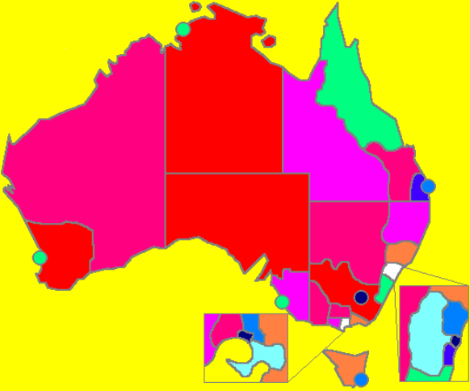
0-1 1-3 3-6 6-9 9-12 12-15 15-18 18-21 21+
Source: Access Economics (2002). LGA = local government area

A Fairer Medicare falls short of addressing many of these key workforce issues. While increases in GP training places to 600 per annum are welcome, this is still well below the levels of the early 1990s and there may be difficulties in filling the extra 150 places until the additional medical school graduates begin to come on stream, four to six years away. There will be competition for trainees, as specialist shortages are also of increasing concern, with AMWAC noting in its 2001-02 annual report that gastroenterology, geriatric medicine, haematological oncology, medical oncology and thoracic medicine are now added to the specialities failing to attract sufficient interest from trainees. A report by the Royal Australasian College of Surgeons also flags a need for 50% more surgeons by the year 2020.

There remains scope for further innovation in scholarship programs, such as targeted recruitment of medical students from rural areas for scholarship programs, as in the US, who found this to be more cost effective than relocation (Croasdale, 2003). It is increasingly important to cultivate rural medical practitioners with special clinical interests, and to recruit and develop a cadre of doctors with the necessary knowledge and skills to provide specialist care (Rosen et al, 2003). A key step to this end is extension of existing scholarships and placements on offer, with appropriate infrastructure and support for students (and the rural doctors mentoring them). The Commonwealth has recognised the importance of investment in students – now rural vocational training pathways need to be supported and strengthened through the new regional training arrangements. Dedicated rural support programs, including the Rural and Remote Area Placement Program (RRAPP) bridge, with ACRRM as a broker are required to follow students on an not lose them.

Training for medical students and junior doctors is one important part of addressing workforce issues. Other key areas include achieving adequate workforce benchmarks in key areas such as on-call, after hours and annual and professional leave, and providing capital infrastructure support. These are put forward as elements in a rural workforce package for the 2004-05 Budget.

Students
RDAA welcomes continued national funding for students to attend certain rural meetings (eg, the National Rural Undergraduate Health Conference) and participation in student bodies, and support for mentoring scholarship systems such as RAMUS (Rural Australian Medical Undergraduate Service) and JFSS (John Flynn Scholarship Scheme). RAMUS, introduced in 2000, is an unbonded scholarship worth $10,000 annually for up to 400 students each year who are prepared to participate in a doctor mentor scheme administered by the National Rural Health Alliance. JFSS was introduced in 1997 to fund a 2-week rural/remote placement of students for four years of their medical course, with up to 600 scholarships in any year worth $1,000 each (to cover food and living expenses while on placement).

MRB (Medical Rural Bonded) scholarships were introduced in the 2000-01 Budget, worth $20,950 for 2003 (indexed annually, untaxed and not means tested), with 100 scholarships offered annually to Australian students who contractually agree to practise in rural areas for 6 years on completion of training, with severe penalties for breach of contract.

While these scholarship schemes are useful, they tend to represent the two ends of a spectrum. If more RAMUS scholarships were offered, there may run the risk of misuse due to lack of commitment to the bush; if more MRB scholarships (in their current form) were offered, they may not be taken up due to the harsh conditions. There is, however, scope for a second MRB scholarship option of lower value with softer terms, as a middle road option that, in addition to the places offered in A Fairer Medicare, would continue to encourage rural recruitment. RDAA envisages that the features of such a second option (MRB#2) would include:

- the time of the bond should be limited to the period of medical school training, allowing for four years post-training service bond rather than six years for post-graduate medical students;
- one of the PY1 or PY2 years could be counted towards the service, if performed in a rural/remote area;
- greater options for compassionate exemptions to buy out of the scholarship if extenuating circumstances arose (eg, diagnosis of terminal illness of a parent/family member in a metropolitan area) – where the scholarship may be repaid in part, without penalties to the recipient’s ability to practice medicine, or perhaps limited to practice in an outer metro area;
- acquisition of at least one procedural skill;
- value at around $15,000 per year (indexed, untaxed, not means tested as per MRB#1);
- 50 scholarships offered in the first year (2005), increasing to 100 recipients in 2006 and 150 in 2007.

Table 8 shows that the total cost of MRB#2 would be $1.9m in FY2004-05 rising to $5.7m in 2005-06 and $9.7m in 2006-07 (assuming 2% indexation and an average of 5 years for each scholarship offered.)

Table 8: Medical rural bonded scholarships – Option 2 (MRB#2) costings
 | 2005 | 2006 | 2007
Number of scholarships | 50 | 100 | 150
Cost per scholarship p.a. | 15,000 | 15,300 | 15,606
Total additional cost ($m) | 3.8 | 7.7 | 11.7
 | 2004-05 | 2005-06 | 2006-07
FY spend | 1.9 | 5.7 | 9.7

Higher Education Contribution Scheme reimbursements should be claimable by all doctors undergoing vocational training who are completing that training in RRMA 3-7.

Furthermore, developing mentoring relationships is critical in exposing students to the attractiveness of rural practice. Rural clinical schools place students with rural practitioners as part of their training programs, recognising that current rural workforce networks are best placed to encourage students’ choices for rural lifestyle and career path, to offer support, respect, appreciation and skills training for different styles of practice (eg, procedural). Each RDA president, at least once a year, meets with universities in their State to talk to students about rural medicine, while rural doctors lecture some classes. It is important to engage students in strategic planning, management and policy development processes relating to procedural training issues. Mentorship programs to support female rural doctors are needed. However, the capacity for rural GPs to provide further medical student placements has reached its limit.

Moreover, adequate student accommodation is also an ongoing and serious issue. Prolonged clinical attachments make the accommodation of students with doctor’s family unrealistic and inappropriate. Moreover, increasing numbers of students are older and may require accommodation for their own family members. The local community (hospital, health service, division, local government etc) assist in ad hoc ways. Dedicated accommodation for students is imperative if a viable ‘teaching rural practice’ model is to be implemented.

To support and encourage the greater number of rural students, additional spending is required for:
- A capital grant of $25,000 as seed funding to build/upgrade student accommodation, paid to the placement entity (eg, rural hospital or practice) on application, and limited to 200 grants per annum ($5m in the first year); and
- Establish a ‘Teaching Rural Practice’ PIP payment at a minimum rate of $500 per student per week, as trialled successfully in the Riverland, with direct teaching of at least 2-3 sessions per week. Modelling is based on 8 weeks of placements (2-3 sessions per week) per year per student and 300 students per annum in total ($1.2m in the first year). This should be supported by ensuring that universities and rural clinical schools undertake in their funding agreements to provide students with extended exposure to rural procedural medicine taught predominantly by rural GPs. Where teaching involves more sessions per week, the payment would need to be in the order of $1,000 per student per week to cover practice costs and lost earnings.

Proposal 4 – Expansion of MRB scholarships through development of a second scholarship option, with a student accommodation and support package.
Medical Rural Bonded Scholarships, Option 2 (MRB#2) $1.9m (2004-05) increasing to $9.7m (2006-07)
Rural and remote students’ accommodation and support package $6.2m (2004-05) indexed p.a.

Junior Doctors
The RDAA welcomes the Federally funded RRAPP (Rural and Remote Area Placement Program), which has been operating since April 2000 and now contains 14 funded sites that use over 25 rural and remote training locations and have places for up to 70 junior doctors each year. However, demand is outstripping supply and a further six sites in a first phase expansion would enable hospitals to make RRAPP placements available to all interested doctors and ensure that specialist trainees are not disadvantaged by the increasing demand from residents targeting a GP vocation.

RRAPP relies on volunteers, high quality, individualised training and well-funded support to practices. It does not lend itself to a blanket, large frame application if it is to maintain its high quality outcomes and meet current expectations, however a well-targeted and incremental expansion should not be detrimental to either quality or sustainability. Bearing in mind that the key to sustainability of the RRAPP is the feeder hospitals’ ability to release junior doctors for the attachment, a further 6-12 sites should not prejudice outcomes. ACRRM advises that the current pattern of inquiries indicates between 4 and 8 practices are ready to develop proposals for the coming year. Evaluation of the RRAPP is showing a high correlation between a rural placements and choice of continuing in a rural vocational training pathway regardless of post graduate discipline.

The total RRAPP budget for calendar year 2003 is $1.8m, rising to $2.0m in 2004, or an average of just under $137,000 per site in 2003-04. Assuming a phased expansion with four new sites in each of 2004-05, 2005-06 and 2006-07 and costs per site increasing at 4.5% pa, the projected budget would be as shown in Table 9.

Table 9: Phased expansion of RRAPP sites
 | 2004-05 | 2005-06 | 2006-07
Additional sites | 4 | 4 | 4
Cumulative | 4 | 8 | 12
Costs ($m) | 0.57 | 1.20 | 1.87

Proposal 5 – Expand RRAPP sites and places on a phased basis to develop 12 new sites.
$0.6m (2004-05) increasing to $1.9m (2006-07)

Rural workforce
“A viable rural general practice meets the particular medical needs of the community by providing appropriate services in a way that takes account of the financial and personal costs to both the practitioner and the community at large.” (Viable Models draft report).

The Viable Models project identified that workforce and economic issues are the most serious threats to viability in rural and remote areas. The top five issues were:
- better remuneration;
- improved after hours;
- locum availability;
- capital funding; and
- educational and professional support.

These results were derived from triangulated sources to ensure validity. Economic, professional and organisational dimensions were consistently identified as the major determinants of, or threats to, future viability. Reduction of the non-remunerated workload was the most important factor in practice cost reduction. Better remuneration, a pricing issue, has been addressed in Proposals 1 and 2, dealing with higher and indexed MBS rebates respectively for rural and remote areas, in view of higher complexity and costs. In-hours is defined in the Viable Models project as 7am to 6pm for rural doctors. Hours listed on call are shown in Table 10, increasing with RRMA from 27 per week (3 worked) in RRMA 3 to 85 per week (11 worked) in RRMA 7.

Table 10: On call hours per GP by RRMA, listed and worked
RRMA | 3 | 4 | 5 | 6 | 7 | 3-7
Hours listed | 27 | 31 | 49 | 38 | 85 | 42
Hours worked | 3 | 5 | 8 | 6 | 11 | 6
Source: Viable Models draft report, Chapter 4.

The Viable Models project derives empirical benchmarks from the data gathered representing minimum core requirements for viability. Failing to meet benchmarks in any core area represents a threat to viability. Relevant benchmarks here are:
- On call maximum 1:4 nights and weekends, which may be compensated in small towns (less than 4 doctor towns) by increased annual leave (2 weeks more per annum);
- 5-6 weeks of annual leave per year (more than the standard 4 to compensate for workplace stress);
- 2 weeks per year of leave for ongoing training (CME/study/sabbatical); and
- long service leave of 13 weeks after 10 years service and 2 weeks for subsequent years.

While these benchmarks are generally achievable in RRMA 3 and 4 towns, there is difficulty in achieving them in RRMA 5-7 communities, where there are often less than four doctors available for on-call (non-salaried, non-specialist). Doctors surveyed in the context of the project proposed that on-call of 1:2 or 1:3 is manageable if time in lieu can be accessed (two weeks per year). The proposal thus centres around the provision of locums for 9.5 weeks per year in RRMA 5 to 7 (including training and benchmark rural annual leave), at 50% of the cost of the locum to the GP.

Table 11 models the proposal, showing the number of ‘communities’ defined in each RRMA group, with estimates for RRMA 5 and 7. The maximum numbers of GPs estimated to require and be eligible for the leave/locum package is modelled as 20%, 25% and 30% for each of the communities in RRMA 5, 6 and 7 respectively. With a locum replacement cost cap of $4,500 per week and with a 50% subsidy for 9.5 weeks per annum (2 weeks CME, 2 weeks in lieu and 5.5 weeks average annual leave), the cost per eligible GP would be $21,375 per annum. Clearly the success of the initiative would depend on obtaining sufficient workforce capacity and coordination to provide the relief locum service. The total cost of the package would be $10.8m per annum.

Table 11: After hours, on-call and leave package for doctors in RRMA 5 to 7
RRMA | No. of communities | Av. docs per comm'y | Modelled share <4 elig. GP | Comm's <4 elig. GPs | Total costs  $m p.a. (modelled)
3 | 18 | 58.7 | 0% | -
4 | 47 | 25.3 | 0% | -
5 | 136* | 14.0* | 20% | 27 | $ 8.09
6 | 16 | 8.3 | 25% | 4 | $ 0.71
7 | 59* | 5.2* | 30% | 18 | $ 1.98
 | 275 | 16.0 |  | 49 | $ 10.78
* Estimate.

Proposal 6 – Develop viable arrangements for after hours, on-call and leave for doctors in RRMA 5-7.
$10.8m (2004-05), indexed

A second key workforce issue raised in the research was the issue of capital price differentials. Considerable concern for established and intending non-salaried rural doctors is the cost of capital infrastructure. Established doctors often identified that they had contributed significantly to premises, facilities and equipment, including through their own superannuation funds, with little hope of growth or return. Intending rural doctors are often put off by the requirement that they invest in the practice premises so that retiring doctors can be paid, as they see no return for their investment and feel they would be trapped with considerable debt. Investment will not occur unless there is a reasonable, secure return.

Benchmarks are discussed in the Viable Models report for practice premises and facilities based on professional and architectural/building standards. A proposal for this Budget is to ensure through a capital guarantee safety net that, where the practice is unable to be sold commercially at a reasonable price and in a reasonable period (to be determined through an agreed process), there is a public sector under-writing of the purchase with a 3% per annum nominal guaranteed return for the purchaser. Legal caveats may need to be imposed on the contract to ensure that the practice is operated in accordance with stipulated principles and that a stipulated retention period of holding and operating the property is observed. The proposal would not be retrospective. In this way, recruitment is encouraged and a major obstacle to viability removed.

An option for such an initiative is costed in Table 12 over the page. The safety net would only apply to practices in RRMA 5 to 7. There would be no cash outlay for the minimum retention period (say, five years). A maximum underwrite of, say, $250,000 may be stipulated. In the event of a ‘bad debt’ (the owner unable to sell the property at a reasonable price after a reasonable period), the Commonwealth would be liable to purchase the property, for private rental or resale at say, 10% per annum nominal rate of return (modelled below). After 5 years, the maximum liability would be $30.4m, with most exposure in RRMA 5.

Table 12: Infrastructure capital safety nets for practices in RRMA 5 to 7
 | No. of  practices | Av. capital value* |  | % 'bad debts' |  | $m underwritten |  | Value 2009-10 ($m)
RRMA | No. of  practices | Low | High | Low | High | Low | High | Low | High
5 | 629 | 150,000 | 250,000 | 1% | 10% | 0.94 | 15.73 | 1.52 | 25.33
6 | 44 | 150,000 | 250,000 | 1% | 10% | 0.07 | 1.10 | 0.11 | 1.77
7 | 81 | 150,000 | 250,000 | 1% | 10% | 0.12 | 2.03 | 0.20 | 3.26
 |  |  |  |  | Total | 1.13 | 18.85 | 1.82 | 30.36
* Estimate.

Proposal 7 – Ensure safety nets for infrastructure capital for practices in RRMA5-7.
$0 cash (2004-05); maximum liability $18.9m increasing to $30.4m by 2009-10

THE THIRD PILLAR–QUALITY ISSUES

To ensure the quality provision of rural and remote health services, a number of infrastructural and support issues are paramount. There is a clear nexus that quality is a function of inputs as well as of innovations. Adequate provision of support for visiting specialists, nurses, families, facilities and technology are as important as innovative solutions such as the use of rural hospitals for research and teaching, to maintain their viability.

Accreditation and certification
Accreditation standards for practices undergird a quality system. It remains important to ensure that costs of quality assurance are not borne wholly by rural practices. RDAA supports implementation of ACRRM’s vocational training pathways to promote attainment and certification of procedural skills, and ACRRM’s professional development program as a mechanism to streamline the multiple reporting, certification and credentialing requirements for maintenance of procedural skills. It will be important to ensure that the Australian Council of Quality and Safety in Healthcare on Credentialing and Clinical Privileging reflects the needs of rural communities, involves rural general proceduralists and reviews certification issues.

Rural hospitals
The importance of local hospitals in rural and remote areas needs to be recognised, in terms of patient access and wellbeing as well as enhancing GPs’ professional satisfaction and viability. Any proposal to downgrade or close must be considered by the relevant community and professional organisations together with the local health authority in this context. While the RDAA supports the Government’s invitation to States to match the growth in Federal spending under the Australian Health Care Agreements (AHCAs) in order to receive maximum grants, it will be important to ensure during the lifetime of the current AHCAs that increased funding for public hospitals is prioritised for rural and remote areas, where such hospitals are so vital to viable health care and outcomes, and where there is rarely the option of private hospital care that is available in urban areas.

Sustaining rural hospitals requires innovation. AHCAs need to quarantine long term funding to utilise regional and rural hospitals as training centres for incoming professionals in medicine, midwifery and allied health and as centres for re-entry and re-skilling programs for professionals already resident in rural areas. These programs should have specific links to integrate then with existing Commonwealth and State workforce programs.

Specialist support
The Medical Specialist Outreach Assistance Program (MSOAP) aims to bring specialist medical services closer to home for rural communities. The long distances that need to be travelled to see a specialist can cause disruption and delays in receiving treatment, and additional cost to families. MSOAP services commenced in 2001 with $48.4m allocated over four years, providing funding to specialists (eg, psychiatrists, paediatricians) to cover some costs in visiting and delivering outreach services including travel and accommodation. Specialists also provide training and upskilling support for local medical practitioners and sometimes other health workers. Funding aims to provide additional services rather than replacing existing services. Decisions on allocation of funding are made on the basis of need, in consultation with State/Territory advisory groups.

RDAA supports the expansion of the MSOAP program by 25% per annum to provide additional specialist support including resident specialists, since specialist services provided still remain inequitably low in rural and remote regions. This is estimated to cost $3.0m in 2004-05, indexed for future years.

Practice nurses
RDAA supports the wider employment of practice nurses to enhance the capacity of rural practice to meet community needs, using a cooperative model of care. The nurse, employed by the GP, provides a variety of services including clinical care (eg, spirometry, immunisations, blood tests), screening, service coordination, health promotion and education. The GP is responsible for associated practice infrastructure costs (ongoing training, a room for the nurse, superannuation, replacements when on leave, job description, supervisory support, debriefing, and peer mentoring etc). As with other practice costs, these are frequently higher in rural and remote areas (eg, involving payments for travel and accommodation for ongoing nurse training).

The Practice Nurse Incentive (PNI) commenced in November 2002 for practices that employ a Practice Nurse (or Aboriginal Health Worker) forming part of the PIP for RRMA 3-7. The nurse (or AHW) must be registered with the Nurses Board, documented to work at least 7 hours per week on average, with nursing requirements based on standardised whole patient equivalents (SWPEs) per practice. The payment is designed as an incentive and does not cover the full costs of employing a nurse. It is $8.00 plus the standard PIP rural loading for each SWPE.

The Viable Models project identified the minimum benchmark of 0.4 FTE practice nurse for each FTE GP. To enable this benchmark to be met, RDAA proposes extension of the PNI in RRMA 3-7 through increase in the SWPE rate, to a value of $20m in the first year, 2004-05, indexed thereafter.

Family support
In March 2002, the Rural Medical Family Support Scheme (RMFSS) provided $3 million over two years to support families of GPs, registrars, other medical practitioners and locums in rural and remote areas. The scheme is administered by the Australian Rural Workforce Agencies Group (ARRWAG) and is locally managed by State and Northern Territory based Rural Workforce Agencies (RWAs). Funds were channelled to ongoing programs (community welcome, orientation, family activity, social networking etc) as well as to new/innovative projects, some of which address recent research findings – eg, telephone counselling service, educational bursaries, crisis/stress management, training for spouse and adolescent employment and advice on childcare options.

The RMFSS was complemented by a two year $175,000 grant to RACGP to further investigate rural medical family needs, improve non-clinical counselling skills and circulate a resource kit. A further $75,000 was provided over three years to the National Rural Medical Family Network Australia (NRMFNA) through ARRWAG to improve its operational capacity and strengthen its national profile.

RDAA recommends that this support to NRMFNA be extended and made recurrent, with ongoing funding increased to $250,000 pa (indexed).

Informatics
Broadband online services in RRMAs 4-7 are important to enhance two-way electronic information exchange including, for example:
- access to emerging medical IT such as HealthConnect and Better Medication Management System projects;
- access to decision-support tools, especially for the management of chronic illness;
- access to libraries of consumer information able to be passed on to patients;
- seamless integration of hospital-based investigations with clinical databases and the ability to make electronic hospital outpatient appointments;
- daily liaison with the local health professionals, pathology providers and the nearest specialists (including referrals and reports);
- continuing professional development programs; and
- spin-off benefits of rural data provision to inform public health research.

Non-broadband connection speed and cut-outs can be prohibitively inefficient, while initial broadband connection costs and barriers can be prohibitively expensive in many rural and remote areas. The contrast with city access to such informatics services is marked. The more remote the practice, the more critical near-real-time information linkages become.

RDAA support the funding of broadband services in RRMAs 4-7 with initial funding in 2004-05 of $8.0m, indexed.

Proposal 8 – Provide a quality infrastructure support package for rural and remote practices, largely based on extending existing delivery mechanisms including expanding MOSAP specialist support by 25% per annum, increasing NRMFNA family support funding to $250,000 per annum, boosting the PNI for practice nurses and supporting broadband IT service provision to RRMAs 4 to 7.
$31.3 (2004-05) indexed

THE FOURTH PILLAR–EQUITY ISSUES
“There are different ways of conceiving of equity. For example, horizontal equity is about the equal treatment of the equal, while vertical equity is about the unequal but equitable treatment of unequals.” Mooney (2003)

Vertical equity is the basis of our taxation and social welfare systems, and should also be the basis of the Medicare system. Gradually key stakeholders are coming to the view that equal rebates are not necessarily equitable. It is time the ‘missing millions’ of the Medicare underspend in the bush are addressed.

This budget submission has primarily focused on the inequity between rural and remote Australians and those in the cities. A key focus in further addressing inequity must involve measures for indigenous Australians.

Indigenous health
The health of Australia’s indigenous population remains a national embarrassment. Aboriginal and Torres Strait Islander (ATSI) people experience a higher burden of preventable disease and mortality at an earlier age than other Australians, including triple the age-standardised mortality rates and substantially lower life expectancy. Indigenous people constitute 1% of the metropolitan zone population, 3% of the rural zone population, 13% of the population in ‘remote centres’ and 26% of the population in ‘other remote areas’ (Strong et al, 1998).

Over the years, RDAs in various States have played a pivotal role in the development of the ATSI health curricula and in lobbying to ensure that ATSI people become part of mainstream systems. RDAA members play a critical role in the provision of health services to ATSI people. RDAA believes that special efforts for ATSI people must include:
- provision of health infrastructure – nutrition, education, employment, housing, water and sewerage, transport;
- culturally appropriate partnership with ATSI people in development and delivery of services;
- additional resources;
- special attention to children;
- measures to attract and retain medical practitioners to Aboriginal Medical Services;
- relevant training included in general training and as specialist training;
- mainstream improvements such as management training and quality workforce contracts; and
- expansion of Aboriginal Health Workers.

Clearly ATSI health policy requires careful development on numerous fronts phased over some years. To ensure that progress builds momentum each year, RDAA proposes that, in 2004-05, a key step to improve indigenous health outcomes is the provision of two-yearly health checks for ATSI people of all ages (i.e., including children) as part of Enhanced Primary Care. There is already support from within the Department of Health and Ageing for health checks for those aged 15-55 years, including the provision of a separate Medicare Item Number. RDAA believes these checks should also apply to indigenous children, so that all indigenous people are entitled to a health check not subject to an age limit. The health check should include history taking, examination and appropriate intervention activity, to improve early detection, diagnosis and treatment, in particular for diabetes and cardiovascular disease. Cultural sensitivities (eg, regarding pap smears) and higher rates of health issues are estimated to make the check more complex than for non-indigenous Australians. Care plans are also likely to be required, but are not costed in this proposal.

Clearly, the ability to implement a health check is dependent on workforce availability, which in turn hinges on adopting the proposals related to prices and quantities in previous sections. There would also be the requirement for an assisting practice nurse and other health care providers, with overall time between 1-1.5 hours. For existing EPC items that are in the schedule, the rebate for the health assessment is about $184 (the care plan is $167).

The 2001 census showed there were 410,000 indigenous Australians (2.2% of the population, up from 1.6% in 1991). By 2002 this is estimated to have increased to 415,000. Assuming that:
- the health care check rebate is 25% higher than for non-indigenous EPC health check ($230);
- that the check is performed every 2 years and captures 50% of the population;
the total cost for $2004-05 would be $23.9m. For the rural and remote populations only (an estimated 151,000 in RRMA 3-5, 31,000 in RRMA 6 and 94,000 in RRMA 7), the cost would be $15.8. Table 13 summarises cost estimates for the next three years, based on these assumptions and a 4.5% average AWOTE indexation.

Table 13: ATSI health check, costed proposal
 | 2004-05 | 2005-06 | 2006-07
All indigenous Australians | 23.9 | 25.0 | 26.1
RRMA 3-7 | 15.8 | 16.5 | 17.3

Proposal 9 – Health checks for indigenous Australians
$23.9m (2004-05) increasing to $26.1m (2006-07)

SUMMARY OF COSTED PROPOSALS

Proposal 1 – As a matter of urgency, increase MBS rebate levels for GP items, with potential for extension to other MBS items, to address the lack of access to medical services for rural and remote Australians.

Option 1 – Rural loadings for existing MBS items $186.5 m (2004-05)
increasing to up to $279.7m (2005-06)
Option 2 – Rural Consultation Item Numbers $187.5 m (2004-05)
increasing to up to $280.7m (2005-06)
Option 3 – Income (SEIFA) based differentiation $205.7m (2004-05)
increasing to up to $308.5m (2005-06)

Proposal 2 – As a matter of urgency, reassess the indexation of MBS items, in particular GP items, to accord with real growth in medical costs, rather than use of the generic WCI5 index, which has proved inappropriate. The government should commit in this Budget to implement the recommendations of the AIRWG for a more appropriate index.
$108.6 m (2004-05, if applied to all professional attendances at average AWOTE growth rate), ongoing

Proposal 3 – Access to direct electronic rebate claiming should be made available to all rural GPs, allowing patient co-payment at point of service coincident with direct rebate reimbursement.
$5.0m (2004-05), one-off

Proposal 4 – Expansion of MRB scholarships through development of a second scholarship option, with a student accommodation and support package.
Medical Rural Bonded Scholarships, Option 2 (MRB#2) $1.9m (2004-05) increasing to $9.7m (2006-07)
Rural and remote students’ accommodation and support package $6.2m pa, indexed

Proposal 5 – Expand RRAPP sites and places on a phased basis to develop 12 new sites.
$0.6m (2004-05) increasing to $1.9m (2006-07)

Proposal 6 – Develop viable arrangements for after hours, on-call and leave for doctors in RRMA 5-7.
$10.8m p.a., indexed

Proposal 7 – Ensure safety nets for infrastructure capital for practices in RRMA5-7.
$0 cash (2004-05); maximum liability $18.9m increasing to $30.4m (2009-10)

Proposal 8 – Provide a quality infrastructure support package for rural and remote practices, largely based on extending existing delivery mechanisms including expanding MOSAP specialist support by 25% per annum, increasing NRMFNA family support funding to $250,000 per annum, boosting the PNI for practice nurses and supporting broadband IT service provision to RRMAs 4 to 7.
$31.3 (2004-05) indexed

Proposal 9 – Health checks for indigenous Australians
$23.9m (2004-05), indexed

Total proposed for 2004-05 for rural and remote health and indexation $393.4m

Table 14: Summary of costed proposals, $million, 2004-05 to 2006-07
Rural health and MBS indexation package | 04-05 | 05-06 | 06-07 | Total
1 Rural MBS loadings for RRMA 3-7 | 186.5 | 279.7 | 279.7 | 745.8
2 Indexation, all professional attendances | 108.6 | 217.1 | 325.7 | 651.3
3 Direct electronic rebate claiming RRMA 3-7 | 5.0 | - | - | 5.0
4 Expansion of MRB#2 scholarships | 8.1 | 12.3 | 16.8 | 37.2
5 Expansion of RRAPP sites (12 new) | 0.6 | 1.2 | 1.9 | 3.6
6 Viable workforce locum AH package RRMA 5-7 | 10.8 | 11.3 | 11.8 | 33.8
7 Capital infrastructure safety nets RRMA 5-7* | - | - | - | -
8 Quality infrastructure support package | 31.3 | 32.7 | 34.1 | 98.1
9 Indigenous health check | 23.9 | 25.0 | 26.1 | 74.9
Total package, cash basis | 374.6 | 579.1 | 696.0 | 1,649.8
* No cash flow but incurred maximum liability | 18.9 | 20.7 | 22.8 | 62.4
Total package, accrual basis | 393.4 | 599.9 | 718.8 | 1,712.1

REFERENCES

Access Economics (2002) “Remodelling of the GP workforce requirements in the Northern Territory” Report prepared for the Australian Medical Association, September, Canberra, and associated modelling.

Australian Bureau of Statistics (2000) Population projections, Australia:1999-2101 Cat No 3222.0, Canberra.

Australian Institute of Health and Welfare (2003) “Medical labour force, 2000” Bulletin, Issue 5, June, Canberra.

Australian Medical Workforce Advisory Committee (2000) “The General Practice Workforce in Australia: Supply and Requirements–1999-2010” AMWAC Report 2000.2, August, Sydney.

Australian Medical Workforce Advisory Committee (1998) “Medical Workforce Supply and Demand in Australia: A Discussion Paper” AMWAC Report 1998.8, AIHW Cat No HWL12, October.

Croasdale M (2003) “Homegrown doctors key to staffing: Scholarships attempt to solve physician shortage in rural areas”, AMNews, 4 August 2003, available on www.amednews.com

Department of Health and Ageing (2003) "Inquiry into the access to and affordability of general practice under Medicare "Submission to the Senate Select Committee on Medicare, July, Canberra.

Elliot A (2003) ‘Is Medicare universal?” Research Note 37/2002/03, Parliamentary Library, Canberra.

Etzioni DA, Liu JH, Maggard MA, Ko CY (2003) “The aging population and its impact on the surgery workforce” Annals of Surgery 238(2): 170-177.

Humphreys JS, Jones J, Mildenhall D, Mara P, Chater B, Rosenthall D, Maxfield N and Boots A (2003) “Rural general practice: It’s not just different, it’s more complex” Medical Journal of Australia, 19 October (forthcoming).

McAuley I (2003) “Bulkbilling by income/electorate” Report to the Australian Consumers’ Association, September, available on www.choice.com.au/campaigns

Mooney G (2003) “Inequity in Australian health care: how do we progress from here?”Australian and New Zealand Journal of Public Health, 27:3.

RDAA (2003) Submission to the Senate Select Committee into Issues relating to Access and Affordability of General Practice under Medicare, June, Canberra.

Rosen R, Stevens R and Jones R (2003) “General practitioners with special clinical interests” British Medical Journal, 327:460-462 (30 August).

Strasser R (1995) “Rural general practice: is it a distinct discipline?”Australian Family Physician, 24:5.

Stratigos S (2003) Equal is not equitable: Medicare in the Bush, RDAA policy paper.

Strong K, Trickett P, Titulaer I and Bhatia K (1998) Health in rural and remote Australia, Australian Institute of Health and Welfare, AIHW Cat No PHE6, Canberra.

APPENDIX: RRMA (Rural, Remote and Metropolitan Area) categories

- RRMA 1: Capital cities–Sydney, Melbourne, Brisbane, Perth, Adelaide, Hobart, Darwin and Canberra.
- RRMA 2: Other metropolitan centres (population over > 100,000)–Newcastle, Wollongong, Queanbeyan (NSW); Geelong (Vic); GoldCoast-TweedHeads, Townsville-Thuringowa (Qld).

- RRMA 3: Large rural centre (population 25,000-99,999)–Albury-Wodonga, Dubbo, Lismore, Orange, Port Macquarie, Tamworth, Wagga Wagga (NSW); Ballarat, Bendigo, Shepparton-Mooroopna (Vic); Bundaberg, Cairns, Mackay, Maroochydore-Mooloolaba, Rockhampton, Toowoomba (Qld); Whyalla (SA); Launceston (Tas).

- RRMA 4: Small rural centre (population 10,000-24, 999)–Armidale, Ballina, Bathurst, Broken Hill, Casino, Coffs Harbour, Echuca-Moama, Forster-Tuncurry, Goulbourn, Grafton, Griffith, Lithgow, Moree Plains, Muswellbrook, Nowra-Bombaderry, Singleton, Taree (NSW); Bairnsdale, Colac, Horsham, Mildura, Moe-Yallourn, Morwell, Ocean Grove-Barwon Heads, Portland, Sale, Traralgon, Wangaratta, Warrnambool (Vic); Caloundra, Gladstone, Gympie, Hervey Bay, Maryborough, Tewantin-Noosa, Warwick (Qld); Mt Gambier, Murray Bridge, Port Augusta, Port Lincoln, Port Pirie (SA); Albany, Bunbury, Geraldton, Mandurah (WA); Burnie-Somerset, Devonport (Tas).

- RRMA 5: Other rural centre (remaining statistical areas within the rural zone)–examples include Cowra shire, Temora shire, Guyra shire (NSW); Ararat shire, Cobram shire (Vic); Cardwell shire, Whitsunday shire (Qld); Barossa, Pinnaroo (SA); Moora shire, York shire (WA); George Town, Ross (Tas); Coomalie, Litchfield (NT).

- RRMA 6: Remote centre (population > 5,000 and hundreds of kms from a major urban centre)–Blackwater, Bowen, Emerald, Mareeba, Moranbah, MountIsa, Roma (Qld); Broome, Carnarvan, East Pilbara, Esperance, Kalgoorlie-Boulder, Port Hedland, Karratha (WA); Alice Springs, Katherine (NT).

- RRMA 7: Other remote centre (remaining areas within the remote zone)–examples are Balranald, Bourke, Cobar, Lord Howe Island (NSW); Orbost, Walpeup (Vic); Aurukun, Longreach, Quilpie (Qld); Coober Pedy, Murat Bay, Roxby Downs (SA); Coolgardie, Exmouth, Laverton, Shark Bay (WA); King Island, Strahan (Tas); Daly, Jabiru, Nhulunbuy (NT).

AMWAC (2000), p41, distribution applied to DHA, 2003, p4, with an Australian average of 5.1 GP attendances.
Sam Eakins’ article in The Advertiser, 7 March 2002, describes a young mother from a small community losing its hospital obstetric facility because of shortage of anaesthetists.
Delayed access to medical attention increase the risk of fatality in motor vehicle accidents.
Medicare was never intended to offer universal bulk-billing; rather, universal insurance. As noted by the Commonwealth Parliamentary Library, ‘a decline in bulk billing does not necessarily challenge the universality of Medicare’ (Elliot, 2003).
Ian McAuley lectures in public sector finance at the University of Canberra.
Submission to the Senate Select Committee on Medicare by Wagga Wagga City Council, p4.
In 2001 there were 1,203 medical school graduates, still somewhat below the number in 1985 (1,356).
The estimate for RRMA 5 is the half-way point between RRMA 4 and 6; for RRMA 7 it represents half the RRMA 6 figure.

