ATTACHMENT 2

Nimbin and Rural Medicine, Document (A): NIMBIN AND ITS CATCHMENT AREA by Dr Len Martin. Nimbin Needs Doctors Rural Action Group [PO Box 61, Nimbin, NSW 2480; telephone, 0266 890 254; e-mail, pteropus42@smartchat.net.au].

Executive Summary The town of Nimbin is the urban centre for a dispersed population of some 5-6000 people. Nimbin lies over 30 km north of Lismore, with poor road access to Lismore. Nimbin’s catchment population, being dispersed over a large area of relatively rugged country, has even worse access to Lismore. It is unjust to classify the Nimbin catchment, which includes RRMA5 areas, as RRMA3.

Introduction Nimbin is a small rural town in the Local Government Area [LGA] of Lismore City, but which is located over 30 km north of the town of Lismore. Nimbin has a population of some 400 in the township, but draws on an outlying population of about 6,000. The single- (previously four-) GP medical practice closed in May 2003, because it could not attract additional GPs. The only practice in the area, it had over 4,000 local residents on its books. A major factor in the practice’s failure to attract or retain GPs was Nimbin’s RRMA3 status. Aside from Lismore, Nimbin is the only urban centre in the Richmond-Tweed area with this status - all others are classed as RRMA 4 or 5.

The issue of changing Nimbin’s RRMA status has been addressed in Briefing Document C. In what follows it will become clear that it is a nonsense and major injustice to rank Nimbin as a town of 25,000-99,999 population – because that is what RRMA3 status implies

Nimbin as a Small Urban Centre

The (2001) Statistical Local Area [SLA] of Lismore (C)-Pt B lists only four “towns”. To quote,

“It includes the towns of Dunoon, Clunes, Modanville and Nimbin, but excludes the town of Lismore”

Only these four towns appear in the Australian Bureau of Statistics [ABS] Census of Population and Housing, Selected Characterisitics for Urban Centres and Localities, New South Wales and Australian Capital Territory 2001 (CPH2001) [ABS Cat. No. 2016.1; ISBN 0 642 47797 3].

The CPH2001 defines an urban centre as a,

“population cluster of 1,000 or more people, while a locality is a population cluster of between 200 and 999 people”.

Thus all four “towns “of the Lismore (C)-Pt B SLA are “localities. The CPH2001 lists Modanville as having the largest population (467) and Dunoon the least (398), with Clunes at 417 and Nimbin at 400.

Nonetheless it is unequivocal that, in terms of services and facilities provided, Nimbin tops the list, and functions as a small rural centre for a broad catchment area of 20-30 km diameter (see maps).

The town centre has: a cinema-restaurant; a bowling club; a central school with >300 pupils; a public swimming pool; several back-packer hostels; a post-office; a guest house; a police station; a hospital, currently undergoing a major upgrade; an established alternative-energy enterprise centre; a St Vincent de Paul thrift shop; a community-based neighbourhood centre; a community centre; a Community Technology Centre; a thriving art gallery and local regional gallery; a pub; a service station; an NRMA service and repair centre; one butcher employing 3-4 staff; a hardware store ditto; one newsagent-supermarket ditto; one emporium-supermarket ditto; one credit union branch ditto; one hot bread shop ditto; one pharmacy ditto; one estate agent ditto; a bookshop!; a hairdresser; one greengrocer; one organic greengrocer; one Pizza restaurant; several cafe/restaurants including The Rainbow, The Oasis, The Cave, Choices and others; various shops selling “touristy” goods; Djanbung Permaculture Centre.

The Village hall regularly hosts locally produced entertainment such as cabarets featuring talented local musicians, plays presented by local drama groups (there are three). There are sports fields and sports clubs, and a showground. Within two to three km of town are: a building supply centre; a produce store and a quarry. Nimbin also boasts a number of professional and other services: surveyor, solicitor, builders, plumbers, electricians; there is a highly active gardening club and magnificent gardens... the list goes on.

While Nimbin is known for its Hippy culture and drugs (and both are obvious on the main street, and attract tourists), it is clear from the thriving businesses and services listed above that Nimbin supports much more than the simple “alternative lifestyle” culture. There are still many farming families in the district and Nimbin continues to run an annual Agricultural Show! There have been numerous rural subdivisions, and increasingly these are being bought by the more affluent: retired professionals; baby-booming refugees from Sydney etc. The housing market is buoyant, as evidenced by the advertisements in the estate agents (http://www.nimbinrealestate.com.au/).

Although a new practice has recently been set up co-operatively by Northern Rivers Division of General Practice, Northern Rivers Area Health Service and Lismore City Council continuing RRMA3 status will seriously compromise its viability, as it did the previous practice. By contributing to the previous practice closure, RRMA3 status has already put the health of a large rural population at risk (not to mention tourists), and it could well do so again!

2. The geographical location of Nimbin Map 1, of the Lismore Local Government Area [LGA] and adjoining LGAs, shows how isolated Nimbin is compared with Wollongbar and Alstonville, rated RRMA4!

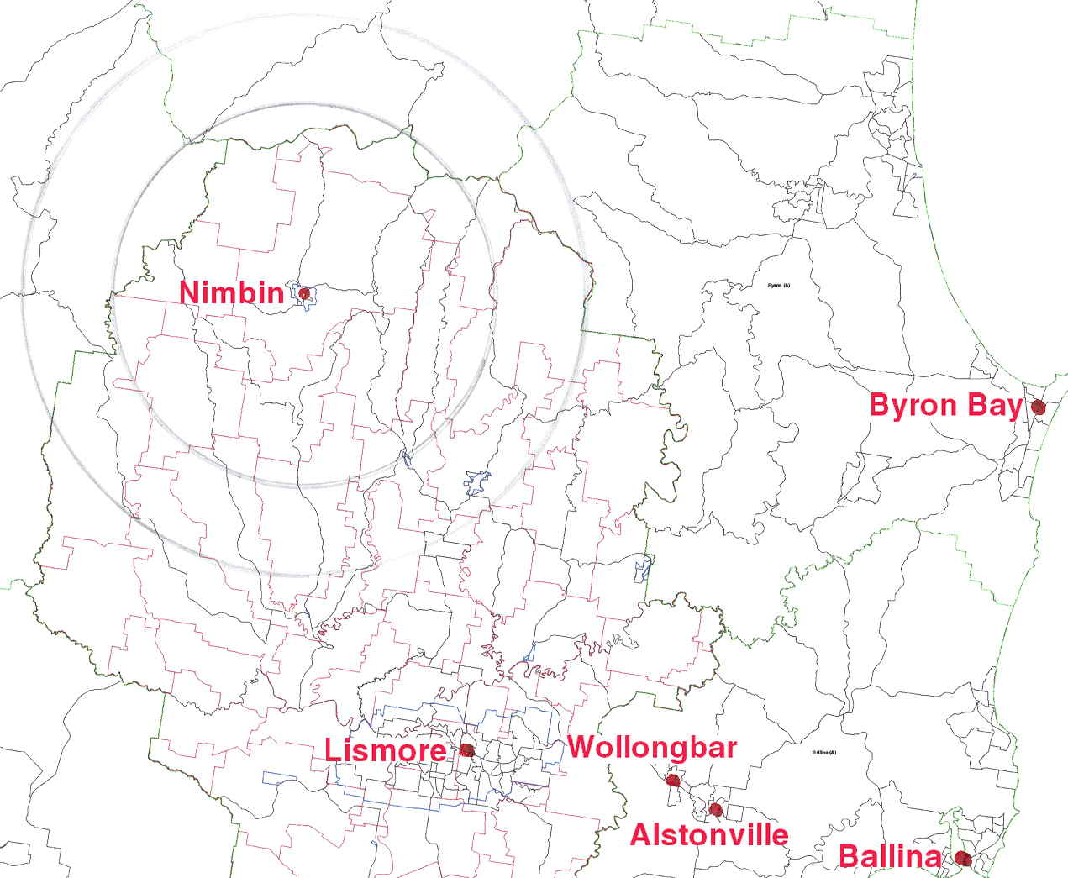

Map 1 A general view of the Lismore Local Government Area [LGA] and adjoining LGAs : Byron Bay, Ballina, Tweed (north), Kyogle (northwest), Casino (southwest). Fine black lines indicate Census collection districts. In the Lismore LGA fine mauve lines indicate boundaries of Lismore “suburbs”. The concentric rings around Nimbin mark 10 and 15 km respectively from the Nimbin Post Office.

Maps 2 and 3 show that Nimbin and its catchment area are in rugged country, a topography that exacerbates the isolation of Nimbin town and its catchment from Lismore.
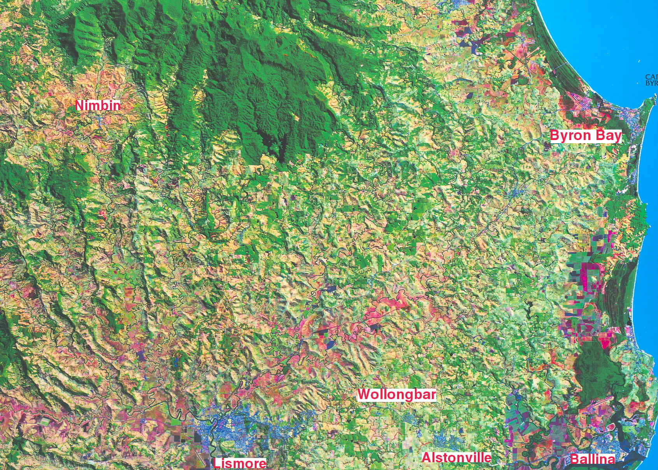
Map 2. Satellite topographic view of the area covered by map 1. This emphasises the isolated position of Nimbin with its catchment area encompassing rugged country and difficult access to Lismore.

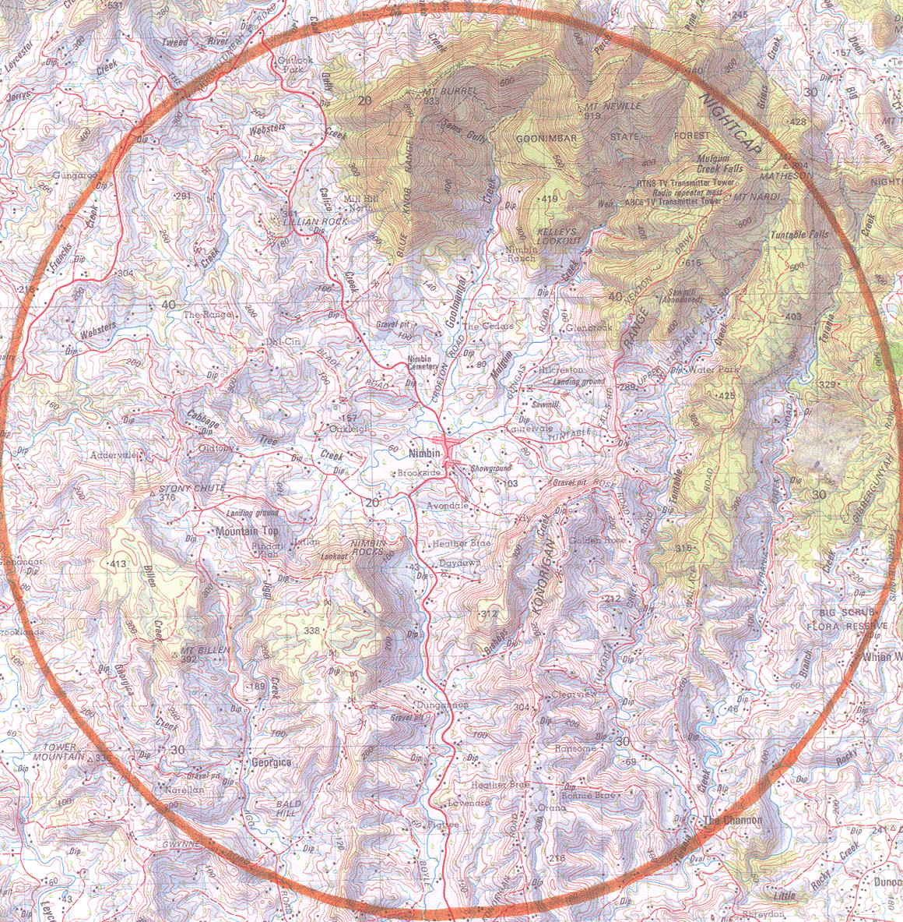
Map 3. A closer topographic view of the Nimbin catchment. This again emphasises the isolation of Nimbin from Lismore and how Nimbin town-ship is a “natural centre” to its catchment - with a network of small winding roads
from the surrounding rugged country. Note also the road that winds south towards Lismore close to Goolmangar creek. It is prone to flooding and traffic hold-ups by dense fog. Orange circle marks 10 km from Nimbin PO.

Lying as it does in the extreme north of the Lismore LGA, Nimbin services populations from the adjoining LGAs of Kyogle and Tweed. Reference to Map 4, (a section of the “Casino” Forestry Map, that shows local roads in good detail), makes clear how natural it is for the populations of Cawongla, Barkers Vale, and Wadeville in Kyogle Shire, and Mount Burrill and Kunghur in Tweed Shire to treat Nimbin as their local centre - particularly given the range of services that Nimbin offers. It should be noted that all of these localities are in SLAs with RRMA5 status.

Areas within the Lismore LGA, which look to Nimbin, include Mountain Top, Jiggi, Coffee Camp, Koonorigan, The Channon, Tuntable Falls and Lillian Rock. The following outlying schools also lie within the Nimbin Catchment: public schools - Barkers Vale, Coffee Camp, Jiggi, The Channon, The Channon-Tuntable Creek; non-government schools – Nimbin-Tuntable Falls Primary School, Rudolph Steiner School (on Lillian Rock Road).

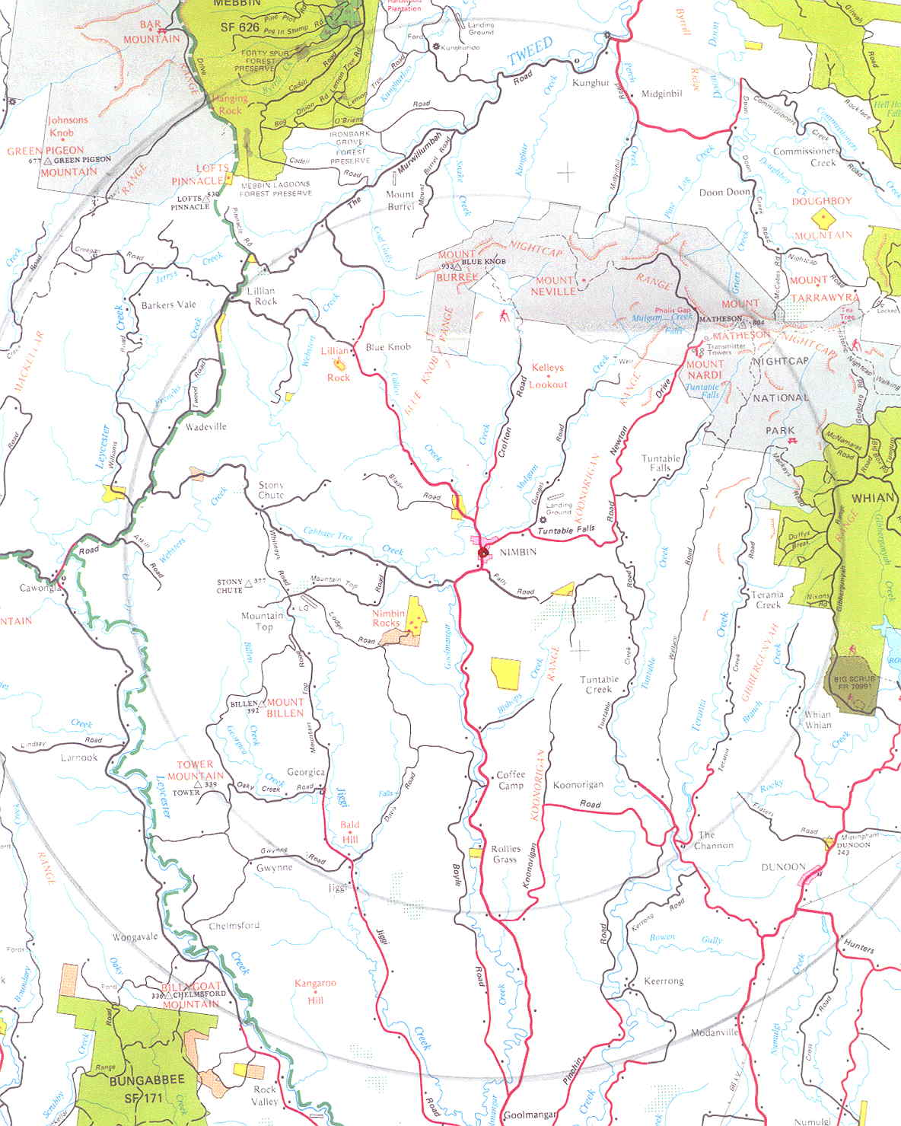
Map 4. Section of “Casino” Forestry Map showing local townships and hamlets served by Nimbin. The two concentric circles show 10 and 15 km from the Nimbin Post Office.
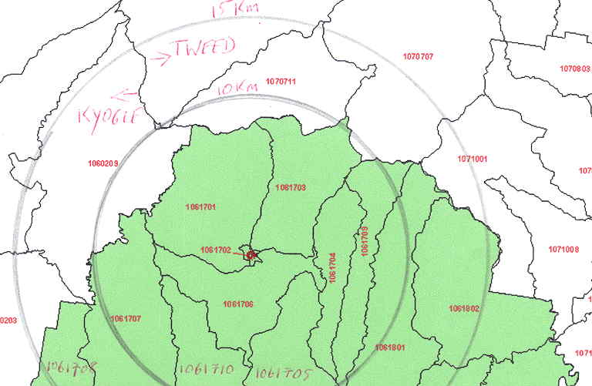
Map 5. Census collection districts in the Nimbin Catchment The two concentric circles show 10 and 15 km from the Nimbin Post Office.

Table 1 The Population of the Nimbin Catchment Area
Counts are based on the Australian Bureau of Statistics 2001 Census data
[Census for Urban Areas, ABS Catalogue No. 2016.1 ISBN 0 642 47797 3 (2003)]
Statistical Local Area | Census Collection District | Number of Residents | Subtotals
Kyogle (C) | 1060209 | 748 | 748
Tweed (C) Part B | 1070711 | 357
 | 1070707 | 399
 | 1070706 | 793 | 1549 (2297)
Lismore (C) Part B | 1061701 | 533
 | 1061702 | 486
 | 1061703 | 308
 | 1061704 | 368
 | 1061705 | 456
 | 1061706 | 427
 | 1061707 | 780
 | 1061708 | 462
 | 1061709 | 221
 | 1061710 | 407
 | 1061801 | 493
 | 1061802 | 281 | 5222
 | Total | 7519 | 7519

Table 1 shows the population numbers for the Census Collection Districts that can be regarded as being in the Nimbin catchment. One notable feature that emerges from these data is the remarkable degree of dispersal of the population across the whole catchment – another feature that emphasises the rural isolation of the catchment population in relation to Lismore.

Clearly it is a monstrous injustice that this rural area does not have the “other rural” status that its geographical location warrants, namely
RRMA5!

