14 July 2003

Elton Humphery
Secretary
Senate select committee on Medicare
The Senate
Parliament House
Canberra ACT 2600
Dear Mr Humphrey

Senate select committee on Medicare

Thank you for the opportunity to contribute to this inquiry. The ANF is the largest national industrial and professional organisation for nurses. There are more than 125,000 members in the State/Territory Branches. The ANF represents registered and enrolled nurses, and assistants in nursing and other unlicensed health care workers (however titled). Please see www.anf.org.au for more information.

The ANF supports a universal health insurance system. It demonstrates that we are a fair society, willing to provide basic services such as health and education to all members of the community. The ANF supports the use of the taxation system including the Medicare Levy to pay for a comprehensive and effective health care system. The Australian community contributes a proportion of their income as an investment in the health care system. This investment ensures that every community member is able to access health care when it is required and not when they can afford it. The ANF is not opposed to an increase in taxation to ensure that a quality health care service is available for all Australians.

The ANF opposes the development of a two or three tiered health care system where Medicare is the safety net for the elderly, those with disabilities and the poor, while the rest of the community gambles with private health insurance and the private health care system.

I have attached some further comments for your information. I would be happy to meet with the Senate select committee and discuss our position on Medicare and I can be contacted in the Canberra office 02-6232 6533 (or anfcanberra@anf.org.au). Please contact Victoria Gilmore in the Canberra office (or professional@anf.org.au) if you require any other information.

Yours sincerely
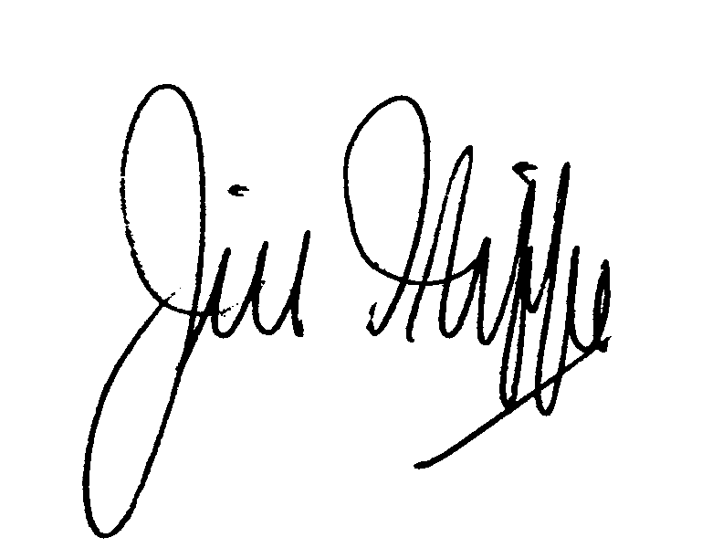

JILL ILIFFE
Federal Secretary

