18th June 2003

The Secretary
Select Committee on Medicare
Suite S1 30
Parliament House
Canberra ACT 2600

Medicare.sen.@aph.gov.au

The Geelong & Region Trades and Labour Council (GTHC) rejects the Howard government’s attempts to destroy Medicare, Australia’s universal health care system.

Under the current system working people receive hassle free health care that they have essentially paid for through taxes, this must continue.

Workers can currently visit a doctor free of charge by using their Medicare card if the doctor bulk bills. Under this system the doctor receives a $25 Medicare Rebate and cannot charge patients any more than this fee. This system keeps health care costs in check and means that everyone has access to the doctor, not just the wealthy.

Under Howard’s proposed changes to the system doctors will still be able to bulk bill patients but also allowed to charge patients the so-called co-payment of $20.

If the government passes this legislation Medicare will be reduced to a safety net that is only available to pensioners and health care card holders. The people who will suffer the most as a result of the proposed changes to Medicare will be low income families and the chronically ill.

Many workers are already paying more that $20 for a visit to the doctor because of the cutbacks the Howard Government have made to Medicare and the bulk billing rebate over the last seven years.

The GTHC does not accept the Howard governments claim that they cannot afford to continue to provide a universal health care system, yet they can spend billions subsidising private health care.

There is no doubt that the $20 co-payment fee will rapidly rise as doctor’s increase their fees. We do not want an American health care system where millions of working families are denied health care because it is just too expensive.

There are examples in Geelong of doctors already charging payment, leaving low income families with the dilemma of whether they put food on the table or pay to see the doctor.

In the Geelong area bulk billing rates have dropped and out of pocket expenses have increased.
The Health Insurance Commission clearly shows that in our two relevant electorates, bulk billing has dropped and out of pocket expenses have increased.

Corio Electorate Bulking Billing Rates Out of pocket Expenses
Sept 02 Dec 02 Sept 02 Dec 02

59.34% 58.50% $11.22 $11.31
Corangamite Electorate Bulking Billing Rates Out of pocket Expenses
Sept 02 Dec 02 Sept 02 Dec 02

42.89% 42.20% $11.97 $12.16

The declining rates of bulk billing and increased out of pocket expenses undermine the central feature of Medicare, free and universal access to health care according to need, not ability to pay.

Medicare is the cheapest most affordable and equitable way to provide health care for all Australians. Australia’s health care costs are only around 8.9 % GDP, very comparable to most OECD countries.

The GTHC reminds the Committee that during the early 1980’s Medicare which was introduced by the Hawke Labor Government saw workers trade off wage increases as a part of the Accord process package of the social wage measures.

Included in the social wage was a universal health care system and on the basis of this, workers moderated and forwent substantial wage increases. In other words, workers actually contribute more in taxes to fund a universal health system. This significant contribution made by Australian men and women workers must be recognised.

At no stage has either political Party been given a mandate by the Australian people to lessen the benefits of our universal health care system, Medicare.

The GTHC calls on the Parliament of Australia to conduct a referendum on whether these changes are acceptable to the people of Australia.

The GTHC welcomes the opportunity to address and give evidence at a public hearing of the Senate Select Committee on Medicare and would strongly support a hearing in Geelong.

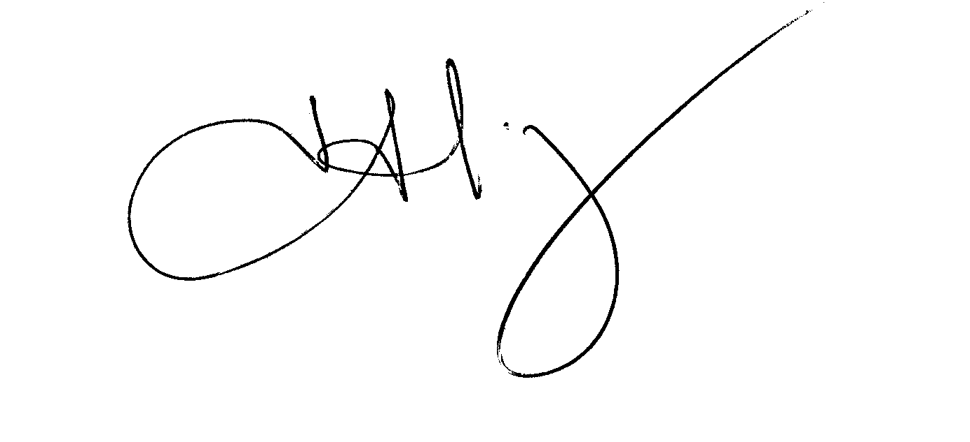Yours in solidarity

John Kranz
Secretary

