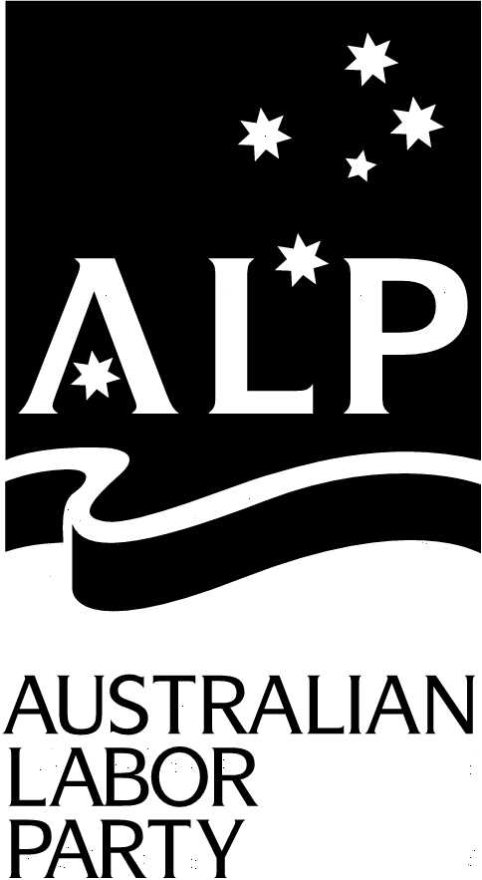Geelong West Branch
Secretary
Chris Couzens
7 Candover Street
GEELONG WEST 3218

16th June 2003

The Secretary
Select Committee on Medicare
Suite S1 30
Parliament House
Canberra ACT 2600

Submission to: Senate Select Committee on Medicare

The Geelong West Branch of the ALP believes in the principle that medical and health services in Australia should be available to all Australians.

A universal health system is the most effective way of ensuring that every Australian has access to health care when required, not only when they can afford it.

We strongly deplore the dramatic decline in bulk billing services, not only in the Geelong area but across the nation.

We strongly object to any attempt to destroy the universality of Medicare through the creation of a two tiered user pay health system where Australians will pay more to see their doctor.

This will only set up a system where those with money will have better access to health care, as opposed to equal access for every Australian.

Medicare should not be a system which has a second class safety net providing bulk billing only to pensioners and concession card holders.

Currently the situation in Geelong is that if the co-payment is paid the patient has immediate access to health care, however if the patients cannot pay the co-payment they cannot access the same health care or they are forced to wait in a queue until all those who have paid the co-payment have been seen.

Due to the introduction of the co-payment we already see families unable to access health care because they simply do not have the money to pay for the co-payment.

The Australian community strongly supports Medicare which has been one of the best health care systems in the world.

The Geelong West Branch of the ALP supports measures to restore bulk billing as a central pillar of Medicare and to adequately fund our public hospital system.

We do not support the $2.5 billion in subsidies to the private health insurance system via the 30% rebate, in fact we believe it to be scandalous. These funds would be better directed into Medicare ensuring the best possible health care system for all Australians, not just those who can afford to pay.

Medicare is not free. It is paid for by all working Australians through the tax system via the Medicare levy.

The Geelong West Branch of the ALP strongly supports an equitable health care system for all Australians.

We would welcome the opportunity to participate in the public hearings to give evidence to the Committee. We would also request that serious consideration be given to conducting a public hearing in Geelong.

Yours sincerely

Chris Couzens
Secretary

