JOHN STAFFORD
3/15 Deviney Street
Morningside
Queensland 4170

12 June 2003

The Secretary
Select Committee on Medicare
Suite S1 30
Parliament House
Canberra
ACT 2600

SUBMISSION TO THE SELECT COMMITTEE ON MEDICARE

General Practice in the area of outer North Brisbane is in considerable strife. Over recent years the number of general practitioners (GPs) has decreased (and this trend is expected to increase as more GPs retire) while the population growth is among the fastest growing in Queensland. Recent population projections have a population of 255,000 at one area on the fringes of our district expanding to 344,000 by 2016. There appears to be little prospect of attracting new GPs to the area to meet this considerable extra demand. I believe this pattern is replicated in man rural, remote and increasingly in outer metropolitan areas and constitutes an unfolding crisis. The key issue is rapidly changing from “How much will my doctor cost” to “Where can I find a doctor?” One GP in my district has a waiting time for a routine appointment of about three weeks which is clearly far too long.

Among the responses to this growing problem have been that practices are closing their books to new patients, are ceasing bulk billing, and/or working longer hours. Obviously these responses are all unsustainable in the long term if adopted by large numbers of GPs. GPs cannot continue to work unhealthy hours, new patients will have no practices to go to, and there will be no bulk billing practices that many, especially those with lower incomes or high health needs, seek. GPs I have spoken to claim that the best decision they have ever made was the one to charge patients a co-payment– it both reduces workload (and stress) and increases their incomes.

The outcome of the above responses will be that patients defer seeking treatment until their conditions are more serious (and probably more expensive) and increasing numbers of patients presenting at hospital Emergency Departments. There is certainly evidence for the latter in my district. This is unsafe on both health and financial grounds. The country needs fit healthy people to drive the economy. Australia needs an effective well- resourced primary health care sector to reduce costs and increase health.

The incentives created by Medicare MBS benefits are working against producing good health outcomes in Australia.

In particular longer consultations earn general practitioners (GPs) less than several shorter ones. A GP can maximize his/her income by having many short consultations - the “six minute medicine” scenario. Anecdotal evidence is that this leads to some GPs booking two appointments for any condition, to having patients make a follow-up visit to get their diagnostic test results (even if there is no critical outcome from the tests), and to having patients visit for routine repeat prescriptions to increase their revenue. It can also lead to doctors taking “quick fix” options such as prescribing drugs for mental health conditions rather than counseling, and to prescribing drugs for weight reduction rather than improving diet and increasing physical activity.

The administrative/compliance costs of the Enhanced Primary Care (EPC) and Practice Incentive Payments (PIP) are so high that some doctors have decided against claiming these incentives because the costs and bother of doing so isn’t worth the effort. HIC auditing has found that claims are almost universally completed poorly – this is as likely to be administrative failure as suboptimal medical care. Medicare claims should be simple to claim and be as a by-product of good medical practice. There should be increasing use of electronic transmissions of claims so that GP time is spent on their core skills of diagnosis and prescribing - not on form-filling. It is intriguing that the response to the review of red tape for GPs has lead to financial reimbursement rather than reducing the amount of paperwork.

A quick glance at the MBS schedule, a book of several hundred pages printed quarterly, shows that it is complex and thus highly unlikely that busy GPs would work their way through this regularly to gain the benefits of the various options available.

MBS benefits are not payable to health professionals other than medical practitioners. This means that in a practice GPs cannot delegate counseling to psychologists, nutritional advice to dietitians etc. This means that general practitioners have to do work that others are better trained for and at greater expense. Probably most critically, it takes up time that could be utilized for diagnosing, prescribing and the other skills that GPs are trained for that could be used to treat more patients. Too much GP time is spent in reviews for Centrelink, insurance and work purposes when other members of a primary health team could do the job more effectively.

Similarly work that could be done in group settings, such as diabetes education and stress management, are not funded under MBS. GPs are also not paid for “non-patient” time like clinical review meetings and professional development so these activities, which could lead to better and more efficient care, are given low priority.

The current Medicare benefits relate to a previous era – when medicine offered all the solutions to illness. The current health issues require a different approach to meet the principal health issues relating to lifestyle issues, most notably obesity, poor nutrition, a lack of physical exercise, and stress. If these are not addressed they can lead to more serious and expensive chronic diseases.

In the future I hope payment to doctors and other health professionals will be on the basis of keeping patients well rather than funding them more when they are sick. In New Zealand this operates by the equivalent of Divisions of General Practice paying GPs the expected costs of the equivalent to MBS benefits for defined populations of enrolled patients. This means they can make decisions on the length of appointment, frequency of recall etc to optimize the health benefits of each visit. Practices have a proportion of their revenue withheld pending confirmation of health targets such as 90% immunization levels. These targets ensure good clinical practice is followed.

I also believe there is the potential to reduce the costs of pharmaceuticals by having GPs holding the budgets for pharmaceuticals – they would be funded for the average use of pharmaceuticals for their patient profile and then pay the pharmacist for actual drugs used. This has been shown to reduce costs by 5-10%. It could be expected to produce similar savings in diagnostic testing. The role of the HIC would then become one of policing underservicing rather than the current role of pursuing overservicing.

A large proportion of admissions to hospital are preventable (I have seen figures of up to 40%) on the basis that the determinants of these conditions are obesity, smoking, lack of physical exercise and the like. To address these a new approach to primary health based on changing lifestyles is required. This will require a truly multidisciplinary approach with a marked focus on preventing illness. I have been developing possible models of practice that are currently being reviewed by a Planning and Management Consultant contracted by Queensland Health. This review, which is to be completed by 30 June 2003, is likely to note that the most proactive models cannot be sustained under current funding systems.

In regard to the Government-announced proposals I believe the incentives are too small to stem the flow away from bulk billing and surveys of GPs have confirmed this view. I strongly support the direct payment of co-payments to the GP – the cash flow implications and hassle with going to a Medicare Office for reimbursement of the Medicare benefit are unnecessary and should be avoided. I however suggest that co-payments should reflect lifestyle issues with co-payments being eliminated where patients do not smoke and are within the normal weight range (perhaps with a half-way step for those who are undertaking recognized remedial programs). This would provide incentives for patients to lead healthy lifestyles and would more closely reflect the cost structures of the practice. I believe that if patients can afford to smoke they can afford to pay co-payments for their health care.

SUMMARY
A fundamental change in Medicare benefits towards encouraging wellness (most notably in preventing lifestyle-related conditions) that encourage a truly multidisciplinary approach is required to stem the shortages of GPs, to reduce the numbers of GPs forced to charge co-payments and to develop lifestyles that will ensure that hospital costs do not escalate unnecessarily as the ageing population increases patient morbidity.

Yours faithfully
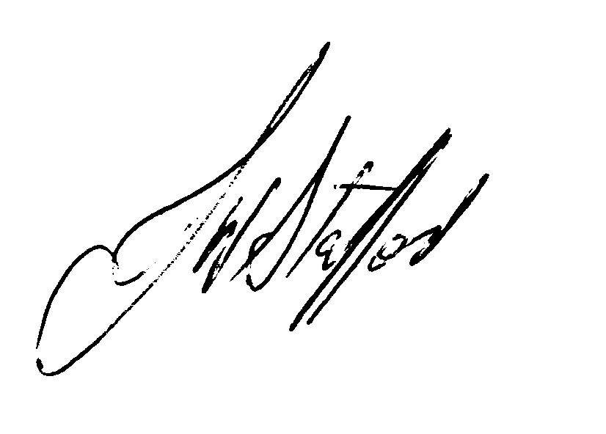
John Stafford

