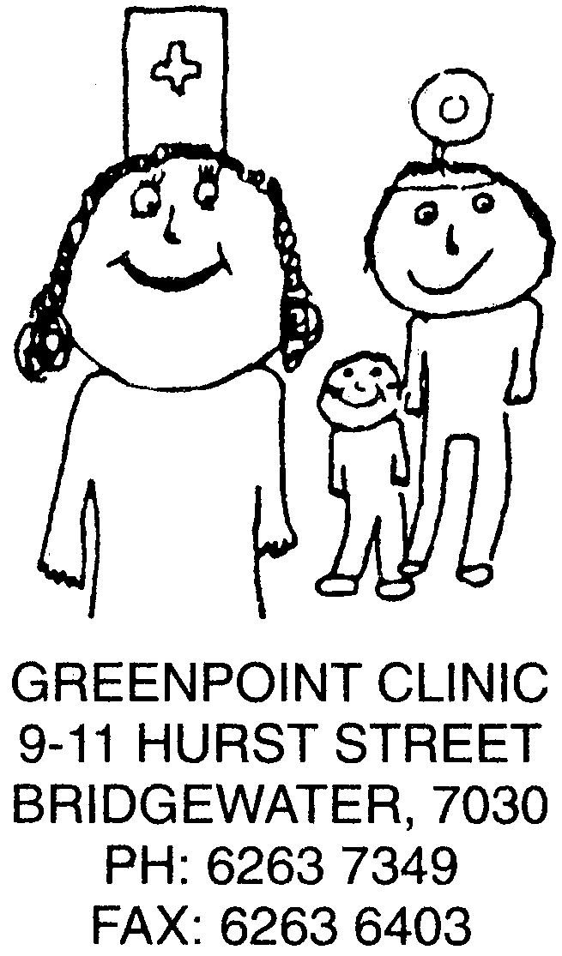

Senator Jan McLucas,
Chairperson,
Senate Select Committee on Medicare

11/6/03

Dear Jan

I would like to take this opportunity to submit some thoughts for the consideration of your committee.

I am the Practice Manager of a 10 doctor practice in a broad-acre housing area in outer Hobart.

We have a patient load of 15,000 patients, with the following demographics:
- 40% < 20 years old,
- 54% < 30 years old,
- 80% are pensioners and health care holders.

The resultant social issues that are incurred by our patients include:
- low income,
- reduced physical, emotional and financial access to resources,
- low expectations for themselves and their children,
- low levels of education,
- 40% of our patients are experiencing unemployment for the 3rd generation.

Greenpoint Medical Services has existed in this community for 26 years and in this time we have always been able to attract young doctors, remunerate them appropriately and provide a quality working environment whilst providing an excellent medical service. We are fully accredited (Australian General Practice Accreditation Limited) and undertake the training of both General Practice Registrars and university medical students

Greenpoint Medical Services has not been a bulkbilling practice for 7 years. At this time the decision was made to cease this method of remuneration, on the grounds that within these income restrictions, it was impossible to continue increase, or in fact maintain the level of care, to which we aspire. During the past 7 years, we have always endeavoured to provide care to those who need it, without confining it to those who can pay. We have a two-tiered system of charges so that those who carry health care cards or are on the pension have only been charged a nominal fee of $2.00. In the past many visits to our surgery have been rebated, and particular consideration has always been given to those families with children, or patients with a chronic illness, both of which result in regular visits to the doctor. The financial outcome for our practice is that 40% of all consultations incur no ‘out of pocket’ expenses to the patient.

During the last 18months we have endeavoured to continue to secure the future of this practice by gradually increasing the ‘gap’ payment to $5.00. In May 2003 we had to make the very difficult decision that this practice could not continue to operate in this manner, as we were beginning to incur a financial loss that was not recoverable. We have increased our pensioner level of ‘gap’ fees to $6.00, and have had to make a decision to reduce our level of rebate consultations to 10%. We are now charging for bandages, a 15% mark-up on vaccines, and $4.00 for repeat prescriptions. In the past all of these services were provided either free of charge or at cost.

The H.I.C. initiatives of practice payments including A.C.I.R., P.I.P. and S.I.P. are of course welcome additions to our income stream. However, they in no way compensate for the failure of the consultation rebate levels of the past, to increase in line with any national measurement of economic growth. Our real income has declined to a level at which we are unable to attract new doctors, continue to remunerate our existing practitioners at the current level, pay our administrative staff at a level that truly reflects their skills and commitment or improve the facilities of our surgery.

The minimum change that would enable us to return to the income levels of 5 years ago, would be an indexed, increase of $5.00 per consultation. In addition to this, the other single most effective way of enabling us to continue to provide quality care, is the introduction of ‘pay doctor’ cheques that are deposited directly into the doctor’s accounts whilst still allowing us to charge a co-payment.

In an area of great need, where we are the only full-time medical resource, we have grave concerns about our ability to continue to meet the needs of our community at a level that maintains to provide quality preventative health care.

We pride ourselves on having achieved:
- an increase in the number of doctors from 5 to 10 over the past 4 years
- a consultation rate of 150 patients per day
- a child immunisation rate of 93.4%,
- 800 cervical smears/annum for the last 3 years
- 180 Health Assessments for our elderly
- the administration of over 700 fluvax/annum.

We can of course decide to change the entire ethos of our practice. Changes to our service could include:
- booking appointments at 8 minute intervals and ‘squeezing’ in emergency patients that arrive at the surgery – this is not quality health care – certainly not what I would want for my family
- reduce any preventative measures, that not only take time in the consultation room, but also require a large commitment of administrative resources – we would consider this to result in short term gains (in costs), but long term losses (in medical and social costs to the community)
- charge a ‘gap’ level that would be financially unsupportable to the majority of our patients - this would impair their ability to be able to source any quality medical care in an area with no other service accessible by foot (many of our patients do not have private transport)

We applaud the Federal and State governments for recognising that we have a health service that is in crisis, and we welcome the establishment of a committee such as yours. Existing measures have certainly been a ‘step in the right direction’ but as costs and standards continue to rise they fall short of addressing the basic issue of appropriate medicare rebate levels.

Thank you for this opportunity to bring these issues to your committee.

Yours truly,

Jane Smith
Practice Manager

