6 March 2001

The Secretary
Senate Finance and Public
Administration References Committee
Parliament House
Canberra ACT 2600

ACCI SUBMISSION TO THE INQUIRY INTO THE GOVERNMENT'S INFORMATION TECHNOLOGY OUTSOURCING INITIATIVE

The Australian Chamber of Commerce and Industry (ACCI) welcomes the opportunity to provide comment to the Senate Finance and Public Administration Reference Committee’s inquiry into IT Outsourcing.

ACCI is the peak council of Australian business associations. ACCI’s members are employer organisations in all States and Territories and all major sectors of Australian industry.

Through our membership, ACCI represents over 350,000 businesses nation-wide, including the top 100 companies, over 55,000 enterprises employing between 20-100 people, and over 280,000 enterprises employing less than 20 people. That makes ACCI the largest and most representative business organisation in Australia.

Membership of the ACCI comprises State and Territory Chambers of Commerce and national employer and industry associations. Each ACCI member is a representative body for small employers or sole traders, as well as medium and large businesses.

Introduction

ACCI believes that government procurement, including outsourcing, is a major market place for Australian business. This is evident by the extent of the IT outsourcing initiative to date. As of January 2001, twenty three departments and agencies have outsourced their IT infrastructure. This represents around half of the agencies in the ‘Whole of Government Information Technology Initiative’ and approximately $1.2 billion in contract value out of a total estimated $4 billion for the entire initiative.

While ACCI agrees in principle with the outsourcing of the supply of goods and services, wherever appropriate, the implementation of purchasing policies at the management and operational level is of critical importance to the success of outsourcing.

The success of current and future outsourcing policy initiatives depends largely on:
- the creation of efficient contracting and purchasing procedures;
- recognition at both policy and implementation level of the strategic value of active purchasing policies in industry development; and
- transparent and user-friendly methods of informing potential suppliers about purchasing practices and opportunities.

Our specific comments against two of the Committee’s terms of reference are as follows:

- The accountable management of IT contract, including improved transparency and accountability of tender processes.

ACCI advocates that value for money and maximum efficiency and effectiveness remain integral to the Commonwealth Government’s IT outsourcing decisions.

The main finding of the ‘The Independent Review of the Government’s Information Technology Outsourcing Initiative’ was that responsibility for implementation of IT outsourcing be devolved to Commonwealth agencies. Thus agency heads will now be directly accountable for implementing the ‘IT Outsourcing Initiative’ (the initiative).

ACCI expects that the devolution of accountability and transparency of the IT contract tender process to the agency head level should not compromise the ability to have value for money and open and effective competition, as paramount in the outsourcing of Government IT.

ACCI is supportive of the Government’s decision to include the implementation of the initiative in the performance assessment of agency heads. This assessment should improve the accountability of management of Government IT contracts. ACCI also encourages the Government to report on how agencies have implemented the initiative in the Public Service Commissioner’s ‘State of the Service Report’.

Improved accountability of Government IT contracts should also include measurement of the extent to which Australia’s SME sector has been contracted as part of the initiative. This does not only mean an assessment of the involvement proposed in the winning bid, but also an accurate assessment of how much of the outsourcing contract was undertaken by SMEs.

- The means by which opportunities for the domestic IT industry, including in regional areas, can be maximised.

In its response to recommendation one of ‘The Independent Review of the Government’s Information Technology Outsourcing Initiative’, the Government decided to keep the industry development component of the initiative with the Department of Communications, IT and the Arts (DCITA).

ACCI supports industry development criteria remaining integral to the Commonwealth Government’s IT outsourcing decisions so that opportunities for Australia’s domestic IT industry can be maximised. ACCI also advocates that a whole of Government approach to achieving industry development criteria is needed. This will be even more important now that there is a split of responsibility for the initiative between agencies and the DCITA.

ACCI welcomed the findings of the ‘IT Outsourcing Initiative 1999-2000: industry development progress report’ that stated 75% of the goods and services under the initiative are being produced in Australia, and that 30% of the work of the initiative is going to the Australian SME sector.

The Minister for Communication IT and the Arts gave a commitment to enter into consultations with industry and agencies on the implementation of the industry development criteria of the initiative on 12 January 2001. ACCI would like to ensure that there are appropriate outcomes to these consultations, that is, the views of industry are considered and reflected in the Government’s industry development criteria.

Conclusion

ACCI believes that the decentralisation of IT outsourcing to the agency level does not diminish the importance of achieving:

- value for money; accountability and reporting, and
- ethics and fair dealing in the outsourcing of Government IT; and
- a recognition of the importance of industry development in outsourcing decisions.

ACCI seeks the approval of the Committee to publish our submission on the ACCI website. We would also welcome the opportunity to meet with the Committee to elaborate on any aspect of our submission. My telephone number is 6270 8006.

Yours sincerely

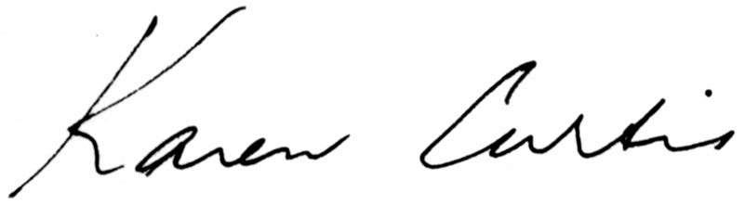

Karen Curtis
Director, Industry Policy

