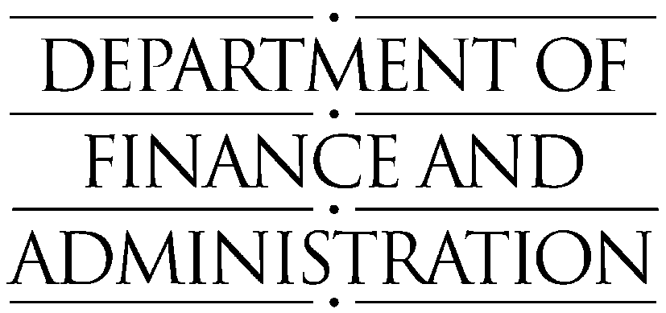
Reference:  Contact:  Telephone:  e-mail: | Michael Whitfield  02 6215 3627  michael.whitfield@dofa.gov.au

Ms Helen Donaldson
Secretary
Senate Finance and Public Administration References Committee
Parliament House (SG60)
CANBERRA ACT 2600

Dear Ms Donaldson

Inquiry into Australian Public Service Employment Matters - Public Hearing 23 June 2000 Update
I refer to your email dated 10 October 2000 to Mike Whitfield, of Corporate Group Department of Finance and Administration (DOFA) regarding an update on two issues raised at the 23rd of June 2000 public hearing on the Inquiry into Australian Public Service Employment Matters. The two issues in question were an update on the meeting with the CPSU which occurred after the hearing date, and an update on the development of an information kit on different options used by and available to DOFA staff in their AWAs.

CPSU Meeting

A meeting was held with the CPSU on 29 June 2000 with representatives from Corporate Group to discuss the Certified Agreement (CA) and the CPSU’s log of claims. At that meeting the CPSU sought a yes/no answer on whether DOFA wanted to negotiate a new CA. DOFA representatives sought further information from the CPSU as to why they, or their members, thought the current CA was no longer appropriate, as issues raised may be of an individual nature and more appropriately resolved at the individual level.

The CPSU agreed that they would go back to their members for more detail and would also reassess their log of claims. To date, DOFA has heard nothing further.

Flexible Conditions Information Kit

As part of an overall upgrading of the DOFA employee relations information system and to publicize the flexibility that DOFA’s CA and AWAs provide, an Information Kit on flexible working options and conditions is being developed. This information kit is now at the draft stage and when finalised will be included in the upgraded DOFA intraweb site with access available to all DOFA employees.

The information kit will provide details of the types of conditions available to employees under the CA and AWAs and will provide actual examples of the types of flexible working conditions employees have included in their AWAs. The intranet site will include links to other information sites such as the OEA web site. This will enhance the access DOFA employees have to information they may wish to consider developing an individual AWA or conditions package.

Please contact Mike Whitfield on (02) 62153627 if you require any further information on these issues.

Yours sincerely

Jenny Morawska-Ahearn
General Manager
Corporate
24 October 2000

