Submission by

The Papua New Guinea Eco-Forestry Forum

to the

Australian Senate Foreign Affairs,
Defence and Trade References Committee

Inquiry into Australia’s relationship with
Papua New Guinea and other Pacific island countries

Submitted by: Jaru Bisa

National Coordinator

PNG Eco-Forestry Forum
P.O. Box 3217

Boroko, NCD

On behalf of: The PNG Eco-Forestry Forum and its Member organisations

Approved by: The Board of Directors and Members

Date: 30th June 2002

Summary

The serious negative impact of the logging industry on good governance in Papua New Guinea must be seriously addressed if any positive benefits are to be seen from financial aid and other development assistance from overseas.

Despite massive foreign support to Papua New Guinea since independence in 1975, social, economic, environmental and political indicators all show that PNG is in a perilous situation. PNG has, for example, a Human Development Index rating that puts it in 127th place compared to neighbouring Pacific countries Vanuatu and Fiji who both rank in the top 50.

Despite a massive wealth in natural resources and a large presence from multinational companies in the mining, petroleum, forestry and agriculture sectors, PNG has rising infant mortality rates and declining life expectancy in many areas.

In PNG the quality of health and education services is falling, access to the most basic services is minimal for the largely rural population, HIV/Aids infection rates are spiralling and the institutions of Government are grinding to a halt.

In these circumstance, it is very difficult for the ordinary people of PNG to understand what benefits they are receiving as a result of foreign support to the Government that includes a US$90 million Governance Promotion Adjustment Loan in 2000/01 and more than Aus$ 340 million a year in aid assistance from the Australian people.

The root cause of this problem is corruption, which the Prime Minister has recently described as both systematic and systemic. This corruption has a major and negative impact on good governance and the distribution of essential social and infrastructure services to the mainly rural population.

There is overwhelming evidence that the foreign owned logging industry in PNG is a major contributor to corruption at the highest Government levels and throughout the bureaucracy.

This is in addition to the massive negative environmental and social impacts of the logging industry at the rural level. These impacts also carry important negative economic consequences and contribute directly to rural poverty and undermine good governance.

Unless the corruption is stopped and the logging industry brought into line, then Australia’s aid dollars and international development assistance will not arrest the social and economic decline of Papua New Guinea.

As a result it will be the rural population who will continue to suffer at the expense of foreign multinational logging companies and corrupt politicians and public servants.

Australian development assistance

The Australian Government currently gives over Aus$ 340 million in cash, donor support and other aid assistance to Papua New Guinea every year. The primary focus of this assistance is on governance, primary health care, primary education, gender equity, disaster response capacity and infrastructure development.

In the forestry sector there have been large investments by Australia in support of improvements in the management of the logging industry. This has included the Independent Forestry Review process, the Human Resource Development Programme, the National Forestry and Conservation Project and funding for the University of Technology Forestry Department and the Timber and Forestry Training College amongst other initiatives.

Unfortunately, none of this support has seen any improvement in the quality of forest management or any reduction in the level of corruption. The evidence is that the situation today is no better than that described by Justice Barnett in 1989 when he talked of the logging companies roaming the countryside like ‘robber barons’.

While the Eco-Forestry Forum and its Members would like to take this opportunity to offer their sincere and grateful thanks to the people and Government of Australia for their unbending support for the development of Papua New Guinea, and while we would also like to humbly request that such support should continue, we urge that future support be better directed and more fully accounted for and that it should be linked to strong and positive measures on corruption and to combat the polluting impact of the logging industry.

The export logging industry

Forest management in PNG is almost exclusively orientated to log extraction and export. The logging industry in Papua New Guinea is dominated by Malaysian multinational companies, three or four of whom control over 90% of all log exports.

The two largest companies by export volume and value now appear to be involved in a political dogfight to gain unlawful access to the last remaining large tracts of unallocated forest.

Declared log export volumes are currently around 1.5 million cubic metres per annum, with a declared value of US$90 million. This reflects the declining importance of the logging industry to the PNG economy, with mining, petroleum and agriculture exports all dwarfing the contribution of log exports. The primary markets for PNG logs are China, Japan and Korea, although there is an increasing trade in sawn timber to the Australian market.

The logging industry has well-documented and severe negative impacts on the environment and on the quality of life for rural people. They have to suffer the destruction of their food sources, the loss of traditional building materials and medicines, the pollution of water sources and increased social problems such as prostitution and drunkenness.

Evidence of the link between logging and corruption

Barnett Inquiry:

In 1988/89 Justice Barnett led the seminal ‘Commission of Inquiry into Aspects of the Timber Industry’, prompted by widespread corruption and scandal arising from the industry.

After two years of close study, Barnett produced a definitive report documenting “pervasive forest crime” and describing some of the logging companies as

“roaming the countryside with the assurance of robber barons”

In 1995, Jerry Nalau, the Labour and Employment Minister, in his resignation speech said,

“Logging companies are the worst offenders for corruption. Some of the managing directors of these companies have a direct line to our national leaders, while I as a senior Minister had problems reaching them.”

In November 2000, the Prime Minister Sir Mekere Morauta admitted that the problems still existed,

“Governance has been particularly poor in the area of forestry, with the side effect of promoting corrupt practices and undermining environmental sustainability.”

In March 2002, one former Forest Minister publicly admitted receiving the offer of a K3 million (Aus$1.5 million) bribe from a foreign logging company.

Kamula Dosa.

The Ombudsman Commission has investigated unlawful attempts by the National Forest Board to grant the huge Kamula Dosa logging concession to Malaysian owned Rimbunan Hijau, PNGs largest logging company.

The Board tried to grant permission for logging through an ‘extension’ to a much smaller logging permit. This was an unlawful attempt to prevent a public tendering process and to short cut and avoid a number of other important procedural steps. The Forest Authority and the local resource owners vigorously opposed the Board’s action.

The Ombudsman Commission stepped in to stop the allocation. But although the Commission completed its preliminary investigation in November 2000, and a final report in June 2001, the findings have never been published and no action has ever been taken against any of the culpable individuals or organisations.

A preliminary Commission report, which is ‘private and confidential’ (and which we cannot publish or reproduce as it is protected by the criminal law from unauthorised disclosure) may well have suggested that many of the parties involved had ‘acted wrongly’ in unlawfully favouring a particular logging company.

Illegal logging at Kiunga Aiambak and Wawoi Guavi.

Two of the most recent examples of illegal logging and corruption involve the two largest log export companies in PNG.

The unlawful Concord Pacific operation at Kiunga Aiambak provides 10% of PNGs total log export volume while the unlawful operation in Wawoi Guavi contributes 6% of total log exports.

The Kiunga Aiambak operation was illegally initiated in 1995 and it has since been given a succession of illegal extensions and unlawful tax concessions.

The same logging company has recently been given another new illegal permit to log a 6 kilometre wide, 830-kilometre long corridor through 8 unallocated logging concession areas covering 2.7 million hectares.

The permit allowing logging in Wawoi Guavi was initially granted in 1982. It was unlawfully extended by 10 years in February 2002. The unlawful extension was given by the Minister on the advice of his Managing Director but was against the express wishes of the landowners and the advice of the Provincial Forest Management Committee and the Forest Authority.

The Australian Government is a frequent and generous financial supporter of the Forest Authority and the Department of Environment and Conservation, the two bodies that are supposed to be at the forefront of controlling the logging industry. Unfortunately, there still seems to be no control being exercised.

The political web of support for logging companies.

Logging companies are continually being shown to operate above and beyond the law with sometimes daily revelations in the media of illegal logging, landowner intimidation, and other unlawful practices.

Senior Ministers are guilty of frequently assisting these companies by using political interference in due administrative processes.

In the case of Concord Pacific, a recent study has meticulously detailed with full supporting documentation the wide political network that includes at least 16 senior ministers, politicians and civil servants.

This political network has ensured that this company has been able to operate illegally for seven years and it continues to protect the company and its senior executive from any effective legal action.

Gulf Province.

A high level Government institution conducted two investigations into the logging industry in Gulf Province in 2000. These investigations found credible evidence of widespread political bribery and corruption by logging companies.

One report concludes that,

“Law and order is slowly breaking down as a result of government mistakes to properly address landowner concerns in dealing with timber companies” and “The State, through certain politicians and corrupt agents of (named logging company) have caused these problems.”

The second report concludes,

“(Named logging company) through it’s wheeling and dealing basically now controls people in (named town). People are basically doing nothing. Political manipulation and free handouts from (named logging company) now rendered people corrupt and lazy“. This report recommends “Fraud squad to immediately investigate the allegations of bribery, nepotism, fraud and threats to lives”.

It seems that no further action has been taken on these reports by the appropriate authorities.

The Australian Government is a frequent and generous financial supporter of initiatives including support for the Ombudsman Commission, police force and the court system, yet political interference in due processes and corruption are seen to be increasing with little or no effective control.

Employment data:

Recently released employment data shows that 90% of the insured workforce of (named logging company) are Malaysian, Indonesian, Chinese or Filipino. These staff are employed across 17 different subsidiary companies and total over 400 in number.

The vast majority work in positions reserved by law for native Papua New Guineans, such as cooks, tractor drivers and sawmill operators. This data is indicative of either a massive immigration scam involving politicians and senior bureaucrats or an illegal people smuggling operation.

The Government of Papua New Guinea recently ordered a high level investigation in to widespread allegations of a passport and immigration scam. The final report was handed to the Prime Minister in March 2002 but its contents have never been revealed and the report remains unpublished.

The Australian Government is a frequent and generous financial supporter of the Forestry Department at the University of Technology and of the Timber and Forestry Training College, institutions that are training young people for jobs that do not exist because of illegal employment practices in the logging industry.

Police brutality on behalf of logging companies:

There are many well-documented instances of policemen and mobile police squads acting as private enforcement agencies for logging companies and committing gross breaches of basic human rights.

This is an extract from one high level Government institution report;

“Three heavily armed policemen were seen at (named logging company) headquarters today at 10.30am. I was informed that they were returning from (named) timber operations area after raiding villages, two houses were burnt down, many personal properties including domestic animals damaged and killed. A person by the name of Peter is in a critical condition with hands and legs broken by the police in the raid. The raid was instigated by (named logging company)”.

The Australian Government is a frequent and generous financial supporter of the PNG Constabulary whose officers are guilty of these crimes and human rights abuses that are never investigated and which go unpunished

Solutions

It will not be easy to find effective solutions to these problems and we cannot offer any easy answers.

But until these issues are addressed and effective solutions found and implemented there is a grave danger that donor assistance will not break the evident decline in economic wealth and social standards in PNG.

Continued aid and donor assistance must be linked to effective processes and mechanism that will robustly tackle the negative impacts of the logging industry on good governance and the environment.

A critical first stage will be for the Australian Government and its international partners to recognise the scale and intensity of the problems created by the logging industry in PNG and to sit down with key stakeholders to openly discuss the issue and vigorously examine the possibilities for positive and radical change.

In initiating this dialogue some critical points must be acknowledged and dealt with:

- That until governance problems are brought under control, aid assistance will continue to be very limited in its impact on the quality of life for ordinary Papua New Guineans

- The problems that Papua New Guinea is facing are largely not of its own making. The corruption is being driven by foreign multinational logging companies

- Papua New Guinea is still only an emergent democratic nation and there is a massive imbalance in power where senior politicians have to deal with unscrupulous multinational logging companies

- Papua New Guinea has a long and honourable history founded on principles of social, economic and political relationships that are very different from those that it is now being obliged to embrace from outside.

- Any effective solutions will have to recognise and work with

- both the strengths and weaknesses of traditional values in Papua New Guinean society and politics

- the conflict between traditional values and western concepts

- Any solution is not just going to be about good laws and an independent judiciary, the 12 years since the Barnett Inquiry into the logging industry show how such an approach, in isolation, will not be effective

- There are strong and clearly established linkages between poor environmental management and governance and increasing rural poverty

In the short term, we urge the Australian government to immediately ban the import of illegally harvested timber from Papua New Guinea and to ensure that all aid projects within PNG do not purchase any illegally harvested timber.

We also urge the Australian Government to vigorously pursue with the Papua New Guinea Government a renewal of the moratorium on any new logging concession allocations and a ban on log exports

We hope that the Australian Government will also ensure

- that there is full narrative reporting and financial accounting for all aid or donor assistance received by government departments and public bodies similar to that which is already required from civil society organisations

- that the recommendations of the Australian funded Independent Forestry Review are fully implemented by the Government of PNG and in particular that the illegal Kiunga Aiambak project and its new extensions are shut down

- that the final Ombudsman Commission report into the Kamula Dosa scandal is published.

- that the ‘immigration scam’ report that was completed in March 2002 is published

- that a process is started to develop with the PNG Government and other stakeholders a financial incentive package that would allow the complete closure of all industrial logging in favour of local, sustainable development

- that all financial assistance to the police force is dependent on a full and independent inquiry into the many allegations and reported instances of police officers being used by logging companies as their private enforcement agencies and committing gross abuses of human rights.

Signed, for and on behalf of the Board of Directors and Members of the PNG Eco-Forestry Forum

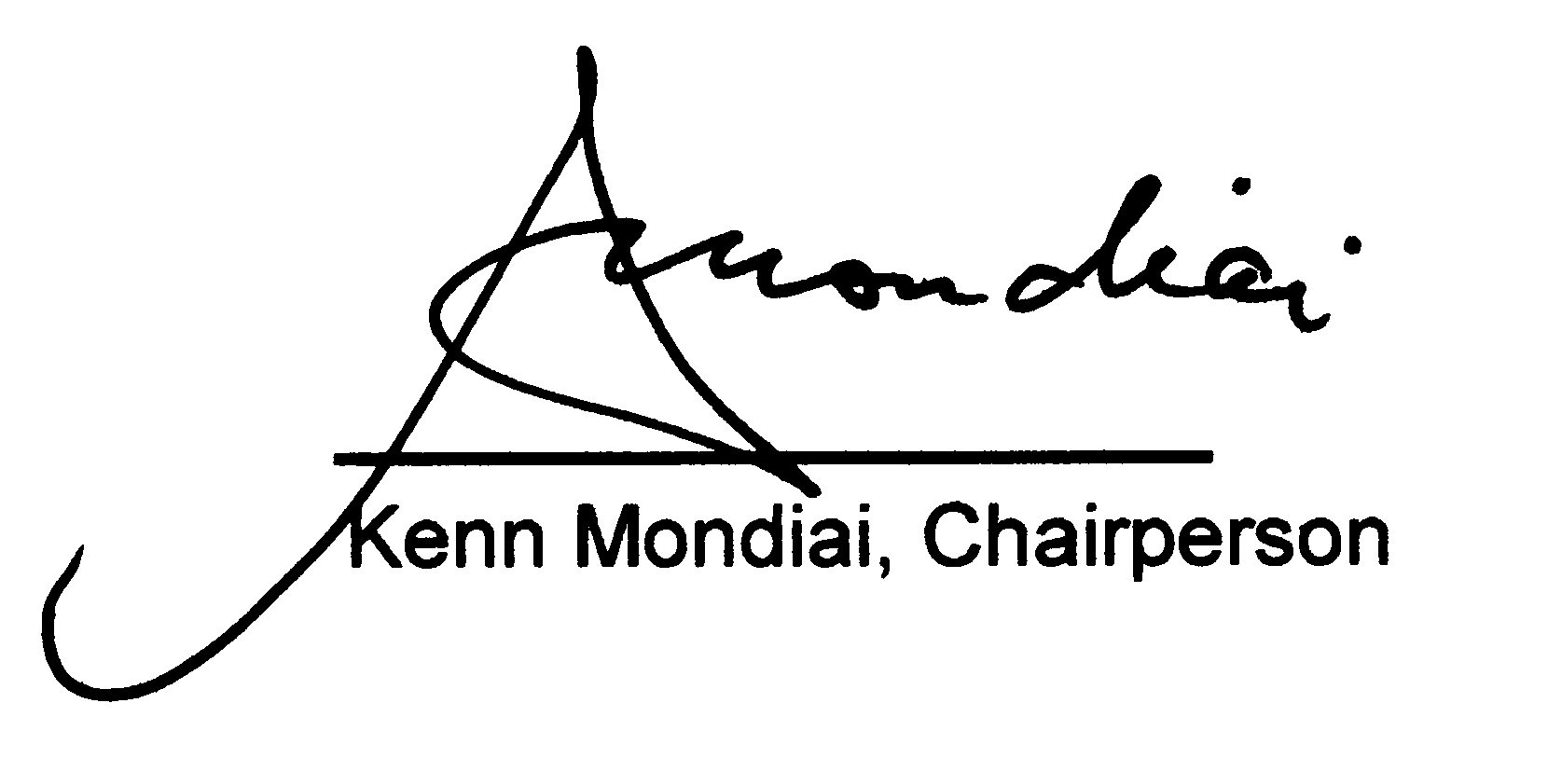

Note:

The Papua New Guinea Eco-Forestry Forum is an umbrella organisation for all those in PNG who support the goal of socially and environmentally sustainable forest management.
The Forum works with 20 member and partner organisations in PNG including local, national and international NGOs. The Forum is legally registered and governed by its members through a written constitution.
The Forum works primarily in the areas of forest policy, publicity and awareness and organisational development support.

Appendix 1
Appendix 2
Appendix 3
Appendix 4
Appendix 4
,
Appendix 5
Appendix 6
Appendix 7
Appendix 8
Appendix 9
Appendix 10
Appendix 11
Appendix 12
See for example Appendix 13
Appendix 14
Appendix 15

