Appendix 4

Regional map of Oceania in the Pacific Ocean

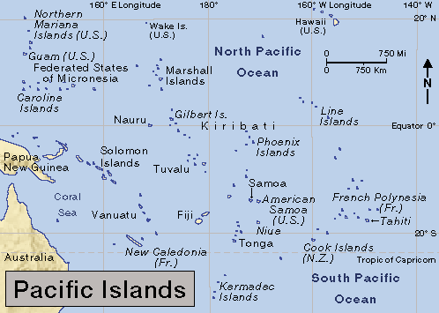
Map courtesy of World Book Inc. website:
http://www.worldbookonline.com/jsp/wbPopup.jsp?/in/mp/cp/mp000669.htm

