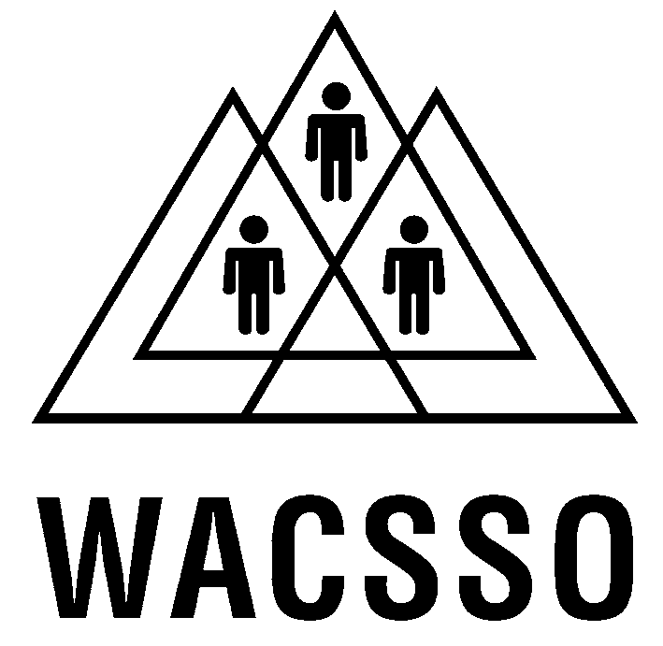

Western Australian Council of State School Organisations

Submission to the Senate Foreign Affairs, Defence and Trade Committee

Inquiry into the General Agreement on Trade in Services

and Australia/US Free Trade Agreement

Presented by: Shelley Norrish
PRESIDENT

Prepared by: Karen Vincent
POLICY & RESEARCH OFFICER

18 March 2003
Background and Rationale for Submission

The Western Australian Council of State School Organisations Inc. (WACSSO) was founded in 1921 as the representative voice of parents, citizens and students associated with government schools in Western Australia. WACSSO is a non-party political and non-sectarian body. There are currently 779 government schools throughout the State with 703 active P&Cs. 638 P&Cs representing 670 government schools, are affiliated with WACSSO. WACSSO is therefore well placed to offer comments, feedback and suggestions for future developments relating to public education and training matters.

WACSSO has a mandate to influence the direction of education for the benefit of all students. Underpinning the workings of WACSSO are values and beliefs about children and young people and the importance of education. The following statements indicate the philosophical basis for this WACSSO submission and reflect our commitment based on informed appreciation and understanding about the place of public education for the future of all Australians.

WACSSO is committed to a public education system available to all young people irrespective of their age, socio-economic status, culture, gender, level of ability or where they live.

The philosophy underlying WACSSO policy centres around the principles of equality, excellence, and participatory democracy and recognises that all human beings depend on each other and so the future well-being of individuals is dependent on the future well-being of all.

Equality is dependent on such premises as: recognition that all children have a capacity to learn; learning is the construction of meaning from experience; school practices must acknowledge and build on the culture and experiences children bring to school; and children have a right to develop their skills, knowledge and aptitudes in challenging but personally successful and fulfilling ways.

The principle of excellence implies that the public school system must provide for all students the highest quality education, which will enable them to learn how to learn throughout their lives and to apply that knowledge for the benefit both of themselves and of others.

Public education must be geared to develop among all students, a sense of justice as well as respect and concern for others.

The principles of participatory democracy hold that the provision of an education system must address the needs of all. This is most likely to be achieved when those involved in the system, students, parents, and teachers, are enabled and empowered to be partners, through representation in all decision-making processes of the system

Accordingly, all persons attending government schools have the right to an unrestricted and effective education of the highest quality to allow them to develop their full potential as individuals. As empowered citizens, these students can take every advantage of social, political, and economic opportunity; obtain fulfillment of their reasonable aspirations within the range of their abilities; contribute their skills and knowledge for the betterment of Australia; and be able to participate harmoniously in all aspects of society.

WACSSO believes that these tenets form an essential statement of principles for guidance in its practical activities toward achieving an excellent, empowering, public education system for all.

WACSSO knowledge and information pertinent to government schools and community development approaches in public education are relevant to the inquiry’s terms of reference. The focus of the WACSSO submission on GATS and FTA will be on the impacts to public education in particular, because WACSSO believes schools to be the heart and soul of a local community and the most important government investment in the future of the country. Any and all, negotiations by governments that affect the nature and wellbeing of our schools is of concern to WACSSO.

General Agreement on Trade in Services (GATS)

1. The relevant issues:
(a) the economic, regional, social, cultural, environmental and policy impact of services trade liberalisation

WACSSO is concerned about negative consequences of proposed services trade liberalisation on the wellbeing of Western Australians, including economic, regional, social, cultural, environmental and policy impacts.

WACSSO believes the public education system would be severely at risk under the General Agreement on Trade in Services (GATS) national treatment rule.

Private schools in Australia already receive significant funding and assistance from all levels of government, with little or no accountability for current subsidies, grants, and a range of indirect support especially low or no interest loans. Market competitiveness in the public/private domains of education would create even more divisions and dissension than currently exists. The resources of huge multinational interests should not be encouraged to think that the Australian public is prepared to further fund private education in such a way that results in private profiteering. Social and cultural divisiveness could be the result of intensified and global competitive tendering in public services.

WACSSO does not agree that the Federal Government should pursue agreements with foreign countries that could harm Australian interests - especially the interests of children and young people. Competitive neutrality should not be constructed between government funded public services like education and private companies operating in a free market place.

1(b) Australia’s goals and strategy for the negotiations, including the formulation of and response to requests, the transparency of the process and government accountability

WACSSO suspects cynical motives behind the current Federal Government goals and strategies as demonstrated to date in negotiations. The process has not been open to public scrutiny, debate and review. Government accountability is suspect given the performance during 1998 negotiations for the (related) Multilateral Agreement on Investment (MAI). The lack of transparency to date fuels criticism and suspicion.

WACSSO is of the view that the Government should make public its’ position on possible privatisation and competitive tendering of government services.

1(c) the GATS negotiations in the context of the ‘development’ objectives of the Doha Round

So-called ‘development’ objectives of the Doha Round of the World Trade Organisation (WTO) have not been convincingly communicated to the Australian people.

WACSSO does not believe that Australia’s best interests will be served by sacrificing essential services, policies and programs ‘on the ground’ during GAT negotiations for supposed greater gain from the WTO.

1(d) the impact of the GATS on the provision of, and access to, public services provided by government, such as health, education and water

The provision of, and access to, public services provided by the Government should not be subjected to GAT negotiations. WACSSO is particularly anxious that public education is protected from the vagaries of the international market place.

Education and training does not stand in isolation. The portfolio interacts and is affected by the totality of government roles and responsibilities. A whole of government approach to education is necessary and therefore the GATS cannot be successfully applied to a narrow range of services whether public or private. Historical mistakes in public policy and planning have seen negative global trends manifested in Australia for example, when governments have not been proactive and creative in recognising interrelations between economic and social development, rural and urban demographics, agriculture and public health, schooling and innovation.

WACSSO is aware of international experience of privatisation and competition in education and urges the Federal Government to resist false temptations to follow trends especially the model promoted by the United State of America. Competition as a basis for public education in Australia is antithetic.

Public education cannot deliver the social purpose of social cohesion if privatisation, competition and market rules prevail.

1(e) the impact of the GATS on the ability of all levels of government to regulate services and own public assets

All levels of government in Australia must retain complementary roles, responsibilities and obligations with regards public services, especially where the care and development of children is concerned.

Regulatory bodies are currently hard pressed to ensure government accountability, and ensure qualifications, standards and licensing requirements are met, let alone oversee and monitor the service standards and impacts of external bodies.

WACSSO is alarmed at the prospect of WA public schools in the future being staffed by teachers with qualifications earned overseas in partner countries that claim equivalence but at the lowest end of the continuum for education and training.

A future in which multinational companies design, deliver, manage and own Australian public assets and services pertaining to education is rejected by WACSSO. The risks associated with losing control of public education and schooling are too great.

2. Australia/US Free Trade Agreement
The issues including:

2(a) the economic, regional, social, cultural, environmental and policy impact of such an agreement

WACSSO is concerned that negotiations between the Federal Government and the United States of America (USA) about an Australia/US Free Trade Agreement (FTA) could include education as a marketable commodity.

The impact of a FTA would be predictably to the benefit of the stronger partner and “least trade restrictive” conditions would result in deterioration to Australian public services especially health, welfare and education, to standards acceptable in the USA. WACSSO strongly urges the Federal Government not to ‘trade off’ education, regardless of short-term benefits to other products such as agricultural crops.

WACSSO is aware that vital funding to education could be reduced in the forthcoming national budget due to the preoccupation with war preparations and demands for resources to ‘fight terrorism’. The apparent disregard for education as highest priority in the land undermines the confidence that WACSSO would like to feel about government commitment to children and education as the primary means to create and nurture and develop Australia according to our national goals.

The preparedness of Australian political leadership to endorse wholeheartedly US perspectives on global issues does not augur well for negotiations for an Australian/US Free Trade Agreement.

Education should not be ‘caught up’ in these political games.

2(b) Australia’s goals and strategy for negotiations including the formulation of our mandate, the transparency of the process and government accountability

Should trade laws take precedence over considerations of public good then Australia’s excellent international reputation and standing in public services could be reduced or lost altogether. The Federal Government cannot engage in any negotiation process about public education - too much is at stake. WACSSO believes that the ‘formulation of our mandate’ is non-negotiable with education.

The Federal Government does not have a public mandate to bargain with education, regardless of how much pressure is brought to bear from overseas interests to open up the potentially lucrative Australian education system.

Already the consequences of competition, privatisation and ‘small government’ are visible in education particularly at the tertiary level. However, there are many schools including primary and secondary public schools, across Australia which are keen to sell their wares to high fee-paying foreign students. More and unrestrained selling of educational services, programs and materials, will be difficult to harness, assess and unwind if, or rather when, the wider community becomes conscious of the impacts and costs in real and indirect ways.

Who will accept responsibility and blame for negative impacts? WACSSO believes that our students are most likely the ones to suffer as their schooling becomes contested.

2(c) the impact on the Doha Development Round

The connection between the WTO and a FTA with the USA is unclear to the Australian public. Therefore WACSSO believes an open process should be instituted so that the progress of negotiations are clearly communicated and debated. Parliamentary decision-making is preferable to secretive Federal Government and Cabinet processes.
Senate Foreign Affairs, Defence and Trade Committee

General Agreement on Trade in Services and Australia/US Free Trade Agreement

Terms of reference
1. The relevant issues involved in the negotiation of the General Agreement on Trade in Services (GATS) in the Doha Development Round of the World Trade Organisation, including but not limited to:

(a) the economic, regional, social, cultural, environmental and policy impact of services trade liberalisation
(b) Australia’s goals and strategy for the negotiations, including the formulation of and response to requests, the transparency of the process and government accountability
© the GATS negotiations in the context of the ‘development’ objectives of the Doha Round
(d) the impact of the GATS on the provision of, and access to, public services provided by government, such as health, education and water
(e) the impact of the GATS on the ability of all levels of government to regulate services and own public assets.

2. The issues for Australia in the negotiation of a Free Trade Agreement with the United States of America including but not limited to:

(a) the economic, regional, social, cultural, environmental and policy impact of such an agreement
(b) Australia’s goals and strategy for negotiations including the formulation of our mandate, the transparency of the process and government accountability
(c) the impact of the Doha Development Round.

