Doc. No.: | 110602
Revision: | Final Draft
Date: | 1-Apr-2004
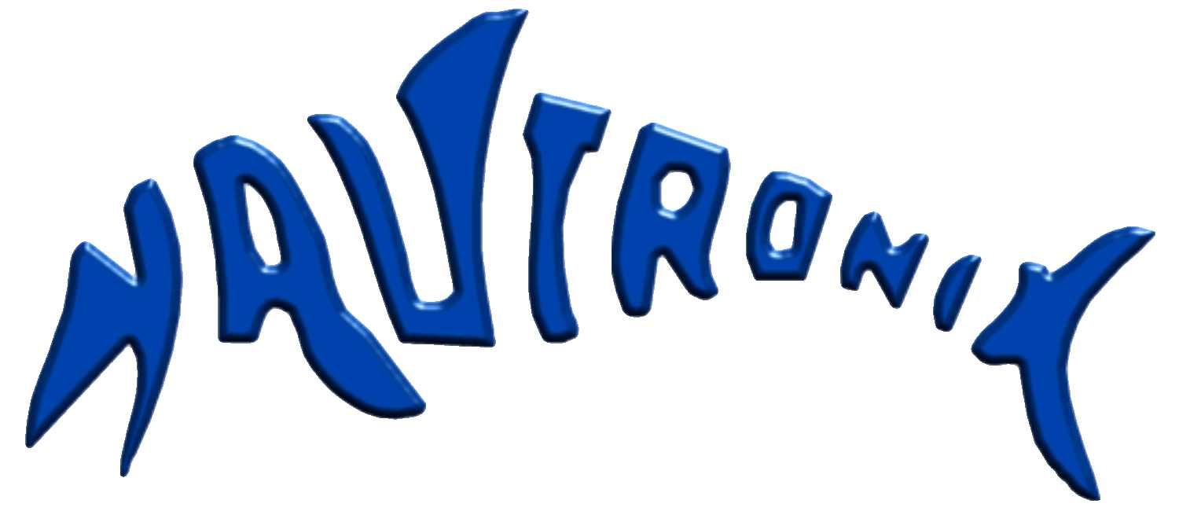
Submission to the Foreign Affairs Defence and Trade References Committee of the Senate

Inquiry into Materiel Acquistion & Management in the Defence Department

Nautronix Ltd
108 Marine Terrace
Fremantle, WA 6160
AUSTRALIA
This document and the specifications contained herein are the property of Nautronix Ltd and shall not be reproduced, copied or used in whole or in part as the basis for the manufacture or sale of items without written permission from Nautronix.
© Copyright 2004 Nautronix Ltd

Control Status
Document Title | Submission to the Foreign Affairs Defence and Trade References Committee of the Senate
Document Number | 110602110602
Document file path | /tmp/in/input.doc
Revision | Final Draft
Author |  | Date:
 | Peter Horobin
Checked by |  | Date:
 | Pat Hall
Approved by |  | Date:
(Type approver’s job title here) | Pat Hall

Revision Control
Rev. No. | DCR No. | Date | Description | Pages
Final Draft |  | 11-06-02 | Final Draft | All

Table of Contents
1. Introduction 1
2. Submission to the Committee 1
2.1 “…. whether the current material acquisition and through life support system is meeting and will continue to meet the needs of Defence and Defence Industry in a timely,cost effective and qualitative manner;” 1
2.2 “… the impact of the Defence Materiel Organisation acquisition reform program on materiel acquisition and management;” 2
2.3 “… the current status of major equipment projects in meeting the organisations requirements;” 2
2.4 “… the impact of the creation of decentralised system program offices on materiel acquisition and management;” 3
2.5 “… any other issues relevant to the effectiveness of the current acquisitions framework which arise in the course of the enquiry.” 3
2.5.1 Defence Export Development 3
2.5.2 The Defence and Industry Advisory Council 3
2.5.3 Project by Project Capability Development is Expensive 4
3. Overview 4
4. Conclusion 4

Introduction
Nautronix is an Australian owned, publicly listed, small to medium sized enterprise (SME) deriving revenue from the Mining, Offshore Oil & Gas and Defence sectors. It employs some 320 people worldwide and it has offices in Brisbane, Aberdeen, Houston, San Diego, Santa Barbara, and Singapore. Its head office is in Fremantle, Western Australia.
As a publicly listed Australian company, Nautronix has quite specific obligations to its shareholders that are not quite so onerous for a privately owned company. In this regard, Nautronix is one of very few Australian publicly listed companies in Defence business.
In the Australian Defence context Nautronix provides services and equipment largely to the RAN and to DSTO for use by the RAN. The services are usually in the areas of Underwater Ranges or Low Probability of Intercept (LPI) Through Water Communications. In these areas Nautronix has recently provided the Australian Defence Force (ADF) with facilities for the measurement of the acoustic signature of the COLLINS Class Submarines and demonstrated capability in LPI through water communications using a system known as the Hydro Acoustic Information Link (HAIL).
HAIL employs spread spectrum technology and exhibits (in addition to its LPI characteristics) very high reliability. It is noticeable that HAIL provides very much higher reliability than other through water communication systems and uses very little power. While the US and the UK have also been researching this technology for some 15 – 20 years it appears that Nautronix is some 12 – 24 months ahead of these countries in delivering the capability to the customer.
Accordingly Nautronix has been attempting to develop markets for HAIL overseas as well as in Australia. It is against a background of working with Defence in specialised niche areas over 12 years that Nautronix makes this submission to the Foreign Affairs Defence and Trade References Committee.

Submission to the Committee
Nautronix submission to the Foreign Affairs, Defence and Trade References Committee is offered for your favourable consider below. It is presented in the format suggested by the terms of reference for the committee.

“…. whether the current materiel acquisition and through life support system is meeting and will continue to meet the needs of Defence and Defence Industry in a timely, cost effective and qualitative manner;”
Nautronix has worked with the Department of Defence for some 12 years developing new products that the Department has perceived to be necessary for the strategic requirements of the ADF. It is believed that Defence would not have contracted Nautronix to provide these capabilities if they were already cost effective and available from another source. As a result Nautronix has developed some unique capability, which meets the particular requirements of the Australian strategic situation.
That this capability now appears to have an international application is an unexpected but welcome bonus.
In recent times Defence funding has been insufficient to make use of the capability that has been developed in Nautronix. While apparently important strategic capability has been established in Nautronix, funding to implement the capability in the ADF has been less readily available. Unfortunately the actions necessary to sustain the Defence capability in Nautronix require a braver act of charity than the company or its shareholders are able to provide.
This issue is not a criticism of the Department or the Defence Materiel Organisation. It is recognition that the Defence budget is not adequate to meet to provide a coherent Defence industry strategy.

“… the impact of the Defence Materiel Organisation acquisition reform program on materiel acquisition and management;”
Nautronix is only just beginning to feel the effects of the reform program. The capacity for certain procurements to be directed for strategic and other reasons is a significant step forward. Most recently it is allowing the DMO to make the best possible use of some of the capabilities, which have been developed in Nautronix.
There remains, unfortunately, a culture within parts of the DMO that is obsessively focussed on process, almost to the exclusion of any outcome. To be fair, this is recognised by the DMO, and it is taking steps to improve the way it works.

“… the current status of major equipment projects in meeting the organisation’s requirements;”
Nautronix exposure to major equipment projects is limited. however, it was the Australian subcontractor in the STN ATLAS bid to supply the Replacement Combat System (RCS) for the COLLINS Class Submarine. It is Nautronix understanding that it not only met the technical requirements for sustainable Australian industry capability in Combat System support, but also that it met the particular requirements for security in the project. It is disappointing that the changes directed by the previous Minister for Defence resulted in the loss of this contract to Nautronix (amongst others) and that the requirements for security of Australian national information and a sustainable Australian industry capability in support of the Combat System appear to have been discarded.

“… the impact of the creation of decentralised system program offices on materiel acquisition and management;”
The current major customer for Nautronix in the ADF is the Sonar and Ranges Program office; this office has performed to a very high standard throughout the twelve years of Nautronix experience with the group. The team is well led and focuses tightly on good outcomes for defence and for industry. This group has established some significant capabilities not only in Nautronix but also in other Australian companies and the recent changes to decentralise the SPO appear to have enhanced this already capable organisation.
Nautronix knowledge of the SPO concept is based on our experience with a Canberra based SPO. It is yet to be seen how a decentralised SPO will fare in competition for resources with the Canberra based SPOs.

“… any other issues relevant to the effectiveness of the current acquisitions framework which arise in the course of the enquiry.”
Nautronix is part of a small group of Australian owned companies, which have developed capability over the recent years to meet requirements that are seen as uniquely necessary for the Australian strategic environment. As indicated earlier had these requirements been able to be met from the International market place it would be unlikely that Nautronix would have been invited to offer its products. Hence Nautronix (and other similar Australian companies) see them as part of a necessary and strategic element of industry.
That which appears to be missing in the current climate is the political will to establish sustainable Australian capability. Whilst the DMO has endeavoured to support the capability it has established in Australian industry it has not been within its budgetary or policy framework to underpin that capability.
Its recommended that the process that the DMO and the industrial base in support of ADF would be assisted if there were clear commitments in government to a sustainable Australian capability in those industries seen to be strategically important.

Defence Export Development
In its attempts to export its products, Nautronix has relied heavily on the DMO for advice and guidance. This has always been willingly and cheerfully offered, and invariably well informed.
The culture of caution (identified in paragraph above) is an occasional inhibition that might be overcome if the policy in this area was a little clearer. Nautronix is one of the many admirers of the UK Ministry of Defence Export Sales Office (DESO), which is unashamed in its determination to promote British industry in the export market place. Nautronix is strongly of the view that DMO staff should be permitted to demonstrate the same level of enthusiasm for Australian exports.

The Defence and Industry Advisory Council
Nautronix views the role of the Defence and Industry Advisory Council (DIAC) as very important, as attempts are made to chart a way forward for developing and sustaining unique and/or strategic capabilities in the Australian environment. Of particular relevance to Nautronix is its active participation in the Defence Electronic Systems Working Group, which also includes participants from the DMO as part of the Commonwealth team.

Project by Project Capability Development is Expensive
The sector plan currently being developed for electronics systems by the DIAC will identify options that promote the notion of a sustainable Defence industry group. The work on this plan and others for the shipbuilding and aerospace, are already challenging the existing project-by-project and open tendering process that has been largely used by the DMO and its predecessors to date. The possibility of DMO ‘bundling’ strategic electronic systems project packages and using more flexible procurement strategies eg directed, sole source, spiral development is considered to be critical to improved efficiency and effectiveness for both the Commonwealth and industry.
Naturally, this is not one sided and industry too will have its part to play in meeting the Dom’s needs by delivering what the customer wants to budget and on time. However, one necessary, albeit negative for some, outcome of pursuing these alternative procurement strategies may well see rationalization in the Australian electronic systems sector.

Overview
Over the past 25 years, the Australian Government through the Department of Defence has established capability in local industry that it believes is necessary for the defence of Australia. In some cases this has been an internationally available capability that the ADF requires in country. An example in this category is the sonobuoy manufacturing facility in Sydney, operated by Thales.
In other cases, the required capability is unique to the Australian strategic environment, and cannot be obtained from any other country, but is considered of sufficient importance to Defence strategy that Government has funded part or all of the development of the capability. The Australian Submarine Corporation is perhaps the most significant example in this category, and Nautronix is a very much smaller company in the category.
Assuming Government wishes to retain access to the strategic and unique Australian defence industry capability it has developed, the issue of sustainability is a major item for resolution. These issues are about the capability Government requires, and not about the methods it uses to procure that capability. The Defence Capability division would seem to be the more appropriate section of Defence to deal with these matters.

Conclusion
Nautronix (as with other Australian SEMS in Defence business) is suffering some pain in its adjustment to the reality of a much-reduced Defence budget. This reduction is seriously exacerbated by the operational demands of placed by the operations in Afghanistan, and the management of “boat people”. If the Defence allocation is to remain at these historically low levels, it seems that any amount of policy adjustment, or organisational review will not provide a basis for a sustainable Australian defence industry capability.
A holistic view of the Australian strategic situation should include industry. Such a view might result in programs to sustain strategic industrial capability.

Roche, M. “On Target”, News and Information bulletin for clients of the DMO, May/June 2002.

