chapter 2

The Artillery Barracks, Fremantle

History of the Cantonment Hill - Artillery Barracks Site
- The Artillery Barracks form part of a site of longstanding significance to Western Australia.
- Evidence was taken that the site has ethnographic significance to Aboriginal people. The area around Cantonment Hill has the name Dwerda Weeardinup, or place of the dingo spirit.
- The site played an important role in the early history of Fremantle. An 1830 engraving shows a view from Cantonment Hill across the Swan River and bears a caption, which identifies the hill as the intended site for a fort. In 1833, only four years after the first European settlement, it was identified as a location for troops defending the new settlement. Limestone was quarried on the site during its early history and it was also treated as a public park. The Committee was told that a natural soak was located on the Tuckfield Street oval and was used to water camels before they set out for the Western Australia’s Eastern Goldfields.
- Following Federation, increased attention was given to the defence of Fremantle Harbour. Batteries were erected at Arthur’s Head and at North Fremantle and completed in 1907–08. It was to support these batteries that the Artillery Barracks were built between 1908 and 1910. The main area of the Artillery Barracks site, the land bounded by Tuckfield and Burt Streets, was purchased from the Municipality of Fremantle for 3,000 on 25 September 1909. It was bought under the Lands Acquisition Act 1906 for Defence purposes, though evidently not with the support of all of the local community.
Modern accommodation was constructed and it is thought that 10 Company would have moved into the facility in about March 1909 following their transfer from Albany in September 1908. Initially they lived under canvas whilst they installed the guns and commissioned Fort forest and awaited the completion of the Burt Street Barracks. There was a good deal of agitation from the public about the Army acquiring this prime piece of real estate.

Committee members inspecting the Army Museum of Western Australia
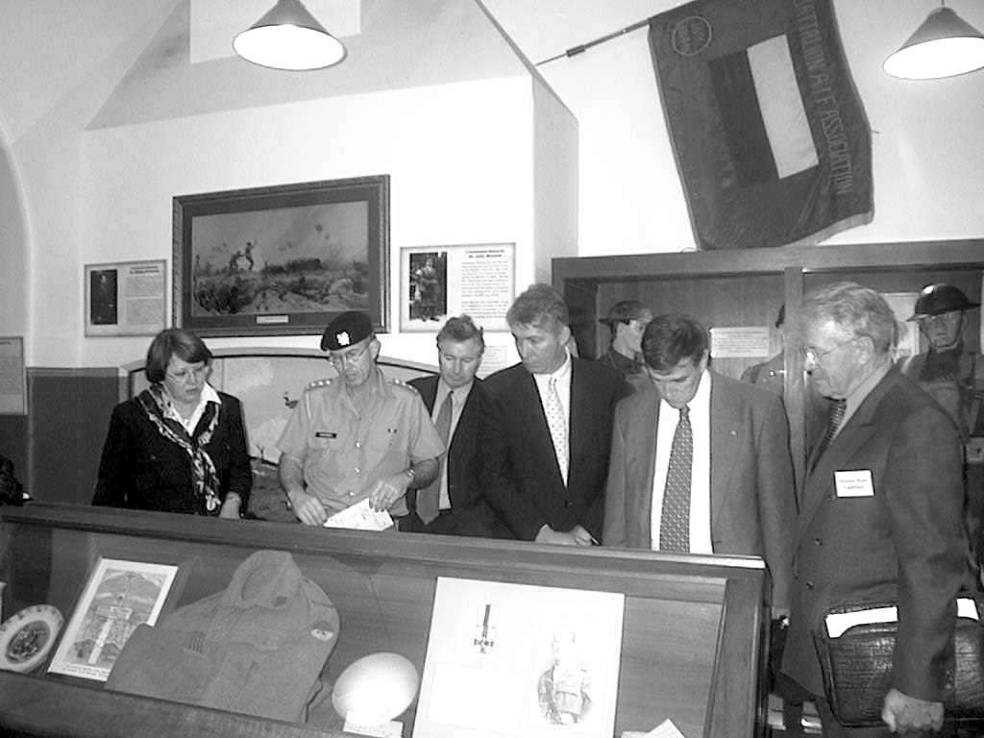
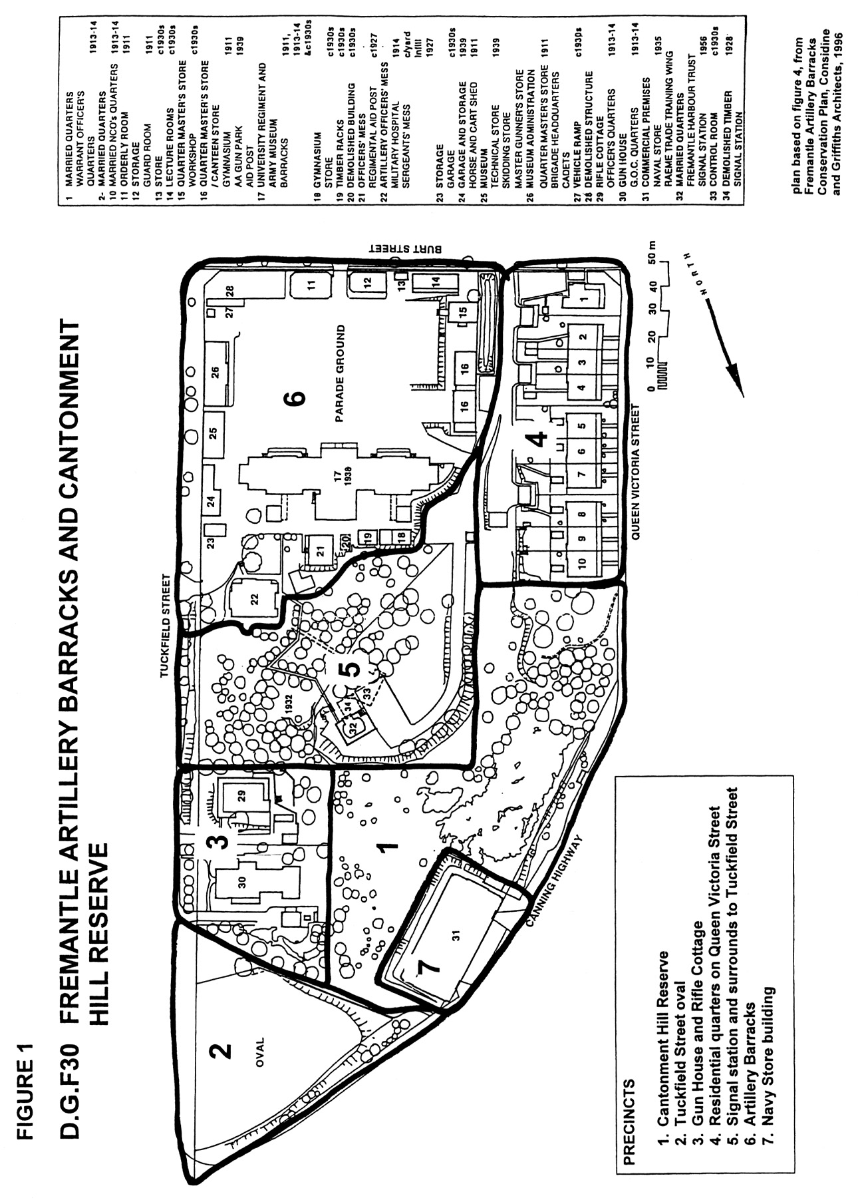

- In 1913, other buildings were constructed on the site. An additional barracks block, which doubled the available accommodation, along with a hospital block, a residence for the commanding officer, and quarters for two officers, a warrant officer and three married non-commissioned officers were completed on 22 December 1913.
- The Committee was told that, during the First World War, many servicemen travelling to the battlefields of the Middle East and Europe spent their last night in Australia in the Barracks. The Committee was also told that the Tuckfield Street oval was used to stable and water horses being sent overseas with the armed forces. After World War I, part of the Barracks was used as a military hospital for servicemen returning from overseas.
- In 1927, the playing field to the north of the site was leased to the Fremantle Council for a period of 25 years and in the following year a signal station of wood construction was erected at Cantonment Hill. In the 1930s, the link block was constructed joining the two existing barracks and, in 1935, the navy store was constructed. At the outbreak of World War Two, a tunnel was constructed from behind the Sergeants’ Mess to an underground control room that was located to the south of the Signal Station. In 1956, the timber signal station was replaced by the current one.

Description of the site
- In its current development plan, the City of Fremantle has divided the overall site into seven distinct precincts. The location of these precincts is set out on the map, which is reproduced on page 5. Briefly, these precincts are described below.

Cantonment Hill reserve
- This area is already owned by the City of Fremantle and has been used as a reserve to protect and regenerate the remnant bushland remaining on the site. This area is one of the few remaining examples of the original coastal bushland in the area.

Tuckfield Street oval
- The area frequently referred to as the Tuckfield Street oval is open space, which was used early in the twentieth century to stable horses for the artillery units and, more recently, was leased by Defence to a local school for use as a playground. The school was recently closed and the site redeveloped with the construction of residential units. The oval overlooks the Swan River and would be of considerable value if redeveloped for medium density housing. Local residents want the area to remain open space for community use.

Gun House and Rifle Cottage
- These two buildings were constructed as officers’ quarters in 1913–1914. The former was the residence of the barrack’s commanding officer. It is currently occupied by the senior military officer in Western Australia. The other is vacant.

Residential quarters on Queen Victoria Street
- The first residential quarters for married Warrant Officers and NCO’s were built during 1913–1914. Additional buildings may have been built later in the 1930s. They are currently unoccupied and no longer meet the standards required for defence housing.

Signal station and surrounds
- The highest point on the site is occupied by a signal station constructed in 1956. The signal station is no longer used but commands excellent views of the harbour and ocean, the Swan River, and Fremantle.

Artillery barracks
- The Artillery barracks themselves consist of the main barracks building and associated buildings grouped around a large central parade ground. The buildings are currently occupied by the Western Australian University Regiment and the Army Museum of Western Australia.

Naval store
- The naval store is a large two-storey building constructed on a site cut into the limestone cliffs of the hill.

Significance of the site
- The site has considerable heritage value, which has been recognised by both Commonwealth and State heritage bodies. The Fremantle Artillery Barracks was classified by the National Trust of Australia in 1980. It was entered in the Register of the National Estate in 1982. It was made a permanent entry in the Heritage Council of Western Australia Register of Heritage Places in1997. The Aboriginal Affairs Department has identified it as having ethnographic significance as a ceremonial and mythological site and it has been placed on the Interim Register under the Aboriginal Heritage Act 1972–80. It is also listed on the Fremantle Interim Heritage Municipal Inventory.

Aesthetic value
- The aesthetic values of the site are set out in the Heritage Council of Western Australia’s Register of Heritage Places.
The complex of buildings that comprise Artillery Barracks and their setting have aesthetic value as a predominantly unified architectural and planning concept in an expression that is best described as Federation Free Classical Style.
The buildings that are part of Beasly’s concept are carefully designed and detailed and exhibit a subtle range of variation to suit the various purposes for which they were intended. The original buildings are fine examples of Measly’s prodigious output.
The Navy Store and the Fremantle Harbour Signal Station (fmr), designed by Hobbs, Winning and Leighton, while not part of the original concept, have aesthetic value in their own right, both as pieces of design and as landmarks that announce the arrival from the north shore of the Swan River to Fremantle.
The natural environment, comprising limestone cliffs and outcrops and remnant heath, is also of aesthetic value.

Historic value
- The Register of Heritage Places also sets out the historic importance of the Artillery Barracks.
Although degraded somewhat by European colonisation and over 160 years of post-settlement use, the place has importance as one of a small number of places in the City of Fremantle that contain remnant indigenous heath vegetation on part of the Spearwood Dune system. A management plan is in place and the vegetation has been subject to rehabilitation planting and management.
The place demonstrates among other things, the topography, flora and culturally modified features, such as the former quarries, indicating the environment encountered by the European colonists, together with evidence of some of their early attempts to exploit the resources of Cantonment Hill. Further, the setting of the culturally modified parts of the site are a demonstration of the Army’s attitude to site planning and landscaping in the first quarter of the twentieth century. Though the physical evidence of plantings from that time is sparse, the organisation of the site and its setting remain clear and unaffected and demonstrate the planning requirements of a military establishment.
The place is significant in connection with the development of the State and, in particular, with the increasing importance of Fremantle and the State’s chief port. With the increase in the strategic importance of the port came the necessity to ensure its defence.
The place has an association with Lieutenant Colonel (later Lieutenant General) Sir J. Talbot Hobbs, who was influential in ensuring that the location was secured for the barracks and who enjoys a prominent place in the nation’s military and architectural history. The place has strong associations with Hillson Beasley who was an important influence on the development of the State’s building stock in the period of the gold boom and up to the time of World War One, in his capacity as chief draftsman and later as chief architect at the Public Works Department of Western Australia.
- Major General Ken Taylor (Retired) explained to the Committee that the historic and military significance of the site goes back to the earliest years of European settlement in Western Australia.
At first sight this would seem to be just a military affair, but it is much wider than that. It is a matter for the whole community, both national and local. One of the major concerns of the very first settlers of the state was defence. This extremely isolated and very small community had no security. In 1833, four years after arrival, they resolved to put a permanent military camp on this hill and they called it Cantonment Hill. They named the two main roads of Fremantle Cantonment Street and Cantonment Road. These roads lead directly to this barracks. This priority concern of this small community continued up to and beyond Federation. This hill is a priceless part of our beginnings and our later history. In another culture, this would be a sacred site of the greatest importance.
- Major General Taylor also told the Committee that the historic significance of the site as part of the first national defence measures following Federation were referred to by the Australian Heritage Commission.
Next year is our nation’s 100th birthday. Defence of the young colonies was a major driving force towards Federation and, because of this vital matter, the colonies joined together for the very first time. They decided to build a series of coastal artillery forts to protect the main ports. Building of these forts was commenced in 1897, four years before Federation. These buildings and this hill are part of that first ever national program. This is national heritage of the highest order.
- The Australian Heritage Commission submitted to the Committee that ‘there may be some possibility that, together with other military barracks, the Fremantle Artillery Barracks could have some national significance as an element within the topic of Defence, Building a Nation theme’.
- During its public hearings, the Committee members questioned witnesses about the significance of the Artillery Barracks and whether there were any other similar sites in Western Australia of such significance. Only three others were mentioned: at Albany, on Rottnest Island and possibly Swan Barracks in Perth.
- The witnesses who appeared before the Committee in Fremantle spoke persuasively about the need to preserve this history for future generations. In her submission, Ms Helen Birch said:
For me, it is important that the Fremantle Artillery Barracks, being the only remaining complete and original military complex in Western Australia, is retained in public ownership as essential evidence of the history of military architecture.
…
My concern is in to retain the Barracks as a public amenity to ensure that the presentation of the military history of this State and of Australia is ensured for coming generations.
- However, they not only argued for maintaining the site in its present form but also its continuing use as a military base.
- Many of the witnesses emphasised the growing importance of Australia’s military history to young Australians.
Military history shows that successful defence structures are built on tradition, as I have said. Military tradition, of course, goes beyond the Australian Defence Force to the wider community, and it transcends the boundaries of barracks. You can tell that by looking at the increased numbers attending Anzac Day commemorations and the pilgrimages to Gallipoli, Hell Fire Pass and Kokoda that young Australians take part in every year.

Social value
- The Barracks site is seen by many Western Australians as having great social value. The Heritage Council assessed its social values in the following manner:
Artillery Barracks has strong association for service personnel who trained or were stationed at the barracks throughout its eighty—four year history. The relocation of the Army Museum to Artillery Barracks has made the place a reference point for former service personnel and their families seeking information about their, or their relatives, involvement in Western Australian military history.
Artillery Barracks is associated with the life and development of Fremantle and contributes to Fremantle’s sense of place by its landmark qualities.
- These values were borne out in submissions received by the Committee and in evidence at the hearings from people throughout the Perth area. For example, Ms Helen Birch submitted details of her family’s extensive military links in Western Australia going back to 1851 and her own connections with the Artillery Barracks. The Committee received similar evidence from Mr William Haskell. Mr Haskell was one of seven siblings who served in the Second World War. He told the Committee:
I believe that this area, for ex-servicemen, is the responsibility of Australia. I do not care whether the defence department or whoever undertakes it, but to those thousands of Aussies who lie in foreign fields and who are commemorated in this area, we pay homage to them, and it is the duty of Australia to preserve this site as it is. I would not even contemplate Hobbs. This is an area of wonderful significance.
When I was a boy, I used to go to school in Fremantle. This area then was an active artillery setup. They have horsedrawn limbers where they used to service the forts over at Fort Forrest. That wonderful hill up there was the only signal station for the port of Fremantle. I can remember the black cane balls and house flags of ships flying there, and they were always put up 24 hours before the ships came in. There was none of this modern-day telecommunications and what have you. The people of Fremantle would look at Signal Hill and they would know that ships were due in within 24 hours, because they would see the house flags, and to me that is just wonderful. Boyhood memories are one thing, I know, but this place is a place of deep significance. That is not just my word. I move around in returned services, I move around in Probus, in all sorts of groups, and I would say that the proposed acquisition by Notre Dame is universally I repeat: universally discounted by the whole lot of them. They think it is appalling that an area like this is going to be supplanted by a private university that has only been around for about five minutes.

Scientific value
- The Artillery Barracks site also has scientific significance as described on the Register of Heritage Places
The reserve under the control of the City of Fremantle contains the majority of the remnant coastal heath and has already been recognised as a teaching resource. It is the intention of the City of Fremantle, under the guidance of its ‘Cantonment Hill Management Plan’, to ensure that, in concert with a rehabilitation program, trials and interpretive material are set in place so the site can be better accused and understood.
Artillery Barracks has a role in contributing to a wider understanding of human occupation in Australia and, in particular, to the early use of the site in terms of the quarrying that occurred there, the aspects of military barracks operations and living, the story of coastal defence and for its more recent role as the Army Museum, which will contribute to an understanding of the role of the Army in Western Australia and Australian history.

Disposal options
- During the Committee’s inquiry, several possible options for the future of the site were brought to the Committee’s attention. One of these options is for Defence to retain ownership of the site and continue to accommodate defence units at the Barracks. The maintenance of a Defence role for the property to emphasise and enhance the military origins and significance of the Barracks was argued strongly at the hearings. However, the Committee believes that the Department of Defence should be able to determine what properties it requires in order to maintain the efficiency of a modern defence force.
- Although the Department of Defence has declared the Artillery Barracks as surplus to requirements and wishes to dispose of it, the Committee is not convinced that the proposed sale to the University of Notre Dame or, for that matter, to any other private purchaser, is the best option for disposal of the property. Concerns were raised during the Committee’s hearing that, even if the University were considered to be a suitable buyer, its requirements may change over time and all or part of the site may be placed on the market again. The Committee shares this concern. The property is of significant heritage value and, while it remains in public hands, there is control over the use made of the property by whoever leases it. Even with heritage and planning controls, once the property is in private hands, that overall control is weakened.
- The option of transferring this property to the Western Australian Government would keep the property intact and allow for long-term planning and preservation of the site.
- It was suggested to the Committee that the property be gifted to the State Government. The Department submitted that ‘The Commonwealth cannot gift, vest or grant land’. Even if the land could be gifted, it would deny the Defence the revenue from the disposal of the property for use in other areas of Defence. The Committee does not propose that the Defence budget be denied such revenue.
- There are, however, mechanisms under which land could be transferred at no cost to the recipient. Major General Taylor proposed such a measure:
I would like to answer a question asked earlier in the day concerning a funding solution. I was very much involved with the Centenary of Federation celebrations. I was the first executive officer of the council. There was $200 million of Centenary of Federation funding allocated to purchase places. We are too late for that here, but it is possible for the government to find the additional funds necessary to buy this location and give them to the Centenary of Federation fund. Say to Professor Geoffrey Blainey, who I know would agree with this, ‘You have got another $4 million or $5 million for your Federation Fund. You can have that funding on the condition that you now buy for the Centenary of Federation Fund the barracks in Fremantle, and when you have got them, gift them as part of the Centenary of Federation gifts to other parts of Australia.’ It is a feasible, practical, simple mechanism, and the end result is that it does not cost the Commonwealth anything. No money changes hands. It is just a book transfer.
- During the Committee’s hearings, there was discussion about the decision of the Commonwealth to transfer the Torrens Parade Ground in Adelaide to the South Australian Government. The transfer of that land was funded from the Centenary of Federation Fund. Reports indicate that the future options for the use of the Adelaide site are still being investigated but one option being considered is to use the site for a military museum.
- The Department of Defence confirmed that this and some other property transfers were funded by the Centenary of Federation Fund.
The Federation Fund initiative, which was last year, included a number of Defence properties. The legislation has still not gone through the parliament, I might add. There is an interim trust being set up in Sydney, the Sydney Harbour foreshores trust. Defence has been given considerable revenue for transferring those properties to this trust and also funding to clean up Cockatoo Island in the harbour. In addition to the Sydney Harbour properties, there was a decision on and I think it has been announced the Torrens Parade Ground, for which the revenue was $3 million.
- The Committee’s attention was also drawn to other examples of land being transferred by the Commonwealth for a nominal payment.
I will give you a couple of WA examples. Earlier this year, Cape Leveque was gifted in freehold to the local Aboriginal community. This was Commonwealth land and there was disagreement with the state government over this decision at the time. There are 26 Commonwealth lighthouses in Western Australia. All are going to be granted to the state government for $1 each. I suppose you could argue that they are being sold. This includes Eclipse Island off the south coast near Albany. The title for this island is in freehold. It will become a nature reserve. In anyone's language, a freehold island with a lighthouse for $1 is a gift.
- The disadvantage of this means of effecting a transfer of a property from the Commonwealth to a State in the case of the Artillery Barracks is that Defence would not receive the remuneration it would otherwise have received had it sold the property.
- The Committee prefers the Artillery Barracks to be kept in public ownership for reasons mentioned above. Given that the Commonwealth wishes to dispose of the property, it would be most appropriate for the property to be transferred to the Western Australian Government, as it is inextricably tied to the history of Fremantle and, more generally, Western Australia. It would obviously be in the interests of the Western Australian Government to ensure that the property is used in such a way as to maintain its significant heritage values, in accordance with its listing on Federal and State Heritage Lists.
- The Committee believes that the most suitable means of achieving this transfer to the Western Australian Government is by means of a Centenary of Federation grant as suggested by Major General Taylor. This would enable the State Government to take possession of the property at no cost and would also allow Defence to receive the revenue it would otherwise have got from the sale of the property.
Recommendation
The Committee recommends that the Australian Government supplement the Centenary of Federation Fund to enable the Fund to make a grant to effect the transfer of the Artillery Barracks to the Western Australian Government.

Future uses of the site
- The Mayor of the City of Fremantle, Mr Richard Utting, told the Committee:
The City of Fremantle’s key objectives with respect to this entire site are fourfold: firstly, to maximise public open space; secondly, to ensure the long-term future on the site for the military museum; thirdly, to maximise public access to the site; and, fourthly, to maintain both the built heritage and the open space.
- In its written submission to the Committee, the City of Fremantle said:
The significance of the site is recorded in the Artillery Barracks Fremantle Conservation Plan, prepared by Considine and Griffiths in 1996. This is outlined in the City of Fremantle policy, D.G.F.30 Fremantle Artillery Barracks and Cantonment Hill, adopted in July 2000 ... The policy is intended to guide potential owners/occupants of the Council’s and community’s view of appropriate use and development on the site and the adjoining reserve into the future. In a recent community comment period on the policy, 294 submissions were received. Only one submission opposed the policy.
- In policy D.G.F30, the City of Fremantle set out its policy for each of the seven precincts on the site. A copy of the plan was included with the City’s submission to the Committee.
- During the inquiry, various options were proposed for the future use of the property. In addition, if the property were to remain in public ownership, several options were also suggested for management of the property.
- BSD consultants, who are acting for Defence in the property disposal, proposed a very aggressive development plan to the City of Fremantle in response to policy D.G.F.30. In essence, the proposal advocated redeveloping every possible area for residential unit development that would be allowable within heritage restrictions. In other words, it sought, in its view, to maximise the return to Defence. Inevitably, it objected to a number of restrictions placed on the site in the City of Fremantle’s policy. The Committee agrees that, in principle, Defence should explore all of the available options in order to maximise the return from the disposal of its properties to the Commonwealth. But, in this case, the proposal put forward on behalf of Defence would clearly be incompatible with the historic significance of the site and its heritage values.
- The University of Notre Dame has been interested in the property for a long time. A decade ago it expressed interest to the then Minister for Defence, Mr Kim Beazley, in the site but the exchange of correspondence lapsed. On 16 November 1998, the University’s Vice Chancellor, Dr Peter Tannock, wrote to the Minister for Defence to renew his University’s interest in acquiring the property on a priority sale basis, if it were surplus to requirements. On 15 May 2000, the Minister for Finance and Administration gave approval in principle to the University of Notre Dame to acquire the property on a priority sale basis, subject to the property being sold at market value.
- With regard to the University’s use of the property, Dr Tannock submitted:
The University’s concept for the use of the Artillery Barracks (assuming the whole of the site was available) has been for it to become, in the long term, its second Fremantle Campus. We would restore and utilize the residential accommodation on the site for the housing of students and staff. We would like to extend the residential accommodation, if possible, to other buildings on the site beyond the twelve cottages and houses which are currently available. We also envisage the use of many of the large and small rooms in the main building as teaching and educational spaces, including a library, computer laboratories etc. We envisage this East End Campus operating in parallel with our West End Campus. It is probable that the University would re-locate one of its larger Colleges to the site (e.g. Business or Health) or, possibly, base its graduate programs there. It would reduce the pressure on the University to acquire further sites in the West End of Fremantle.
- Dr Tannock also submitted that the University would be prepared to allow the Army Museum to remain where it is on the site. At the hearing, he went further to offer the Museum a 20 year lease at peppercorn rental. In his submission, he said that:
In our view the public interest and the interests of the city would be much better served by a joint tenancy arrangement involving the Museum, the University and the Fremantle City Council. The University would be happy with the site remaining in public ownership (either Commonwealth or State), with appropriate leasing and managerial arrangements being entered into in relation to the occupancy of various portions by the above three parties. The overall management of the site could be placed by government in the hands of a board representative of these three parties. If the Museum eventually moves, the University would like to replace it in the buildings it occupies.
- In his submission and in evidence at his hearing, Dr Tannock drew attention to the University’s very good record in preserving and restoring the heritage values of other buildings it has acquired in Fremantle. He assured the Committee that the University would meet all heritage requirements in preparing buildings on site for University purposes.
- Although the Committee argued earlier in the chapter for the site to remain in public ownership, it was not reflecting on the University’s fitness to lease part of the site. The University’s record in preserving heritage buildings and its stated end-use of the site would not be inimical to the long-term heritage interests of the site. However, it is clear that Defence does not intend to use the site and a continued military presence, other than possibly the Army Museum, appears to be out of the question.
- The Army Museum of Western Australia Foundation also submitted a proposal for management of the whole site, The Master Plan for the Management of the Artillery Barracks Precinct Cantonment Hill Fremantle, dated September 2000. Its key considerations are:
The whole Barracks Precinct should remain intact as a single heritage entity for the use of the public through the auspices of the Army Museum, city of Fremantle, the FCC Residents Precinct Group and the broader community.
The Precinct should be managed in such a way that it is operationally self-funded with corporate and appropriate grant funding for special projects support from State and Federal Government sources.
All moneys raised on site are to be reinvested in the precinct to maintain the site’s built, cultural, environmental, heritage and community values—in perpetuity.
- The Plan’s land use proposal provides for:
- Married Quarters, Gun House and Rifle Cottage to be leased as residential and short stay accommodation.
- Naval store and the smaller buildings presenting to the parade ground to be leased as commercial/artisans tenancies.
- Barracks block and associated buildings to remain the home of the Army Museum of Western Australia.
- The City of Fremantle’s management area to be increased with a long-term lease of the oval, the signal station and the surrounding bushland.
- The Plan also set out management and administrative arrangements and income and expenditure projections for the proposal.
- The Committee believes that the Foundation’s Master Plan is consistent with the heritage values of the site and in keeping with Fremantle’s disposition as a tourist destination.
- Leaving aside the ‘aggressive option’ of BSD consultants, other proposals and individual witnesses generally supported leaving the Tuckfield Street oval as open space for community purposes, as it is listed in the City of Fremantle’s policy. The local residents argued strongly that the oval should be kept as open space for residents and visitors to the site. Mr Johnston, Councillor, City of Fremantle, told the Committee that:
The so-called Tuckfield Street open space is in this corner of the site amongst all of that green area of reserve. If you look at the contours, you can see that it is the only flat area … and the only area that could be regarded as public open space where you can take your children and kick a ball around. You cannot do that elsewhere. Other sites are hilly and covered with vegetation.
…
The residents to the east of Tuckfield Street and to the south of Burt Street have no public open space. Let us concentrate on the residents to the east of Tuckfield Street: they have no public open space in which they can exercise or take their children to without crossing a four-lane road on two sides and a busy two-lane road on a steep hill on the other side. There is absolutely no other public open space accessible to the community other than the Tuckfield Street open space in this vicinity. It has significance beyond its size in that regard: it is the only space. It is not public open space at the moment—that is conceded—but the city’s desire is that it should be.
- The Committee notes that the whole site, including the Tuckfield Street oval, is listed on Federal and State Heritage Registers. The Committee is sympathetic to the needs of the residents of the area. If, in the final analysis, it came down to a compromise to achieve the best outcome for the site, which would be in the interests of the City of Fremantle and its residents, the oval is the only area which could be used as a bargaining point. If any development occurred on the oval area, it would need to be carefully and sympathetically designed so as not to affect adversely the heritage values of the rest of the site. This part of the site is covered by the current heritage assessment but in evidence to the Committee, Dr Heffernan, Assistant Director, Historic Environment Advice Section of the Heritage Commission said:
It is possible for an assessment to recognise that a whole site has heritage values but that in the end it could be possible that part of the site could be the subject of sympathetic development. I am talking hypothetically here because we would need to be looking at a whole proposal and looking at the upgraded assessment that we would expect would come from the conservation management plan that Defence are commissioning. It is possible for there to be opportunities within a heritage site for sympathetic development.

Conclusions
- The Artillery Barracks, Fremantle is an important and in many ways unique heritage site. It clearly has considerable significance to the ex-service community, to the people of Fremantle and broader community of Western Australia. It is one of a very few military properties in Western Australia of high heritage significance and the need for its preservation is recognised by its inclusion on both the Federal and State Heritage Registers and by the policy adopted by the City of Fremantle.
- In light of this, the Committee considers that the property should be retained in public ownership; preferably under the control of the Western Australian Government. This would provide the continuity of ownership needed to ensure that the heritage values of the site are not degraded over time.
- While the Committee believes that the significance of the site would be enhanced by its continued use by some military units, it is ultimately the role of Defence to determine what properties it needs to meet its current requirements. Defence has declared the property to be surplus to its requirements and, in accordance with its policy, wishes to dispose of it. In these circumstances, the Committee recommended earlier in the chapter that the property be transferred to the Western Australian Government using funding from the Centenary of Federation Fund. This arrangement has the added benefit that Defence will receive due revenue from the disposal of the property.
- If the property were transferred to the Western Australian Government, the Committee believes that the State Government should decide who should lease the property or part of it and how the property should be managed. The Committee is not in a position to determine the merits of the proposal of the University of Notre Dame compared with that of the Army Museum of Western Australia Foundation. The question of the location of the Army Museum is addressed in the next chapter.

INTERFET uniform worn by Australian Forces serving in East Timor.
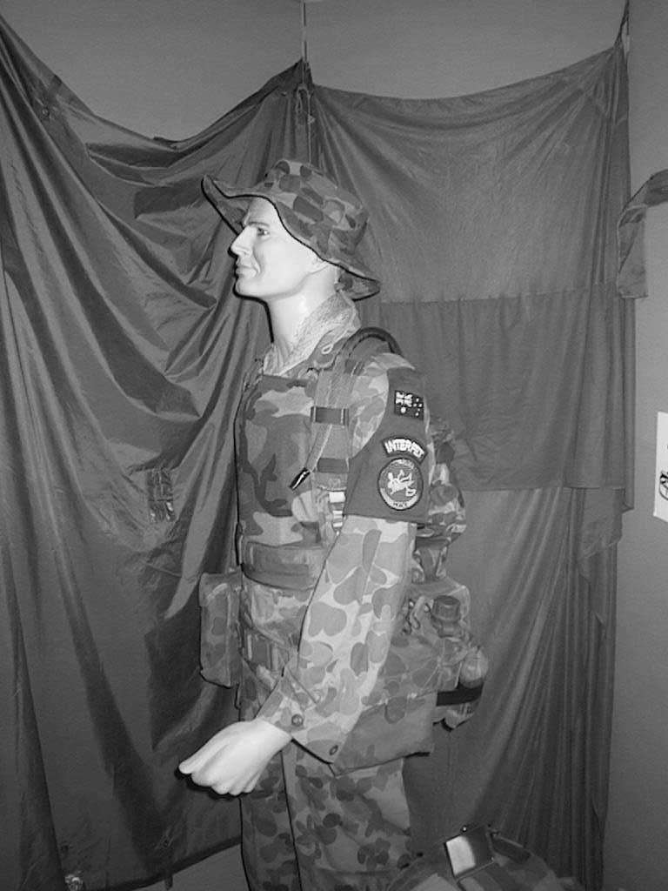

City of Fremantle, submission no. 16, p 3.
Artillery Barracks Fremantle Conservation Plan, Considine and Griffiths Architects, March 1996, p. 10.
Major General Ken Taylor (Retired), submission no. 42, p. 114.
Artillery Barracks Fremantle Conservation Plan, Considine and Griffiths Architects, March 1996, p. 10.
Australian Heritage Commission, Register of the National Estate Database.
Department of Defence, submission no. 37, p. 5; Heritage Commission, Register of the National Estate Database.
Australian Heritage Commission, Register of the National Estate Database.
Australian Heritage Commission, Register of the National Estate Database.
Artillery Barracks Fremantle Conservation Plan, Considine and Griffiths Architects, March 1996, p. 14.
Artillery Barracks Fremantle Conservation Plan, Considine and Griffiths Architects, March 1996, p. 14.
Artillery Barracks Fremantle Conservation Plan, Considine and Griffiths Architects, March 1996, p. 15.
Artillery Barracks Fremantle Conservation Plan, Considine and Griffiths Architects, March 1996, p. 16.
Artillery Barracks Fremantle Conservation Plan, Considine and Griffiths Architects, March 1996, p. 3.
Australian Heritage Commission, submission no. 46.
Australian Heritage Commission, submission no. 46.
Artillery Barracks Fremantle Conservation Plan, Considine and Griffiths Architects, March 1996, p. 4.
City of Fremantle, submission no. 16, p. 2.
Register of Heritage Places—Assessment Documentation, Heritage Council of Western Australia.
Register of Heritage Places—Assessment Documentation, Heritage Council of Western Australia.
Major General Ken Taylor (Retired), Committee Hansard, 19 October 2000, p. 111.
Major General Ken Taylor (Retired), Committee Hansard, 19 October 2000, pp. 111-12.
Australian Heritage Commission, submission no. 46.
Ms Helen Birch, submission no. 25, p. 2.
Mr Don Hall, Member, State Executive, Returned and Services League of Australia, Western Australia Branch, Committee Hansard, 19 October 2000, p. 84.
Register of Heritage Places—Assessment Documentation, Heritage Council of Western Australia.
Ms Helen Birch, submission no. 25, p. 2.
Mr William Haskell, Committee Hansard, 19 October 2000, p. 117.
Register of Heritage Places—Assessment Documentation, Heritage Council of Western Australia.
Department of Defence, submission no. 37, p. 4.
Major General Ken Taylor (Retired), Committee Hansard, 19 October 2000, p. 112.
Adelaide Advertiser, 24 October 2000.
Mr Rod Corey, Acting Deputy Secretary, Department of Defence, Committee Hansard, 10 November 2000, p. 184
Mr Paul Bridges, Committee Hansard, 10 November 2000, p. 250.
Mr Richard Utting, Mayor, City of Fremantle, Committee Hansard, 18 October 2000, p. 2.
City of Fremantle, submission no. 16, p. 2.
BSD Consultants, submission on behalf of the Department of Defence on Draft Policy D.G.F.30—Fremantle Artillery Barracks and Cantonment Hill Reserve, September 2000.
The University of Notre Dame Australia, submission no. 41, p. 1.
Dr Peter Tannock, Vice Chancellor, University of Notre Dame, Committee Hansard, 18 October 2000, p. 36.
The University of Notre Dame, Australia, submission no. 41, p. 2.
Mr David Johnston, City of Fremantle, Committee Hansard, 18 October 2000, p. 13.
Mr Ken Heffernan, Australian Heritage Commission, Committee Hansard, 10 November 2000, p. 248

