Senate Employment,
Workplace Relations and
Education Legislation Committee

Inquiry into the

Workplace Relations
Amendment (Paid Maternity Leave)
Bill 2002

Joint submission by –
Department of the Prime Minister and Cabinet
Department of Employment and Workplace Relations
Department of Family and Community Services

July 2002
Sandra Parker
Office of the Status of Women
Department of the Prime Minister and Cabinet
3-5 National Circuit
Barton ACT 2600
Phone (02) 6271 5772

Shelley Cooper
Workplace Relations Policy and Legal Group
Department of Employment and Workplace Relations
148-180 City Walk, Canberra City ACT 2601
GPO Box 9879,
Canberra ACT 2601
Phone (02) 6121 7734

Fiona Mallise
Department of Family and Community Services
Athllon Dr, Greenway, Tuggeranong ACT 2900
Box 7788
Canberra Mail Centre ACT 2610
Phone (02) 6212 9337

© Commonwealth of Australia, 2002
Department of the Prime Minister and Cabinet
Department of Employment and Workplace Relations
Department of Family and Community Services
TABLE OF CONTENTS
1 introduction 5
2 Workplace Relations Regulatory framework 5
2.1 Legislative Provisions 6
2.2 Award and agreement provisions 7
2.2.1 Unpaid parental leave 7
2.2.2 Paid maternity leave in federal awards and agreements 8
2.2.3 Incidence of paid maternity leave 8
2.2.4 Coverage of paid maternity leave 8
2.2.5 Survey of employment arrangements and superannuation (SEAS) 9
2.3 The Public Sector 9
2.4 Relationship with international conventions and standards 10
2.4.1 CEDAW 11
2.4.2 ILO Maternity Protection Standards (C183 and R191) 11
2.4.3 ILO Workers with Family Responsibility Standards (C156 and R165) 13
3 demographics RELEVANT TO pAID MATERNITY LEAVE 13
3.1 Birth Rate 14
3.2 Women’s labour force participation 15
3.2.1 Labour force participation rates – all women 15
3.3 Labour force participation - women of child-bearing age 15
3.3.1 Labour force status of women of child-bearing age 16
3.3.2 Employment status of women of child-bearing age 17
3.3.3 Casual work – women of child-bearing age 17
3.4 Labour force participation - women with dependent children 18
3.4.1 Labour force status of women with dependent children 18
3.4.2 Labour force status of women with dependent children by youngest dependant’s age group 19
3.5 Breaks in employment of women with young children 20
3.6 Employed women’s earnings 21
3.7 Women in small business 23
4 Financial assistance provided following the birth of a child 24
4.1 Maternity Allowance 24
4.2 Family Tax Benefit Part A and B 24
4.3 Parenting Payment 25
4.4 Child Care Benefit 25
4.5 Support services for families 26
4.6 Baby Bonus 26
ATTACHMENT A 28
ATTACHMENT B 29
ATTACHMENT C 31
AtTACHMENT D 32
ATTACHMENT E 34
ILO Convention 183 concerning the revision of the Maternity Protection Convention (Revised), 1952 34

1 introduction 5
2 Workplace Relations Regulatory framework 5
2.2.1 Unpaid parental leave 7
2.2.2 Paid maternity leave in federal awards and agreements 8
2.2.3 Incidence of paid maternity leave 8
2.2.4 Coverage of paid maternity leave 8
2.2.5 Survey of employment arrangements and superannuation (SEAS) 9
2.4.1 CEDAW 11
2.4.2 ILO Maternity Protection Standards (C183 and R191) 11
2.4.3 ILO Workers with Family Responsibility Standards (C156 and R165) 13
3 demographics RELEVANT TO pAID MATERNITY LEAVE 13
3.2.1 Labour force participation rates – all women 15
3.3.1 Labour force status of women of child-bearing age 16
3.3.2 Employment status of women of child-bearing age 17
3.3.3 Casual work – women of child-bearing age 17
3.4.1 Labour force status of women with dependent children 18
3.4.2 Labour force status of women with dependent children by youngest dependant’s age group 19
4 Financial assistance provided following the birth of a child 24
4.1 Maternity Allowance 24
4.2 Family Tax Benefit Part A and B 24
4.3 Parenting Payment 25
4.4 Child Care Benefit 25
4.5 Support services for families 26
4.6 Baby Bonus 26
ATTACHMENT A 28
ATTACHMENT B 29
ATTACHMENT C 31
AtTACHMENT D 32
ATTACHMENT E 34
ILO Convention 183 concerning the revision of the Maternity Protection Convention (Revised), 1952 34

1 introduction

1. This submission is a joint submission by the Department of the Prime Minister and Cabinet, the Department of Employment and Workplace Relations and the Department of Family and Community Services.
- Australia’s workplace arrangements and the social security safety-net work in a complementary way to provide a comprehensive system of support for families at the time of birth of a child, and ensure that support for families is broad-based, practical and long term.
- Features of this system of support for parents in Australia is comprehensive and includes:
- The entitlement of all permanent full-time and part-time employees who have been with their employer for 12 months (and some long term casuals) to 12 months unpaid leave with the right to return to their former job or equivalent job;
- Protection for women while at work and when returning to work after maternity leave through anti-discrimination legislation;
- Access to part time and flexible working arrangements through awards and agreements;
- A maternity allowance, available to most women regardless of whether they are in the labour force;
- Other family payments, with the highest payments going to those in most need;
- A high quality childcare system;
- The Baby Bonus, which is available to eligible parents for up to five years after birth of a first-born child; and
- A comprehensive system of universally available health care.

- This submission provides factual information in relation to the following workplace relations arrangements in Australia and international standards relevant to paid maternity leave;
- statistics about the extent of paid maternity leave in Australia, including agreement making in the federal sphere;
- labour force statistics in relation to the participation in the workforce of women of childbearing age; and
- financial assistance provided by the Federal Government following the birth of a child.
2 Workplace Relations Regulatory framework

- Under Australia’s federal system of government some powers, including workplace relations powers, are shared between the federal government and the various State and Territory governments.
- Employment conditions, including parental leave and paid maternity leave, may be derived from a number of sources including federal and State workplace relations laws, industrial awards and industrial agreements; both federal and State.

2.1 Legislative Provisions

- The Workplace Relations Act 1996 (the WR Act) is the primary legislative instrument at the federal level which regulates employee entitlements. It establishes a framework which assists employees to balance their work and family responsibilities and is the basis for the industrial safety net of awards and minimum conditions.
- Under the WR Act, permanent full-time and part-time employees who have 12 months continuous service with their employer have a minimum entitlement to 52 weeks of shared unpaid parental leave following the birth or adoption of a child. Except for one week, parents cannot take leave simultaneously as the provision is designed to meet the needs of the primary care-giver. Employees taking parental leave have a right to return to the position they held prior to taking leave, or to one similar in status. Parental leave will not break an employee's continuity of service.
- Continuous service is defined in Schedule 14 of the WR Act as
service (otherwise than as a casual or seasonal employee) under an unbroken contract of employment, and includes a period of leave, or a period of absence, authorised:
- by the employer; or
- by an award or order of a court or a tribunal that has power to fix wages and other terms and conditions of employment, or a workplace agreement certified by such a body; or
- by a contract of employment; or
- by this Schedule or another law of the Commonwealth or of a State or Territory:
- This entitlement supplements, not overrides, entitlements under other federal, State and Territory legislation and awards. The federal legislation is intended to supplement any existing entitlements. Employees are required to use any parental leave entitlements that exist under relevant agreements, awards or State laws before accessing the Act's entitlements.
- Most States have legislated for parental leave for permanent employees - see Attachment A for a comparison of legislative requirements regarding parental leave across jurisdictions. Legislation in two States, Queensland and New South Wales, provides that casual employees who have regular/continuous service with one employer may take unpaid parental leave.
- In Queensland, a long-term casual employee (a casual employee who has been engaged on a regular and systematic basis for several periods of employment during a period of at least 1 year) is entitled to 1 week's unpaid short parental leave and a further 51 weeks unpaid long parental leave.
- In New South Wales legislation provides an entitlement to 52 weeks unpaid parental leave for casual employees who work for an employer on a regular and systematic basis for at least 12 months and who have a reasonable expectation of on-going employment.

2.2 Award and agreement provisions

2.2.1 Unpaid parental leave
- The vast majority of federal awards contain unpaid parental leave provisions (as per the 1990 Parental Leave Test Case Standard) similar to those contained in the Act but also covering a short period before the birth. Almost 90 per cent of a sample of 100 major federal awards contain parental leave provisions.
- Over the past two decades, the existing parental leave provisions contained in federal awards have evolved through a process of test case decisions of the Australian Industrial Relations Commission. Significant test cases are outlined below.
- The 1979 maternity leave test case provided for a maximum 52 weeks unpaid maternity leave for full-time or permanent part-time employees, including a compulsory period of six weeks immediately following confinement. Although provisions made by the Full Bench with respect to the period and commencement of leave are flexible, allowing for the exigencies of pregnancy, the Commission emphasised that a 52 week maximum period is to apply.
- In 1985 the adoption leave test case awarded up to 52 weeks' unpaid leave to female employees if adopting a child under the age of five. Qualification for the leave depended on continuous service with one employer for not less than 12 months immediately preceding the date leave was to commence.
- The 1990 parental leave test case added to the 1979 and 1985 maternity and adoption leave provisions by allowing male employees to share up to 52 weeks of the parental leave with their spouse of which 1 week is able to be taken concurrently at the time of the birth. Job protection was also extended to male employees eligible for the leave. In its decision, the Commission established that parental leave was associated with the birth or adoption of a child and was intended to provide additional choices for workers with family responsibilities.
- In the Award Simplification Decision on 23 December 1997, and a supplementary decision on 15 September 1998, the Commission streamlined the parental leave test case clause in order that the clause be expressed in plain English and be easier to understand.
- In May 2001, an AIRC Full Bench decision granted access to unpaid parental leave to federal award-covered casual employees employed on a “regular and systematic basis for several periods of employment or on a regular or systematic basis for an ongoing period of employment during a period of at least 12 months, and has a reasonable expectation of on-going employment”. These new provisions will be inserted into federal awards on application by the award parties on an award-by-award basis.

- Parental leave entitlements in the States/Territories provided for by test cases vary across jurisdictions. The SA IRC has adopted the AIRC Full Bench decision in relation to unpaid parental leave for casual employees.

2.2.2 Paid maternity leave in federal awards and agreements
- Eighty two federal awards currently provide for paid maternity leave. Fifty nine of these awards are in the government sphere (including education, health and local government). The private sector industry with the highest number of awards is the film, broadcasting and journalism sector (11 awards). The majority of these and the remaining awards are for individual companies.
- The Workplace Agreements Database (WAD) is a database maintained by the Department of Employment and Workplace Relations (DEWR) containing all approved federal certified agreements made since January 1997. The WAD provides information regarding the incidence of paid maternity leave in agreements as well as the coverage of female employees by paid maternity leave provisions.

2.2.3 Incidence of paid maternity leave
- DEWR analysis of WADfound
- Seven per cent of all current agreements (917 federal agreements) made provision for paid maternity leave.
- The duration of paid maternity leave provisions in agreements ranges from two days to 18 weeks, with the most frequent periods offered being six weeks (32 per cent), 12 weeks (30 per cent) and two weeks (12 per cent). The average duration across all current agreements is seven weeks.
- The incidence of paid maternity leave provisions in current federal agreements is greatest in the Education (50 per cent), Health and Community Services (33 per cent), Finance and Insurance (30 per cent), and Government Administration and Defence (27 per cent) industries.

2.2.4 Coverage of paid maternity leave
- Coverage of female employees with access to paid maternity leave is detailed in Attachment B. The proportion of women covered by a federal agreement which provides for paid maternity leave is higher than the proportion of federal agreements which provide for paid maternity leave. There are two main reasons. First, those federal agreements which contain paid maternity leave generally cover larger workplaces/organisations. Secondly, agreements containing paid maternity leave are more likely to be made in industries where women make up a higher proportion of employees.
- Thirty six percent of women currently covered by a federal certified workplace agreement have an entitlement (subject to eligibility requirements) to paid maternity leave.
- While paid maternity leave provisions have been included in agreements across all industries, the extent of coverage varies, with the highest coverage being 73 per cent of females covered by agreements in Government Administration and Defence, followed by 63 per cent in Health and Community Services industries, 55 per cent in Education industries and 47 per cent in Electricity, Gas and Water Supply industries [Table ii].

- Attachment C provides statistics in relation to the incidence and coverage of paid paternity leave in current federal certified agreements.

2.2.5 Survey of employment arrangements and superannuation (SEAS)
- SEAS is an Australian Bureau of Statistics survey that collected information on the diversity of employment arrangements and superannuation coverage in Australia. The survey collected information from individuals (April to June 2000) and superannuation funds and administrators (May to October 2000). The survey was a special stand-alone survey and collected information on paid maternity and paternity leave. However these data are unpublished.
- SEAS data are outlined at Attachment D and identify that
- thirty-eight per cent of female employees responded that they were entitled to paid maternity leave (51 per cent of full time employees and 21 per cent of part time employees); [Table iv]
- women in casual employment had almost negligible access to paid maternity leave (0.4 per cent of self-identified casuals responded that they were entitled to paid maternity leave, compared to 53.6 per cent of other female employees); [Table iv]
- the highest coverage of paid maternity leave (percent of female employees) occurred in the following industries: Government Administration and Defence (68.1 per cent), Communication Services (59.1 per cent ), Finance and Insurance (59 per cent) and Education (57 per cent ); [Table v]
- the lowest coverage of paid maternity leave was found in the following industries: Agriculture (4.5 per cent), Accommodation, Cafes and Restaurants (13.4 per cent), Retail (20.2 per cent of female employees) and Cultural and Recreational Services (28.2 per cent); [Table v]
- the highest incidence of paid maternity leave was recorded in the following occupations: Managers and Administrators (65 per cent) and Professionals (54 per cent); [Table v]
- the lowest incidence of paid maternity leave was recorded in the following occupations: Elementary Clerical, Sales and Service Workers (18 per cent) and labourers and related workers (21 per cent); [Table v] and
- access to paid maternity leave was higher the greater an employee’s length of service with an employer. [Table v]

2.3 The Public Sector

- Paid maternity leave is a common entitlement for women employed permanently in the public sector, both federal and State/Territory, and is provided through legislation, certified agreements, awards and as a result of government policy, such as Ministerial Directions.
- While the duration of maternity leave varies across Commonwealth, State and Territory public sectors, most public servants have a legislative entitlement of four to twelve weeks paid maternity leave.
Table 1: Legislative entitlements for public servants by jurisdiction, July 2002

Jurisdiction | Amount of paid maternity leave | Period of service required to be eligible for paid maternity leave
Commonwealth | 12 weeks | 12 months of continuous service
Queensland | 6 weeks | 12 months of continuous service
Western Australia | N/A | N/A
South Australia | 4 weeks | 12 months of continuous service
New South Wales | 9 weeks | At least 40 weeks service before the expected date of birth
Victoria | 12 weeks | 12 months of continuous service
Tasmania | 12 weeks | 12 months of continuous service

- The level of paid paternity leave available to public sector employees also varies across State/Territories and the Commonwealth. Victorian and Queensland public servants are entitled to one week’s paid paternity leave at the time of birth, provided through state-wide certified agreements.
- Similarly, the level of paid adoption leave also varies, from 6 weeks in Victoria and Queensland, to 4 weeks in South Australia and 3 weeks in NSW.

2.4 Relationship with international conventions and standards

- The international standards relevant to paid maternity leave include:
- 1979 United Nations Convention on the Elimination of Discrimination Against Women (CEDAW)

- International Labour Organisation (ILO) Convention 183, Maternity Protection, 2000 (C183) and ILO Recommendation 191, Maternity Protection, 2000 (R191)

- The Bill refers to CEDAW and to two other international instruments in its proposed section 170KD(1). They are:
- ILO Convention 156, Workers with Family Responsibilities, 1981 (C156) and ILO Recommendation 165, Workers with Family Responsibilities, 1981 (R165)

- While ILO Conventions are treaties, ILO Recommendations are not, and as such are not open to ratification. When Recommendations supplement Conventions, they provide guidelines as to how the Convention might be implemented, without being binding.
- As is demonstrated below, Australia has no specific obligation in international law to provide paid maternity leave.

2.4.1 CEDAW
- CEDAW is the second most widely ratified of the United Nations human rights treaties, with 169 signatories since it was adopted 23 years ago (cf. the UN Convention on the Rights of the Child which has 191 signatories and one non-signatory).
- Article 11.2(b) of CEDAW provides:
In order to prevent discrimination against women on the grounds of marriage or maternity and to ensure their effective right to work, States Parties shall take appropriate measures:
…
(b) To introduce maternity leave with pay or with comparable social benefits ….

- Notably, CEDAW is silent on the length of the leave to be taken, the conditions under which such leave is to be taken, and the level of pay of social benefits.
- CEDAW was ratified by Australia in 1983 with a reservation concerning Article 11.2, and Australia is therefore not bound by Article 11.2. New Zealand also has a reservation against Article 11 and the United Kingdom has a qualified reservation concerning Article 11.2(b) in relation to reserving the right to apply qualifying periods (the USA is not a party to CEDAW).

2.4.2 ILO Maternity Protection Standards (C183 and R191)
- Convention 183 revises Convention 103, Maternity Protection, 1952 (C103) which is now closed to ratification. As Australia has not ratified either Convention it is not bound by their terms.
- C183, which was adopted in June 2000, has only three ratifications (Bulgaria, Italy and Slovakia).
- C103, which is now closed to ratification following the coming into force of C183, had only 40 ratifications from 175 ILO Members since it was adopted in 1952.
- C183 has not been ratified by Australia, and no Australian jurisdiction complies fully with its provisions. Australia did not ratify C103, as no Australian jurisdiction complied with its provisions, largely for reasons similar to those concerning C183. In brief, areas where Australia does not comply or where there are doubts about compliance with Convention 183 include the following mandatory criteria:
- access to maternity leave for all employed women (including those in “atypical forms of dependant work”) (article 2);
- a minimum of 14 weeks maternity leave, of which 6 weeks should be compulsory (article 4);
- the delivery and level of cash benefits (article 6);
- the burden of proof of non-discrimination to rest with the employer (article 8); and
- access to paid breast-feeding breaks (article 10).

- C183 is more detailed than CEDAW, and specifies to whom maternity leave should apply, the length of such leave, and the level of payment during the leave. The full text of C183 is at Attachment E.
- C183 requires its provisions to apply to “all employed women, including those in atypical forms of dependent work”, with the possibility of exempting “limited categories of workers when its application to them would raise special problems of a substantial nature” (Article 2). Ratifying countries must report to the ILO on progress made in applying C183 to exempted categories of workers.
- Article 4 provides that women “shall be entitled to a period of maternity leave of not less than 14 weeks”. Article 6 details the cash and medical benefits due to a woman who is entitled to 14 weeks maternity leave. The provisions include the following.
- Cash benefits shall enable a woman to maintain herself and her child in “proper conditions of health and with a suitable standard of living” (article 6.2).
- Where cash benefits paid are based on previous earnings, the amount of such benefits shall not be less than two-thirds of the woman's previous earnings (article 6.3).
- Where other methods are used, the amount of such benefits “shall be comparable” on average to two-thirds of a woman’s previous earnings (article 6.4).
- A large majority of women must be able to qualify for cash benefits (article 6.5).
- If a woman does not qualify for cash benefits, she is to be entitled to adequate benefits out of public social security funds, which may be subject to a means test (article 6.6).
- Cash benefits shall be provided through compulsory social insurance or public funds or as provided by law and practice (article 6.8).
- An employer shall not be individually liable for the direct cost of any such monetary benefit to a woman employed by him or her without that employer's specific agreement, except where there was legislative provision prior to June 2000, or it is subsequently agreed by the government and the employer and worker organisations (article 6.8).

- The ILO Recommendation which is associated with C183, i.e. R191, increases the length of leave to 18 weeks (paragraph 1) and raises the level of cash benefits to the full amount of a woman’s previous earnings, where practicable (paragraph 2).

- R191 is not a treaty, and is therefore not open to ratification and Australia is not bound by its provisions.

- As C183 came into force in February 2002, no country has yet reported to the ILO on its application of the Convention. The ILO Committee of Experts, which is the independent supervisory body that oversees compliance with ratified Conventions by Member States, has therefore not commented on the implementation of C183. As a consequence, there is nothing to establish precedent in relation to interpretation of C183.

2.4.3 ILO Workers with Family Responsibility Standards (C156 and R165)
- Australia ratified C156 in 1990. Consequently Australia is bound by the provisions of C156 and reports regularly to the ILO on its implementation. As the ILO Committee of Experts has not commented negatively in response to these reports, it is taken that Australia satisfactorily meets the obligations under the Convention.
- C156 has been ratified by only 34 ILO Members in the 21 years since it was adopted by the ILO.
- C156 has no specific provision concerning maternity leave, paid or unpaid. However, it does require at Article 4:
With a view to creating effective equality of opportunity and treatment for men and women workers, all measures compatible with national conditions and possibilities shall be taken—
… (b) to take account of their needs in terms and conditions of employment and in social security.

- This provision is supplemented by the ILO Recommendation associated with C156, i.e. R165, at paragraph 22. It refers to parental leave following maternity leave, as follows:

22. Either parent should have the possibility, within a period immediately following maternity leave, of obtaining leave of absence (parental leave), without relinquishing employment and with rights resulting from employment being safeguarded.

- R165 is not a treaty, and is therefore not open to ratification and Australia is not bound by its provisions.

- Notably, the ILO Committee of Experts has taken the view that maternity leave falls under the scope of maternity protection standards rather than workers with family responsibilities standards.
3 demographics RELEVANT TO pAID MATERNITY LEAVE

- This part of the submission summarises available published data from the Australian Bureau of Statistics about demographic data, women’s labour force participation, women in employment and women’s earnings.
- This data shows that:
- the peak child-bearing age for women is 25-34 years;
- labour force participation for women has been increasing and fewer women have been leaving the labour force in the peak child-bearing years;
- labour force participation of women of child-bearing age (15-44 years) remains relatively high, and of these women;
- 65 per cent are employed; and
- of the employed women, 54 percent work full-time and 46 per cent work part-time.
- labour force participation of women with dependent children (0-14 years) shows that:
- 57 per cent are employed; and
- of women in the peak child-bearing age group (25-34 years), 49 per cent are employed.
- Labour force participation of women whose youngest dependent child is aged 0-4 years shows that:
- they have relatively low employment participation (45 per cent) compared with women whose dependent children are older; and
- the majority of employed women whose youngest child is aged four years or under work part-time (67 per cent).

3.1 Birth Rate

- There were 249,600 births registered in Australia during the year 2000. The median age for Australian mothers in 2000 was 29.8 years.
- Figure 1 shows the age-specific birth rates for women. The peak child-bearing age for Australian women is between 25 and 34 years.

Figure 1: Age specific birth rates per 1000 women, 2000
0
20
40
60
80
100
120
15-19
20-24
25-29
30-34
35-39
40-44
Age group (years)

Births per 1000 women

Source: Births 2000 (ABS Cat. no. 3301.0)

3.2 Women’s labour force participation

3.2.1 Labour force participation rates – all women
Labour force participation rates for women are changing. Figure 2 shows the age specific participation rates for the years 1981, 1991 and 2001. It shows that the overall participation rates have increased, and that fewer women have been leaving the labour force in the 25-34 year age group (the peak child-bearing years).

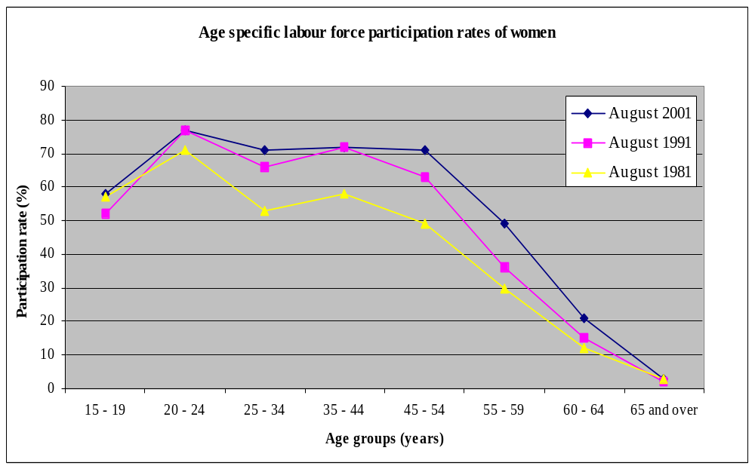Figure 2: Age specific labour force participation rates of women, 1981, 1991 and 2001

Source: Labour Force, Selected Summary Tables, Monthly (ABS Cat. no. 6291.0.40.001)

- The labour force participation rate for women aged 15-64 years is currently 66 per cent.

3.3 Labour force participation - women of child-bearing age

- Figure 3 shows the differences in labour force participation of women of child-bearing age according to the women’s age group. In particular, it highlights the current participation rate of women of peak child-bearing age (25-34 years) which, although lower than that of women aged 20-24 years, remains relatively high at 70 per cent.

Figure 3: Labour force participation rates for women of child-bearing age, May 2002

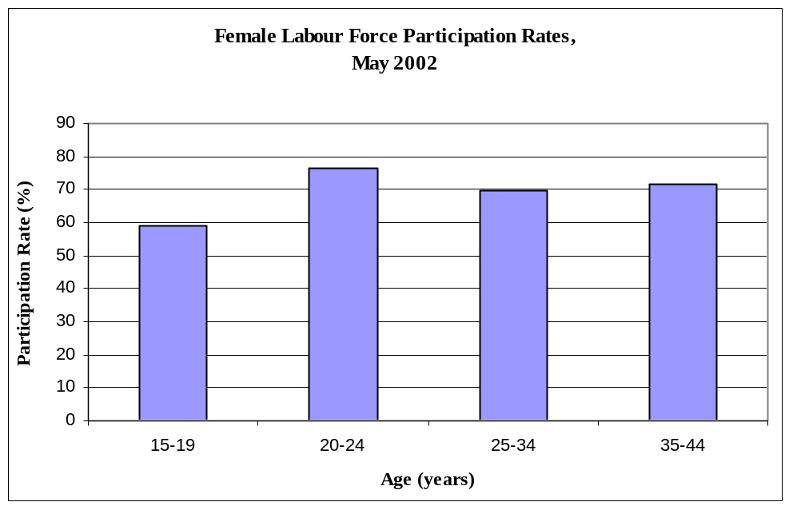

Source: Labour Force, May 2001 (ABS Cat. no. 6203.0)

3.3.1 Labour force status of women of child-bearing age
- Table 2 shows the most recent labour force status data for women of child-bearing age (15-44 years). Of these women, 65 per cent are employed, 5 per cent are unemployed and 30 per cent are not in the labour force.

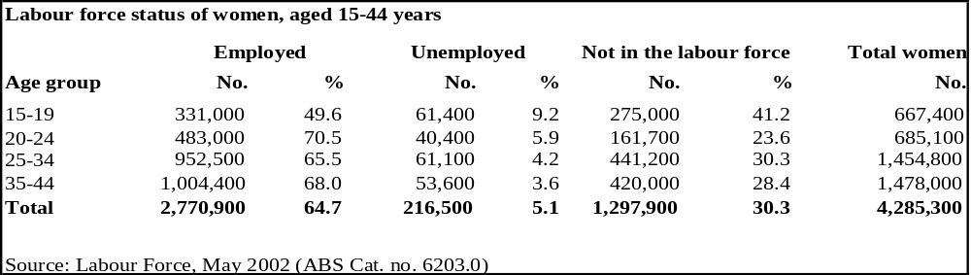Table 2: Age-specific labour force status of women of child-bearing age

3.3.2 Employment status of women of child-bearing age
- Table 3 shows the proportions of full-time and part-time employment among women of child-bearing age in May 2002. Fifty-four per cent of employed women of child-bearing age were in full-time employment while 46 per cent of this group worked part-time. Rates of part-time work are highest in the youngest age group of 15-19 years followed by the 35-44 year age group. Rates of part-time work are lowest in the peak child-bearing age group of 25-34 years.

Table 3: Full-time and part-time employment of women workers of child-bearing age
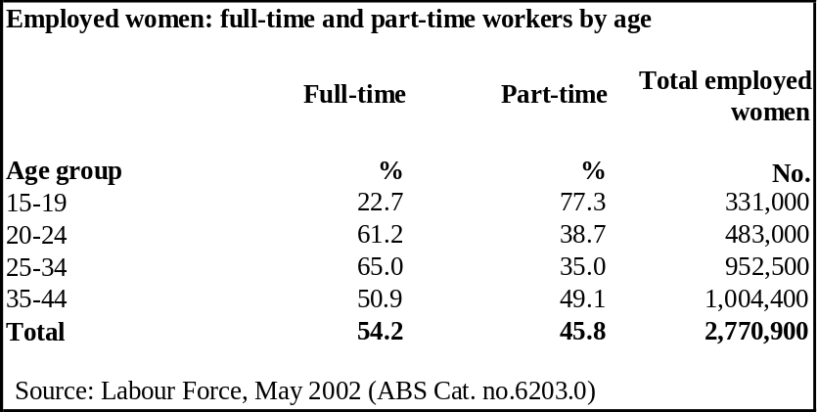

3.3.3 Casual work – women of child-bearing age
- In 2000, the percentage of employed women of child-bearing age who worked in casual employment was 29 per cent. Table 4 shows that rates of casual work decreased with age from a high of 72 per cent in the youngest age group, to a low of 20 per cent in the 35 to 44 year age group.

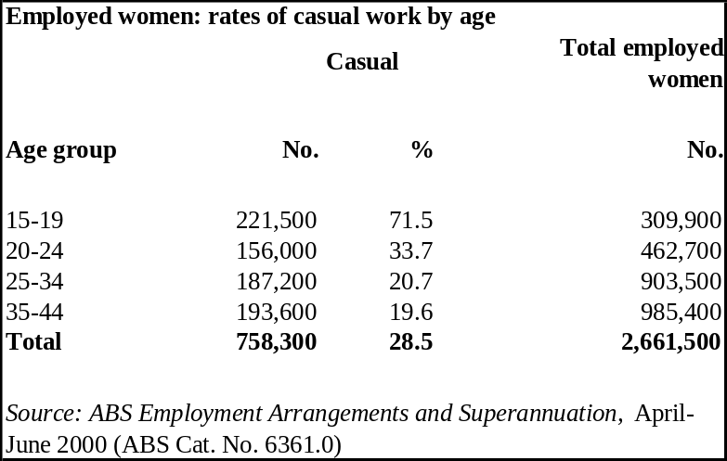
Table 4: Rates of casual employment of women workers of child-bearing age

3.4 Labour force participation - women with dependent children

3.4.1 Labour force status of women with dependent children
- Table 5 and Figure 4 show the labour force status of women with dependent children in 2000 (according to the women’s age group, where women were aged between 15 and 44 years). Of these women, 57 per cent were employed, 5 per cent were unemployed and 39 per cent were not in the labour force. A total of 46 per cent of women aged between 15 and 44 years had dependant children.
- The 35-44 year age group had the highest rate of employment of the age groups recorded, with 66 per cent within this age group employed (representing 64 per cent of employed women with dependant children across the age groups given). Forty-seven per cent of women of peak child-bearing age were not in the labour force.
- Published data on whether these women worked full-time or part-time (or whether they worked casually or permanently) is not available.
Table 5: Labour force status of women with dependent children

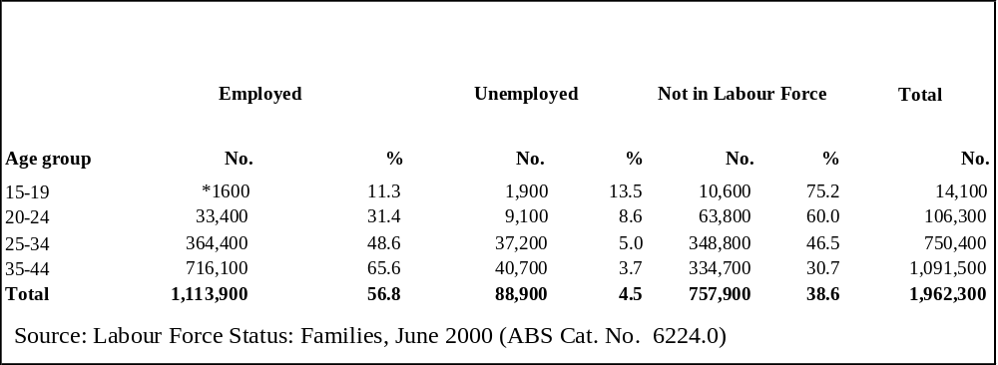*subject to sampling variability

Figure 4: Labour force status of women aged 15-44 years with dependent children

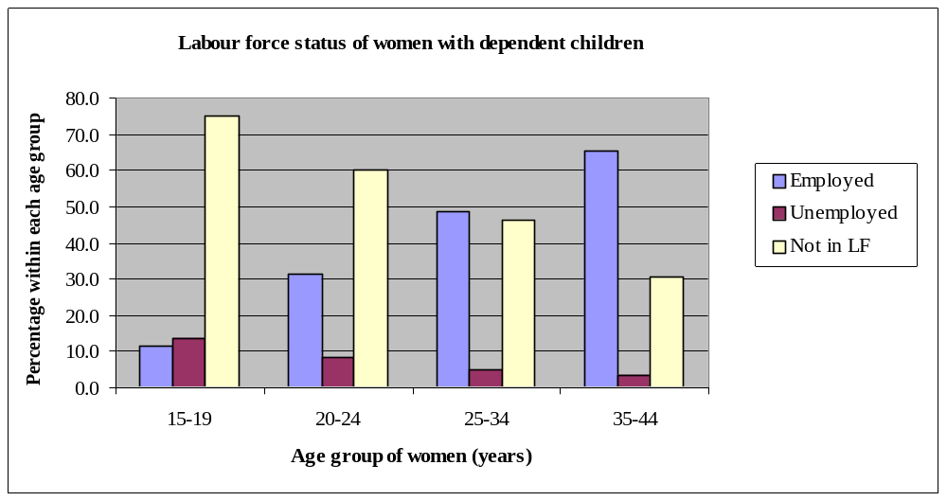Source: Labour Force Status: Families, June 2000 (ABS Cat. no. 6224.0)

3.4.2 Labour force status of women with dependent children by youngest dependant’s age group
- Table 6 shows the labour force status of women with dependants according to the age of the youngest dependant, with dependants aged up to 14 years, in 2000.
- Women with youngest children aged four years and under had the lowest employment rate of this population at 45 per cent, the majority (67 per cent) of whom worked part-time). Of this group just over half were not in the labour force (51 per cent).
- In contrast, women whose youngest dependant children were aged 10 years and over had the highest rate of employment of the population at 70 per cent, with about half of these women working full-time and half working part-time.
- Published data on whether the women worked casually or permanently is not available.
Table 6: Labour force status of women with dependants by age of youngest dependant
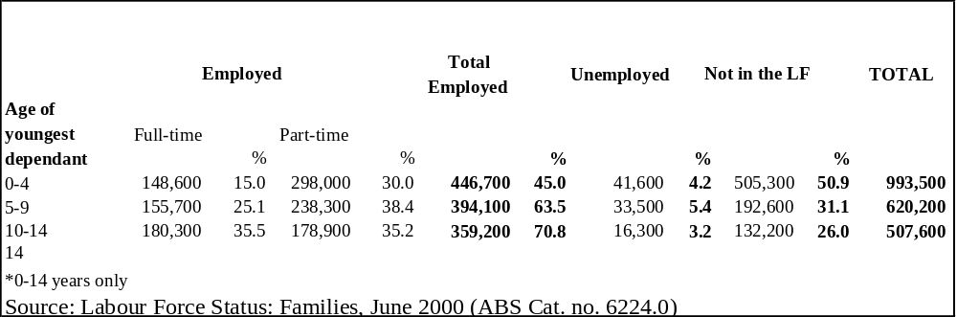

3.5 Breaks in employment of women with young children

- A 1998 survey recorded the responses of women employees with children under six years, who took a career break when their youngest child was born and had completed their break at the time of the survey. Figure 5 shows the lengths of breaks taken by this group. Seventy-three per cent took less than one year’s leave.
- Lengths of breaks under one year were taken as follows:
- Nine percent took less than six weeks’ leave;
- Twelve per cent took six weeks and less than three months’ leave;
- Twenty per cent took three months and less than six months’ leave; and
- Thirty-two per cent took six months and less than one year’s leave.

Figure 5: Length of break taken by women employees with children under six years when youngest child was born
0
5
10
15
20
25
30
35
Less than 6
weeks
6 weeks to < 3
months
3 months to < 6
months
6 months to < 1
year
1 year or more
Length of break taken
Percentage

Source: Career Experience, November 1998 (ABS Cat. no. 6254.0)

- Figure 6 shows the type of leave taken by women employees with children under six years who took a break when their youngest child was born. Of this group, 16 per cent took ‘paid leave only’ (importantly, paid leave may consist of other leave entitlements than paid maternity leave, for example recreation or long service leave), 43 per cent took unpaid leave only, 23 per cent took ‘paid and unpaid leave or other arrangements’, and 18 per cent ‘ceased work’.
Figure 6: Type of leave taken by women employees with children under six years who took a break when the youngest child was born
0
10
20
30
40
50
Paid leave only
Unpaid leave only
Paid and unpaid leave
or other
arrangements
Ceased work
Type of leave
Percentage

Source: Career Experience, November 1998 (ABS Cat. no. 6254.0)
- Figure 7 shows the relationship between the type of leave and the length of time taken on leave. It shows that the most common length of time taken for women on ‘paid leave only’ was six weeks to less than three months (28 per cent), while few women in the ‘paid leave only’ category took leave for one year or more (six per cent). By contrast, of all those who ceased work, 47 per cent took a long break of one year or more.
Figure 7: Women employees with children under six years who took a break when their youngest child was born
0.0
5.0
10.0
15.0
20.0
25.0
30.0
35.0
40.0
45.0
50.0
Paid leave only
Unpaid leave only
Paid and unpaid leave
or other arrangements
Ceased work
Type of break taken
Percentage
Less than 6 weeks
6 weeks to < 3 months
3 months to < 6 months
6 months to < 1 year
1 year or more

Source: Career Experience, November 1998 (ABS Cat. no. 6254.0)

3.6 Employed women’s earnings

- Figure 8 sets out the weekly earnings of full-time and part-time women workers in all jobs. The distribution for both full-time and part-time women workers is skewed towards lower rates of earnings. The median weekly earnings in all jobs for full-time women workers is $651 per week, while the median earnings for part-time workers is $284 per week.
- Seven per cent of all full-time women workers and 66per cent of all part-time women workers earn less than $400 per week. Thirty-three per cent of all women workers earn less than $400 per week.

Figure 8: Weekly earnings in all jobs of full-time and part-time female workers
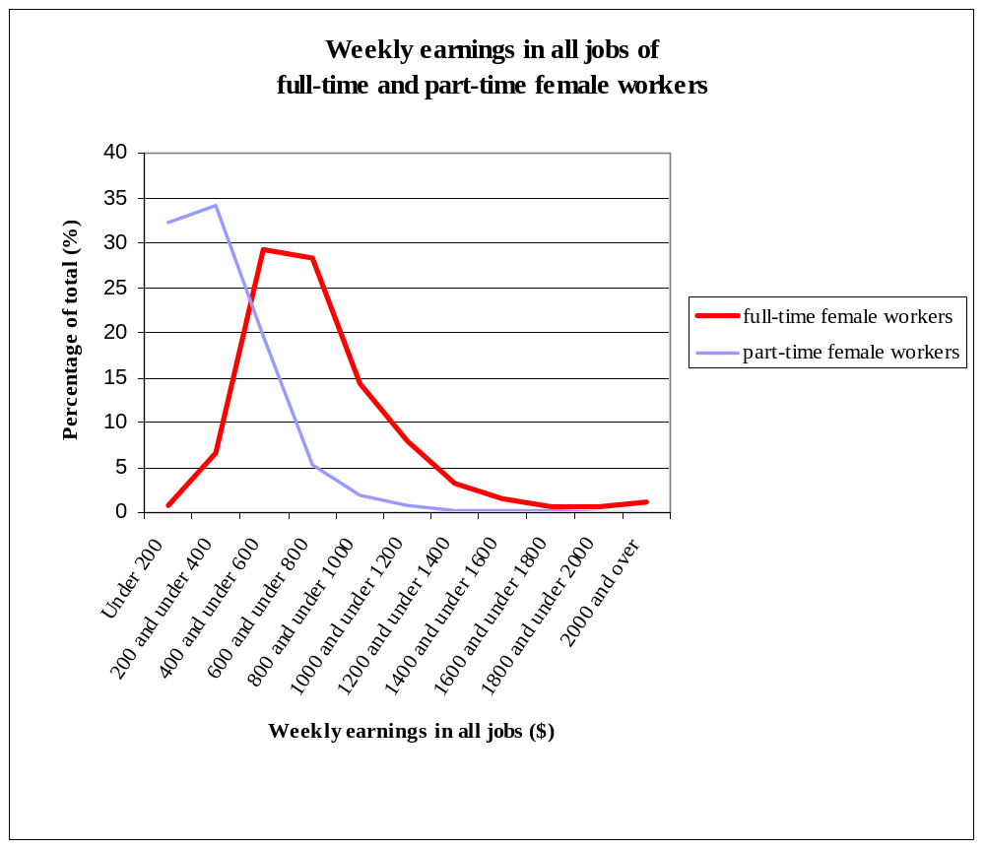

Source: Employee Earnings, Benefits and Trade Union Membership, August 2001
(ABS Cat. No. 6310.0)

3.7 Women in small business

- In June 2001, 526,900 small business operators were women. This represents about 13 per cent of all women in employment at the time. Of the women who were small business operators, 329,000 (62 per cent) were aged between 30 and 50.
- The number of female small business operators has increased at an average annual rate of 10 per cent since 1999 (compared to 8 per cent for male operators).
4 Financial assistance provided following the birth of a child

- The Department of Family and Community Services (FaCS) provides a range of financial and other supports to help families with their caring responsibilities in relation to children. This support is provided in a number of ways, including financial assistance and parenting and relationship services. The following describes the range of financial assistance available to families following the birth of a child, and includes the governments recent tax initiative – the Baby Bonus.

4.1 Maternity Allowance
- Maternity Allowance - a lump sum payment available for each child born in recognition of the costs incurred at that time. Maternity Allowance is:
- a one-off payment of $798.72; and
- available to families who qualify for Family Tax Benefit Part A within 13 weeks of the baby’s birth and who claim within 26 weeks of birth.
During 2001-2002, around 210,000 customers (families) were paid Maternity Allowance for around 214,000 children.*
- In addition, Maternity Immunisation Allowance (MIA) is available once a child reaches 18 months and meets immunisation requirements for its age (or has an exemption). MIA is a one-off lump sum payment of $208 and subject to similar conditions as Maternity Allowance. Around 206,000 customers (families) received Maternity Immunisation Allowance in 2001-02 for around 210,000 children.*
(* Final figures for 2001-02 are not currently available.)

4.2 Family Tax Benefit Part A and B
- Family Tax Benefit Part A (FTB(A)) - provides income-tested help with the cost of raising children. Rates of payment generally vary depending on the number and age of children and the family income level. In short, FTB(A):
- is paid up to a maximum rate of $126.70pf for children aged under 13 years, up to $160.72pf for children aged 13-15 years. FTB(A) is also available for dependents aged 16-17 years (up to a maximum of $40.74pf) and those aged 18-24 years (up to a maximum of $54.74pf);
- is paid at the maximum rate for families with taxable incomes of $30,806 or less (regardless of the number of children);
- reduces by 30c for every dollar over this amount until it reaches a basic payment level, which continues to be available up to a family income level of $79,643pa plus $3,212 for each FTB dependent child after the first - after which assistance is reduced by 30 cents in the dollar;
- is available as a fortnightly payment, reduced tax instalments or annual lump sum through the tax system – most (around 90 per cent) people choose fortnightly payment; and
- may be payable for dependent children up to the age of 21, or dependent student child up to 24;
- at June 2002, there were approximately 1.8 million customers with approximately 3.5 million children who received FTB(A) fortnightly during 2001-02. (Around a further 97,000 families accessed FTB(A) through the tax system for the year 2001-02.)
- the vast majority of Australian families receive FTB(A); and
- there is a range of extra payments that may be provided as part of FTB(A). These include:
- Large Family Supplement - a payment of $8.68 per fortnight, available for the fourth and each subsequent child in a family;
- Multiple Birth Allowance - available where three or more children are born during the same birth, paid for children aged under 6 years and at rates of $105.98 per fortnight for triplets or $141.40 per fortnight for quadruplets or more; and
- Rent Assistance – for people who rent privately, with the amounts varying depending on the amount of rent paid and the number of children.

- Family Tax Benefit Part B (FTB(B)) - provides additional income tested assistance for families with only one main income earner (including lone parents). Payment can be fortnightly, as reduced tax instalments or as a lump sum (as per FTB(A)).
- FTB(B) is paid to families with dependent children aged up to 16, or 18 if an eligible dependent student. Maximum rate of $108.78pf where the youngest child is below 5 years and $75.88pf if the youngest child is 5 or older.
- The only income test that applies is to the secondary earner in a couple. For these, an annual income limit of $1,752 applies, after which payment is reduced by 30 cents for each dollar. No income test applies to primary earners in a couple or lone parents.
- At 30 June 2002, there were approximately 1.2 million single income families with 2.3 million children receiving FTB (B) through fortnightly payments. Figures are not available on the number of claims made through the tax system.

4.3 Parenting Payment
- Parenting Payment - provides income support for the primary carer of a dependent child under 16.
- It is income and assets tested and paid to both single and partnered parents.
- The maximum rate for Parenting Payment single is $421.80 a fortnight and for Parenting Payment partnered is $322.80.
- Parenting Payment recipients may also qualify for Pharmaceutical Allowance, Education Entry Payment and Employment Entry Payment. They are also eligible for assistance under the Jobs, Education and Training (JET) Program, which assists with workforce entry or re-entry.
- As at June 2002, 427,847 parents received Parenting Payment (single) and 191,576 parents received Parenting Payment (partnered).
- Government spending on Parenting Payment was $5.571 billion in 2001-02.

4.4 Child Care Benefit
- In addition to direct financial assistance, families may also be assisted in other ways following the birth of a child. These include:
- Child Care Benefit (CCB) - which is paid where approved or registered child care is used.
- CCB for approved child care may be provided as reduced child care fees or as a lump sum after the end of financial year. CCB for registered care is reimbursed upon production of receipts at FAO offices (in Centrelink, ATO or Medicare Offices).
- CCB for approved child care is income tested and makes allowance for multiple children in care.
- Maximum benefit for low income families of $133 a week for one child using 50 hours week at an approved child care service.
- Minimum rate of CCB of $0.447 per hour of approved or registered child care (up to 50 hours per week).
- There are currently approximately 720,000 children from 508,000 families in Commonwealth approved child care services; 36.4% are low income families.
- The number of child care places, the number of children in care and the usage of child care services have been increasing.

4.5 Support services for families
- FaCS also administers payments for a range of family relationships and parenting support programs to help provide a better environment for raising children.
- Stronger Families and Communities Strategy focuses on early intervention and prevention initiatives to help strengthen and support Australian families.
- Family Relationships Services Program (FRSP) provides funding for over 100 community organisations to provide family relationship services through over 400 outlets around the country.
- Indigenous Parenting and Family Wellbeing Initiative recognises and promotes the importance of strong families among Aboriginal and Torres Strait Islander people.
- Services for Families with Children supports the provision of practical assistance to families with babies and young children, recognises and supports the needs of carers at home with children, and provides a wide range of activities in the areas of health, welfare, education and child care.

4.6 Baby Bonus
- The Government has implemented its election commitment to provide further tax relief to families, through the introduction of the Baby Bonus. The Baby Bonus is a refundable tax offset that recognises that one of the hardest times for families financially is the birth of a first child, where one parent may give up or reduce paid employment to care for the child.
- The Baby Bonus took effect on 1 July 2002 and applies to the first child born on or after 1 July 2001. As a transitional measure, the Baby Bonus is also available to families who already have children, for the arrival of their first subsequent child on or after 1 July 2001.
- The main elements of the Baby Bonus are:
- it is available to parents following the birth, adoption or otherwise obtaining of legal responsibility for a child on or after 1 July 2001;
- it is a refundable tax offset of up to one fifth of the tax payable on the income earned in the year prior to the birth of the child, up to a maximum of $2,500 per annum until the child turns 5 years of age;
- the Baby Bonus entitlement is calculated by comparing the taxable income of a person in the base year to the taxable income in the claim year – parents returning to work are still eligible for the Baby Bonus, but the entitlement is reduced in proportion to the income earned;
- a minimum annual benefit of $500 is available to parents with annual incomes of $25,000 or less in the year they claim the Baby Bonus;
- mothers who were not in the workforce and did not pay tax in the year prior to the birth of a child are eligible for this minimum entitlement;
- a person may choose to transfer their entitlement to the Baby Bonus to their spouse; and
- the Baby Bonus is claimed as part of the tax return. It is available for tax returns submitted from the 2001-2002 financial year. For those individuals who would not otherwise lodge a tax return, a claim form is available from the Australian Taxation Office.

ATTACHMENT A
Comparison of legislated minimum parental leave conditions

 | Federal | Federal Awards | Vic | Qld | NSW | Tas | WA | SA
Parental leave | 52 weeks unpaid after 12months continuous service (can be shared between parents- parents cannot take parental leave at the same time, except for the initial one week entitlement of the spouse of the woman on maternity leave)(s.14). This entitlement applies to all employees nationally as it is based on the external affairs power but it is intended to supplement not override arrangements in other State and Territory legislation and awards. | 52 weeks unpaid after 12months continuous service (can be shared between parents). Parental leave test case (1990). | 52 weeks unpaid after 12months continuous service (can be shared between parents- but cannot be taken at the same time (except for the initial one week entitlement of the spouse of the woman on maternity leave) and the period of maternity leave must be unbroken. 6 weeks maternity leave immediately following confinement is compulsory. | 52 weeks unpaid after 12 months continuous service or (for casuals) after 12 months employed on a regular and systemic basis, excluding seasonal employees and pieceworkers. Parents cannot take parental leave at the same time (except for the initial one week entitlement of the spouse of the woman on maternity leave). (s.16,17,18,25) Overrides less favourable award conditions (s.41) | 52 weeks unpaid after 12 months continuous service (s.54) including part-time and regular casual employees. | The lowest amount of parental leave specified in any award (s.61F[2]c).  52 Weeks as per federal WR Act to act as a minimum. | 52 weeks unpaid after 12mths continuous service. Parents cannot take parental leave at the same time except for 1 week at the time of the birth of the child). 10 weeks notice is required (Minimum Conditions of Employment Act 1993, s.33). | 52 weeks unpaid after 12mths continuous service (can be shared between parents)(IERA, s.72, Schedule 5)

ATTACHMENT B

Table i: Periods of paid maternity leave and paid paternity leave in current** federal agreements.

 | Number of CAs |  | % of CAs
Period of paid leave | Maternity Leave | Paternity Leave | Maternity Leave | Paternity Leave
Days: 1 | # | 3 | # | 1
2 | 7 | 17 | 1 | 3
3 | 2 | 15 | * | 3
Weeks: 1 | 74 | 433 | 8 | 76
2 | 107 | 46 | 12 | 8
3 | 15 | 8 | 2 | 1
4 | 47 | 2 | 5 | *
5 | 3 | # | * | #
6 | 298 | 20 | 32 | 4
7 | # | # | # | #
8 | 20 | # | 2 | #
9 | 14 | 2 | 2 | *
10 | 1 | # | * | #
11 | # | # | # | #
12 | 276 | 3 | 30 | 1
13 | 7 | # | 1 | #
14 | 2 | # | * | #
16 | # | # | # | #
18 | 2 | # | * | #
Quantum not specified | 42 | 18 | 5 | 3
Number of CAs with Paid Leave | 917 | 567
As % of all current CA's | 7 | 4

Source: DEWR Workplace Agreements Database
* no incidence recorded
** current as at 31 March 2002
# less than 0.05 per cent

Table ii: Current** Incidence, Coverage of Females and Duration of Paid Maternity Leave by Industry

Industry |  | Incidence % |  | Coverage % |  | Duration  (Average weeks per year)
Agriculture, Forestry & Fishing |  | 6 |  | 46 |  | 9.0
Mining | 1 |  | 3 |  | 12.0
Manufacturing | 5 |  | 17 |  | 4.8
Electricity, Gas & Water Supply | 21 |  | 47 |  | 11.2
Construction | 1 |  | 1 |  | 1.6
Wholesale Trade | 8 |  | 26 |  | 3.9
Retail Trade | 2 |  | 1 |  | 4.9
Accommodation, Cafes & Restaurants | 5 |  | 3 |  | 5.9
Transport and Storage | 3 |  | 43 |  | 6.4
Communication Services | 18 |  | 11 |  | 9.3
Finance & Insurance | 30 |  | 36 |  | 7.7
Property & Business Services | 8 |  | 15 |  | 9.1
Government Administration & Defence | 27 |  | 73 |  | 9.3
Education | 50 |  | 55 |  | 10.5
Health & Community Services | 33 |  | 63 |  | 5.0
Cultural & Recreational Services | 21 |  | 19 |  | 9.7
Personal & Other Services | 10 |  | 47 |  | 7.8
Total | 7 |  | 36 |  | 7.0

Source: DEWR Workplace Agreements Database
** current as at 31 March 2002

ATTACHMENT C

Table iii: Current** Incidence, Coverage of Males and Duration of Paid Paternity Leave by Industry.

Industry | Incidence % | Coverage % | Duration (Average weeks per year)
Agriculture, Forestry & Fishing | 1 | * | 1.0
Mining | * | 1 | N/A
Manufacturing | 3 | 11 | 1.2
Electricity, Gas & Water Supply | 17 | 25 | 1.1
Construction | 1 | 1 | 1.0
Wholesale Trade | 5 | 13 | 0.7
Retail Trade | 1 | * | 1.9
Accommodation, Cafes & Restaurants | 3 | * | 1.0
Transport and Storage | 3 | 4 | 1.1
Communication Services | 11 | 8 | 1.0
Finance & Insurance | 21 | 23 | 1.5
Property & Business Services | 5 | 13 | 1.9
Government Administration & Defence | 14 | 23 | 1.6
Education | 34 | 41 | 1.5
Health & Community Services | 16 | 12 | 1.2
Cultural & Recreational Services | 10 | 8 | 1.1
Personal & Other Services | 7 | 48 | 3.4
Total | 4 | 14 | 1.4

Source: DEWR Workplace Agreements Database
* represents less than 0.5 per cent
** current as at 31 March 2002
N/A industry did not specify the amount of paid maternity leave provisions

AtTACHMENT D

SURVEY OF EMPLOYMENT ARRANGEMENTS AND SUPERANNUATION (SEAS)

Table iv: Entitlement to paid maternity or paternity leave - Employees (excluding owner-managers)

 | Entitled to paid maternity/paternity leave |  | Not entitled | Did not know | Total
 | ('000) | (%) | ('000) | ('000) | ('000)
Female
Self identified casuals | 3.4 | 0.4% | 891.5 | 59.9 | 954.8
Other employees | 1232.4 | 53.6% | 537.5 | 529.9 | 2299.8
Total | 1235.8 | 38.0% | 1429 | 589.8 | 3254.6
Male
Self identified casuals | 3.7 | 0.6% | 583.1 | 54.7 | 641.5
Other employees | 1204.1 | 40.9% | 758.1 | 985.2 | 2947.4
Total | 1207.8 | 33.7% | 1341.2 | 1039.9 | 3588.9
Total
Self identified casuals | 7.1 | 0.4% | 1474.7 | 114.6 | 1596.4
Other employees | 2436.6 | 46.4% | 1295.7 | 1515.1 | 5247.4
Total | 2443.7 | 35.7% | 2770.4 | 1629.7 | 6843.8

Source: ABS 6361.0 Survey of Employment Arrangements and Superannuation April – June 2000 unpublished data.

Table v: Female employees (excluding owner-managers) entitled to paid maternity leave

 | Public sector  (‘000) | Private sector  (‘000) | Not determined  (‘000) | Total  (‘000) | % of total female employees
Labour force status
Employed full time | 402.4 | 537.9 | 9.1 | 949.4 | 50.9%
Employed part time | 116.5 | 167.9 | 2.0 | 286.5 | 20.8%
Industry
Agriculture Forestry and Fishing | - | 1.8 | - | 1.8 | 4.5%
Mining | - | 3.2 | - | 3.2 | 47.1%
Manufacturing | - | 86.2 | - | 86.2 | 36.7%
Electricity Gas and Water Supply | 2.9 | 1.9 | - | 4.7 | 49.5%
Construction | 0.5 | 12.3 | - | 12.8 | 32.0%
Wholesale Trade | 0.3 | 37.1 | - | 37.4 | 33.8%
Retail Trade | 1.2 | 108.6 | - | 109.7 | 20.2%
Accommodation Cafes and Restaurants | 0.1 | 28.2 | 0.6 | 28.9 | 13.4%
Transport and Storage | 5.5 | 14.8 | - | 20.3 | 30.8%
Communication Services | 20.1 | 4.2 | 0.7 | 25.0 | 59.1%
Finance and Insurance | 11.2 | 92.7 | 0.4 | 104.2 | 59.0%
Property and Business Services | 8.6 | 104.1 | 0.6 | 113.2 | 30.5%
Government Administration and Defence | 113.1 | 1.4 | 0.4 | 114.9 | 68.1%
Education | 180.1 | 59.0 | 0.6 | 239.7 | 57.0%
Health and Community Services | 147.7 | 120.0 | 6.8 | 274.4 | 44.9%
Cultural and Recreational Services | 10.7 | 13.3 | 0.9 | 24.9 | 28.2%
Personal and Other Services | 17.2 | 17.4 | 0.1 | 34.6 | 31.4%
Occupation
Managers and Administrators | 27.1 | 24.1 | - | 51.3 | 64.6%
Professionals | 247.4 | 136.4 | 5.9 | 389.7 | 54.2%
Associate Professionals | 56.8 | 83.7 | 0.6 | 141.2 | 46.0%
Tradespersons and Related Workers | 3.3 | 15.8 | - | 19.0 | 24.3%
Advanced Clerical and Service Workers | 27.0 | 80.6 | 0.4 | 108.1 | 44.1%
Intermediate Clerical, Sales and Service Workers | 121.0 | 231.1 | 2.9 | 355.0 | 37.4%
Intermediate Production and Transport Workers | 0.8 | 26.0 | - | 26.7 | 25.6%
Elementary Clerical, Sales and Service Workers | 20.3 | 69.7 | 0.9 | 91.0 | 17.9%
Labourers and Related Workers | 15.0 | 38.4 | 0.3 | 53.8 | 20.5%
Time worked in job
Less than 1 year | 47.3 | 157.0 | 2.4 | 206.7 | 23.7%
1 year to less than 5 years | 133.3 | 271.3 | 4.2 | 408.8 | 34.2%
5 years to less than 10 years | 110.4 | 136.3 | 3.0 | 249.7 | 48.4%
10 years and over | 227.9 | 141.4 | 1.4 | 370.7 | 55.2%
Total | 518.9 | 705.8 | 11.1 | 1235.9 | 38.0%

Source: ABS 6361.0 Survey of Employment Arrangements and Superannuation April – June 2000 unpublished data.
ATTACHMENT E

ILO Convention 183 concerning the revision of the Maternity Protection Convention (Revised), 1952
The General Conference of the International Labour Organization,

Having been convened at Geneva by the Governing Body of the International Labour Office, and having met in its 88th Session on 30 May 2000, and

Noting the need to revise the Maternity Protection Convention (Revised), 1952, and the Maternity Protection Recommendation, 1952, in order to further promote equality of all women in the workforce and the health and safety of the mother and child, and in order to recognize the diversity in economic and social development of Members, as well as the diversity of enterprises, and the development of the protection of maternity in national law and practice, and

Noting the provisions of the Universal Declaration of Human Rights (1948), the United Nations Convention on the Elimination of All Forms of Discrimination Against Women (1979), the United Nations Convention on the Rights of the Child (1989), the Beijing Declaration and Platform for Action (1995), the International Labour Organization's Declaration on Equality of Opportunity and Treatment for Women Workers (1975), the International Labour Organization's Declaration on Fundamental Principles and Rights at Work and its Follow-up (1998), as well as the international labour Conventions and Recommendations aimed at ensuring equality of opportunity and treatment for men and women workers, in particular the Convention concerning Workers with Family Responsibilities, 1981, and

Taking into account the circumstances of women workers and the need to provide protection for pregnancy, which are the shared responsibility of government and society, and

Having decided upon the adoption of certain proposals with regard to the revision of the Maternity Protection Convention (Revised), 1952, and Recommendation, 1952, which is the fourth item on the agenda of the session, and

Having determined that these proposals shall take the form of an international Convention;

adopts this fifteenth day of June of the year two thousand the following Convention, which may be cited as the Maternity Protection Convention, 2000.

SCOPE

Article 1

For the purposes of this Convention, the term woman applies to any female person without discrimination whatsoever and the term child applies to any child without discrimination whatsoever.

Article 2

1. This Convention applies to all employed women, including those in atypical forms of dependent work.

2. However, each Member which ratifies this Convention may, after consulting the representative organizations of employers and workers concerned, exclude wholly or partly from the scope of the Convention limited categories of workers when its application to them would raise special problems of a substantial nature.

3. Each Member which avails itself of the possibility afforded in the preceding paragraph shall, in its first report on the application of the Convention under article 22 of the Constitution of the International Labour Organization, list the categories of workers thus excluded and the reasons for their exclusion. In its subsequent reports, the Member shall describe the measures taken with a view to progressively extending the provisions of the Convention to these categories.

HEALTH PROTECTION
Article 3

Each Member shall, after consulting the representative organizations of employers and workers, adopt appropriate measures to ensure that pregnant or breastfeeding women are not obliged to perform work which has been determined by the competent authority to be prejudicial to the health of the mother or the child, or where an assessment has established a significant risk to the mother's health or that of her child.

MATERNITY LEAVE
Article 4

1. On production of a medical certificate or other appropriate certification, as determined by national law and practice, stating the presumed date of childbirth, a woman to whom this Convention applies shall be entitled to a period of maternity leave of not less than 14 weeks.

2. The length of the period of leave referred to above shall be specified by each Member in a declaration accompanying its ratification of this Convention.

3. Each Member may subsequently deposit with the Director-General of the International Labour Office a further declaration extending the period of maternity leave.

4. With due regard to the protection of the health of the mother and that of the child, maternity leave shall include a period of six weeks' compulsory leave after childbirth, unless otherwise agreed at the national level by the government and the representative organizations of employers and workers.

5. The prenatal portion of maternity leave shall be extended by any period elapsing between the presumed date of childbirth and the actual date of childbirth, without reduction in any compulsory portion of postnatal leave.

LEAVE IN CASE OF ILLNESS OR COMPLICATIONS
Article 5

On production of a medical certificate, leave shall be provided before or after the maternity leave period in the case of illness, complications or risk of complications arising out of pregnancy or childbirth. The nature and the maximum duration of such leave may be specified in accordance with national law and practice.

BENEFITS
Article 6

1. Cash benefits shall be provided, in accordance with national laws and regulations, or in any other manner consistent with national practice, to women who are absent from work on leave referred to in Articles 4 or 5.

2. Cash benefits shall be at a level which ensures that the woman can maintain herself and her child in proper conditions of health and with a suitable standard of living.

3. Where, under national law or practice, cash benefits paid with respect to leave referred to in Article 4 are based on previous earnings, the amount of such benefits shall not be less than two-thirds of the woman's previous earnings or of such of those earnings as are taken into account for the purpose of computing benefits.

4. Where, under national law or practice, other methods are used to determine the cash benefits paid with respect to leave referred to in Article 4, the amount of such benefits shall be comparable to the amount resulting on average from the application of the preceding paragraph.

5. Each Member shall ensure that the conditions to qualify for cash benefits can be satisfied by a large majority of the women to whom this Convention applies.

6. Where a woman does not meet the conditions to qualify for cash benefits under national laws and regulations or in any other manner consistent with national practice, she shall be entitled to adequate benefits out of social assistance funds, subject to the means test required for such assistance.

7. Medical benefits shall be provided for the woman and her child in accordance with national laws and regulations or in any other manner consistent with national practice. Medical benefits shall include prenatal, childbirth and postnatal care, as well as hospitalization care when necessary.

8. In order to protect the situation of women in the labour market, benefits in respect of the leave referred to in Articles 4 and 5 shall be provided through compulsory social insurance or public funds, or in a manner determined by national law and practice. An employer shall not be individually liable for the direct cost of any such monetary benefit to a woman employed by him or her without that employer's specific agreement except where:

(a) such is provided for in national law or practice in a member State prior to the date of adoption of this Convention by the International Labour Conference; or
(b) it is subsequently agreed at the national level by the government and the representative organizations of employers and workers.

Article 7

1. A Member whose economy and social security system are insufficiently developed shall be deemed to be in compliance with Article 6, paragraphs 3 and 4, if cash benefits are provided at a rate no lower than a rate payable for sickness or temporary disability in accordance with national laws and regulations.

2. A Member which avails itself of the possibility afforded in the preceding paragraph shall, in its first report on the application of this Convention under article 22 of the Constitution of the International Labour Organization, explain the reasons therefore and indicate the rate at which cash benefits are provided. In its subsequent reports, the Member shall describe the measures taken with a view to progressively raising the rate of benefits.

EMPLOYMENT PROTECTION AND NON-DISCRIMINATION
Article 8

1. It shall be unlawful for an employer to terminate the employment of a woman during her pregnancy or absence on leave referred to in Articles 4 or 5 or during a period following her return to work to be prescribed by national laws or regulations, except on grounds unrelated to the pregnancy or birth of the child and its consequences or nursing. The burden of proving that the reasons for dismissal are unrelated to pregnancy or childbirth and its consequences or nursing shall rest on the employer.

2. A woman is guaranteed the right to return to the same position or an equivalent position paid at the same rate at the end of her maternity leave.

Article 9

1. Each Member shall adopt appropriate measures to ensure that maternity does not constitute a source of discrimination in employment, including - notwithstanding Article 2, paragraph 1 - access to employment.

2. Measures referred to in the preceding paragraph shall include a prohibition from requiring a test for pregnancy or a certificate of such a test when a woman is applying for employment, except where required by national laws or regulations in respect of work that is:

(a) prohibited or restricted for pregnant or nursing women under national laws or regulations; or
(b) where there is a recognized or significant risk to the health of the woman and child.

BREASTFEEDING MOTHERS
Article 10

1. A woman shall be provided with the right to one or more daily breaks or a daily reduction of hours of work to breastfeed her child.

2. The period during which nursing breaks or the reduction of daily hours of work are allowed, their number, the duration of nursing breaks and the procedures for the reduction of daily hours of work shall be determined by national law and practice. These breaks or the reduction of daily hours of work shall be counted as working time and remunerated accordingly.

PERIODIC REVIEW
Article 11

Each Member shall examine periodically, in consultation with the representative organizations of employers and workers, the appropriateness of extending the period of leave referred to in Article 4 or of increasing the amount or the rate of the cash benefits referred to in Article 6.

IMPLEMENTATION
Article 12

This Convention shall be implemented by means of laws or regulations, except in so far as effect is given to it by other means such as collective agreements, arbitration awards, court decisions, or in any other manner consistent with national practice.

FINAL PROVISIONS
Article 13

This Convention revises the Maternity Protection Convention (Revised), 1952.

Article 14

The formal ratifications of this Convention shall be communicated to the Director-General of the International Labour Office for registration.

Article 15

1. This Convention shall be binding only upon those Members of the International Labour Organization whose ratifications have been registered with the Director-General of the International Labour Office.

2. It shall come into force 12 months after the date on which the ratifications of two Members have been registered with the Director-General. 3. Thereafter, this Convention shall come into force for any Member 12 months after the date on which its ratification has been registered.

Article 16

1. A Member which has ratified this Convention may denounce it after the expiration of ten years from the date on which the Convention first comes into force, by an act communicated to the Director-General of the International Labour Office for registration. Such denunciation shall not take effect until one year after the date on which it is registered.

2. Each Member which has ratified this Convention and which does not, within the year following the expiration of the period of ten years mentioned in the preceding paragraph, exercise the right of denunciation provided for in this Article, will be bound for another period of ten years and, thereafter, may denounce this Convention at the expiration of each period of ten years under the terms provided for in this Article.

Article 17

1. The Director-General of the International Labour Office shall notify all Members of the International Labour Organization of the registration of all ratifications and acts of denunciation communicated by the Members of the Organization.

2. When notifying the Members of the Organization of the registration of the second ratification, the Director-General shall draw the attention of the Members of the Organization to the date upon which the Convention shall come into force.

Article 18

The Director-General of the International Labour Office shall communicate to the Secretary-General of the United Nations, for registration in accordance with article 102 of the Charter of the United Nations, full particulars of all ratifications and acts of denunciation registered by the Director-General in accordance with the provisions of the preceding Articles.

Article 19

At such times as it may consider necessary, the Governing Body of the International Labour Office shall present to the General Conference a report on the working of this Convention and shall examine the desirability of placing on the agenda of the Conference the question of its revision in whole or in part.

Article 20

1. Should the Conference adopt a new Convention revising this Convention in whole or in part, then, unless the new Convention otherwise provides:

(a) the ratification by a Member of the new revising Convention shall ipso jure involve the immediate denunciation of this Convention, notwithstanding the provisions of Article 16 above, if and when the new revising Convention shall have come into force;
(b) as from the date when the new revising Convention comes into force, this Convention shall cease to be open to ratification by the Members.

2. This Convention shall in any case remain in force in its actual form and content for those Members which have ratified it but have not ratified the revising Convention.

Article 21

The English and French versions of the text of this Convention are equally authoritative.

The 100 selected awards are a sample of major awards in the federal jurisdiction and all provide the basis for conditions of employment for large numbers of employees. Included in the selection are public and private sector awards, single employer and multi-employer awards, industry awards, occupational awards and awards from a broad cross-section of industry awards. The survey was undertaken by the Department of Employment and Workplace Relations in late 2000.
[(1979) 218 CAR 120]
[(1985) 298 CAR 321]
Print J3596
Print P7500
Print Q5596
PR904631
Data in this section is provided from the Department of Employment and Workplace Relations Workplace Agreements Database dated 3 April 2002 unpublished data - Attachment B [Table ii]
The following analysis of data is drawn from ABS 6361.0 Survey of Employment Arrangements and Superannuation April – June 2000 unpublished data.
This also applies to the Territory Governments.
Employees of departments and statutory authorities receive paid maternity leave however, those operating as trading enterprises do not.
In Western Australia there is scope for up to 6 weeks to be negotiated through the bargaining process, and this is occurring through local Certified Agreements. However, to date the provisions are not widespread, with only 58% of public sector employees having access up to 6 weeks paid maternity leave..
Both New Zealand and the United Kingdom have recently introduced legislative changes concerning paid maternity leave, which will enable both countries to review the status of their reservations to article 11 of CEDAW.
“Report of the Committee of Experts on the Application of Conventions and Recommendations: General Report and observations concerning particular countries, Report III (Part 4A), International Labour Conference, 81st Session, 1994”, International Labour Office (ILO), Geneva, 1994. In relation to Venezuela’s implementation of Convention 156 on page 493, the Committee states: “The maternity leave for adoptive mothers in the new Venezuelan Labour Act comes under the measures of protection provided for in Convention No. 103 which Venezuela has also ratified.”
Births 2000 (ABS Cat. no. 3301.0)
Labour Force, May 2002 (ABS Cat No 6203.0)
The ABS survey measures the full-time and part-time status by the number of hours worked per week. This does not identify whether the workers are casual or permanently employed. Full-time workers are defined as employed persons who usually work 35 hours or more a week (in all jobs). Part-time workers usually work less than 35 hours per week in all jobs.
The ABS survey (2000) measures people with one or more jobs who self-identify as casual workers.
Family members under 15 years of age
This only includes dependants up to the age of 14 years.
Full-time workers are employed persons who usually work 35 hours or more a week (in all jobs). Part-time workers usually work less than 35 hours per week in all jobs.
Career Experience, November 1998 (ABS Cat. no. 6254.0)
This was for women who completed their break at the time of the survey. There were a number of women in the survey who were still on breaks at the time of the survey for whom details of length and type of break were unavailable. Smaller percentages may be subject to standard error.
Career Experience, November 1998 (ABS Cat. no. 6254.0)
Weekly earnings equals the amount of “last total pay” from wage and salary jobs prior to the ABS survey interview (ie before taxation and other deductions have been made) - Employee Earnings, Benefits and Trade Union Membership, August 2001 (ABS Cat. No 6310.0).
92 per cent of all women workers (aged 15-69) have one job. Eight per cent have two or more jobs – Employment Arrangements and Superannuation, 2000 (ABS Cat. no 6361).
Employee Earnings, Benefits and Trade Union Membership, August 2001 (ABS Cat. no. 6310.0).
Ibid.
Of a total of 1,597,200 small business operators (men and women) in June 2001 (Characteristics of Small Business Survey June 2001, ABS Cat. no. 8127.0)
4,061,200 women were employed in June 2001 (Labour Force, June 2001, ABS Cat No 6203.0).

