 | First Floor, NFF House  14-16 Brisbane Avenue  BARTON ACT 2600  PO Box E10  KINGSTON ACT 2604  Phone 02 6273 2308  Freecall 1800 647 798  Fax 02 6273 7364

14 February 2003

Mr John Carter
Committee Secretary
Senate Employment, Workplace Relations
and Education References Committee
Parliament House
CANBERRA ACT 2600

Senate Inquiry into Skill and Labour Shortages and Related Matters

Please find attached a submission prepared by Rural Skills Australia (RSA) against the advertised terms of reference for the Senate Employment, Workplace Relations and Education References Committee inquiry into skill and labour shortages and related matters.

I would stress that this submission is a collection of views, opinions, suggestions and relevant supporting information complied by officers of RSA with an interest in the matters covered by the Inquiry’s terms of reference. It does not, nor purport to in any way represent or express the views, opinions or policies of the RSA Board or any of its member bodies, which include the National Farmers’ Federation, Australian Workers’ Union, Rural Training Council of Australia, Sheepmeat Council and the Grains Council.

The electronic version of a report ‘Skill needs for the rural industry” included at Attachment A may be of particular interest to Committee Members. If required RSA can provide copies of this report in its hardcopy published form.

Yours sincerely

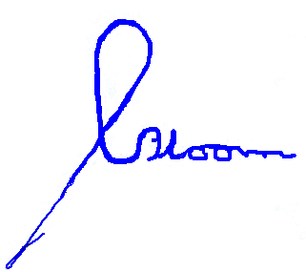

G M Bloom
Executive Director

