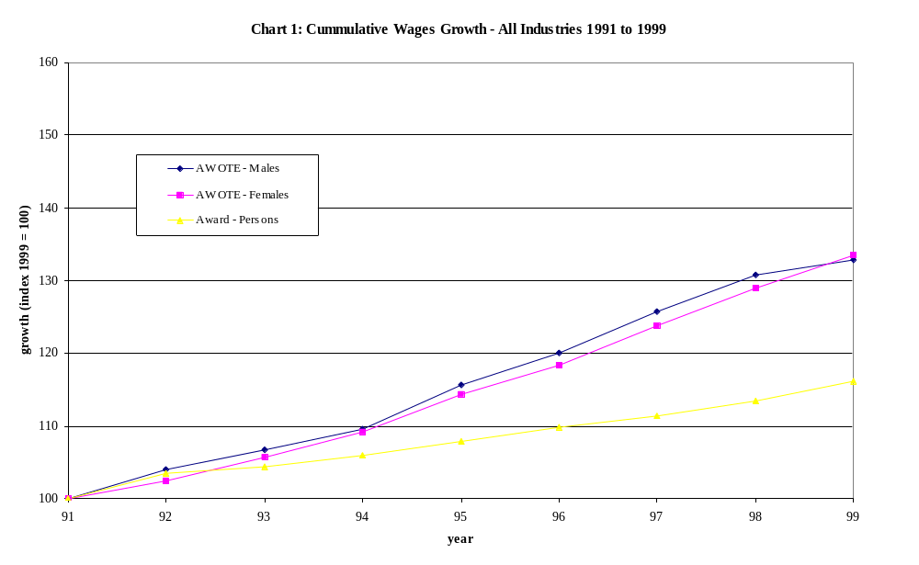
Source: ABS Cat. Nos. 6302.0 & 6312.0
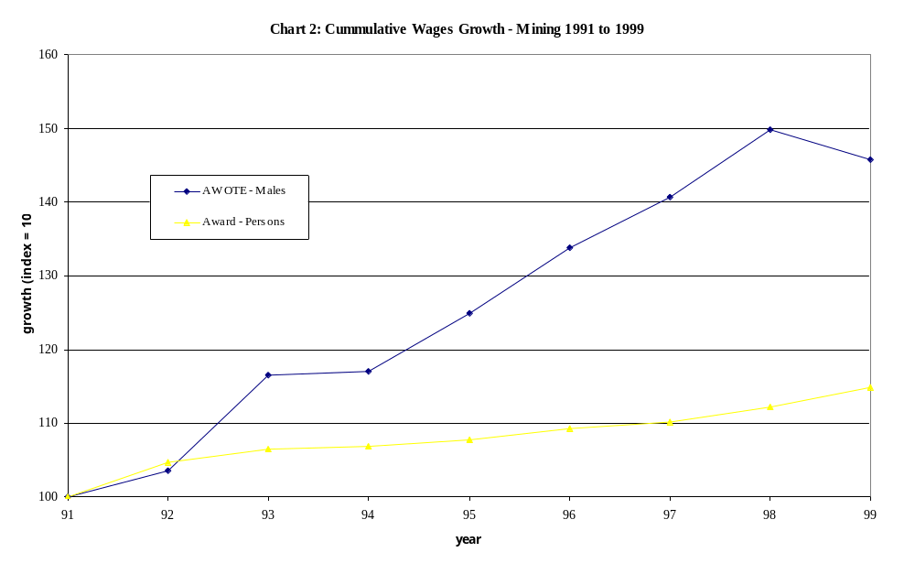
Source: ABS Cat. Nos. 6302.0 & 6312.0
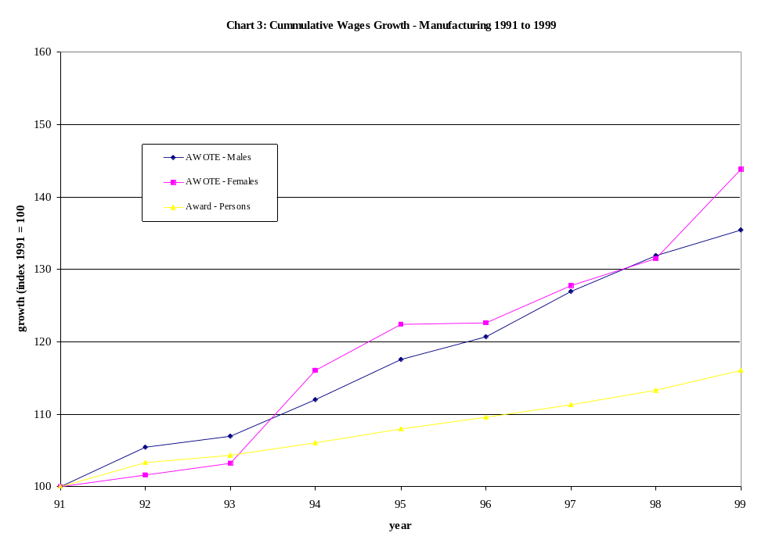Source: ABS Cat. Nos. 6302.0 & 6312.0
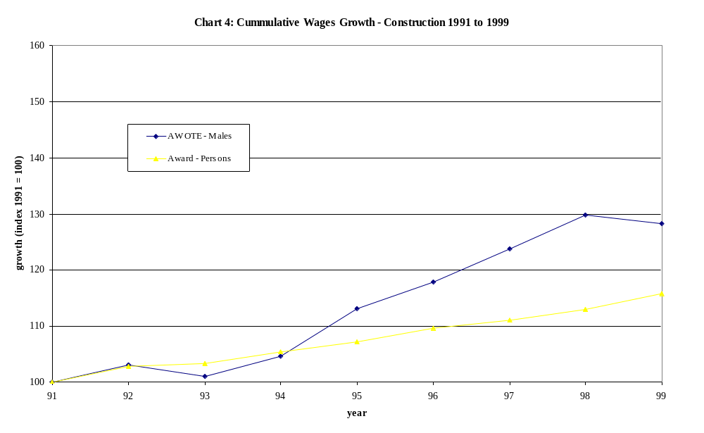
Source: ABS Cat. Nos. 6302.0 & 6312.0
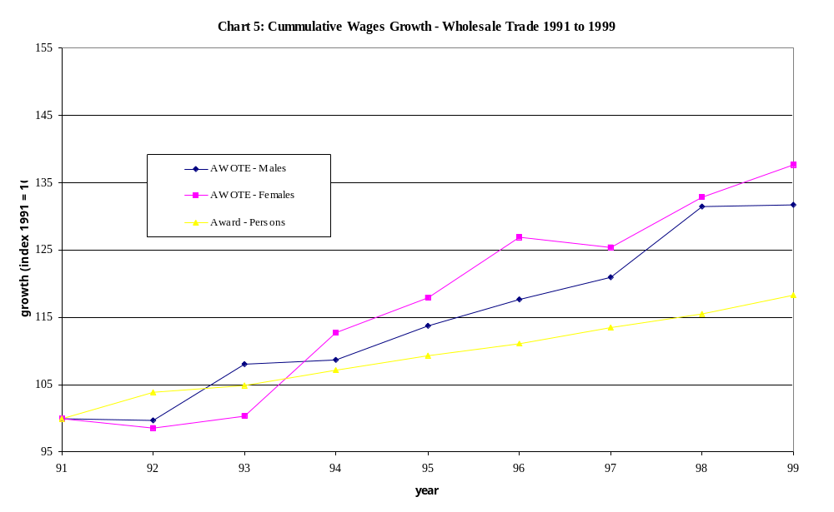
Source: ABS Cat. Nos. 6302.0 & 6312.0
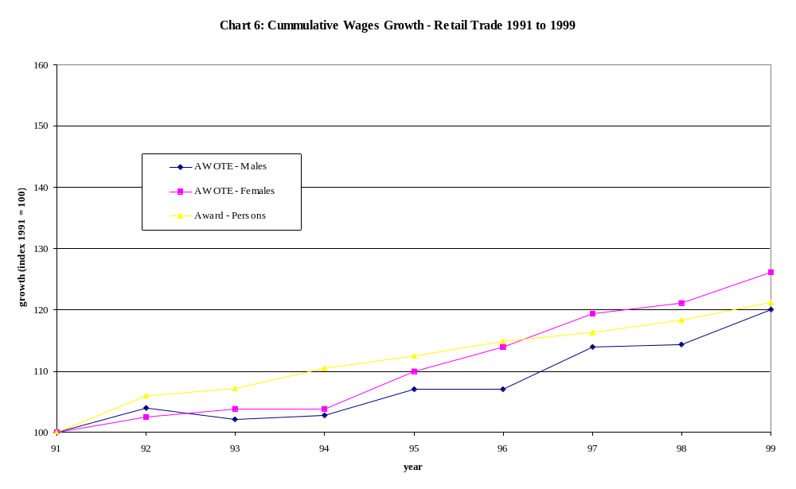
Source: ABS Cat. Nos. 6302.0 & 6312.0
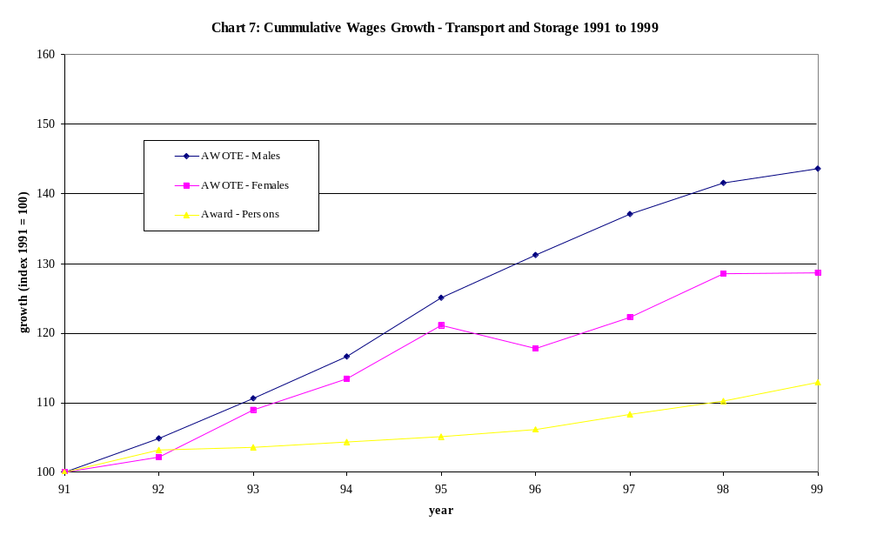
Source: ABS Cat. Nos. 6302.0 & 6312.0
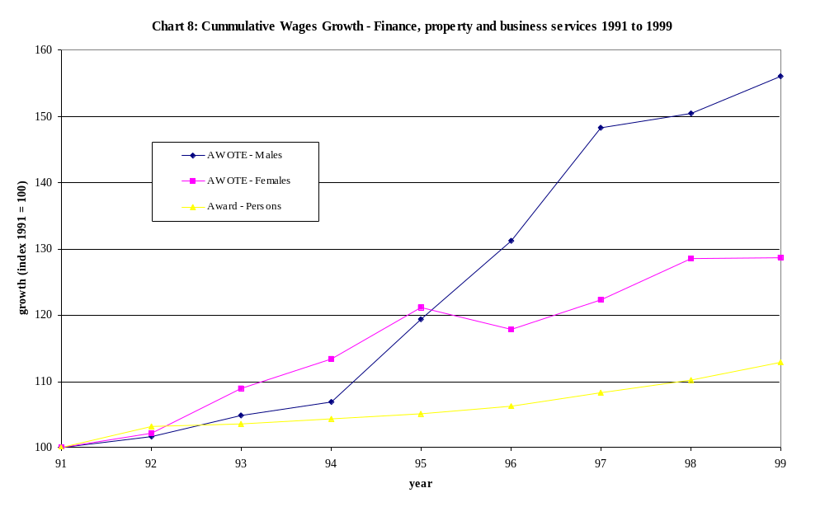
Source: ABS Cat. Nos. 6302.0 & 6312.0
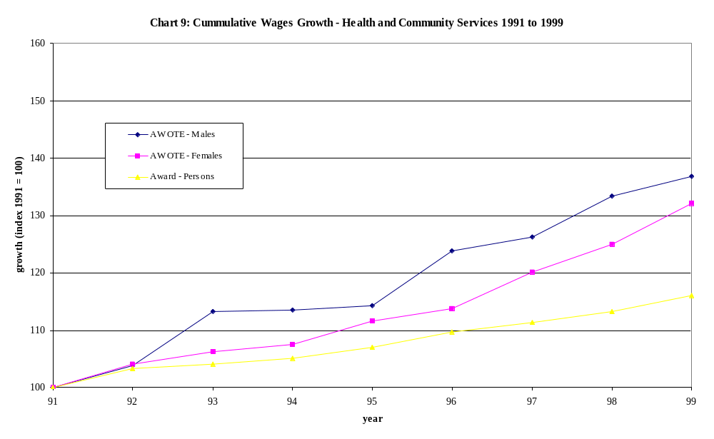

Source: ABS Cat. Nos. 6302.0 & 6312.0

Chart 10: Productivity Growth - by Industry 1995-1999
 |  | 1996-97 |  | 1998-99 |  | 1995-99
Agriculture, forestry and fishing |  | 30.2 |  | 9.9 |  | 15.8
Mining |  | 17.4 |  | 4.7 |  | 35.0
Manufacturing |  | 9.5 |  | 3.6 |  | 11.6
Electricity, gas and water supply |  | 27.8 |  | -0.7 |  | 35.0
Construction |  | 9.0 |  | 7.5 |  | 14.0
Wholesale trade |  | 10.4 |  | 10.2 |  | 41.5
Retail trade |  | 10.2 |  | 4.7 |  | 12.0
Accommodation, cafes and restaurants |  | -1.2 |  | 9.3 |  | 9.4
Transport and storage |  | 6.9 |  | 2.6 |  | 11.6
Communication services |  | 8.3 |  | 29.4 |  | 38.5
Finance and insurance |  | 11.9 |  | 12.6 |  | 33.2
Cultural and recreational services |  | 0.8 |  | 2.4 |  | -3.0
All industries |  | 5.5 |  | 6.2 |  | 12.3
Source: ABS Cat. No. 5204.0
Note: The ABS does not provide productivity estimates for those industries not included here, due to difficult measuring output (eg. Education, Health and Community Services)



