Trends in skill levels in Australian industry

A.1. The difficulty of measuring ‘skill intensity’
A range of indicators could be used to measure skill intensity but many of these suffer from a lack of available statistical data, particularly data over a reasonable time frame. This paper utilises three measures for which data is gathered by the Australian Bureau of Statistics (ABS):
- Occupational skill levels;
- Educational achievement;
- Business expenditure on training.

The occupational skills classification has three categories:
- High-skill occupations: Managers, professionals, and associate professionals;
- Medium skilled occupations: Tradespersons, advanced clerical workers, and intermediate clerical and service workers are considered; and
- Low skilled occupations: Intermediate production and transport workers; elementary clerical and service workers, and labourers.

A difficulty with using an occupational skills classification is that it assumes that there is very low mobility of labour between different occupations in the skilled and low skilled categories, when in reality there are likely to be both skilled and low skilled workers in any particular group. Occupational data also says little about the balance of demand and supply in a market. It is possible, for example, that the labour force is becoming more highly skilled, in general terms, and that the demand for those skills just does not exist.

Trends in educational attainment provides another measure of skills but different conclusions can be reached by using either occupational skills or education attainment as proxies for skill levels. As can be seen from Table A1, the use of these alternative proxies can lead to very different outcomes regarding the state of skills in Australia.

Table A1. Employed persons: educational attainment and skill levels - May 1997

 | High-skilled occupations |  | Medium-skilled occupations |  | Low-skilled occupations
 | Number of employees  000s | % age of qualified employees | Number of employees  000s | % age of qualified employees | Number of employees  000s | % age of qualified employees
Bachelor degree or higher | 1131.5 | 80 | 191.2 | 14 | 90.3 | 6
Undergraduate or associate diploma | 433.7 | 58 | 220.3 | 30 | 90.5 | 12
Skilled vocational qualification | 208.9 | 20 | 633.1 | 61 | 200.1 | 19
Basic vocational qualification | 221.1 | 29 | 381.9 | 49 | 168.9 | 22
Completed highest level of secondary school | 384.8 | 26 | 576.7 | 39 | 533.2 | 36
Did not complete highest level of secondary school | 503.4 | 20 | 865.9 | 34 | 1206.9 | 47
Notes: Percentages should be added across rows but may not add to 100% due to rounding errors.
Source: ABS cat 4224.0, table 4.19

Table A1 classifies employees in each of the occupational skill groups described above according to their educational attainment. It appears that, although there is some correlation between occupational skill levels and qualifications achieved, there are also some significant differences. For example, although 80 per cent employees in the high-skills category have a bachelor degree or higher, 6 per cent of those with this level of qualifications are in low skilled occupations. Similarly, 20 per cent of those not completing the highest level of secondary school were in ‘high skilled occupations’ and 34 per cent in ‘medium skilled occupations’.
In addition to formal education, skills are gained through informal training, on-the-job-training and work experience. While it is extremely hard to measure informal/on-the-job component of skill formation, it is at least possible to measure the level of expenditure businesses are committing to training. This measure will be the third used in this paper.

A.2. Measure 1: Occupational skill levels
The data demonstrating the trends in the skill levels in recent years at the national level is illustrated in Figure A1. To compile this chart, the occupational groupings have been classified into the three categories: low-skilled, medium-skilled, and high-skilled, described above.

Figure A1: Total employment share by occupational skills: (Nov 1986 to Nov 1998)
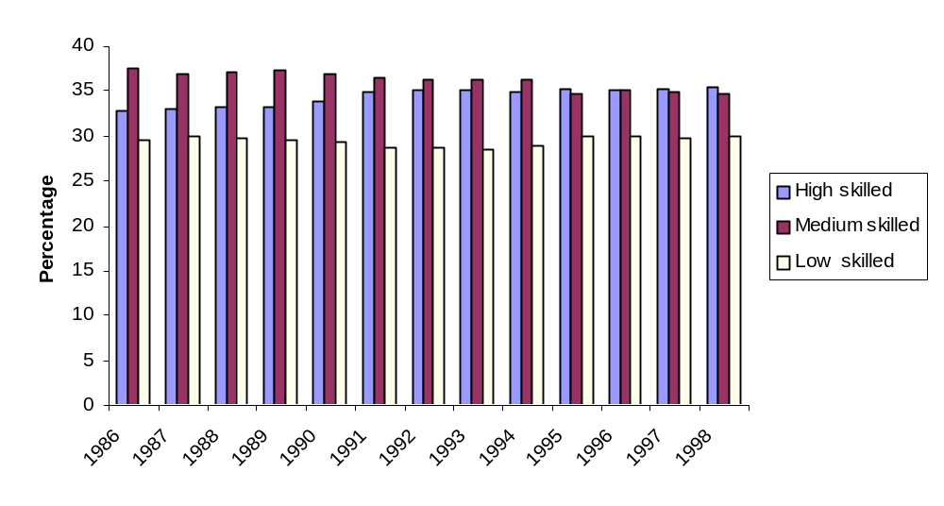
Note: Occupational data classified according to the ABS Australian Standards of Occupations, Second Edition.

Source: ABS Catalogues 6203.0 and 1232.0 and ISR calculations

The figure shows that the proportion of low-skilled employees in the total workforce appears to have changed very little between 1988 and 1998. Although there seems to have been a small fall in this category’s share from mid 1980s to early 1990s, this was followed by a rise in the more recent years and its overall share in 1998 was similar to that prevailing in 1986.

The data for the medium and high-skilled categories, however, show a significantly different picture. There appears to have been a significant change in the relative importance of these categories. Over the period from 1986, Australian industry seems to have been using an increasing proportion of more highly skilled workers and this has been offset by a reduction in the proportion of medium skilled workers. Both these categories, however, are still responsible for a greater proportion of employment than the low-skilled category.

A.2.1 Occupational skills at the sectoral level
An examination of this data at the sectoral level reveals a different picture and shows a marked contrast in the use of the various occupational groupings. As indicated in Figure A2, for example, the manufacturing sector has a significantly higher proportion of low skilled occupations and a markedly lower proportion of high skilled occupations than the economy wide average.

Low skilled workers made up around 39-42 per cent of the sector’s workforce over the period examined and medium-skilled workers represented a similar proportion. High skilled occupations, on the other hand, only represented a relatively modest 18-22 per cent of the manufacturing workforce. It is notable, however, that high-skilled manufacturing occupations became relatively more prevalent over the twelve year period, rising from around 18 per cent of the workforce in 1986 to around 21 per cent in 1998. This increase has been offset by a marginal decline in the relative importance of medium-skilled workers over the same period, from 42 per cent of the manufacturing workforce in 1986 to 38 per cent in 1998. Although the proportion of low skilled manufacturing workers has fluctuated slightly, it has remained relatively stable.

Figure A.2: Occupational skill intensity, Manufacturing Sector (Nov 1986 to Nov 1998)
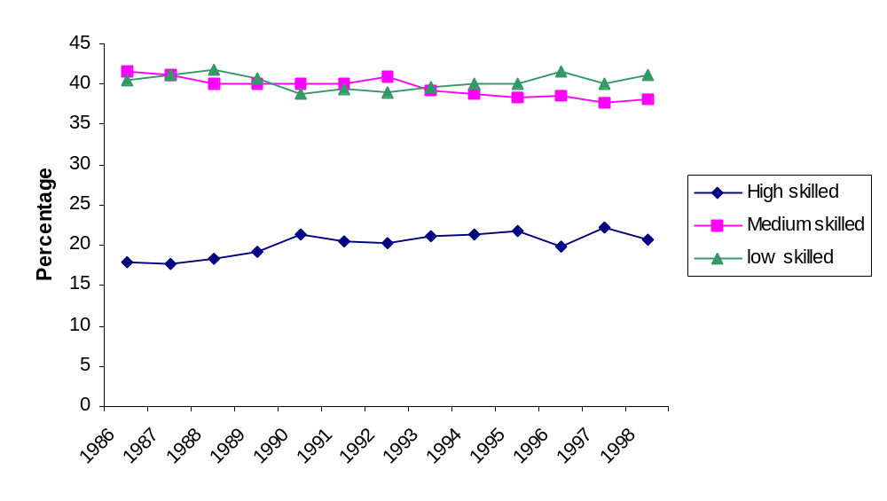
Source: ABS Catalogue 6203.0 and IRS calculations

As Figure A3 shows, the mining sector, on the other hand, has a dominance of low-skilled workers. Between 1986 and 1998, low skill occupations comprised between 50 and 39 per cent of the mining workforce. Over this period, medium-skilled employees accounted for between 27 and 33 per cent of the workforce and high-skilled workers between 17 and 30 per cent.

Figure A3: Occupational skill intensity, Mining Sector (Nov 1986 to Nov 1998)
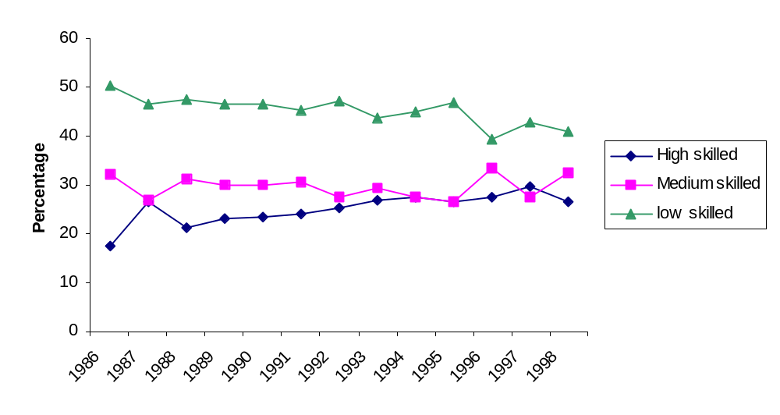
Source: ABS cat 6203.0 and ISR calculations

Figure A4 shows that in the services sector, medium and high-skilled workers dominate, each accounting for around 36 per cent of the workforce in 1998. Low skilled workers only made up around 28 per cent of the workforce in that year.

In trend terms, high-skilled services sector workers have increased their relative numbers over the period from 34 to 37 per cent. This has been offset by a decline in medium-skilled workers, from 39 per cent of the workforce to 36 per cent. The share of low-skilled occupations has remained relatively constant at around 26 to 28 per cent. Given the relative size of the services sector, the trends in this sector have a significant influence on the overall economy wide trends.
Figure A4: Occupational skill intensity, Services Sector (Nov 1986 to Nov 1998)
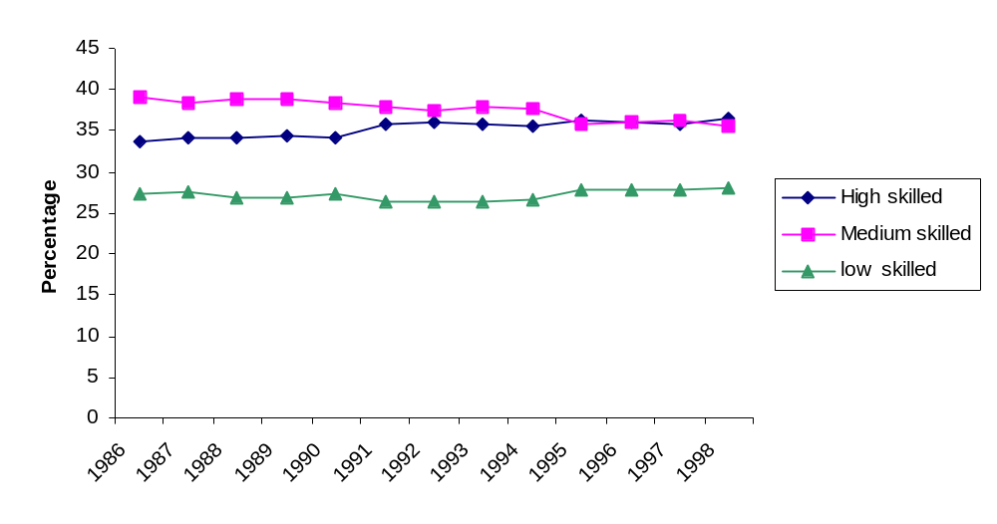
Source: ABS cat 6203.0 and ISR calculations

A.2.2 Industry level occupational skills
The above analysis can be extended to examine skill intensity at the broad industry level, although only for data at November 1998. It appears from Figure A5 that the industries that employ relatively more highly skilled workers are generally found in the services sector. Services industries such as property and business services; government administration and defence; health and community services; cultural and recreational services; and most notably education all employed a relatively high proportion of high skilled workers in November 1998.

Figure A5: Employment by Industry and skill intensity, November 1998

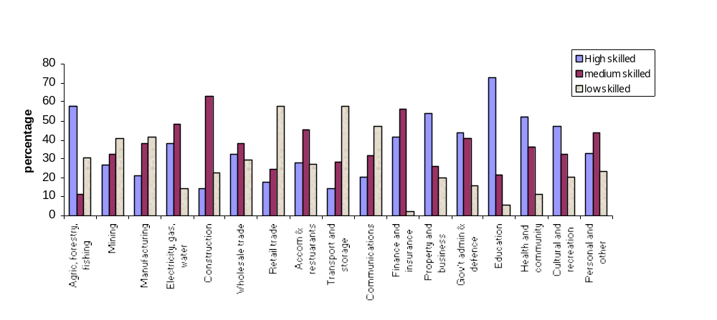Source: ABS catalogue 6203.0

In all but three service industries (retail trade; transport and storage; and communication industries) low skilled workers make up the smallest proportion of the industry’s workforce. In the accommodation, cafes and restaurant sector there are more high skilled or medium skilled workers than there are low-skilled.

A.2.3 International comparisons
Another method of examining Australia’s performance in the occupational skills area is through international comparisons and, in particular, by looking at how Australian trends compare with those for economies that are in a similar stage of development. Organisation for Economic Cooperation and Development (OECD) data which provides comparisons of occupational skill levels for selected member countries. The data are somewhat dated but they provide the most recent comparison of changes in skill categories for a large number of OECD countries. It should be noted that the definitions used by the OECD to classify workers into skill categories differ to that used elsewhere in this paper.

It is clear from Table A2 that employment across the OECD grew fastest in white collar jobs, and slowest in blue collar jobs. Within the white collar category the fastest growth occurred in the high-skilled sub-category, although low-skilled white collar workers grew in every country. With a few notable exceptions, employment of both categories of blue collar worker declined in most countries.

Table A2: Growth in occupations, total economy, selected OECD countries (Average growth rates between indicated years
 | White collar | Blue collar | White-collar high-skilled | White-collar low-skilled | Blue-collar high-skilled | Blue-collar low-skilled
United States 1983-93 | 2.5 | 0.6 | 2.8 | 2.3 | 0.6 | 0.7
Canada 1981-91 | 2.3 | -0.4 | 3.1 | 1.8 | -0.5 | -0.3
Japan 1980-90 | 2.4 | -0.6 | 2.9 | 2.1 | -1.1 | 0.7
Australia 1986-91 | 2.6 | 0.3 | 2.9 | 2.1 | 0.0 | 0.6
New Zealand 1981-91 | 4.0 | -1.5 | 5.8 | 1.2 | -1.8 | -1.1
France 1982-90 | 1.8 | -1.5 | 2.5 | 0.9 | -1.8 | -1.1
Finland 1980-90 | 2.1 | -1.8 | 3.3 | 0.9 | -2.0 | -1.4
Germany 1980-90 | 2.2 | -0.9 | 2.6 | 1.9 | 0.7 | -1.8
Italy 1981-91 | 2.1 | -0.9 | 2.1 | 2.1 | -0.7 | -1.1
U K 1981-91 | 2.1 | -0.9 | 3.6 | 0.8 | -0.8 | -1.0
Austria 1984-92 | 2.3 | -0.2 | . . . | . . . | . . . | . . .
Denmark 1981-93 | 0.8 | -0.5 | . . . | . . . | . . . | . . .
Greece 1981-92 | 3.4 | -0.4 | . . . | . . . | . . . | . . .
Ireland 1981-91 | 3.1 | -3.5 | . . . | . . . | . . . | . . .
Mexico 1980-93 | 8.4 | 4.6 | . . . | . . . | . . . | . . .
Netherlands 1981-90 | 3.7 | 0.3 | . . . | . . . | . . . | . . .
Norway 1980-93 | 1.6 | -1.8 | . . . | . . . | . . . | . . .
Portugal 1981-90 | 4.9 | -0.2 | . . . | . . . | . . . | . . .
Spain 1980-90 | 2.9 | -0.8 | . . . | . . . | . . . | . . .
Sweden 1980-90 | 1.4 | -0.8 | . . . | . . . | . . . | . . .
Source: OECD (1997), Science, Technology and Industry: Scoreboard of Indicators 1997.

While the trends in Australia had much in common with the other countries studied, the distinction between the growth in high and low-skilled workers was generally less marked in Australia. Australia was also one of few countries that did not experience a decline in either category of blue collar worker. Overall, there appeared to be less polarisation in the employment growth rates in Australia than in most other countries.

The OECD data also provided a breakdown for occupational employment for the manufacturing and services sectors in the same periods. While total employment in the manufacturing sector declined in most countries, white-collar high-skilled manufacturing employment increased. The services sector, on the other hand, experienced strong employment growth in all countries. Most of the sector’s employment growth also occurred in the white-collar category, with relatively little growth being derived from blue-collar employment.

Although employment in Australia moved in line with these trends, the local decline in manufacturing employment was lower than for most of the countries examined. Australia also had strong growth in services employment, largely due to the growth in white collar workers.

A.3. Measure 2: Educational attainment
While the trends in ABS data on educational attainment of Australians is not as clear cut as that discussed above on occupational skills, it still does lend some support to the trends in that area. This data is illustrated in Figure A6 and categorises individuals in the population on the basis of their highest level of educational achievement.

There is some evidence in this data of a movement toward higher education in the population, possibly reflecting the move towards higher skilled jobs noted above. While the proportion of the population obtaining other post-secondary qualifications fell from 32 per cent in 1992 to
27 per cent in 1997, this fall appears to have been largely due to an increasing number of the population attaining a bachelor degree or higher, which increased from 9 per cent to 14 per cent. The average decline in those obtaining other post secondary qualifications, however, was slightly greater than the move to higher qualifications, possibly in part reflecting the move out of medium skilled occupations discussed above, and there consequently was a slight overall fall in the proportion gaining post secondary qualifications towards the end of the period.

There was, however, an increase in the relative numbers attaining secondary qualifications as their highest level of education, from 14 per cent to 18 per cent, primarily at the expense of those not completing secondary education, which fell from 39 per cent to 36 per cent of the population. There was also a slight increase in the numbers still at school.

Figure A6: Educational attainment of the Australian population (Feb 1992 and May 1997)
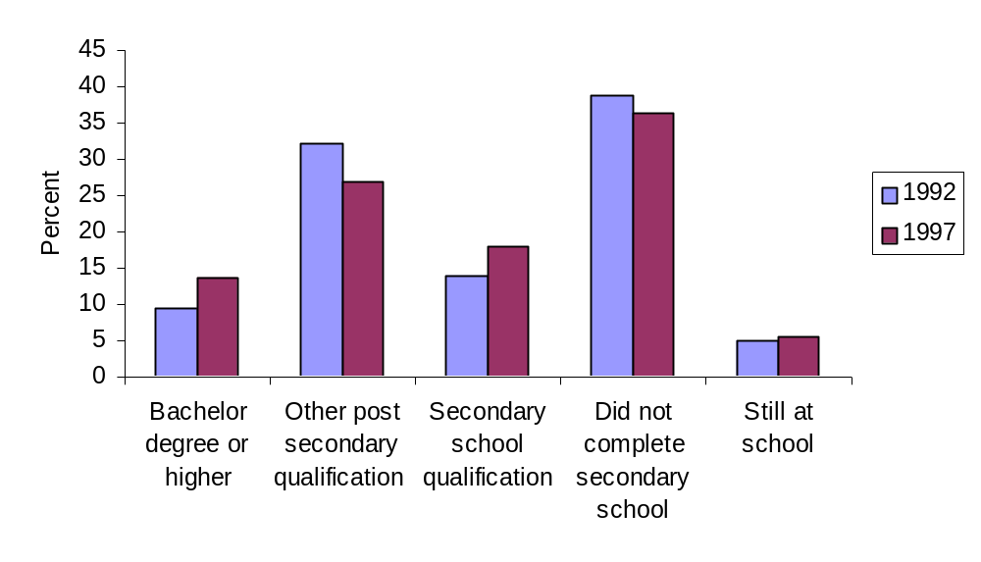
Note: 1997 data includes all persons aged 15-64 years, 1992 data includes persons aged 15-69 years.
Source: ABS cat 4224.0, ISR calculations

In terms of overall education standards, however, a significant proportion of the population aged over 15 years is not completing secondary education. In May 1997, for example, some
36 per cent had not completed secondary schooling and had left school. On the other hand, around 14 per cent had obtained a bachelor degree or higher and a further 27 per cent had obtained other post-secondary qualifications.

A.3.1 Educational attainment in the Australian workforce
Evidence of a trend towards a more highly educated workforce also appears in the data on educational attainment in the workforce. As indicated in Figure A7, all sectors of the economy recorded increases in the share of their workforces obtaining a bachelor degree or higher, although the mining sector experienced the smallest change. In general terms, the percentage of the overall workforce that had obtained a bachelor degree or higher rose by almost 5 per cent between 1992 and 1997, and accounted for over 17 per cent of the workforce in 1997. The services sector clearly had the highest proportion of its workforce educated at this level (19 per cent in May 1997) followed by the mining sector (12 per cent). The services sector’s workforce also achieved the highest growth in the proportion of its workforce with these qualifications.

Figure A7: Share of workforce with a bachelor degree or higher (Feb 1992 and May 1997)
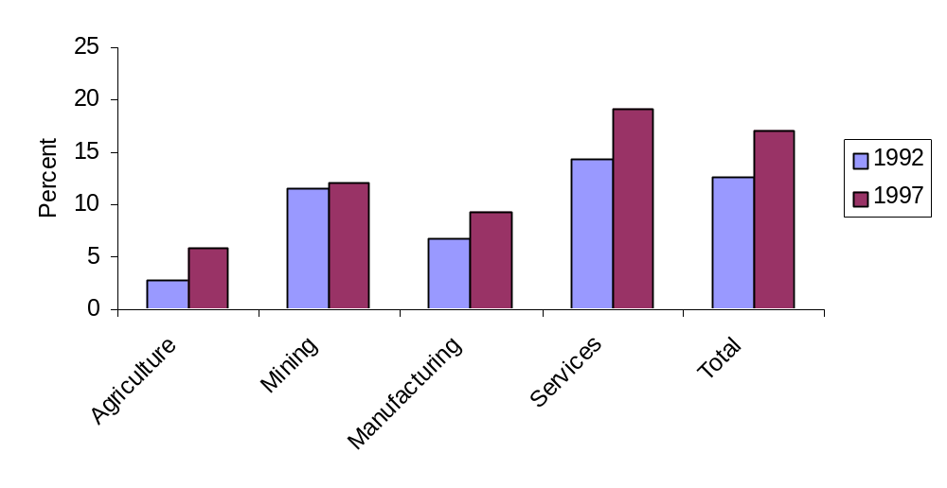
Source: ABS cat 4224.0, ISR calculations

From Figure A8 it appears that the rise in the share of workers with bachelor degrees or higher has been more than offset by a decline in those achieving other post secondary qualifications. The share of the total workforce that achieved a non-university post-secondary attainment as their highest level of education, declined over the period by some 6.6 per cent to around 31 per cent of the total workforce. This trend was reflected across all sectors although the largest declines were in mining (7 per cent) and services (7 per cent).

Figure A8: Share of workforce with other post-secondary education (Feb 1992 and May 1997)
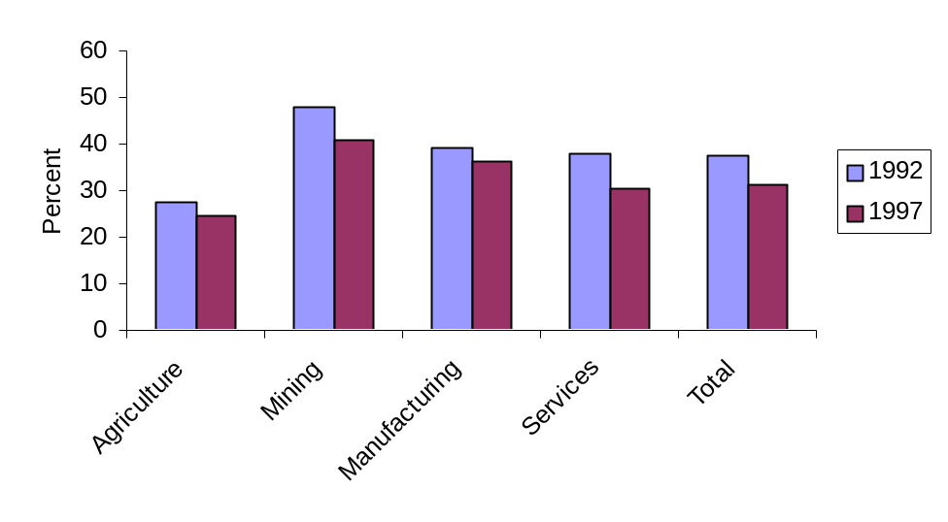
Note: Other post secondary education includes undergraduate or associate diploma, a skilled or basic vocational qualification, a trade qualification, a certificate, or a diploma
Source: ABS cat 4224.0, ISR calculations

The mining sector appears more heavily dependent on workers with post-secondary, non-university education with this category accounting for just over 40 per cent of the workforce in 1997. This was followed by the manufacturing sector at 36 per cent.
The proportion of the workforce that had at most attained a secondary school qualification, however, increased across all sectors during the period 1992-1997. As indicated in Figure A9, the percentage of the overall workforce with this educational attainment as the highest level of achievement increased from around 15 per cent to around 18 per cent.

Figure A9: Share of workforce with a maximum of secondary school education (Feb 1992 and May 1997)
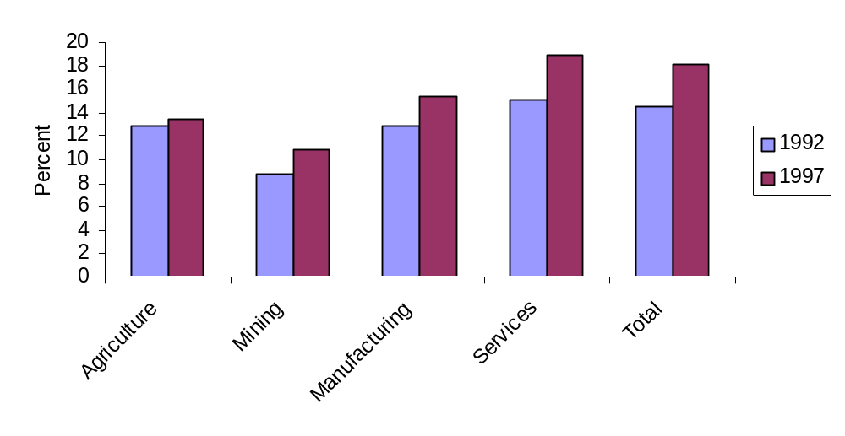
Source: ABS cat 4224.0, ISR calculations

The services sector had the highest level of its workforce in this category (19 per cent in 1997) and achieved the largest increase of almost 5 per cent over the period. This contrasted with the agriculture sector which had an increase of only 0.6 per cent to about 14 per cent of its workforce in 1997. The mining sector had the lowest reliance on workers in this category.

While the share of workers without secondary school qualifications declined over the period, falling from 33 per cent to 31 per cent, it remained relatively high (Figure A10). The agriculture sector, in particular, stands out with 54 per cent of the workforce in this sector not completing secondary school. Services, by contrast, employed relatively few workers in this category, with the share of workers failing to complete secondary school falling from 30 to 29 per cent of the workforce in 1997. Declining shares were experienced in all sectors apart from agriculture.

Figure A10: Share of workforce not completing secondary school (Feb 1992 and May 1997)
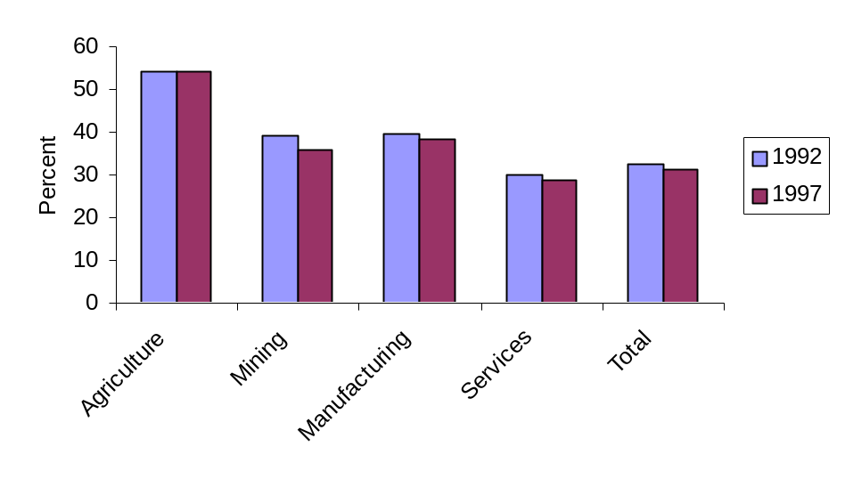
Source: ABS cat 4224.0, ISR calculations

In overall terms, the services and mining sectors have the most highly educated workforces. As indicated above, the services sector has the highest usage of employees with bachelor degrees, has about average usage of other post-secondary education and high usage of those achieving a maximum of secondary education. As the services sector dominates employment in Australia the overall trends in educational attainment in Australia are largely driven by that sector’s performance. As indicated in Table A3, the services sector is responsible for some 81 per cent of the workforce and 90 per cent of those with bachelor or higher degrees.

Table A3. Sectoral share of workforce by educational attainment, May 1997

 | Agriculture  % | Mining  % | Manufacturing  % | Services  %
Bachelor degree or higher | 1.6 | 0.7 | 7.4 | 90.3
Other-post secondary qualification | 3.7 | 1.3 | 15.8 | 79.1
Completed highest level of secondary schooling | 3.5 | 0.6 | 11.4 | 84.5
Did not complete secondary schooling | 8.2 | 1.1 | 16.6 | 74.2
Total Workforce | 4.7 | 1.0 | 13.8 | 80.5
Source: ABS cat 4224.0, ISR calculations

The next biggest sector in terms of employment, the manufacturing sector, accounts for only
14 per cent of the workforce. While manufacturing is a relatively heavy user of those with other post secondary qualifications and those not completing secondary education, the sector’s use these types of employees has little impact on the overall economy-wide usage of these groups.

A.3.2 International comparisons of educational attainment
Another option for examining the trends in educational attainment in Australia in recent times is through international comparisons. Consistent international data provide a basis for comparing the local trends to that prevailing in other similar economies.

The OECD’s figures on educational attainment in the labour force provide a similar outcome are shown in Figure A11. Australia’s relative level of educational attainment appears to be skewed to the higher and lower categories of educational attainment. With 37 per cent of its labour force with below upper secondary education, Australia is only eclipsed by Spain, Ireland and Korea.

Figure A11: Educational Attainment of the Labour Force, 1996
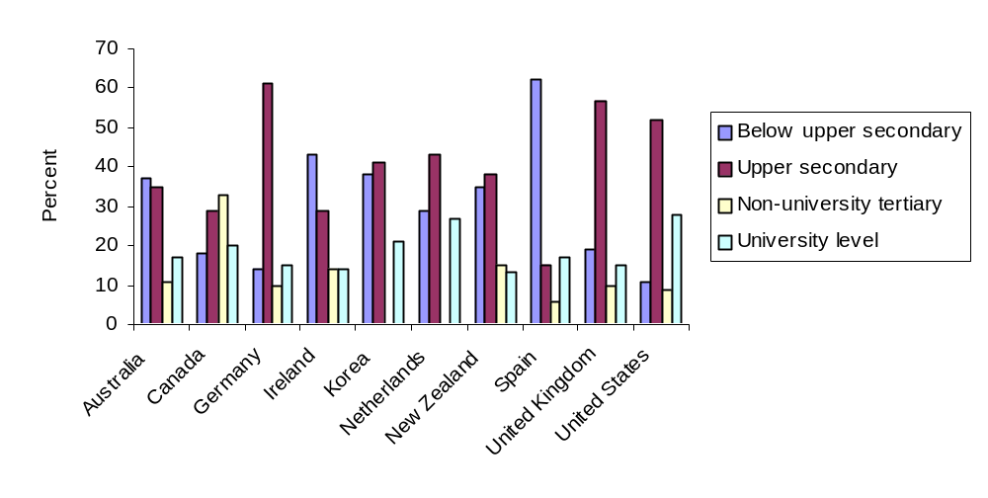
Source: OECD (1998), Education at a Glance: OECD indicators 1998.

Australia, on the other hand, appears to have a relatively high propensity for its work force go on to higher levels of education, once an upper secondary level of education has been achieved. The Australian labour force has a relatively low level of participants with at most upper secondary education and a relatively high levels of tertiary education. Only Canada and the United States have a higher level of tertiary qualified people in their labour force than the
28 per cent achieved by Australia in 1996, although both Ireland and New Zealand had achieved similar levels to Australia.

A.4. Measure 3: Trends in employer provided training

In its Employer Training Expenditure Survey (ABS 6353.0, 1997) ABS estimated that during the three-month period from 1 July to 30 September 1996, employers in Australia spent $1,179 million on structured training for their employees. Expenditure for the same period in 1993 was $1,103 million. While this is a small increase in expenditure, employers spent less per employee on structured training ($184.49) compared to 1993 ($191.25) and provided less hours of structured training per employee (4.91 hours per employee in 1996 compared with 5.55 hours in 1993). More telling, though, the overall ratio of expenditure on structured training to employees’ gross wages and salaries fell from 2.9 per cent in 1993 to 2.6 per cent in 1996.

The lower average training expenditure in 1996 reflected a lower proportion of employees providing structural training. For in 1996 only 18 per cent of employers provided training compared to 23 per cent in 1993. The fall in employees providing training was most marked in employers with less than 100 employees (small to medium employers). One of the key explanations of the lower levels of training expenditure and reduction in the proportion of employers providing training is the suspension of the Training Guarantee in mid 1994, and its abolition in July 1996.

These findings are supported by some observations of the ABS data. In its 1994 Employer Training Expenditure Survey ABS observed that between July and September 1993, some
80 per cent of medium sized organisations reported training expenditure. This was a significant increase since 1990, when the corresponding figure was 64 per cent. This same group of firms, as noted above, saw a marked fall in commitment to employee training in the 1996 survey.

The Department of Employment, Education, Training and Youth Affairs also noted in The Training Guarantee: its Impact and Legacy, 1990-1994 (Report no 5/1996) that except for the largest and smallest organisations, Australian industry continued to increase its training effort all through the 1990-93 recession. Particularly strong growth occurred in medium-sized organisations (20-99 employees) where expenditure per employee grew by 60 per cent between 1990 and 1993. Other indicators suggested training quality also continued to improve over the period, enhanced by the greater use of training plans.

The report noted, however, that little progress occurred from 1990 to 1994 in those parts of industry, such as small firms, which had traditionally been poor trainers. Also, disadvantaged groups in the workforce generally fell further behind in their access to training, while more money was spent to train fewer and, on average, higher paid workers in 1993 than in 1990. The report also found that in low training activity industries, the demand for training was often constrained by poor information and forms of workplace organisation which offered little opportunity for the use of new skills.

Table A4 shows that the most notable change in expenditure on structured training as a proportion of gross wages and salaries between 1990 to 1996 is the general increase that took place in 1993, which was generally offset by falls in 1996. The big exceptions to this rule were Mining, and Electricity, Gas and Water. In 1996, for example, the mining industry spent nearly 6 per cent of its gross wages and salaries on structured training. This translated into $896.49 expended per employee compared to the all industry average of $185.49 per employee.

Table A4. Training as a proportion of gross wages and salaries by industry

Industry | 1990 | 1993 | 1996ª
Mining | 4.0 | 5.1 | 5.8
Manufacturing | 2.1 | 2.6 | 2.2
Electricity, gas & water | 4.1 | 4.4 | 4.5
Construction | 1.9 | 1.8 | 1.3
Wholesale trade | 2.4 | 2.8 | 2.1
Retail trade | 1.5 | 2.0 | 1.9
Transport & storage | 2.7 | 2.7 | 2.6
Communication | 4.3 | 5.4 | 3.2
Finance, property & business services | 3.1 | 3.2 | ..
Public administration & defence | 3.3 | 3.2 | 3.2
Health & community services | 2.6 | 2.9 | 2.1
Recreation, personal & other services | 1.5 | 1.9 | ..
Total | 2.6 | 2.9 | 2.5
a. Due to changes in industry classifications, industry groups may vary slightly from the 1990 and 1993.
Source: ABS cat 6353.0, 1991, 1994, 1997

Furthermore, while most industries spent a lower proportion of their wages and salaries on training in 1996 compared to 1993, the change was most notable in the Communications industry where expenditure fell from 5 per cent of gross wages and salaries in 1993 to 3 per cent in 1996.

It is possible to see, however, some emphasis being placed on structured training in industries identified earlier as highly skilled service industries such as the property and business services industry and government administration and defence. Conversely, some low and medium skilled industries committed less than the national average to training. Industries in this category include construction, retail trade, and manufacturing.

A.4.1 OECD Training Comparisons
Table A5 shows the proportion of different age groups participating in job-related training from across a number of OECD countries. This data indicates Australia was reasonable well placed in comparison to the listed OECD countries. Australia is either at or above the average of the countries from which the relevant data are available across all age groups. In 1994-95, over
38 per cent of all employed adults in Australia participated in job-related training, a slightly higher figure than the sample average of 34 per cent. This data may not reflect, however, the lower levels of training recorded in the 1996 ABS survey.

Table A5: Participation by employed adults in job-related training, by age group (1994-1995)

 | Age 25-34 | Age 35-44 | Age 45-64 | All Ages
Australia | 42.9 | 41.7 | 30.7 | 38.1
Belgium (Flanders) | 21.4 | 17.0 | 21.6 | 20.0
Canada | 41.4 | 39.7 | 31.6 | 37.5
Ireland | 27.5 | 23.6 | 18.8 | 23.4
Netherlands | 36.3 | 35.5 | 25.2 | 32.5
New Zealand | 50.2 | 49.4 | 41.9 | 46.9
Poland | 17.0 | 17.6 | 14.4 | 16.5
Switzerland | 35.5 | 32.1 | 28.2 | 31.7
United Kingdom | 59.1 | 58.0 | 41.3 | 51.9
United States | 46.2 | 48.1 | 43.3 | 45.6
Sample Mean | 37.8 | 36.3 | 29.7 | 34.4
Source: OECD, Human Capital Investment: An International Comparison, p.108

OECD (1997) Science, Technology and Industry: Scoreboard of Indicators
Care needs to be taken in interpreting these figures because there was a change in description of other than post secondary qualifications between 1992 and 1997.

