Submission to
Senate Employment, Workplace Relations, Small Business and Education References Committee

The capacity of public universities
to meet Australia’s higher education needs

by the Postgraduate Board, UNSW

12th April 2001

Contents
Summary of recommendations page 2
Introduction 3
Current funding arrangements and the capacity of universities to manage and serve increasing demand 3
Current funding and its effects on autonomy, flexibility, teaching and research 4
The increasing reliance on private funding and the production of appropriately qualified graduates to meet industry demand 8
The increasing reliance on private funding and the adequacy of campus infrastructure and resources 10
The increasing reliance on private funding on Australia’s immediate and long-term capacity in research 10
The effect of universities’ commercialised research and development structures 11
The levels of access among social groups under-represented in higher education 11
The affordability and accessibility of higher education 14
The adequacy of current student income support measures 16
The ability of Australian public universities to attract and retain staff 19
The capacity of public universities to contribute to economic growth 20
Higher education as an export industry 20
Accreditation regimes and quality assurance 21
University governance 23
- Summary of recommendations

- Increase the core funding for universities to ensure that the quality of education and resources are not further eroded.
- Increase research funding to Australian universities to free them from reliance on private funding from industry and individuals.
- Increase the funding to Australian universities for both research and teaching to stop the emaciation of our higher education sector.
- Ensure that diversity of research is maintained, indeed enhanced, at universities so that Australia will be able to contribute to future developments, both socially and economically.
- Establish an Indigenous Postgraduate Scholarship scheme (consisting of a HECS award and a living stipend).
- Raise the HECS income threshold to the Average Male Weekly Earnings.
- Fund research into how the introduction of full fees and HECS has affected the accessibility of higher degrees, particularly for Indigenous peoples, women and people from low socio-economic backgrounds.
- Postgraduate Board recommends that:
- APA awards are extended to a maximum of 4 years;
- the Government investigates the problem of high living costs associated with some campuses, in order to determine an appropriate supplement;
- part time APA scholarships are classified as non-taxable income; and
- Government assistance be extended to those people undertaking courses necessary for entry to a profession.
- The contributions of universities to Australian culture be formally recognised.
- The AUQA set the minimum time for a Masters degree to 2 years, and that all Masters degrees should be set to the same level of attainment
- Greater regulation of “fast track” degrees (i.e. undergraduate and postgraduate degrees packaged together in one “course”) by the AUQA.
- The length of funded candidature for research students be reverted to the lengths funded in 2000.
- The AUQA address the issue of involvement of Australian universities in global on-line education.

- Introduction

The Postgraduate Board of the University of New South Wales (UNSW) is the representative body of approximately 12, 000 postgraduate students at UNSW. We address below the concerns that we have regarding the capacity of public universities to meet Australia’s higher education needs. We would like to thank the committee for providing us the opportunity to voice our concerns regarding higher education. We trust that our submission will be seen as a valuable contribution toward a better higher education sector for all participants. The issues we wish to raise are discussed within the terms of reference.

Due to the fact that UNSW is one of the largest universities, with students from diverse backgrounds, we believe our experience of postgraduate issues and the trends that we observe at UNSW are indicative of issues occurring at many other universities in Australia. As a constituent member of the Council of Australian Postgraduate Associations (CAPA), the Postgraduate Board supports their concerns and policies, and recommends that this submission be read in conjunction with the CAPA submission.

- Current funding arrangements and the capacity of universities to manage and serve increasing demand – section a)i)

From 1974 to 1989 the Federal Government assumed prime responsibility for fully funding higher education. For the first six years this was accompanied by a policy of not charging fees for tuition. In 1980, however, the Liberal Government introduced fees for the increasing number of foreign students studying at Australian universities called the Overseas Student Charge. In 1987 this system was extended by the Labor Government to include local students under a scheme called the Higher Education Administration Charge. Up until this time fees for tuition had been nominal. The following year, however, the Government introduced the Higher Education Contribution Scheme (HECS) with the stated aim of recouping some 20% of the tuition costs from each local student. At the same time, the Government introduced arrangements, which allowed fees to be charged for a selected number of postgraduate courses. These changes were significant as they not only dramatically increased the cost of tertiary education to the student but they also introduced a culture of ‘user pays’, therefore, focusing universities and the community on the financial aspects of the provision of higher education.

Despite the significant rise in cost, the introduction of tuition fees and other charges, this has not stopped a dramatic increase in enrollments at most public universities throughout the 1990s. The increased revenue gained from charging fees has not, however, seen a parallel rise in government funding but, rather, a decline in real terms. As a consequence, higher education in Australia is caught between increasing demand and lower levels of public funding.

In an environment where universities are constrained by the Government’s commitment to the demands of the marketplace and decline in government spending, the capacity of Australian universities to deliver quality tertiary education to an increasing number of students has proved problematic. This can be demonstrated by the overall increase in the number of students to staff from 1989 to 2000 at the University of New South Wales (Figure 1).

Figure 1. Total Staff/student ratio at UNSW (excluding ADFA) from 1989 to 2000.
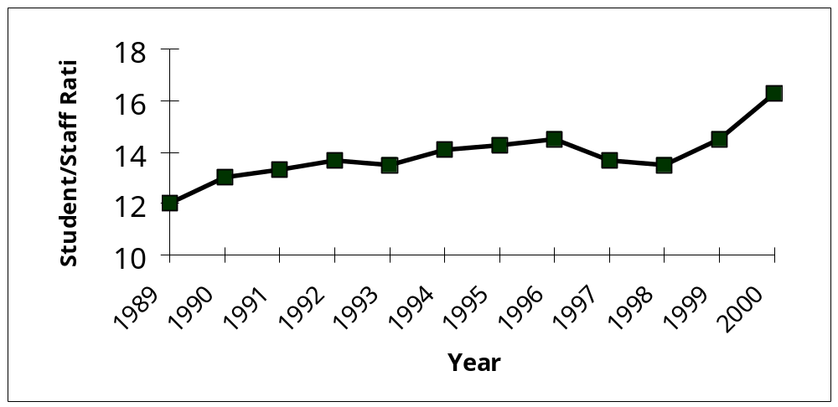

Another measure of the declining ability of Australia’s public universities to provide quality tertiary education can also be demonstrated by the reductions in library funding. Between 1997 and 2000, the library’s operating fund only rose from $16,317,206 to $17,609,489 even though the total student numbers rose from 34,124 to 39,680 during this period. On a per capita basis, this is a reduction from $499.55 to $459.82 per student p.a., which when inflation is taken into account, indicates a significant reduction in the library’s ability to maintain and grow an excellent facility.

Funding levels, however, do not reveal the loss of expertise and services to students that have come as a result of retrenchments of skilled library staff over a number of years. Following from this, photocopying and inquiry services have dropped significantly. Students report that around one third of all the libraries photocopiers are no longer working after 7pm as staff members are not available to refill paper trays and conduct minor repairs. Lack of funding has also meant that the library has been unable to keep pace with the demand for books in new subject areas such as information technology, and Asian languages and culture.

The Postgraduate Board calls for there to be an increase in the core funding for universities to ensure that the quality of education and resources are not further eroded.

- Current funding and its effects on autonomy, flexibility, teaching and research - sections a)ii), a)iii) and b)i)

Australian universities now operate in an environment in which they are forced to rely heavily on income from sources other than the Government: industry (e.g. research income at UNSW, Figure 2) and fee paying students (including international, postgraduate and undergraduate; for example UNSW, Table 1).

Figure 2. Sources of Research income at UNSW 1996 -1998
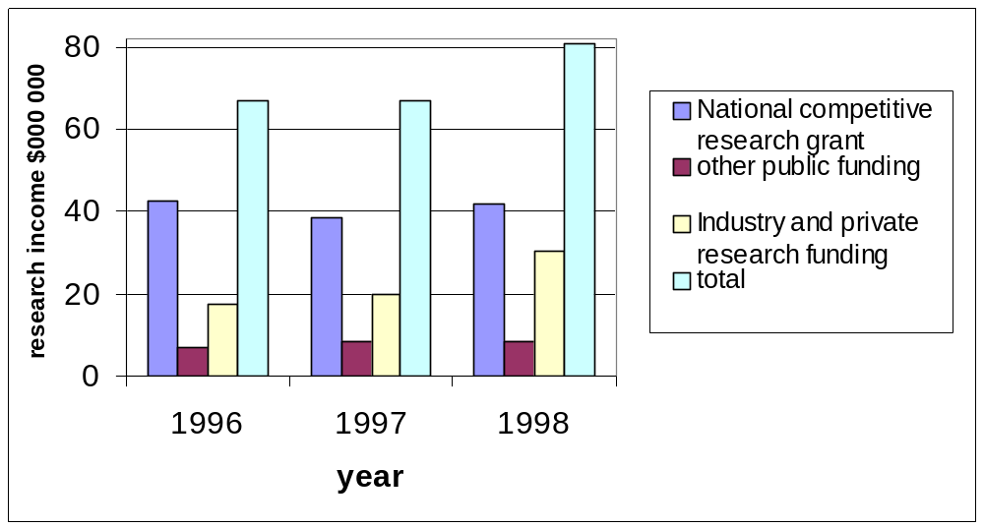

Across the Australian tertiary sector, there has been a decrease in government funding for research and a correspondingly greater reliance on industry funding (for example UNSW, Figure 2). The Postgraduate Board asserts that industry funding should be additional to public funding and in no way should replace any shortfalls in government funding.

While we recognise that an increased investment in research by Australian industry is needed, it is vital to recognise the implications of this funding in the university system. As funding from private companies has increased there has been more research in areas tied to industry agendas and hence less flexibility in basic, pure and non applied research (see also comments on section b)iv)). The reliance on industry funding has set up a two tier university system, with those disciplines that can easily attract industry funding (i.e. most scientific, technological and some commerce disciplines) versus those cannot demonstrate such a clear economic gain (e.g. arts, humanities, social sciences, biology). This is easily seen at UNSW where over the period 1996 to 1998 there were particularly large increases in industry funding in the areas of Commerce and Economics, Engineering and Science. In Engineering alone the industry funding grew from $2.05 million to $3.38 million. While this trend is encouraging for these disciplines, no such reciprocation was seen in the arts, humanities and social sciences.

The Postgraduate Board recommends that the government increase funding to Australian universities to free them from reliance on industry income.

Academics are discouraged from expressing dissent about this process or the administration of universities, which seriously degrades the level of public discourse and engagement of universities with the wider community. Such an environment discourages critique of this trend as universities, starved of funds, are thankful for any injection of money to carry on their role. One of the major negative effects of the commercialization of research is how it affects the impartiality of quality research. As research funding has increasingly become more reliant on private sources, there has been a parallel development. Many academics fear criticising firms that provide significant funds to their school or faculty, and feel discouraged from criticising the administration of the university as they are aware just how dependent it is on private and industry funding. Whereas once academics saw the fruits of their research benefiting the wider community, now research is increasingly seen in terms of benefiting only the providers of research funding. These developments invariably lead to a breakdown in trust and collegiality and the gradual disengagement of the academic community with the broader community.

Table 1. Fee income (all fees) as a percentage of total UNSW income and actual dollar values.

 | 1991 | 1992 | 1993 | 1994 | 1995 | 1996 | 1997 | 1998
% of total income | 10.9 | 14 | 16 | 19 | 17 | 20 | 21 | 22
Amount  ($000 000) | 44.8 | 60.5 | 73.1 | 83.9 | 90.7 | 103.2 | 114.1 | 126.3

After the partial deregulation of postgraduate coursework degrees in 1988, universities introduced some fee paying postgraduate courses. At UNSW the increase in the importance and therefore the reliance on fee income increased from 10.9% of income in 1991 to 22% in 1998 (Table 1). Additionally, the number of fee paying postgraduate
courses jumped from 6 in 1991 to 195 in 2001 (figure 3) and the proportion of postgraduates that are fee paying continues to rise (figure 4). Even over just the last three and a half years at UNSW, the proportion of postgraduates who are fee paying leapt from 61.8% (session 2 1997) to 74.1% (session 2 2000, Figure 4).

We believe that this current and growing reliance on fee paying students, particularly postgraduate students, is decreasing the quality of postgraduate courses at Australian universities. The increase in the number of fee paying courses particularly postgraduate diplomas (which may merely be repackaging of current subjects into a new structure) increases the appearance of diversity however is not in fact an increase due to the use of already existing subjects and courses.

We therefore call on the government to increase funding to Australian universities to stop their reliance on income from individuals (see also comments on section f)ii)).

Figure 3. Number of fee paying postgraduate courses at UNSW in the period 1991-2001
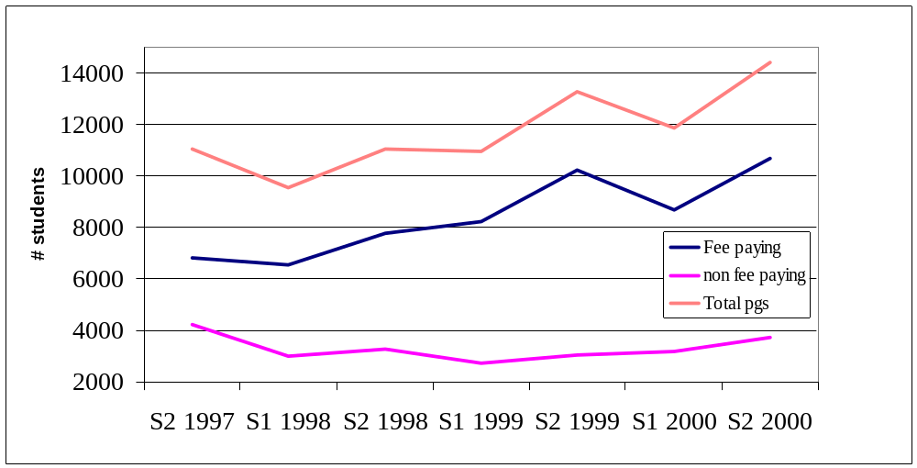

Figure 4. Number of fee paying postgraduates versus the total number of postgraduates Session 2 1997 to Session 2 2000. (S1 and S2 refer to session 1 and session 2 of the academic year). Percentages relate to the proportion that fee paying students are in terms of the whole postgraduate student population.
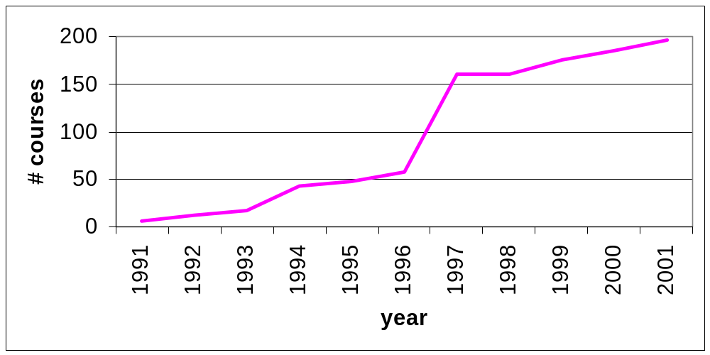
The reduction in government funding has also lead to closures of schools and departments that were no longer economically viable. At UNSW, schools that were closed between 1991 and 2001 included Fibre science and Technology (including areas of Textile Technology, Wool and Animal Science), Sport and Leisure Studies. Other schools and departments were amalgamated and their research and teaching combined (e.g. School of German and Dept of Russian Studies became the Department of Russian and German Studies). This practice has a lesser effect than an outright closure, but such amalgamations also reduce the diversity and expertise at an institution.

While restructuring may save running costs, other implications of this action are not considered, such as the discipline’s importance and need in the community. Technological advances in the sciences are important but if these technologies cannot be administered in a sensitive and ethical manner, it can disrupt society. An economically successful society with no room for the critique of the arts becomes a soulless society that squashes creative thought. The loss of diversity in school structures may lead to a loss of diversity in both teaching and research and additionally decreases the flexibility of universities to adapt to change and the needs of an evolving society (also addresses section b)iv)).

We call on the government to increase the funding to Australian universities for both research and teaching to stop the emaciation of our higher education sector.

- The increasing reliance on private funding and the production of appropriately-qualified graduates to meet industry demand – section b)ii)

The Postgraduate Board is greatly concerned with the over emphasis that the concept of industry demand has in current discussion of higher education at the expense of the other beneficiaries of education. Rarely are the broader societal demands of the education system considered. As outlined above universities have increased their reliance on funding from industry with the decrease in government funding and in the process have been forced to downplay other areas of university education, such as the arts and humanities. These degrees provide a high level education for people who enter and become leaders in the public service; who become Australian novelists, playwrights, musicians and artists; who become teachers in all levels of our education system; and who become historians, sociologists, and journalists and improve the level of public discourse in Australia. Clearly all these professions add greatly to our society but do not necessarily bring in large economic returns.

We believe that the industrial training and education of graduates provides a direct financial benefit to the industrial sector. And hence the industrial sector should be willing to pay for this education at university, although the amount of direct support (in the forms of course fee payment and study leave) given to postgraduates by industry is small.

The only way to ensure that Australia can take part in unknown technologies of the future is to build a comprehensive basic science research education. There is currently a paucity of mathematicians that is causing great concern to various sectors of society, including industry .To ensure that Australia will be able to participate in technology development will also involve a commitment to the training of science teachers at all levels of education.

Research operates in an international forum. It is important that Australian graduate research students can continue to compete internationally for research positions. Given the fluidity in international research, if Australian investment in postgraduate research to benefit Australia, then comparable opportunities for post-doctoral graduates must be created in Australian universities and government research institutes. Currently a large proportion of top Australian Ph.D. graduates go to the US and/or Europe for their first post-doctoral position. The Postgraduate Board welcomes the recent announcement of an increase in postdoctoral fellowships, but encourages the government to further increase these fellowships to enable Australian research to reach its full potential.

Figure 5. Change in the number of each type of postgraduate course at UNSW during 1995-2000.

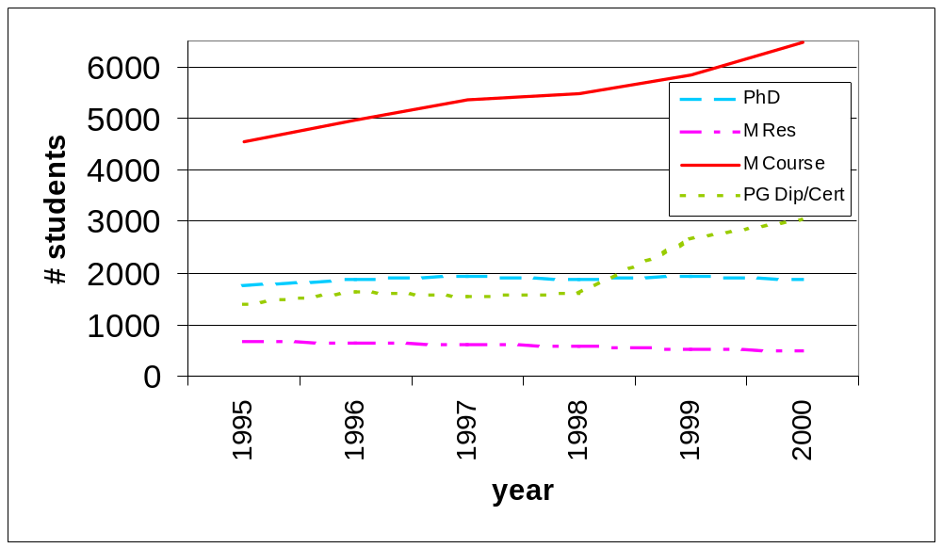
Table 2. Percentage change in number of postgraduate students at UNSW over the period 1995-2001. M Res = Masters by Research degree, M Course = Masters by Coursework degree, PG Qualify = Postgraduate qualifying course, PG Dip/Cert = Postgraduate diploma and postgraduate certificate. ( – indicates decrease).

Course | % change
PhD | 5
M Res. | - 26
M Course | 42
PG Qualify | - 78
PG Dip/Cert | 120
Total | 40.8

- The increasing reliance on private funding and the adequacy of campus infrastructure and resources - section b) iii)

Our experience at UNSW, where there has been a steady program of improving buildings on campus since the early 1990’s, indicates that without the help of industry benefactors, much of this would not have been possible. The most recent example is the Leighton Co. donating one million dollars to the construction of the award winning Scientia building.

However private funding such as this tends to be siphoned to projects with more obvious and immediate appeal, such as function centres and new halls, rather than the construction of classrooms, lecture theatres and laboratories. Along with the library, we argue that these form the intellectual infra-structure of the university.

- The increasing reliance on private funding on Australia’s immediate and long-term capacity in research – sections b) iv) and f) iii)

The Postgraduate Board asserts that only if the diversity of disciplines can be maintained at Australian universities will the national research capacity be preserved. Increasingly only applied areas of research are well supported while basic areas struggle to attract any funding – this drastically reduces the diversity of research at Australian universities. Short term returns may well come, however the capacity of universities to respond to the needs of society will be reduced.

The Postgraduate Board stresses the concept that unless there is a strong base of diversity it is not possible to ensure future innovation necessary to form the backbone of a technologically and socially advanced society. It is imperative that diversity of research is maintained, indeed enhanced, at universities due to the inability to predict in which areas will impact in future developments, both socially and economically.
- The effect of universities’ commercialised research and development structures – section b) v)

There has been an increasing reliance on industry funding with 25.2% of research postgraduates at UNSW in 2000 funded by industry. Additionally, 29% of these students are expected to work on problems dictated by industry, 22% expected to produce a patent before the end of their course and 15.6% a product or software.

Within this more commercialised structure, problems with student ownership of their intellectual property are not uncommon. There have been examples of students unable to publish results due to contractual arrangements with private companies, students whose work was taken by the company that they worked under, and students that were forced into signing an intellectual property contract at the very beginning of their projects. (Refusal to sign would preclude the student from working on this project). These occurrences all show a lack of recognition of the postgraduate students in the research process and the difficulties surrounding the involvement of industry in public education institutions.

- The levels of access among social groups under-represented in higher education – section d)i)

The Postgraduate Board believes there is broad inequity in access of higher education in Australia, specifically with respect to three groups: indigenous people, women and people from low socio-economic backgrounds. There are proportionally fewer of these groups than in both undergraduate study and in the general population. This indicates that there are inequities in postgraduate education that need to be addressed.

Indigenous people
There is exceedingly poor representation of Indigenous Australians in higher education, especially postgraduate level. For example at UNSW in 2000, ATSI postgraduate students represented 0.11% of all postgraduate students (13 students of a total of 11 869 postgraduates). We believe that it is the Government’s responsibility to ensure access to and participation of Indigenous Australians in universities and call on the government to set-up an Indigenous Postgraduate Scholarship scheme (consisting of a HECS award and a living stipend).

Women
There is still an under-representation of women in postgraduate study in Australia. For example, at UNSW in spite of a large increase in the number of postgraduate students between 1995 and 2000, the discrepancy in the number of women and men in postgraduate studies persists (Figure 6). Additionally, in 2000 the proportion of undergraduate students who were women was 48% while in postgraduate studies it was only 41.9%. The causes of this imbalance require further investigation.

Figure 6. Gender of postgraduate students at UNSW from 1995-2000.
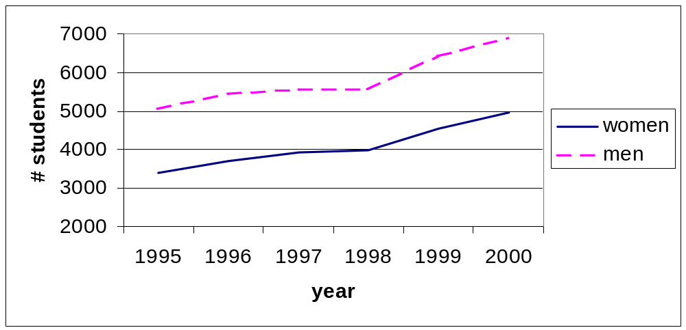
Additionally remuneration for course field placements is clearly unequal. Many students must complete field placements in community settings (eg hospital, government organisations, private companies). Remuneration exists for some degrees (eg medicine, engineering, architecture) at the undergraduate and postgraduate level, however many female dominated degrees (eg psychology, social work) do not receive remuneration. Indeed, the organisations at which the students are undertaking placements often make money from the work of the students. For example, Master of Psychology (Clinical)
students at UNSW must complete 1000 hours of placement across four professional settings. One placement must be at the UNSW Psychology Clinic. Clients pay between $10-$30 each session, the money going directly to the School of Psychology and not the students. Additionally, students must pay HECS or up front fees to undertake these placements. We believe that this inequity is inappropriate.

In the area of employer support there is also great inequity in postgraduate education. More men (~45%) than women (~23%) have their course fees paid partially or fully by their employer . Additionally the level of support increases for men employed full time with the brevity of degree: ~30% men receive financial support for research degrees, ~48% for masters coursework and more than 50% for postgraduate diploma/certificates. Women employed full time on the other hand, receive support from employers in only ~ 20% of cases for research degrees, and about ~30% of cases for masters coursework, postgraduate diplomas and postgraduate certificates. This lack of support for women to access postgraduate education by industry further confounds their participation.

Figure 7. Number of students on HECS awards in Masters coursework, graduate diploma and graduate certificate courses at UNSW from Session 2 1997 to Session 2 2000. Percentages indicates the proportion of all students in these courses on HECS awards.

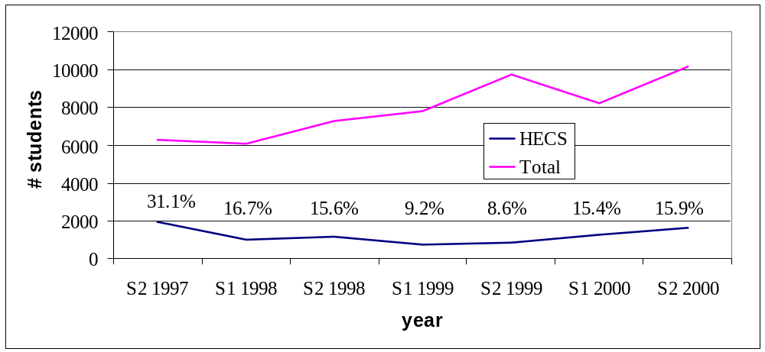
People from low socio-economic backgrounds
Due to the high up front fee levels and lack of government assistance such as Austudy and Abstudy, many people from low socio-economic groups cannot afford a postgraduate education. This means that there is now an over representation of high income and full fee paying students in coursework. As pointed out previously, the proportion of postgraduates overall that are paying full fees for their courses has increased to 74.1% in 2000 (Figure 4). These figures do not reveal the extent of the inequity as they include research students who as a matter of policy do not pay fees. In fact the percentage of students with HECS awards in postgraduate fee paying courses was only 15.9% in 2000 (Figure 7). In the last 3 and a half years, the number of students enrolled in these courses has increased dramatically, although the number of students on HECS has decreased overall (Figure 7).

The number of full fee paying courses at UNSW has also increased with the deregulation of postgraduate education, from 6 in 1991 to 195 in 2001 (Figure 3) with only 13 of these courses HECS only courses (and these are all in education, health and medicine).

Additionally it appears that industry support for people in postgraduate study (in the form of full or partial fee payment) increases as their income increases. With an increase in salary comes a greater chance that a person’s employer will support their further study. This produces a situation where those people who need assistance the most (i.e. low income earners) receive less financial support than those people who are more likely to be able to afford it. This situation is also relevant in the following section d) ii).

- The affordability and accessibility of higher education – section d)ii)

HECS Awards were introduced to allow students to pay HECS rather that up front fees and in the process increase the access of postgraduate education. However, we question whether this intention is effective due to the following observations at UNSW:
- HECS Awards do not provide any support for the cost of living, rendering higher education inaccessible for many. This is particularly pertinent for students wishing to study full time courses.
- Many courses offer HECS Awards, but no other scholarships.
- Some schools refuse to offer HECS Awards. For example, the School of Optometry does not offer HECS Awards as it is believed that many (not all) students would not meet the eligibility criteria for the award and they are concerned about the financial ramifications to the school. Similarly, the School of Aviation does not offer HECS Awards in its postgraduate courses, nor can they be used to study the postgraduate courses of drug development, business technology, technology management, and couple and family therapy.
- There are reports of students on HECS Awards taking out student loans to cover the cost of living as there are no scholarships and no government financial support (e.g. Austudy) for postgraduate students engaged in Masters level courses.

Over the last decade the HECS income threshold has decreased substantially (Figure 8) and in 1997 the present Government reduced the income limit dramatically to $20, 700. It has since risen slightly. However in this situation, people with previous HECS debts are more greatly constrained by having to pay their HECS debts when their earnings are considerably less than the average weekly wage, and nearer to the poverty line. The combination of this reduction in HECS income threshold and the predominance of full fee paying postgraduate courses further decreases the access of low income earners to access postgraduate education. To counter this problem there needs to be recognition by the Government of the issue, and the Postgraduate Board therefore recommends that the Government raise the HECS income threshold to the Average Male Weekly Earnings.

There is a paucity of information on potential students who want to enrol in postgraduate education and how fees affect their decision to study and their access to further education. Therefore it is difficult to determine the size and the extent of the effect of the fees on this group. The Postgraduate Board also believes it is inappropriate that individuals should pay a large sum for their postgraduate education, with little support
Figure 8. HECS income threshold over the period 1989 – 2001. 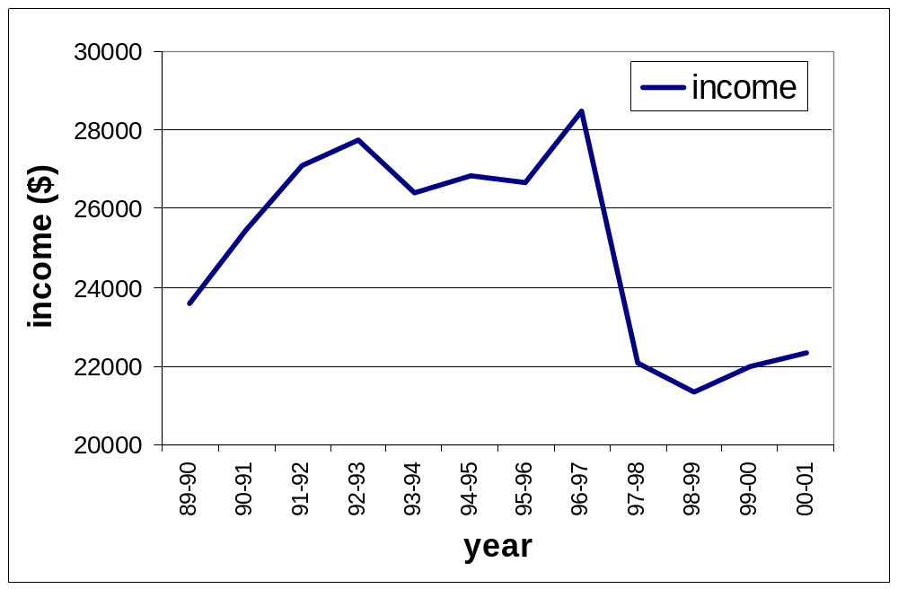

from the government as this fails to recognise that a more educated and skilled population gives greater benefit to society than to the individuals involved. The benefit of a postgraduate education should also not be seen only in terms of economic benefit, but also social stability, the promotion of cultural values, democracy and an educated citizenry that is equipped to play its part in shaping Australia’s future. The Postgraduate Board therefore recommends that the government funds research into how the introduction of full fees and HECS has affected the accessibility of higher degrees, particularly for the groups of society described in section d) i).

The introduction of full fees in postgraduate education has decreased the accessibility of Masters level courses. For example, at UNSW the number of local students in Masters Coursework degrees has remained constant over the last six years with the increase being in international student enrolments (Figure 9a). The situation is the opposite for postgraduate diplomas and postgraduate certificates: international student numbers are constant and the increase has been in local student enrolments (Figure 9b). Therefore proportionally less local students are commencing full fee paying Masters courses as compared to postgraduate diploma and certificate courses, in which students can receive Government allowances such as Austudy and Abstudy. Students also pay lower fees in these courses (due to the smaller number of subjects and the decreased time taken to obtain a diploma or certificate). However they are often the same subjects as the Masters by Coursework. We argue that this is an example of the deterrent effect that full fees have had in the participation of Australian students in Masters coursework courses.

Figure 9a. Masters by Coursework students at UNSW: numbers of international and local students.
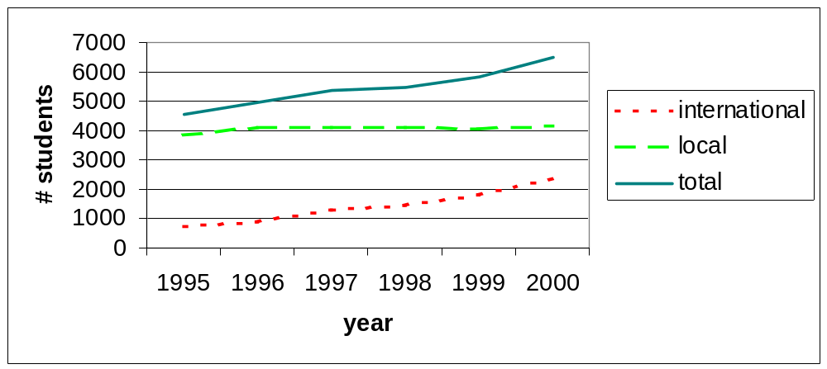

Figure 9b. Postgraduate diploma and certificate students at UNSW: numbers of international and local students.
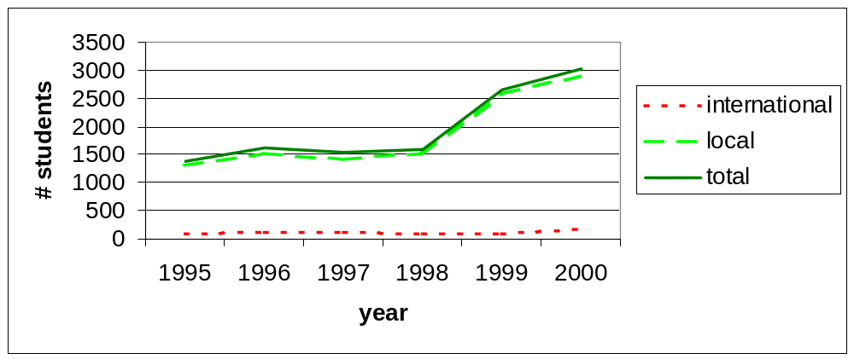

- The adequacy of current student income support measures – section d)iii)

The Postgraduate Board believes the current income support measures for postgraduate students are limited. The following has been noted with regards to scholarships and research education:
- APA Scholarships do not meet the cost of living, particularly in suburbs in geographical proximity to universities in large cities, e.g. the UNSW Kensington campus which is located in the high-rent area of the Eastern suburbs.
- APA Scholarships are provided for only 3 years of study (with a possible 6 month extension), when the average time taken to complete a PhD is 4.7 years. The actual time taken to complete a PhD may be prolonged due to this discrepancy, as students often need to take full time positions when their scholarships expire, and complete the remainder of their study part time. This causes great stress to the students and extends the completion times for PhDs.
- Other research scholarships (such as university postgraduate awards) are generally set to meet the APA rate, and therefore also fail to meet minimum living costs.
- The taxing of part-time APA scholarships actively discriminates against disabled students and students with caring responsibilities. As these scholarships are only available to these groups of people, the fact that they are not tax exempt in line with the full time scholarships, discriminates against these already disadvantaged groups.

The following has been noted for coursework students:
- Scholarships are generally unavailable.
- HECS Awards are available for some students, but these only supplant HECS fees for up front fees and do not provide support for living costs.
- Some courses restrict the amount of time students are to spend in non-study activities. For example, at UNSW Master of Psychology (Clinical, Organisational, Forensic) requires full time students be available between Monday-Friday, 9-5. Accepting a position in the degree means accepting that part-time or casual work be completed outside of normal business hours.

Government assistance (e.g. Austudy, Abstudy) is also only available for Graduate Diploma and Graduate Certificate students not for Masters or Doctoral students. This discriminates against people who require a Masters or Doctoral degree to qualify for entry into a profession (e.g. Clinical Psychology). The lack of financial support can exclude students from postgraduate study. Many people that accept positions in postgraduate study evidently work excessive hours in order to support themselves. If more scholarships and government financial assistance were available it would ease the extraneous demands placed on students. This can only result in students getting more from the time they put into their studies and enhance the completion rates.

In respect to these issues the Postgraduate Board recommends that:
- APA awards are extended to a maximum of 4 years.
- the Government investigates the problem of high living costs associated with some campuses, in order to determine an appropriate supplement.
- Part time APA scholarships are classified as non-taxable income.
- Government assistance be extended to those people undertaking courses necessary for entry to a profession.
Individual Case Example, supporting section d).

Course: Master of Psychology (Clinical)
Institution: UNSW
The course qualifies psychologists to practice as clinical psychologists. These skills cannot be gained through undergraduate study. Whilst they may be gained through on-the-job training, the quality and diversity of the training and skills gained through postgraduate training is considered superior.

Course Requirements
- 1000 hours of unpaid field placement, to be divided across four settings. NB – in the majority of placements the placement setting receives payment from clients for the services provided by the Intern Clinical Psychologists (who are conditionally registered as psychologist by the NSW Psychology Registration Board)
- Thesis
- Coursework
- Full time students must be available weekdays during normal business hours

Finances
The student is in a position where she must partially support herself, and cannot work in her professional industry due to course imposed time constraints. “I am currently working 70 hours a week, and being paid for 18 hours. There is no financial support available from the government or through scholarships.”

Income
- $200/wk (family support) + $180/wk (casual employment)

Living Expenses
- Rent $150 /wk
- Transport $20 /wk (to placement)
- Food etc $70 /wk
- University expenses $20 /wk
(i.e. photocopying, preparing resources for clients, stationery)
- Utilities $20 /wk
- Textbooks/resources $500 p.a.

Average Week
Sunday | Monday | Tuesday | Wednesday | Thursday | Friday | Saturday
Casual work  6 hr  Uni prep  2 hr | Placement  8.5 hr  Uni prep  2 hr | Thesis/course  work  10 hr | Placement  9-10 hr  Uni prep  2 hr | Placement  9 hr  Casual work  3 hr | Placement  8.5 hr | Casual work  9 hr

Totals
- Placement 36 hours
- Uni (thesis/coursework/prep) 16
- Casual work 18
Grand total 70 hours

The student further notes that “I am one of two people in a course of 20 that originally attended a state high school. One full time student of 12 is completely self sufficient; all others receive financial support from family and partners.”

- The ability of Australian public universities to attract and retain staff – section e)
The Postgraduate Board is specifically interested in casual academic staff, as postgraduate students make up a high proportion of casual academics. Casual academics in turn make up a large proportion of the total academic staff. For example, at UNSW there are approximately 1000 casual academics versus approximately 2600 full or fractional full time academics. Casual academics are those that work part time to lecture, tutor and demonstrate undergraduate classes. These academics do a large amount of the teaching and are often exploited due to their desire for teaching experience, the relationship with their supervisor and/or their need for income to support their studies. The lack of adequate funds to pay casual academics can be directly seen as a result of a decrease in government funding to universities, as more courses are taught with less money, resulting in a decrease in funds available to any one subject. A pertinent example is of a postgraduate at UNSW who was paid only enough to spend 5 minutes per assignment for a second year undergraduate course, when it realistically took 15 minutes for each assignment. She was told that there was not enough money in the course funds to pay for the marking. This lack of funding meant that she was paid only 1/3 of the time she worked.

A decrease in the funding to universities has meant that undergraduate courses are not adequately resourced. This then affects what can be taught and the quality of the content, and at times forcing academics to compromise their standards. An example is of a postgraduate at UNSW who chose to no longer demonstrate a second year science subject as she could no longer bear the lack of resources available and the implications to the course. The lack of resources meant that only low cost experiments could be taught and large sections of the course were removed as they could not be taught experimentally. This lead to an overall lowering of the subject’s standard and the casual academic refused to teach the subject again. Such occurrences have turned many excellent, energetic and young academics off teaching and potentially away from a career in academia.

Additionally, in high demand courses, such as computer science, where graduates can attract substantial salaries outside the university, there is little incentive to remain in academia. The present academic environment demands that teaching duties, administration, development of new and up-to-date courses for classes of up to 800 students and the option of research must all be carried out concurrently. Academics are therefore required to work 60-70 hours weeks for an uncompetitive salary.

While it is true that the freedom of being an academic and engaging in research of interest is a benefit, they must now “make time” to attract their own funding. Additionally, as research output is the measure for career advancement with little reward for excellence teaching or community service, there is more pressure on academics to compete for research funding . This situation further erodes the quality of teaching as there simply is no incentive. This environment is hardly attractive to the close to finishing Ph.D. student when they are offered twice the money and half the headaches elsewhere. There is therefore, a net loss of potentially excellent academics to the corporate world, and with this a loss to university teaching and research.

- The capacity of public universities to contribute to economic growth – section f)

Economic growth cannot occur on its own and cannot be divorced from the issues of justice, access and equity. While we recognise the importance of economic growth in Australian society, the Postgraduate Board believes that Australian Universities should be recognised for their wider contributions to society such as in the cultural and social arenas, and not only for the economic returns that they generate. The current emphasis on the economic returns of government investment into higher education belittles the contributions that universities, their students and their staff make in areas that enrich our culture and our lives. An educated population can more rigorously decide the direction in which their society should move. This increased level of debate, stimulated by a strong education system, should be the aspiration of all governments. The Postgraduate Board recommends that the contributions of universities to Australian culture be formally recognised.

- Higher education as an export industry – section f)ii)

The Postgraduate Board voices our concern about the trend toward enrolling full fee paying international students in order to recompense the short fall in Government funding. This is achieved with vigorous and targetted marketting of Australian degrees overseas. Currently it appears international students are used as “cash cows” to bring in money to Australian universities, with little regard given to the effect of this increase in student numbers on the overall student population. This is seen in the increase in the number of international postgraduate students at UNSW (120% increase on 1995 numbers versus 25% increase for domestic students; Table 3). International students’ status as alternate income is also clear from the differential fees charged to international students. At UNSW in 2001 International student fees range from 1.28 times (Master in Urban Development and Design) to 2.48 times (Graduate Diploma in International Social Development) the fee paid by local postgraduate students. Within this context, we assert that public Australian universities need to provide a high quality education for all students, as well as ensuring that educational opportunities are not lost for domestic students due to preference for fee paying International students.
Table 3. Number of international and domestic postgraduates at UNSW from 1995 to 2000.
 | 1995 | 1996 | 1997 | 1998 | 1999 | 2000
International | 1292 | 1491 | 1825 | 1930 | 2306 | 2890
domestic | 7131 | 7623 | 7633 | 7617 | 8637 | 8966

We recognise and value the cultural diversity that international students bring to a campus, as well as the international collegiality that is fostered and remains long after graduation and the importance of international input to research output. However we are concerned about the current overcrowding of campuses and the subsequent pressures on existing university structures.

- Accreditation regimes and quality assurance – section g) i)

The Postgraduate Board supports the decision to establish the Australian Universities Quality Agency (AUQA) but expresses concern with its lack of teeth: in its current form it will be unable to assure quality across the Australian higher education sector.

Masters Coursework degrees
The Postgraduate Board is concerned by the lack of control of masters degrees in Australia and the decrease in the length of the masters degree at Australian institutions. For example, at UNSW the length of a Masters by Coursework degree ranges from 1 year to 3 years (Table 4). There has also been a reduction in the number of 2 year degrees and an increase in the 1.5 years masters over the period 1991 to 2001. This reduction in time of a course we believe invariably leads to the reductions in the amount of content that can be covered in a Masters course, and therefore leads to a “dumbing down” of the Masters by Coursework degrees.

In line with our national body CAPA, we believe that the minimum time for a Masters degree should be 2 years, and that all Masters degrees should be set to the same level of attainment . In 2001 only 6 out of 98 Masters courses (i.e. 6%) at UNSW are of an appropriate length for a Masters degree. Without this standard, the dropping quality of the Masters degree will continue to the detriment of students, universities and society.

Table 4. Range of the duration of Masters by coursework at UNSW 1991 – 2001
Duration | 1991 | 1992 | 1993 | 1994 | 1995 | 1996 | 1997 | 1998 | 1999 | 2000 | 2001
1 yr | 67 | 64 | 54 | 52 | 59 | 69 | 56 | 66 | 69 | 70 | 69
1.25 yr | 0 | 0 | 0 | 0 | 0 | 0 | 0 | 2 | 3 | 2 | 4
1.3 yr | 0 | 0 | 0 | 0 | 0 | 0 | 0 | 0 | 2 | 1 | 1
1.5 yr | 6 | 3 | 3 | 5 | 7 | 8 | 11 | 20 | 23 | 19 | 18
2 yr | 8 | 13 | 10 | 11 | 14 | 5 | 8 | 6 | 5 | 6 | 6
3 yr | 0 | 1 | 1 | 1 | 1 | 1 | 1 | 1 | 1 | 0 | 0
Total | 81 | 81 | 68 | 69 | 81 | 83 | 76 | 95 | 103 | 98 | 98

Fast track degrees
The last few years have also seen the introduction of “fast track” degrees that package an undergraduate degree with a postgraduate degree. There are currently 22 of these degrees at UNSW. We argue that packaging two levels of degrees in this manner devalues the postgraduate qualification, and further “dumbs down” the Masters qualifications that are offered in combination. We believe that there should be greater regulation of these types of degrees by the AUQA.

Research Training Scheme
We believe the governments proposed Research Training Scheme (RTS) has the potential to damage the reputation of Australian research degrees. In this scheme, the time of funding to universities for research students will be reduced (eg. PhD students will be funded for 4 years while the current funding is for 5 years) and the structure of the funding regime will be altered so that much greater focus will be on completions and not the process. In the new scheme, a completion of a research degree will be worth almost 10 times the current value. A result of this restructuring will be a decrease in the quality of research degrees, because risky and more innovative projects will not be supported by universities on economic grounds. This will lead to research degrees that may take only 4 years but will be inferior in quality. We recommend that length of funded candidature for research students be reverted to the lengths funded in 2000.

On-line degrees
Additionally there is currently no framework set-up to regulate and assure on-line courses offered by Australian universities in the international arena, or by international universities to Australians on-line. This promises to be a growing area of concern for the sector, with five Australian universities already involved, or on the brink of involvement with global on-line universities. The quality of exclusively on-line education, while offering many advantages to students, is inferior to that offered by an on-campus education. Students learn in vastly different ways and on-line technologies only augment this process but cannot replace a "classroom" environment. This is due to the fact that a large part of education is learning from direct interaction with lecturers as well as with other students in the class. These direct interactions cannot be provided in an on-line environment.

An example of an on-line venture is U21 Global that will involve three Australian universities and at this stage plans to offer a limited number of courses for full fees. As yet the academic governance structure of this “university” is not finalised. The proposal for U21 Global has been undermined by the recent announcement by the Massachusetts Institute of Technology (MIT) that all of their course notes will be made available freely on their website. This therefore takes away the emphasis of course content as a commodity that can be sold to students for full fees. Rather the resource offered by MIT is in their staff and teaching, augmented by the course notes that are available to all and sundry. Only when enrolled and attending classes at MIT does the student receive MIT's famous and highly regarded qualification. This is an important distinction that the Postgraduate Board fears the present higher education policy does not address.

For these reasons, we assert there is a need to address this deficiency immediately and call on the Government via the AUQA to address the involvement of Australian universities in global on-line education.

- University governance – section g) iii

The Postgraduate Board expresses its concerns with the current lack of transparency of university governing bodies. Transparency in university decision-making was determined to be of moderate to very high importance by 86% of students at UNSW . Recent discussions in the University Council of UNSW in the two areas of budgetary processes and commercial have been held in closed sessions of the Council, with only the final decisions made public. We believe this lack of transparency in decision making processes is inappropriate for a public institution. Large budgetary allocations and decisions regarding relationships with commercial entities involvement have the potential to affect the whole institution, including its teaching and research, and therefore should be treated in an open and transparent manner. Accountability to not only the university community, but also the wider community is a fundamental aspect of public universities that must also be upheld.

We additionally support the ongoing involvement of student and staff representatives on University governance structures, as they contribute valuable perspectives and experience to insuring the equity, diversity and quality is maintained at Australian Universities.

Prepared on behalf of the Postgraduate Board of UNSW by Ms Harriet Baillie, Ms Michelle Maloney, Mr Craig Roberts and Mr Ross Grainger.

Contact details:
Ms Harriet Baillie
Convenor
Postgraduate Board
Student Guild
East Wing, Quadrangle Bldg
UNSW NSW 2052

h.baillie@unsw.edu.au
mob 0412 533 562
ph. 02 9385 6712

Planning Office, UNSW.
Planning Office, UNSW.
Figure 5, Annual Statistics Bulletins 1992-2000.
Table 4, Annual Statistics Bulletins 1992-2000.
UNSW Calendars Summary Volume 1991-2001. Some of these lists of postgraduate courses are acknowledged to be incomplete so these data are the minimum number of courses for which fees are charged in any year.
Planning Office, Student Statistics, On-line via www.planning.unsw.edu.au
Federation of Australian Science and Technology Societies, Study on Mathematics graduates, September 2000.
Postgraduate qualifying courses not displayed due to small numbers.
Grant Harman, Survey Ph.D. students in Australia: Course Experience, Career Goals and Industry Links. (preliminary results). UNE.
ibid.
Planning Office, UNSW.
Planning Office, UNSW.
A. Woolf and D. Quarmby, 1999, Postgraduate Fee-paying Courses: Equity Implications, CAPA. p. 116.
Graduate Careers Council of Australia, 1998 Postgraduate Destination Survey.
Student Statistics On-line, Planning Office, UNSW http://www.planning.unsw.edu.au
Postgraduate Fee-paying Courses: Equity Implications, A. Woolf and D. Quarmby, CAPA 1999. p. 116.
Although the per annum amount is equivalent in most courses.
Planning Office, UNSW
Planning Office, UNSW.
Section 7.1 Part-time APA, DETYA Guidelines for Australian Postgraduate Awards Scheme 2001 http://www.detya.gov.au/highered/research/documents/apa2001.htm#7_1
Personal communication, Pro Vice Chancellor (Academic Planning), Prof John Ingleson, UNSW.
Full and fractional full time staff by award type, continuing status and sex 1999. Staff Statistics, Planning Office, UNSW. http://www.planning.unsw.edu.au/statisticsdocs/staff_status_sex.html
Postgraduate Programs, Faculty of Arts and Social Sciences, UNSW Calendar 2001, http://www.publications.unsw.edu.au/handbooks/calendar/28202.htm
Planning Office, UNSW
CAPA Response to the Australian Qualifications Framework Advisory Board Review of the AQF Guidelines for the Bachelor degree and Postgraduate Qualifications. February 2001, pp. 9-11..
UNSW Calendar Summary Volumes 1991-2000.
New York Times, April 4, 2001, “Auditing Classes at M.I.T., on the Web and Free”
Table 14, page 21, Report on the UNSW Student Survey 1999, August 2000, Planning Office, UNSW

