The Professional Surveyors’ Occupational Association
NSW Incorporated

Registered No: Y2426234
12 March 2004
Ref: TLA Submission 0304

The Secretary
Senate Economics Legislation Committee
Room SG.64
Parliament House
CANBERRA ACT 2600

Treasury Legislation Amendment (Professional Standards) Bill 2003
The Professional Surveyors Occupational Association NSW Inc. was established in 1996 to facilitate the Professional Surveyors Limitation of Liability Scheme governed by The Professional Standards Act (NSW) 1994.
A survey of potential members to the scheme prior to setting up indicated a wide interest. The scheme was established to recognise two classes of membership:
- individual registered surveyors or surveyors who hold an approved Bachelor Degree or equivalent in a discipline of surveying and have at least two years experience
- firms where each partner and employee qualifying for individual membership is also a member.
At the time there were in the order of 1,000 practising registered surveyors in New South Wales plus an unknown number of graduates with more than two years experience and approximately 400 firms and sole traders.
In the first year of operation the Association received applications from 110 members. Since then applications have reached 151 but 68 resignations have been received leaving only 83 members.
Three main reasons have been given for resigning from the scheme:
- The failure of the scheme to protect against claims bought under the Trade Practices Act. The major provider of professional indemnity insurance to our industry, ACSIS Ltd, has reported that approximately 30% of claims now cite “misleading or deceptive conduct” as a component of claims lodged.
- The failure of the scheme to cover for work undertaken outside of New South Wales. With improving technology a number of surveyors are now undertaking work in more than one state.
- No differentiation in premiums to scheme members. ACSIS Ltd report that insurers are unable to recognise perceived benefits in membership of the scheme in New South Wales mainly due to the above two factors.
Those who have not joined the Association have given similar reasons. It is our opinion that within the industry there is a strong support for the capping of professional liability.

It is our opinion that the use of the Trade Practices Act reference to “misleading and deceptive conduct” has increased due to the steady change in the litigious nature of our society. There is a concern that once this avenue to pursue a claim is removed other similar opportunities might be sought through other legislation. It is hoped that the possibility of such “opportunity seeking” has been considered and if necessary will also be addressed before it becomes another deterrent to the capping of professional liability.
The process of preparing a scheme that was acceptable to the Professional Standards Council in New South Wales required considerable effort. Ample opportunity was given for amendments to fulfil the legislative requirements of the Act including a time of public display before gazettal. For administration purposes we are concerned that there should only be one scheme that meets the requirements of both state and federal bodies. In our opinion if amendments are required to meet federal requirements these should be advised at the time of application or renewal so that gazettal at state and federal levels can be achieved at the same time.
Overall we believe that the Treasury Legislation Amendment (Professional Standards) Bill 2003 is a positive move towards improving the value of professional standards legislation.

Yours sincerely

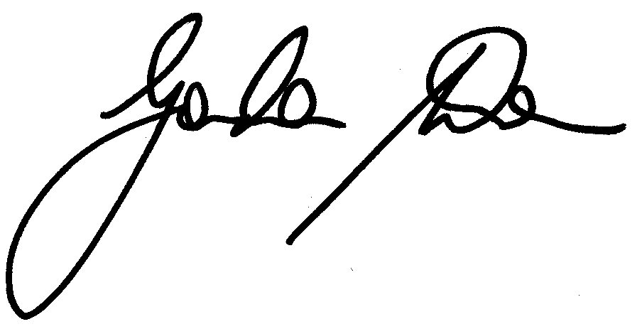

Gordon Wren
Chairman

