
The Independent Liquor Group
Distribution Co-operative Ltd
42 Lamb St
Locked Bag 13
Glendenning NSW 2761
Telephone: 9675 8400
Facsimile: 9625 0601
E-mail: ilg@ilg.com.au
ABN: 70 252 541 400

15th January 2003

Dr Sarah Bachelard
Secretary
Senate Economics References Committee
Room SG.64
Parliament House
CANBERRA ACT 2600

Via email: economics.sen@aph.gov.au

Dear Dr Bachelard

Re: Inquiry into the Effectiveness of the Trade Practices Act 1974 in Protecting Small Business

Attached please find a supplementary submission respectfully submitted by the Independent Liquor Distribution Group Co-Operative Limited (ILG) on behalf of our 600 members, comprising both hoteliers and independent liquor retailers.

This supplementary submission is provided in response to a request by the Committee to take into account the significance of the High Court’s decision in the Rural Press vs ACCC [2003] HCA 75 case.

Yours faithfully
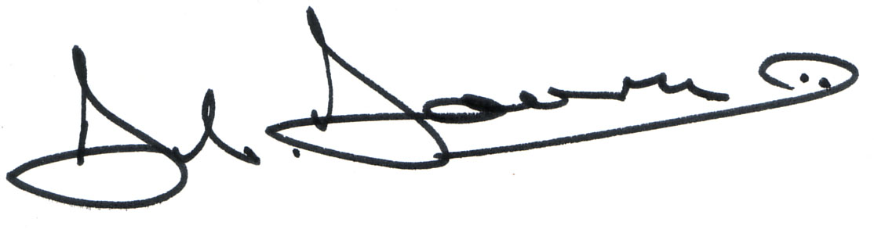

Bob Bourne
Chairman

Att.


A FOUNDATION MEMBER OF


SENATE ECONOMIC REFERENCE COMMITTEE INQUIRY INTO THE EFFECTIVENESS OF THE TRADE PRACTICES ACT 1974
IN PROTECTING SMALL BUSINESS

SUPPLEMENTARY
SUBMISSION ON BEHALF OF THE
INDEPENDENT LIQUOR GROUP
ON
THE HIGH COURT’S DECISION
IN THE RURAL PRESS CASE

January 2004

Table of Contents

Introduction 3

Section 46 – Misuse of Market Power 3

Analysis 4

Conclusion 6

Introduction

Further to our substantive submission to the Committee, ILG submits for the Committee’s consideration a supplementary submission that outlines our concerns and a response to the recent High Court decision on relation to the Rural Press Limited vs ACCC [2003] HCA 75 (hereafter referred to as the ˆRural Press Case”).

ILG has heightened concern over the misuse of market power following the Rural Press decision and urges the Parliament to enact legislation that provides clearer definitions of this particular section of the Act in order to provide guidance to business and the courts.

It appears that the majority of High Court members have not taken into consideration the original intentions of Parliament when drafting Section 46 and have taken a very narrow view of the law and its interpretation.

ILG support the dissenting comments made by Kirby.

Section 46 – Misuse of Market Power

ILG has already submitted that the Boral decision resulted in a weakening of the Parliament’s intention with this particular section of the Act.

It has been indicated that certain parties would prefer to adopt a ‘wait and see’ approach as more case law develops.

We originally submitted that the development of case law is a lengthy process, and that it is was more likely that further decisions will follow the precedent clearly set in the Boral decision. This has clearly occurred with the Rural Press decision.

The recent Rural Press case has shown that instead of the Courts proceeding to further define breaches of Section 46 that would have provided clearer guidance for small business in particular, they have instead made it substantially more difficult for small business to take action against larger competitors who abuse their market power.

If the “common person” rather than the High Court were judging the Rural Press case, it would be quite apparent that Rural Press had engaged in behaviour that would be deemed a breach of Section 46 and support the interpretation that the Trial Judge took.

The focus by the Federal and High Courts on the word “could” and the “market” fails to recognise the original intent of Parliament and further delivers another blow to small business trying to effectively compete against big business.

The ACCC argument was hampered due to the Act not containing a definition of what is market power. The Commission instead had to rely on weaker arguments in its case. The decision and the High Courts’ reasoning clearly demonstrates that Parliament needs to pass legislation that effectively validates their original intent so that small business is faced with a more certain competitive future.

The Parliament must act to ensure that the principal purpose of the Act, namely to protect and advance competition in markets in the Australian economy, are interpreted appropriately by the Courts.

Analysis

ILG supports the ACCC’s assertion that Rural Press and Bridge were involved in conduct that involved “taking advantage” of their market power for an anti-competitive purpose.

The threat to retaliate made by Rural Press to print in the Riverland area is in ILG’s opinion the clear conduct of a big business “taking advantage” of a small business seeking to compete. When the threat is backed, by the resources of Rural Press to effectively eliminate the existing small business operation in the Riverland area (through production of a ‘free’ newspaper), it amounts to what ILG would interpret as a clear breach of Section 46 and misuse of market power.

Further, the threats made by Rural Press could only have been made if ‘market power’ existed and they were seeking to preserve that market power. It appears to defy logic for the Courts to decide otherwise.

The threat made by Rural Press was conditional in nature, and effectively deterred Waikerie from engaging in competitive conduct in the Murray Bridge regional newspaper market.

Rural Press did not even attempt to compete fairly, and instead threatened retaliation in such a way that it was excising its market power and position to force the withdrawal of Waikerie from their own newspaper market.

It is a clear case of Rural Press using its market power, even though it did not have a competing product in the Riverland area.

Additionally, Rural Press used its market power to force a situation that ultimately restored its near monopoly position in the Murray Bridge market.

The Court’s focus on whether Rural Press “could” have engaged in the same conduct in the absence of market power does not excuse Rural Press from wielding the market power that it obviously held. Appropriate market behaviour in the absence of market power would have been demonstrated by Rural Press competing in both markets on the basis of price and quality of product. If the markets were not profitable for two newspapers to operate, then the normal forces of the market would ultimately decide who remained to service which markets. Ultimately it would have been the newspaper that offered the best value and most desirable product for the consumer.

The outcome that prevailed ultimately left the consumer and the small business operator as the losers and the High Courts’ decision will allow this scenario to be played out with other products and services in other markets.

ILG agrees with Kirby’s comments in his definition of market power to include the “physical and financial resources” of the organisation.

Our original submission argued that the present Trade Practices Act needed to include a stronger definition on market power. The Rural Press Case decision has given greater urgency for Parliament to provide explicit guidance on prohibited conduct.

Conclusion

The Trade Practices Act needs strengthening so that guidance is provided on conduct that adversely affects the competitive process, such as that exhibited in the Rural Press Case.

The Court’s decision in the Boral and Rural Press Cases have demonstrated a narrow view of the Act and concluded that big business did not directly take advantage of their market power. These decisions do not protect small business in its attempt to fairly compete in the market in the faith they are doing so under the protection of a strong Trade Practices Act.

The objective of the Trade Practices Act is to protect and uphold market competition.

It is therefore imperative that Parliament pass legislation that effectively validates the Parliament’s original intent in relation to the misuse of market power.

