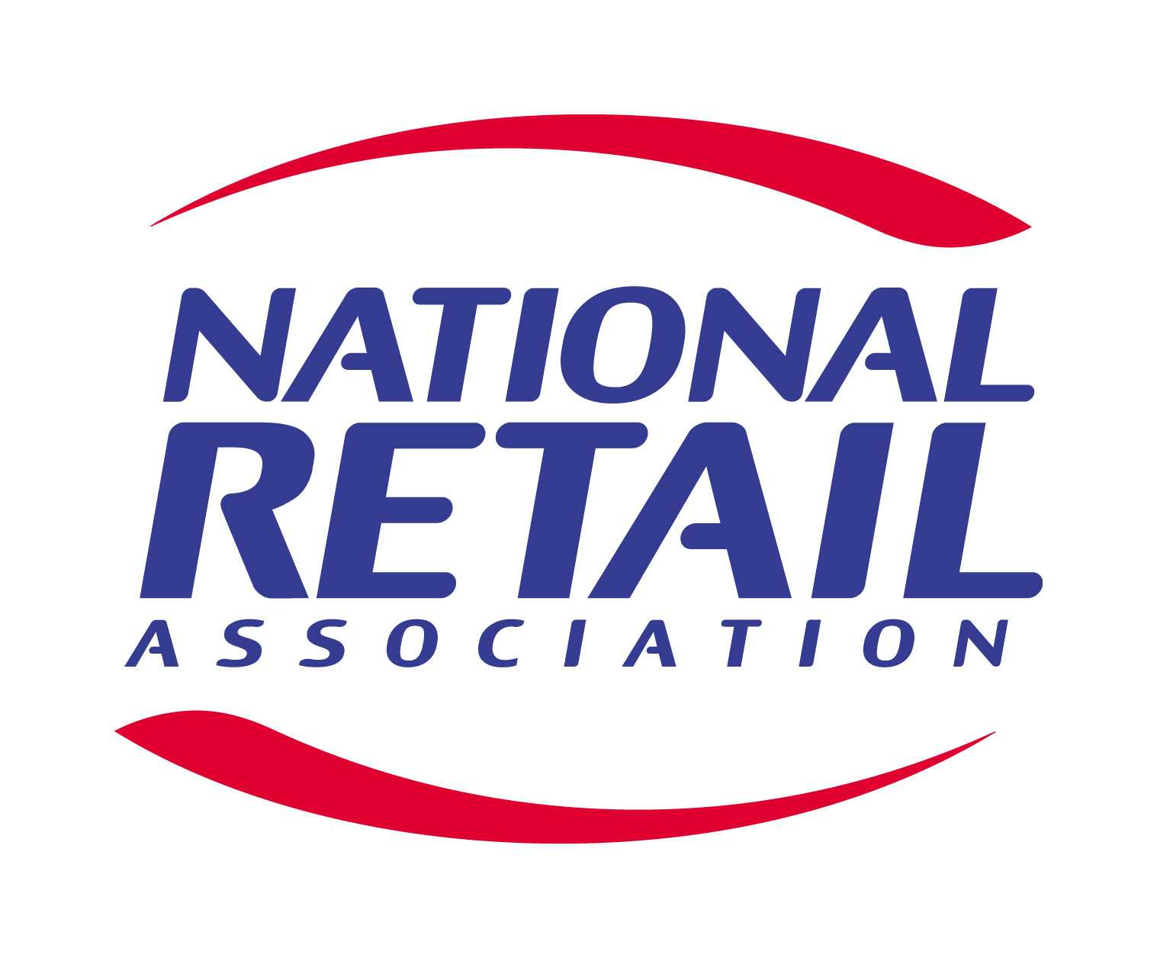
SUBMISSION TO
SENATE ECONOMICS REFERENCES COMMITTEE

INQUIRY INTO
THE EFFECTIVENESS OF THE TRADE PRACTICES ACT 1974 IN PROTECTING SMALL BUSINESS

September 2003
1. INTRODUCTION

The Senate Standing Committee on Economics has sought public submissions on the Effectiveness of the Trade Practices Act 1974 [the Act] in protecting small business.

The National Retail Association notes that this inquiry follows a review of the Act that was undertaken recently by the Dawson Committee. The National Retail Association also notes the report of the Dawson Committee, which was released in April 2003 and the response of the Commonwealth Government to its 43 recommendations.

In making this observation, the National Retail Association places on record its support for the Dawson Committee’s conclusion that the competition provisions of the Act have served Australians well; and that the Act has achieved an appropriate balance between the prohibition of anti-competitive conduct and the encouragement of competition.

As an industry organisation, the National Retail Association is committed to ensuring the ongoing success of its members and maximising opportunities for business growth and development. In this respect, the National Retail Association is focused on providing its members with the information, knowledge and skills necessary to operate more effectively in a dynamic and increasingly competitive environment.

The National Retail Association does not support the notion that section 46 of the Act needs to be amended in order to protect small business. As such, the National Retail Association most strongly supports the findings of the Dawson committee, and in particular the sentiment expressed by the committee, that competition provisions should protect the competitive process, rather than particular competitors. The National Retail Association also supports the view that competition laws should be distinguished from competition policy.

2. NATIONAL RETAIL ASSOCIATION

The National Retail Association is a progressive industry organisation that represents retailers in every Australian state and territory. It is an organisation that is committed to ensuring the ongoing growth of the retail industry and the prosperity of its members.

Retail is a highly competitive industry that has experienced extensive growth over the past 10 years. The National Retail Association provides its members with the information, knowledge and skills necessary to operate more effectively in a dynamic and increasingly competitive environment.

Members of the National Retail Association range from small sole operator enterprises to medium, large, independent, chain and franchise stores of all types and sizes throughout Australia.

As an industry organisation, the National Retail Association works to raise the profile of retailing through a number of key events including:

- Australian Fashion Design Awards
- Rewards for Excellence
- Young Retailer of the Year

The National Retail Association also represents the needs and views of its members to governments, media and the wider community.

3. RETAILING IN AUSTRALIA

Since 1991 the number of retail businesses in Australia has increased by over 18 per cent, while the Australian population has grown by only 15.7 per cent. Similarly, since 1991 the value of goods sold by retailers has increased by 50 per cent, from $114 billion to $171 billion.

Of the 99,000 retail businesses operating in 1999, 95 per cent employed less than 20 people.

Based on this statistical evidence, the National Retail Association submits that competition in the retail sector is not so much big retailers against small retailers, but primarily small to medium retailers against small to medium retailers.
4. MISUSE OF MARKET POWER

The National Retail Association acknowledges there has been substantial debate in the Australian community about the effectiveness of section 46 of the Act. This has especially been the case since the High Court judgement in Boral Besser Masonry Limited (now Boral Masonry Limited) v Australian Competition and Consumer Commission [2003] HCA 5 (7 February 2003).

The National Retail Association submits that many of the arguments used in support of amendments to section 46 of the Act have been emotive and outside the public interest.

It is the view of the National Retail Association that no changes should be made to section 46 and that this inquiry needs to ensure that competition laws are distinguished from industry policy.

5. BUSINESSES NEED CUSTOMERS NOT REGULATION

While debate rages about whether section 46 of the Act deals effectively with abuses of market power by big business, the National Retail Association submits that some small business commentators appear to have lost sight of the real issues that influence market conditions.

The National Retail Association believes that a successful retail business needs to deliver the right product, to the right place, at the right time, for the right price. These basic principles of marketing will remain central for as long as consumers have sovereignty over their expenditure. It is therefore misleading to contend that changes to section 46 will ensure the economic prosperity of small business.

Small business organisations that continue to push for reform of the Act, in order to blunt the realities of the marketplace, need to be careful they do not end up doing more harm than good. On this basis, the National Retail Association considers it would be retrograde and conceited to try and pressure governments into embracing policies that would force consumers to favour small businesses.

The harsh reality of business is that consumers vote with their hip pocket. Businesses that do not focus on customer needs will not survive.

The National Retail Association is of the view that a number of small business associations have survived merely by telling members things they want to hear. These associations have not had the courage to help members face the realities of competition. The result has been an obvious vacuum in small business policy debate.

A prime example of this vacuum exists in the grocery sector, which is dominated by industry associations that are totally focused on how they have been failed by government. The National Retail Association does not recall many occasions in which these same organisations have talked about need for members to satisfy the demands of the market.

The National Retail Association submits that regulation, which is designed to blunt the challenges presented by discerning and sometimes fickle consumers, or even price slashing competitors, cannot be contemplated by government and should not be promoted by business organisations. That is why it is wrong to think that changes to section 46 will help small business compete. Small business organisations and operators that ignore this fact are not only deceiving themselves, but are failing to recognise that utility maximising consumers will continue to spend money how, and where, they want. To think otherwise is to assume that Australia’s canny shoppers are big dopes.

6. UNCONSCIONABLE CONDUCT

Given the uncertainty about the operation of Part IVA and the scope of section 51AC, the National Retail Association supports the view that the Australian Competition and Consumer Commission should issue guidelines on its approach to this part of the Act.

The National Retail Association does not believe it is necessary to consider amendments to section 51AC, at this stage. It does note, however, that section 51AC was only added to the Act in 1998 and there are not many legal cases that have explored this provision.

7. SUPPORT FOR COLLECTIVE NEGOTIATION

The National Retail Association supports endeavours by the Minister for Small Business, the Hon Joe Hockey MP, to focus on the delivery of improved collective negotiation outcomes, rather than changes to section 46.

To help small business, governments and industry associations need to focus on practical policies and realistic outcomes. Maintaining low interest rates to foster investment; simplifying workplace relations laws and amending unfair dismissal laws; properly funding vocational training; and abolishing unfair taxes, like payroll tax; are ways to ensure the ongoing success of small business.

The National Retail Association believes that state governments need to remove payroll taxes and that non-government members in the Senate need to work with the Howard Government to pass workable unfair dismissal laws.

9. RETAIL TENANCIES

In its submission to this inquiry, the Shopping Centre Council of Australia has made a number of comments regarding state and territory regulation of retail tenancies.

The National Retail Association supports the existence of legislation regulating retail leases and works closely with its members to assist them in negotiations with landlords.

Shopping centre ownership in Australia is becoming increasingly concentrated amongst a small number of owners and managers. In light of this situation, it is important to ensure the Act provides sufficient scope to allow the effective operation of state based retail tenancy legislation.

The National Retail Association does not support the suggestion by the ACCC in the proposed introduction of a voluntary code of conduct for tenancy issues. The National Retail Association believes that for any code to be effective it must be mandatory for all key stakeholders. In addition, the National Retail Association would not support any industry code that derailed state-based tenancy legislation.

10. RETAIL PLANNING

The National Retail Association submits that the most significant anti-competitive force, which is presently impacting on retailing, is the inconsistency and bias of retail planning laws.

In recent times, major retailers, shopping centre owners and the Shopping Centre Council of Australia [SCCA] have been involved in protracted legal battles with developers, retailers and local government authorities, regarding planning approvals for bulky and direct factory outlet centres.

Those taking legal action against these centres claim they are seeking to protect the fairness and integrity of land use planning schemes. They ignore the fact that these centres represent a new trend in retailing and have been well received by customers and tenants.

Bulky goods centres have been stand out performers in the retail sector, while some regional shopping centre owners and managers have been struggling to sustain turnover growth. Nonetheless, Dr Frank Gelber, Chief Economist BIS Shrapnel, suggests the losses to regional shopping centres, as a consequence of bulky goods centres, are probably less than the losses incurred by strip shopping locations (The Australian, 10/4/03. p16)

The SCCA has indicated it has no concerns with genuine bulky goods retailers operating from bulky goods centres. It claims, however, there is no justification for general retail shops within such facilities. These comments reflect an attempt by the SCCA to justify a form of economic protection for its members, which are predominantly major operators in the shopping centre industry. They also seek to deflect the fact that shopping centres evolved, in competition to strip retail centres, as a consequence of changing consumer demands.

Restrictive retail planning laws present a genuine threat to the growth and development of bulky goods and direct factory outlet centres. These concepts account for over $30 billion in annual retail sales, which is equivalent to nearly one in every five dollars spent by Australian consumers. Planning laws that limit the growth of bulky goods and direct factory outlet centres act simply to protect shopping centre owners and stifle new retail models

Recent media reports have suggested that Westfield is taking action against these centres, merely to “protect the public interest”. This sentiment appears at odds with the SCCA, which was quoted in the Australian Financial Review on 4 March 2003, saying that direct factory outlets “clearly affect the surrounding shopping centres.” In the case of a direct factory outlet, which is proposed for development at Brisbane Airport, it is important to note that Westfield owns a major shopping centre (Chermside) eight kilometres from the proposed DFO site and recently sold a centre (Toombul), which was four kilometres from the site.

It would appear that SCCA and its members are clearly trying to stifle the growth of bulky goods and direct factory outlet centres in order to protect existing assets from competition.

The National Retail Association raises this issue, in order to reinforce its view that there are significant issues, other than the Act, which have substantial impacts on the competitiveness of the retail industry.

11. CONCLUSION

Many things influence the marketplace and one retailer’s gain is quite often the cause of another’s pain. Often these influences are social, economic or demographic. Sometimes all three combine to create new challenges and opportunities. Small businesses that look to selling solutions, rather than just goods and services, have clearly tuned into these changes.

Governments across Australia must also tune into these changes, to help businesses add value to their operations – through training, employment laws that work and a growing economy.

Information, skills and knowledge, rather than ongoing arguments about anti-competitive behaviour and unfair conduct, are the keys to fostering a prosperous environment for small business.

